"Tuberculous Meningitis: A Rare but Deadly Form of Tuberculosis"
Vishal Varathan .R , Shneha kari , S.Nirmala*
Department of Pharmacognosy, Faculty of Pharmacy, SBMCH. BIHER, Chrompet, Chennai-600 044, Tamil Nadu, India.

ABSTRACT:
Mycobacterium tuberculosis (MTB) bacilli are introduced into the meninges it is termed as tuberculosis meningitis (TBM). The bacterium that causes tuberculosis (TB) is this one. From another part of the body, generally the lung, the germs spread to the brain and spine. During the transmission of TB, Mycobacterium tuberculosis is disseminated through the central nervous system (CNS) and other areas. There are numerous potential mechanisms by which the bacilli enter the lymphatic or circulatory systems.MTB invades and passes through by infecting the alveolar macrophage by droplet inhalation, MTB is first delivered into the host. The lung is where the primary infection starts, but it spreads to the lymph nodes. h the brain endothelial cells in the microvasculature, as shown by in vitro and animal studies, by rearranging their actin. The bacilli can cross the blood-brain barrier (BBB) and blood-cerebrospinal fluid barrier (BCSFB) thanks to a variety of virulence factors that allow for the invasion and migration through cerebral vascular endothelial cells. According to WHO the treatment for this TBM should follow this, First-line therapy for tuberculous meningitis (TBM) includes isoniazid (INH), rifampin (RIF), pyrazinamide (PZA), streptomycin (SM), and ethambutol. Second-line therapy includes ethionamide, cycloserine, para-aminosalicylic acid (PAS), aminoglycosides, capreomycin, and thiacetazone.
Keywords: Tuberculosis meningitis, Mycobaterium, Rifampizine, Isoniazid

*Corresponding Author
*S.Nirmala
Associate Professor
Faculty of pharmacy
Sree Balaji Medical College & Hospital Campus
Bharath Institute of Higher Education and Research
Chrompet, Chennai-600 044, Tamil Nadu, India. E mail: nirmala.cognosy@gmail.com

INTRODUCTION:
When Mycobacterium tuberculosis (MTB) bacilli are introduced into the meninges, it results in tuberculous meningitis (TBM), This condition is characterized by inflammation of the meninges surrounding the brain or spinal cord.
Meningitis, tuberculoma, and spinal arachnoiditis can all be signs of Mycobacterium tuberculosis is a type of infection that affects the central nervous system (CNS). MTB infection is thought to affect about one-third of people worldwide.95% of patients should recover fully if they receive prompt diagnosis and treatment, but if the illness worsens despite a microbiological cure, death and disability are frequent outcomes.

CAUSATIVE AGENT:

Tuberculous meningitis is caused by Mycobacterium tuberculosis. This is the bacterium that causes tuberculosis (TB). The bacteria spread to the brain and spine from another place in the body, usually the lung.

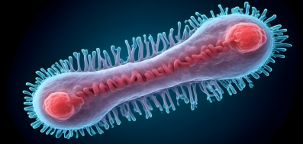z 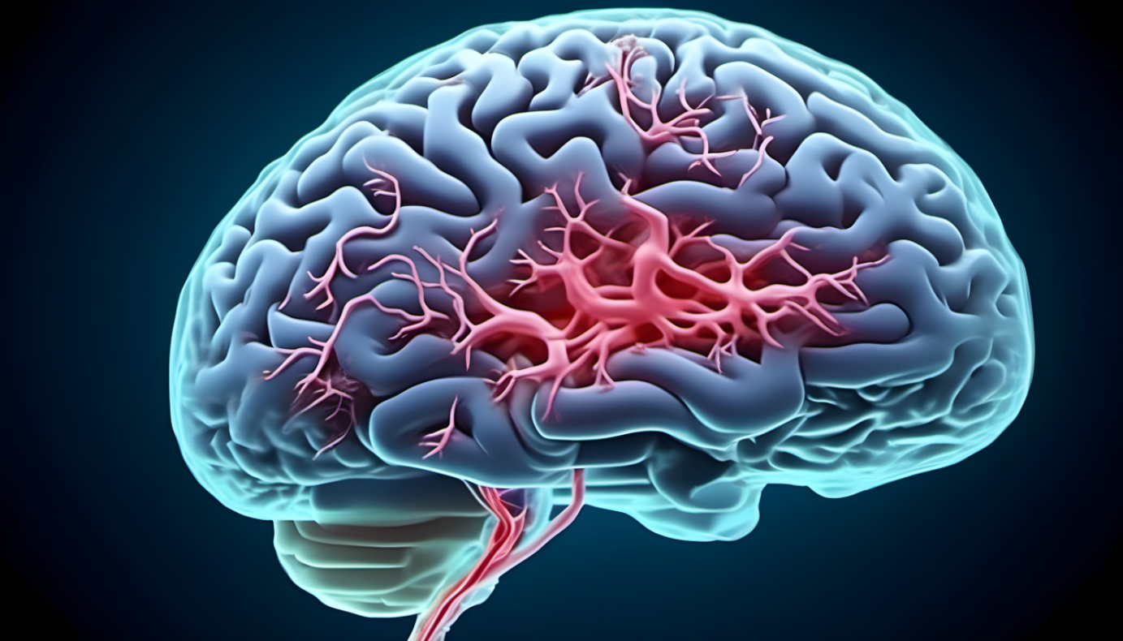

MYCOBACTERIUM TUBERCULAR MTB AFFECTED BRAIN

TYPES:

The bacilli may subsequently spread to the central nervous system (CNS) and cause one of three types of CNS TB: tuberculous meningitis, spinal tuberculous arachnoiditis, or intracranial tuberculoma.

INTRACRANIAL TUBERCULOMA: This term refers to the masses of granulomatous tissue that fill a space and are disseminated by blood from a distant site of tuberculosis infection.

SPINAL TUBERCULOUS ARACHNOIDITIS: Unlike other varieties of arachnoiditis, it frequently affects the spinal cord as well as the meninges and the nerve roots; it may arise as the primary or secondary result of intracranial or vertebral infection.

DISSEMINATION TO THE BRAIN:

Mycobacterium tuberculosis is spread through the central nervous system (CNS) and other locations during the transmission of TB. There have been many hypothesized processes by which the bacilli move into the bloodstream or lymphatic system. Early secretory antigenic target 6KDa (ESAT-6) and culture filtrate protein 10KDA (CFP-10) of the bacteria are implicated in cell lysis, whereas heparin-binding hemagglutinin adhesion (HBHA) facilitates MTB translocation through the epithelium without lysis. Additionally, MTB has the ability to enter and move through vascular endothelial cells, reproduce in lymphatic endothelial cells, and be transported by phagocytes to distant sites.

Two vascular barriers—the blood-brain barrier (BBB) and the blood-cerebrospinal fluid barrier (BCSFB)—protect the central nervous system (CNS) from the entry of potentially dangerous blood-borne microorganisms. The BBB is mostly made up of brain microvascular endothelial cells, which exhibit specialized transport mechanisms to control inflow and efflux across the CNS and blood compartments. These cells are distinguished by intracellular tight junctions, a lack of endocytic vesicles and fenestrae, and intracellular tight junctions. Endothelial cells are supported by pericytes embedded inside a basement membrane, and astrocyte end feet also significantly contribute to the integrity of the BBB. The choroid plexus epithelial cells that make up the BCSFB, in contrast, are connected by tight junctions and the arachnoid membrane.MTB bacilli move over these barriers despite these defenses.

MTB invades and passes through the brain endothelial cells in the microvasculature, as shown by in vitro and animal studies, by rearranging their actin. The MTB gene Rv0931C (pknD), which enables bacilli to interact with extracellular components on the brain endothelium and facilitates bacillary endothelial adherence, has also been identified as a possible virulence factor that promotes CNS infection in some TB strains. The 'Trojan horse' process, in which MTB is transported into infected macrophages and neutrophils across the BBB, is another possible entrance point.

PATHOGENESIS OF TBM:
The major location of infection, the lung, is where Mycobacterium tuberculosis bacilli (MTB) disseminate to seed the brain. The bacilli can cross the blood-brain barrier (BBB) and blood-cerebrospinal fluid barrier (BCSFB) thanks to variety of virulence factors that allow for the invasion and migration through cerebral vascular endothelial cells, or they can enter the central nervous system when infected peripheral innate immune cells are present rich foci, which are small tuberculous growths that first appear in the brain, spinal cord, or meninges, are the disease’s first symptoms in CNS tuberculosis. Which type of CNS TB manifests eventually depends on the location of these foci and the ability to regulate them. A tuberculous brain abscess, intracranial tuberculoma, and tubercular encephalitis are less frequent signs of CNS tuberculosis than tuberculous meningitis (TBM), which is the main symptom. Microglia, neurons, and astrocytes in the central nervous system (CNS) recognize and internalize pathogens, which is facilitated by a variety of host variables.

As a result, pro-inflammatory cytokines, chemokines, and other immune mediators are released, which aids in the breakdown of the blood-brain barrier and the infiltration of innate and adaptive immune cells from the periphery. TNF-, IFN-, IL-1, IL-8, and IL-10 are among the inflammatory mediators (cytokines and chemokines) that are the concentration of certain substances has been found to be elevated in the cerebrospinal fluid (CSF) of patients with type 1 diabetes mellitus (TBM).

Through the development of granulomata, TNF-, IFN-, IL-6, IL-8, and IL-10 are among the inflammatory mediators (cytokines and chemokines) that are the concentration of certain substances has been found to be elevated in the cerebrospinal fluid (CSF) of patients with type 1 diabetes mellitus (TBM). Through the development of granulomata, TNF- has been related to a protective role against M. tuberculosis. High levels of TNF- in CSF have been linked to worse results, according to studies using rabbit models of TBM. TNF- antagonists and antibiotics were combined to increase rabbit survival and results.

An extensive inflammatory reaction follows. The inflammatory exudate in the basal cisterns. The development of hydrocephalus is influenced by various factors., increased intracranial pressure, and cerebral vascular disease. The influx of proteins via the breached BBB causes vasogenic edema, which raises pressure, and cytotoxic edema, which results from cellular damage. The general decline in cerebral blood flow increases the likelihood of ischemia, infarction, and unfavorable patient outcomes in the brain. Sometimes the infection is contained in isolated abscesses or tuberculomas, which heal over time and with therapy. Spinal arachnoiditis, tuberculomas, or an accumulation of exudate are signs that the disease has spread into the spinal canal.

PATHOPHYSIOLOGY OF TBM:

By infecting the alveolar macrophage by droplet inhalation, MTB is first delivered into the host. The lung is where the primary infection starts, but it spreads to the lymph nodes. A significant amount of bacteremia can seed the entire body at this stage of the infectious process. MTB seeds the meninges in tuberculous meningitis, causing Rich foci, which are sub-ependymal clusters. These foci have the potential to burst into the subarachnoid space, triggering a severe inflammatory reaction that results in meningitis symptoms. This reaction's exudates have the potential to enclose Nerve palsies can occur due to damage to cranial nerves, while vasculitis can occur when blood vessels are entrapped., or they may obstruct the flow of cerebral spinal fluid (CSF), resulting in hydrocephalus, which may or may not be communicative.
Intracerebral arteries become constricted, spastic, thrombosed, and occluded as a result of tuberculous vasculitis. In the end, this results in numerous, tiny, bilateral infarcts that are frequently found in the periventricular areas. The internal capsule, thalamus, and basal ganglia are most frequently affected. These infarcts may result in stroke syndromes affecting the cerebellum, pons, basal ganglia, and/or cerebral cortex.

PATHOGENIC AND PATHOPHYSIOLOGICAL MECHANISMS WITHIN THE BRAIN:

Pathogenesis and immunological response of cerebral tuberculosis: Bacilli proliferate in the lungs after initial aerial infection, spread as blood vessels invade, and then result in systemic infection that affects the brain. After early bacteremia, small clusters of inflammatory cells are found in the subpial or subependymal regions (Rich nodules), where bacilli are present and may lie latent for a long period. Meningeal tuberculosis is later caused by the expansion and rupture of these lesions. Pro-inflammatory cytokines are useful for killing bacteria and are produced as a result of mycobacterial infection, but they can also result in immunological disease. Anti-inflammatory cytokines, which prevent tissue damage from excessive inflammation and promote the regeneration of nerve tissue, are also abundantly produced.

CLINICAL FEATURES OF TUBERCULOSIS MENINGITIS IN CHILDREN AND ADULTS:

There are typically three main stages of clinical presentation:
- At the subtle start, the individual experienced a low-grade fever, malaise, headache, and a significant personality change. are characteristics of the early prodromal phase. Typically, it lasts between one and three weeks.
- The meningitic phase, which follows, The statement is characterized by prominent neurologic symptoms such as prolonged headache, nausea, and meningismus. Lethargy, disorientation, and cranial nerve sign presentations.
- In the paralytic phase, confusion is followed by stupor, seizures, coma, and frequently hemiparesis. Within five to eight weeks of the illness's beginning, death usually follows.

Atypical symptoms include slowly progressing over time, dementia can lead to personality changes, social disengagement, memory problems, and loss of libido. The quickly progressing meningitis syndrome, may indicate pyogenic meningitis. Patients may occasionally also exhibit an encephalitic course, which includes convulsions, stupor, and coma but no obvious meningitis symptoms.

CHILDREN:
SYMPTOMS:
- Early signs and symptoms include fever, cough, vomiting, lethargy, and weight loss; they are non-specific.
- >6 days of symptoms' duration
- Children get seizures more often than adults do.
CLINICAL FINDINGS:
- Meningitis, decreased state of consciousness, bulging anterior fontanelle in babies, VI cranial nerve palsy, ocular atrophy, aberrant movements, and focal neurological indications, such as hemiplegia, are among the symptoms of apathy and irritability.
CSF FINDINGS:
- White cell count is elevated (0.5-1 109/l), with neutrophils and lymphocytes present. Usually transparent and colorless.
- Raised protein(0.5–2.5g/l)

- In 95% of instances, the CSF to plasma glucose ratio is 0.5.

ADULTS:

SYMPTOMS:
- A prodromal phase of low-grade fever, malaise, and weight loss is followed by the gradual emergence of a headache over the course of one to two weeks.
- headache that gets worse, nausea, confusion, and coma. Symptoms lasted for around 6 days.

CLINICAL FINDINGS:
- Neck stiffness, mental confusion, and coma Cranial nerve paralysis: VI, III, and IV
- Focused neurological symptoms, such as paralysis, hemiparalysis, and monoplegia retention of urine.
CSFFINDINGS:
- 50% of the time, high opening pressure >25 cm H20, typically transparent and colorless
- Increased neutrophil and lymphocyte counts in the white blood cells (0.05–109/l) (0.5–2.5 g/l) increased protein
- In 95% of instances, the CSF to plasma glucose ratio is 0.5.

DIAGNOSISOFTBM:

TBM is often a subacute illness, and symptoms may last for weeks before being identified. A lymphocytic-predominant pleocytosis, increased protein, and low glucose are typical cerebrospinal fluid (CSF) findings of TBM. With several, big volume samples, the yield of CSF acid-fast smear and culture is boosted despite their relatively low sensitivity. Although PCR's nucleic acid amplification of the CSF is extremely specific, its poor sensitivity prevents TBM from being ruled out in the event of a negative result.
TREATMENT FOR TBM:
ANTI-TUBERCULOSIS DRUGS USED IN TUBERCULOSIS MENINGITIS AND DRUG-RESISTANCE TUBERCULOSIS:
FIRST LINE DRUGS:

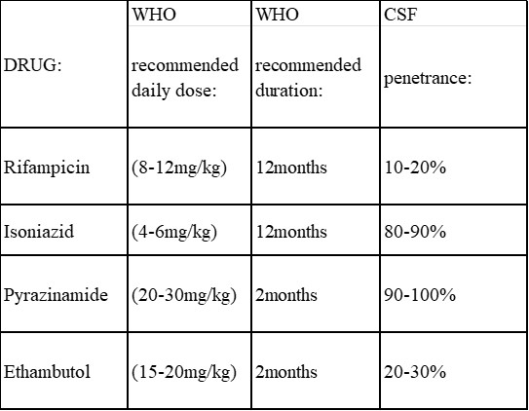

SECOND LINE DRUGS:

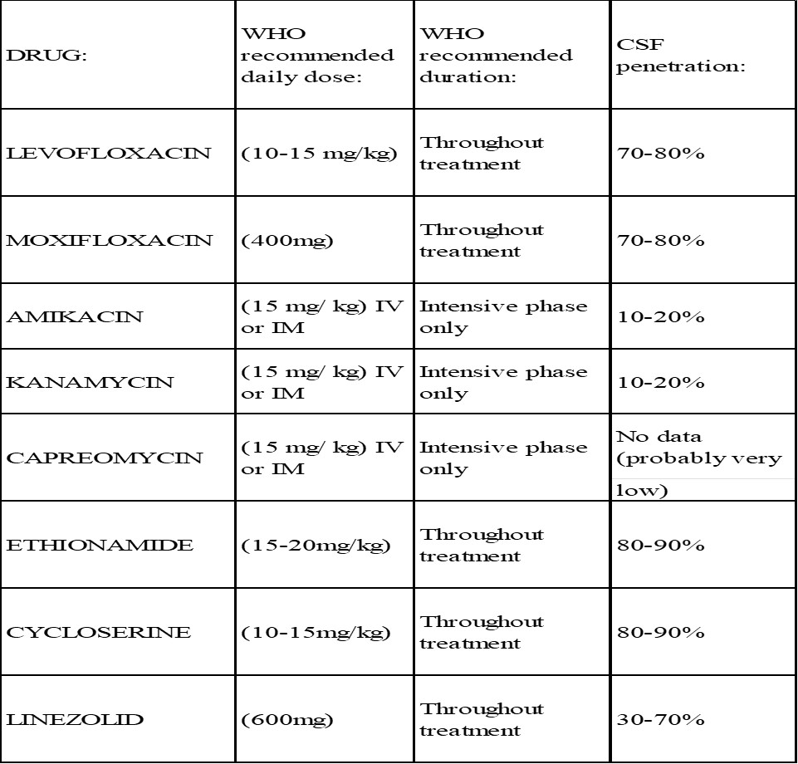

According to the most recent WHO recommendations for treating TBM, all patients should first get 2 months of rifampicin (RMP), isoniazid (INH), pyrazinamide (PZE), and ethambutol (ETB), followed by up to 10 months of RMP and INH. The highest indicator of survival from TBM is starting this regimen before the beginning of coma, however, this regimen does not account for the varying capacity of anti-tuberculosis medications to enter the brain. To reduce morbidity and mortality in tuberculous meningitis, immediate anti-tuberculous treatment is necessary. Treatments for tuberculosis in the first line show good CSF penetration. A two-month intense phase of daily isoniazid (INH), rifampin (RIF), pyrazinamide (PZD), and either streptomycin (SM) or ethambutol (EMB) treatment is required for TBM. The continuation phase of INH and RIF typically lasts seven to ten months after the implementation of this regimen.. The premise of this treatment strategy is that the MTB is not a resistant strain. It may take months to get drug sensitivity data, but once they are known, treatment can be customized. Ethambutol (EMB) is replaced in children by either an aminoglycoside or ethionamide due to the difficulties in detecting optic neuritis caused by ethambutol. With isoniazid-resistant CNS TB, daily treatment with rifampin, ethambutol, pyrazinamide, and fluoroquinolone is recommended. Additionally, depending on the clinical response to treatment, the seriousness of the condition, and the patient's immune status, the course of therapy should be prolonged to 18 to 24 months.

CONCLUSION:
Tuberculosis meningitis is a complex disease with a multifaceted set of challenges. Understanding its causative agent, pathogenesis, pathophysiology, mechanism of brain dissemination, and effective treatment options is crucial for healthcare professionals and researchers. The information provided in the review article serves as a valuable resource for improving the management and outcomes of tuberculosis meningitis cases, ultimately contributing to better patient care and public health efforts.

REFERENCES:
- Marx GE, Chan ED. Tuberculous meningitis: diagnosis and treatment overview.TubercResTreat.2011;2011:798764.doi:10.1155/2011/798764. Epub 2011 Dec 21. PMID: 22567269; PMCID: PMC3335590.
- Davis A, Meintjes G, Wilkinson RJ. Treatment of TuberculousMeningitis andItsComplicationsinAdults.CurrTreatOptionsNeurol. 2018 Feb 28;20(3):5. doi: 10.1007/s11940-018-0490-9.PMID:29492737; PMCID: PMC5830467.
- AngharadDavis, BSc, MBBS, MRCP, GraemeMeintjes, MBChB, FRCP, FCP, DipHIVMan, MPH, PhD, and Robert J. Wilkinson, MA, BM, BCh, DTM&H, PhD, FRCP, FMedSci
- Slane VH, Unakal CG. TuberculousMeningitis.[Updated2022Nov18].In:StatPearls[Internet].TreasureIsland(FL):StatPearlsPublishing;2023Jan-. Available from:https://www.ncbi.nlm.nih.gov/books/NBK541015/
- https://medlineplus.gov/ency/article/000650.htm#:~:text=Tuberculous%20meningitis%20is%20caused%20by,rare%20in%20the%20United%20States.
- https://www.meningitisnow.org/meningitis-explained/what-is-meningitis/types-and-causes/tb-meningitis/

J.F. Schoeman, P.R. Donald, in Handbook of ClinicalNeurology,2013
- Peter R Donald, Johan F Schoeman, in Tuberculosis,2009
- Chang KH, Han MH, Choi YW, Kim IO, Han MC, Kim CW.Tuberculous arachnoiditis of the spine: findings on myelography, CT, and MRI imaging.AJNRAmJNeuroradiol.1989 Nov-Dec;10(6):1255-62. PMID: 2512792; PMCID: PMC8332431.
- DavisAG, RohlwinkUK, ProustA, FigajiAA, Wilkinson RJ.The pathogenesis of tuberculous meningitis. J Leukoc Biol. 2019Feb;105(2):267-280. doi: 10.1002/JLB.MR0318-102R. Epub 2019Jan15.PMID:30645042; PMCID: PMC6355360.
- Ryndak, M. B., &Laal, S. (2019). Mycobacterium tuberculosis Primary Infection and Dissemination: ACritical Role for Alveolar Epithelial Cells.FrontiersinCellularandInfectionMicrobiology,9.doi:10.3389/fcimb.2019.00299
- Rock RB, Olin M, Baker CA, Molitor TW, Peterson PK. Central nervoussystemtuberculosis:pathogenesisandclinicalaspects.ClinMicrobiolRev.2008Apr;21(2):243-61,tableofcontents.doi:10.1128/CMR.00042-07.
- PMID:18400795;PMCID:PMC2292571.
- Torok,M.E.(2015).Tuberculous meningitis: advances in diagnosis and treatment. British Medical Bulletin, 113(1), 117–131.doi:10.1093/bmb/ldv003
- Thwaites, G.E., Simmons, C.P., ThanHaQuyen, N., ThiHongChau, T., PhuongMai, P., ThiDung, N.,…Farrar, J.J.(2003).PathophysiologyandPrognosisinVietnameseAdultswithTuberculousMeningitis.TheJournalofInfectiousDiseases,188(8),1105–1115.doi:10.1086/378642
- AhmedIqbalBhigjee;RivashneePadayachee;HoosainParuk;KumariDeviHallwirth-Pillay; Suzaan Marais; Cathy Connoly (2007). Diagnosis of tuberculous meningitis: clinical and laboratory parameters. , 11(4), 348–354. doi:10.1016/j.ijid.2006.07.007
- Tripathi, K. D. (2018). Essentials of medical pharmacology (8th ed.). JaypeeBrothersMedical.
- 17.J.Clin.Med. 2020,9(9),2962;https://doi.org/10.3390/jcm9092962
- .Byrd, T., Zinser, P. Tuberculosis meningitis. Curr Treat Options Neurol 3, 427–432(2001).https://doi.org/10.1007/s11940-001-0030-9
- https://www.slideshare.net/ManojPrabhakar61/tb-meningitis-81523602

