INTRODUCTION:

Over the decades, many novel treatment options have been developed to aid in the maintenance of proper oral health. The field of periodontics also is booming with such new therapies aiming to acheive good oral hygiene.
This chapter deals with the overview of lately available treatment modalities in periodontal management.

NON SURGICAL APPROACHES:

OBJECTIVES:
  - Elimination and the prevention of their recurrence of supra and subgingivally located bacterial deposits, by
    - Motivation
    - Education
    - Scaling and Root planing
    - Removal of additional retention factors

INSTRUMENTS:
- Hand Instruments:
  - Area specific (Gracey curettes)
  - Extended shank curettes
  - Mini bladed curettes
  - Gracey curvettes
  - Langer & mini langer curettes
  - Plastic instruments for Implants

ULTRASONIC & SONIC INSTRUMENTS:
- Modified contraangled tips (EW-PIOR & EW PIOL) resemble a periodontal probe for hopeless teeth.
- Diamond coated ultrasonic tips
- Teflon coated sonic inserts (kocher et al 2002).
- Plastic tips with sonic scalers
- Diamond coated ellipsoid terminal tips for furcation
- Air powder systems

ROTATING & RECIPROCATING INSTRUMENTS:
- Fine grained diamonds.
- Rotosonic instruments – mounted on air turbine.
- Periosonic instruments – modified version of endodontic system.
- Profin Directional system (II gen. of EVA system)
- PER-IO-TOR Instruments (Mengel et al, 1994).

PERIODONTAL VACCINE:
- Vaccine candidate - antigen of P.gingivalis. It is a potential vaccine candidate because this pathogen carries several high potent antigens like LPS capsule, Lipids and outer membrane proteins.
- Whole cell formalin killed P. gingivalis has been used.
- Rajapakse et al (2002) – Immunisation with RgpA induces an Ig G2 response with a restricted colonization by P.gingivalis and periodontal bone loss.
- Large variation in P.gingivalis ribotypes recognized by serum Ig G from subjects with chronic periodontitis also exist.
- Kaizuka et al (2003) – With human Monoclonal Ab that is capable of recognizing the 43 & 49 kDa proteins from P. gingivalis and inhibiting the haemagglutinating ability of P.gingivalis proven useful in passive immunization against periodontitis.
SHORTCOMINGS……….
- Disparate results obtained due to;
  - Difference in Ag/Ab complexes studied.
  - Difference in serum assays used.
  - Difference in Periodontitis disease severity.
  - Classification and existing subgingival microflora.
  - Difference in efficacy of different agents.
PROBIOTICS & PREBIOTICS:
- Probiotics are live microorganisms prescribed in required amounts provide health benefit on the host. (Guarner et al 2005).
- Mechanisms proposed: (Lewis & Freedman 1998)
  - Competition with potential pathogens for nutrients.
  - Degradation of toxins.
  - Local and systemic immunomodulation.

PROBIOTICS AND PERIODONTAL DISEASE:
- The microbial load causing periodontal diseases could be regulated by microorganisms having beneficial effect.
- A decrease in bleeding points and reduced gingival inflammation has been observed by (Krasse et al, 2006) on application of L. reuteri in periodontal diseases.
- Koll-klais et al (2006) mentioned that lactobacilli flora inhibited the growth of P. gingivalis and P. intermedia in 82% and 64% respectively.

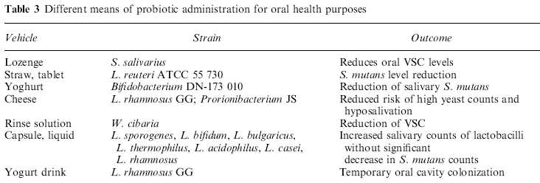

FIGURE 1: DIFFERENT MEANS OF PROBIOTIC ADMINISTRATION

PROBIOTICS IN PERIODONTAL DRESSINGS & REDUCTION OF VSCs:
- Volozhin et al (2004); Periodontal dressings comprised of collagen and L.casei to decrease the number of most frequently isolated periodontal pathogens (Bacteroides sp., Actinomyces sp., and S. intermedius and also C. albicans).
- Kang et al (2006) – inhibitory effect on volatile sulphur compounds after ingestion of Weissella cibaria. (by generation of Hydrogen peroxide).
- Safety Aspects is of special concern.

LOCAL & SYSTEMIC ANTIMICROBIAL THERAPY:
- Current Indications:
  - Patients showing poor compliance
  - Physically & Mentally handicapped individuals.
  - Medically compromised patients.
  - Patients wearing ortho appliances.
  - Secondary prevention following periodontal surgery.
  - Elderly & long term hospitalized patients.
  - To limit bacteremia in patients susceptible to bacterial endocarditis.
CURRENT USAGE & INDICATIONS:
- Because of potential risks & side effects associated with systemic therapy, its usage is limited to unresponsive patients, rapidly progressing, recurrent, Aggressive cases.
- Superiority of combination therapy (Metronidazole and amoxicillin) over monotherapy.
- Local antimicrobial delivery is addressed to localized nonresponding sites in otherwise well controlled patients. (Rams & Slots, 1996).
- Antiseptic agents are primarily indicated during the healing phase after therapy.

HOST MODULATION AND THERAPY:
- Better understanding of the participation of host immune inflammatory mediators in disease progression has increased the investigation of the use of host modulating agents.
- Subantimicrobial Dose Doxycycline:
  - Anticollagenase activity efficient in inhibiting mammalian collagenase activity without developing antibiotic resistance.
  - Reddy et al (2003), in an metaanalysis on long term use of SDD showed significant benefit on CAL & PD when used in combination with SRP.
- NSAIDS:
  - Shown to prevent prostanoid formation.
  - Invitro & Invivo studies shown suppression of osteoclast differentiation & concomitant decreased alveolar bone resorption.
  - In a systematic review (Reddy et al 2003) a variety of different NSAIDS (Flurbiprofen, meclofenamate, ibuprofen, ketorolac, naproxen and aspirin) were systemically or locally administered showed significant benefit related to alveolar bone preservation.
  - Long term studies are necessary.

BISPHOSPHONATES:
- These binds to hydroxyapatite crystals of bone and prevents their dissolution by interfering with osteoclast function.
- Studies with bisphosphonates presented significant improvement when compared with placebo, including PD reduction, CAL gain, BOP reduction, Alveolar bone gain, and increase in bone mineral density.

FIGURE 2: HOST MODULATION THERPAEUTIC MEASURES
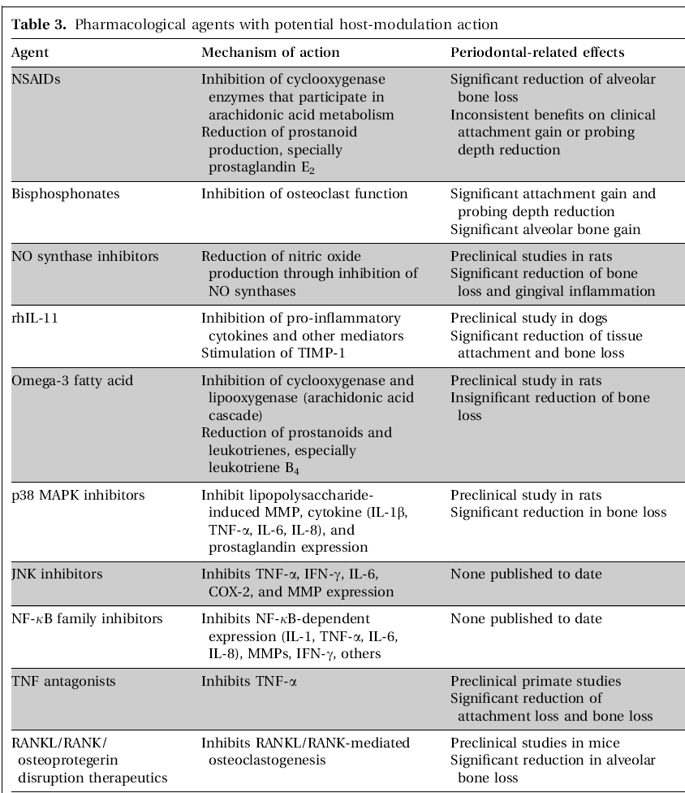

FIGURE 3: PHARMACOLOGICAL AGENTS WITH HOST MODULATORY ACTION

OXYGEN THERAPY IN PERIODONTAL DISEASE:
- The spectrum of pO2 in deep pockets, define the pocket microbiological composition.
- It is known that significant changes in ginigval O2 utilization accompany inflammatory and healing status of gingival tissues.
- Clinical application: Agents used
  - Molecular oxygen (Hirsh et al 1981).
  - Hyperbaric oxygenation (Gotsko et al 198un C:\WINDOWS\hinhem.scr0)
  - Hydrogen peroxide (Baer et al 1985).
  - Ozone therapy.

O2 THERAPY……….
    - Effectively supports antibiotic and surgical therapy.
    - Enhances the function of leukocytes.
    - Activating or supporting body defense mechanism.
    - Enhances regenerative processes by increasing tissue capillarity and increasing fibroblast replication.

- Hanioka (1994); found therapeutic effects of Ubiquinone Q10 a hydrogen carrier in krebs cycle which increase the availability of O2.
- Schlagenhauf (1994) repeated subgingival O2 irrigation and found clinical improvement of periodontal baseline conditions.
- Alexander et al (2006) used localized oxygenation therapy for treatment of Acute necrotizing periodontal disease.
- Ripolles et al (2004) Found periodontal treatment with ozone produces significant reduction in the amount of gingival bleeding, microbiological & immunological parameters.
- Chen (2002) showed beneficial therapeutic effect of HBO on severe periodontitis.

SURGICAL TECHNIQUES:

ROOT BIOMODIFICATION:
- Daly et al 1982 suggested this as a part of regenerative procedures because of the ability of acid to modify the root surface by detoxifying it.
- EDTA which has less acidic pH, may also expose collagen fibers and thus promote cell attachment without having a damaging effect on the surrounding tissues. (Blomlof 1997)
- A recent systematic review confirmed that the application of citric acid, tetracycline or EDTA to modify root surface provides no clinically significant benefit in regeneration of patients with chronic periodontitis. (Mariott A 2003).

CORONALLY ADVANCED FLAPS:
- The periosteum is viewed as having regenerative potential due to its rich structure in osteoprogenitor cells (Gantes B, Garrett S 1988).
- The regenerative potential is believed to be resulted by the cellular activity of the periosteal cells and a also by barrier type effect created by the repositioned periosteum.
- It is necessary to test a large no. of patients with a larger follow up period to fully evaluate this technique.

BONE REPLACEMENT GRAFTS:
- Includes
- Autogenic grafts
- Allogenic grafts,
- Xenografts
- Alloplasts.
- It has been proved that bone grafts improved treatments of periodontal osseous defects compared with surgical traetment alone.
- Their benefits for the use of furcation defects remain to be determined.
EXTRA AND INTRAORAL AUTOGENOUS BONE GRAFTS:
- Successful bone fill has been demonstrated using iliac cancellous bone with marrow in furcations, dehiscence and intra osseous defects of various morphologies. (Dragoo, Sulliva, 1973)
- The maxillary tuberosity or a healing extraction site is typically the donor choice.

ALLOGENIC BONE GRAFTS:
- Human mineralized bone: (Puros)
  - Human bone that undergoes a tutoplast process, involving delipidization, osmotic treatment, oxidation with H2O2, solvent dehydration with acetone.
- Grafton demineralized bone matrix:(DBM)
  - Processed from cadaver bones to remove lipid, blood, and cellular components and then is kept under frozen conditions.
  - To improve the handling and to stabilize the proteins, a glycerol carrier is used commonly.

  - 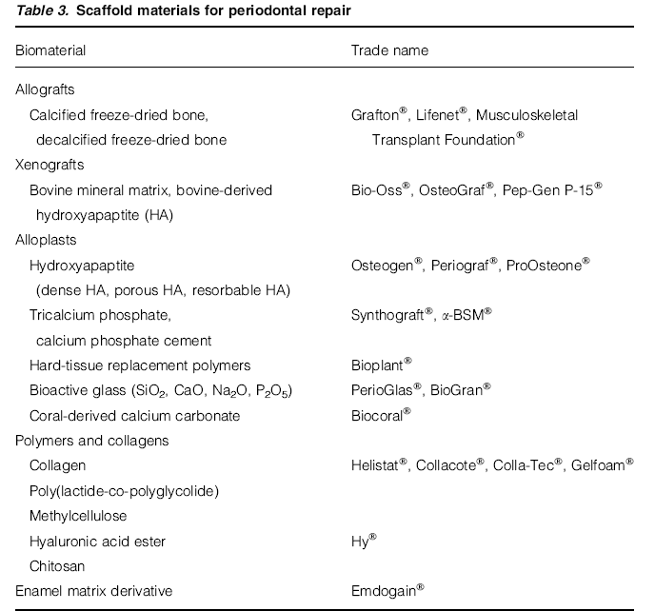

FIGURE 4: COMMERCIALLY AVAILABLE SCAFFOLD MATERIALS FOR PERIODONTAL REPAIR

ALLOLASTS:
- Alloplastic materials are synthetic, inorganic, biocompatible, or bioactive bone graft substitutes and promote bone healing through osteoconduction.
- On a whole the effect of alloplast material has been inconsistent (Reynolds 2003) and it appears that it function as non irritating fillers.

XENOGRAFTS:
- Graft taken from a donor of different species. Proprietary processes are suggested to remove all cells and proteinaceous material and only absorbable bone scaffolding is left.
- To date there are minimal clinical data supporting the use of xenografts in periodontal defects. Only one study shows improvements in clinical parameters similar to DFDBA. (Mellonig JT, 2000).
- Recently concern about the risk of transmission of prion medicated disease from bovine derived products has arisen, but WHO labeled bone as Type IV (no transmission) for prion disease. (Asher, 1999).

GUIDED TISSUE REGENERATION:
- The concept is done to exclude the migration gingival connective tissue cells and prevention of epithelial downgrowth into the wound, thereby allowing cells with regenerative potential to enter the wound first.
- GTR has proved to be more effective than open flap procedures in the gain of clinical attachment and reduction of probing depths in treatment of intrabony and furcation defects. (Murphy 2003).

FIGURE 5: COMMERCIALLY AVAILABLE BARRIER MEMBRANES

- The treatment of furcation defects with a combination of GTR barrier membranes and bone grafts proven to achieve greater clinical improvements than when GTR alone is done (Evans, Yukna 1993).
- Currently polylactic acid and collagen membranes (Absorbable) have reported clinical improvements comparable to non absorbable membranes.
- A study comparing polylactic acid with polyglycolic acid, a type I collagen membrane in the treatment of intrabony defects, has reported similar clinical improvements for both the membranes. (Mettson, 1999).

BIOLOGIC MODIFIERS:
- Bone Morphogenetic Proteins:
  - BMPs have unique properties in inducing ectopic bone formation and new cementum formation.
  - Several animal research studies reported improved regenerative results when BMP-2 & BMP-7 were used for the treatment of periodontal defects.
  - Future research is needed to clearly understand the applicability of BMPs in periodontal regeneration.

GROWTH FACTORS/ PRP:
- These play a prominent role in the stimulation and regulation of the events required for healing of the wound.
- Growth factors found include PDGF, VEGF,TGF,FGF,EGF,IGF,CGF,PTHrP,BMPs 1-12.
- Limited human clinical data are available. One human clinical trial using rPDGF & IGF has shown promising results in intrabony defects & furcations. (Howell 1997).
- Aghaloo et al (2002) used anorganic bone mineral with PRP and showed that additon of PRP significantly increased the percentage of bone formation over that of bone mineral.

OTHER EMERGING MATERIALS:
- Enamel Matrix Derivative:
  - Group of enamel matrix proteins isolated from developing porcine teeth.
  - The freeze dried protein extract is made soluble in a propylene glycol alginate carrier solution.
  - A recent in vivo study showed that it was not an osteoconductive material but was osteoconductive named osteopromotive by some (Boyan BD et al 2000).
  - Although clinical trials of enamel matrix derivative have demonstrated significant improvements in probing measurements and radiographic evidence of bone fill, long term benefits have not been established. (Giannobile 2003).
Pep Gen P-15:
- It is a collagen binding peptide that has a combination of an anorganic bovine derived hydroxyapatite matrix and a synthetic 15 aminoacid sequence type I collagen (p-15).
- It is believed to attract and bind fibroblasts and osteoblasts to promote periodontal fibroblast attachment.
- Few clinical trials have reported greater regeneration compared with OFD, DFDBA or anorganic bovine derived hydroxyapatite matrix alone.
GEM 21 S:
- The matrix component of this is highly porous.
- It is a synthetic beta-tricalcium phosphate (β-TCP) - an osteoconductive matrix for cellular migration and proliferation and subsequent matrix deposition.
- PDGF - It exerts its effect primarily through the recruitment of cells within the surrounding matrix. Extensive in vitro and animal studies have demonstrated PDGF's potent chemotactic (directed cell migration) and mitogenic (proliferative) effects on cells derived from bone and periodontal ligament.

PERIODONTAL MICROSURGERY:
- Microsurgery refers to a refinement in the surgical techniques by which normal visual acuity is enhanced through magnification.
- Periodontal microsurgery will positively influence the professional acceptance as it include;
  - Better cosmetic results
  - Better predictability
  - Reduced trauma and relative painlessness
  - Higher patient acceptance
- Under magnification, in the range of 10x - 20x, periodontists can easily learn to increase the precision of their motor skill from tolerances of 1-2 mm to as small as 10 pm (Shanelee & Tibbetts 1992).
- Keplerian loupes of three types are used;
  - Simple loupes
  - Compound loupes
  - Prism Telescopic loupes

MICROSURGICAL INSTRUMENTS:
    - Make clean incision, established at 90 degree angle to the surface.
    - Easy identification of ragged wound edges.
    - Microsutures in the range of 6.0 to 9.0 are to be used for approximation of the wound edges.

PIEZOSURGERY:
  - It is an control system monitoring cutting temperature, vibration amplitude to ensure a clean cut.
  - Because the instrument’s tip vibrates at different ultrasonic frequences, hard and soft tissues can be selectively cut.
  - Therapeutic features: (Schlee, Markes;2006)
    - Micrometric cut – precise and secure action to limit tissue damage, especially osteocytes.
    - Selective cut – affecting mineralized tissue, but not surrounding soft tissue.
    - Clear surgical site – result of the cavitation effect created by irrigation/cooling solution and oscillating tip.
ADVANTAGES:
  - Minimal risk of jeoparadizing critical anatomic structures,
  - Minimal intraoperative bleeding
  - Minimal postoperative swelling.
  - Minimal thermal damage.
    - Giulio preti et al (2007) suggested that bone surgery using peizosurgery appears to be more efficient in the healing of osseous structures in the early stages.
    - It induces early release in BMPs, TGF-beta 2 proteins and reduction in proinflammatory cytokines.
    - It also controlled the inflammatory process efficiently and stimulated bone remodelling as early as 56 day post treatment of implant surgery.

ADVANCES IN DENTAL IMPLANT MATERIALS:
- Modification of surface Ti oxide:
    - By heat treatment, sol-gel derived oxidation and electrochemical oxidation.
- Chemically modified Ti oxides:
  - By treatment in simulated body fluid, covalent attachment of biological molecules, changes in surface ion content, glow discharge or alkali treatment.
- Fluoride modification of Ti oxide:
  - Fluoride is suggested to induce the differentiation of precurosor cells into osteoblasts.
- Growth factors in peri-implant healing:
  - Studies have shown that BMP-2 can be incorporated into biomimetic coatings on Ti while retaining a biological activity for implant integration.
- Bone extracellular matrix:
  - Bone extracellular matrix is a biologically active entity containing molecules that if added to the implant surface, could represent break through in guided interfacial osteogenesis.

RECENT ADVANCES IN IMPLANT SURGICAL TECHNIQUES:
- Computer imaging software to simulate preoperatively the implant position into a virtual patient, i.e a three dimensional computer image of the patient’s jaw created from the CT data.
- Computer generated surgical guides with drill holes based on the presurgical “virtual” implant positioning.
- Computer assisted implant surgery through simultaneous tracking and guidance of the implant instrumentation.

LASERS:
- It is an acronym for Light Amplification by Stimulated Emission of Radiation.
- Characteristics:
  - Depends on its wavelength.
  - Delivered as a continuous or as a pulsed beam emission.

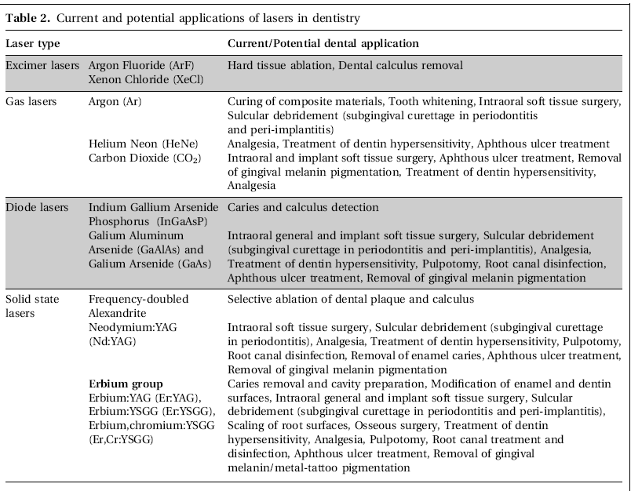

FIGURE 6: APPLICATIONS OF LASER

IN PERIODONTAL THERAPY;
Lasers were first employed in dentistry for caries removal and cavity preparation, as an alternative for conventional methods.
Until early 1990s, the use of lasers in periodontal therapy was limited to soft tissue procedures, as application to periodontal hard tissues had previously proved to be clinically unpromising. In the early and mid 1990s, scientific research was begun on root surface modification and curettage using an Nd:YAG laser. The clinical application of the Nd:YAG laser had already been tried by general practitioners because its convenient, flexible fiber optic delivery system made it appropriate for use in periodontal pockets
- In 1965, Kinersly – used ruby laser to remove dental calculus.
- CO2 & Nd:YAG – Excellent soft tissue ablation & hemostatic effect. Carboniation of hard tissues.
- Diode & Nd:YAG – for pocket curettage.
- Er:YAG – for sulcular debridement & osseous surgery.
- In periimplantitis – Nd:YAG is not suitable. Er:YAG & CO2 can be used.

STEM CELLS:
- Broadly divided into:
  - Embryonic stem cells
  - Adult stem cells.
- Depending on origin & differentiation potential;
  - Hematopoeitic & Mesenchymal cells.
- MSCs,
  - Gives origin for mature cell types.

Progenitor cells are partially differentiated cells which divide and give origin to differentiated cells. Such cells are usually regarded as committed to differentiating along a confined cellular pathway.
Undifferentiated cells are usually considered to be progenitor cells until their pluripotent tissue differentiation and self-renewal properties can be demonstrated in order to designate them as stem cells.

- Trubiani et al (2005); isolated a population of MSCs from the periodontal ligament.
- Seo et al (2005); stated that cells isolated from cryopreserved periodontal ligament cells, provide ready source of MSCs.
- Future prospects;
  - MSC identification and localization.
  - Cementoblast like cell applications.

The credibility of a stem cell-based tissue engineering approach to achieving periodontal regeneration is contributed by studies performed on animals which stated that periodontal ligament cells cultured in vitro can promisingly aid in periodontal regeneration (Hasegawa et al, 2005).

FIGURE 7: TISSUE ENGINEERING APPROACHES IN PERIODONTICS

NANOTECHNOLOGY:
- It is the contriving of matter at the atomic level to create materials with remarkably varied and new properties.
- Nanomaterials are those materials which are less than 100nm in atleast one dimension.
- Properties:
  - Has improved properties including mechanical and thermal.
  - Development of self assembly.
- Polyelectrolytic materials consisting charged groups are most commonly used in self assembly, as they enable stable, smooth, homogenous films to be formed into functional groups.
  - E.g. Poly(allylamine), Poly(styrene sulfonate) & diazo resin.

DENTAL TISSUES AND NANOSTRUCTURES:
- Nanoparticles are being developed for biomedical and biotechnological application including drug delivery, enzyme immobilization, & DNA transfection.
- Pinon-Segundo et al (2005) produced triclosan loaded nanoparticles by emulsification diffusion process.
- Drugs in nanospheres provides regulated release of the drug with the degradation of nanospheres.
- Polymer scaffolds for cell seeding and delivery of growth factors can be created.
Recent development of nanoparticles and nanotubes for periodontal management such as the hollow nanospheres, core-shells, nanocomposites, nanoporous materials and nanomembranes will play a growing role in the materials used for the dental industry.
Many studies have been published concerning nanocomposite and nanoporous materials in dentistry.
But further research has to be done to develop nanomaterials for the management of periodontal diseases exclusively. It is envisioned that this technology will be further under research in the future.

PROTEOMICS:

Proteomics analyses the expression of proteins in specific cells. Recent advances in tissue isolation, protein separation, quantification, sequence analysis, and structural and interaction lead to use proteomics for understanding the periodontal structures in detail.

TECHNIQUES:
  - Two hybrid system
  - Two dimensional polyacrylamide gel electrophoresis.
  - Capillary electrophoresis
  - Mass spectrometry
  - Electrospray

CURRENT APPLICATIONS:
- Maccarthur (2003); As far as oral microorganisms are concerned, only two dimensional electrophoresis has been used.
- Proteomic analysis has been applied to fibroblasts, osteoblasts and for rare cells like osteoclasts.
- However, identification and quantification of proteins alone are not sufficient to understand functional changes.

Current proteomics analyses have the capacity to provide new insights into the repertoire of expressed proteins and some inkling of their interactions, at a more global level than previously considered.
An important challenge that needs to be met in periodontology is to embrace proteomics approaches when required, and to apply them to demanding, unsettled questions such as the biological basis for the diversity in gingiva, bone, and cementum cell populations.

GENE THERAPY:
- Genes are specific sequences of bases that encode information on making proteins.

Many investigators predict that information concerning polymorphism will be useful in the prevention and therapy of periodontitis, as well as in the recognition of patients in need of more comprehensive therapy.
The early identification of risk factors for the development of periodontitis may also form the basis for more focused and costeffective preventive approaches.

- Gene therapy is a technique for modifying defective genes associated to the disease.
- Approaches for correcting faulty genes:
  - Inserting a functional gene to replace a nonfunctional gene.
  - Through homologous recombination.
  - Through selective reverse mutation.
  - The regulation of genes.

CLINICAL IMPLICATIONS:
- Gene enhanced tissue engineering
- Periodontal vaccine
- Gene therapy for antibiotic resistant biofilm
- For alveolar remodelling.
- To control disease progression.

Future studies – associations between the disease and the gene should be confirmed and that the gene should have a biologically plausible relationship with the periodontal disease.

CONCLUSION:
Despite the fact that out right regeneration of the periodontal tissues and predictable management of periodontal diseases might not be foreseeable for many years owing to the multifactorial etiology, emerging developments have provided a assuring insight into the application of all these materials and methods.

As periodontology continues to evolve, one thing to be noted is: The future is optimistic!!!

