A SHIFT FROM ACTIVATED SLUDGE PROCESS TO
UPFLOW SLUDGE BLANKET FILTRATION (USBF)– A Review

Vijay Samuel G¹, Sudarshan Choudhary², R. Selvakumar³, J. Sandhya¹, Lakshmi Sundeep¹,
G. Joseph Samuel Rajan⁴, Aakash R¹, Vikash S R¹, Roshin Robinson¹

¹Department of Biotechnology & Chemical Engineering, Hindustan Institute of Technology & Science, Chennai, India.
²Health, Safety & Environment, Adani Group, Ahmedabad, India.
³Department of Automobile Engineering, Hindustan Institute of Technology & Science, Chennai, India.
⁴Department of Political Science, Madras Christian College, Chennai, India.

*Corresponding author: vijaysamjuly@gmail.com

ABSTRACT

The detrimental effects of industrial and domestic wastewater discharge to the environment is of exigent concern with reference to the ecological impact on biota. In this regard, management of wastewater to produce effluent with the best quality is imperative and technology selection criteria requires a process that is not only cost-effective for a community but also environment friendly. USBF is an influential modification of the activated sludge process and extends over the treatment of wastewater converting dissolved and colloidal contaminants in water into a separate floc solution via agglomeration techniques. It develops in a system divided into interconnected zones where primary sedimentation, nitrification-denitrification and clarification takes place. The conditions that put this process in a favourable position are single-tank configuration, small foot print, self-regulating hydraulic flexibility, alkalinity recovery, easily expandable and low capital costs. By dint of its performance, this system at optimal operating conditions can be effective for wastewater treatment.

Keywords: Activated sludge, biota, nitrification-denitrification, USBF, self-regulating

INTRODUCTION

Contemporary statute put forward for wastewater treatment has led to formulation of high grade quality effluent. Eventually, this had subsidizing effects of human negligence towards environmental safety and escalated the demands on superior technologies. In 1914, Edward Arden and W. T. Lockett (England) proposed an idea on Activated Sludge Process (ASP) This is an aerobic suspended-growth treatment system that includes a clarifier-settler and an aeration tank. [42]. It entails the creation of a mass of microbes that have been triggered, which includes a diverse community of heterotrophs and autotrophs, capable of stabilizing waste aerobically and to remove organic carbon and nutrients present in wastewater. The major hindrance that depletes the efficiency of the process is the high sludge age that is used for nitrification which deteriorates sludge digestion.In order to address this impediment, an advanced radical design is integrated into the system. This revamp of the ASP is termed Upflow Sludge Blanket Filtration (USBF). On analogizing, the activated sludge process provides moderate removal efficiency than USBF for COD, BOD and TSS. Inorder to overcome certain limitations of the ASP system such as hydraulic flexibility, abrupt changes in the characteristics of wastewater or in its working volume, the USBF system. [21, 33] The process such as UV treatment, Reverse Osmosis, Enzyme filtration process and ion exchange or vacuum distillation (for the removal of oil and grease) can be employed for further treatment of waste water so that it can also be used for drinking purposes.

TREATMENT PATHWAYS IN ETP
Various stages of treatment of wastewater before effective discharge are as follows: Initial assessment and primary treatment, secondary treatment, and tertiary treatment. Initial processing and primary treatment involves physical separation of coarse solids, fine solids and other large-sized materials (organic and inorganic) like cloth, plastics, wood logs, paper, etc. This is a vital factor to enhance the operation and maintenance of the subsequent units. [38, 10]. Common unit operations include: 1) Screening: using meshes of uniform size is used to remove large solids such as plastics, cloth etc. (Usually, 10mm is used). 2) Sedimentation: Physical water treatment process using gravity to remove suspended solids from water. 3) Clarification: Deals with separation of solids from fluids. Common unit processes include: 1) pH Control: To adjust the pH of wastewater to specific standards in the treatment process. NaOH, Na₂CO₃, CaCO₃, or Ca(OH)₂ are utilized for acidic wastes (low pH), whereas H₂SO₄ or HCl are used for alkali wastes (high pH). 2) Chemical coagulation: Method for neutralizing charges and creating a gelatinous mass large enough to catch (or bridge) particles and settle or be trapped in the filter. Wastewater is treated with chemical coagulants like Al₂(SO4)₃ (also known as alum) or Fe₂(SO4)₃ to increase the attraction of the tiny particles, causing them to group together and form flocs. 3) Flocculation: This is the process of gently swirling or agitating a mixture to help the newly generated particles coalesce into masses large enough to settle or be filtered from the mixture. The flocculation process is improved by a chemical flocculent (often a polyelectrolyte), which binds particles together to produce bigger flocs that settle out more quickly.

Biological and chemical procedures that can be utilized to either eliminate or reduce the concentration of organic and inorganic chemicals are a part of secondary treatment. When certain effluents require only aerobic processes for treating, others necessitate collaborative effects of both aerobic and anaerobic processes.[20] Utilizing the microorganisms (aerobes) that use molecular/free oxygen to assimilate organic pollutants and convert them to carbon dioxide, water, and biomass, aerobic treatment methods take place in the presence of air (oxygen). Anaerobic treatment techniques use microorganisms (anaerobes) that do not require air (molecular/free oxygen) to digest organic pollutants to take place in the absence of air (oxygen). The activated sludge processes, trickling filters or biofilters, oxidation ditches, and rotating biological contactors (RBC) are examples of common high-rate processes. Municipal wastewater containing a high percentage of organic material from industrial sources is occasionally treated using a combination of these procedures in series (for example, biofilter followed by activated sludge).[31, 39]

Prior to wastewater being reused, recycled, or released into the environment, Tertiary / Advanced Treatment includes a thorough cleaning process. Mechanism entails the elimination of any leftover inorganic chemicals as well as potentially dangerous bacteria, viruses, and parasites, as well as elements like nitrogen and phosphorus. [40] Alums are utilized to group the remaining solids for straightforward removal in the filters and to aid in the removal of extra phosphorus particles. By eliminating germs from treated wastewater, the chlorine contact tank sterilizes secondary treated wastewater. Just before it is released, sodium bisulphate is added to eliminate any leftover chlorine. [12, 13]

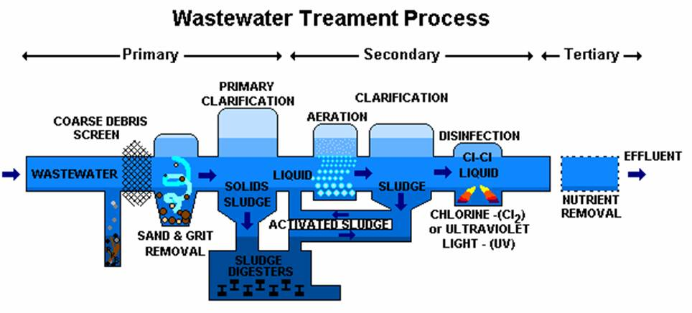

Fig 1: Wastewater treatment process stages

INNOVATIVE NECESSITIES IN WASTEWATER TREATMENT

Urbanization, industrialization, and agricultural expansion all have parallel consequences that have resulted in severe water shortage problems. As a result, the majority of river basins are shutting or have already closed. In terms of the required standards, the performance criteria used to evaluate the state-owned sewage treatment plants (STP) and common effluent treatment plants (ETP) for processing sewage from municipalities and other effluents from various small-scale companies are similarly subpar. Therefore, we have serious concerns about the development of novel technologies for the treatment of wastewaters from various industries.

Because the properties of the sludge have a significant impact on the efficiency of the solids/liquids separation, Edward Arden and W. T. Lockett (England - 1914) proposed the idea of the activated sludge process (ASP), which was developed as an intermittent to biological filter and is especially advantageous for large populations where land is at a premium. Later on in their work, they reported that the defined system had significantly lower biological oxygen demand (BOD), chemical oxygen demand (COD), total suspended solids (TSS), and total dissolved solids (TDS), as well as a high percentage of toxic and nutrient removal (e.g., nitrate, phosphate, etc.).

ACTIVATED SLUDGE PROCESS (ASP)

Through the transformation of biodegradable organic matter into forms that can guarantee the stability of wastewater while some are pathogenic, microorganisms play a significant role in the purification of wastewater. Basically, water bodies in systems like rivers and streams have a capacity to purify themselves with the aid of microorganism-based processes. Pollution has outpaced these abilities, thus technological advancements were advocated. ASP is a unit process that involves the growth of suspended microorganisms (both living and dead), which are activated by an air supply, thereby reducing carbonaceous pollution. The sludge that settles down in a secondary sedimentation tank after the effluent has been freely agitated and aerated for a predetermined period of time is known as activate-sludge. The process comprises 3 components: 1) Aeration tank 2) Sedimentation tank or clarifier 3) Recycler system

Process is initiated by confining naturally-occurring microorganisms present in wastewater at higher concentrations in the aeration tank. Aeration has two major motives which includes supplying the required oxygen to the organisms to grow and providing optimum contact between the dissolved and suspended organic matter and the microorganisms. Aeration devices commonly used include submerged diffusers that release compressed air and mechanical surface aerators that introduce air by agitating the liquid surface. The suspension of wastewater and microorganisms make the mixed liquor. The microbes consume organic carbon molecules and as a result, they flourish, and the wastewater quality is improvised. Following the aeration step, the microorganisms are separated from the effluent by sedimentation and the clarified liquid is the secondary effluent. To keep the level of mixed-liquor suspended solids high, a portion of the biological sludge is recycled to the aeration basin through a recycling system. To keep the level of microorganisms in the system roughly constant, the leftovers are taken out of the process and sent for sludge processing. Following treatment, the wastewater or effluent can be released into water bodies. [5, 48]

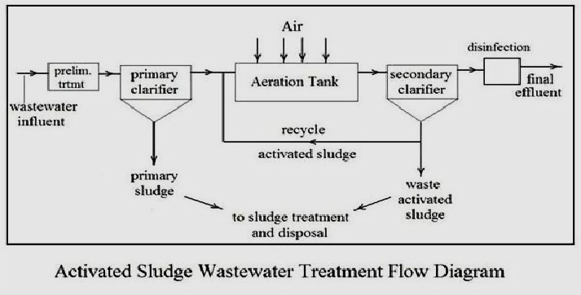

Fig 2: ASP flow diagram

Pseudomonas, Micrococcus, Bacillus, and Alcaligenes are engaged in the denitrification process, which is fueled by the presence of bacteria like Nitrosomonas, Nitrococcus, and Nitrobacter. Dissolved oxygen (DO) concentration needs to be kept at 1.5 to 2 mg/L and alkalinity needs to be kept at a minimum of 1 to 1.5 mmol/L in order to maintain an adequate nitrification rate in the ASP. Additionally, phosphorus can be removed using the ASP through chemical precipitation. By storing phosphorus as an energy reserve, bacteria like Acinetobacter spp. also remove phosphorus from the environment. [19] The ASP has been characterized as effective in the oxidation or reduction of polymerized molecules including nitrogen, phosphorus, sulfur, and a wide range of other organic compounds.

Although the system is direct and uncomplicated, the control over the process is very abstruse because of certain variables that affect it. These embrace changes in the combinations of bacterial flora on the treatment tanks, changes in the effluent parameters passing into the plant (parameters like flow rate, chemical composition, pH and temperature) and toxic shock loadings. The ASP suffers poor primary clarification which causes plugging and foul odours. Hydraulic overload and nitrification leads to high effluent total suspended solids, high chlorine demand and low pH. These limitations effectively reduce the overall efficiency of the process. [2]

TRICKLING FILTERS

The emerging stress-induced environments led to an urge for development of the tricking filter process, primarily designed for BOD removal. This system has attracted a great deal of attention due to its ability to take advantages of a biofilm reactor.[3, 23] An attached growth process is carried out in the filter wherein the microbes responsible for purification are allowed to thrive on an inert packing material (mountainous rock, gravel, fibres and other non-reactive synthetic materials). [24]

The feed wastewater is dispersed through a sprinkler from the upper section of a cylindrical trickling filter. Air is distributed in the vacant spaces by blowers or natural airflow, which helps the bacteria' need for oxygen. The wastewater's organics are broken down into new cellular material by the biomass (biological slime) that has clung to the medium. The medium face cannot be oxygenated because of the thicker slime layer, and eventually anaerobic organisms appear. The bacteria that are developing close to a piece of media lose their capacity to adhere to it. The feed then washes the slime away, and a new layer of slime starts to form. Sloughing is the name given to this phenomenon of slime layer erosion.The cleaned wastewater and sloughed-off film are collected by an underdrainage that also allows air to pass via filters. The collected liquid is sent to a settling tank for the separation of solids from liquids.[14, 45, 50] Trickling filters demonstrate greater footprint usage and are only trustworthy, leading to notable BOD reductions.

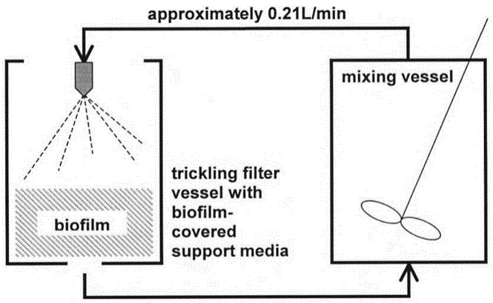

Fig 3:Aerobic trickling filter schematic [47]

Recently, efforts have been undertaken to effectively extract organic compounds from wastewater by combining fixed-film reactors with suspended growth methods. For instance, combining a trickling filter with an activated-sludge process has made it possible to reduce shock loads on the more delicate activated sludge while producing an effluent that is highly polished, something that a trickling filter by itself is unable to do. The maximum biomass thickness is constrained by the hydraulic dosage rate, the kind of media, the type of organic matter, the temperature, and the nature of the biological development. However, accumulation of excess biomass that cannot maintain an aerobic condition lingers and can somewhat compromise filter performance. [25, 28]

Inorder to address the limitations faced by the activated sludge process and trickling filters, a revolutionary new wastewater treatment plant design concept was developed and named ‘Upflow Sludge Blanket Filtration (USBF)’. [34] This system uses the whole spectrum of physical, chemical and biological treatments to reduce the toxic content of wastewater.

UPFLOW SLUDGE BLANKET FILTRATION (USBF)

USBF is a bioreactor that involves aerobic-anaerobic process. Figure 4 represents the schematic overview of the whole process. The removal of toxic compounds is typically done through biological processes by activated sludge. It is a reduced footprint single-tank configuration system comprising of 3 zones: anoxic/anaerobic zone, oxic/aerobic zone and clarifying zone. [30]

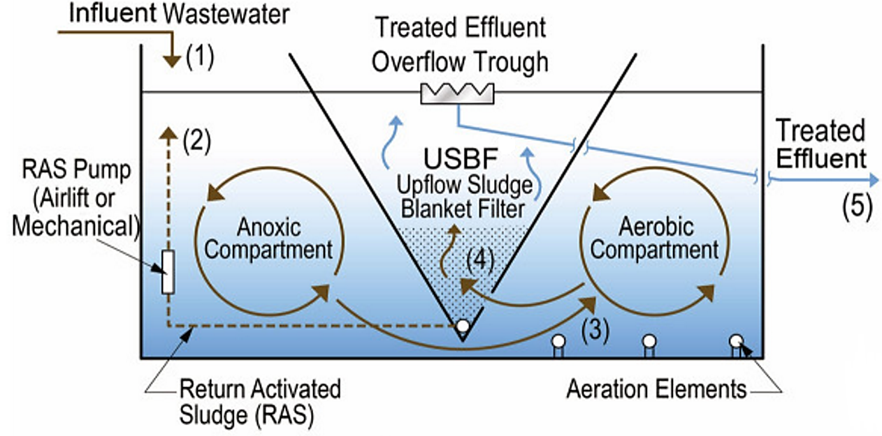

Fig 4: Schematic overview of USBF process

In anoxic zone, the influent (wastewater) is introduced in the anaerobic zone where it mixes with activated sludge recycled from the bottom of the sludge blanket filter. Here, primary sedimentation and denitrification occurs. About 60% - 70% reduction in the total suspended solids (TSS) concentration is anticipated in this zone. Here, nitrate reduction takes place which is microbially expedited through denitrifiers (Thiobacillusdenitrificans, Micrococcus denitrificans, Achromobacter, Pseudomonas aeruginosa etc.) and molecular nitrogen is produced. Agitated and moved in a plug flow manner, the mixed liquor flows into the aerobic compartment.

Denitrification:NO³⁻→NO²⁻→NO+N₂O→N₂ (g)

In oxic zone, the denitrified wastewater is subjected to aeration and simultaneously nitrification occurs. The 2 step reaction wherein ammonia/ammonium ions present are initially converted to nitrites which is facilitated by nitrifying bacteria (Nitrosomonas, Nitrosospira, Nitrosococcus, Nitrosolobus). Progressing, the nitrites is converted to nitrates which is facilitated by nitrifying bacteria (Nitrobacter, Nitrospina, Nitrococcus). After aeration, mixture of microbial cells and water enters the USBF filter at the bottom.

Nitrification: 2 NH₄⁺ + 3 O₂ → 2 NO₂⁻ + 2 H₂O + 4 H⁺
2 NO²⁻ + O₂ → 2 NO³⁻

The trapezoidal shape created by the holes in the clarifying zone allows the continuous removal of fine solids (sludge production). The particles settle at their own distinct velocities and create a sludge blanket as a result of the dissimilarity in flocculation velocities in the lower and upper region caused by an increase in cross sectional area. The flocs of cells stop being supported by the lowered upward velocity and become immobile, forming their own filtering media. The flocs eventually sink to the bottom of the filter where they agglomerate and grow larger before being recycled back into the anoxic compartment. When wastewater reaches the top of the filter and spills into the effluent overflow trough, the system is discharged. Even very small particles are filtered away, leading to a high level of filtering efficiency. [26]

Incoming nitrogen is removed by nitrification and denitrification processes. All USBF integrated bioreactors are designed for complete nitrification of ammonia to nitrate. The technology’s single-sludge denitrification uses an endogenous carbon source to maintain the denitrifiers. Influent is mixed with recycled activated sludge in the anoxic compartment providing the carbon source needed for denitrification. Incoming phosphorus is reduced by biological phosphorus uptake where the cells store more energy in the form of phosphorus than needed for their survival. Unlike most other methods of clarification, the sludge blanket filter maintains oxide conditions, which enable phosphorus retention by the cells and its subsequent removal with excess sludge. [29]

DESIGN CONSIDERATIONS AND ITS PERFORMANCE CRITERION

The geometrical variables that influences the efficiency of the system are slope and slot of the diffuser (clarifying zone). There can be three different types of diffusers, a cone, longitudinal prism and toroidal prism. The longitudinal prism is the most conventional diffuser.

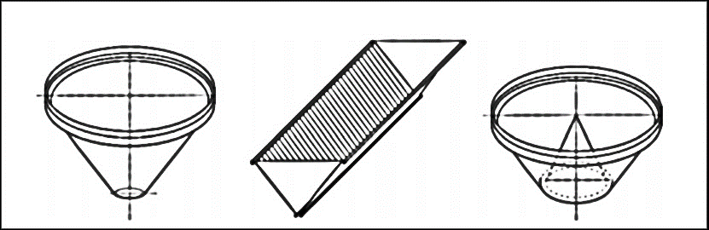

Fig 5: Diffuser types – cone (left), longitudinal prism (centre), toroidal prism (right) [4]

The slope inﬂuences ﬂocculation, the ﬂuid velocity and the forming of the sludge blankets. An upwardly widened shape is necessary because the velocity of the ﬂuid has to decrease as it goes further into the diffuser. These differences in velocity are ideal for ﬂuidization.
From the figure 6, the base level, Vs depicts free sedimentation velocity, above which the ﬂuidized layer will distribute the velocity of the liquid. There has to be a minimum velocity of full ﬂuidization, Vff, to get a ﬂuidized bed ﬁltration. On the top of the diffuser there has to be a minimum ﬂuidizing velocity, Vmf. These velocities are necessary because the varying velocities will tend the particles to sediment at their own speciﬁc velocity and form a sludge blanket. When the slope is too small, the velocity in the x-axis (Vx in Figure 6) will push the particles to the walls and there will be sedimentation on the walls. This is inadmissible as it has an inﬂuence on the velocity and there won’t be an equal velocity on one plane in the diffuser. [4, 15]

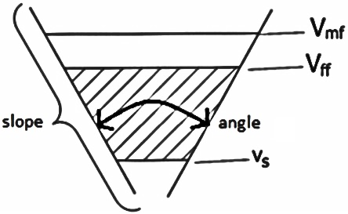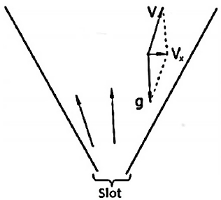

Fig 6: Schematic overview of ﬂuidization in a diffuser – Slope, Slot [4]

The slot is another important geometric variable which facilitates formation of the sludge blankets and impacts the velocity of the ﬂuid that enters the diffuser at the bottom. Velocity has significant effect on the formation of ﬂuidized layers. When the slot is large, it is possible for the particles to fall through because of the gravitational forces, which results in no blanket at all and there will not be any considerable difference in decreasing velocity which has an inﬂuence on the forming the sludge blankets. Therefore, an optimal slot is indispensable.

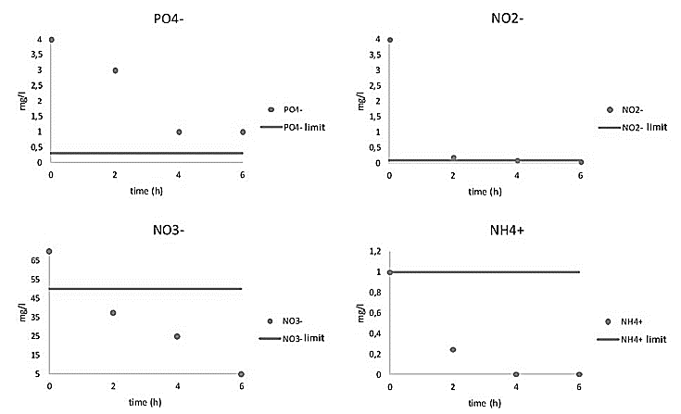

Fig 6:Decreasing concentration of nutrients of wastewater with respect to optimal slope angle of 52º and slot 4 cm at 6 hrs hydraulic retention time [4]

It is possible to achieve BOD and COD removal efficiency of up to 82% and 85% in the final effluent at varied HRT as low as 20 mg/l and 23 mg/l, respectively. Table 1 displays the treatment analysis for BOD, COD, TSS, and turbidity of the effluent for various stages of wastewater treatment. The production of compact sludge clots in the system's sedimentation separators was one of the primary causes of the TSS content in effluent being less than 1 mg/l in the majority of cases. This phenomena lessened the chance that sludge would escape the system.
Table 1: Wastewater treatment analysis [4]
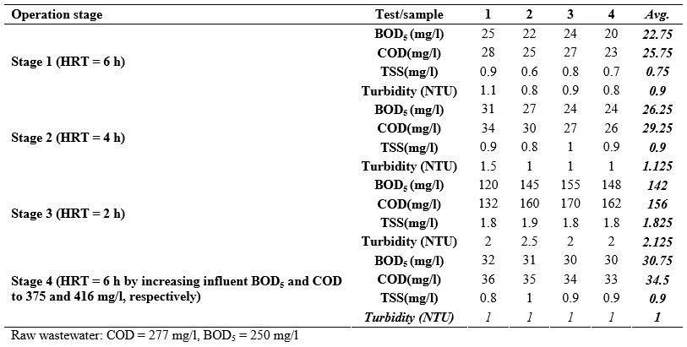

BENEFITS

High treatment effectiveness from USBF includes biological nutrient elimination. In other words, the interior anoxic compartment offers the ideal circumstances for phosphorus elimination through "luxury uptake" and dissimilarity nitrate reduction (denitrification). [46] The integral denitrification process makes it possible to partially restore the alkalinity that was lost during nitrification, and the anoxic compartment functions as a "selector zone" that treats the mixed liquor to improve settleability and control filamentous bacterial growth, which results in alkalinity recovery.

The odour is drastically reduced under aerobic conditions throughout the bioreactor and extended sludge age.The hydraulics in the bioreactor is self-regulated wherein it accommodates high peak flows and flow swings; the flow is proportional to the sludge blanket rise and larger is the filtration area. This is facilitated by the sludge filter’s trapezoidal shape.Modularity of design allows to stage plant development and reduce initial capital costs. Even with a quick population growth, the modular nature of the system enables easy expansion. The sludge filters can be fabricated from a variety of materials, and they can be retrofitted into virtually any existing tank or reactor. [26, 29]
CONCLUSIONS

By analogy, the COD, BOD, TSS, and TDS removal efficiency of the activated sludge process are lower than those of the USBF. The properties of the wastewater, the hydraulic retention time, the age of the sludge, and the overall process control have a significant impact on the biological removal efficiency of nitrogen, phosphorus, and preservation of the sludge blanket. The USBF system is a good choice to get over some of the drawbacks of the ASP system, such as hydraulic rigidity, abrupt changes in wastewater properties, or its operating volume. For the USBF system, feeding and draining can be done simultaneously with a maximum volumetric exchange rate of around 80%. This may thus result in a shorter cycle time and greater utilization of the reactor space. The USBF bioreactor, while capable of removing nutrients from municipal wastewater under ideal conditions, is not advised for wastewater with a high (Total Kjeldahl Nitrogen) TKN/COD ratio because to growing sludge and disordering blanket in the USBF clarifier. Based on the effluent quality, the hydraulic retention duration is optimized to prevent sludge from rising as a result of the denitrification process. To further treat wastewater so that it can also be rendered potable, processes including UV treatment, reverse osmosis, enzyme filtration, ion exchange, and vacuum distillation (for the removal of oil and grease) can be used. As a result, this cutting-edge technology offers secondary wastewater treatment a cost-effective and dependable alternative.

REFERENCES

1. Abeling, U. & Seyfried, C. F. Anaerobic-aerobic treatment of high-strength ammonium wastewater - Nitrogen removal via nitrite. in Water Science and Technology26, 1007–1015 (1992).
2. Ahansazan, B., Afrashteh, H., Ahansazan, N. & Ahansazan, Z. Activated Sludge Process Overview. Int. J. Environ. Sci. Dev.5, 81–85 (2014).
3. Andersson, S. Characterization of Bacterial Biofilms for Wastewater Treatment. Technology (2009). doi:10.1007/s10811-007-9223-2
4. Benjana, BaruDebtera, Design and optimization of Upflow Sludge BlanketFiltration
(USBF) for waste water treatment, Research Gate (2015).
5. Bitton, G. Activated Sludge Process. Wastewater Microbiology (2005). doi:10.1002/0471717967.ch8
6. Boelee, N. C., Temmink, H., Janssen, M., Buisman, C. J. N. & Wijffels, R. H. Nitrogen and phosphorus removal from municipal wastewater effluent using microalgal biofilms. Water Res.45, 5925–5933 (2011).
7. Bond, P. L., Hugenholtz, P., Keller, J. & Blackall, L. L. Bacterial community structures of phosphate-removing and non-phosphate-removing activated sludges from sequencing batch reactors. Appl. Environ. Microbiol.61, 1910–1916 (1995).
8. Boufadel, M. C. & Suidan, M. T. Tracer Studies in Laboratory Beach Simulating Tidal Influences. J. Environ. Eng.9372, 9372 (2006).
9. Carrera, J., Vicent, T. & Lafuente, J. Effect of influent COD/N ratio on biological nitrogen removal (BNR) from high-strength ammonium industrial wastewater. Process Biochem.39, 2035–2041 (2004).
10. Chan, Y. J., Chong, M. F., Law, C. L. & Hassell, D. G. A review on anaerobic-aerobic treatment of industrial and municipal wastewater. Chemical Engineering Journal155, 1–18 (2009).

11. Dermou, E., Velissariou, A., Xenos, D. & Vayenas, D. V. Biological chromium(VI) reduction using a trickling filter. J. Hazard. Mater.126, 78–85 (2005).
12. Droste, R. L., Theory and Practice of Water and Wastewater Treatment. John Wiley &Sons Inc New York, USA, (1997).
13. El-Gohary, F. A. & Nasr, F. A. Cost-effective pre-treatment of wastewater. in Water Science and Technology39, 97–103 (1999).
14. Evans, E. A., Ellis, T., Gullicks, H. & Ringelestein, J. Trickling Filter Nitrification Performance Characteristics and Potential of a Full-Scale Municipal Wastewater Treatment Facility. J. Environ. Eng.130, 1280–1289 (2004).
15. Fartoos, S., Ganjidoost, H. & Ayati, B. Determining the optimized hydraulic retention time in the USBF reactor for biological phosphorus removal. in World Environmental and Water Resources Congress 2008: Ahupua’a - Proceedings of the World Environmental and Water Resources Congress 2008316, (2008).
16. Fernàndez, J. M., Méndez, R. J. & Lema, J. M. Anaerobic treatment of eucalyptus fiberboard manufacturing wastewater by a hybrid usbf lab-scale reactor. Environ. Technol. (United Kingdom)16, 677–684 (1995).
17. Fernández, J. M., Omil, F., Méndez, R. & Lema, J. M. Anaerobic treatment of fibreboard manufacturing wastewaters in a pilot scale hybrid USBF reactor. Water Res.35, 4150–4158 (2001).
18. García-Diéguez, C., Molina, F., Fernández, E. & Roca, E. Control of re-startup of anaerobic USBF reactors after short stops. Ind. Eng. Chem. Res.49, 4748–4755 (2010).
19. Gebara, F. Activated sludge biofilm wastewater treatment system. Water Res.33, 230–238 (1999).
20. Grady, C. P. L., Daigger, G. T. & Lim, H. C. Biological wastewater treatment. Hazard. WasteOctober, 1076 (1999).
21. Khorsandi, H., Movahedyan, H., Bina, B. & Farrokhzadeh, H. Innovative anaerobic/upflow sludge blanket filtration bioreactor for phosphorus removal from wastewater. Environ. Technol.32, 499–506 (2011).
22. La Motta, E. J., Jimenez, J. A., Josse, J. C. & Manrique, A. Role of bioflocculation on chemical oxygen demand removal in solids contact chamber of trickling filter/solids contact process. J. Environ. Eng.130, 726–735 (2004).
23. Lazarova, V. & Manem, J. Biofilm characterization and activity analysis in water and wastewater treatment. Water Research29, 2227–2245 (1995).
24. Lekang, O. I. & Kleppe, H. Efficiency of nitrification in trickling filters using different filter media. Aquac. Eng.21, 181–199 (2000).
25. Lemji, H. H. & Eckstädt, H. Performance of a trickling filter for nitrogen and phosphorous removal with synthetic brewery wastewater in trickling filter biofilm. Int. Journalof Appl. Microbiol. Biotechnoogy Res.2, 30–42 (2014).
26. Lettinga, G., van Velsen, A. F. M., Hobma, S. W., de Zeeuw, W. & Klapwijk, A. Use of the upflow sludge blanket (USB) reactor concept for biological wastewater treatment, especially for anaerobic treatment. Biotechnol. Bioeng.22, 699–734 (1980).
27. Liu, Y. & Tay, J. H. Strategy for minimization of excess sludge production from the activated sludge process. Biotechnol. Adv.19, 97–107 (2001).
28. Logan, B. E., Hermanowicz, S. W. & Parker, D. S. Engineering implications of a new trickling filter model. J. Water Pollut. Control Fed.59, 1017–1028 (1987).
29. Mahvi, A. H., Nabizadh, R., Pishrafti, M. H. & Zarei, T. Evaluation of single stage USBF in removal of nitrogen and phosphorus from wastewater. Eur. J. Sci. Res.23, (2008).

30. Mesdaghinia, A. R., Mahvi, A. H., Saeedi, R. & Pishrafti, H. Upflow sludge blanket filtration (USBF): An innovative technology in activated sludge process. Iran. J. Public Health39, 7–12 (2010).
31. Metcalf, E. & Eddy, H. Wastewater engineering: treatment and reuse. Wastewater Engineering, Treatment, Disposal and Reuse. Techobanoglous G, Burton FL, Stensel HD (eds). Tata McGraw-Hill Publishing Company Limited, 4th edition. New Delhi, India (2003). doi:10.1016/0309-1708(80)90067-6
32. Molina, F., Ruiz-Filippi, G., García, C., Roca, E. & Lema, J. M. Winery effluent treatment at an anaerobic hybrid USBF pilot plant under normal and abnormal operation. in Water Science and Technology56, 25–31 (2007).
33. Noroozi, A., Safari, M. & Askari, N. Innovative hybrid-upflow sludge blanket filtration (H-USBF) combined bioreactor for municipal wastewater treatment using response surface methodology. Desalin. Water Treat.56, 2344–2350 (2015).
34. Nourmohammadi, D., Esmaeeli, M.-B., Akbarian, H. & Ghasemian, M. Nitrogen removal in a full-scale domestic wastewater treatment plant with activated sludge and trickling filter. J. Environ. Public Health2013, 504705 (2013).
35. Ratsak, C. H. Effects of Nais elinguis on the performance of an activated sludge plant. in Hydrobiologia463, 217–222 (2001).
36. Shrivastava, A. K. A review on copper pollution and its removal from water bodies by pollution control technologies. Indian Journal of Environmental Protection29, 552–560 (2009).
37. Simsek, H., Kasi, M., Ohm, J. B., Blonigen, M. & Khan, E. Bioavailable and biodegradable dissolved organic nitrogen in activated sludge and trickling filter wastewater treatment plants. Water Res.47, 3201–3210 (2013).
38. Singh, R., Kumar Sar, S., Singh, S. & Sahu, M. Wastewater Treatment by Effluent Treatment Plants. SSRG Int. J. Civ. Eng.3, 32–38 (2016).
39. Sperling, M. Von. Wastewater characteristics, treatment and disposal. Choice Reviews Online45, (2008).
40. Tchobanoglous, G., Burton, F. L. & Stensel, H. D. Wastewater engineering: treatment and reuse. McGraw-Hill (2003). doi:10.1016/0309-1708(80)90067-6
41. Tekerlekopoulou, A. G. & Vayenas, D. V. Simultaneous biological removal of ammonia, iron and manganese from potable water using a trickling filter. Biochem. Eng. J.39, 215–220 (2008).
42.T. Van Winckel, Development of high–rate activated sludge process for energy-efficient wastewater treatment, (2013).
43. Van den Akker, B., Holmes, M., Pearce, P., Cromar, N. J. & Fallowfield, H. J. Structure of nitrifying biofilms in a high-rate trickling filter designed for potable water pre-treatment. Water Res.45, 3489–3498 (2011).
44. Van Limbergen, H., Top, E. M. & Verstraete, W. Bioaugmentation in activated sludge: Current features add future perspectives. Applied Microbiology and Biotechnology50, 16–23 (1998).
45. Vianna, M. R., de Melo, G. C. B. & Neto, M. R. V. Wastewater treatment in trickling filters using Luffa cyllindrica as biofilm supporting medium. J. Urban Environ. Eng.6, 57–66 (2012).
46. Wang, D., Li, X., Ding, Y., Zeng, T. & Zeng, G. Nitrogen and phosphorus recovery from wastewater and the supernate of dewatered sludge. Recent Pat. Food. Nutr. Agric.1, 236–242 (2009).
47. Woodhouse, C. & Duff, S. J. B. Treatment of log yard runoff in an aerobic trickling filter. Water Qual. Res. J. Canada39, 230–236 (2004).

48. Yasui, H., Nakamura, K., Sakuma, S., Iwasaki, M. & Sakai, Y. A full-scale operation of a novel activated sludge process without excess sludge production. Water Sci. Technol.34, 395–404 (1996).
49. Zaman, A. U. Comparative study of municipal solid waste treatment technologies using life cycle assessment method. Int. J. Environ. Sci. Tech.7, 225–234 (2010).
50. Zhao, Q. et al. Removal and transformation of organic matters in domestic wastewater during lab-scale chemically enhanced primary treatment and a trickling filter treatment. J. Environ. Sci. (China)25, 59–68 (2013).

