Effect of temperature for the synthesis of ZnS nanoparticles by hydrothermal method
Bincy John^{a,*}, Julin Josephª and G. Genifer Silvena^{b}
ª Post Graduate Department of Physics, St. Joseph’s College for Women, Alappuzha, University of Kerala, Thiruvananthapuram, India
^{b} Post Graduate & Research Department of Physics, St.Joseph’s College (Autonomous), Tiruchirappalli, Tamilnadu, 620002, India
*Corresponding Author Mail ID: bincyjohnmannullil@gmail.com
ABSTRACT
ZnS nano materials are synthesized using the facile hydrothermal method. Here the work is to introduce the influence of reaction temperature for the formation of ZnS nanoparticles using simple hydrothermal method. In this work, the experiments were conducted at temperatures of 140 ºC, 150 ºC and 160 ºC respectively. Systematic investigations are carried out for the synthesized nanomaterials using different analysis techniques and the significant changes that are occurring on the crystal structure, morphology and optical properties are discussed in detail by XRD, FTIR, SEM, UV-Vis spectroscopy and PL spectroscopy. The obtained band gap was in the range of 4.41-4.83 eV which shows that the material has potential advancement in optoelectronic device applications.
Keywords- ZnS nano materials; hydrothermal; reaction temperature
I. INTRODUCTION
Zinc sulfide with the chemical formula ZnS is an inorganic compound with main form of Zinc formed in nature, which can adapt three different forms as cubic sphalerite, hexagonal wurtzite and a body centered tetragonal phase. This mineral which is used as pigment are in black with various impurities and as pure material as white. Zinc sulfide in its clear synthetic form can be transparent that has wide applications such as catalysis, photonics, nonlinear optical devices, LEDs, flat panel displays, infrared windows, field emitters, sensors, and lasers [1-5]. ZnS is an significant II-IV semiconductor material with wide bandgap energy in the range of 3.72- 3.77 eV and having large exciton binding energy [6]. ZnS nanomaterials can be prepared using different methods as sol - gel, electrochemical, sonochemical and solvothermal methods [7].
Here the article focus on the synthesis and characterization of ZnS nanoparticles attained by a simple hydrothermal method ranging reaction temperature of 140 ºC-160 ºC in steps of 10 ºC. The uniqueness of this work is to examine the influence of reaction temperature for the development of crystal structure, change in morphology and reduced crystallite size.
II. EXPERIMENTAL PROCEDURE FOR THE PREPARATION OF ZnS NANOPARTICLES
The chemicals used for the preparation of zinc sulfide nanoparticles include zinc chloride (ZnCl₂.2H₂O), thiourea (CH₄N₂S) and double distilled water was the solvent.
ZnS nanoparticle synthesis was followed a cost efficient and low-temperature hydrothermal method. Here, a blend comprising of 0.5 mM zinc chloride dihydrate and 0.75 mM thiourea were dissolved in double distilled water, maintained stirring for 30 min. After complete dissolution of the chemicals, the precursor solution was carefully transferred into a stainless steel autoclave with Teflon- line. It was then placed in a hot air oven and held at varying temperature of140 ºC, 150 ºC and 160 ºC for duration of 6 hours. After the designated time had elapsed, the oven was gradually allowed to reach room temperature. Subsequently, the autoclave was removed from the oven, and the resultant nanoparticles were separated though repetitive centrifugation steps using distilled water and ethanol at 3000 rpm f or 15 minutes. The resulting product, which appeared white, was then dried at approximately 120°C
The synthesized ZnS nanoparticles underwent characterization through powder XRD using, Rigaku instrument prepared with Cu-K $α$ ($λ$ =1.5406 Å, 40 kV and 30 mA). The surface morphology of the sample was assessed utilizing SEM (CAREL ZEISS model: EVO 18). FTIR spectra were recorded by Perkin Elmer instrument in the range of 4000 cm ⁻¹ – 400 cm^{-1.} For the investigation of optical properties of the ZnS nanoparticles, UV-Visible Spectrometer readings were taken across a range of 300-1100 nm using Perkin Elmer instrument (Model Lambda-35) and the fluorescence spectrometer readings were collected within a range of 200-900 nm using Perkin Elmer (Model LS 45).

III. RESULTS AND DISCUSSION
A) X-Ray Diffraction (XRD) analysis
Figure 1: XRD pattern of ZnS nanomaterials
The formation of phase and crystal structure of the obtained ZnS nanoparticles provided with an explanation through the analysis of the XRD pattern. Figure 1 gives the X-ray diffraction pattern of ZnS nanoparticles obtained on different reaction temperature of 140˚C, 150˚C and 160˚C. The XRD peaks of 140ºC and 150ºC shows the rhombohedral crystal structure along with its corresponding space group of R3m [160] with intense diffraction peaks which are agreeable referencing the JCPDS Card No. 89-2427. While with the further increase in temperature to 160ºC obtains cubic crystal structure having the sphalerite mineral name having space group F43m [216] exhibiting strong concordance with the standard JCPDS Card No. 79-0043. As the temperature rises, there is a corresponding augmentation in the intensity of the diffraction peaks and their by broadening of peaks reduces, resulting decrease in the values of FWHM. This decrease indicate size increase in the crystal which is found out by Debye Scherrer’s formula,
D = $\frac{Kλ}{β\text{cos}θ}$
Where $Κ$ is the Scherrer constant ($Κ$ = 0.89), $λ$signifies the wavelength of utilized Cu-K$α$ ($λ$= 1.5406 Å), $β$ gives FWHM of the diffraction peaks and $θ$ stands for Bragg’s angle. Subsequently, average of the calculated crystallite sizes are 8.4 nm for 140˚C, 4.16 nm for 150˚C and 3.4 nm for 160˚C. Consequently, with increasing temperature, both the crystal structure of the material undergoes changes and the crystallite size of the material decreases.
B) Fourier Transform Infra Red (FTIR) analysis
Figure 2 depicts the FTIR spectra ranging from 4000-400 cm⁻¹. The notable vibration peaks observed at 477, 612, 675 and 1018 cm⁻¹ originates from symmetric bending modes associated with Zn-S vibrations. The appearance of the peak at 1337 cm⁻¹ is a result of the atmospheric CO₂ adsorption on the surface of the synthesized particles. Again the peaks falls within the range of 3000-3600 cm⁻¹ can be ascribed to the O-H stretching frequency, showing the presence of adsorbed water on the surface of the ZnS particles. The IR bands centered on 1644 cm-¹ arise from the stretching vibrations of the C=O mode [8]. From the FTIR analysis it is clear that the synthesized product is composed of the presence of ZnS material.

Figure 2: FTIR spectrum of the obtained ZnS nanoparticles at 140ºC, 150ºC and 160ºC
C) Scanning Electron Microscopy analysis (SEM)
The surface morphology of the ZnS nanoparticles obtained under varied reaction temperatures was examined using scanning electron microscopy is shown in Figure 3. From figure 3.3 (a) it is clear that the ZnS nanoclusters prepared at 140ºC gives not much regularity in the features of the image. However, as the temperature is raised to 150ºC, it become evident from the image that the structures self- assemble, forming hexagonal nanoplates. Furthermore, at a temperature of 160ºC, the ZnS nanoparticles consist of a significant quantity of particles resembling nanotubes.
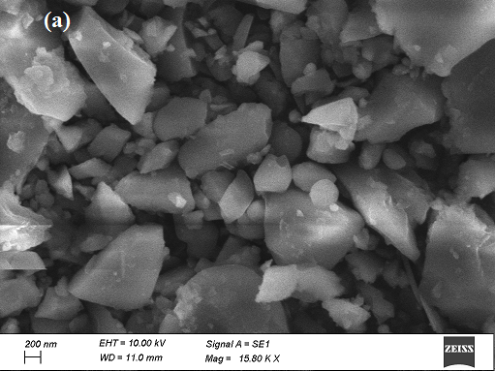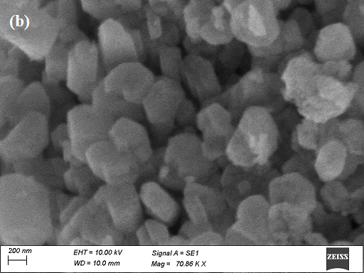
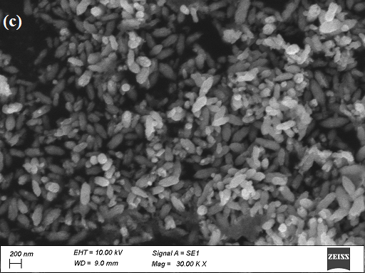
Figure 3 SEM images of ZnS nanoparticles at (a) 140ºC, (b) 150ºC and (c) 160ºC
D) UV-Visible spectroscopy analysis
The optical properties of ZnS nano products are characterized by UV-Vis spectroscopy. Before doing the characterization the nano powder is completely dispersed in distilled water by sonication. UV-Visible absorption and transmittance spectrum and tauc plot of the ZnS nanoparticles obtained at 140 ˚C, 150 ˚C and 160 ˚C are shown in figure 4 (a), (b) and (c). From the absorption spectrum it is clear that the ZnS nano powder has obtained maximum absorption at 235 nm. From the transmittance spectra of figure (b), it is evident that the material exhibits 100% transmittance in both the visible and IR regions. The optical band gap energies for varying temperatures were determined using the tauc plot and are presented in figure 3.4 (c). The resulting band gap energies at 140 ˚C, 150 ˚C and 160 ˚C are 4.41 eV, 4.72 eV and 4.83 eV respectively.
In all the three samples at different temperature showed that the band gap values the material is having the wide band gap energy. This signifies the bulk ZnS material obtains band gap energy around 3.66 eV and that the reduction in particle size corresponds to rise in band gap energy, leading to higher values raging between 4.41- 4.83 eV. This phenomenon can be elucidated by the quantum confinement effect [9].

Figure 4(a), (b) and (c) shows the absorbance and transmittance spectrum and tauc plot of ZnS nanoparticles
E) Photoluminescence (PL) analysis
Figure 5 the photoluminescence emission spectrum (PL) of ZnS nano particles is depicted, with a Xenon lamp serving as the light source, and specific optical filters employed to isolate the desired wavelength of light. Emission was observed at an excitation wavelength of 240 nm. The spectra of all three temperature variations reveal multiple emission peaks, including blue emission bands at 417 nm, 432 nm, and 480 nm, along with a peak at 525 nm and a broad peak at 725 nm. The PL emission characteristics of ZnS materials closely hinges on their morphologies and the parameters used in their preparation. Generally, the presence of blue emission can be attributed to defect states within ZnS material, such as stoichiometry vacancies, interstitial lattice defects and surface states. Within the specific samples, the luminescent peak at 480 nm can be attributed to Zinc vacancies, while the emission peaks at 417 nm are attributed to the radiative recombination involving interstitial zinc and sulfur vacancies. Similarly, the peak at 432 nm is attributed to interstitial zinc and sulfur vacancies [10].

Figure 5 Photoluminescence spectrum of ZnS nanoparticles at 140ºC, 150ºC and 160ºC
IV. CONCLUSION
ZnS nanoparticles were prepared using the simple and cost effective hydrothermal method, wherein the reactions were carried out at distinct temperatures: 140 ºC, 150 ºC and 160 ºC respectively. Systematic investigations are carried out for the synthesized nanomaterials using different analysis techniques. The XRD pattern confirmed the crystalline nature of the ZnS nanoparticles. The average crystallite size was calculated to be 8.4 nm, 4.16 nm and 3.4 nm using Debye Scherrer formula. FTIR results validated the presence of ZnS material in the final product. SEM images clearly showed that the surface morphology of the material was changing as the reaction temperature increases. Optical properties showed that ZnS band gap energy was found to be 4.41 eV, 4.72 eV and 4.83 eV. Photoluminescence spectrum showed that the emission peaks were in visible region. The aforementioned results demonstrate that the material is suitable for optoelectronic applications.

REFERENCES
[1] X. S. Fang, Y. Bando, G. Z. Shen, C. H.Ye, U. K. Gautam, P. M. F. J. Costa, C. Y. Zhi, C. C. Tang and D. Golberg, “Ultrafine ZnS Nanobelts as Field Emitters”, Adv. Mater. vol.19, pp.2593−2596, 2007.
[2] X. Fang, Y. Bando, M. Liao, T. Zhai, U. K. Gautam, L. Li, Y. Koide and D. Golberg, “ An Efficient Way to Assemble ZnS Nanobelts as Ultraviolet-Light Sensors with Enhanced Photocurrent and Stability”, Adv. Funct. Mater. vol. 20, pp.500−508, 2010.
[3] X. S. Fang, C. H. Ye, L. D. Zhang, Y. H. Wang and Y. C. Wu, “Temperature-Controlled Catalytic Growth of ZnS Nanostructures by the Evaporation of ZnS Nanopowders”, Adv. Funct. Mater. vol.15, pp. 63−68, 2005.
[4] B. J. Morgan, “First-Principles Study of Epitaxial Strain as a Method of B4 → BCT Stabilization in ZnO, ZnS, and CdS”, Phys. Rev. B: Condens. Matter Mater. Phys. vol. 82, pp. 153408, 2010.
[5] Nicola Dengo, Andrea Vittadini, Marta Maria Natile, and Silvia Gross,” In-Depth Study of ZnS Nanoparticle Surface Properties with a Combined Experimental and Theoretical Approach”, J. Phys. Chem. C 124, (2020), 7777−7789

[6] Biswas S and Kar S, “Fabrication of ZnS nanoparticles and nanorods with cubic and hexagonal crystal structures: a simple solvothermal approach”, Nanotechnology 19 (2008), 045710
[7] Tran Thi Quynh Hoa, Le Van Vu, Ta Dinh Canh and Nguyen Ngoc Long, “Preparation of ZnS nanoparticles by hydrothermal method”, Journal of Physics: Conference Series vol. 187 pp. 012081, 2009.
[8] A . Esakkiammal, A. Malathi, Ujjal Kumar Sur and Balaprasad Ankamwar, “ Honey mediated Green synthesis of Photoluminiscent ZnS Nano/Micro Particles”, Research in Medical & Engineering sciences, Jan 23, 2018
[9] W.Q Peng, G.W Cong, S.C Qu and Z.G Wang, “ Synthesis and photoluminescence of ZnS: Cu nanoparticles”, Opt Mater, vol. 29, pp. 313- 317, 2016.
[10] R. Jeyachitraa, P. N Rajasekara and V. Senthilnathan, “Optical and photoluminescence studies of vacuum evaporated ZnS thin films,” Chalcogenide Letters.vol.11, pp. 303-310, 2014.

