Ecology and behaviour of Bolas spiders: Aggressive chemical mimicry of insect sex pheromones
Durga G^{1*} and Ramesh M Maradi¹
1 Ph.D. Research Scholar, University of Agricultural and Horticultural Sciences, Shivamogga, Karnataka.
2 Ph.D. Research Scholar, University of Agricultural Sciences, Dharwad- 05, Karnataka
Corresponding author Email ID: durga.g.chowdary@gmail.com
Abstract
About one-third of the spiders in the world use a silk web to capture prey and 30 per cent of these are orb-web weavers. One of the most curious non-orb weaving araneids is the bolas spider so called because of their hunting method: they use a ‘bolas’ to capture prey. Bolas spiders are so named because late-stadia immature and adult females swing a droplet of adhesive on a silk thread at their flying prey (moths). The nocturnal hunting activity of the adult female bolas spiders which constructed a sticky globule at the end of a silk thread (bolas) and holds this with one of her forelegs. Moths have been observed approaching these spiders suggesting that the spiders in this posture are indeed emitting the pheromone components of a prey species and that wing-beat vibrations from the attracted moths stimulate the spider to make a bolas. The adult female bolas spider has a unique hunting tactic that combines aggressive mimicry strategy which provides a direct evidence that are efficient in mimic and hunting wide range of noctuid moths. Hence biologists, ecologists, should focus on diversity, conservation, biology and especially on adult biology of bolas spider.
Key words: Bolas Spider, Ecology, Pheromones
Introduction
The bola is a primitive hunting weapon that was used by many primitive people and is still a viable weapon in a survival situation. The bola is most well known as used by the South American cowboys, known as gauchos, for wrapping the legs of runaway cattle, when thrown from the back of a horse. This is a two-weighted bola that is often as long as its thrower, from weight to weight, but remember this variety is thrown from the back of a horse. This particular bola is thrown holding one of the weights in one hand and swinging it toward the target.
Likewise, in nature this weapon superficially resembles the bolas of a spider which is used to capture the prey. By swinging the bolas at flying male moths or moth flies in their vicinity, these spiders snag their prey much like a fisherman snagging a fish on a hook. A bolas spider is a member of the orb-weaver spider (Family Araneidae) that, instead of spinning a typical orb web, hunts by using one or more sticky "capture blobs" on the end of a silk line, known as a bolas. By swinging the bolas at flying male moths or moth flies nearby, the spider may snag its prey rather like a fisherman snagging a fish on a hook. Because of this, they are also called angling or fishing spiders (although the remotely related genus Dolomedes is also called a fishing spider). The prey is lured to the spider by the production of up to three sex pheromone-analogues.
Bolas spiders have been treated as either the whole or part of either the tribe "Mastophoreae" or Mastophorini, the subfamily Mastophorinae, or the informal group mastophorines. Recent studies show that the genus Celaenia, which does not use a bolas, belongs in the same taxonomic group (Eberhard, 1980).
Why the name bolas spiders?
The genus of bolas spiders deserves special attention. They are very uncommon nocturnal orb-weaver spiders, famous for their unusual predatory behaviour. Bolas spiders are so named because instead of spinning the orb web typical for other members late-stadia immature and adult females produce a silken thread, swing a droplet of adhesive on a silk thread at their flying prey (moths). The spider's bolas are swung rather than literally thrown at prey, and its effectiveness depends on adhesion to the droplet rather than entanglement in the line to which this globule is attached. The gluey bolas silk evolved from the viscid silk of normal orb-weavers but overcomes a serious challenge the scales of moths and butterflies rub off easily, allowing these insects to escape most orb webs. The bolas glue, in contrast, soaks through the scales and adheres to the underlying cuticle of these challenging preys.
Difference between bolas and spider
The bolas spiders are differentiated with other spiders by the presence of conspicuous outgrowths on the dorsal surface of the cephalothorax which morphologically distinguish from typical Araenidae. The sexual dimorphism is extreme where females are ten times bigger than males. Bolas spiders are unique type of spiders that do not construct typical spiral web. The bolas spider produces a special type of chemical mimicry such type of defensive response is very unusual for normal spiders.
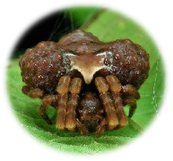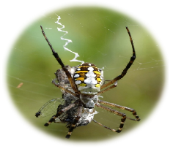
Figure1. a) Bolas spider b) Normal spider
Evolutionary process of the Moth-Specialized spider sub-family Cyrtarachninae
Spiders of the subfamily Cyrtarachninae construct webs with strikingly unique and diverse structures (Figs. 2A–C;). The most curious web is the ‘bolas’ made by Ordgarius and Mastophora spiders (Fig. 2C). These spiders hold a viscid thread with a huge droplet at the end and whirl the thread when a moth (their exclusive prey) approaches nearby prey. Spiders of Cyrtarachne, Poecilopachys and Paraplectana spin so-called ‘spanning-thread webs’ with a small number of radii and widely spaced non-spiral viscid threads. The spanning-thread web of Pasilobus consists of only two sectors, and thus looks triangular (Fig. 2B; Robinson and Robinson, 1975). When an insect happens to touch a spanning thread of these webs, one end of the thread, the “low-shear joint”, breaks free from the radii, while the other remains firmly attached. This characteristic is quite different from that of ordinal spiral threads of orb web spiders, which are firmly attached to the radii and do not break. The stickiness of the spanning thread is so great, owing to the large attached viscid droplet, that the thread retains the prey until the spider hauls it up. There are striking similarities between prey hanging by a single spanning thread and a moth caught with a bolas, although the web structures are quite different. The properties of the viscid droplet provide another similarity: the strong adhesiveness of Cyrtarachne droplets decreases to zero in a few hours (Cartan and Miyashita, 2000) and the huge droplets of the bolas spider. The evolution of these unique web types is thought to have occurred through reduction of orbicular spanning thread webs such as those of Cyrtarachne or Poecilopachys (Fig. 2A), i.e., from orbicular webs, triangular webs, bolas and finally to webless (Robinson and Robinson, 1975; Eberhard, 1980). A phylogenetic analysis using morphological traits indicated that Pasilobus and Cyrtarachne form a sister group to Mastophora, due to two synapomorphies shared by Pasilobus and Cyrtarachne: lacking a sustentaculum at the fourth tarsus and having a low-shear joint in webs.
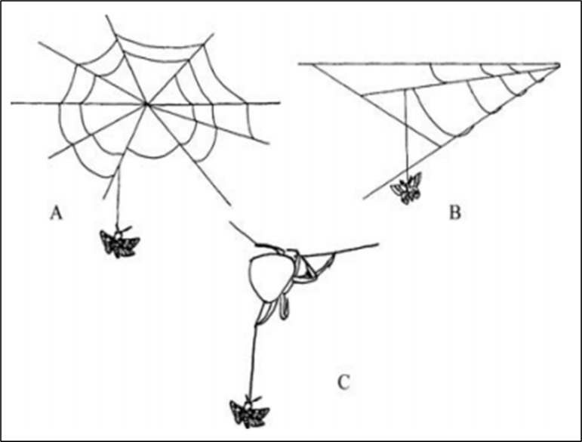
Figure 2. Webs of (A), Cyrtarachne (from Cartan and Miyashita, 2000), (B) Pasilobus (redrawn from Robinson and Robinson, 1975), and (C) Ordgarius, with prey hanging in a single thread.

Molecular phylogeny of bolas spiders
The molecular phylogeny of the bolas spider indicated that Bayesian inference resulted in the phylogenetic tree shown in Fig.3. Paraplectana, Poecilopachys, Cyrtarachne and Palilobus formed a strongly supported (pp = 100) monophyletic clade, in which Pasilobus hupingensis was united with Cyrtarachne yunoharuensis. Bolas spiders, Mastophora and Ordgarius, formed a strongly supported (pp = 100) independent clade. It has been thought that bolas spiders evolved by reduction of orbicular spanning-thread webs through triangular spanning thread webs (Robinson and Robinson, 1975; Eberhard, 1980). The study indicates that a common ancestor diverged into two clades: a spanning-thread web clade (Fig. 3, Clade C) and a bolas or non-web clade (Fig. 3, Clade B). This indicates that the emergence of the bolas spider is not due to a gradual reduction of the orbicular spanning-thread web; rather, this spider emerged in the early stage of diversification of the subfamily Cyrtarachninae. We note that the posterior probability and bootstrap value of Clade B, uniting Celaenia and bolas spiders, was not high (pp = 88, bs = 58) and this relationship thus remains ambiguous.
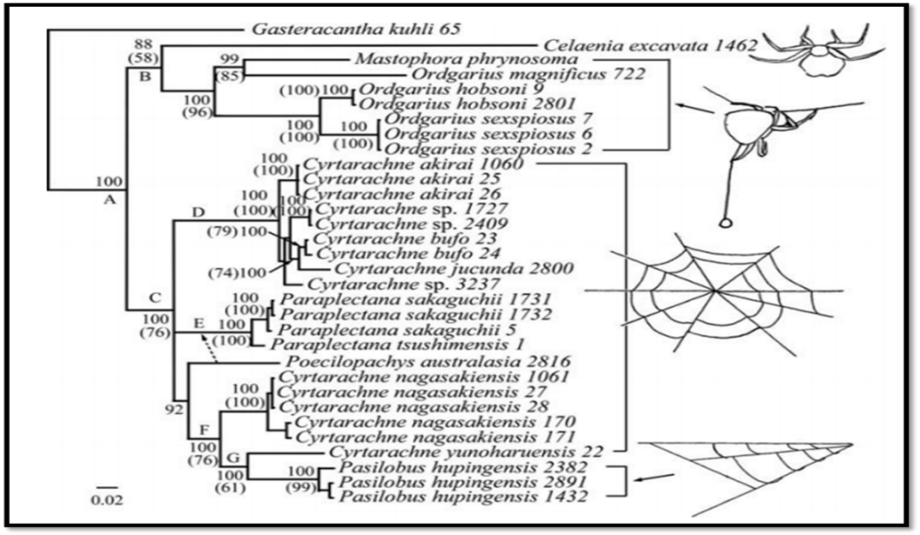
Figure 3. Molecular phylogeny of bolas spiders

Biology of bolas spiders
Bolas spiders are known from most parts of the world except temperate Eurasia. Six genera of bolas spiders, which comprise the tribe Mastophoreae: Cladomelea (three species) and Acantharanea (six species) in Africa; Ordgarius (seven species) and Dicrostichus (three species) in Oriental Asia, the East Indies, New Guinea, and Australia; and Agatostichus (two species) and Mastophora (20 species) in North, Central, and South America and the West Indies were recognised.
Structural features of egg case
The egg cases produced by the female represents their striking difference from egg cases of more common spider species. In general, in Mastophora genus they are globose or subspherical cups which are drawn out into a thick stem or stalk of variable length. The surface of the egg case was also studied and examined by the scanning electron microscopy, where the image (Figure. 4 (a-b)) indicates the external surface with well-defined separate silk lines, (c-d) which are apparently formed by thinner silk lines fused together, (e-f) indicate the cross section of the egg case with homogenous fibres. From this it was noted that due to the high thickness of the egg case the attack of external predators and parasites on the egg case is less.
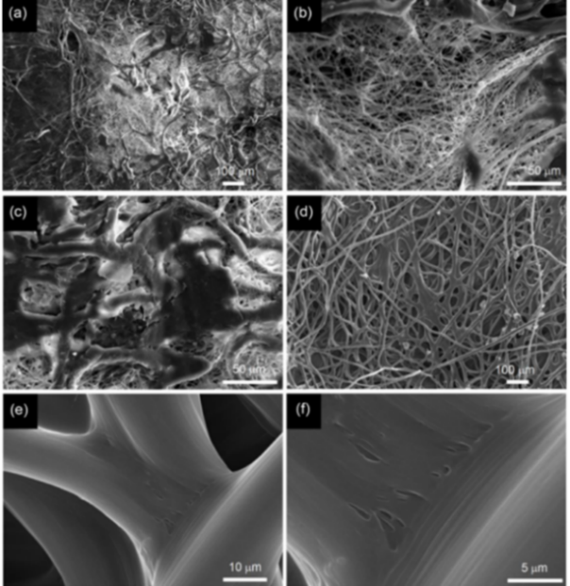
Figure 4. Structural features of egg case
External (a-b); Internal surfaces (c-d) and Cross-section (e-f)

Ecology and Hunting behaviour
The ecology and behaviour of the bolas spider varies with different life stages. Bolas spider shows sexual dimorphism, males are ten times smaller than the females. The newly emerged spiderlings and also the males are easily mistaken with mites with their appearance. The newly emerged spiderlings hunt without a bolas and suggested this might be because of small sticky globose that these spiders could produce would dry out easily due to high surface to volume ratio.
Males and females of M. hutchinsoni are very similar in size at emergence. Thereafter, their sizes diverge as females grow several times larger than males (Figure. 6). Adult males are found in late June and early July, some two months before females mature in early September. Adult males remain in the same habitat with developing females during July-September, but males were not observed in the immediate vicinity (e.g., on the same twig) of females during that period Newly-emerged M. hutchinsoni spiderlings did not use a bolas, but instead hunted by positioning themselves on the underside of leaf margins where they ambushed small arthropods that crawled along the leaf margins. Subadult and adult female M. hutchinsoni used a bolas to capture moths, they are small and show nocturnal activity.

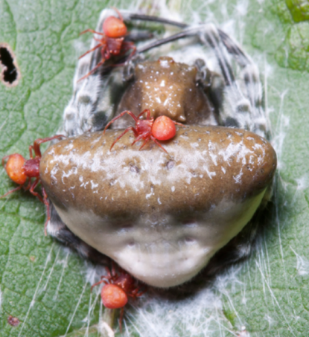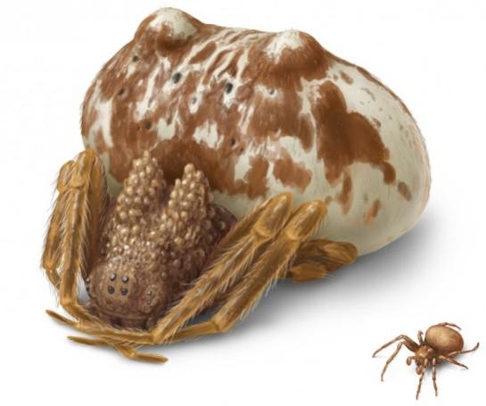
Figure 6. a) Newly emerged spiderlings resembling mites. b) Sexual dimorphisms: Males are ten times smaller than females
a
b

Juvenile bolas spiders attract psychodid flies
Bolas spiders do not build prey-catching webs at any life stage. Eberhard (1980) and Yeargan (1988) observed that Mastophora dizzydeani Eberhard and Mastophora hutchinsoni Gertsch, respectively, hunted without a bolas for a few weeks following emergence. Eberhard (1980) suggested that if these spiderlings could make a small bolas, it probably would quickly dry out due to its high surface-to-volume ratio. The newly emerged M. hutchinsoni spiderlings positioned themselves along leaf margins with the front two pairs of legs periodically extended and held motionless. Mastophora bisaccata and Mastophora phrynosoma spiderlings hunt in the same manner as those of M. hutchinsoni. Eberhard (1980) reported the capture of two nematocerous flies by M. dizzydeani spiderlings, but gave no further identification of those prey. Field observations of recently emerged Mastophora spp. spiderlings in Kentucky by K.V. Yeargan revealed that most of their prey were nematocerous flies in three families, Cecidomyiidae and Ceratopogonidae and most observed prey were adult Psychoda spp. (Psychodidae).
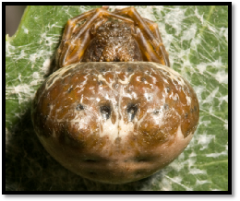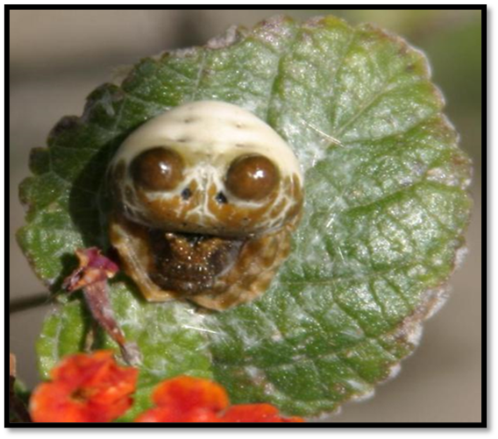
Figure 7. Adult bolas spider resembling bird dropping with prominent brown cephalothorax

This is a form of defensive mimicry as the animals that prey on spiders pay little attention to bird droppings (Figure 7). They are usually cryptic and hide under surface of the leaf during day time. They show nocturnal activity with oddly lumpy abdomen. The female lose those bristles on the forelegs after few moultings. It suggests that they switch to produce bolas for hunting.
Production and use of the bolas
Due to its nocturnal activity the production and use of the bolas actually starts at the late evening hours. Bolas spiders in all the genera behave similarly during preparation for hunting and production of the bolas. The spider begins hunting by crawling from a daytime resting site to a nearby leaf / twig. They are famous for their unusual prey capture technique rather than a web, they produce a single silk line with a super ball of glue at the end that is bolas.
Web construction and prey capture
The form of the bolas and its construction were basically the same in almost all the bolas spiders as described by (Eberhard, 1980). Initially the spider moved back and forth on the horizontal (trapeze) line prior to starting bolas (Fig. 8a), she did not reinforce the line, but rather repeatedly broke it, and reeled up the old line as she played out a new one behind, her body thus forming a bridge between the two lines. She often descended somewhat as she broke the line, and waved her front legs actively as she moved (Fig. 8a), perhaps in order to sense the presence of objects beneath her future hunting site.

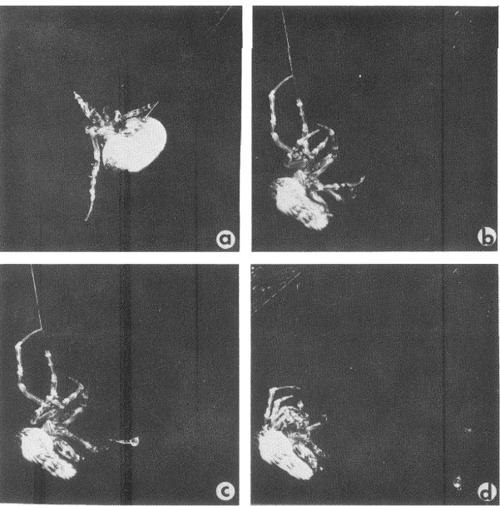
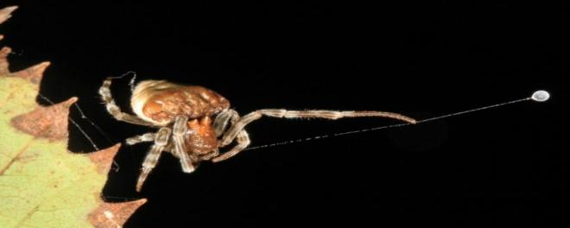
Bolas line

Figure 8. Construction of a sticky ball. a) Spider moves horizontally, waving her front leg. b) Spider hangs from the horizontal trapeze line c) Spider continues to produce sticky silk d). The last of the sticky silk has been produced.

As she produced the ball of sticky material at the end of the bolas line (Fig. 8b-d), it did not seem that she swept viscid material along a central line, but rather that a line as well as viscid material was pulled out with her IV legs. This impression was confirmed by microscopic examination of completed balls which showed large accumulations of thread. About 80-100 pulls with alternating legs IV were performed before the ball was complete, rather than 16-20 as with M. cornigera. Typically, the spider began with shorter and quicker strokes, and then slowed as the ball began to form. When the ball was finished, it appeared that the silk simply ran out rather than that the spider somehow cut the line with one leg IV. The production of a ball took only 1-2 minutes from start to finish.
Internal structure of a sticky ball
The balls of M. dizzydeani were largely liquid. When touched to a piece of filter paper, a ball immediately wet an area two to three times its diameter and, to the naked eye, disappeared. When touched to a non-absorbent object like a glass slide, the ball remained visible as a mass of jelly-like material surrounded by a pool of liquid (Fig. 9a). That the ball’s wetness is essential to its stickiness was shown by taking a newly made ball away from a, spider and letting it hang free at the hunting site for 90 minutes. At the end of this time its size was substantially reduced (Fig. 9b an estimated 40% loss of volume) and it was no longer sticky. The spiders’ ingestion of balls after about 30-minute intervals thus probably served to insure that the ball is sufficiently sticky.
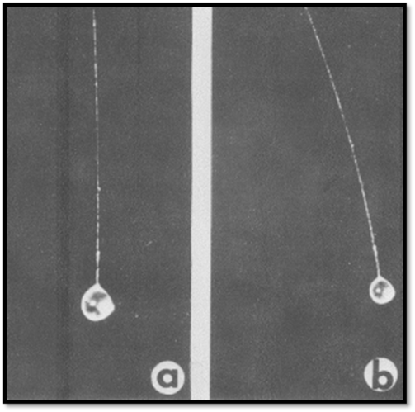
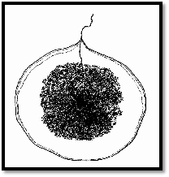

Figure 9. a) Internal structure of a sticky ball b) Shrinkage of a sticky ball

The reduction in size contrasts with the almost complete lack of shrinkage of the balls of adhesive on the sticky spirals of the orbs of araneids such as Metazygia sp., Leucauge sp. Spiders never discarded balls, always carefully ingesting them even when they accidentally stuck to their own bodies. Cursory examination of balls on glass slides showed that their internal structure was complex, and consisted of a mass of curled or folded fibres which were embedded in a viscous matrix which was in turn surrounded by a less viscous layer (Fig. 9a). More refined observations showed that the folded "spring" fibres are noodle-like ribbons which are nearly rectangular in cross section (Fig. 9a), with only slightly rounded corners and slight bulges on their flat sides.
Aggressive chemical mimicry
Insects perform different types of mimicry like Batesian mimicry, Mullerian mimicry etc., to obtain some benefit. The aggressive mimicry is one such type of mimicry where the predators, bolas spider which imitates a signal of another species usually (potential mate) moth in order to exploit. The alternate term for aggressive mimicry is peckhamian mimicry. Here the promise of food or sex are most commonly used as lure. They produce chemicals that mimic the sex pheromone of moth. Predatory exploitation of intraspecific communication involves extreme specialization to intercept or aggressively mimic signals that are often species-specific (Haynes & Yeargan 1999). The female mimics the sex pheromones of its moth prey (Gemeno et al. 2000), and swings the bolas at attracted male moths, which she detects by their wing vibrations (Haynes et al. 2001). The sex pheromones of moths are usually female-produced, species-specific blends of two or more compounds. Specialization of the bolas spiders on a few species of moths is dictated by two factors that relate to the species-specificity of the moths communication systems. First, an optimal blend ratio of compounds is typically required for effective attraction and second, behavioural antagonism caused by minor components in the blend often shuts down the response of heterospecific males. Thus, for animals that exploit species-specific communication, predatory efficiency and specialization are inextricably linked.
Hunting activities of Mastophora sp.
The activity of the one of the major bolas spider named Mastophora sp. was studied by (Eberhard, 1980) and how it mimics the moth. Initially the spider was observed in hunting position holding a ball on the horizontal thread, and holds the vertical thread with one front leg (Fig. 10), swinging the ball at passing insects. When the ball hits an insect, it sticks, and the spider then descends the line, paralyzes the prey, and feeds (Fig.10 a). The spider usually assumed its hunting stance without the ball (Fig. 10 b), prey only approached when the spider was in its hunting position (with or without a ball), and never when it was resting (Fig. 10 c), suggesting that the spider only releases attractive substance when hunting.
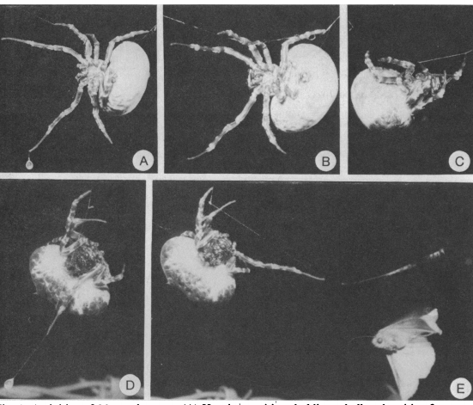
Figure 10. Hunting activities of Mastophora sp a) holding a ball and waiting to prey b) Hunting position without a ball c) Resting position d) Front leg drawn back ready to swing the ball e) Swinging ball at a nearby moth

The front leg of the bolas spider drawn back ready to swing the ball at the passing moth. The prey always approached slowly from directly downwind of the spider (more than 100 observations) with their antennae extended (Fig. 10e) and often they made repeated passes at the spider. Occasionally it was possible to follow their flight several meters from the spider Evidence is presented here showing that this improbable and seemingly ineffective trapping method derives its success in Mastophora sp. The use of volatile substances that apparently mimic prey sex attractant pheromone.
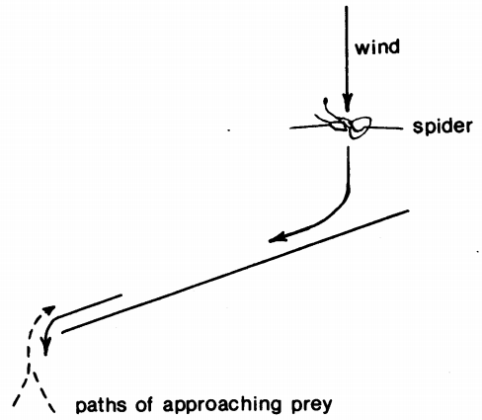

Figure 11. Deflection of approaching prey with a windscreen

Deflection of approaching prey with a windscreen
To see the activity of the moth further a cardboard sheet was held just downwind side of the spider to deflect the airflow and hide the spider from the sight. But still the prey continued to approach arriving by way of the trailing edge (Fig.11) The prey was attracted to the spider and typically made several attempts and erratic arcs to reach the spiders. The prey was attracted to the spider rather than the ball was shown by experimentally removing the ball just after it.
Table 1. Moths captured by female bolas of genus Mastophora
Spider | Prey species | Family: Subfamily
Mastophora bisaccata | Autographa precationis | Noctuidae: Plusiinae
 | Feltia subgothica | Noctuidae: Noctuinae
 | Metalectra quadrisignata | Noctuidae: Catocalinae
 | Mocis texana | Noctuidae: Catocalinae
 | Palthis asopialis | Noctuidae: Herminiinae
 | Pseudaletia unipuncta | Noctuidae: Hadeninae
 | Scolecocampa liburna | Noctuidae: Catocalinae
 | Acrolophus piger | Tineidae: Acrolophinae
 | Acrolophus plumifrontinellus | Tineidae: Acrolophinae
 | Choristoneura parallela | Tortricidae: Tortricinae
 | Ptycholoma peritana | Tortricidae: Tortricinae
Mastophora dizzydeani | Spodoptera frugiperda | Noctuidae: Amphipyrinae
 | Leucania sp. | Noctuidae: Hadeninae
 | Unidentified species | Tortricidae: Olethreutinae
Mastophora hutchinsoni | Lacinipolia renigera | Noctuidae: Hadeninae
 | Nephelodes minians | Noctuidae: Hadeninae
 | Tetanolita mynesalis | Noctuidae: Herminiinae
 | Parapediasia teterrella | Pyralidae: Crambinae
Mastophora Phrynosoma | Disclisioprocta stellata | Geometridae: Larentiinae
 | Eulithis diversilineata | Geometridae: Larentiinae
 | Nephelodes minians | Noctuidae: Hadeninae
Mastophora cornigera | Euxoa messoria | Noctuidae: Noctuinae
 | Heliothis phloxiphagus | Noctuidae: Heliothinae
 | Lacinipolia quadrilineata | Noctuidae: Hadeninae
 | Peridroma saucia | Noctuidae: Noctuinae
 | Protorthodes melanopis | Noctuidae: Hadeninae
 | Discestra trifolii | Noctuidae: Hadeninae
 | Parapediasia teterrella | Pyralidae: Crambinae
 | Phthorimaea operculella | Gelechiidae: Gelechiinae

Indian Spiders of the Genus Ordgarius
In India recently (Thumar et al., 2016) reported specimens collected by visual searching under the leaves Banana and Papaya crops from Agriculture University, Navsari, Gujarat-India and it might be the first record after 34 years belonging to Ordgarius sp.
Ordgarius hexaspinus (Keyserling, 1886)
Ordgarius hobsoni (Cambrige, 1877)
Ordgarius sexspinosus (Thorell, 1894)
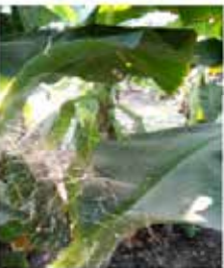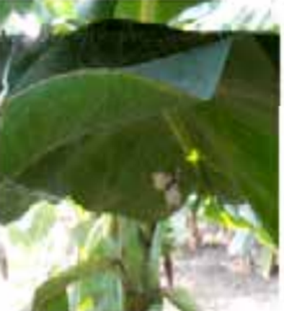
Egg sac and spiderlings

Natural habitat and web

Natural enemies of bolas spiders
The records of the natural enemies of bolas spiders were reported by (Yeargan ,1994), all are pertaining to the predators/parasitoids of the egg stage. The tromatobia notator belonging to Ichneumonidae which is known to parasitize Mastphora cornigera, M. bisaccata, M.phrynosoma. Arachnophaga ferruginea on Mastophora and Gelis sp. on Mastophora cornigera.

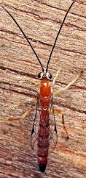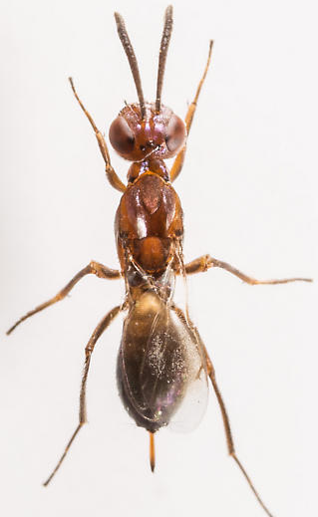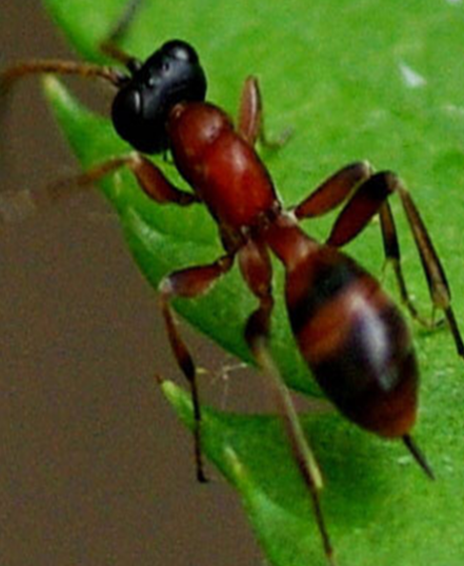
Tromatobia notator
Arachnophaga ferruginea
Gelis sp.

Conclusion:
The bolas spiders are fascinated enough to produce a unique type of threads which consist of adhesive suspension for capturing the prey. The sex-attractant pheromone is produced by female bolas spiders and in response to the wing- beat vibrations of the attracted moths. The adult female bolas spider has a unique hunting tactic that combines aggressive mimicry strategy which provides direct evidence that are efficient in mimic and hunting wide range of noctuid moths. Hence biologists, ecologists, should focus on diversity, conservation, biology and especially on adult biology of bolas spider.

References
- EBERHARD, W. G. 1980, The natural history and behavior of the bolas spider Mastophora dizzydeani sp. (Araneidae). Psyche., 87:143–169.
- GEMENO, C., KENNETH, V., YEARGAN AND HAYNES, K. F., 2000, Aggressive chemical mimicry by the bolas spider Mastophora hutchinsoni: Identification and quantification of a major prey’s sex pheromone components in the spider’s volatile emissions. J. Chem. Ecol., 26: 1235–1243.
- Haynes, K. F. AND Yeargan, K. V., 1999, Exploitation of intraspecific communication systems: illicit signalers and receivers. Ann. Entomol. Soc. Amer., 92:960–970.
- HAYNES, K. F., YEARGAN, K. V. AND GEMENO, C., 2001, Detection of prey by a spider that aggressively mimics pheromone blends. J. Insect Behav., 14: 535-544.
- ROBINSON, M.H., AND ROBINSON, B., 1975, Evolution beyond the orb web: The web of the areneid spider Pasilobus sp. its structure, operation and construction. Zoo.l J. Linn. Soc., 56: 301–314.
- THUMAR, R.H., DHOLAKIA, A.H., AND ADE, P, P., 2016, Indian Spiders of the Genus Ordgarius (Araneae: Araneidae). Global J. Res. Anal., 5(9): 223-226.
- YEARGAN, K. V., 1988, Ecology of a bolas spider, Mastophora hutchinsoni: phenology, hunting tactics, and evidence for aggressive chemical mimicry. Oecologica, 74: 524-530.

