Greening the Flow: Phytoremediation and its Role in Wastewater Treatment

Ratnapriya Das¹, Durgesh Kumar Verma^{2*} and Arya Sen¹

¹Department of Aquatic Animal Health, Faculty of Fishery Sciences, West Bengal University of Animal and Fishery Sciences, Kolkata 700094, India
²ICAR-Central Inland Fisheries Research Institute, Prayagraj, Uttar Pradesh-211002, India
*Corresponding author: durgeshkumarverma4@gmail.com

Abstract
Water scarcity becomes a pressing issue when proper conservation measures are not employed. In recent times, there has been a gradual increase in the quantity of polluted water, commonly referred to as wastewater. To address this challenge and utilize wastewater for human needs, modern eco-friendly technology called phytoremediation has emerged. Phytoremediation is a green approach that involves selecting suitable terrestrial and aquatic plant species to treat wastewater and remove various contaminants. Hydrophytes, also known as aquatic macrophytes, have proven to be effective phytoremediators in both research and commercial applications. This article aims to raise awareness about the importance of phytoremediation in wastewater treatment.
Keywords: Contaminated water, Sewage, Aquatic macrophytes, Sustainable technology, Ecofriendly

- Introduction

One of the most important components of the primary system sustaining life is the availability of water. Pure water is very essential for all living creatures on earth apart from food and shelter. The primary sources of clean water are surface and subsurface water. Aquatic ecosystems play a vital role in performing numerous valuable environmental functions. Among these functions are nutrient recycling, water purification, flood attenuation, stream-flow augmentation and maintenance, groundwater recharge, and provision of wildlife habitats. Additionally, these ecosystems serve as sources of hydroelectric power and supply water for municipal, industrial, and agricultural needs. They also offer recreational opportunities for people to enjoy [1]. However, numerous waterways have been contaminated due to rapidly expanding population and rising industrialization. This is caused by manmade activities that continuously release organic and inorganic pollution into natural waterways [2]. The release of waste materials into natural water bodies can harm aquatic ecosystems and pose a major hazard to both human beings and the environment [3]. So, before being released into the environment, wastewater needs to receive proper treatment. Currently, total removal of water pollutants is not always possible using standard wastewater treatment procedures. In treated water, a negligible amount of these pollutants can therefore still be discovered [4]. Due to the hazardous nature of the pollutants, which can disrupt numerous cellular processes in plants, such residues may damage habitats [5]. Alternative treatments of wastewater are necessary due to the adverse impact of these toxins on humanity and aquatic systems. To achieve sustainable management of clean water and aquatic ecosystems, it is essential to adopt eco-friendly and cost-effective remediation techniques [6]. The Water (Prevention and Control of Pollution) Act, approved in 1974, aimed to prevent and manage water pollution while also restoring the overall quality of water in the nation. Subsequently, the Act underwent amendments in 1988 and again in 2003 [7]. Although numerous environmental laws have been put into practice, a significant issue persists where industrial and untreated domestic effluents continue to be released directly into aquatic systems, leading to a decline in water quality. To attain the objective of clean and healthy water, it is crucial to raise awareness and educate the general public residing near various water catchment areas worldwide [8]. Recent research has shown the promising potential of aquatic plants in removing both inorganic and organic pollutants. Phytoremediation, a branch of bioremediation, involves using plants to remediate wastewater by leveraging their capacity to absorb nutrients from the water. Certain plant species have been identified for their ability to accumulate specific pollutants or a wide range of contaminants [9]. Compared to conventional treatment methods, phytoremediation is considered more efficient and economically viable.

Wastewater treatment

Wastewater treatment is a critical process aimed at eliminating contaminants from wastewater and transforming it into an effluent that can be reintegrated into the water cycle. This treated effluent, after undergoing water reclamation, has a minimal environmental impact and can be reused for a wide range of purposes.

Waste and wastewater treatment are crucial processes to protect the environment and human health by properly managing and removing harmful pollutants. There are various methods and technologies used for waste and wastewater treatment, depending on the type and complexity of the waste or wastewater being treated. Here are some common waste and wastewater treatment methods:

Municipal solid waste (MSW) treatment [10]

Landfilling: Disposal of non-hazardous solid waste in engineered landfills.

Incineration: Controlled burning of solid waste, with energy recovery in some cases.

Recycling: Recovery of useful materials from waste for reuse or reprocessing.

Composting: Biological decomposition of organic waste to produce compost.

Industrial Waste Treatment [11]

Physical Treatment: Includes processes like sedimentation, screening, and filtration to separate solid waste from wastewater.

Chemical Treatment: Involves the use of chemicals to neutralize, precipitate, or oxidize pollutants in wastewater.

Biological Treatment: Utilizes microorganisms to break down organic pollutants in wastewater.

Wastewater Treatment (Municipal and Industrial) [12]

Primary Treatment: Physical separation of large solids and floating debris from wastewater through processes like screening and sedimentation.

Secondary Treatment: Biological treatment using microorganisms to decompose organic matter in the wastewater.

Tertiary Treatment: Advanced treatment processes to further remove nutrients, pathogens, and other remaining pollutants.

Advanced Wastewater Treatment:

Advanced wastewater treatment refers to additional treatment processes applied after primary and secondary treatments to further improve the quality of the effluent before discharge or reuse. These include tertiary filtration, disinfection, dissolved air floatation, dual media filter, activated carbon filter, sand filtration and tank stabilization, clariflocculator, secondary clarifiers and sludge drying beds, nanotechnology, acoustic nanotube technology, photocatalytic water purification technology, UV purification, Sun Spring system, RO purification, Ion exchange technology, aquaporin technology, automatic variable filtration technology, bioremediation (mainly phytoremediation), etc USEPA [10].
One of the treatment technologies is bioremediation, a treatment technology that harnesses the power of microorganisms, primarily bacteria, to break down complex organic chemical waste into simpler, less harmful substances for the environment. This approach finds application not only in the steady-state treatment of sewage and waste stabilization ponds but also shows promise in cleaning up accidental hazardous spills in aquatic environments [13].
Phytoremediation, on the other hand, is a specific subset of bioremediation that involves using green plants to address environmental contamination. These plants have the ability to remove, contain, inactivate, or transform harmful contaminants into harmless substances [14].

- Phytoremediation

Phytoremediation originates from the combination of the Greek prefix "Phyto," meaning "Plant," and the Latin suffix "remidium," signifying "to correct or remove an evil." In the context of soil or water, the term "evil" refers to anthropogenic toxic contaminants such as organic solvents, heavy metals, pesticides, and radionuclides. Phytoremediation is a broad concept that involves using plants to clean up contaminated sediments or water [15].
Phytoremediation offers a profitable, non-intrusive, and environmentally friendly alternative to conventional cleanup techniques. Certain tree, shrub, and grass species possess the potential to remove, degrade, or immobilize hazardous chemicals. By utilizing these plants, it becomes possible to reduce the risk of polluted soil, sludge, sediments, and water by effectively removing, degrading, or containing contaminants [16].
Aquatic plants play a crucial role in biological wastewater treatment systems due to their ability to participate in various phytoremediation techniques such as rhizofiltration, phytoextraction, phytovolatilization, phytodegradation, and phytotransformation [6]. The success of pollutant eradication through these methods depends on several factors, including the duration of exposure, pollutant concentration, environmental conditions such as pH and temperature, and the characteristics of the plants themselves, such as species and root system [6]. It is worth noting that different species of aquatic plants have been effectively used in the phytoremediation of wastewater, leading to noteworthy achievements [17].

- Phytoremediation process

The technology of phytoremediation capitalizes on the inherent detoxification capabilities of plants and their associated microorganisms. By utilizing these natural processes, phytoremediation is able to effectively degrade, contain, and transform the chemical nature of a diverse range of organic and inorganic pollutants found in contaminated soil and water systems. As a result, this approach proves to be cost-effective in the cleanup and restoration of polluted environments [18]. Below are the major processes in phytoremediation involved (Fig. 1).

  - Phytoextraction
Phytoextraction is a phytoremediation process that involves using specific plants to extract or accumulate heavy metals and other pollutants from contaminated soil or water. The process takes advantage of the ability of certain plants, known as hyperaccumulators, to absorb and accumulate high concentrations of metals or other contaminants from the environment into their tissues. Once these plants have absorbed the pollutants, they can be harvested and properly disposed of, effectively removing the contaminants from the site. Hyperaccumulation of heavy metals is a phenomenon observed in a significant number of plant species [19, 20]. Plant species exhibiting phytoextraction capabilities can be classified into different categories based on their response to heavy metal contamination. These categories include indicators, excluders, accumulators, and hyperaccumulators. The presence of these plants aids in detoxifying the environment by actively absorbing and accumulating heavy metals from the soil or water [21]. Interestingly, in greenhouse experiments, gold was successfully extracted from hyperaccumulator plants that had accumulated this precious metal, as documented by Anderson et al. [22]. To manage the hyperaccumulator plants that have accumulated contaminants, two common methods are employed. One method involves cofiring the harvested plants with coal or using them in incineration processes. The other method is composting, where the plants are used to create compost, facilitating the safe disposal or reuse of the accumulated contaminants. These approaches, as discussed in the study by Singh et al. [14], play a crucial role in treating and managing the hyperaccumulator plants after they have fulfilled their phytoremediation function.

  - Phytostabilization
Phytostabilization is a phytoremediation technique that involves using plants to immobilize or stabilize contaminants, particularly heavy metals, in the soil or sediment to reduce their mobility and bioavailability. Unlike phytoextraction, which aims to remove contaminants from the environment, phytostabilization seeks to contain the pollutants in place, preventing their spread and potential uptake by plants and animals. Phytostabilization is particularly well-suited for remediating soils contaminated with heavy metals, and it can be effectively achieved through the in-situ cultivation of fibre-yielding crops [23, 24]. In this process, the contaminant uptake by plants may involve the sequestration of pollutants from the soil and their accumulation in the lignin present in the cell walls of the selected plant species. This sequestration process in the lignin-rich cell walls leads to a two-step mechanism known as lignification and humification, as described by Cunningham et al. [25]. By preventing the mobility of contaminants and halting their speciation into groundwater or air, phytostabilization serves as a barrier to the potential entry of these pollutants into the food chain. This way, phytostabilization plays a vital role in breaking the bioavailability of contaminants in the ecosystem and contributing to the protection of environmental and human health.

  - Phytovolatilization
Phytovolatization is a method primarily used to eliminate highly volatile contaminants. This process involves the uptake of contaminants by growing trees or aquatic plants from water and soil. Specifically, it is effective in removing toxic forms of mercury and selenium, as these contaminants are transformed into non-toxic volatile forms within the plants. Once the conversion occurs, the contaminants are released into the atmosphere through the plants' leaves or shoots. Certain plant species, like those in the Brassica genus and floating aquatic macrophytes, are capable of converting toxic methylated selenium into non-toxic dimethyl selenium through this process [14]. Additionally, researchers have explored enhancing phytovolatization by introducing engineered bacterial genes into specific plant species, further improving their ability to uptake and volatilize contaminants, such as mercury [26, 27].

  - Rhizofiltration
This process involves using plant roots to absorb, concentrate, and remove heavy metal pollutants from surface and/or groundwater. Wetlands, designed as shallow lagoons with low dissolved oxygen in the sediment, have been created and maintained to act as facultative microbial communities. This method, known as rhizofiltration, effectively purifies groundwater or wastewater by passing it through the wetland system, where pollutants are removed by the plants. Wetlands have been successfully employed for many years as a means to remediate metals [28, 29, 30]. Rhizofiltration is particularly suitable for treating groundwater and wastewater. Plant species grown hydroponically can efficiently remove heavy metals from water sources, accumulating them in their roots and shoots. Both aquatic and terrestrial plant species can be selected for rhizofiltration, and the harvested plants can be recycled to economically recover the accumulated heavy metals [14].
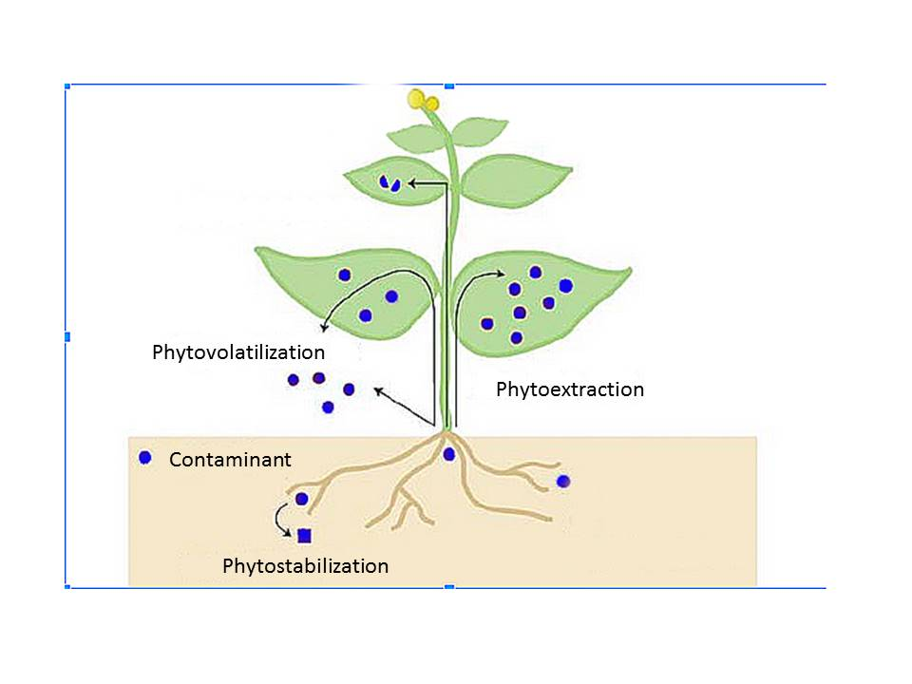

Figure 1: Phytoremediation process used to remove contaminants from wastewater.

- Characteristics of Phytoremediation Plants

For phytoremediation to be an environmentally sustainable and efficient technology, specific characteristics are crucial for the plants involved:

Native and Rapid Growth: Phytoremediation plants should be indigenous to the remediation area to thrive in the local environment. Additionally, they should exhibit fast growth rates, enabling them to establish themselves quickly and commence the remediation process effectively [31].

High Biomass Yield: The selected plants should have a substantial biomass yield, enabling them to accumulate significant amounts of contaminants from the soil or water. This feature enhances the overall effectiveness of phytoremediation [32].

Efficient Heavy Metal Uptake: Phytoremediation plants should demonstrate the ability to absorb and accumulate large quantities of heavy metals from the contaminated environment [33].

Aboveground Metal Transport: The plants need to be able to transport the absorbed heavy metals from their roots to aboveground parts, such as stems and leaves. This transport mechanism is essential for the efficient removal of contaminants from the soil or water [25].

Metal Tolerance Mechanisms: Phytoremediation plants must possess mechanisms that enable them to endure high levels of heavy metals without being significantly impacted by metal toxicity. These tolerance mechanisms allow the plants to survive and continue the remediation process even in contaminated environments [33].

Considering these plant characteristics is essential when implementing phytoremediation to ensure its efficacy and sustainability. Carefully chosen plants with these attributes can significantly contribute to the successful cleanup of contaminated sites while minimizing environmental impact.

- Aquatic macrophytes in phytoremediation of wastewater

Aquatic macrophytes used in wastewater treatment can vary depending on the geographical location, climate, and specific treatment goals. Here are some common types of aquatic macrophytes that are known to be used in wastewater treatment:

Common Reed (Phragmites australis): Common reed is a tall, perennial grass that is often found in wetlands and along the edges of lakes and ponds. It is known for its ability to take up nutrients like nitrogen and phosphorus, making it effective in nutrient removal from wastewater. Studies have shown that Phragmites australis can significantly reduce nitrogen and phosphorus levels in wastewater effluents [34].

Water Hyacinth (Eichhornia crassipes): Water hyacinth is a floating aquatic plant with rapid growth and high nutrient uptake rates. It is particularly effective in removing nitrogen and phosphorus from wastewater. The plant's dense root system and floating leaves provide an ideal environment for bacteria that aid in the breakdown of organic matter (Fig. 2B). Water hyacinth has been used successfully in constructed wetlands and floating treatment systems for wastewater treatment [35].

Duckweed (Lemna spp.): Duckweed is a small, floating plant with rapid growth rates (Fig. 2C). It has high protein content and can efficiently remove nutrients like nitrogen and phosphorus from wastewater. Duckweed-based treatment systems have shown promise in enhancing wastewater treatment efficiency and providing a potential biomass resource [36].

Cattails (Typha spp.): Cattails are common emergent aquatic macrophytes found in wetlands and along the edges of water bodies (Fig. 2E). They have the ability to take up nutrients and metals from wastewater and can contribute to the removal of pollutants through both physical filtration and biogeochemical processes [37].

Water Lettuce (Pistia stratiotes): Water lettuce is another floating aquatic plant that can be used in wastewater treatment (Fig. 2A). It has a high nutrient uptake capacity and can be effective in reducing nitrogen and phosphorus levels in wastewater. Water lettuce can thrive in a wide range of water conditions, making it suitable for diverse wastewater treatment applications [38].

The effectiveness of these aquatic macrophytes in wastewater treatment may vary depending on the specific circumstances and the types of pollutants present in the wastewater (Fig. 2). It is crucial to consider local conditions and conduct proper research and monitoring when selecting and implementing aquatic macrophytes in wastewater treatment systems.

Application of aquatic macrophytes in wastewater phytoremediation

Aquatic macrophytes have been widely studied and applied in various wastewater treatment systems, particularly in constructed wetlands. These plants offer a natural and eco-friendly approach to removing pollutants and improve water quality. Here is a summary of their applications:

Nutrient Removal: Aquatic macrophytes, such as water hyacinth (Eichhornia crassipes), duckweed (Lemna spp.), water lettuce (Pistia stratiotes) and common reed (Phragmites australis), are known for their ability to uptake nutrients, including nitrogen and phosphorus, from wastewater. They can significantly reduce nutrient levels, thus mitigating eutrophication and algal blooms in receiving water bodies [39].

Organic Matter Reduction: The root systems of aquatic macrophytes provide a habitat for microbial communities, enhancing the degradation of organic matter and pollutants in wastewater [40].

Heavy Metal Uptake: Some macrophyte species, such as cattails (Typha spp.), have shown the potential to accumulate heavy metals, helping to remove these contaminants from wastewater [41].

Pathogen Removal: Aquatic macrophytes, especially in floating treatment systems, can create physical barriers and improve microbial processes, leading to the removal of pathogens from wastewater [42].

Biodiversity Support: Macrophyte-rich systems can support diverse communities of microorganisms and small aquatic organisms, contributing to the overall health and ecological balance of the treatment system [43].

Enhancement of Treatment Efficiency: The presence of aquatic macrophytes in constructed wetlands can enhance treatment efficiency, especially in terms of nutrient removal and overall water quality improvement [39].

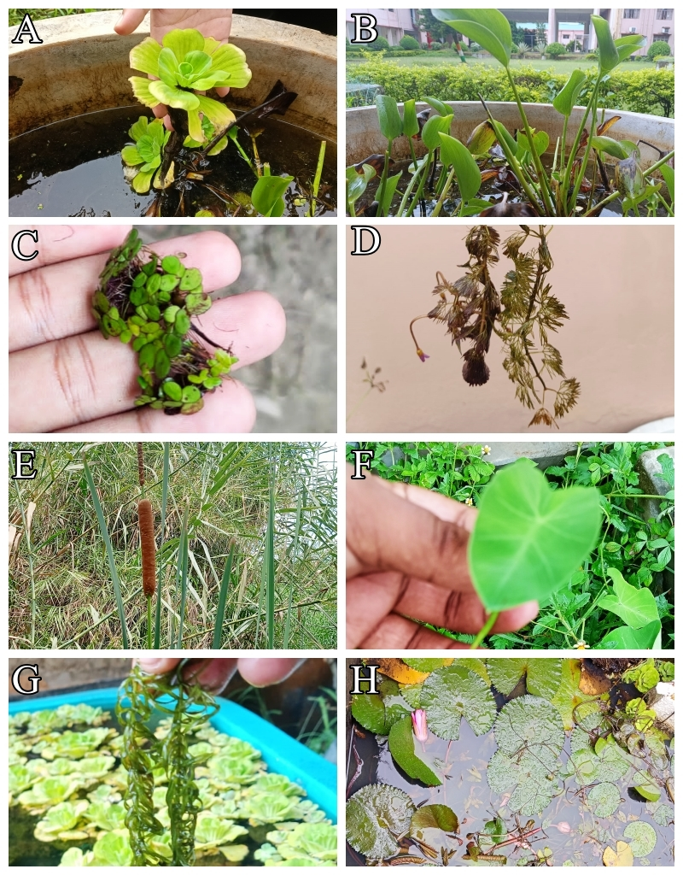

Figure 2: Common aquatic macrophytes found in wastewater. A-Pistia sp.; B-Echhornia sp.; C-Lemna sp.; D-Ceratophyllum sp.; E-Typha sp.; F-Colocasia sp.; G-Hydrilla sp.; H-Nymphaea sp.

Indices of phytoremediation

Various indices have been developed to assess the effectiveness of phytoremediation for specific pollutants or contaminated sites. Here are some commonly used indices in phytoremediation studies:

Bioaccumulation Factor (BAF): BAF is a measure of the concentration of a contaminant in the plant's tissue divided by the concentration of the same contaminant in the soil or water. It indicates the plant's ability to take up and accumulate pollutants from the surrounding environment.

Translocation Factor (TF): TF is the ratio of the concentration of a contaminant in the above-ground part of the plant to the below-ground part (roots). It reflects the ability of the plant to transport contaminants from the roots to the aerial parts.

Shoot-to-Root Concentration Ratio (SRCR): SRCR is the ratio of the contaminant concentration in the shoot (above-ground part) to the root. It provides insights into the distribution of contaminants within the plant and can be useful for selecting hyper-accumulating plants for phytoremediation.

Removal Efficiency (RE): RE is a measure of the percentage of a contaminant removed from the soil or water by the plants. It is calculated as the difference between the initial contaminant concentration and the final concentration divided by the initial concentration.

Degradation Index (DI): DI assesses the ability of plants to degrade organic pollutants. It is calculated as the difference between the initial concentration of the pollutant and the concentration after phytoremediation, divided by the initial concentration.

Stabilization Index (SI): SI is used to evaluate the effectiveness of plants in stabilizing contaminants, particularly metals. It compares the concentration of the metal in the treated soil to the initial concentration.

Growth and Biomass Parameters: In addition to specific indices related to contaminants, growth parameters like plant biomass, height, and root/shoot ratio are often used to evaluate the overall health and growth of plants during phytoremediation.

Advantages of phytoremediation

Phytoremediation offers several advantages as a sustainable and eco-friendly approach to environmental cleanup and pollution control. Some of the key advantages include:

Cost-effectiveness: Phytoremediation is often more economical than conventional remediation methods, such as excavation and disposal or chemical treatments, making it an attractive option for managing contaminated sites [44].

Less secondary waste generation: As mentioned earlier, phytoremediation generates less secondary waste compared to other techniques, reducing the need for costly waste disposal and minimizing the environmental impact [45].

Aesthetic and ecological benefits: Phytoremediation can enhance the visual appeal of contaminated areas by using green vegetation. It also helps restore and improve the ecological balance by creating habitats for wildlife and promoting biodiversity [46].

Long-term effectiveness: Once established, some plant species used in phytoremediation can continuously remediate the environment, providing long-term and sustainable pollution control [47].

Versatility: Phytoremediation can be applied to various types of contaminants, including heavy metals, organic pollutants, and nutrients, making it a versatile technique for different types of pollution [48].

Low energy requirements: Unlike some traditional methods that require energy-intensive processes, phytoremediation relies on natural plant processes, reducing energy consumption and associated greenhouse gas emissions [49].

Ability to treat large areas: Phytoremediation can be applied to large-scale polluted sites, making it suitable for remediating extensive contamination [50].

Community acceptance: Phytoremediation is often well-received by local communities and stakeholders due to its non-intrusive and eco-friendly nature [51].

Reduced risk of environmental disturbances: Phytoremediation is less likely to cause disruptions to the surrounding environment during the remediation process compared to some traditional methods [52].

Overall, phytoremediation presents numerous advantages that make it a promising and sustainable tool in the efforts to clean up polluted sites and protect the environment.

Disadvantage of phytoremediation

Like any other technology, phytoremediation has its disadvantages and limitations. Some of the key disadvantages include:

Site-specific efficacy: The effectiveness of phytoremediation heavily depends on various factors such as the plant species used, the type and level of contaminants present, soil conditions, and climate. As a result, the success of the technique may be limited to specific types of contaminants or certain environmental conditions [53].

Limited plant selection: Not all plant species are suitable for phytoremediation. Some contaminants may not be taken up effectively by plants, and some plants may not survive in contaminated environments. The availability of appropriate plant species can be a limiting factor in some cases [44].

Contaminant storage: While phytoremediation can remove contaminants from the environment, it does not necessarily destroy or degrade them. In some cases, the contaminants may accumulate in the plant tissues, which can pose risks if the plants are not properly disposed of or managed after the remediation process [49].

Lack of public awareness: Phytoremediation is a relatively novel and specialized technique, and there may be limited awareness and understanding of its benefits and limitations among the general public and decision-makers. This could hinder its adoption in some situations [54]. Phytoremediation is not possible to large scale operation [55].

Despite these disadvantages, phytoremediation remains a promising and environmentally friendly approach to clean up contaminated sites. It is often used in combination with other remediation techniques to enhance overall effectiveness. As research and technology continue to advance, the limitations of phytoremediation may be addressed, making it an even more valuable tool for environmental cleanup.

Conclusion

Policymakers need to implement strategies for phytoremediation to detoxify contaminated soil and wastewater, and they should consider using rapidly growing agro-economic plant species to achieve an eco-friendly ecosystem. Among hydrophytes suitable for phytoremediation are Lemna sp., Pistia sp., Vallisneria sp., and Ceratophyllum sp., which can significantly improve the water quality in aquatic systems. In the phytoremediation process, aquatic macrophytes are particularly vulnerable to harmful metals that persist in aquatic systems. These plants also serve as bio-indicators, signalling potential environmental hazards. Phytoremediation has several advantages over conventional techniques, as it is cost-effective, aesthetically pleasing, requires low maintenance, and offers long-term agro-economic returns. Free-floating small hydrophytes are more effective in reducing toxicants compared to larger aquatic macrophytes, and their rhizomes play a crucial role in pollutant removal from wastewater. Rooted submerged and emergent aquatic plant species also significantly contribute to the removal of contaminants from polluted soil and sediments. The use of aquatic plants in phytoremediation for wastewater treatment is both economically viable and environmentally friendly. Consequently, phytoremediation is a promising and applicable technology for wastewater management. It is essential to acknowledge that phytoremediation is not a one-size-fits-all solution. The effectiveness of specific plant species and their remediation capacities can vary depending on the contaminants present, environmental conditions, and site-specific factors. Consequently, thorough site assessment and careful selection of appropriate plant species are crucial for successful phytoremediation projects. While phytoremediation holds great potential, it is not always a rapid process and may require longer treatment periods for substantial contaminant removal. In some cases, phytoremediation may be used in conjunction with other treatment technologies to achieve optimal results. Despite these considerations, the integration of phytoremediation into wastewater management strategies aligns with the growing focus on sustainable and nature-based solutions. Continued research, innovation, and implementation of phytoremediation technologies will undoubtedly contribute to more effective and environmentally-friendly wastewater treatment practices in the future.

References

[1] R.K. Mishra, “Fresh water availability and its global challenge,” British Journal of Multidisciplinary and Advanced Studies, vol. 4(3), pp. 1-78, 2023. doi: https://doi.org/10.37745/bjmas.2022.0207
[2] S.H. Safauldeen, H. Abu Hasan, and S.R.S. Abdullah, “Phytoremediation efficiency of water hyacinth for batik textile effluent treatment,” Journal of Ecological Engineering, vol. 20(9), pp. 177-187, 2019. https://doi.org/10.12911/22998993/112492
[3] E. Basiglini, M. Pintore, and C. Forni, C. “Effects of treated industrial wastewaters and temperatures on growth and enzymatic activities of duckweed (Lemna minor L.),” Ecotoxicology and Environmental Safety, vol. 153, pp. 54–59, 2018. https://doi.org/10.1016/j.ecoenv.2018.01.053
[4] H.A. Mohiyaden, L.M. Sidek, G.H.A. Salih, A.H. Birima, H. Basri, A.F.M. Sabri, and M.D. Noh, “Conventional methods and emerging technologies for urban river water purification plant: a short review,” Journal of Engineering and Applied Sciences, vol. 11(4), pp. 2547-2556, 2016.
[5] H.M. Mustafa, and G. Hayder, “Recent studies on applications of aquatic weed plants in phytoremediation of wastewater: A review article,” Ain Shams Engineering Journal, vol. 12(1), pp. 355-365, 2021. https://doi.org/10.1016/j.asej.2020.05.009
[6] S. Anand, S. Bharti, N. Dviwedi, and S.K.N. Barman, Macrophytes for the reclamation of degraded waterbodies with potential for bioenergy production, Springer: Singapore, 2017, pp. 333–351.
[7] CPCB, The water (Prevention and Control of Pollution) act, Central Pollution Control Board, MoEFCC, GoI, 1974. https://cpcb.nic.in/water-pollution/.
[8] W.J. Cosgrove, and D.P. Loucks, “Water management: Current and future challenges and research directions,” Water Resources Research, vol. 51(6), pp. 4823-4839, 2015. doi:10.1002/ 2014WR016869
[9] R. Chandra, N.K. Dubey, and V. Kumar, Phytoremediation of environmental pollutants, CRC Press, 2017, pp. 1-481.
[10] USEPA, Municipal Solid Waste (MSW) Landfills, Retrieved from: https://www.epa.gov/landfills/municipal-solid-waste-landfills, 2021.
[11] G. Tchobanoglous, H. Theisen, and S. Vigil, Integrated Solid Waste Management: Engineering Principles and Management Issues, McGraw-Hill Education, 1993, pp. 1-388.
[12] E. Metcalf, G. Tchobanoglous, H.D. Stensel, R. Tsuchihashi, and F. Burton, Wastewater Engineering: Treatment and Resource Recovery, McGraw-Hill: New York, 2013, pp. 1-300.
[13] S. Sharma, “Bioremediation: features, strategies and applications,” Asian Journal of Pharmacy and Life Science, vol. 2231, pp. 4423, 2012.
[14] Y. Singh, V. Singhal, and J.P.N. Rai, “Phytoremediation: A plant assisted technology for treatment of industrial wastewater,” in Aquatic Ecosystem and its Management, K. Vijaykumar, and B.Vasanthkumar, Eds., Daya Publishing House: India, 2010, pp. 325-350.
[15] H. Ali, E. Khan, and M.A. Sajad, “Phytoremediation of heavy metals—concepts and applications,” Chemosphere, vol. 91(7), pp. 869-881, 2013. https://doi.org/10.1016/j.chemosphere.2013.01.075
[16] J. Zavoda, T. Cutright, J. Szpak, and E. Fallon, “Uptake, selectivity, and inhibition of hydroponic treatment of contaminants,” Journal of Environmental Engineering, vol. 127(6), pp. 502-508, 2001. https://doi.org/10.1061/(ASCE)0733-9372(2001)127:6(502)
[17] C.O. Akinbile, T.A. Ogunrinde, H. Che bt Man, and H.A. Aziz, “Phytoremediation of domestic wastewaters in free water surface constructed wetlands using Azolla pinnata,” Journal of International Phytoremediation, vol. 18(1), pp. 54-61, 2016. https://doi.org/10.1080/15226514.2015.1058330
[18] B.D. Ensley, “Rationals for the use of phytoremediation in Phytoremediation of toxic metals,” in Using plants to clean up the environment, John Wiley and Sons: New York, 2000, pp. 1-12.
[19] R.R. Brooks, “Phytoremediation by volatilization,” in Plant that Hyperaccumulate Heavy Metals: Their Role in Phytoremediation, Microbiology, Archaeology, Mineral Exploration and Phytomining, CAB International: Oxon, UK, 1998, pp. 1-380.
[20] H. Dhamani-Muller, F. Oort, and M. Balabane, “Metal extraction by Arabidopsis helleri grown on an unpolluted soil amended with various metal-bearing solids, a pot experiment,” Environmental Pollution, vol. 114, pp. 77-84, 2001. https://doi.org/10.1016/S0269-7491(00)00203-7
[21] D.J. Glass, US and International Markets for Phytoremediation, DJ Glass Associates Inc.: USA, pp. 212, 1999.
[22] C.W.N. Anderson, R.R. Brooks, R.B. Stewart, and R. Simcock, “Harvesting and crop of gold in plants,” Nature, vol. 395, pp. 553-554, 1998.
[23] H. Felix, “Field trials for in situ decontamination of heavy metal polluted soil using crops of metal: Accumulation plants,” Zeitschrift für Pflanzenernährung und Bodenkunde, vol. 160, pp. 525, 1997.
[24] M.N.V. Prasad, “Phytoremediation of metal-polluted ecosystem-Hype for commercialization,” Russian Journal of Plant Physiology, vol. 50, pp. 686-701, 2003.
[25] S.D. Cunningham, and D.W. Ow, “Promises and prospects of phytoremediation,” Plant Physiology, vol. 110, pp. 715, 1996.
[26] S.P. Bizily, C.L. Rugh, A.O. Summers, and R.B. Meagher, “Phytoremediation of methyl mercury pollution: Mer B expression in Arabidopsis thalianacon feres resistance to organimercurials,” The Proceedings of the National Academy of Sciences: USA, vol. 96, pp. 6808-6913, 1999.
[27] A.C.P. Heaton, C.L. Rugh, N. Wang, and R.B. Meagher, “Phytoremediation of mercury and methylmercury polluted soils using genetically engineered plants,” Journal of Soil Contaminatyion, vol. 7, pp. 497-510, 1998.
[28] S.P. McGranth, and E. Lambi, “Plant and rhizosphere processes involved in phytoremediation of metal-contaminated soils,” Plant and Soil, vol. 232, pp. 207-214, 2001. https://doi.org/10.1023/A:1010358708525
[29] W.J. Fitz, and W.W. Wenzel, “Arsenic transformations in the soil-rhizosphere-plant system. Fundamentals and potential application to phytoremediation,” Journal of Biotechnology, vol. 99, pp. 259-278, 2002. https://doi.org/10.1016/S0168-1656(02)00218-3
[30] W.W. Wenzel, M. Bunkowski, M. Puschenreiter, and O. Horak, “Rhizosphere characteristics of indigenously growing nickel hyperaccumulators and excluder plants on serpentine soil,” Journal of Environmental Pollution, vol. 123, pp. 132-138, 2003.
[31] M.H. Saleem, S. Ali, M. Rehman, M. Hasanuzzaman, M. Rizwan, S. Irshad, F. Shafiq, M. Iqbal, B.M. Alharbi, T.S. Alnusaire, and S.H. Qari, “Jute: A potential candidate for phytoremediation of metals—A review,”. Plants, vol. 9(2), pp. 258, 2020. https://doi.org/10.3390/plants9020258
[32] M. Hauptvogl, M. Kotrla, M. Prčík, Z. Pauková, M. Kováčik, and T. Lošák, “Phytoremediation potential of fast-growing energy plants: challenges and perspectives–a review,” Polish Journal of Environmental Studies, vol. 29(1), pp. 505-516, 2019. https://doi.org/10.15244/pjoes/101621
[33] R.D. Reeves, A.J. Baker, T. Jaffré, P.D. Erskine, G. Echevarria, and A. Van der Ent, “A global database for plants that hyperaccumulate metal and metalloid trace elements,” New Phytologist, vol. 218, pp. 407–411, 2018. https://doi.org/10.1111/nph.14907
[34] Q. Yuan, X. Zhou, Y. Wang, and C. Peng, “Performance of Phragmites australis in a subsurface flow constructed wetland,” Ecological Engineering, vol. 26(3), pp. 241-247, 2006.
[35] K.R. Reddy, Y. Xu, R.D. DeLaune, and D.A. Graetz, “Use of water hyacinth to treat municipal wastewater,” Water Science and Technology, vol. 40(3), pp. 283-290, 1999.
[36] K.J. Appenroth, K.S. Sree, and M.A. Borowitzka, “Biotechnology of aquatic macrophytes: a review on potential use as water quality indicators, biofuels and other applications,” Journal of Applied Phycology, vol. 29(2), pp. 985-1018, 2017.
[37] R. H. Kadlec, and R.L. Knight, Treatment Wetlands, CRC Press: UK, 1996.
[38] V.K. Mishra, A.R. Upadhyay, and S.K. Pandey, “A review on the use of aquatic macrophytes for the treatment of wastewater,” Environmental Science and Pollution Research, vol. 25(11), pp. 10159-10174, 2018.
[39] Q. Lu, Z.L. He, D.A. Graetz, P.J. Stoffella, and X. Yang, “Phytoremediation to remove nutrients and improve eutrophic storm waters using water lettuce (Pistia stratiotes L.),” Environmental Science and Pollution Research, vol. 17, pp. 84-96, 2010. DOI 10.1007/s11356-008-0094-0
[40] S. Mangkoedihardjo, G. Samudro, “Research strategy on kenaf for phytoremediation of organic matter and metals polluted soil,” Advances in Environmental Biology, vol. 8(17), pp. 64-67, 2014.
[41] A. Sumiahadi, and R. Acar, “A review of phytoremediation technology: heavy metals uptake by plants,” in IOP conference series: earth and environmental science, IOP Publishing, vol. 142, pp. 012023, 2018. doi :10.1088/1755-1315/142/1/012023
[42] R. Alufasi, J. Gere, E. Chakauya, P. Lebea, W. Parawira, and W. Chingwaru, “Mechanisms of pathogen removal by macrophytes in constructed wetlands,” Environmental Technology Reviews, vol. 6(1), pp. 135-144, 2017. http://dx.doi.org/10.1080/21622515.2017.1325940
[43] J. Fletcher, N. Willby, D.M. Oliver, and R.S. Quilliam, “Phytoremediation using aquatic plants,” Phytoremediation: In-situ Applications, pp. 205-260, 2020.
[44] H. Farraji, N.Q. Zaman, R. Tajuddin, and H. Faraji, “Advantages and disadvantages of phytoremediation: A concise review,” International Journal of Environmental Science and Technology, vol. 2, pp. 69-75, 2016.
[45] A. Kafle, A. Timilsina, A. Gautam, K. Adhikari, A. Bhattarai, and N. Aryal, “Phytoremediation: Mechanisms, plant selection and enhancement by natural and synthetic agents,” Environmental Advances, vol. 8, pp. 100203, 2022. https://doi.org/10.1016/j.envadv.2022.100203
[46] C.K. Odoh, N. Zabbey, K. Sam, and C.N. Eze, “Status, progress and challenges of phytoremediation-An African scenario,” Journal of Environmental Management, vol. 237, pp. 365-378, 2019. https://doi.org/10.1016/j.jenvman.2019.02.090
[47] C. Yang, Y.N. Ho, C. Inoue, and M.F. Chien, “Long-term effectiveness of microbe-assisted arsenic phytoremediation by Pteris vittata in field trials,” Science of the Total Environment, vol. 740, pp. 140137, 2020. https://doi.org/10.1016/j.scitotenv.2020.140137
[48] C. Garbisu, J.H. Allica, O. Barrutia, I. Alkorta, J.M. Becerril, “Phytoremediation: a technology using green plants to remove contaminants from polluted areas,” Reviews on Environmental Health, vol. 17(3), pp. 173-188, 2002.
[49] J. Ahmad, S.R.S. Abdullah, H.A. Hassan, R.A.A. Rahman, and M. Idris, “Screening of tropical native aquatic plants for polishing pulp and paper mill final effluent,” Malaysian Journal of Analytical Sciences, vol. 21(1), pp. 105-112, 2017. http://dx.doi.org/10.17576/mjas-2017-2101-12
[50] C. Cameselle, R.A. Chirakkara, and K.R. Reddy, “Electrokinetic-enhanced phytoremediation of soils: status and opportunities,” Chemosphere, vol. 93(4), pp. 626-636, 2013. http://dx.doi.org/10.1016/j.chemosphere.2013.06.029
[51] K.E. Gerhardt, P.D. Gerwing, and B.M. Greenberg, “Opinion: Taking phytoremediation from proven technology to accepted practice,” Plant Science, vol. 256, pp. 170-185, 2017. https://doi.org/10.1016/j.plantsci.2016.11.016
[52] A.K. Gupta, S.K. Verma, K. Khan, and R.K. Verma, “Phytoremediation using aromatic plants: a sustainable approach for remediation of heavy metals polluted sites,” Environ. Sci. Technol., vol. 47(18), pp. 10115–10116, 2013. https://doi.org/10.1021/es403469c
[53] S.R. Vishnoi, and P.N. Srivastava, “Phytoremediation–green for environmental clean” in Proceedings of Taal2007: the 12th World Lake conference, vol. 1016, pp. 1021, 2007.
[54] P.K. Padmavathiamma, and L.Y. Li, “Phytoremediation technology: hyper-accumulation metals in plants,” Water, Air, and Soil Pollution, vol. 184, pp. 105-126, 2007. DOI 10.1007/s11270-007-9401-5
[55] Maurya N. K., M. Shivakumar, Bhooleshwari, and Verma D. K., “Phytoremediation: Concept and Application”. Biotica Research Today 5(2), 140-142, 2023.

