**Experimental Study Of Solar Refrigeration System By Using Thermoelectric Effect**

**1Prof Mayuri Wandhare  2Prof.Kanchan Ganvir**

Mechanical Engineering Department Mechanical Engineering Department

Suryodaya College of Engineering.& Technology Priyadarshani Bhagwati College of Engineering

Vihirgaov,Umred Road Nagpur 441204 Bhande plot Square, Ngapur 440024

mayuriwandhare25@gmail.com kanchan.ganvir100@gmail.com

# ABSTRACT

The increase in demand for refrigeration globally in the field of air-conditioning, food preservation, medical services, vaccine storages, and for electronic components temperature control led to the production of more electricity and consequently an increase in the CO2 concentration in the atmosphere which in turn leads to global warming and many climatic changes. Thermoelectric refrigeration is a new alternative because it can reduce the use of electricity to produce cooling effect and also meet today’s energy challenges. Therefore, the need for thermoelectric refrigeration in developing countries is very high where long life and low maintenance are needed. The objectives of this study is to develop a working thermoelectric refrigerator to cool a volume 2L cabin that utilizes the Peltier effect to cool and maintain a selected temperature range of 5 0C to 25 0C. The cooling chamber design integrates thermoelectric modules (TEMs), which operate on the Peltier effect to cool juicer down to nearly 18’C. Solar panel added advantage to provide the energy. The design and fabrication of solar powered thermoelectric refrigerator for required applications are presented.

***Keywords: Solar energy, Thermoelectric generator, heat sink, refrigeration unit etc.***

1. **INTRODUCTION**

As the demand for refrigeration in various fields increases and the electricity production increases, the emission of harmful gases such as CO2 is increasing worldwide, which is causing global warming and climate change. Thermoelectric cooling is a new alternative method. Thermoelectric modules are made of semiconductor materials that are electrically connected in series and thermally connected in parallel to create a cold and hot surface. Although less efficient than vapor compression systems, they are very light, inexpensive, quiet in operation and environmentally friendly.

Traditional refrigeration systems in use today require a refrigerant that undergoes a phase change through heat exchange and a compressor that compresses the refrigerant. The compressor required more power and space. Refrigerants are also not environmentally friendly, increase global warming and are a major cause of ozone layer depletion.

The eco-friendly mini refrigerator is cooled by using a thermoelectric element called a Peltier element based on the PELTIER EFFECT. MEFR refrigerators do not require a compressor or refrigerant. Semiconductor thermoelectric coolers with temperature control (< ± 0.1 °C) (also called Peltier coolers) can be achieved with Peltier coolers. However, the efficiency is low compared to conventional refrigerators. It is therefore used in niche applications where the inherent advantages outweigh the low performance. Although some large-scale applications (submarines and watercraft) have been

considered, Peltier coolers are generally used for applications that require small size and do not have too large cooling requirements, such as cooling electronic components.

The main aim of this project is to develop a portable thermoelectric cooling system capable of maintaining vaccine temperatures between 8°C and 13°C. The main system consisted of a thermoelectric module as a cooling generator with an isolated cabin, battery and charger. Thermoelectric elements perform the same cooling function as vapor compression or absorption refrigerators based on Freon. Several criteria must be met to ensure the success of this project, such as portability, system size, and cost. The conservation design is based on the principle of a thermoelectric module (ie the Peltier effect) to create a hot side and a cold side. The cold side of the thermoelectric module is used for cooling. Make sure the vaccine chamber is cool.

1. **PROBLEM DEFINITION**

The system is designed for use in residential homes, offices, small vendors, and more. to provide a low-energy alternative to expensive and energy-intensive mobile solar refrigeration system refrigerators. The system wаs designed with size in mind. The inner chamber uses thermoelectric modules to cool the internal environment. Thermoelectric modules (TEMs) work based on the Peltier effect, where a temperature difference is created across the module when an electric current is applied. Heat is absorbed by the surface on the cold side and removed on the hot side of the module. TEMs have been used as an alternative to compressors and condensers because they are low-maintenance and solid-state, making them applicable to small-scale cooling. After the cold chamber has cooled, the user can discharge the chamber to reach the cold filter environment of the portable machine, measured through the temperature sensor.

1. **OBJECTIVES**

The main objective of our project was to design and analyze a unique energy source (i.e. solar) heating and cooling system using a model- Thermoelectric heaters work on the principle of the Peltier effect. It will be a suitable and affordable system for people living in remote parts of India where load balancing is an important issue.

❖ Research on air conditioning based on efficiency, economy and application.

❖ Fabrication of machines using solar energy

❖ Construction of parts for processing mobile refrigeration machines.

❖ Air conditioner cost analysis.

❖ Environmentally friendly prevents ozone layer depletion.

1. **EXPERIMENTAL BLOCK DIAGRAM**

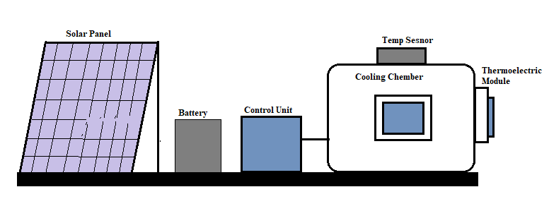

1. **WORKING FLOW DIAGRAM**

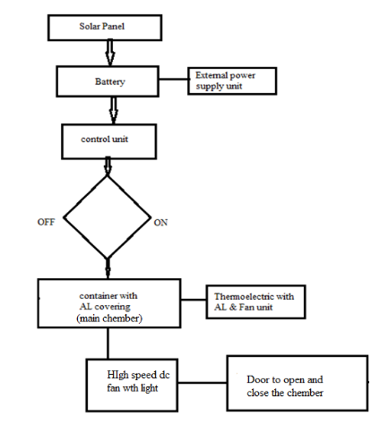

1. 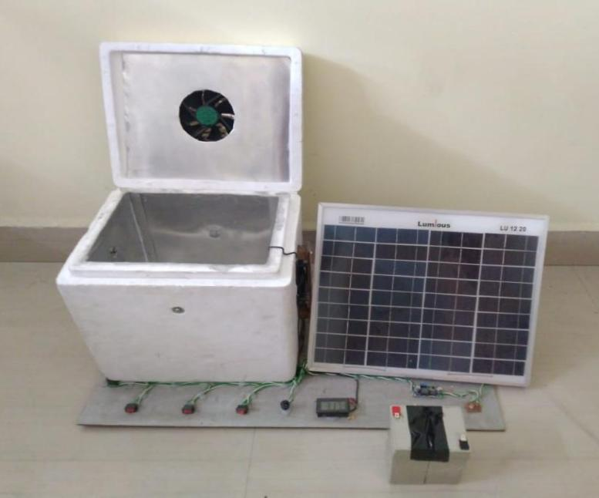**FINAL ASSEMBLY OF RESEARCH MODEL**
2. **WORKING**

* Renewable energy source like, solar energy is used in this project. Solar panel of 12v 20w used to extract the solar energy and convert into electric energy.
* This electric energy is stored into battery of 12v , 8 Amp. Whole system is operate with this power stored energy.
* Also external power source added advantage for emergency situation when their is very less energy available min battery.
* The control unit also provide to operate each function. When any products is insert into cooling chamber unit. Try to close the door present at front of cabin. The overall cabin is insulated with aluminium sheet, to maintain and spread the cooling temperature through out the are inside cabin/chamber.
* To mention the temperature inside the container. Thermoelectric unit (with aluminium block , aluminium sink and exhaust fan) is covered both side of container. And try to cool down the internal temperature. Also high speed fan are added to internal unit of container for more efficiency in cooing.
* Total 2 thermoelectric system is used to cover the apron. 2 litre capacity of chamber. Inside this chamber high speed fan with led lights gives proper refrigerator feelings. Outside the chamber temperature sensor is placed which measure the drop down temperature of cooling chamber.
* This type of solar powered portable refrigeration machine gives more advantage for poor people in India.
* ***Working Principle***

In portable-Refrigerator the peltier device is used which works on peltier effect

**PELTIER EFFECT:** The Peltier effect occurs whenever electrical current flows through two dissimilar conductors, depending on the direction of current flow, the junction of the two conductors will either absorb or release heat.



**Peltier effect**

The Seebeck Effect- is the reverse of the Peltier Effect. By applying heat to two different conductors a current can be generated. The Seebeck Coefficient is given by:

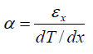

A typical thermoelectric cooling component is shown. Bismuth telluride (a semiconductor), is sandwiched between two conductors, usually copper. A semiconductor (called a pellet) is used because they can be optimized for pumping heat and because the type of charge carriers within them can be chosen. The semiconductor in this examples N type (doped with electrons) therefore, the electrons move towards the positive end of the battery.



**Heat Transfer In “N” type**

The semiconductor is soldered to two conductive materials, like copper. When the voltage is applied heat is transported in the direction of current flow.



**Heat Transfer in “p” Type**

When a P type semiconductor (doped with holes) is used instead, the holes move in a direction opposite the current flow. The heat is also transported in a direction opposite the current flow and in the direction of the holes. Essentially, the charge carriers dictate the direction of heat flow.

1. **COMPONENTS SPECIFICATION**

* Thermoelectric module
* Solar panel
* Aluminium Heat sink (Fin)
* DC Fan
* Battery
* Power supply unit
* Cooling Chamber/Insulated box
* Frame
* Others
* ***Thermoelectric Modules***

The thermoelectric module consists of pairs of P-type and N-type semi-conductor thermo element forming thermocouple which are connected electrically in series and thermally in parallel. The modules are considered to be highly reliable components due to their solid state construction.

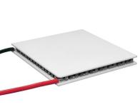

* ***Lead Acid Battery***

**Lead-acid batteries** are the most common in PV systems because their initial cost is lower and because they are readily available nearly everywhere in the world. There are many different sizes and designs of lead-acid batteries, but the most important designation is that they are deep cycle batteries. Lead-acid batteries are available in both wet-cell (requires maintenance) and sealed no-maintenance versions.

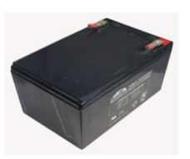

* ***Solar panel***

Solar energy can be stored to utilize at night and when there is a cloudy conditions. Storage is an important issue in the development of solar energy because continuous availability is a vital requirement of modern energy use. Solar energy is only available in the hours of daylight. Solar energy is stored in form of heat or electrical energy.

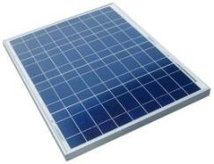

* ***Exhaust fan with Aluminum heat sink***

The geometry of the heat-sink chosen also greatly affects the performance of the fan. A rotary fan slapped on top of your typical linear finned heat-sink will actually be quite inefficient. **In those circumstances, installing the fan in the "suck" direction can actually improve the situation** since the air will enter the sides of the heat-sink more linearly to fill the void in air pressure created by the fan. It is used to maintain or cool down the temperature of thermoelectric.

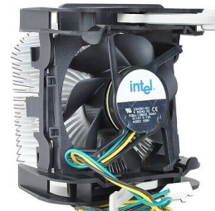

* ***Power Supply/Charge Controller***

Controller is a device which works as a power supply. It converts A.C. to D.C. which helps to decrease the temp of the chamber by controlling the palter device and cooling fans.

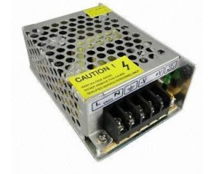

* ***Temperature sensor***

The most commonly measured physical parameter is temperature whether in process industry applications or in laboratory settings. Exact measurements are critical part of success.

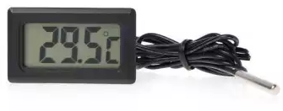

1. **ADVANTAGES**

We believe that thermoelectric cooling offers a number of advantages over traditional refrigeration methods, as:

1. System have no moving parts,

2. No Freon’s or other liquid or gaseous refrigerants required,

3. Precise temperature control,

4. High reliability & durability - We guarantee 5 years hours of no failures,

5. Compact size and light weighted,

6. Noiseless operation,

7. Relatively low cost and high effectiveness,

8. Easy for maintenance,

9. Eco-friendly C-pentane, CFC free insulation.

1. **DISADVANTAGE**

1. C.O.P. is less as compared to conventional refrigeration system.

2. Suitable only for low cooling capacity.

1. **LIMITATION**

In rainy season it cannot be possible to charge battery due to irregular atmospheric condition as our project is totally based on solar energy. This is the limitation of our project, but this problem can be solved by giving direct electric supply.

1. **APPLICATIONS OF SYSTEMS**

1. Can be uses for remote place where electric supply is not available,

2. Medical and pharmaceutical equipment,

3. Military applications,

4. Laboratory, scientific instruments, computers and video cameras.

1. **FUTURE SCOPE**

Though refrigerator is working successfully to its full capacity, still there are many changes and improvements to be made so that it is more user-friendly and cultivated in nature. Some changes are as follows:

1. By increasing the number of Peltier modules and keeping the size of refrigerator unchanged and decrease the temperature inside the box.
2. similar process can be used for heating purpose
3. also , if we add the heating side of the refrigerator
4. chamber inside system.
5. by increasing the volume of refrigerator the
6. capacity can be varied
7. efficiency can be increased by choosing better
8. insulation material.
9. The use of this refrigerator can also implement in Four Wheeler by installing it at the time of
10. manufacturing of vehicle
11. **RESULTS AND DISCUSSIONS**

**Experimental Investigation**

An experimental and performance analysis on fabricated thermo electric refrigerator was conducted. The cold end of the thermoelectric module was used in the system to cool the refrigerator cabin and a digital thermo meter is used to measure the temperature. The hot end is attached to a heat sink for heat rejection. In order to validate the performance of the system cool down experiment was conducted on the system.

**A. Cool down test**

For analyzing the performance of system, water load is considered is considered as the active heat load to the system. Water at 33˚C was filled in the container before switching ON the system. The temperature at every 20min.intervel was tabulated. The readings were recorded for 450 mins.

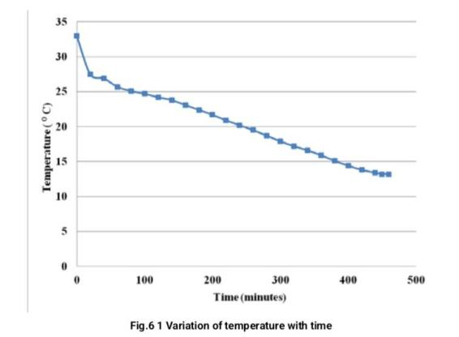Even though the conventional system is mainly designed for maintain a fixed temperature, the above cool down experiment was proved that the system can be adapted for sensible cooling also. The figure 7.1 shows the variation of temperature with time in the given setup. The lower steady temperature was attained around 13oC at a time of 450 minutes. It took about 7 hours and 30 minutes to attain the same from 33oC (ambient temperature).The cabin temperature drop was at an average rate of 2.67 o C per hour.

**B. Performance of the thermoelectric refrigerator**

The active heat load is expressed as the equivalent cooling power that the unit will need to provide when the sample at ambient temperature is placed in the container. It was decided that two liter of water at room temperature took as the test sample .When the designed thermoelectric refrigerator was tested, it was found that the inner temperature of the refrigeration area was reduced from 33.1 ˚C to 13.2 ˚C in approximately 450 min. Coefficient of performance of the refrigerator (COPR) was calculated. Water is used in place of vaccine for taking measurements and calculation. In these calculations, the properties of water are (density = 1 kg/L and CP = 4187 J/kg).V = 2.0 L.

Coefficient of performance of the refrigerator ( COPR) was calculated,

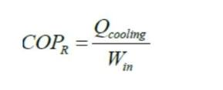

Q = m CPΔ T

Mass of water, m = density x volume = 2 kg

Total heat removed from the water = 166642.6 J

Power given to the system for working,

W IN = V x I + fan input

= 12 x 4 + 2

= 50 W

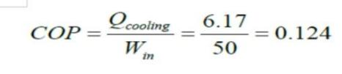 Coefficient of performance of this refrigeration system is given by,

COP of this refrigerator system is lower than conventional refrigerator. This is because the efficiency of thermoelectric modules is usually four times lesser than that of vapour compression system. And the heat leakage is also detected through doors; this too reduces the efficiency of the system.

We have done experimentation on project without load. Cooling by using peltier circuit is done. Temperature change with respect to time is measured.

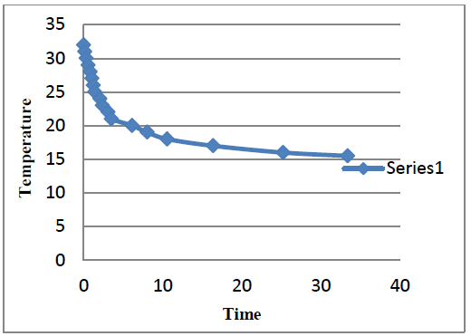

GRAPH 1-COOLING (WITHOUT LOAD)

* Cooling by thermo-electric device reduces temperature 32oC to 15.5oC in 35 minutes.

Thermoelectric refrigerators are greatly needed, particularly for developing countries, where long life, low maintenance and clean environment are needed. In this aspect thermoelectric cannot be challenged in spite of the fact that it has some disadvantages like low coefficient of performance and high cost. These contentious issues are the frontal factors hampering the large scale commercialization of thermoelectric cooling devices. The solution to above problems can only be resolved with the development of new techniques. There is a lot of scope for developing materials specifically suited for Thermoelectric cooling purpose and these can greatly improve the C.O.P. of these devices. Development of new methods to improve efficiency catering to changes in the basic design of the thermoelectric set up like better heat transfer, miniaturization etc. can give very effective enhancement in the overall performance of thermoelectric refrigerators. Finally, there is a general need for more studies that combine several techniques, exploiting the best of each and using these practically.

Thermoelectric module for producing effective heating and cooling placed inside an aluminium cabinet. By using a temperature sensor inside the cabinet surface, we get the corresponding temperature values for each instant which are displayed in an LCD (Liquid crystal display). The graph between temperature produced inside the cabinet against corresponding time interval are also presented and results are in line with the predictions. The advantages of the thermoelectric heater cum refrigeration on comparison with the existing heater and refrigeration system are elaborated. The physical dimensions and specifications of the thermoelectric module are presented. It is observed that the life span of thermo electric heater cum refrigeration system is more than twice the life span of existing conventional refrigeration or heater system. The principle of solar panel along with its specifications and dimensions are displayed. As the future relies heavily on Non conventional energy resources, the solar powered thermoelectric heater cum refrigeration system will definitely be a large aspect in terms of energy saving capacity and the fact that the system is eco-friendly. The important aspect to be noted is that it is a one time investment and is maintenance free.

# REFERENCES

1. Jonathan Michael Schoenfeld, Master of Science,2008 “Computational Model for Refrigerators Based on Peltier Effect Application”, Applied Thermal Engineering, Vol. 25, No. 13, pp. 3149-3162.
2. Bass et al. (2004), “Multi-layer quantum well (MLQW) thermo electrics in a cooling application” International journal of research in aeronautical and mechanical engineering ISSN (online): 2321-3051
3. Chain and Chen Vol. 120 (2011) “Performance Prediction and Irreversibility Analysis of a Thermoelectric Refrigerator with Finned Heat Exchanger” Wuhan 430033, P.R. China, ACTA PHYSICA POLONICA No.03
4. Riff at and Qiu (2005) “Air conditioning systems with an air and water cooled heat sink” International Journal of Emerging Technology and Advanced Engineering Volume 3, Special Issue 3: ICERTSD 2013, Feb 2013, ISSN 2250-245
5. Zhang H Y (2010), “A General Approach in Evaluating and Optimizing Thermoelectric Coolers”, Int. Journal of Refrigeration, Vol. 33, No. 10, pp. 1187-1196.
6. Angrist, S.W., 1971. Direct Energy Conversion (Allyn and Bacon, Inc., Boston, MA,).
7. Ismail, B. I., Ahmed,W. (2009). Thermoelectric Power Generation using Waste-Heat Energy as an Alternative Green Technology. Recent Patents on Electrical Engineering, 2(1), 27–39.
8. Riffat, S. B., Ma, X. (2004). Improving the Coefficient of Performance of Thermoelectric Cooling Systems: a Review. International Journal of Energy Research, 28, 753–768.
9. Omega.(n.d.)The thermocouple. Retrieved October 10, 2010, from http://www.omega.com /temperature/ z / pdf/z021-032.pdf
10. Riffat SB. Xiaolima Thermo-Electric: A Review of Present and Potential Applications. Applied Thermal Engg. International Journal of Engineering(IJE),Volume(5): Issue(1):2011, 2003:23:913– 35.
11. Luo, Q., Tang, G., Liu, Z., Wang, J. (2005). A Novel Water Heater Integrating Thermoelectric Heat Pump with Separating Thermo siphon. Applied Thermal Engineering, 25, 2193–2203.
12. Riffat, S. B., Qiu, G. (2004). Comparative Investigation of Thermoelectric Air-Conditioners versus Vapour Compression and Absorption Air-Conditioners. Applied Thermal Engineering, 24, 1979–1993.
13. Bansal, P. K., Martin, A. (2000). Comparative Study of Vapour Compression, Thermoelectric and Absorption Refrigerators. International Journal of Energy Research, 24, 93–107.