Drug Allergy

(Drug idiosyncrasy, drug sensitivity, stomatitis or dermatitis medicamentosa)

Introduction
Drug allergy includes a variety of sensitivity reactions following exposure to any one of a great many drugs and chemicals but is not related to any pharmacologic activity or toxicity of these materials.

Furthermore, some patients have a greater susceptibility to drugs manifest reactions more readily than others. This is particularly true in patients who have other allergic diseases, such as asthma or may fever.¹

Multiple drug hypersensitivity (MDH) was first described in 1989 by Sullivan et al as drug allergies to two or more chemically different drugs which were mainly antibiotics.⁸¹

Pathogenesis:
It may be related to either immunologic or non-immunologic mechanisms. The immunologic mechanisms are triggered by an antigen component (hapten) on the drug molecule, resulting in a hyperimmune response or drug allergy. Drug reactions that are non immunologic in nature do not stimulate an immune response and are not antibody dependent.⁶⁵

- Hyperimmune response (allergy)
Related to drug immunogenicity, frequency, route of delivery, patient’s immune system.

Mediated by
- Mast cells coated with Ig E
- Antibody reaction to cell bound drug
- Deposition of circulating Ag-Ab complexes.

- Non-immunologic response (not antibody dependent) direct release of inflammatory radiators by mast cells, overclose, toxicity, side effects.⁶⁵

Clinical features
The common allergic reactions to systemic administration of a drug include skin lesions, arthragia, fever, lymphadenophy and rarely agranulocytosis. The allergic reaction of the skin is called dermatitis. The skin lesions may be of erythematous type as in erythema multiforme, or as fixed drug exeptions. Commonly drugs such as aspirin, barbiturates, chloramphenicol, tetracycline, penicillin, streptomycin and sulfonamides are implicated in allergic drug reactions.

Oral manifestations
An allergic reaction of the mucosa to the systemic administration of a drug is called stomatitis medicamentosa. Common reactions in oral cavity are stomatitis, ulceration and necrosis, hemorrhage, gingival hyperplasia, pigmentation, altered salivary function and altered taste sensation.

The most common type of allergic reaction of oral mucosa is erythema multiforme characterized by multiple ulcerations of tongue, palate, buccal mucosa and givgiva with pain and discomfort.

Intraoral fixed drug eruption is due to exogenous drugs or chemicals are the sole cause. It consists of erythematous round to oral lesions of a reddish, dusky purple or brown colour, sometimes featuring blisters, either bulla or vesicles. The site of eruption is fixed, i.e whenever the individual takes the causative drug the eruption occurs within hours at exactly the same site. Sulphonamides, tetracyclines and NSAIDs are frequently implicated.⁸² Nicorandil, a new class of potassium channel activators used for the treatment of angina pectoris . It has the potential to induce painful oral ulceration involving tongue, buccal mucosa .⁸³

Histopathologic features:
A nonspecific pattern of subacute musositis with an admixture of lymphocytes, eosinophils and neutrophils is observed in anaphylactic stomatitis. Similar features with spongiosis and exocytosis of epithelium and individual cell necroses are characteristics of fixed drug eruption distinctive annular fluorescence pattern, termed string of pearl’s noted along cell membrane of basal layers in lichenoid reactions by indirect immunofluorescence.

Treatment
The signs and symptoms of drug allergy usually regrets with discontinuance of the causative agent. The localized acute signs may be relieved by antihistaminic drugs or cortisone.

DRUG ALLERGY

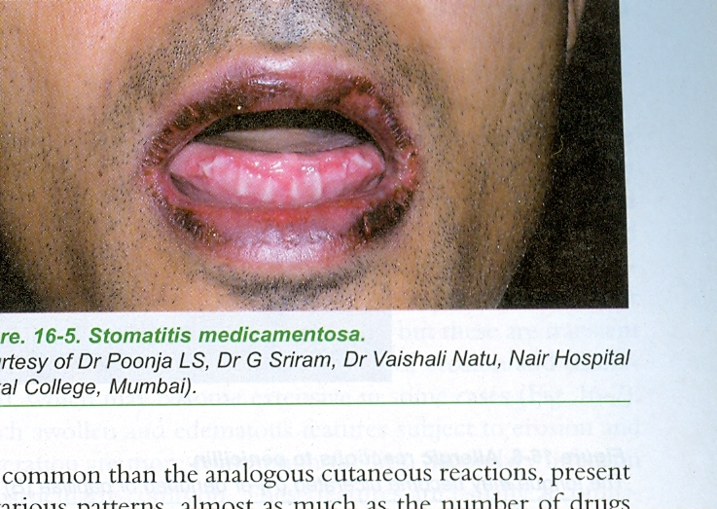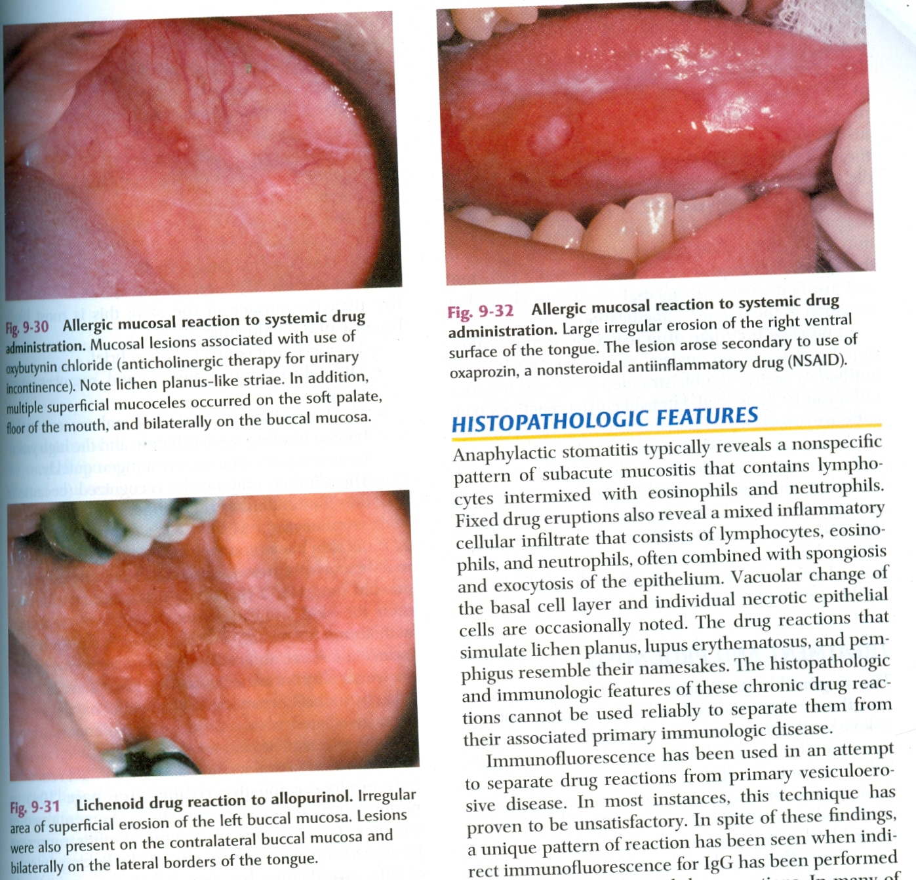
Stomatitis medicamentosa
Allergic mucosal reaction to systemic drug administration-lichen planus like striae with the use of anticholinergics (oxybutynin chloride)

Lichenoid drug reaction to allopurinol-Irregular area of superficial erosion of the left
buccal mucosa
Large irregular erosion of right ventral surface of the tongue secondary to use of NSAID

