Asclemedco amelioration of self - medication using data analysis.

|  |  |  |
| --- | --- | --- |
| Mr. Kirankumar Ramalingam  UG Scholar  Dept of Information Technology  Sri Sairam Engineering College  Chennai, India  sec21it177@sairamtap.edu.in | Mr. Jeevanandham A  UG Scholar  Dept Information technology  Sri Sairam Engineering College  Chennai, India  sec21it074@sairamtap.edu.in | Mrs. T. Manju  Assistant Professor  Dept Information technology  Sri Sairam Engineering College  Chennai, India  manju.it@sairamtap.edu.in |

**ABSTRACT**

**Self-medication is the use of medical drugs to treat illnesses and diseases. S­elf-medication, as defined by the World Health Organization (WHO), is the use of medication to self-diagnose illnesses, diseases, disorders, pregnancy, or conflict or regularity with prescribed medication. Research shows that there is no general definition of self-medication, but it can be considered the selection and use of over-the-counter (OTC) medications, as well as the repeated use of medications in the past healthcare and the use of medical drugs to treat personal symptoms or diseases.**

**Situations such as using a friend or family member's prescription, not following the treatment plan, or changing the prescribed medication may also constitute self-medication. However, self-medication may have health benefits, such as better use of and access to medication, but is associated with increased risks such as misdiagnosis, overdose, and long-term medication use. and drug interactions. Self-medication can increase and strengthen the immune system (AMR), which can affect human and animal health. Antibiotics are a type of self-medication available over the counter in many parts of the world, accounting for approximately 5% of antibiotics sold without a prescription. Proper education and awareness of individuals can improve self-medication behavior and promote health in vulnerable groups.**

**INTRODUCTION**

Practicing self-medicate without proper knowledge or guidance, which can be dangerous and the lack of

accurate and reliable information about the drug, its side effects and proper nutrition rules contributes to this problem.

Without professional guidance, users may be unaware of misuse of medications or drug combinations, which 044can lead to adverse reactions, drug interactions, or even drug overdose.

There is a need for a self-medication app that addresses these issues and provides users with a platform to make informed decisions about self-medication. The application must provide accurate and up-to-date information about various medications, including their indications, contraindications, possible side effects and recommended dosages.

In addition, it should have features that will ensure the safety of users, such as drug interaction reports, drug alert programs and emergency instructions.

Overall, Personal Health Issues Application aims to create a user-friendly and reliable platform by providing accurate, supportive information security and reduce the risk associated with self-medication so that people can become self-sufficient.

**METHODS**

Self-medication the use of an application or website can be a convenient way to manage positive health troubles, but it's vital to method it responsibly and seek advice from a healthcare professional while essential. Here are techniques for self-medication via an app or website: Symptom Checker: Provide a symptom checker that permits customers to input their signs and get hold of pointers on feasible situations or self-care measures.

Dosage and Medication Information: Offer facts on over-the-counter (OTC) medicinal drugs, which includes dosage instructions, capability side consequences, and precautions and condition Information it provides comprehensive records on diverse health situations, their symptoms, causes, and self-care suggestions.

Virtual Pharmacies: Enable customers to purchase OTC medicinal drugs or healthcare products at once thru the app or website and have them brought to their door and also home remedies and self-care tips where share home treatments and self-care tips for commonplace health troubles such as colds, complications, or minor injuries.

Medication Tracking: Allow users to log the medications they take and set reminders for the next dosage and telemedicine consultations where Facilitate video or chat consultations with healthcare specialists for non-urgent health concerns or comply with-ups.

Medication Reviews and Ratings: Allow users to go away opinions and rankings for OTC medicines and self-care merchandise and also provide a characteristic for users to preserve a fitness diary wherein they are able to track symptoms, remedy utilization, and changes of their fitness.

Emergency Information: Include facts on while to searching for immediate clinical interest and how to contact emergency offerings.

Personal health records: Allow users to input and save their health facts, together with scientific records and lab consequences.

Privateness and certainty: Implement strong safety features to guard users health statistics and ensure compliance with information privateness policies. And also community Support it creates forums or communities in which users can discuss health issues and share their reviews. Educational Content: Offer articles, motion pictures, and infographics to educate users approximately various fitness topics.

Medication interplay checker: Include a device that tests for capability interactions among OTC medicinal drugs and a consumer's existing prescriptions.

Call to mind that self-remedy have to be used with caution, and customers ought to be recommended to are searching for expert clinical advice for extreme or chronic health problems. The application or website must additionally emphasize accountable self-care and not update the role of healthcare experts.

**COMPUTING DEVICE REQUISITE**

Operating System: Applications is developed for a specific operating system such as Windows, MacOS or Linux. Software requirements will depend on the functionality for which the application is developed.

Development Tools: Development tools will depend on the programming language used to develop the application. For example, a developer using Python can use tools such as Jupyter Notebook, pandas, and scikit-learn for data analysis.

Libraries and Content: Drug review applications may require the use of specific libraries and frameworks for data analysis and visualization. Libraries and templates used for chemical data analysis include ChemPy and RDKit.

**OPERATION**

**1. Secure login**

Provide secure access to applications to ensure user privacy and data security.

**2. User Survey**

Give users a survey asking about their medical history, current health, allergies, and medications they currently take.

**3. Medication usage**

Allows users to enter the name, dosage and frequency of medication they need

4**. Drug Interaction Analyst**

Become a drug interaction analyst for the user's drug list with information about drug interactions.

**5. Drug Information**

Be a feature that provides information on all medications, including directions, side effects and dosage instructions.

**6. Health Consultation**

Enables a feature that allows Provides a mechanism for users to report adverse reactions to the appropriate regulatory agency

**7.Continuous Database Update**

Constantly update the app's database with new drug information

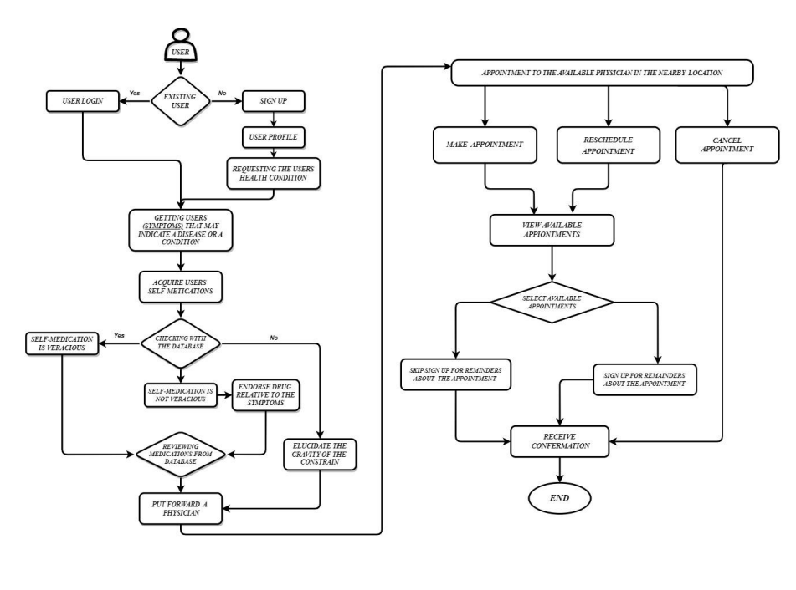**APPLICATION OF ANALYSIS OF DATA**

**Work flow of the self-medication application**

Data analytics plays an important role in personalized medicine by providing better insights into user behavior, medication adherence, and overall health outcomes. Here's how to use or include identifying information in a personalized medicine app:

Medication tracking data can track users' compliance with medication management. By analyzing user input and usage patterns, the application can provide alerts, personalized recommendations and information to improve compliance. User behavior analysis data can track user interaction with the application. It can capture the frequency of logins, which features are most commonly used, and how long users spend on the app. This information helps developers make data-driven improvements to enhance user experiences.

Self-medication applications often collect data on users' health conditions, symptoms, and vital signs. Data analytics can process this information to identify trends, risk factors, and potential health issues, providing users with early warnings or recommendations and also by applying predictive analytics, self-medication apps can use historical user data to predict future health outcomes. For example, they can predict the risk of certain diseases based on lifestyle and medication use.

Data analysis allows the application to create personalized recommendations for users. For example, he or she may recommend over-the-counter medications based on symptoms, allergies, or interactions with other medications and also the application can identify medications entered by users and provide warnings about drug interactions or contraindications and can measure the effectiveness of

self-medication by tracking health outcomes. This may include improving symptoms, vital signs, or resolving health problems.

Analyze user feedback and comments to understand user opinions, concerns and suggestions. This information will help us continuously improve the application and data analysis can help monitor the security and privacy of the application to ensure that data is used correctly. Ensure that protection and data protection laws are complied with.

may indicate future traits or data sources. By Data-Driven Decisions the developers and implementers can use data analysis to make informed decisions about direction and strategy. Develop personalized medicine based on real user experience.

Self-medication practices are generally required to comply with medical regulations. Data analytics can help ensure apps comply with these rules by monitoring data security and user consent. Integrating analytics into personalized medicine applications can lead to more efficient, personalized and user-friendly healthcare solutions.

However, it is important to prioritize data security, user privacy and compliance with health legislation throughout the process.

**RESULT AND OBJECTIVE**

Self-medication is a major public health problem worldwide, with a global prevalence between 11.7% and 92%. According to “THE HINDU” newspaper nearly 52 per cent Indians indulge in self-medication, a practice bearing severe health risks.

And a trend that is increasing due to either time constraints or the perception of doing away with the doctors’ fees, as per a survey conducted by “Lybrate”, a doctor-patient end-to-end communication platform (2015).

According to WHO numbers from a 2016 report quoted in FAQs released by the Ministry of Health and Family Welfare in August 2019, 57.3% of personnel practicing allopathic medicine (in 2016) did not have a medical qualification. January 21, 2022.

Out of the $42 billion domestic pharma market in India, close to **1.5%** of medicines either expire or have to be destroyed (2022).

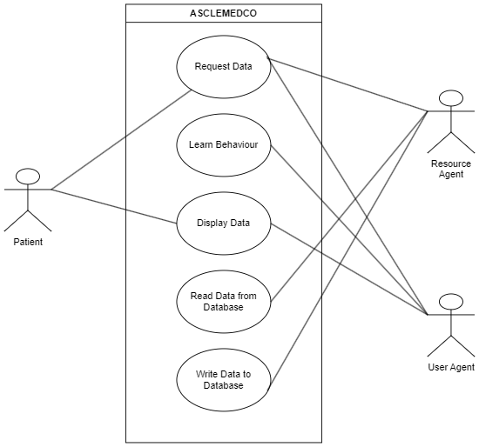

**Use case diagram of the application**

**VANTAGE AND SHORTCOMING**

Users can access health information and self-care tips from the comfort of home or on the go, saving time and reducing the need to visit the doctor. By symptom assessment apps provide an initial assessment of the condition, helping users decide whether a particular treatment is necessary and also the accessibility is 24/7, making it easy to find information and help at any time, even during an outage.

Medication Tracking features can help users manage their medications, set reminders, and track their medication history and by medical records we can store digital medical records, making it easier to track health history, share information with doctors, and manage chronic conditions.

And shortcomings of self-medication are Misdiagnosis and Inaccurate Information which is of the most significant risks is relying on inaccurate or incomplete information that can lead to misdiagnosis or incorrect self-medication and the overuse and overdependence without seeking professional medical help when needed, which could delay treatment for more serious conditions.

It is not suitable for all health problems Self-medication are best for minor ailments and self-care advice. They do not replace professional health care for serious or complex medical conditions and also potential for self-diagnosis anxiety, some users may experience anxiety and stress when trying to self-diagnose health problems, especially when they misrepresent symptoms.

It is essential to practice self-medication responsibly. They can be valuable tools for managing minor health problems and gathering information, but users should be aware of their limitations and seek professional medical advice for more complex or persistent health problems. Additionally, users should exercise caution when sharing sensitive health information.

**CONCLUSION**

In summary, examining personal leadership through data analysis presents a complex picture with both benefits and challenges. Data analysis can provide insight into patterns, trends, and consequences associated with self-medication. Data-driven insight into practice highlights the need for responsible use of self-medication. Users should be knowledgeably aware of the strengths and limitations of these tools.

Self-medication should be viewed as a complement to treatment and supported by evidence to encourage individuals to manage their own health. But caution, accuracy, and a willingness to seek medical training when needed should be principles of personal leadership. Data-driven approaches to self-medication emphasize the importance of informed decision-making and self-care.

**REFERENCES**

1.Verma RK, Mohan L, Pandey M. Evaluation of self-medication among professional students in North India: proper statutory drug control must be implemented. Evaluation. 2010;3(1):60–4.

2. Da Silva MGC, Soares MCF, Muccillo-Baisch AL. Self-medication in university students from the city of Rio Grande, Brazil. BMC Public Health. 2012;12(1):1–7.

3. El Ezz NF, Ez-Elarab HS. Knowledge, attitude and practice of medical students towards self-medication at Ain Shams University, Egypt. J Prev Med Hyg. 2011;52(4):196–200.

4.. Ershadpour R, Zare Marzouni H, Kalani N. Review survey of the reasons of the prevalence of self-medication among the people of Iran. Navid No. 2015;18(60):16–23.

5. Porteous T, Bond C, Hannaford P, Sinclair H. How and why are non-prescription analgesics used in Scotland? *Fam Pract.*2005;22:78–85. [[PubMed](https://pubmed.ncbi.nlm.nih.gov/15640291)] [[Google Scholar](https://scholar.google.com/scholar_lookup?journal=Fam+Pract&title=How+and+why+are+non-prescription+analgesics+used+in+Scotland?&author=T+Porteous&author=C+Bond&author=P+Hannaford&author=H+Sinclair&volume=22&publication_year=2005&pages=78-85&pmid=15640291&)]

6. Pagán JA, Ross S, Yau J, Polsky D. Self-medication and health insurance coverage in Mexico. *Health Policy.*2006;75:170–7. [[PubMed](https://pubmed.ncbi.nlm.nih.gov/16338480)] [[Google Scholar](https://scholar.google.com/scholar_lookup?journal=Health+Policy&title=Self-medication+and+health+insurance+coverage+in+Mexico&author=JA+Pag%C3%A1n&author=S+Ross&author=J+Yau&author=D+Polsky&volume=75&publication_year=2006&pages=170-7&pmid=16338480&)]

7. World Health Organization: Report of the WHO Expert Committee on National Drug Policies. 1995. [Last accessed on 8-9-2010]

8.. Mosleh A, Darbui S, Khoshnevis Ansari S, Mohammadi M. Condition of drug prescriptions according to WHO indexes in health centers without drugstore. Tehran U Med J. 2007;65(2):12–5.

9. Nahimana T, Harimenshi D, Ntawukuriryayo G, Girukwishaka D. Self-medication and associated factors among nursing student trainees at Ngozi Hospital-Burundi. Health Sci Dis. 2022;23(1):6–11.

10. Ghafouri M, Yaghubi M, Lashkardoost H, Seyed Sharif SH. The prevalence of self-medication among students of Bojnurd universities and its related factors in 2013. J North Khorasan Univ Med Sci. 2014;5(5):1129–35.

11.. Krajewska-Kułak E, Kułak-Bejda A, Kułak P, Bejda G, Cybulski M, Guzowski A, et al. A comparative analysis of self-treatment in a population of medical students in 2012 and 2017. Fam Med Prim Care Rev. 2019;1:35–40