T. Pullaiah¹, M.Naresh²
Multi-neighbor selection technique for Efficient Routing in MANETs

¹ Associate Professor, ECE Dept., Vignan's Institute of Management and Technology for women,
Kondapur ,Ghatkesar,Telangana state India.
⁴Assistant Professor, ECE Dept.,, Matrusri Engineering College, Saidabad, India.

Abstract: Quality of Service (QoS) is very essential for MANETs. The distributed way of route cache update algorithm is used to send explicit ROUTE ERROR (RERR) message to all nodes. The performance of UDSR protocol is improved by using Multi neighbor selection approach. This approach helps in improving network performance by using different parameters. In this paper, we compare the DRS, cache update algorithm, Multi neighbor selection techniques for transmission of data. Network simulator (NS2) is used for experimental evaluation. This proposed approach helps in improving the QoS parameters like Packet Delivery Ratio (PDR), end to end delay.

Keywords: DRS, cache update algorithm, QoS, multi neighbor selection.

INTRODUCTION:
Wireless networks comprises of wireless sensor networks, MANETs and VANETs. MANET is Freestanding, regionalized, heal-up Free space packets is easy for displace one end or the other end. To entail QoS of ad-hoc network there is a distinctive type of application in order to improvise the performance of MANET applications. In the literature, different protocols in MANET are proposed in order to obtain efficient routing. The reach identifying first area change the available content varies by routing algorithms whenever there is movement of host. The MANET's routing concord is mostly classified into table determined, on-demand and hybrid routing protocol. In ad-hoc network, the table-driven routing protocol keeps contemporary and compatible information. Hybrid routing use reactive and proactive appeal to discover route, when it comes to on-demand protocol establish the route whenever they require. Caching is much needed in various present day utilization. With highest priority network programming wires performs essential work. Due to flexibility, the persistent network failure is observed in temporary packets, upon working ultimately QoS is reduced which further reduces the performance of network. When route is amputated, the alternate route is to be searched. Again, to all its neighbors the ROUTE ERROR (RERR) message is forwarded .

packet drop may take place if cached route is dry and find another path identified and make turn on . with this initiated another path finds window happening high load on the data packet on by further resultst low speed for the datagram outreach the transmitted . Hence energy consumption is high and plenty of packets drop rate is high as well. Again, transport layer may be mistaken as obstruction occurring on the path. All disadvantages are removed in MANET and QoS is improved only if presence of efficient caching mechanism.
various approaches have been proposed for problems to overcome and surpass the performance of network to update cache scheme and which is found in the literature by authors of [3-8]. prediction of wire fault with existing method data gram is presented by author of [8]. The link adversity in this protocol is further dictated by the flexibility of the node position, node movement and power level. When compared to traditional AODV protocol perform the best. All the neighbours update cache by removing hard route, with the help of auxiliary datagram procedure, wire breakage is produced by cache new scheme. In this proposal the with proposed method, infuses existing methods that are involved existing topology. To all its neighbors, RERR information of size 60 bytes broadcasts using source node. That being the case, in their cache all neighbours replaces the hard route.
We intend to use the existing protocol and implemented it. We have seen that DRS protocol is not providing the top most QoS for mobile Ad-hoc network. Secondly, we have proposed a new protocol which has improved QoS of the mobile Ad-hoc network. We have introduced multi neighbor selection method to improve the QoS of the mobile Ad-hoc network further. Additionally, we have compared parameters like delay, PDR and have presented the comparative analysis in the form of graphs for existing, proposed and extension schemes.
Benefaction of authours’ ideology , earlier with existing method notifying RERR information to co networks of amputated connection , matter is spread across to the existing packets which participate in working. If primary neighbor of source fail hard route entries are also removed from route cache or amputated link then cache will upgrade with new link and finds this new link which may take some time to cause less PDR and more delay. Hence, we are using MULTI NEIGHBOUR selection to allow source to send data by using multiple neighbors. To overcome from the existing problem.
The rest paper is organized as follows. Literature Survey is described in Section II, in the Section III. Proposed System is elaborated. Section-IV describes the performance metric evaluation and experimental results. Section-V provides the conclusion and suggests the further research direction.

LITRATURE SURVEY:
To enhance the Quality of Service the route caching takes part wonderful role in on-demand routing protocol. The QoS is most vital for many applications of MANET. Mobile Ad hoc Network which is so called (MANET) is a cluster of mobile nodes without any centralized control. Mobile ad hoc networks (MANETs) are further classified by multi-hop wireless connectivity plus frequently changing network topology. In [2] at this condition a diversity of routing protocols have been targeted categorically and some performance simulations built on numbers of routing protocols naming Ad hoc On-Demand Distance Vector Routing (AODV), Dynamic Source Routing (DSR) and Location-Aided Routing (LAR). In [5] operates entirely on-demand with the use of detailed simulations of wireless ad hoc networks of 50 mobile nodes based on the Dynamic Source Routing protocol (DSR). Authors of [6] drafted that, for one node to exchange data with another node across the network multiple network "hops" may be needed. Due to the limited transmission range of wireless network interfaces, a detailed packet-level simulation comparing four multi-hop wireless ad hoc network routing protocols that cover a range of design choices naming TORA, DSR, DSDV and AODV. The Author of [7] bring forward negative route caches, timer-based route discovery, and wider error notification with a purpose to lower cache entries in order to keep away cache pollution. As the output shows as much as 10% - 70% refinement using proposed approach. The downside of this method is that, originality of routes is not taken into contemplation. Authors of [8] using the ESRS algorithm enhanced the energy efficiency. Authors of [6] exerted routing mechanism, which is known as proactive route maintenance (PRM), and is used to reconstruct the simple route mechanism in subsisting reactive (on-demand) routing protocols in order to enhance reliability and reduce route discovery cost. Routing information is disclosed only by active nodes that move the data packets and dispensed all the way through active routes. Alternatively paths vigorously came across and remain the level by active nodes and their 1-hop neighbors (so called passive nodes). End-to-End connections have been perpetuated reliably by PRM in dynamic networks with less overhead, and has the very worthwhile properties comprising low latency, fair load distribution, high delivery ratio, self-healing and self-optimization. When a sending node is set about a data packet addressed to that node, on-demand routing protocol for wireless ad hoc networks came across a route to several receiver nodes.

PROPOSED SYSTEM:
How cache update is done during transmission is shown in conventional DRS protocol. When amputated link is observed, RERR message is generated and sent. Only those nodes which are a part of routing path will get their Route Cache updated. The new protocol UDSR from authors of [9] used a distributed route cache update algorithm in order the update the cache, in neighbors 60 bytes is allocated in this message. Hence, using new approach the RERR notification is generated and sent to all neighboring nodes in the topology and updates Route Cache. In case, the neighboring node used to send the data in the using UDSR protocol also breaks or fails to transmit the data, the cache will try to final a new route in order to transmit the data. This process may take some time. Hence, it results in more delay and less PDR. We proposed a solution to the above problem by identifying a secondary neighboring node for data transmission. So, in case the primary node fails to send the data, this secondary node will be used and the data transmission takes place without causing much delay. Thus, this improves the QoS of network by different parameters. The algorithm used is shown below. The Fig.1 shows the block diagram of our proposed methodology.

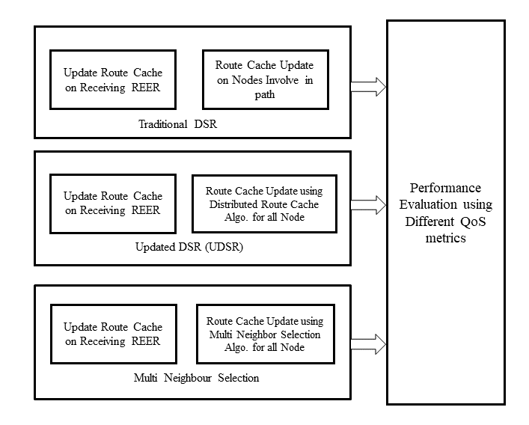
Fig 1: Block diagram of Multi-neighbor selection method

PERFORMANCE METRICS:

Simulation Parameters
The use NS-2 is used for our simulation experiments. 1000 meters (m) x 1000m is taken as the area of simulation. We use Constant Bit Rate (CBR) to generate mobile traffic where, the CBR is the application agent. The Queue length of 500 packets and the antenna used for means of propagation is Omni Antenna with the Two Ray Ground propagation type. UDP (User Datagram Protocol) is an alternative communications protocol or Transport agent used. For routing data from the source and selected destination module, Multi neighbor selection protocol is used. Rest of the simulation parameters are enlisted in Table 1.
- SIMULATION PARAMETERS.
Parameters | Values
Area | 1000m x 1000m
MAC Type | IEEE802.11
 | 500
 | Two Ray Ground
 | AODV
 | 50ms
No. of nodes | 10 to 100

Packet Delivery Ratio
Packet delivery ratio is defined as the ratio of packets reached to a destination without failing to the no. of sent packets by the source/sender.
PDR  PC_{nr}  PC_{ns}                                                                                        

Where,
PC_{nr} = The number of Packets Received,
PC_{ns} = The number of Packets Sent.

Delay
It is the difference between the time taken by source to generate packets and taken time by which the packet reach the destination.

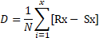 (2)

Where,
D = Delay,
R_{x} = No. of packets received at x^{th} time.
S_{x} = No. of packets sent at x^{th} time.
N = number of nodes.

Algorithm:

- Nodes append a path from data packet.
- If it is a destination node then source node is stored, setting the data packet (DP) as 0.
- It checks cache of the node if it is not intermediate node.
- Checks whether path is present then cache list entry is done by DP to 0 creates Record where neighbors understand link.
- Checks whether path is present then it appends entry to Record.
- DP is given 1, if source path is in cache.
- In case there is no path then it is destination node, DP is given 1.
- Check if path is not there then, it is intermediate node, upraised DP by 1.
- In case full path is not present then creates a cache list entry.
- Cache is null.
- For every path entry, store in cache list.
- Check whether node identifies path, appends it to Record which includes nodes to which path is sent.
- Check whether node is source, identifies the path then the DP gets upraised by 1.
- In case link breakage occurs.
- If identifying path is alternate path then entry is appended in the cache list and DP gets upraised by 1.
- If link breakage occurs again.
- If identifying path is second alternate path then it is appended in cache list and DP is upraised by 1.
- If it survives then no change is made in cache list.

RESULTS
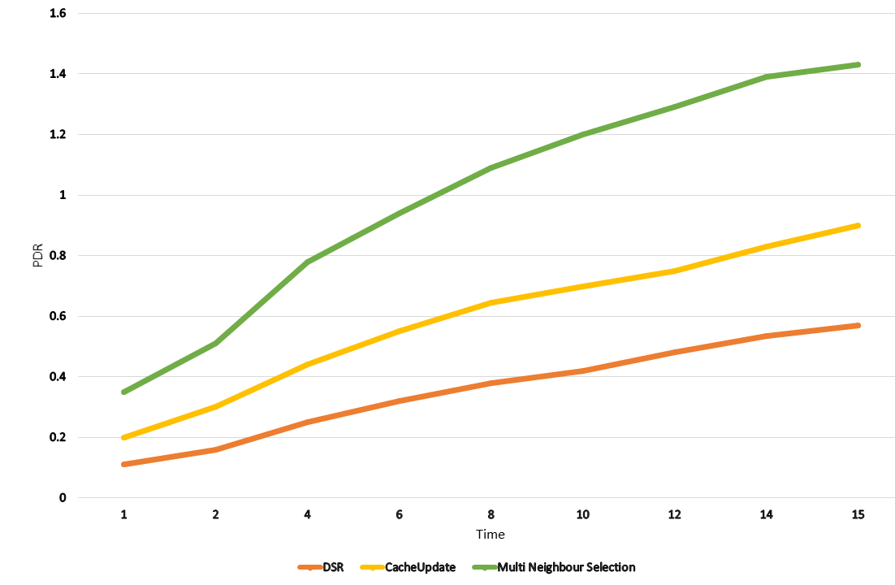
Fig 2: Representing PDR vs time graph
The Fig 2. Describes that Multi-neighbor methodology has achieved higher PDR than other techniques. Average PDR obtained by DSR, Cache-Update and Multi Neighbour Selection technique are 26%, 64% and 75% respectively.

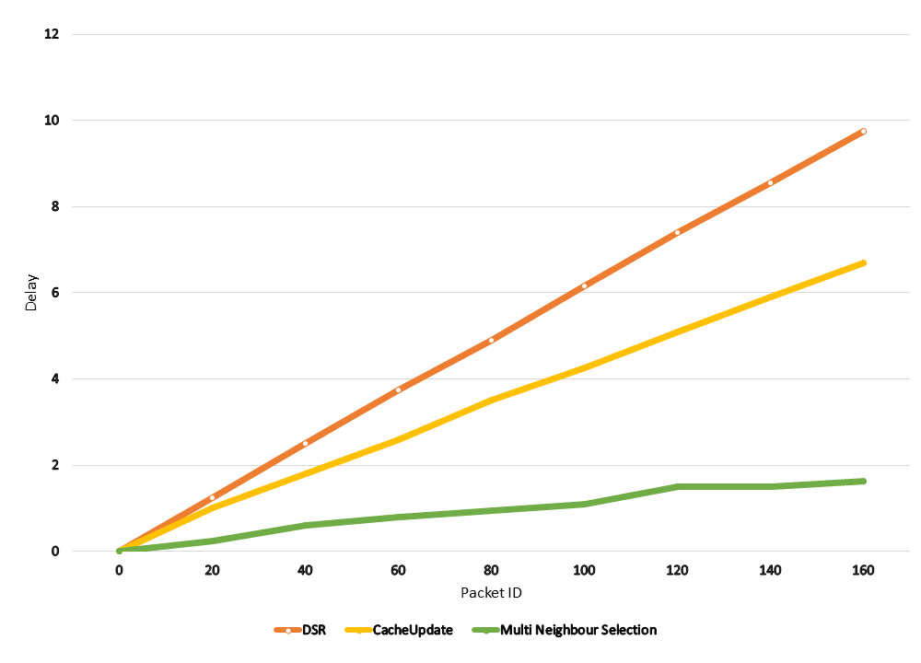
Fig 3: Delay Vs time graph.

In the Fig 3 we can see that our proposed methodology has achieved less delay than other techniques.
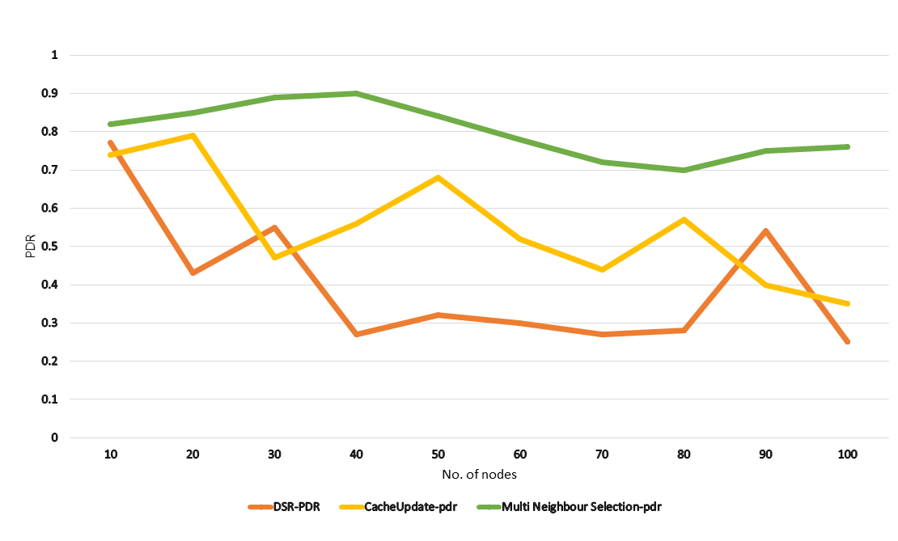
Fig 4: PDR w.r.t no. of Nodes graph.
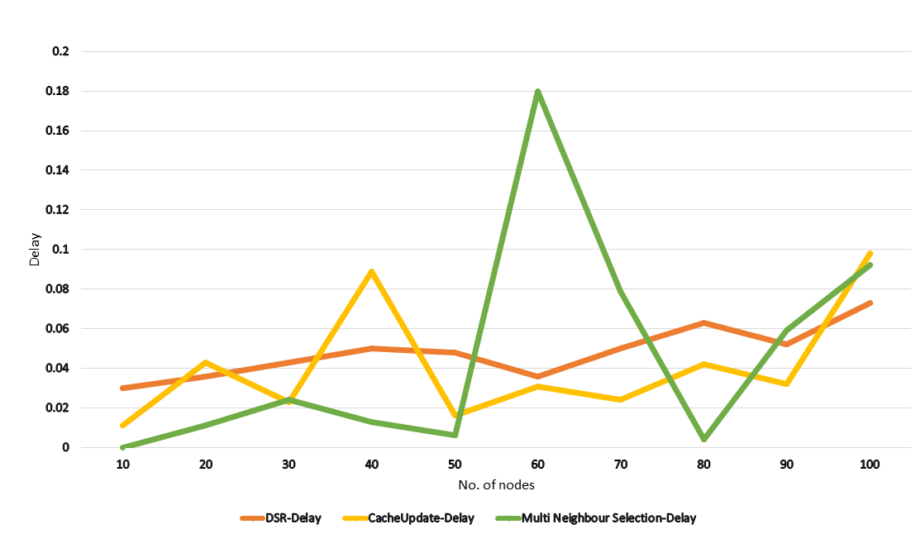
Fig 5: Delay w. r. t no. of Nodes graph.
The Fig.4 and 5 shows observed that by proposed method we have achieved less delay and more PDR.

CONCLUSION:
We have successfully implemented and verified all three methods. We observe that our proposed system has achieved better performance when compared to DSR and UDSR techniques.

References:
- Gunseerat Kaur ; Poonam Thakur “Routing Protocols in MANETS”. ICICICT-IEEE 2019.

- Y.-C. Hu and D. Johnson. “Caching Strategies in On-Demand Routing Protocols for Wireless Ad Hoc Networks”. Proc. Sixth ACM MobiCom, pp. 231-242, 2000.
- B. Sreevidya ; M. Rajesh, “Enhanced energy optimized cluster based on demand routing protocol for wireless sensor networks”, ICACCI, IEEE-2017.

- L.M. Freeny, “Energy efficient communication in ad hoc networks,‖ Mobile Ad Hoc Networking” , Wiley-IEEE press, pp. 301-328, 2004
- S. Menaka and M.K. Jayanthi. “Effective Stale Routes Management Using Preemptive Routing in DSR”. World Applied Sciences Journal 22 (11): 1554-1560, 2013 ISSN 1818-4952.

- Narasa Reddy, G., A. Avanthi and R. Prasanth Reddy. “Enhancing DSR Protocol Performance in Mobile Ad Hoc Networks using Proactive Route Maintenance (PRM)”. International Journal of Advanced Research in Computer Science and Software Engineering, 2(5): 366-371, 2012.

- Mahesh K. Marina and Samir R. Das, “Performance of Route Caching Strategies in Dynamic Source Routing”, Department of Electrical& Computer Engineering and Computer Science, University of Cincinnati.

- Ajeet Singh ; Ramesh Kumar ; Sonu Pant. “Advanced routing on AODV using link prediction in Mobile Ad-Hoc Network”, IEEE ICACCA-2017.
- V. V. Mandhare, R. C. Thool. “Improving Performance In Mobile Ad-hoc Network Using Data Caching Schemes”: A Review, International Journal of Computer Technology & Applications, Vol 5 (5),1780-1788, 2014.

 

