Antimicrobial resistance in Intensive Care Units is an alarming Public Health issue. – A review article
Dr.Vaskar Majumdar,Associate Professor,AGMC,Agartala
Dr.Mohit Aggarwal ,Resident ,AGMC

Introduction-
Since last few decades Antimicrobials have been used to treat infectious diseases.In this battle against microorganism- antimicrobials is definitely a blessing.But these microorganism are being resistant to different type of antibiotic by different mechanisms. Antibiotics resistance is defined as micro- organisms which are not inhibited/ killed by usual systemic concentration of an anti microbial agent. WHO has named antibiotic resistance as one of the three important 21st century public health threats. According to a report in India on average in 9 minute a child dies from an antibiotic resistant bacterial infection.
Antimicrobial resistance is ancient.Antimicrobial resistance should be considered as normal adaptive response and it is one kind of Darwinian principles of evolution.
The very first requirement in a hospital is that it should do the sick no harm---- Florence Nightingale. Infectious disease are currently a significant cause of morbidity and mortality worldwide.A large percentage of patients admitted in ICU have infections involving different systems of the body. Most of the times these patients are critically ill and hence are immune compromised. Moreover, various invasive procedures and devices including peripheral and central IV lines, endotracheal tube and mechanical ventilation, arterial lines, Foleys catheter, etc increases risk of acquiring additional infections in ICU patients.
The micro organisms found in ICU patients are found to have more antimicrobial resistance as compared to those which are found in other patients, as the ICU patients being chronically ill have already received number of antibiotics previously which promotes the development of anti microbial resistance in these patients. Common organisms in ICU patients are classified as- a) Bacterial- Staphylococcus aureus, Enterococcus, Pseudomonus aeruginosa, Klebsiella, E.Coli b) Virus- HIV,HBV,HCV,CMV etc c) Fungal- Candida, aspergillus d) parasites.
Many a times the treating clinician has to start an empirical broad spectrum antimicrobial in diagnostic uncertainty after understanding the risk- benefit ratio. Inadequate treatment of the infection will increase the morbidity and mortality. On the other hand over treatment have antibiotic related systemic side effects, drug reaction and antimicrobial resistance.
The development of antimicrobial resistance is of major concern in ICU practice and is a significant challenge to all health systems worldwide.In this review article the cause, pattern of antibiotic resistance, impact on health system and the measures to control the antibiotic resistance will be discussed.

Common resistant pathogens:
Among Gram positive organisms, the most important resistant microorganism in ICU is Methicillin resistant Staphylococcus aureus, Vancomycin resistant enterococci. Klebsiella pneumonie, E.coli and Proteus mirabilis ,Pseudomonas aeruginosa are among Gram negative bacteria.
Methicillin resistant Staphyloccous aureus (MRSA)
Staphyloccus aureus is a type of bacteria found on skin.Methicilin resistant stahyloccus aureus is a cause of staphyloccus aureus infection that is difficult to treat due to resistance to some antibiotic.MRSA is the most important causes of hospital associated bacterial infections worldwide. Admission of a patient who is already infected with MRSA and cross- contamination are two main factors for development of MRSA in ICUs. Most important risk factors for MRSA colonization and infection includes previous stay in hospital or long-term care facilities, ICU stay, intravenous or intra-arterial lines, prior or prolonged administration of antibiotics, chronic illnesses, surgical wounds, advanced age, and cross-contamination.

Vancomycin-resistant enterococci (VRE)

Enterococci are bacteria normally present in human intestine, female genital tract and in soil and water. It spreads through contaminated surfaces. Patient with low immunity, transplant organ, ICU patients with surgical devices, patient on Vancomycin for long duration are vulnerable to get VRE infection. As per EPIC II Study Vancomycin resistance among enterococcus isolates were approx. 33-50 % in different countries. Enterococci can adopt environmental changes and acquire antimicrobial resistance. They develop resistance to aminoglycosides, B lactams and when resistance occurs against Vancomycin then it is called Vancomycin resistant enterococci (VRE).
Enterobacteriaceae
Drug resistance in gram negative bacilli if more complex and diverse as compared to MRSA and VRE as gram negative bacilli are resistant to a large number of antibiotic groups mostly due to cross-transmission of resistance characteristics. There are multiple studies showing emerging resistance of gram-negative bacilli third-generation cephalosporins, carbapenems, and fluoroquinolones. Gram negative bacilli (esp. E. coli, Klebsiella and Proteus) produces ESBLs (extended spectrum beta-lactamases), which is plasmid mediated and responsible for resistance of gram-negative bacteria in ICUs.
Pseudomonas/Acinetobacter
Pseudomonas and Acinetobacter strains isolated from hospital environment are highly resistant to a wide range of antibiotics. There is increasing proportion of these bacteria in severe burn injury and Ventilator associated pneumonia cases. Production of enzymes, such as beta-lactamases and DNA-gyrases, active efflux pumps and changes in permeability are the main factors responsible for their resistance. They are highly resistant organisms, resistant against most of the antibiotics.
Clostridium difficile
Clostridium difficile infection disease severity ranges from mild diarrhoea to acute life threatening pseudo-membranous colitis. It is most common organism responsible for antibiotic-associated pseudo-membranous colitis. Important risk factors associated with Clostridium associated diarrhoea are antimicrobial therapy, older age (>65 years), anticancer drugs, length of hospital stay and other interventions like enemas, nasogastric tubes, gastrointestinal surgery, and anti-peristaltic drugs.
Candida infections
ICU patients being immune-compromised are susceptible to a wide range of fungal infections and Candida is the most common fungal pathogen infecting these patients. Candida infections can be due to albicans or non-albicans species. Treating non-albicans Candida infections are more difficult to treat as they are intrinsically fluconazole-resistant.
Mechanism of antibiotic resistance
Sir Alexander Fleming in his Nobel Prize lecture, himself warned of antibiotic resistance in 1945,-“It is not difficult to make microbes resistant to penicillin in the laboratory by exposing them to concentration not sufficient to kill them, and the same thing has occasionally happened in the body…and by exposing microbes to non lethal quantities of the drug make them resistant.”

Classifications of antimicrobials according to mechanism of action
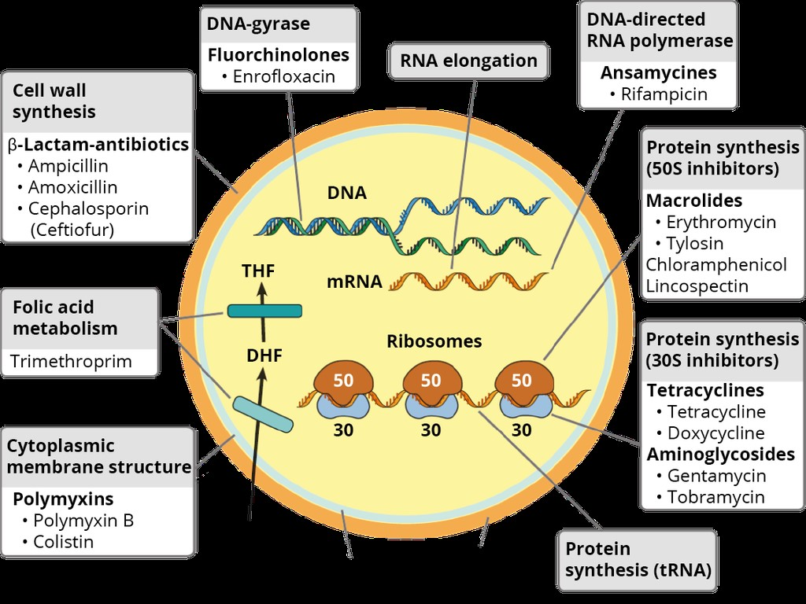

Staphylococci became resistant to methicilin in 1961 and is no longer in clinical practice.MRSA was described later as first superbug.Resistance can occurs in any type of pathogen encountered in ICU setups. Mechanism of resistance to anti microbial is different in different type of organism.Understanding the biochemical and genetic basis of resistance is of paramount importance to design strategies to curtain spread of resistance.
Bacteria use two major genetic strategies to adapt to the antibiotic attack.One is mutation in gene . Another is acquisition of foreign DNA coding for resistance determinants through horizontal gene transfer.This is frequently responsible for development of antimicrobial resistance.
Bacteria acquire external genetic material transfer through three main strategies- a.Transformation(incorporation of nacked DNA) b.Transduction- (phage mediated) c. Conjugation(bacterial sex)
Resistance to Beta lactam antibiotic are due to destruction of antibiotic by beta lactamase, impermeability and extrusion of antibiotics by efflux pumps.

Persistance versus resistance
All the daughter cell of a resistant bacterium will be resistant to that microbial agent also.The persistence is due to the fact some cells in a bacterial population may be stationery growth phase.
Natural Resistance
It may be intrinsic or induced.The genes naturally occurring in the bacteria ,but only expressed to resistance levels after exposure to an antibiotic. It is independent of previous antibiotic exposure .Mechanism may be reduced permeability and natural activity of efflux pump.
Resistance to one anti microbial class can usually be achieved through multiple biochemical pathways.As per biochemical route involved in resistance – resistance mechanism are classified as – 1. Modification of antimicrobial molecule
2. Prevention to reach to the antimicrobial targets
3. Changes or bypass of target sites
4. Resistance due to global cell adaptation.
Microorganism also developed mechanism to cope environmental stress and hostile environment like human body They also need to fight for nutrients,attack by other organism ,host immune response.

Table- Mechanism of resistance in different classes of antibiotics.
 | Permeability | Enzymatic destruction | Altered binding sites | Efflux
β- lactams | Yes | Yes  Β- lactamases | Yes  Penicillin-binding proteins | Yes
Fluoroquinolones | Yes |  | Yes  Alterations in DNA gyrase and topoisomerase IV  Protection by plasmid- mediated Qnr Protein | Yes
Aminoglycosides | Yes | Yes  Adenolyating and acetylating enzymes | Yes  30s ribosomal subunit | Yes
Tetracyclines | Yes | Yes  Modification enzymes | Yes  70s ribosomal subunit | Yes

Strategies to control antimicrobial resistance:
Antimicrobial resistance is increasing ,however antimicrobial drug development is slowing.Marked increase in antimicrobial resistance among common bacterial pathogen is jeopardizing the successful outcome of critically ill patients.Antimicrobial resistance will be one of the leading cause of death in the coming years.Studies shows upto one-third of hospital prescriptions of antimicrobials are either not required or duration of treatment is inadequate.
Antimicrobial Stewardship Programs(ASP)- It is effort to measure and imorove how antibiotic are prescribed by clinicians and used by patients.It is a strategy to optimise antimicrobial prescription.Right drug ,correct dose,,right drug route , suitable duration timely duration – all these are the components of Antimicrobial stewardship program.
Scope for reducing antibiotic consumption in the ICU are as follows-1. Reduction of initial broad spectrum antimicrobials.2. Avoiding combination therapy.3. Duration of antimicrobials should not be excessive.
Surviving sepsis campaign guideline-In patients suspected of having septic shock or sepsis ,after microbiological sampling and within 1 hr broad spectrum antibiotic needs to start. But sepsis and septic shock should be differentiated .
Source of infection should be identified and accordingly antimicrobials can be planned.It is better not to start antimicrobials when no potential source is there and patient should be reassessed. When source identified but patient is not in shock ,then better to start monotherapy. New molecular diagnostic tools for infection can guide antimicrobials therapy.

There should be multidisciplinary coordination between hospital administrators, clinicians, infectious diseases specialists, infection control teams and microbiologists to control antimicrobial resistance. Education and promotion of hand washing and hand hygiene is most basic and most importance step in preventing ICU infections and multi drug resistance. Regular and frequent assessment of hospital flora, especially the ICUs and patients colonised with resistant pathogens and notification of these to the infection control for necessary actions. There should be standardised guidelines formulated for antibiotic use in ICUs including escalation and de-escalation guidelines keeping the local ecological pathogen pattern. Evidence based treatment should be encouraged taking the microbiological investigations into consideration, with early blood, urine and pus culture and antibiotics sensitivity test.

References-

1. Antimicrobial resistance: global report on surveillance 2014. World Health Organization; 2014. Downloaded from http://www.who.int/drugresistance/documents/surveillancereport/en/, last accessed on March 4, 2015. [Google Scholar]
2. Cosgrove SE. The relationship between antimicrobial resistance and patient outcomes: mortality, length of hospital stay, and health care costs. Clin Infect Dis. 2006 Jan 15;42(Suppl 2):S82–9. [PubMed] [Google Scholar]
3. DiazGranados CA, Zimmer SM, Klein M, Jernigan JA. Comparison of mortality associated with vancomycin-resistant and vancomycin-susceptible enterococcal bloodstream infections: a meta-analysis. Clin Infect Dis. 2005 Aug 1;41(3):327–33. [PubMed] [Google Scholar]
4. Sydnor ER, Perl TM. Hospital epidemiology and infection control in acute-care settings. Clin Microbiol Rev. 2011 Jan;24(1):141–73. [PMC free article] [PubMed] [Google Scholar]
5. Antibiotic Resistance Threats in the United States. Centers for Disease Control and Prevention. 2013 Downloaded from http://www.cdc.gov/drugresistance/threat-report-2013/index.html, last accessed on March 9, 2015.
6. Antimicrobial Resistance: Tackling a Crisis for the Future Health and Wealth of Nations. 2014 Downloaded from http://amr-review.org/, last accessed on March 11, 2015.

7. Miller Textbook Of Anaesthesia
8. Paul Marino ICU book

