Conservative Management for Congenital Scoliosis: A Case Report

Dr. Viral Kansara Dr. Darshana Tadvi
Pediatric Department, Shree B.G. Patel Pediatric Department, Shree B.G.Patel
college of physiotherapy college of physiotherapy
Anand, India Anand, India
Drviralkansara96@gmail.com drdarshanatadvi@gmail.com

Abstract
Introduction: This is the case report of a 11-year-old girl diagnosed with Congenital Scoliosis thoraco-lumbar cobb’s angle 30, conservatively managed as the parents were not in capacity to buy braces or have surgery. Intervention: She was treated conservatively with flexibility training, strength training, self-active corrections, habitual corrections, task oriented training and home exercise protocol and patient/parents education. Results: After 6 months of treatment there no change in cobb’s angle. But Posture, Muscle strength(MMT), and Range of motion(ROM) where showing significant change. Conclusion: The preferred treatment options for congenital scoliosis are generally braces and surgery. This case report has shown feasibility of Physiotherapy management in congenital scoliosis, with a newer approach like self-correction exercise with task oriented training focusing on her chief complain related to her daily functions & quality of life.
Keywords: Congenital scoliosis; cobb’s angle; active self-correction; task oriented training
- Introduction
The term scoliosis describes a three-dimensional deformity of the trunk and spine. In phases of high-growth velocity, it may deteriorate dramatically (1). A variety of causes may lead to symptomatic scoliosis, for example, congenital scoliosis, neuromuscular scoliosis, scoliosis in mesenchymal disorders and many other underlying diseases or syndromes (2). Congenital scoliosis is a lateral curvature of the spine arising from vertebral anomalies present at birth that accounts for 10% of scoliotic deformities. The prevalence of congenital vertebral abnormalities is estimated at 0.5 to 1/1000 live births (5). Abnormalities of the vertebrae evolve from failures in formation or segmentation that occur within the first 6 weeks of embryogenesis as a result of genetic or environmental lesions. Clinical deformity typically presents during the first few years of life but may not fully develop until the period of rapid skeletal growth that accompanies puberty (6,7). The ultimate goal of treatment whether its observation or surgery should be preventing curve progression while achieving spinal balance. In order to achieve these goals, and as mentioned above, the age at presentation, deformity location and nature are taken into consideration. The time of presentation is important since curve progression is linked to spinal growth (8). Therefore, an abnormal curvature presenting at a young age is more likely to progress and should be managed until after skeletal maturity. Over 70% of CS progresses aggressively with a need for surgery. The ideal indications for corrective or prophylactic surgery are: unilateral bar with or without contralateral hemivertebra, a curve magnitude more than 40° and deformities showing aggressive progression presenting before 5 years of age. However, it is known that certain deformities such as bloc vertebra and wedged hemivertebra can be managed conservatively. Patient should be followed up frequently in his first 5 years of life (every 6 months till age of 4 then once a year before puberty and during pubertal growth (every 6 months)(9). Congenital curves are usually rigid and inflexible which makes primary bracing concealed. Bracing could be advised for compensatory curves. The conservative management involves Physiotherapy & Bracing. Bracing can manage secondary, compensatory curves and maintain correction following surgical intervention. Studies have shown significant effect of Physical therapy and bracing on adolescent idiopathic scoliosis, but there are no as such evidences on conservative management on congenital scoliosis cases. This gives us an in site of treating a congenital scoliosis case with Physiotherapy with primary focus on improving secondary problems created by deformed spine and improving quality of life.
II. Case discussion & Treatment plan
The patient is 11 years old school going premenarchial girl. She presented with her mother complaining about her back pain & after consulting 2 orthopaedician for the same reason in past 1 year. The girl comes from a poor illiterate family and her spine deformity went unnoticed till she had difficulty with her daily functions and her altered sitting posture noticed by her parents. Their chief complain was patient has deviated sitting and walking and prominence of bone in the back from last 1 year. Pain and discomfort in thoraco-lumbar area with prolonged sitting(30mins), bike riding (70-80kms) & standing (30mins). According to parents there were no other complains related to cardiopulmonary, neurological or genitourinary functions. We analyzed her medical reports and x-rays suggested thoraco-lumbar curve cobb’s angle 30°.Unfortunately, the upper thoracic spine was not visible on the initial X-ray. Therefore, the Cobb angle measurement may have been prone to a technical error on this X-ray. Then the patient was examined for clinical impairments and function. On observation we examined Posture (observatory method & took all the measurement starting from earlobes to the foot given in table no. 1), Pain (Visual Analog scale) for her back pain, ROM(Trunk & Lower Limb), MMT(trunk), Tightness(Trunk & Lower Limb), Observatory Gait Analysis(OGA- no any significant deviations were found), Cobb’s angle(Thoraco-Lumbar curve- 30°), respiratory status (Spirometry was normal). We also did Environmental and her routine schedule analysis. Environmental factors helped us to analyze her Psychological status, Parents awareness and support for her , what all are the contributing factors to her pain and adapted postures. Patient was diagnosed with APTA PATTERN 4B. According to her surgeon she has to undergo surgery but parents were not convinced due to financial issues. Thus we tried to manage conservatively. According to studies primary focus was on the curvature of spine and her chief complain related to functional impairments. There are many studies for idiopathic scoliosis providing guidelines for conservative management but due to lack of guidelines for co0ngenital cases we tried to maximize similarity between the evidences and our patient problems and related management. According to an RCT study, they compare an innovative outpatient programme combining active self-correction, task-oriented exercises and education with a routinely followed programme of traditional exercises to verify whether it could reduce spinal deformities and improve HRQL(health related quality of life in adolescents with mild (Cobb angle <25°) AIS, including thoracic, lumbar, thoracolumbar and S-shaped curves and they found to be effective (4). Same protocol was followed by us to test its feasibility in this case.

Table 1: Shows treatment plan for 6 months.
Oct- Nov 2018 | Dec 2018- Jan 2019 | Feb-March 2019
Flexibility program  Task oriented exercises  Self-correction exercises and habits  HEP  Total- 28 sessions | Strength training  Task oriented and functional training.  Self-correction exercises and awareness.  Habitual corrections with HEP.  Total -41 | Strength training  Task oriented and functional training.  Self-correction and awareness  Habitual modification and HEP.  Total -29

Home exercise protocol & modification included, Practicing conscious weight bearing on both the limb equally. Stretching exercises in non-painful range. Putting one side thin pillow to correct pelvic obliquity while studying in at home & school in sitting. Hard rolled pillow on convexity side in side-lying daily for 20 min & max bearable. Compulsory sports outdoor play for 1 hour.
III . Results and conclusions
Figure 1 & 2 shows the before and after effect on patients posture and her x-rays. Table 2, 3, 4, 5 shows the pre-post analysis of primary & secondary outcome measures.
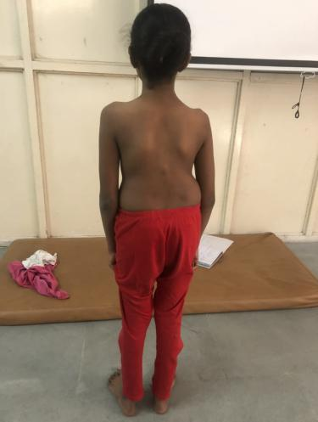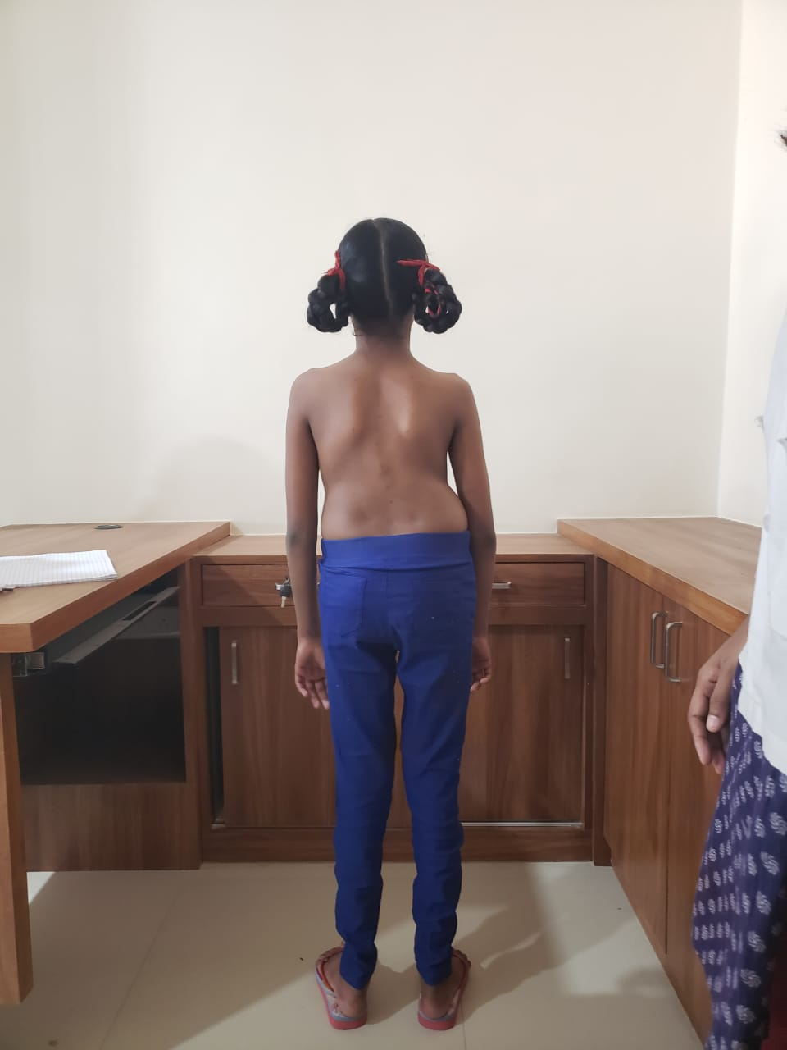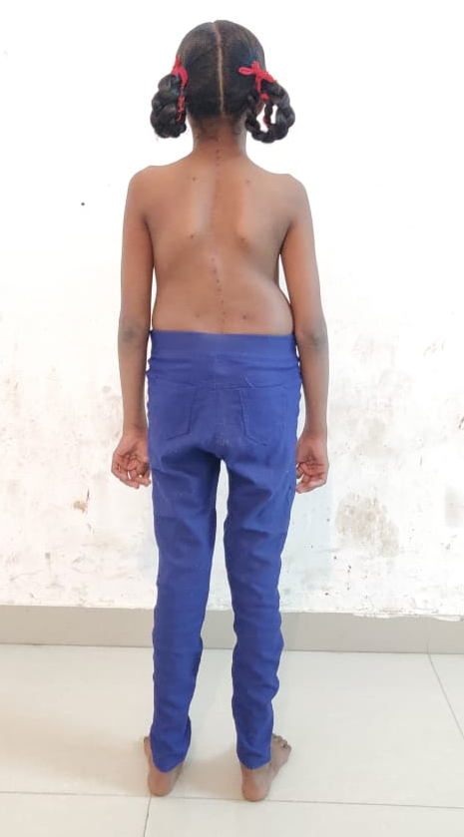

Figure 1 : Shows posture from starting to end of 6 months consecutively taken every 2 months.

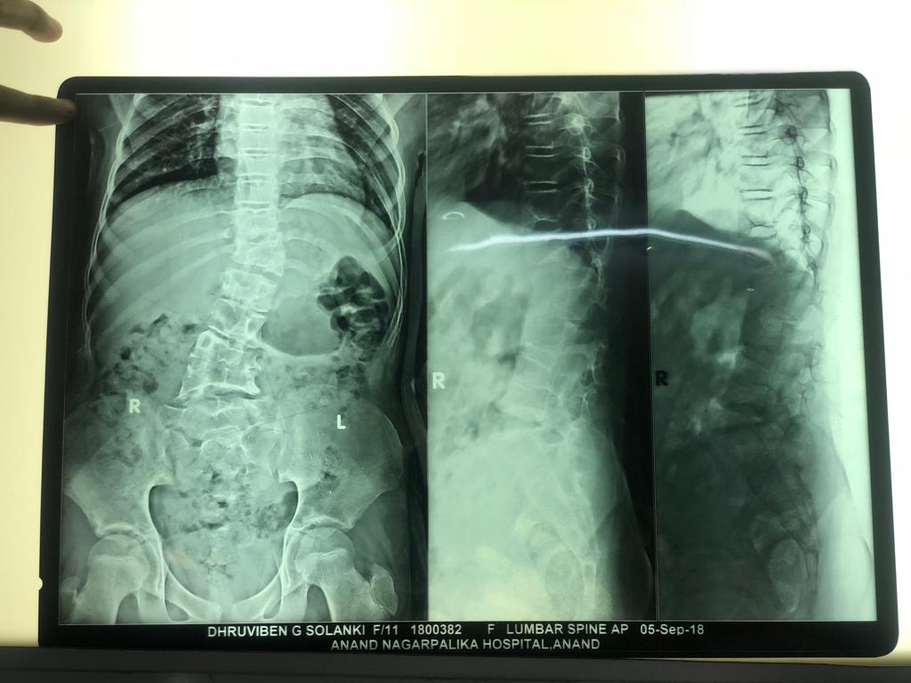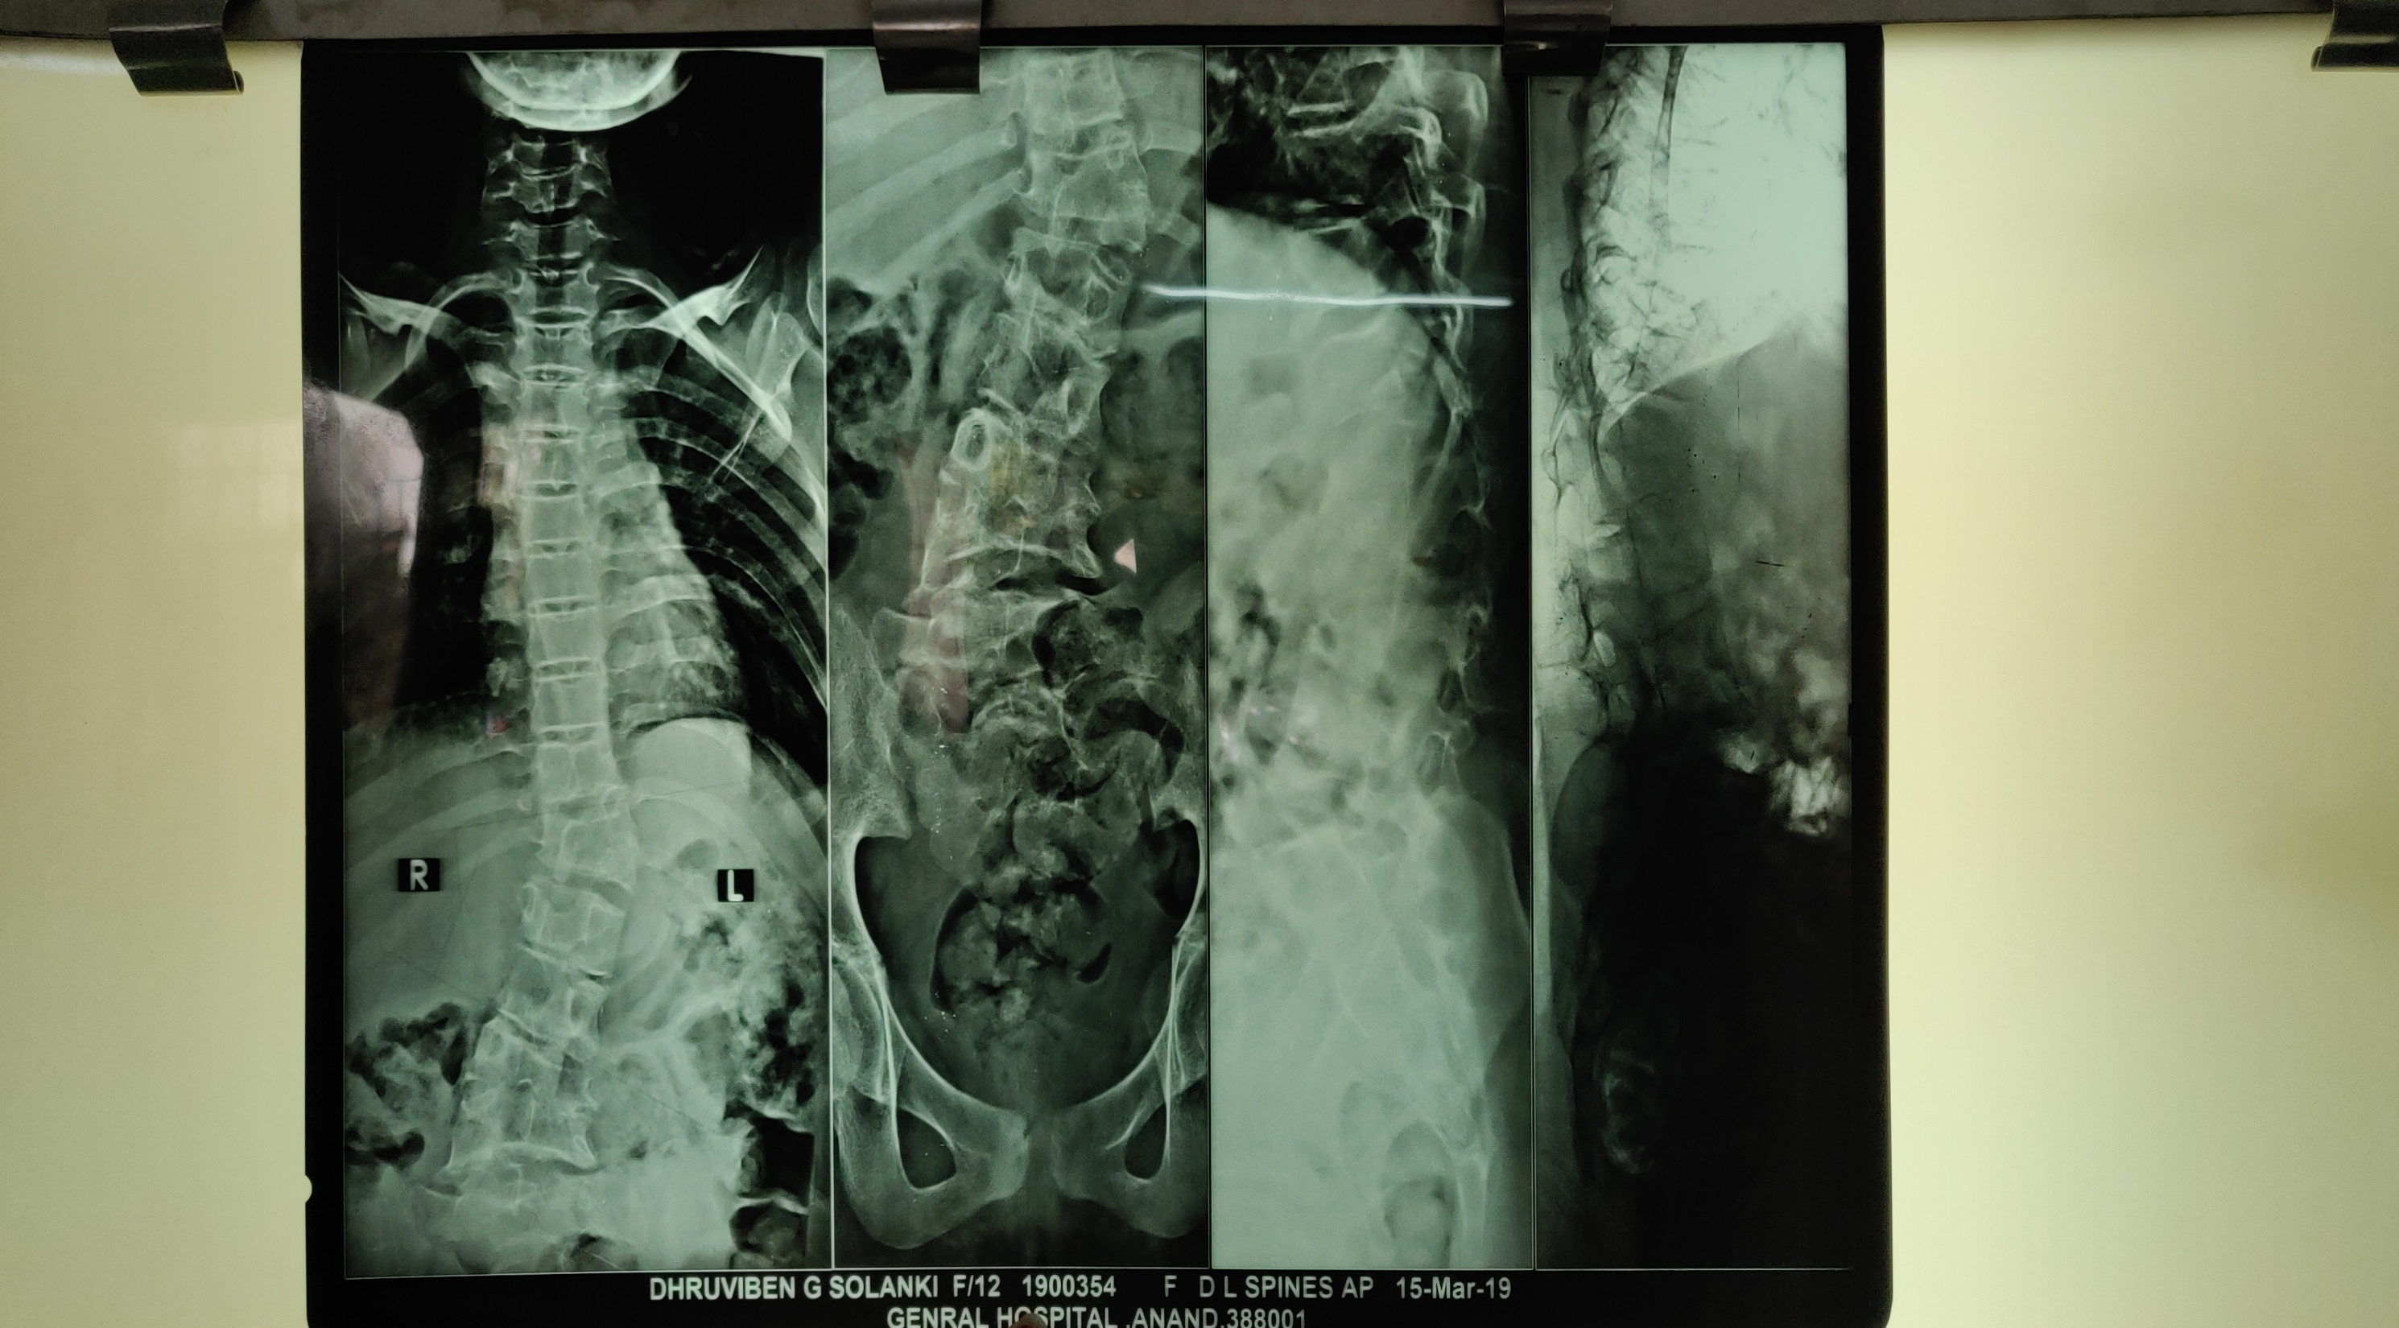

Figure 2 : Shows Before and After Xrays.

Table 2: Shows changes in primary outcome measure
Primary outcome measure
Cobb’s Angle | Pre | Post
Thoraco -lumbar angle | 30° | 30°

Table 3: Posture analysis pre & post treatment Table 4 : Muscle strength pre & post treatment

Posture | Pre (october) | Post (March)
  Manual muscle testing (MMT) | Pre (October) | Post(March)
  Upper Trapezius | Rt/Lt- 4 | Rt/Lt- 5
  Lower Trapezius | Rt- 4, Lt- 3+ | Rt/Lt- 4
  Middle Trapezius | Rt/Lt- 4 | Rt/Lt- 4
  Rhomboids | Rt/Lt- 4 | Rt/Lt- 4
  Multifidus | 4 | 4
  Quadratus Lumborum | Rt- 5, Lt- 4 | Rt/Lt- 5
  Lumbar Flexors | 5 | 5
  Lumber Extensors | 4 | 4
  Gluteius | Rt/Lt- 4 | Rt/Lt- 4
Ear to Acromion | Rt-12cm  Lt-11cm | RT- 13cm  Lt- 12.5cm
Spine of scapula to Spinous Process | Rt- 6.5cm  Lt- 5cm | Rt- 6cm  Lt- 5cm
Lower angle to Spinous Process | Rt- 5.5cm  Lt- 4cm | Rt- 6cm  Lt- 4.5cm
Psis to Spinous Process | Rt- 4cm  Lt- 5cm | Rt- 4.5cm  Lt- 5cm
Gluteal Level | Equal during weight bearing | Equal during weight bearing
Weight Bearing | Total weight -25kg  Rt -14,  Lt- 11kg | Total weight -25kg  Rt- 13kg ,  Lt- 12kg

Table 5 : Range of motion pre & post treatment.
ROM | Pre | Post
Lumbar Flexors | 7cm | 10cm
Lumbar Extensors | 4cm | 7cm
Side Flexion Rt/Lt | Rt- 5cm , Lt-12cm | Rt- 10cm , Lt- 18cm
Rotation Rt/Lt | Rt- 0°-50° , Lt- 0°-60° | Rt- 0°-70°, Lt- 0°-70°

IV. Conslusion
Till now congenital scoliosis studies have shown, preferred bracing and surgical approaches. There could be rare studies or no studies on only conservative management of these type of patient. We can say this case report have shown feasibility of Physiotherapy management in congenital scoliosis, also we used a newer approach like self correction exercise with task oriented training focusing on her chief complain. As it was the case of congenital deformity we could not use any vigorous mode of exercise . The protocols were always designed in non painful ranges only. Follow up data of 6 months showed us no change in the primary outcome measure Cobb’s angle but posture is improved. There is change seen in secondary outcome measures such as Range of Motion like over all, trunk mobility improved by 3-5cm and Rotation by 20° and Muscle strength of Core muscle specifically improved to maximum I.e 5 grade. Also the overall Aesthetic of body changed according to give pictures of patient due to improvement in posture. The reason behind that is change in muscle property through intervention. The initial complain of pain and discomfort was being resolved within 1 month like she was having little or no difficulty in prolonged sitting in classroom and also when she has to stand for more than 30 mins like Physical exercise class. Also she was having mild pelvic tilt due to which she had unequal weight bearing we were able to bring difference of weight distribution from 3 kg to 1 kg given in the table. later its was being resolved which explains reason for discomfort. Here we work on active self correction(neuromotor control and awareness) , psychological aspect of patient. Here the patient and parents were educated about her condition and how they can correct the wrong posture and habits adapted by patient. And few pain relieving techniques like stretching and posture correction. Total of 6 months of treatment patient has attended 98 sessions and remaining days she was performing home exercise protocol. Thus we can say Home Protocols have proved to be useful for the patient and it also reduces the cost of the treatment. This change we could say in patients condition will help her to function better in her daily life till they make up for surgical treatment. Also it might have helped preventing the progression of the curve but we could not justified due to lack of long term follow up. Thus we can say it is “TIME BUYING APPROCH” that will improve patient’s Quality of Life.

V. Limitations
Long term treatment including Physiotherapy and Bracing and follow up could have given us better results.A case report is of limited evidence. However, if there is no existing evidence that describes the outcome of an intervention, the publication of a case report is justified. Lack of patient adherence(attendence & home exercise protocol) might have affected results .

References
- Asher, M.A. & Burton, D.C., 2006, ‘Adolescent idiopathic scoliosis: Natural history and long term treatment effects’, Scoliosis 1(1), 2. https://doi.org/10.1186/1748- 7161-1-2
- Chik, S.K.T., 2020, ‘Classification and terminology’, in M. Moramarco, M. Borysov, S.Y. Ng & H.R. Weiss (eds.), Schroth’s textbookof scoliosis and other spinal deformities, pp. 150–158, Cambridge Scholars Publishing, Newcastle upon Tyne.
- Active self-correction and task-oriented exercises reduce spinal deformity and improve quality of life in subjects with mild adolescence idiopathic scoliosis. Results of a randomised controlled trial Marco Monticone et al. 2014.
- Indications for conservative management of scoliosis (guidelines) SOSORT guideline committee, Hans-Rudolf Weiss et al .2006.
- Birnbaum K, Weber M, Lorani A, Leiser-Neef U, Niethard FU (2002) Prognostic significance of the Nasca classification for the long
term course of congenital scoliosis. Arch Orthop Trauma 122:383–389. https://doi.org/10.1007/s00402-002-0401-z.
[6] Giampietro PF, Raggio CL, Blank RD, McCarty C, Broeckel U, Pickart MA (2013) Clinical, genetic and environmental factors
associated with congenital vertebral malformations. Mol Syndromol 4:94–105. https://doi.org/10.1159/000345329
- McMaster MJ, Ohtsuka K(1982) The natural history of congenital scoliosis. A study of two hundred and fifty-one patients. J Bone Joint Surg Am 64:1128–1147
- McMaster MJ & Singh H. Natural history of congenital kyphosis and kyphoscoliosis: a study of one hundred and twelve patients. Journal of Bone and Joint Surgery A 1999 81 1367–1383.
- Mackel CE, Jada A, Samdani AF, Stephen JH, Bennett JT, Baaj AA, Hwang SW. A comprehensive review of the diagnosis and management of congenital scoliosis. Child's Nervous System. 2018 Nov;34:2155-71.
- Burnei G, Gavriliu S, Vlad C, Georgescu I, Ghita RA, Dughilă C, Japie EM, Onilă A. Congenital scoliosis: an up-to-date. Journal of medicine and life. 2015 Jul;8(3):388.
- Kotwicki T, Jozwiak M. Conservative management of neuromuscular scoliosis: personal experience and review of literature. Disability and rehabilitation. 2008 Jan 1;30(10):792-8.
- Sebaaly A, Daher M, Salameh B, Ghoul A, George S, Roukoz S. Congenital scoliosis: a narrative review and proposal of a treatment algorithm. EFORT open reviews. 2022 May 1;7(5):318-27.
- Tikoo A, Kothari MK, Shah K, Nene A. Suppl 2: M2: Current Concepts-Congenital Scoliosis. The open orthopaedics journal. 2017;11:337.

