Study of Review on Neural Network Tool in Recognition of Pattern

Dr. Siddharth K. Undirwade

Professor Mech. & Dean IQAC, P.E.S. College of Engineering, Aurangabad, M.S., India.
Email: siddharthundirwade@gmail.com

Abstract: Recognition of pattern can be done both in normal computers and neural networks. Neural networks may not perform miracles, but if constructed with the proper architecture and trained correctly with good data, they will give amazing results, not only in pattern recognition but also in other scientific and commercial applications. Neural networks will never replace conventional methods; but for a growing list of applications, the neural architecture will provide either an alternative or a complement to these other techniques. The significance and scope of neural network, which is simplified model of the biological neuron system, is a massively parallel distributed processing system made up of highly interconnected neural computing elements. That has the ability to learn and there by acquire knowledge and make it available for use. There are various types of neural network applications. Particularly for pattern recognition is the most popular application in neural network. Neural network is being used in manufacturing plants for controlling automated machines.

1. Introduction

1.1 Introduction
Neural network is internal processing paradigm which consists of various high powered interconnected nodes or elements known as neurons which gives the output as per desired one. Pattern recognition is the application of neural network in which the pattern can be recognized by detecting the properties of actual one and matching it with desired one. Computers use conventional arithmetic algorithms to detect whether the given pattern matches an existing one. It is a straightforward method. It will say either yes or no. It does not tolerate noisy patterns. On the other hand, neural networks can tolerate noise and, if trained properly, will respond correctly for unknown patterns. ‘An Artificial Neural Network (ANN)’ is an information-processing paradigm that is inspired by the way biological nervous systems, such as the brain, process information.
Only feed-forward networks are used for pattern recognition. Feed-forward means that there is no feedback to the input. Similar to the way those human beings learn from mistakes, neural networks also could learn from their mistakes by giving feedback to the input patterns.
Feature recognition is best accomplished by humans whose eye/brain system is capable of immediate and robust performance. Artificial neural networks were originally designed to replicate some of this human ability and, while the technology is still far from reaching human standards, it does offer significant advantages over other computing options for pattern recognition. Based upon the biological brain's process of thought transmission, stimuli recognition and physical response, neural networks are massively parallel computing mechanisms.
1.1.1 History: The development of artificial neural networks has an interesting history. In the 1940s, scientists found out that the physiology of the brain was similar to the processing mode used by electronic computing devices like computers. In both cases, large amounts of data are manipulated. In computers, the processing element is the bit, while in the brain; the processing element is the neuron. This phenomenon suggests that research in the design of brain-like processing might be interesting. In 1943, McCulloch and Pitts outlined the first formal model of an elementary computing neuron. Their neuron model laid the groundwork for future development.
In 1949, Hebb stated that information can be stored in connections and proposed a learning scheme for updating a neuron’s connections. His learning rule known as the Hebbian learning rule made a primary contribution to the development of artificial neural networks. In 1954, Farley and Clark set up models for adaptive stimulus-response relations in random networks. Several researchers further elaborated their theories. Rosenblatt invented the perceptron, which is a trainable machine capable of learning to classify certain patterns by modifying connections to the threshold elements. Caianiello outlined a theory for thinking machines. Widrow and Hoff introduced a device called Adaptive Linear combiner. A learning rule, the popular Widrow-Hoff learning rule was then devised for neural networks with multiple adaptive elements. Other early works include Stark’s mode-seeking technique and Steinbuch’s Learning Matrix. A book on learning machines by Nilsson clearly summarizes many of these early developments. The book also formulates inherent limitations of learning machines with modifiable connections. During the 1950s, the first neurocomputer was built and tested. Many implementations of neural computers were realized in the 1960s. However, the existing machine learning theorems of that time were too weak to support more complex computational problems. The computational resources available were also relatively modest at that time. As a result, neural network research entered a stagnation phase.
In 1969, Minsky and Papert criticized the existing neural network research as being worthless in their book entitled perceptrons. It has been claimed that the pessimistic views presented in this book discouraged further funding for neural network research for several years. It is only after the mid-1980s that neural networks have begun to make a strong comeback. In Japan, Amari studied the learning in networks of threshold elements and the mathematical theory of neural networks. Also in Japan, Fukushima developed a class of neural network architectures known as Cognitrons and Neocognitrons. In Finland, Kohonen pursued the research on associative memory. He also developed unsupervised learning networks for feature mapping into regular arrays of neurons. Carpenter and Grossberg introduced a number of neural network architectures and theories and developed the Adaptive Resonance Theory that is ART. Hopfield developed recurrent neural network architecture for associative memories in the early 1980s. More recently, Kosko extended some of the ideas of Hopfield and Grossberg to develop his adaptive bidirectional associative memory network that is BAM network.
Neural network simulations appear to be a recent development. However, this field was established before the advent of computers, and has survived at least one major setback and several areas. Many important advances have been boosted by the use of inexpensive computer emulations. Following an initial period of enthusiasm, the field survived a period of frustration and disrepute. During this period when funding and professional support was minimal, relatively few researchers made important advances. These pioneers were able to develop convincing technology, which surpassed the limitations identified by Minsky and Papert. Minsky and Papert, published a book in 1969 in which they summed up a general feeling of frustration against neural networks among researchers, and was thus accepted by most without further analysis. Currently, the neural network field enjoys a resurgence of interest and a corresponding increase in funding.
The first artificial neuron was produced in 1943 by the neurophysiologist Warren McCulloch and the logician Walter Pits. But the technology available at that time did not allow them to do too much. [1, 2]
The neural networks research can be broadly divided into several periods: Initially there were some initial simulations using formal logic. In 1943, McCulloch and Pitts, developed models of neural networks based on their understanding of neurology. These models made several assumptions about how neurons worked. Their networks were based on simple neurons, which were considered to be binary devices with fixed thresholds. The results of their model were simple logic functions such as "a or b" and "a and b". Another attempt was by using computer simulations by two groups of Farley and Clark, 1954; and Rochester, Holland, Haibit and Duda, 1956. The first group of IBM researchers maintained closed contact with neuroscientists at McGill University. So whenever their models did not work, they consulted the neuroscientists. This interaction established a multidisciplinary trend, which continues to the present day.
Keeping view towards upcoming of promising & emerging technology, not only was neuroscience influential in the development of neural networks, but psychologists and engineers also contributed to the progress of neural network simulations. In 1958, Rosenblatt stirred considerable interest and activity in the field when he designed and developed the Perceptron. The Perceptron had three layers with the middle layer known as the association layer. This system could learn to connect or associate a given input to a random output unit. Another system was the ADALINE that is adaptive linear element, which was developed in 1960 by Widrow and Hoff of Stanford University. The ADALINE was an analogue electronic device made from simple components. The method used for learning was different to that of the Perceptron; it employed the Least-Mean-Squares that is LMS learning rule. [2, 3]
According to period of frustration & disrepute in 1969, Minsky and Papert wrote a book in which they generalized the limitations of single layer perceptrons to multilayered systems. In the book they said about their intuitive judgment that the extension to multilayer systems is sterile. The significant result of their book was to eliminate funding for research with neural network simulations. The conclusions supported the disenchantment of researchers in the field. Innovative Contributions includes that although public interest and available funding were minimal, several researchers continued working to develop neuromorphically based computational methods for problems such as pattern recognition.
During this period several paradigms were generated which modern work continues to enhance. Grossberg’s that is Steve Grossberg and Gail Carpenter in 1988 influence founded a school of thought, which explores resonating algorithms. They developed the ART network that is adaptive resonance theory network based on biologically models. Anderson and Kohonen developed associative techniques independent of each other. Henry Klopf in 1972 developed a basis for learning in artificial neurons based on a biological principle for neuronal learning called heterostasis. In 1974, Paul Werbos developed and used the back-propagation learning method, however several years passed before this approach was popularized. Back-propagation nets are probably the most well known and widely applied of the neural networks today. In essence, the back-propagation network is a perceptron with multi layers, a different threshold function in the artificial neuron, and a more robust and capable learning rule. In 1967, Shun-Ichi was involved with theoretical developments. He published a paper, which established a mathematical theory for a learning basis by error-correction method dealing with adaptive pattern classification. Fukushima and F. Kunihiko developed a stepwise trained multilayered neural network for interpretation of handwritten characters. The original network was published in 1975 and was called the cognitron. [3]
Re-emergence progress during the late 1970s and early 1980s was important to the re-emergence on interest in the neural network field. Several factors influenced this movement. For example, comprehensive books and conferences provided a forum for people in diverse fields with specialized technical languages, and the response to conferences and publications was quite positive. The news media picked up on the increased activity and tutorials helped to disseminate the technology. Academic programs appeared and courses were introduced at most major universities in US and Europe. Attention is now focused on funding levels throughout Europe, Japan and US and as this funding becomes available, several new commercial with applications in industry and financial institutions are emerging.
Current Scenario meant for significant progress which has been made in the field of neural networks-enough to attract a great deal of attention and fund further research. Advancement beyond current commercial applications appears to be possible, and research is advancing the field on many fronts. Neurally based chips are emerging and applications to complex problems developing. Clearly, today is a period of transition for neural network technology. [2, 3, 4]
    - Characteristics: The characteristic of ‘Artificial Neural Network’ that is ANN is an information-processing paradigm that is inspired by the way biological nervous systems, such as the brain, process information. The key element of this paradigm is the novel structure of the information processing system. It is composed of a large number of highly interconnected processing elements that is neurons working in unison to solve specific problems. ‘Artificial Neural Networks’, like people, learn by example. An ‘Artificial Neural Network’ is configured for a specific application, such as pattern recognition or data classification, through a learning process. Learning in biological systems involves adjustments to the synaptic connections that exist between the neurons. This is true for ‘Artificial Neural Networks’ as well.
Neural network has been described as brain metaphor of information processing or as biologically inspired statistics. It has the capability to learn or to be trained about a particular task, its computational capabilities and the ability to formulate abstractions and generalizations. Neural network has an organization similar to that of a human brain and it is a network made up of processing elements called neurons. The neural network can also be defined as an interconnection of neurons, such that neuron outputs are connected, through weights, to all other neurons including themselves; both lag-free and delay connections are allowed. [4]

2. Review on NN Tool

2.1 Nervous System
Pattern recognition by neural network is in connection with similarities of sense of the nervous system. Only feed-forward networks are used for pattern recognition. Feed-forward means that there is no feedback to the input. Similar to the way those human beings learn from mistakes, neural networks also could learn from their mistakes by giving feedback to the input patterns.
Based upon the biological brain's process of thought transmission, stimuli recognition and physical response, neural networks are massively parallel computing mechanisms. Feature recognition is best accomplished by humans whose eye/brain system is capable of immediate and robust performance. Artificial neural networks were originally designed to replicate some of this human ability and, while the technology is still far from reaching human standards, it does offer significant advantages over other computing options for pattern recognition. [5]
2.1.1 Structure of the neuron: Nervous tissue is composed of two main types of cells: neurons and glial cells. Neurons transmit nerve messages. Glial cells are in direct contact with neurons and often surround them as shown in Figure 1 below:

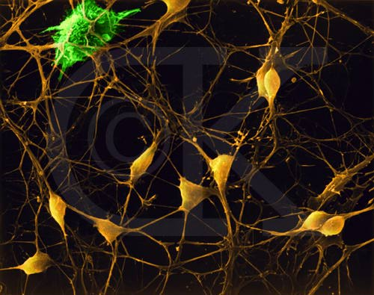
Figure 1: Microscopic view of nerve cells and astrocyte

The neuron is the functional unit of the nervous system. Humans have about 100 billion neurons in their brain alone. While variable in size and shape, all neurons have three parts. Dendrites receive information from another cell and transmit the message to the cell body. The cell body contains the nucleus, mitochondria and other organelles typical of eukaryotic cells. The axon conducts messages away from the cell body. Three types of neurons occur. Sensory neurons typically have a long dendrite and short axon, and carry messages from sensory receptors to the central nervous system. Motor neurons have a long axon and short dendrites and transmit messages from the central nervous system to the muscles or to glands. Interneurons are found only in the central nervous system where they connect neuron to neuron.
Some axons are wrapped in a myelin sheath formed from the plasma membranes of specialized glial cells known as ‘Schwann’ cells. ‘Schwann’ cells serve as supportive, nutritive, and service facilities for neurons. The gap between ‘Schwann’ cells is known as the node of Ranvier, and serves as points along the neuron for generating a signal. Signals jumping from node to node travel hundreds of times faster than signals traveling along the surface of the axon. This allows human brain to communicate with the toes in a few thousandth part of a second. The details are shown in figure 2 below:

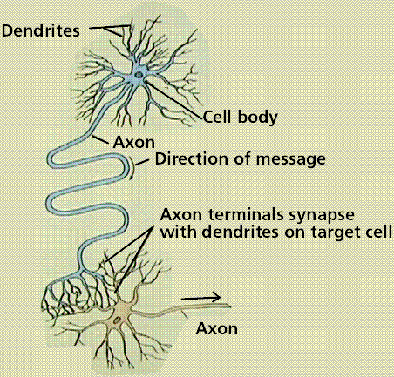
Figure 2: Structure of a neuron and the direction of nerve message transmission

2.1.2 The details of synapses: The junction between a nerve cell and another cell is called a synapse. Messages travel within the neuron as an electrical action potential. The space between two cells is known as the synaptic cleft. To cross the synaptic cleft requires the actions of neurotransmitters. Neurotransmitters are stored in small synaptic vesicles clustered at the tip of the axon as shown in figure 3 below:

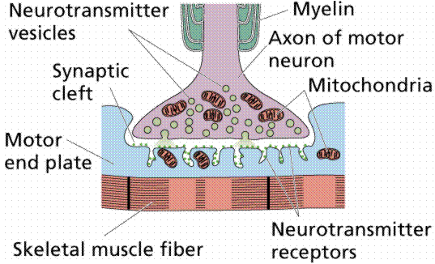
Figure 3: Details of synapses

2.1.3 Central nervous system details: The Central Nervous System that is CNS is composed of the brain and spinal cord. The CNS is surrounded by bone-skull and vertebrae. Fluid and tissue also insulate the brain and spinal cord.

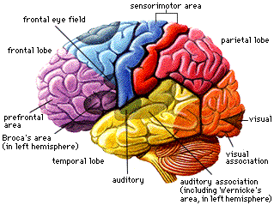
Figure 4: Central nervous system details

a. Functional parts of the brain: The brain is composed of three parts: the cerebrum that is seat of consciousness, the cerebellum, and the medulla oblongata which are part of the unconscious brain. Input to the nervous system is in the form of our five senses: pain, vision, taste, smell, and hearing. Vision, taste, smell, and hearing input are the special senses. Pain, temperature, and pressure are known as somatic senses. Sensory input begins with sensors that react to stimuli in the form of energy that is transmitted into an action potential and sent to the CNS.
2.1.4 The brain as an information processing system: During embryonic development, the brain first forms as a tube, the anterior end of which enlarges into three hollow swellings that form the brain, and the posterior of which develops into the spinal cord. Some parts of the brain have changed little during vertebrate evolutionary history.
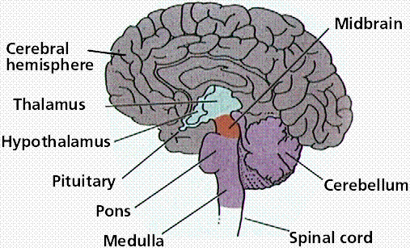
Figure 5: Parts of the brain as seen from the middle of the brain.

a. Information processing capability: The human brain contains about 10 billion nerve cells, or neurons. On average, each neuron is connected to other neurons through about 10000 synapses. The actual figures vary greatly, depending on the local neuroanatomy. The brain's network of neurons forms a massively parallel information processing system. This contrasts with conventional computers, in which a single processor executes a single series of instructions.
Against this, consider the time taken for each elementary operation: neurons typically operate at a maximum rate of about 100 Hz, while a conventional CPU carries out several hundred million machine level operations per second. Despite of being built with very slow hardware, the brain has quite remarkable capabilities as follows:
- Its performance tends to degrade gracefully under partial damage. In contrast, most programs and engineered systems are brittle: if you remove some arbitrary parts, very likely the whole will cease to function.
- It can learn or reorganize itself from experience.
- This means that partial recovery from damage is possible if healthy units can learn to take over the functions previously carried out by the damaged areas.
- It performs massively parallel computations extremely efficiently. As an example, complex visual perception occurs within less than 100 ms, or 10 processing steps.
- It supports our intelligence and self-awareness, yet unknown exactly.

Table 1: Comparison between brain and computer
 | 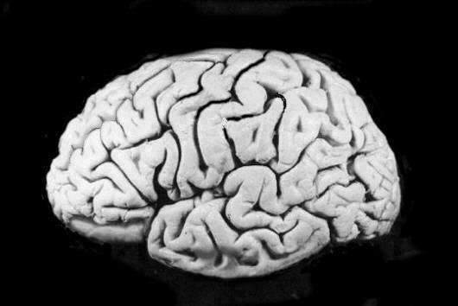 | 
Processing elements | 10¹⁴ synapses | 10⁸ transistors
Element size | 10⁻⁶ m | 10⁻⁶ m
Energy use | 30 W | 30 W (CPU)
Processing speed | 100 Hz | 10⁹ Hz
Style of computation | Parallel, distributed | Serial, centralized
Fault tolerant | Yes | No
Self Learning | Yes | No
Intelligent, conscious | Usually | Not yet

As a discipline of artificial intelligence, neural networks attempt to bring computers a little closer to the brain's capabilities by imitating certain aspects of information processing in the brain, in a highly simplified way. [4, 5, 6]
2.1.5 Neural networks in the brain: The brain is not homogeneous. At the largest anatomical scale, we distinguish cortex, midbrain, brainstem, and cerebellum. Each of these can be hierarchically subdivided into many regions, and areas within each region, either according to the anatomical structure of the neural networks within it, or according to the function performed by them.
The overall pattern of projections that is bundles of neural connections between areas is extremely complex, and only partially known. The best mapped and largest system in the human brain is the visual system, where the first 10 or 11 processing stages have been identified. We distinguish feed forward projections that go from earlier processing stages near the sensory input to later ones near the motor output, from feedback connections that go in the opposite direction. In addition to these long-range connections, neurons also link up with many thousands of their neighbors. In this way they form very dense, complex local networks shown in figure 6 below:

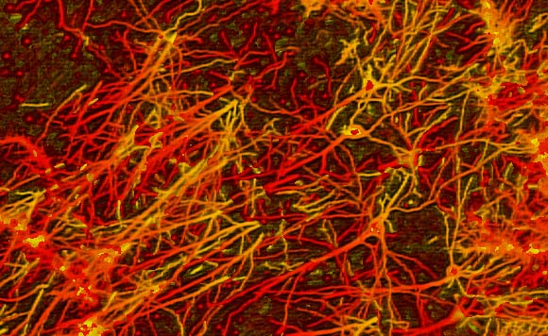

Figure 6: Neurons and synapses

The basic computational unit in the nervous system is the nerve cell, or neuron. A neuron consists of dendrites which are inputs, cell body and axon which are outputs.
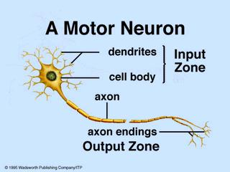

Figure 7: Structure of a Neuron

A neuron receives input from other neurons typically many thousands. Once input exceeds a critical level, the neuron discharges a spike that is an electrical pulse that travels from the body, down the axon, to the next neuron or other receptors. This spiking event is also called depolarization, and is followed by a refractory period, during which the neuron is unable to fire. The axons ending which is output zone almost touch the dendrites or cell body of the next neuron. Transmission of an electrical signal from one neuron to the next is effected by neurotransmitters, chemicals which are released from the first neuron and which bind to receptors in the second. This link is called a synapse.
Brains learn of course from what we know of neuronal structures, one way brains learn is by altering the strengths of connections between neurons, and by adding or deleting connections between neurons. Furthermore, they learn on-line, based on experience, and typically without the benefit of a benevolent teacher. The efficiency of a synapse can change as a result of experience, providing both memory and learning through long-term potentiation. One way this happens is through release of more neurotransmitter. Many other changes may also be involved.
The following properties of nervous systems will be of particular interest in our neurally inspired models:
- Parallel, distributed information processing
- High degree of connectivity among basic units
- Connections are modifiable based on experience
- Learning is a constant process, and usually unsupervised
- Learning is based only on local information
- Performance degrades gracefully if some units are removed

3. Artificial Neuron Model
Much is still unknown about how the brain trains itself to process information, so theories abound. In the human brain, a typical neuron collects signals from others, through a host of fine structures called dendrites. The neuron sends out spikes of electrical activity through a long, thin stand known as an axon, which splits into thousands of branches as shown in figure 8 below:

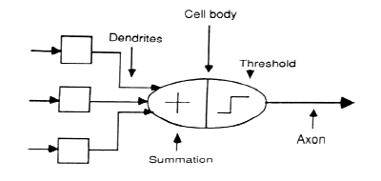
Figure 8: The electronic model of neuron

At the end of each branch, a structure called a synapse converts the activity from the axon into electrical effects that inhibit or excite activity in the connected neurons. When a neuron receives excitatory input that is sufficiently large compared with its inhibitory input, it sends a spike of electrical activity down its axon. Learning occurs by changing the effectiveness of the synapses so that the influence of one neuron on another changes.
These neural networks are conducted by first trying to deduce the essential features of neurons and their interconnections. We then typically program a computer to simulate these features. However because our knowledge of neurons is incomplete and our computing power is limited, our models are necessarily gross idealizations of real networks of neurons.
3.1 A simple artificial neuron: Our basic computational element which is model neuron which is often called a node or unit. It receives input from some other units, or perhaps from an external source. Each input has an associated weight w, which can be modified so as to model synaptic learning. The unit computes some function f of the weighted sum of its inputs:
y_{i} = f ∑w_{ij} y_{j}
j
Its output, in turn, can serve as input to other units.

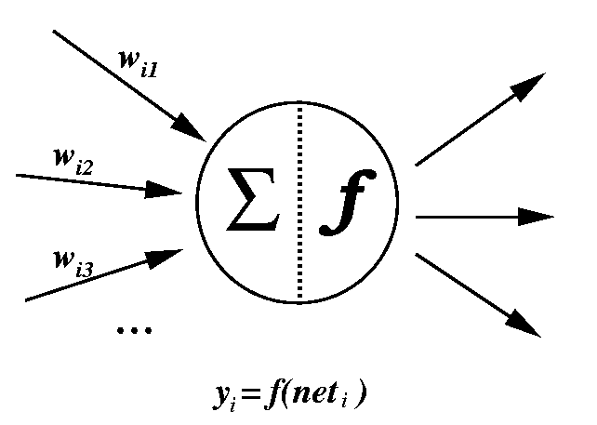
Figure 9: Simple mathematical form of artificial neuron

Where the weighted sum ∑w_{ij} y_{j} is called the net input to unit i, often written net _{i}. It is noted that w_{ij} refers to the weight from unit j to unit i and not the other way around. The function f is the unit's activation function. In the simplest case, f is the identity function, and the unit's output is just its net input. This is called a simple neuron.
An artificial neuron is a device with many inputs and one output. The neuron has two modes of operation; the training mode and the using mode. In the training mode, the neuron can be trained to fire or not, for particular input patterns. In the using mode, when a taught input pattern is detected at the input, its associated output becomes the current output. If the input pattern does not belong in the taught list of input patterns, the firing rule is used to determine whether to fire or not. [5, 6]
3.2 Constraints in modeling neural network: There are mainly four constraints in the modeling of neuron network.
- It is difficult to find out which neurons should be connected to which. This is the problem of determining the neural network structure. Further, the interconnections in the brain are constantly changing. The initial interconnections seem to be largely governed by genetic factors.
- The weights on the edges and thresholds in nodes are constantly changing. This problem has been subject of much research and has been solved to a large extent.
- The functioning of individual neurons may not be so simple after all. As an example, remember that if a neuron receives signals from many neighboring neurons, the combined stimulus may exceed its threshold. Actually, the neuron need not receive all signals at exactly the same time, but must receive them all in a short time-interval. It is usually assumed that such details will not affect the functioning of the simulated neural network much. But maybe it will.
- Another example of deviation from normal functioning is that some edges can transmit signals in both directions. Actually, all edges can transmit in both directions, but usually they transmit in only one direction, from one neuron to another. The approach has been as follows:
Given some input, if the neural network makes an error, then it can be determined exactly which neurons were active before the error. Then we can change the weights and thresholds appropriately to reduce this error. For this approach to work, the neural network must know that it has made a mistake. In real life, the mistake usually becomes obvious only after a long time. This situation is more difficult to handle since we may not know which input led to the error.
Also notice that this problem can be considered as a generalization of the previous problem of determining the neural network structure. If this is solved, that is also solved. This is because if the weight between two neurons is zero then, it is as good as the two neurons not being connected at all. So, if we can figure out the weights properly, then the structure becomes known. But there may be better methods of determining the structure.

4. The Multilayer Network Paradigm
The most well known and commonly used neural network paradigm is the multilayered perceptron trained by back propagation given by Rumelhart in 1986. This is popularly called a back propagation network. This network is versatile, simple and handles pattern classification tasks, of which pattern recognition is one. Back propagation can accommodate both binary and continuous input and output. From a statistical viewpoint, back propagation is the optimal supervised training method. Back propagation is readily available in software form, and increasingly, in hardware form. For these reasons back propagation, or a variation of back propagation, is usually the network of choice for pattern recognition when teacher data is available.
A back propagation network is a feed forward network, typically consisting of an input layer, one or more hidden layers, and an output layer all containing varied numbers of neurons. It has been arithmetically proven that this network with at least three layers; input, output and one hidden layer and a non-linear transfer function can implement any function. Back propagation works by using the theory of least squares calculating the derivatives of error with respect to the connection weights, and adjusting the weights based on steepest error surface descent.
Weights are modified during training until they reach a stable state; this translates to the network achieving a state of error minimization. Since weights are usually adjusted after each vector input instead of after the whole training set, the resultant descent is not necessarily the steepest, but closely approximates it. Although classical back propagation cannot escape from local minima during its descent along the error surface, in practice a local minimum significantly far from the global minimum is rarely encountered.
There are several critical factors when formulating and training a back propagation network, these are as follows:
a. Number of input neurons
b. Number of output neurons
c. Number of hidden layers
d. Number of neurons in each hidden layer
e. Size and composition of training set
f. Training rate and modifications
g. Size and composition of test set for trained network validation.

The numbers of input and output neurons are usually dictated by the problem, for example a network categorizing features; each described by an input vector of length 40, into 4 categories might have 40 input neurons and 4 output neurons. Practically speaking, choice of number of hidden neurons is tied to choose of number of hidden layers. In applications, the choice of number of hidden layers is generally confined to one or two. Once the number of hidden layers is selected the size of each layer can be estimated. The objective is to find the least number of hidden neurons which can achieve adequate performance. Decreasing number of hidden neurons increases generalization and is more computationally efficient, but impairs the network's ability to learn. Over fitting with too many hidden neurons tends to decrease generalization because of training set memorization, and is computationally inefficient. Estimating optimum hidden neurons is usually done by trial and error. The training set is presented to the network many times during training. It should be in random order and contain all the training features. Upper and lower bounds for number of training pairs have been directly related to numbers of neurons and weights, and rate of classification error. A disadvantage of back propagation is the long training time it often takes a network to work its way down to the bottom of the error surface. This is in part determined by the step size or training rate. A large training rate implies large step size, which will decrease convergence time; however moving too quickly down the error surface increases the chance of non-convergence. A small learning rate avoids these problems but increases training time. The learning rate is often constant through training, but can be decreased during training to avoid network instability. It is somewhat randomized so that the network can arbitrarily jump out of local minima. Training rate can be sized based on the number of hidden neurons. [7, 8]
4.1 Error back propagation algorithm (EBPA): It is assumed that a network hand-written digit is required to be recognized. We have to use an array of, say, 256 sensors, each recording the presence or absence of ink in a small area of a single digit. The network would therefore need 256 input units one for each sensor, 10 output units one for each kind of digit and a number of hidden units.
For each kind of digit recorded by the sensors, the network produces high activity in the appropriate output unit and low activity in the other output units. In order to train the network, an image of a digit is presented and compared the actual activity of the 10 output units with the desired activity. We then calculate the error, which is defined as the square of the difference between the actual and the desired activities. Next, we change the weight of each connection so as to reduce the error. We repeat this training process for many different images of each different images of each kind of digit until the network classifies every image correctly.
This procedure is implemented by calculating the error derivative for the weight denoted by EW in order to change the weight by an amount that is proportional to the rate at which the error changes as the weight is changed. One way to calculate the EW is to perturb a weight slightly and observe how the error changes. But that method is inefficient because it requires a separate perturbation for each of the many weights.
Another way to calculate the EW is to use the Back-propagation algorithm which is described below, and has become nowadays one of the most important tools for training neural networks. It was developed independently by two teams, of Fogelman-Soulie, Gallinari and Le Cun in France, and the other of Rumelhart, Hinton and Williams in U. S.
Two methods are commonly used in neural network applications - neocognitron and back propagation. Neocognitron is a hierarchical network made up of many layers and its organization is like that of the visual cortex. Neocognitron is a method of pattern recognition. It has the capability to recognize shapes and sizes of characters even if it involves noise and distortion. Back propagation allows the training of multi-layer networks, it is a powerful and practical tool for solving problems that would be quite difficult using conventional computer science techniques and these problems range from image processing to speech recognition to character recognition forecasting to Optimization.
Back propagation is the best-known supervised learning method for Neural Network with three or more layers. In the back-propagation procedure, the network first uses the input data set to produce its own output, and then compares this with the desired output, if there is no difference, no learning takes place else the weights are changed to reduce the error term. One of the most important steps in the development of a neural network is the development of the training data set and the training data set must be constructed carefully to include examples of many different operational scenarios. Approximately equal numbers of examples of each scenario should be included in the data set.
In order to train a neural network to perform some tasks, we must adjust the weights of each unit in such a way that the error between the desired output and the actual output is reduced. This process requires that the neural network compute the error derivative of the weights. In other words, it must calculate how the error changes as each weight is increased or decreased slightly. The back propagation algorithm is the most widely used method for determining the EW.
The back-propagation algorithm is easiest to understand if all the units in the network are linear. The algorithm computes each EW by first computing the EA, the rate at which the error changes as the activity level of a unit is changed. For output units, the EA is simply the difference between the actual and the desired output. To compute the EA for a hidden unit in the layer just before the output layer, we first identify all the weights between that hidden unit and the output units to which it is connected. We then multiply those weights by the EAs of those output units and add the products.
This sum equals the EA for the chosen hidden unit. After calculating all the EAs in the hidden layer just before the output layer, we can compute in like fashion the EAs for other layers, moving from layer to layer in a direction opposite to the way activities propagate through the network. This is what gives back propagation its name. Once the EA has been computed for a unit, it is straight forward to compute the EW for each incoming connection of the unit. The EW is the product of the EA and the activity through the incoming connection.
It is noted that for non-linear units, the back-propagation algorithm includes an extra step. Before back propagating, the EA must be converted into the EI, the rate at which the error changes as the total input received by a unit is changed. [8, 9]

5. Pattern Recognition
The word recognition plays an important role in our lives. It is a basic property of all human beings; when a person sees an object, he or she first gathers all information about the object and compares its properties and behaviors with the existing knowledge stored in the mind. If we find a proper match, we recognize it.
For example, when we see a dog, first we recognize that it's an animal; after taking a closer look, we recognize that it has four legs and a tail. As we are aware, most animals have four legs and a tail. The question is how we recognize that it's a dog. We look at other properties of dogs such as face, shape of ear, mouth, nose, body structure, teeth, eyes and voice. We might have seen lots of dogs and learned what a dog will look like. After making proper analysis of all the properties, we recognize and conclude that it is a dog. Going a step further, we can differentiate or recognize our own dog when our dog is with other dogs. This recognition concept is simple and familiar to everybody in the real-world environment, but in the world of artificial intelligence, recognizing such objects is an amazing feat. The functionality of the human brain is amazing; it is not comparable with any artificial machines or software.
The act of recognition can be divided into two broad categories: recognizing concrete items and recognizing abstract items. The recognition of concrete items involves the recognition of spatial and temporal items. Examples of spatial items are fingerprints, weather maps, pictures and physical objects. Examples of temporal items are waveforms and signatures. Recognition of abstract items involves the recognition of a solution to a problem, an old conversation or argument, etc. In other words, recognizing items that do not exist physically.
Recognition of concrete items by neural network applications include finger print identification, voice recognition; face recognition, character recognition, signature recognition and classification of objects in scientific/research areas such as astronomy, engineering, statistics, medical, machine learning and neural networks. Recognition of an item involves three levels of processing: input filtering, feature extraction and classification
a. Filtering: It is removing unwanted information or data from input. Depending on the application, the filter algorithm or method will change. For example, consider finger print identification. Each time we scan our fingerprints through a non-ink fingerprint device, the scanned output may be different. The difference may be due to a change in contrast or brightness or in the background of the image. There could be some distortion. In order to process the input, we may need only lines in the fingerprints and we may not need the other parts or background of the fingerprint. In order to filter out the unwanted portion of the image and replace it with a white background, we need a filter mechanism. Once the image is filtered through the filter mechanism, we will get standard clean finger prints only with lines, which in turn help with the process of feature extraction.
b. Feature extraction: It is a process of studying and deriving useful information from the filtered input patterns. The derived information may be general features, which are evaluated to ease further processing. For example, in image recognition, the extracted features will contain information about gray shade, texture, shape or context of the image. This is the main information used in image processing. The methods of feature extraction and the extracted features are application dependent. In manufacturing operating parameter of machine is normalizing between 0 to 1. There are different techniques to normalize the values measure on pattern.
c. Classification: It is the final stage of the pattern recognition. This is the stage where an automated system declares that the inputted object belongs to a particular category. There are many classification methods in the field. Classification method designs are based on the following concepts.
i. Member-roster concept: Under this template-matching concept, a set of patterns belonging to a same pattern is stored in a classification system. When an unknown pattern is given as input, it is compared with existing patterns and placed under the matching pattern class.
ii. Common property concept: In this concept, the common properties of patterns are stored in a classification system. When an unknown pattern comes inside, the system checks its extracted common property against the common properties of existing classes and places the pattern or object under a class, which has similar, common properties.
iii. Clustering concept: Here, the patterns of the targeted classes are represented in vectors whose components are real numbers. So, using its clustering properties, we can easily classify the unknown pattern. If the target vectors are far apart in geometrical arrangement, it is easy to classify the unknown patterns. If they are nearby or if there is any overlap in the cluster arrangement, we need more complex algorithms to classify the unknown patterns. One simple algorithm based on the clustering concept is minimum distance classification. This method computes the distance between the unknown patterns and the desired set of known patterns and determines which known pattern is closest to the unknown and, finally, the unknown pattern is placed under the known pattern to which it has minimum distance. This algorithm works well when the target patterns are far apart. [8, 9, 10]

6. The Neural Network Approach to Pattern Recognition
The pattern recognition approaches discussed so far are based on direct computation through machines. Direct computations are based on math-related techniques. Next is a bionics-related concept in recognizing patterns. Bionics means application of biological concepts to electronic machines. The neural approach applies biological concepts to machines to recognize patterns. The outcome of this effort is invention of artificial neural networks.
A neural network is an information processing system. It consists of massive simple processing units with a high degree of interconnection between each unit. The processing units work cooperatively with each other and achieve massive parallel distributed processing. The design and function of neural networks simulate some functionality of biological brains and neural systems. The advantages of neural networks are their adaptive-learning, self-organization and fault-tolerance capabilities. For these outstanding capabilities, neural networks are used for pattern recognition applications. Some of the best neural models are back-propagation, high-order nets, time-delay neural networks and recurrent nets.
Normally, only feed-forward networks are used for pattern recognition. Feed-forward means that there is no feedback to the input. Similar to the way those human beings learn from mistakes, neural networks also could learn from their mistakes by giving feedback to the input patterns. This kind of feedback would be used to reconstruct the input patterns and make them free from error; thus, increasing the performance of the neural networks. Of course, it is very complex to construct such types of neural networks. These kinds of networks are called as auto associative neural networks. As the name implies, they use back-propagation algorithms. One of the main problems associated with back-propagation algorithms is a local minimum.
In addition, neural networks have issues associated with learning speed, architecture selection, feature representation, modularity and scaling. Though there are problems and difficulties, the potential advantages of neural networks are vast. The addition of input weights and of the threshold makes this neuron a very flexible and powerful one. The MCP neuron has the ability to adapt to a particular situation by changing its weights and/or threshold. Various algorithms exist that cause the neuron to adapt; the most used ones are the delta rule and the error back propagation with feed-forward networks.
6.1 Neural networks in pattern recognition: Pattern recognition is the association of an observation to past experience or knowledge. Humans continuously perform perceptual pattern recognition, and the amazing complexity of the cognitive processes involved has made pattern recognition an active area of search in psychology and neurophysiology for many decades.
With the recent advances in the computing technology, many pattern recognition tasks have become automated. These include tasks naturally performed by humans, such as speech and handwritten character recognition, as well as the jobs that are unnatural and difficult. Today useful applications of automatic pattern recognition are prevalent. As computers and the methods of automatic pattern recognition progress, more and more fascinating applications are being discovered in the fields of finance, manufacturing and medicine.
Pattern recognition is the science and art of giving names to the natural objects in the real world. A pattern is essentially an arrangement or an ordering, in which some organization of underlying structure can be said to exist. So a pattern can be referred to as a quantitative or structural description of an object or some other item of interest. A set of patterns that share some common properties can be regarded as pattern class. It naturally involves extraction of significant attributes of the data from the background of irrelevant details, for example
- Speech recognition maps a waveform into words
- Character recognition maps a matrix of pixels into characters and words.
The pattern recognition solution involves many stages such as making the measurements, preprocessing and segmentation, finding a suitable numerical representation for the objects we are interested in, and finally classifying them on these representations.
Handwritten character recognition: The constant development of computer tools leads to a requirement of easier interfaces between the man and the computer. Handwritten character recognition may for instance be applied to zip-code recognition, automatic printed form acquisition, or checks reading. The importance of these applications has led to intense research for several years in the field of off-line handwritten character recognition.
Substantial progress has been recently achieved, but the recognition of handwritten text cannot yet approach human performance. The difficulties decent from the following facts:
- Variability of someone's calligraphy over time
- The similarity of some character with each other
- Infinite variety of character shapes
- Infinite variety of writing styles produced by different writers.
The operation of pattern recognition system is presented as a series of consecutive processing stages. The basic setting of pattern recognition is shown in figure 10 below:
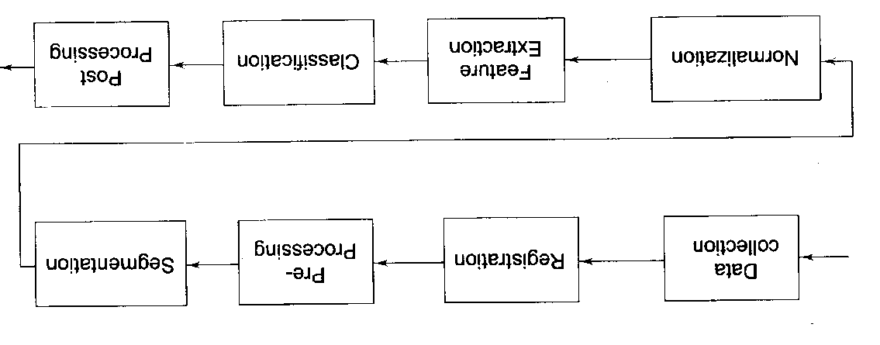
Figure 10: Block diagram of pattern recognition processing

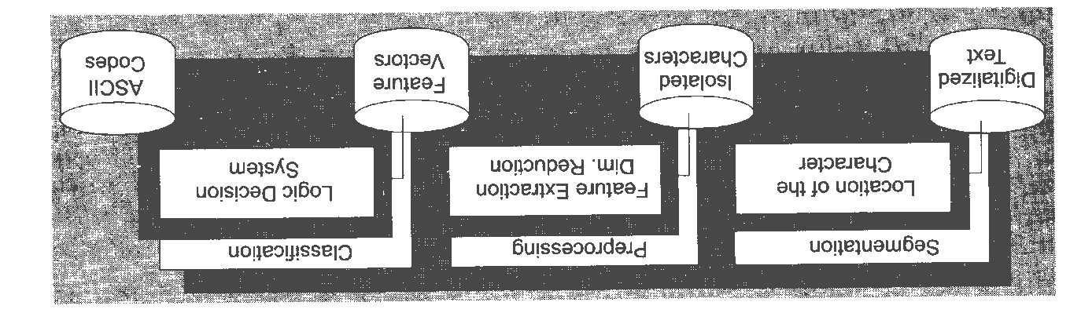
Figure 11: Structure of pattern recognition processing

The above figure 11 shows the structure of pattern recognition. The first step is segmentation, which consists in analyzing the digitalized image provided by a scanning device, so as to localize the limits of each character, and to isolate them from each other. Despite of constrains of writing that does often exist on the original printed form, the segmentation process is not so easy in practice. Indeed, these constrains are not always respected, and, moreover, they do not encourage people to use automatic character recognition systems.
The aim of the second step of the recognition structure is to extract discriminant information from an image of a character, as well as to reduce its dimension of representation. This reduction is required in order to ease the conception of the classification system, when discriminant feature extraction allows presenting competently a character to the classifier. Once discriminant features have been extracted, they are submitted to a logic decision system whose task is to identify the character that they represent and to assign them the corresponding ASC II code. This classification is the last step after which characters can be post processed.
For some years, artificial neural networks, and especially multilayer perceptrons, have shown good capabilities in performing classification tasks. This is due to the non-linearities that are included in these connectionist systems, and the discriminant-training phase that they are submitted to. However, their performance is strongly affected by the quality of the representation of the characters. This may require a large number of parameters to represent the character, which then results in difficulty in establishing the rules for recognition. In other words, the MLPs become difficult to train. Moreover, the greater the size of the network, the greater is the computation time. This can greatly restrict their practical use. So, it is necessary to perform efficient features extraction on the one hand, and to optimize the layout of the artificial neural network on the other hand.
Data collection: The first stage in any pattern recognition system is data collection. Before a pattern is made up of a set of measurements, these measurements need to be performed using some technical equipment and converted to numerical form. In the case of character recognition, such equipment includes video cameras and scanners. The input data, whatever its form, is sampled at fixed intervals in time and digitalized to be presented with a preset number of bits per measurement. In any case, the data collection devices should record the objects with the highest fidelity available.
Additional noise will be disadvantageous to successful operation of the system. The data collection phase should also be designed in such a manner that the system will be robust to variations in operation of individual signal measurement devices.
Registration: In the registration of data, rudimentary model fitting is performed. The internal coordinates of the registration system are somehow fixed to the actual data acquired. Some appropriate knowledge about the world surrounding the system is utilized in designing this stage.
This external information mainly answers questions such as: How has the data been produced? Where or when does the sensible input begin and end? The registration process thus defines the framework in which the system operates so that it knows what to expect as valid input.
Preprocessing: The next stage of the process is data preprocessing. The goal of preprocessing data is to simplify pattern recognition problem without throwing away any important information. Real world input data always contains some amount of noise. One of the primary reasons for preprocessing is to reduce noise and inconsistent data. Noisy data can obscure the underlying signal and cause confusion, especially if the key input variable is noisy. Preprocessing can often reduce noise and enhance the signal.
The term noise is to be understood broadly: Anything that hinders a pattern recognition system in fulfilling its commission may be regarded as noise no matter how inherent this noise is in the nature of the data. Some desirable properties of data may also be enhanced with preprocessing before the data is fed further in the recognition system. Preprocessing is normally accomplished by some simple filtering method on the data.
Segmentation: Two different algorithms bottom up and top down have been developed to insure an efficient segmentation of the characters. The bottom-up or analytic approach, very simple but very fast, is systematically applied and is sufficient to perform the segmentation of the characters in most practical cases. It builds words out of the recognition of their component characters. This is the most traditional meaning of segmentation, where betters are intelligently separated from the rest of the word.
The top-down algorithms attempt to recognize the attributes present within words. They operate on a higher level of abstraction, extracting features from words rather than partitioning the word and attempting to recognize each part of it. It has also been especially conceived so as to separate characters from each other when they are surrounding themselves. This second algorithm is required, and appears to be sufficient, in order to maintain the overall recognition performance as this situation occurs, which is often the case in practice, when there is no constraint of writing on the original document. As this second method is more complex and more expensive in terms of computation time than the first one, its use is controlled by the classification step, which allows to limit its frequency, and, by doing so, optimizes the average segmentation time.
Feature extraction: Several methods have been deeply analyzed. The vectorization of the characters has appeared to be a failure, in the case of off line character recognition. As a matter of fact, the writing process is then unavailable. The two most efficient of these methods have been improved further by using complementary techniques. This has led to two new methods, which appear to be extremely efficient.
The first method is called the averaged pixel method that is AP method. It is the easiest to use and involves reduction of the size of each character to a normalized dimension. A grid area is superimposed on the image of the character, and the averaged value of the pixels of each area is computed. In order to keep information about the original aspect of the character, the ratio between the initial width and height of the character is also computed and included in the feature vector as discussed in figure 12 below:

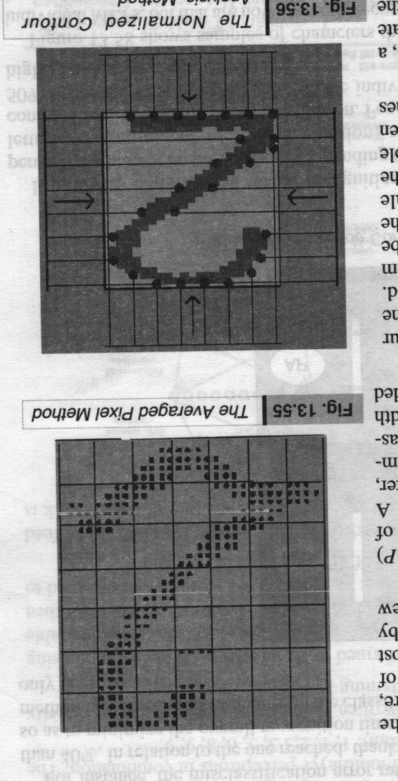
Figure 12: Average pixel method Figure 13: Normalized contour analysis

The second method is called the normalized contour analysis method. A contour analysis is performed on the normalized characters obtained by use of the first method. It consists of sending probes up to the character from several directions as illustrated in figure 13 above. The length of each probe is the ordinate, according to the search direction, of the first non-background pixel met. In order to get scale invariance and normalized values between 0 and 1, the length of each probe is divided by its highest possible value. In addition, the number of intersections between the layout of the character and vertical and horizontal lines is also taken into account.
Finally, for each of these feature extraction methods, a discriminant analysis is performed, so as to eliminate redundancy and noise, and to provide to the classifier the most efficient features only. [8, 10, 11]
Classification: The classification step is based on the use of artificial neural networks, or, in more distinct terms, multilayer perceptrons that is MLPs. These realize a set of discriminant functions that associate a score to each possible class. These scores may be regarded as being representative of the probability of each class to be one of the characters presented to the system.
Two kinds of multilayer perceptrons are available to obtain these values. Each of them is associated with a given kind of features, provided by the previous step of the recognition system. The normalized contour analysis that is NCA method has appeared to be more efficient, and is the one that is applied with priority. Moreover, as the NCA method and the average pixel that is AP method are applied in combination, the recognition rate is significantly improved. For instance, the misclassification error rate on handwritten digits has since been reduced by more than 40%, in relation to the one reached, thanks to the use of the best of the individual MLPs. Moreover, so as to minimize the overall recognition time while retaining a high recognition rate, the use of the AP method is restricted and depends on the classification results obtained by first applying the NCA method only as discussed in figure 14 below:
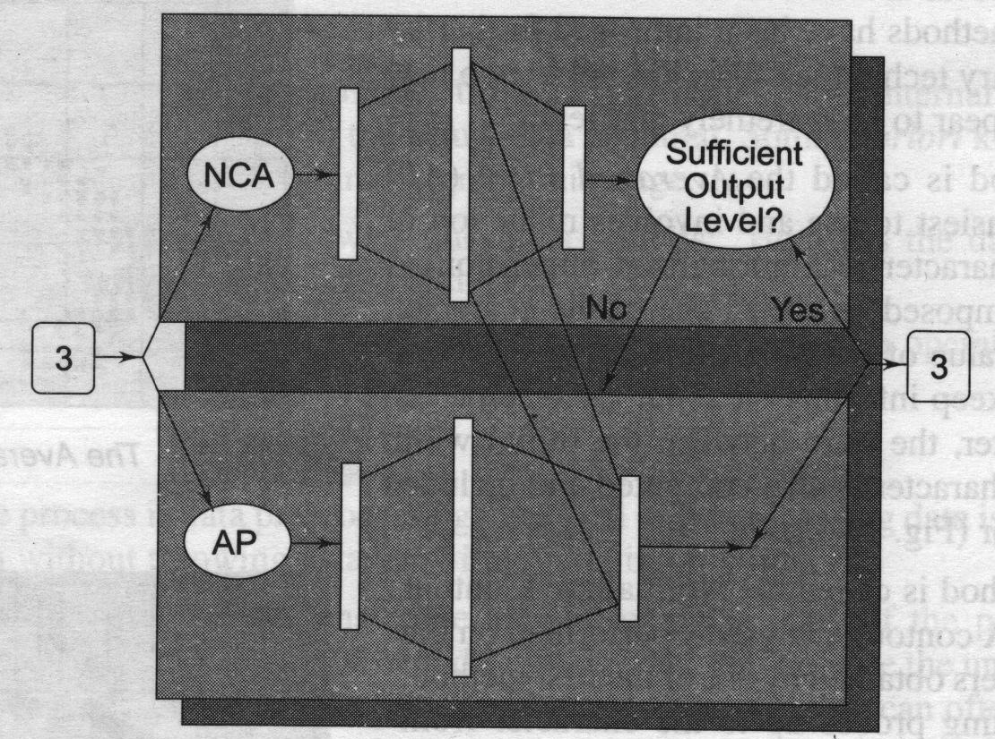
Figure 14: Cascade combination of multilayer perceptrons

In order to optimize the whole recognition process, several combination methods of multilayer perceptrons have been investigated. Depending on the practical application like digits recognition, uppercase letters recognition, or symbol recognition, several small multilayer perceptrons may be used in combination, in cascade or by substitution. For handwritten digits, a recognition system that is close to 50% faster than the most efficient of the individual MLPs, while retaining the recognition rate at its highest value, has been developed. Figure 15 shows samples of characters that were not correctly classified by using the best of the individual MLPs, but that are now correctly recognized, thanks to the use of several multilayer perceptrons in combination.
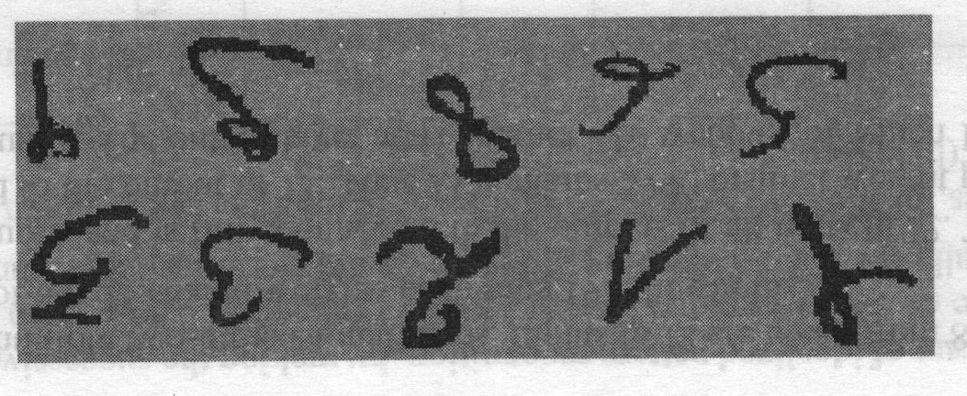
Figure 15: Recognition of handwritten characters based on EBPT
Samples of digits that were not correctly classified by using the best of the individual MLPs, but that are now correctly recognized, due to the use of several multilayer perceptrons in combination. The correct classes are from left to right, and from top to bottom are as 1, 1, 2, 3, 3, 5, 6, 8,-9, 9. The multi layer feed forward neural network for handwritten character recognition can be directly fed with images obtained as slightly original patterns containing low-level information. [11]

7. Scope of NN Pattern Recognition
- Machine learning: Having a computer program itself from a set of examples so you don't have to program it yourself. This will be a strong focus of this course: neural networks that learn from a set of examples.
    - Optimization: For constraints set and a cost function, to find an optimal solution
    - Classification: Grouping patterns into classes as handwritten characters into letters.
- Associative memory: Recalling a memory based on a partial match as regression: function mapping
- Cognitive science: For modeling higher level reasoning of
    - Language
    - Problem solving
And for modeling lower-level reasoning of
- Vision
- Audition speech recognition
- Speech generation
- Neurobiology: Modeling models of how the brain works.
    - Neuron-level
    - Higher levels: vision, hearing, etc. overlaps with cognitive folks.
- Mathematics:
    - Nonparametric statistical analysis and regression.
- Philosophy:
    - Human souls/behavior is explained in terms of symbols, or does it require something lower level, like a neurally based model?
- Neural network for real-world postal address recognition.

8. Neural Network Tool in Mechanical Engineering
Some of the important applications of the neural network methods that are being extensively used in the mechanical engineering industry for research-based applications are described below in short.
8.1 Process planning: The first attempt to use neural network techniques in process planning might be that of Osakada. The authors applied neural network techniques to an expert system for the process planning of cold forging in order to increase the consultation speed and to provide more reliable results. A three-layer neural network is constructed to relate the shapes of rotationally symmetric products to there forming methods. The shapes of the products are transformed into 16 x 16 black and white pixels and are given to the input layer of the neural network. The back-propagation algorithm is employed. After training, the network is able to determine the forming methods for the products, which are exactly the same, or slightly different from those used as training examples.
8.2 Tool breakage monitoring: In the paper “Neural Network-Based Tool Breakage Monitoring System for End Milling Operations” by Po-Tsang Huang, Dr. Joseph C. Chen the machining parameters as a pattern input data and output is tool condition. Milling is a fundamental machining process in the operation of CNC machines, and milling operation can be of two varieties peripheral and face milling. Face milling is commonest in manufacturing systems. Cutting tooth moving in the same direction generates a cyclic cutting force ranging from zero to maximum force, and back to zero. This cyclic force is a series of peaks. Therefore, if the tool is in good condition, the peak force of each tooth should be the same for one revolution of the cutting process. Comparatively, if one tooth is broken, the broken tooth will generate a smaller peak force due to a smaller chip load causing the following tooth to obtain a larger peak force than normal. The maximum peak force in each revolution should be different between the good tool and the broken tool, and the maximum peak force of the broken tool should be larger than that of the good tool.
This experiment used a Fadal CNC vertical machining center for test purposes. A Kistler 9257B 3-component dynamometer was mounted on the table to measure the cutting force, and the steel AISI-1018 and BHN 100 was then mounted on the dynamometer as the work piece. A proximity sensor was built in near the spindle to confirm the data in each revolution. Four ¾ inch doubt-end four-flute high speed steel cutters were used. In each cutter, one side of the tool was in proper working order and the other side was broken. The broken side of the tool possessed varying degrees of breakage.
The cutting parameters were set as: spindle speed - 450, 500, 550, 600, 50 revolution per minute; feed rate - 10, 12, 15, 18, 20 inches per minute; depth of cut- 0.06, 0.07, 0.08, 0.09, 0.1 inches. Cutting force was measured in voltage by the Charge Amplifier and transformed to Newton, N by the computer. Five input neurons were used for tool breakage prediction data: A₁=Maximum peak force, A₂= Spindle speed, A₃= Feed rate, A₄= Depth of cut, A₅= Maximum variance of adjacent peak force. Output neurons were either ‘1’ that is ‘Good’, or ‘0’ that is ‘Broken’.
Three groups of training and testing data separated. The first group is 200 training and 100 testing data (200 ×100), second group (225 × 75), and third group (250 × 50) data. The back propagation net with different sample sizes of training and testing data is very useful in this concern. The last two columns show training and testing errors. From this table the ideal ratio between training and testing data was 3:1 for neural networks. The 225 × 75 sample size was employed in this analysis. Unipolar continuous activation function is use for hidden and output layer. So five input – four hidden – two output neurons are use in this architecture. The neural networks were capable of detecting tool conditions accurately and in process. The accuracy of training data was 96.4%, and the accuracy of testing data was 90.7%.
Hidden output = $\text{ah}1=\frac{1}{\left(1+{\text{exp}}^{−\left[a1∗\left(\text{va}1\right)+a2∗\left(\text{va}2\right)+a3∗\left(\text{va}3\right)+a4∗\left(\text{va}4\right)+a5∗\left(\text{va}5\right)−1\left(\text{va}0\right)\right]}\right)}$
Output =a_{out1}$=\frac{1}{\left(1+{\text{exp}}^{−\left[\text{ah}1∗\left(\text{wah}1\right)+\text{ah}2∗\left(\text{wah}2\right)+\text{ah}3∗\left(\text{wah}3\right)+\text{ah}4∗\left(\text{wah}4\right)−1\left(\text{wah}0\right)\right]}\right)}$
If a _{out1} > a _{out2}, then tool condition is good, If a _{out1} < a _{out2}, then tool is broken.

8.3 Tool flank wear measurement: P. Thangavel and Dr. V. Selladurai has published a paper on “Tool Flank Wear Measurement Using BPN” where he discuss about the metal cutting operations the rake face of the cutting tool comes into contact with the chip and the flank face with the machined work piece, both at high velocities. So friction exists between these surfaces of the tool and the chip and work piece and as a result, tool wears gradually.
Trial experiments were carried out by varying one of the process parameters while keeping the rest of them at constant values. The working range was decided on the basis of data given in hand book, machine capabilities. The selected process parameters are cutting speed in rpm, feed rate in mm/rev., and depth of cut in mm that is V F T respectively. In present work an EN24 work piece was turned HSS tool on Kirloskar lathe the cutting component and the feed component of the cutting force were measured with an industrial engineering dynamometer of 620B. Flank wear measured by using toolmaker’s microscope. Factorial design procedure is adopted to reduce the total number of experiment and to obtain data uniformly from all the regions of the selected working area.
Back propagation training neural network that is BPTNN is used for wear measurement of tool flank. Input layer has five inputs; these are cutting speed in rpm, feed rate in mm/rev, and depth of cut in mm, cutting force ratio and diameter of the work piece in mm. The numbers of middle layer neurons are decided by trial-and-error method, which are seven for training the experiments. The output layer has eight neurons, which is an 8-bit binary representation of the flank wear. The output of the out put layer neurons have either a value of 0 or 1.
Every connection carries a weight factor, which are initially assigned by a random generator algorithm. A sigmoid activation function is use with unipolar continuous function. Errors for all patterns are summed and the algorithm is run till error falls below 0.1. Trained weights corresponding to this error are then stored. These trained weights are then used with a new untrained set of input data.
A plot was drawn between the measured tool wear and the predicted tool wear by neural network for 20 values with the measured tool flank wear on x-axis and calculated tool flank wear on the y-axis. A good correlation was obtained between those sets of values. Also, graphs were plotted by taking six values randomly with machine time on x-axis and predicted wear on the y-axis. These graphs were able to predict actual wear highly accurately. In his conclusion a simple three-layer Back Propagation Neural Network that is BPNN with a 5-7-1 structure has been developed and used for cutting tool wear monitoring based on the measurement of cutting force components. There are two network models are used as given below:
- Training model- Back propagation training neural network that is BPTNN
- Prediction of flank wears- Back propagation prediction neural network that is BPPNN.
Predicted flank wear was close matching between the model output and directly measured flank wear. Prediction of forces without using a force sensor would definitely improve the implementation of proposed approach in shop floor practice. Tool condition monitoring system has great potential to improve machining using high speed steel tool.
8.4 Designing of Boeing aircraft: At Boeing Aircraft Company, researchers have been developing a neural network to identify aircraft parts that have already been designed and manufactured, in efforts to help them with the production of new parts. Given a new design, the system attempts to identify a previously designed part that resembles the new one. If one is found, it may be able to be modified to conform to the new specifications, thus saving time and money in the manufacturing process. [12, 13]
8.5 Template matching: One of the simplest and earliest approaches to pattern recognition is based on template matching. Matching is a generic operation in pattern recognition, which is used to determine the similarity between two entities of pints, curves, or shapes of the same type. In template matching, a template typically, a 2 D shape or a prototype of the pattern to be recognized is available. The pattern to be recognized is matched against the stored template while taking into account all allowable post translation and rotation and scale changes. The similarity measure, often a correlation, may be optimized based on the available training set. Often, the template itself is learned from the training set.
Template matching is computationally demanding, but the availability of faster processors has now made this approach more feasible. The rigid template matching mentioned above, while effective in some application domains, has a number of disadvantages. For instance, it would fail if the patterns were distorted due to the imaging process, viewpoint change, or large interclass variations among the patterns. Deformable template models or rubber sheet deformations can be used to match patterns when the deformation cannot be easily explained or modeled directly.
8.6 Monitoring of self-tapping screw fastenings: Kaspar Althoefer, Bruno Lara, Lakmal D. Seneviratne publish a paper on “Monitoring of Self-Tapping Screw Fastenings Using Artificial Neural Networks” in which they discussed about Screw fastenings account for a quarter of all assembly operations and automation of the process is highly desirable. This paper presents a novel strategy for monitoring this manufacturing process, focusing on the insertion of self-tapping screws. An artificial neural network that is ANN, using ‘Torque-versus-Insertion-Depth’ signals as input, is designed to distinguish between successful and failed insertions. The ANN is first tested using simulation data from an analytical model for screw insertions, and then validated using experimental torque signals obtained from an electric screwdriver. The results demonstrate that ANNs can effectively monitor the screw fastening process and cope with a wide range of insertion cases interpolating for unseen insertion signals.
8.7 Biomedical application: In 1990, Stubbs presents three biomedical applications in which neural networks have been used, one of which involves drug design. Nonsteroidal anti-inflammatory drugs that are NOSAIDs are a commonly prescribed class of drugs, which in some cases may cause adverse reactions. The rate of adverse reactions that is ADR is about 10%, with 1% of these involving serious cases and 0.1% being fatal elaborated by Stubbs in 1990. A three-layer back propagation neural network was developed to predict the frequency of serious ADR cases for 17 particular NOSAIDs, using four inputs, each representing a particular property of the drugs. The predicted rates given by the model matched within 5% the observed rates, a much better performance than by other techniques. Such a neural network might be used to predict the ADR rate for new drugs, as well as to determine the properties that tend to make for safe drugs.

8.8 Rotation–invariant neural pattern -coin recognition application: Minoru Fukumi, Sigeru Omatu, and Toshihisa Kosaka. Publish a paper on “Rotation – Invariant Neural Pattern Recognition System with Application to Coin Recognition” where they talked about conventional pattern recognition methods require an input pattern to be presented in a standard position, orientation, size, etc. In practice, however, the input pattern may be shifted in position, rotated, or scale-changed in relation to its standard form. Furthermore, the patterns can be corrupted by noise. Conventional pattern recognition methods, for example, pattern matching, do not work well under these conditions.
The object of this paper is to achieve automatic recognition of various coins, and for this purpose a rotation-invariant pattern recognition system involving neural networks is considered. In coin recognition, one can easily distinguish one coin from another on the basis of size. This paper presents a neural pattern recognition system, which is insensitive to rotation by any number of degrees. As such a system is useful in problem related to coin recognition, this algorithm to classify a 500 yen coin and a 500 won coin, which have the same shape and size, the same thickness, and a similar pattern structure.
8.9 Image data processing:Visual image recoginition has many applications particularly in object recognition for attributes automatic handling & machinery and in image data processing such as image enhancement image compression image transformation & special effects in cinematography & other real –time graphics application. It also used in identification & security palm recognition, fingerprint recognition & face recognition.
Generally the method for pattern recognition may be classified as follows:
- Statistical pattern recognition where features are algorithmically extracted & template matching techniques are used.
- Structural pattern recoginition where primary components of pattern are extraced & the relations betweeen them are defined with decision trees or graphs. [14]

9. Research Area of Neural Networks
    - Signal processing: suppress line noise, with adaptive echo canceling, blind source separation
    - Control: for example, backing up a truck in which cab position, rear position, and match with the dock get converted to steering instructions. Manufacturing plants for controlling automated machines.
    - Siemens successfully uses neural networks for process automation in basic industries, for example in rolling mill control more than 100 neural networks do their job, 24 hours a day
    - Robotics - navigation, vision recognition
    - Pattern recognition, that is. recognizing handwritten characters, for example the current version of Apple's Newton uses a neural net
    - Medicine, i.e. storing medical records based on case information
    - Speech production: reading text aloud for example NET talk
    - Speech recognition
    - Vision: face recognition, edge detection, visual search engines
    - Business: for example, rules for mortgage decisions are extracted from past decisions made by experienced evaluators, resulting in a network that has a high level of agreement with human experts.
    - Financial Applications: time series analysis, stock market prediction
    - Data compression: speech signal, image, for example faces

10. Benefits of Neural Networks
It is apparent that a neural network derives its computing power through, first, its massively parallel distributed structure and, second, its ability to learn and therefore generalize. Generalization refers to the neural network producing reasonable outputs for inputs not encountered during training or learning. These two information-processing capabilities make it possible for neural networks to solve complex or large-scale problems that are currently intractable. In practice, however, neural networks cannot provide the solution by working individually. Rather, they need to be integrated into a consistent system engineering approach. Specifically, a complex problem of interest is decomposed into a number of relatively simple tasks, and neural networks are assigned a subset of the tasks that match their inherent capabilities. It is important to recognize, however, that we have a long way to go if ever before we can build a computer architecture that mimics a human brain.
The use of neural networks offers the following useful properties and capabilities:
- Nonlinearity: An artificial neuron can be linear or nonlinear. A neural network, made up of an interconnection of nonlinear neurons, is itself nonlinear. Moreover, the nonlinearity is of a special kind in the sense that it is distributed throughout the network. Nonlinearity is a highly important property, particularly if the underlying physical mechanism responsible for generation of the input signal, for example, speech signal is inherently nonlinear.
- Input-output mapping: A popular paradigm of learning called learning with a teacher or supervised learning involves modification of the synaptic weights of a neural network by applying a set of labeled training samples or task examples. Each example consists of a unique input signal and a corresponding desired response. The network is presented with an example picked at random from the set, and the synaptic weights of free parameters of the network are modified to minimize the difference between the desired response and the actual response of the network produced by the input signal in accordance with an appropriate statistical criterion. The training of the network is repeated for many examples in the set until the network reaches a steady state where there are no further significant changes in the synaptic weights. The previously applied training examples may be reapplied during the training session but in a different order. Thus, the network learns from the examples by constructing an input-output mapping for the problem at hand. Such an approach brings to mind the study of nonparametric statistical inference, which is a branch of statistics dealing with model-free estimation, or, from a biological viewpoint, tabula rasa learning explained by Geman in 1992; the term nonparametric is used here to signify the fact that no prior assumptions are made on a statistical model for the input data. Consider, for example, a pattern classification task, where the requirement is to assign an input signal representing a physical object or event to one of several prespecified categories or classes. In a nonparametric approach to this problem, the requirement is to estimate arbitrary decision boundaries in the input signal space for the pattern-classification task using a set of examples, and to do so without invoking a probabilistic distribution model. A similar point of view is implicit in the supervised learning paradigm, which suggests a close analogy between the input-output mapping performed by a neural network and nonparametric statistical inference.
- Adaptivity: Neural networks have a built-in capability to adapt their synaptic weights to changes in the surrounding environment. In particular, a neural network trained to operate in a specific environment can be easily retrained to deal with minor changes in the operating environmental conditions. Moreover, when it is operating in a nonstationary environment that is one where statistics change with time, a neural network can be designed to change its synaptic weights in real time. The natural architecture of a neural network for pattern classification, signal processing, and control applications, coupled with the adaptive capability of the network, make it a useful tool in adaptive pattern classification, adaptive signal processing, and adaptive control. As a general rule, it may be said that the more adaptive we make a system, all the time ensuring that the system remains stable, the more robust its performance will likely be when the system is required to operate in a nonstationary environment. It should be emphasized, however, that adaptivity does not always lead to robustness; indeed, it may do the very opposite. For example, an adaptive system with short time constants may change rapidly and therefore tend to respond to spurious disturbances, causing a drastic degradation in system performance. To realize the full benefits of adaptivity, the principal time constants of the system should be long enough for the system to ignore spurious disturbances and yet short enough to respond to meaningful changes in the environment; the problem described here is referred to as the stability-plasticity dilemma given by Grossberg, in 1988.
- Evidential response: In the context of pattern classification, a neural network can be designed to provide information not only about which particular pattern to select, but also about the confidence in the decision made. This latter information may be used to reject ambiguous patterns, should they arise, and thereby improve the classification performance of the network.
- Contextual information: Knowledge is represented by structure and activation state of a neural network. Every neuron in the network is potentially affected by the global activity of all other neurons in the network. Consequently, contextual information is dealt with naturally by a neural network.
- Fault tolerance: A neural network, implemented in hardware form, has the potential to be inherently fault tolerant, or capable of robust computation, in the sense that its performance degrades gracefully under adverse operating conditions. For example, if a neuron or its connecting links are damaged, recall of a stored pattern is impaired in quality. However, due to the distributed nature of information stored in the network, the damage has to be extensive before the overall response of the network is degraded seriously. Thus, in. principle, a neural network exhibits a graceful degradation in performance rather than catastrophic failure. There is some empirical evidence for robust computation, but usually it is uncontrolled. In order to be assured that the neural network is in fact fault tolerant, it may be necessary to take corrective measures in designing the algorithm used to train the network explained by Kerlirzin and Vallet in 1993.
- VLSI implementability: The massively parallel nature of a neural network makes it potentially fast for the computation of certain tasks. This same feature makes a neural network well suited for implementation using very-large-scale-integrated that is VLSI technology. One particular beneficial virtue of VLSI is that it provides a means of capturing truly complex behavior in a highly hierarchical fashion explored by Mead in 1989.
- Uniformity of analysis and design: Basically, neural networks enjoy universality as information processors. We say this in the sense that the same notation is used in all domains involving the application of neural networks. This feature manifests itself in different ways: First, neurons, in one form or another, represent an ingredient common to all neural networks. Second, this commonality makes it possible to share theories and learning algorithms in different applications of neural networks. Third, Modular networks can be built through a seamless integration of modules.
Neurobiological Analogy: The design of a neural network is motivated by analogy with the brain, which is a living proof that fault tolerant parallel processing is not only physically possible but also fast and powerful. Neurobiologists look to artificial neural networks as a research tool for the interpretation of neurobiological phenomena. On the other hand, engineers look to neurobiology for new ideas to solve problems more complex than those based on conventional hard-wired design techniques. These two viewpoints are illustrated by the following two respective examples:
In 1993, Anastasio explains an idea about linear system models of the vestibulo-ocular reflex which are compared to neural network models based on recurrent networks that are described. The vestibulo-ocular reflex that is VOR is part of the oculomotor system. The function of VOR is to maintain visual or retinal image stability by making eye rotations that are opposite to head rotations. The VOR is mediated by premotor neurons in the vestibular nuclei that receive and process head rotation signals from vestibular sensory neurons and send the results to the eye muscle motor neurons. The VOR is well suited for modeling because its input that is head rotation and its output that is eye rotation can be precisely specified. It is also a relatively simple reflex and the neuro-physiological properties of its constituent neurons have been well described. Among the three neural types, the premotor neurons known as reflex interneurons in the vestibular nuclei are the most complex and therefore most interesting. The VOR has previously been modeled using lumped, linear system descriptors and control theory. These models were useful in explaining some of the overall properties of the VOR, but gave little insight into the properties of its constituent neurons. This situation has been greatly improved through neural network modeling. Recurrent network models of VOR can reproduce and help explain many of the static, dynamic, nonlinear, and distributed aspects of signal processing by the neurons that mediate the VOR, especially the vestibular nuclei neurons.
The retina, more than any other part of the brain, is where we begin to put together the relationships between the outside world represented by a visual sense, its physical image projected onto an array of receptors, and the first neural images. The retina is a thin sheet of neural tissue that lines the posterior hemisphere of the eyeball. The retina's task is to convert an optical image into a neural image for transmission down the optic nerve to a multitude of centers for further analysis. This is a complex task, as evidenced by the synaptic organization of the retina. In all vertebrate retinas the transformation from optical to neural image involves three stages described by Sterling in 1990:
- Photo transduction by a layer of receptor neurons.
- Transmission of the resulting signals produced in response to light by chemical synapses to a layer of bipolar cells.
- Transmission of these signals, also by chemical synapses, to output neurons that are called ganglion cells.
At both synaptic stages that is from receptor to bipolar cells, and from bipolar to ganglion cells, there are specialized laterally connected neurons called horizontal cells and amacrine cells, respectively. The task of these neurons is to modify the transmission across the synaptic layers. There are also centrifugal elements called inter-plexiform cells; their task is to convey signals from the inner synaptic layer back to the outer one. A few researchers like Mahowald and Mead, 1989; Boahen and Ardreou, 1992; Boahen, 1996 have built electronic chips that mimic the structure of the retina. These electronic chips are called neuromorphic integrated circuits, a term coined by Mead in 1989. A neuromorphic imaging sensor consists of an array of photoreceptors combined with analog circuitry at each picture element or pixel. It emulates the retina in that it can adapt locally to changes in brightness, detect edges, and detect motion. The neurobiological analogy, exemplified by neuromorphic integrated circuits is useful in another important way: It provides a hope and belief, and to a certain extent an existence of proof, that physical understanding of neurobiological structures could have a productive influence on the art of electronics and VLSI technology. With inspiration from neurobiology in mind, it seems appropriate that we take a brief look at the human brain and its structural levels of organization. [13, 14, 15]

11. An Overview of MATLAB
Regarding the project work the analysis is made by using pattern A, B, C for which the recognition of pattern can be achieved by means of mat-lab software algorithm and programming. Dr. Cleve Moler, chief scientist at Math Works, Inc., originally wrote MATLAB to provide easy access to matrix software developed in the LINPACK and EISPACK projects. The first version was written in the late 1970s for use in courses in matrix theory, linear algebra, and numerical analysis. MATLAB is therefore built upon a foundation of sophisticated matrix software, in which the basic data element is a matrix that does not require predimensioning.
MATLAB is a product of The Math Works, Inc. and is an advanced interactive software package specially designed for scientific and engineering computation. The MATLAB environment integrates graphical illustrations with precise numerical calculations, and is a powerful, easy-to-use, and comprehensive tool for performing all kinds of computations and scientific data visualization. MATLAB has proven to be a very flexible and useful tool for solving problems in many areas. MATLAB is a high-performance language for technical computing. It integrates computation, visualization and programming in an easy-to-use environment where problems and solutions are expressed in familiar mathematical notation. Typical areas of application of MATLAB include:
- Math and computation
- Algorithm development
- Modeling, simulation and prototyping
- Data analysis, exploration, and visualization
- Scientific and engineering graphics
- Application development, including graphical user interface building.

MATLAB is an interactive system whose basic element is an array that does not require dimensioning. This helps in solving many computing problems, especially those with matrix and vector formulations, in a fraction of the time it would take to write a program in a scalar non-interactive language such as C or FORTRAN. Mathematics is the common language of science and engineering. Matrices, differential equations, arrays of data, plots and graphs are the basic building blocks of both applied mathematics and MATLAB. It is the underlying mathematical base that makes MATLAB accessible and powerful. MATLAB allows expressing the entire algorithm in a few dozen lines, to compute the solution with great accuracy in about a second. Therefore, it is especially helpful for technical analysis, algorithm prototyping and application development.
MAT Lab’s two-and three-dimensional graphics are object oriented. MATLAB is thus both an environment and a matrix/vector-oriented programming language, which enables the user to build own reusable tools. The user can create his own customized functions and programs known as M-files in MATLAB code. The Toolbox is a specialized collection of M-files for working on particular classes of problems. MATLAB Documentation Set has been written, expanded and put online for ease of use. The set includes online help, as well as hypertext-based and printed manuals. The commands in MATLAB are expressed in a notation close to that used in mathematics and engineering. There is a very large set of these commands and functions, known as MATLAB M-files. As a result, solving problems through MATLAB is faster than the other traditional programming. It is easy to modify the functions since most of the M-files can be opened and modified. For ensuring high performance, the MATLAB software has been written in optimized C and coded in assembly language.
The main features of MATLAB can be summarized as:
- Advance algorithms for high-performance numerical computations, especially in the field of matrix algebra.
- A large collection of predefined mathematical functions and the ability to define one's own functions.
- Two- and three-dimensional graphics for plotting and displaying data.
- A complete online help system.
- Powerful, matrix/vector-oriented, high-level programming language for individual applications.
- Ability to cooperate with programs written in other languages and for importing and exporting formatted data.
- Toolboxes available for solving advance problems in several application areas.

An optional extension of the core of MATLAB called SIMULINK is also available. SIMULINK means SIMUlating and LINKing the environment. SIMULINK is an environment for simulating linear and non-linear dynamic systems, by constructing block diagram models with an easy to use graphical user interface. The details of features and capabilities of MATLAB is illustrated in following figure 16 below. It gives information about MATLAB programming language, user- written function, built in function, graphics which includes 2-D graphics, 3-D graphics, color and lighting, animation etc., computations which includes linear algebra, data analysis, signal processing, quadrature etc., external interface and tool boxes which includes signal processing, image processing, control system, optimization, neural network, communication, robust control, statistics, splines etc. [15, 16]
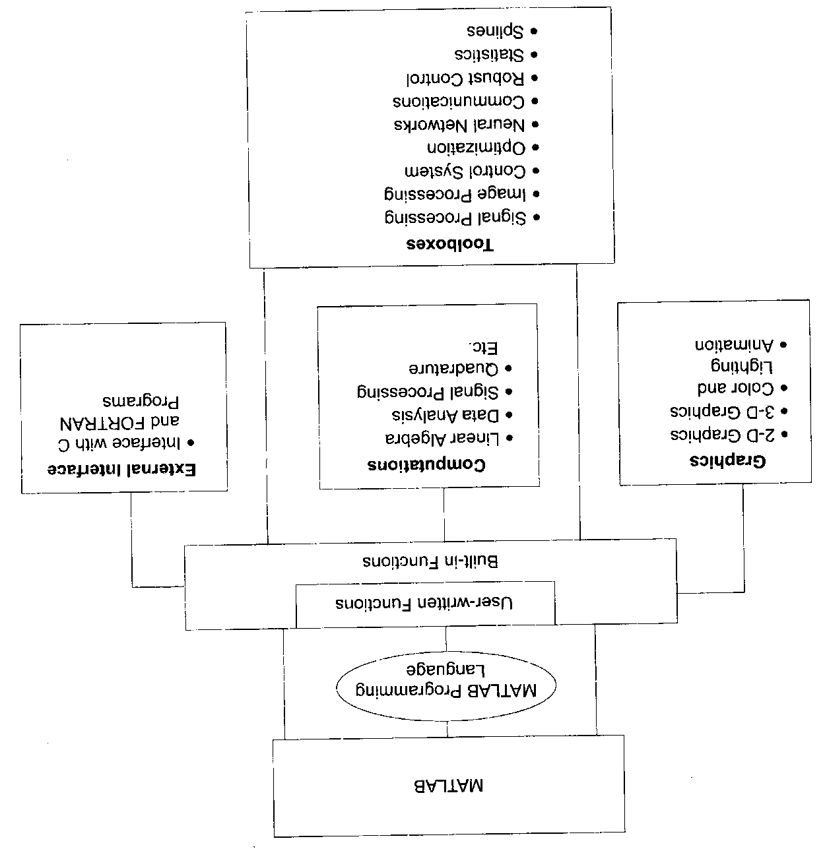
Figure 16: Features and capabilities of MATLAB.
11.1 Perceptron networks: Developed large class of artificial neural networks called Perceptrons. The perceptron learning rule uses an iterative weight adjustment that is more powerful than the Hebb rule. The perceptrons use threshold output function and the McCuUocn Pitt, model of neuron. Their iterative learning converges to correct weights that are the weights that produce the exact output value for the training input pattern. Original perceptron is found to have three layers, sensory, associator and response units as shown in figure 17 below.

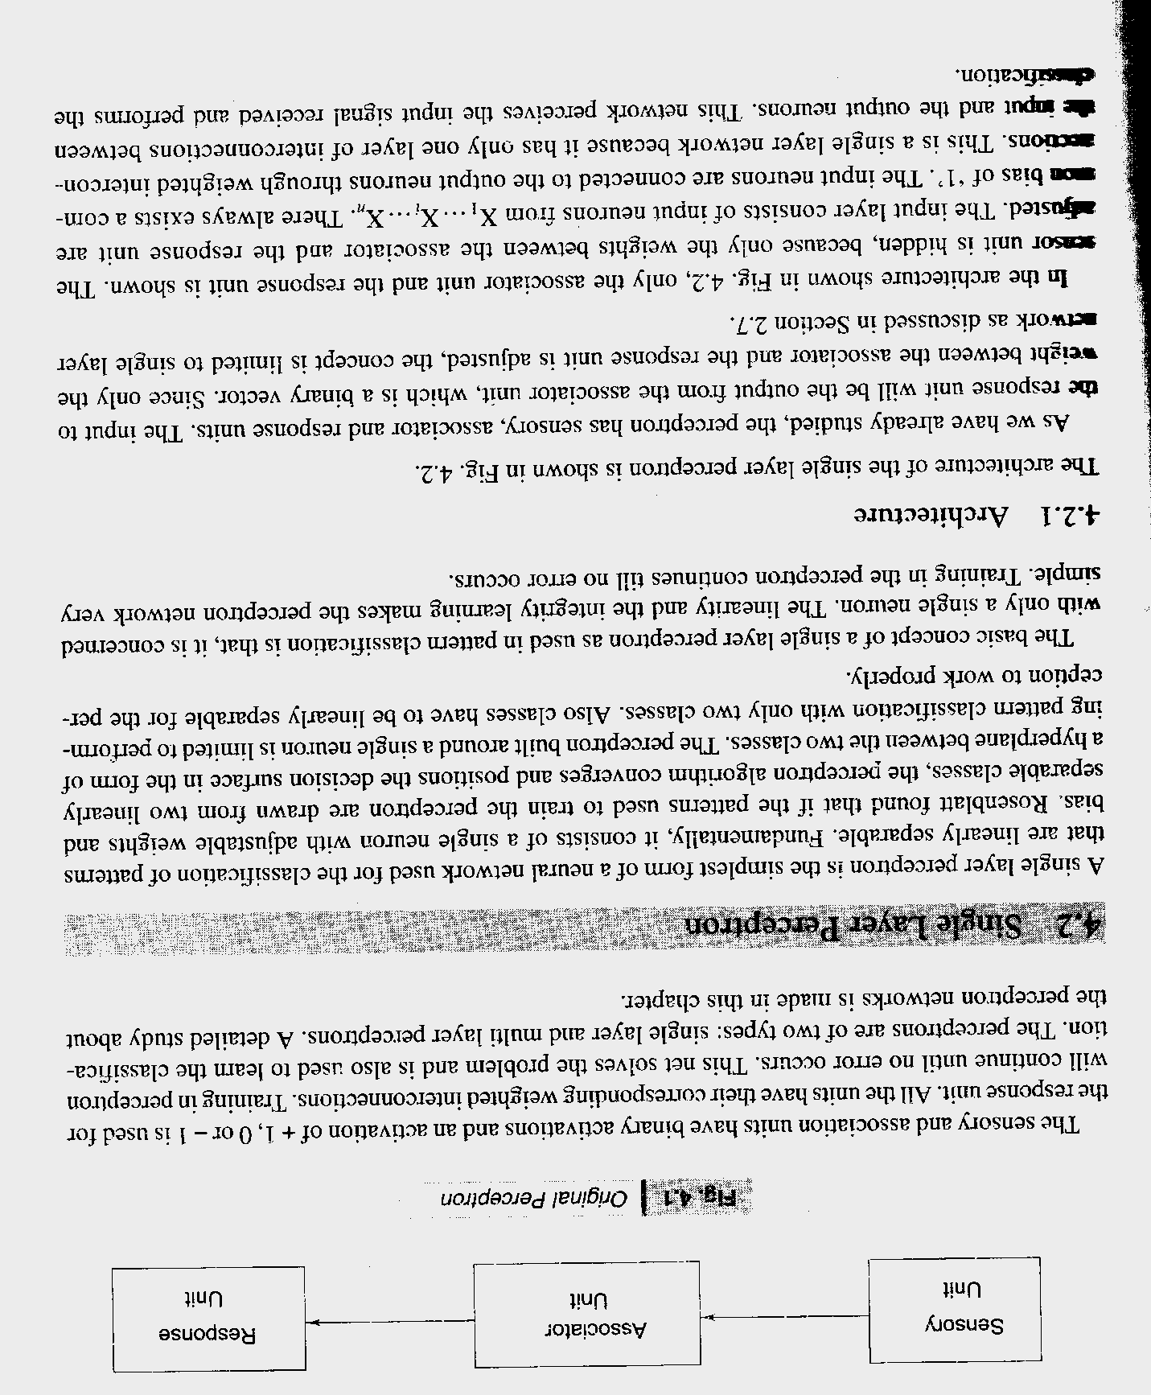
Figure 17: Original perceptron

The sensory and association units have binary activations and an activation of + 1, 0 or - 1 is used for the response unit. All the units have their corresponding weighted interconnections. Training in perceptron will continue until no error occurs.
Single layer perceptron: A single layer perceptron is the simplest form of a neural network used for the classification of patterns that are linearly separable. Fundamentally, it consists of a single neuron with adjustable weights and bias. Rosenblatt found that if the patterns used to train the perceptron are drawn from two linearly separable classes, the perceptron algorithm converges and positions the decision surface in the form of a hyper plane between the two classes. The perceptron built around a single neuron is limited to performing pattern classification with only two classes. Also classes have to be linearly separable for the perception to work properly.
The basic concept of a single layer perceptron as used in pattern classification is that, it is concerned with only a single neuron. The linearity and the integrity learning make the perceptron network very simple. Training in the perceptron continues till no error occurs.
a. Architecture of perceptron network: The architecture of the single layer perceptron is shown in figure 18 below. As we have already studied, the perceptron has sensory, associator and response units. The input to the response unit will be the output from the associator unit, which is a binary vector. Since only the weight between the associator and the response unit is adjusted, the concept is limited to single layer network.
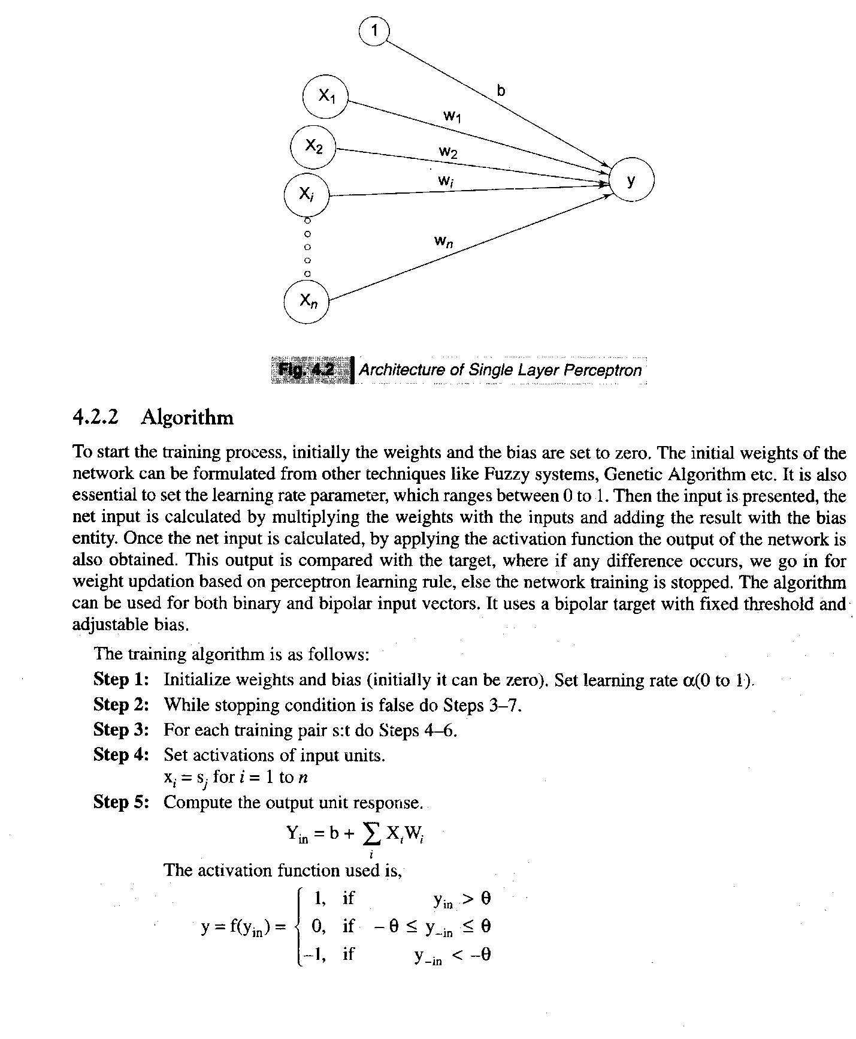
Figure 18: Architecture of the single layer perceptron

In the architecture shown in above figure 2.15, only the associator unit and the response unit are shown. The leaser unit is hidden, because only the weights between the associator and the response unit are riposted. The input layer consists of input neurons from X₁….X_{i}……. X_{n}. There always exists a corn on bias of '1'. The input neurons are connected to the output neurons through weighted interconnections. This is a single layer network because it has only one layer of interconnections between ac input and the output neurons. This network perceives the input signal received and performs the classification.
b. Algorithm of perceptron network: To start the training process, initially the weights and the bias are set to zero. The initial weights of the network can be formulated from other techniques like ‘Fuzzy Systems’, ‘Genetic Algorithm’ etc. It is also essential to set the learning rate parameter, which ranges from 0 to 1. Then the input is presented, the net input is calculated by multiplying the weights with the inputs and adding the result with the bias entity. Once the net input is calculated, by applying the activation function the output of the network is also obtained. This output is compared with the target, where if any difference occurs, we go in for weight updatation based on perceptron learning rule, else the network training is stopped. The algorithm can be used for both binary and bipolar input vectors. It uses a bipolar target with fixed threshold and adjustable bias.
The training algorithm is as follows:
Step 1: Initialize weights and bias initially can be 0. Set learning rates a (0 to 1).
Step 2: While stopping condition is false do steps 3-7.
Step 3: For each training pairs: do steps 4-6.
Step 4: Set activations of input units. x_{i} = s_{j} for i = 1 to n
Step 5: Compute the output unit response.
The activation function used is, 1, if
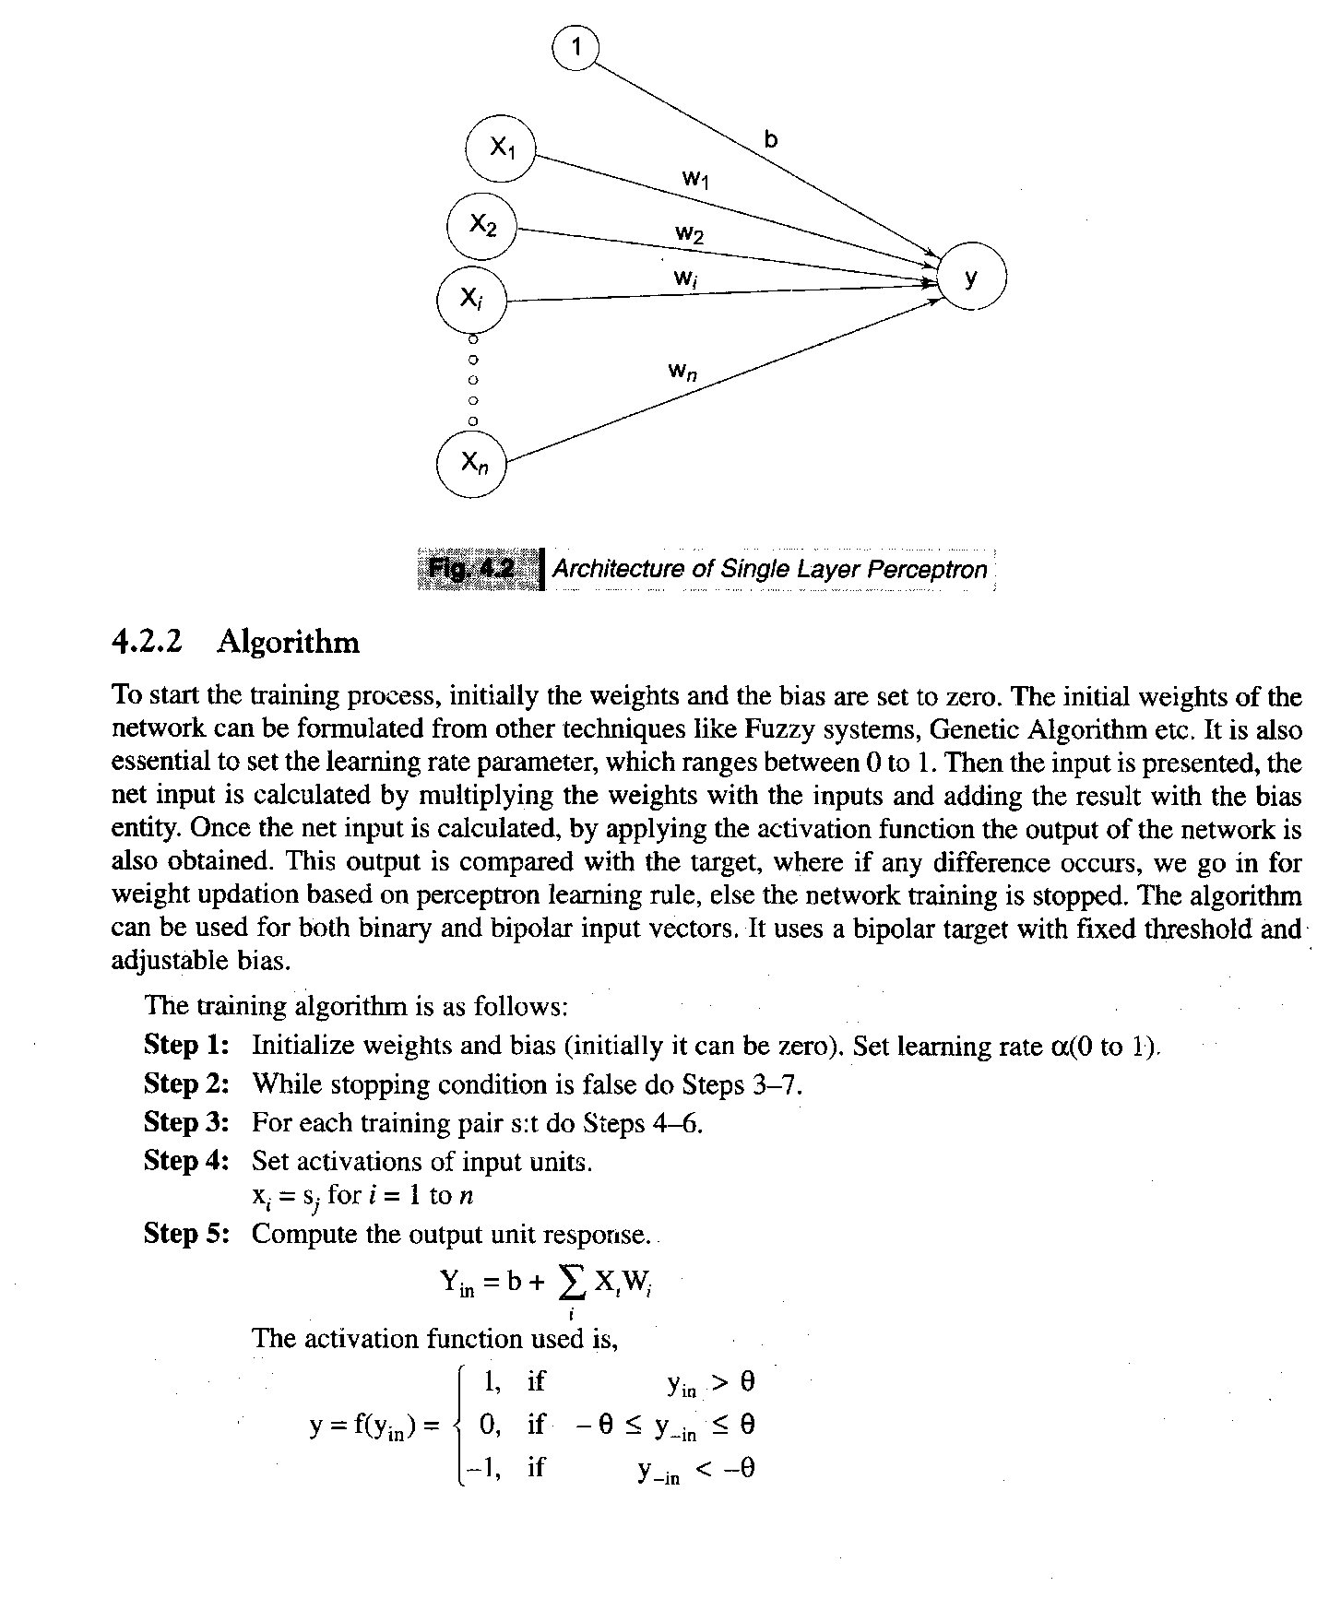
Step 6: The weights and bias are updated if the target is not equal to the output response. If t ^ y and the value of x, is not zero.
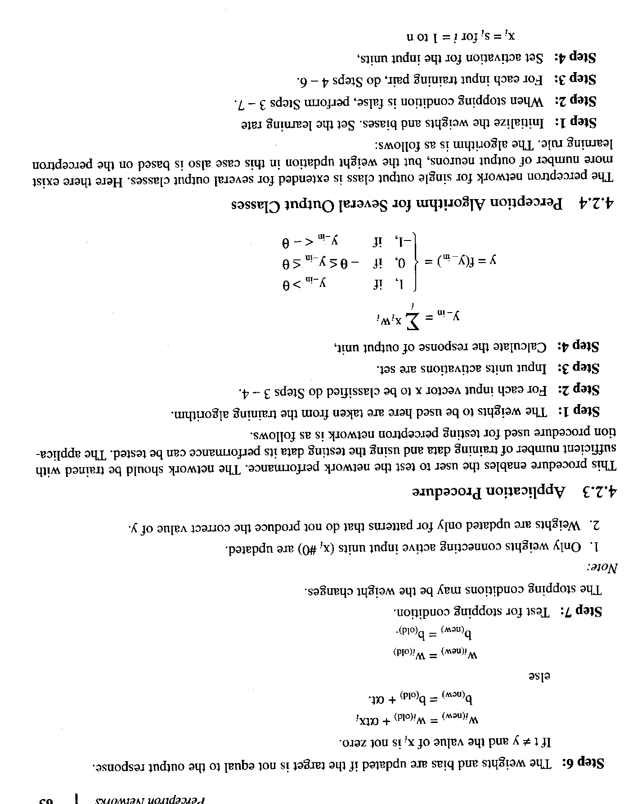
Step 7: Test for stopping condition that may be weight changes.
c. Application Procedure of perceptron network: This procedure enables the user to test the network performance. The network should be trained with sufficient number of training data and using the testing data its performance can be tested. The application procedure used for testing perceptron network is as follows.
Step 1: The weights to be used here are taken from the training algorithm.
Step 2: For each input vector x to be classified do steps 3-4.
Step 3: Input units activations are set.
Step 4: Calculate the response of output unit,
11.2 Feedback networks: In the networks discussed till now, one output vector was assigned to every input vector. This arrangement is determined in the sense of a feed forward flow of information. But there exist situations, in which one can return back the output to the input, thereby giving rise to an iteration process. These types of networks come under the category of feedback networks. Feedback networks include simulated annealing, Boltzmann machine, Hopfield net, etc.
a. Discrete Hopfield net: This type of network was described by J.J. Hopfield in 1982. Hopfield while working on the magnetic behavior of the solids that is spin glasses described property of magnetic atoms using two states (1 and -1). The magnetic mutual exchange between the atoms is represented by a mathematical formula, which led to the development of the Hopfield net. The topology of a Hopfield network is very simple: it has 'n' neurons, which are all networked with each other. A Hopfield network is able to recognize unclear pictures correctly. However, only one picture can be stored at a time. In practical applications one must assume that many pictures will be given, which have to be stored and then classified. The discrete Hopfield net is a fully interconnected neural net with each unit connected to every other unit. The net has symmetric weights with no self connections i.e. all the diagonal elements of the weight matrix of a Hopfield net are zero.
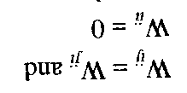
The two main differences between Hopfield and iterative auto associative net those are recurrent associative net are that, in the Hopfield net, they are only one unit updates its activation at a time and each unit continues to receive an external signal in addition to the signal from the other units in the net. The asynchronous discrete time updating of the units allows a function known as an energy function or Lyapunov function to be found for the net. This function proves that the net will converge to a stable set of activations. The formulation of the discrete Hopfield net shows the usefulness of the net as a content addressable memory.
b. Architecture feedback network: The architecture of the discrete Hopfield net is shown in the figure 2.16 below. The architecture shown in figure 19 below consists of 'n' number of x input neurons and Y output neurons.

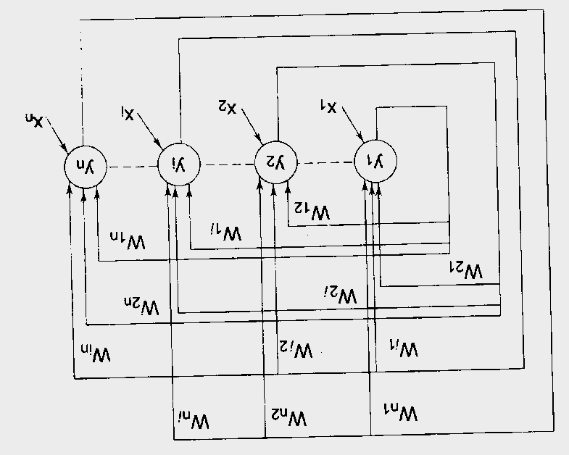
Figure 19: Architecture of feedback network
It should be noted that apart from receiving a signal from input, the y neuron receives signal from its other output neurons also. This is the same for the all-other output neurons. Thus, there exists a feedback output being returned to each output neuron.
That is why the Hopfield network is called a feedback network. The architecture of feedback network differs from the architecture of feed forward network in the fact that the responses from the output returns back to the input where the architecture was initially started. In the figure 2.16 shown below x₁, x₂, x₃,…..x_{n} are input neurons and the y₁, y₂, y₃,……y_{n} are output neurons. The factor W is the weight factor to each input neuron.
c. Training algorithm of feedback network: Discrete Hopfield net is described for both binary as well as bipolar vector patterns. The weight matrix to store the set of binary input patterns s(p), p = 1, ... P, where
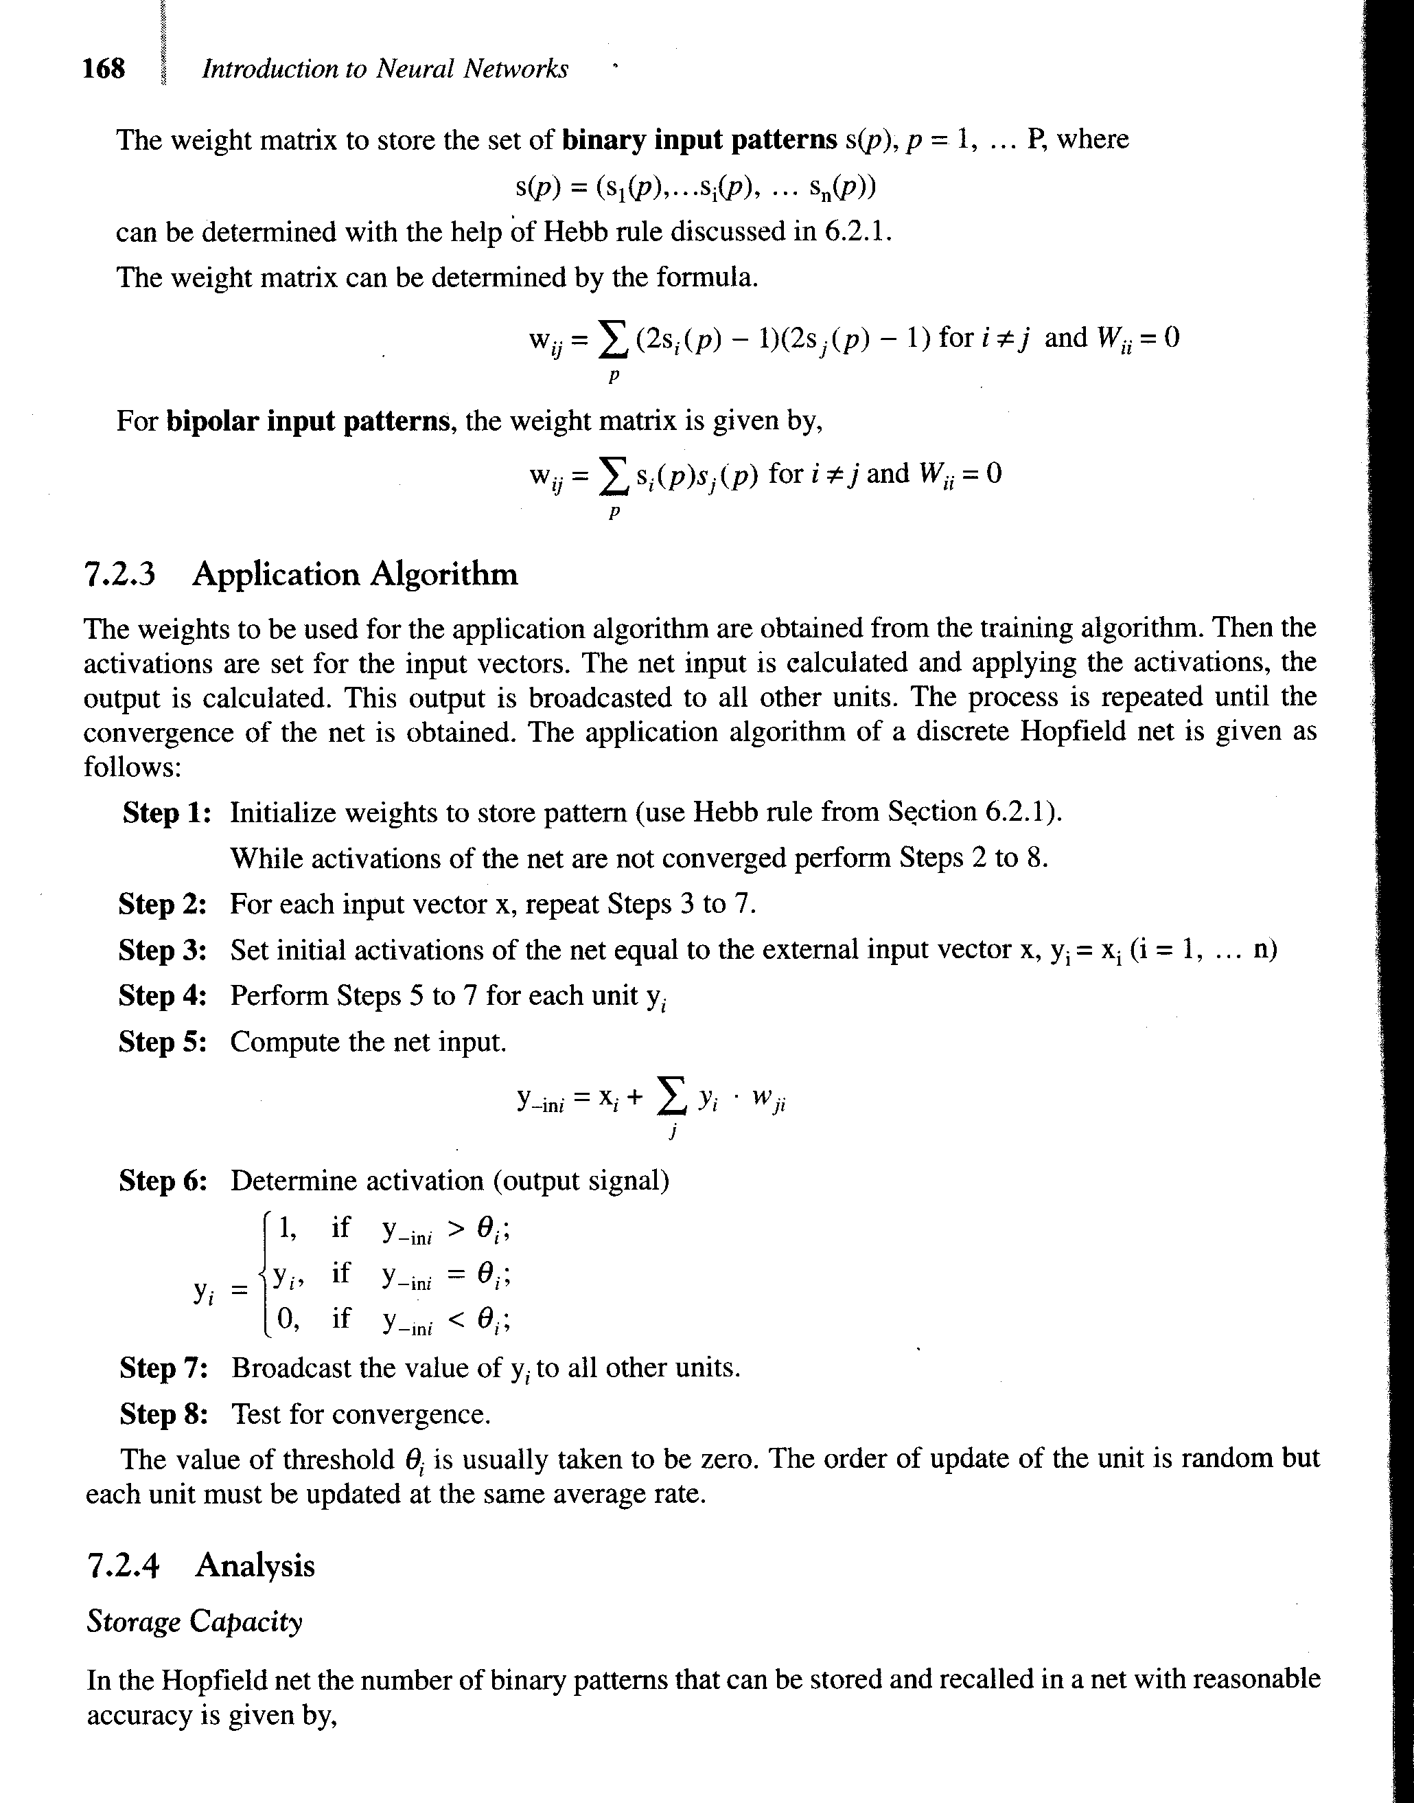
This can be determined with the help of Hebb rule. The weight matrix can be determined by the formula.
For bipolar input patterns, the weight matrix is given by,
d. Application algorithm of feedback network: The weights to be used for the application algorithm are obtained from the training algorithm. Then the activations are set for the input vectors. The net input is calculated and applying the activations, the output is calculated. This output is broadcasted to all other units. The process is repeated until the convergence of the net is obtained. The application algorithm of a discrete Hopfield net is given as follows:
Step 1: Initialize weights to store pattern (use Hebb rule). While activations of the net are not converged perform steps 2 to 8.
Step 2: For each input vector x, repeat steps 3 to 7.
Step 3: Set initial activations of the net equal to the external input vector x, y; = x; (i = 1, ... n)
Step 4: Perform steps 5 to 7 for each unit y,
Step 5: Compute the net input.
Step 6: Determine activation (output signal)
Step 7: Broadcast the value of y, to all other units.
Step 8: Test for convergence.
The value of threshold 0 is usually taken to be zero. The order of update of the unit is random but each unit must be updated at the same average rate. [16, 17]

12. Conclusions
Pattern recognition can be done both in normal computers and neural networks. Computers use conventional arithmetic algorithms to detect whether the given pattern matches an existing one. It is a straightforward method. It will say either yes or no. It does not tolerate noisy patterns. On the other hand, neural networks can tolerate noise and, if trained properly, will respond correctly for unknown patterns. Neural networks may not perform miracles, but if constructed with the proper architecture and trained correctly with good data, they will give amazing results, not only in pattern recognition but also in other scientific and commercial applications.

References
  - Anil K. Jain, Robert P. W. Duin and Jianchang, “Statastical Pattern Recognition: A Review”, in IEEE Transactions on Pattern Analysis and machine intelligence, Volume 22, January 2000, pp. 1325- 1367.
  - John Makhoul, “Pattern Recognition properties of Neural Networks”, in BBN Systems and Technologies, Cambridge MA 02138.
  - Hubert Cardot and Oliver Lezoray, “Graph of Neural Network for Pattern Recognition”, Lusac, IUC SRC, 120, pp. 873-876.
  - Taiwei Lu, Xin Su, Shudong Wu and Francis T. S. Yu, “Hetero Associative Neural Network for Pattern Recognition”, CH2809-2/89/0000-0658, 1989, IEEE.
  - Shigeru Katagiri, Biing Hawang Juang and Chin-Hui Lee, “Pattern Recognition Using a Family of Design Algorithms Based Upon the Generalized Probabilistic Descent Method”, Proceedings of the IEEE, Vol. 86, November 1998, pp. 2345- 2361.
  - H. Greenspan, M. Fleisher and Y. Y. Zeevi, “Pattern Recognition by Neural Network Processing in the Combined Spatial Oriented Space”, pp. 1-5.
  - Po-Tsang Huang, Dr. Joseph C. Chen, “Neural Network-Based Tool Breakage Monitoring System For End Milling Operations” In Journal of Industrial Technology”, Volume 16, Number 2, February 2000 to April 2000.
  - P.Thangavel and Dr.V.Selladurai “Tool Flank Wear Measurement Using BPN” in “11/Manufacturing Technology today”, August 2006, pp. 11-16.
  - Kaspar Althoefer, Bruno Lara, Lakmal D. Seneviratne. “Monitoring of Self-Tapping Screw Fastenings using Artificial Neural Networks” the ASME Vol. 127, February 2005 pp. 236–243.
  - Abraham Kandel, Yan-Qing Zhang and Horst Bunket. “A Neural Network for Pattern Recognition”, 0-7803-3796-4/97/1997 IEEE.
  - Christos Stergiou and Dimitrios Siganos, “Neural Networks“Article.
  - Shigeo abe Masahiro Kayama Hiroshi Takenaga, “Synthesizing Neural Networks for Pattern Recognition”, CH 3065-0/91/0000/IEEE, pp. 1105-1110.
  - DeLiang Wang, Ohio State University, “Pattern Recognition Neural Networks in Perspective”, 0885/9000/93/0800/IEEE, pp. 52-60.
  - Jacek M.Zurada, “Introduction to Artificial Neural Systems” Jaico Publishing House, year 2000.
  - Ramesh Rajagopalan, Ph.D. and Pumima Rajagopalan, “Applications of Neural Networks in Manufacturing”, Proceedings of the 29th Annual Hawaii International Conference on System Sciences – 1996, 1060-3425/96, 1996 IEEE, pp. 447-453.
  - Minoru Fukumi, Sigeru Omatu, Fumiaki Takada, Associate Member, IEEE, “Rotation Invariant Neural Pattern Recognition System with Application to coin Recognition”, 1027/9245IEEE Transaction on Neural Networks, Vol.3, NO.2, MARCH 1992, pp. 272-279.
  - Peter J. Edwards, Alan F. Murray, Senior Member, IEEE, Georgios Papadopoulos, A. Robin Wallace, John Barnard, and Gordon Smith, “The Application of Neural Network to the Papermaking Industry” ,IEEE transactions on neural networks, vol. 10, no. 6, November 1999, pp. 1456-1464.

