DESIGN AND FABRICATION OF STAIR LIFT CHAIR

Dr.Kanchan Ganvir
Department of Mechanical Engineering,
Priyadarshini Bhagwati College of Engineering
Nagpur ,India

Akhilesh Dhanwij
Department of Mechanical Engineering,
Priyadarshini Bhagwati College of Engineering
Nagpur,India

Prajwal Ladekar
Department of Mechanical Engineering,
Priyadarshini Bhagwati College of Engineering
Nagpur,India.

Ayush Sakhare
Department Of Mechanical Engineering,
Priyadarshini Bhagwati College Of Engineering
Nagpur, India

Prof. S. M. Pimpalgaonkar
Department of Mechanical Engineering,
Priyadarshini Bhagwati College of Engineering

Nagpur ,India

Prakash Naidu
Department of Mechanical Engineering,
Priyadarshini Bhagwati College of Engineering
Nagpur,India

Pranay Moon
Department of Mechanical Engineering,
Priyadarshini Bhagwati College of Engineering

Nagpur,India

Abstract This topic deals with the fabrication and analysis of a stair case lift, which can be use as Material Handling System. A stair case lift is a mechanical device for lifting people and wheelchairs up and down on the stairs, who may find difficulty in doing so themselves. For sufficiently wide stairs, a rail is mounted to the treads of the stairs. A chair or lifting platform is attached to the rail. A person on the chair or platform is lifted as the chair or platform moves along the rail, old age and goods are to be carried across the staircase. Stair case lift is a type of lift that can be mounted on the stair case without altering civil structure. This lift runs on electric power and consists of a motor, reduction gear box, rope drive, two rails a sliding chair. In this system we use DC motor for changing the polarity of the power supply which will make the motor run in reverse direction connected with the earlier, while the later will form the entire assembly run to in downward direction, with the help of Toggle switches and push buttons. Advantages over the conventional hydraulic lift are no civil structure and alteration is required, low cost, less bulkiness, less power, less maintenance requires. Easy design, easy installations. Can be of industrial use too. Moreover, considering some drawbacks due to weight carrying capacity completely depend upon the capacity of motor. There is lot of scope for further modification in the project as using monorail instead of two. Use of belt drive or chain drive instead of rope drive. Incorporation and automation/ timer unit which will ease the use of device. Rack and carrier arrangement for using the device for curved stair case. Use of work & roller reduction gear assembly

Keywords: STAIR LIFT; CAD,CAM

- INTRODUCTION

There are many old and physically disable peoples in the world and it is difficult for them to climb stairs as compared to normal persons. So to help them and to help the persons who cannot afford lift as their houses are small, the project is made. The most concern of this project is to fabricate a mechanism which will lift them up and put them down whenever they want and at very low budget. A stair with escalator is a mechanical device for lifting people up & down. Rail is mounted on the stairs on which a platform is attached. The platform is lifted by a simple mechanism of rope & pulley by it is lifted. Person gets on the platform is lifted when he/she switch on the plug the motor starts, after that the shaft of motor is connected to gearbox (speed reducer) by the Oldham’s coupling. The outlet shaft of gearbox is connected to another Oldham’s coupling which transmits the power to the spindle to wind or unwind the rope.

Winding the rope will lift the platform up & unwinding will make the platform go down.
Hydraulic lifts use the principles of hydraulics (in the sense of hydraulic power ) to pressurize an above ground or in-ground piston to raise and lower the car. Roped hydraulics use a combination of both ropes and hydraulic power to raise and lower cars. Recent innovations include permanent magnet motors, machine room-less rail mounted gearless machines, and microprocessor controls. The technology used in new installations depends on a variety of factors. Hydraulic lifts are cheaper, but installing cylinders greater than a certain length becomes impractical for very high lift hoist ways. For buildings of much over seven storey’s, traction lifts must be employed instead. Hydraulic lifts are usually slower than traction lifts. Lifts are a candidate for mass customization. There are economies to be made from mass production of the components, but each building comes with its own requirements like different number of floors, dimensions of the well and usage patterns.
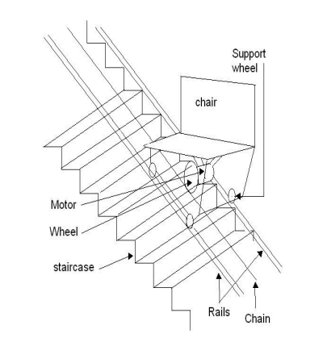
Fig. 1 Stair Case Lift

For Controlling and monitoring a connecting system we are adding a Bluetooth system 5.0

- OBJECTIVE

Stair case lift can be adapted for its stair use simplicity and economy. Therefore it can be widely used for home as well as industrial which ensures a promising future to the concept. A stair lift can be a good solution that allow users to safely move up and down through the Stair. The work is design with aim and following objective:
1. To develop a lifting system which can be helpful for disabled and old people.
2. To introduce a lower cost solution for material handling to the upstairs.
3. To design a safe lifting system which can installed easily without changing the stair.
4. To give a solution for the old buildings where commercial lift cannot be installed.
5. To determine the working efficiency and beneficial working of the stair lift.
6. Stair lift having the heavyweight carrying capacity.

- LITERATURE SURVEY

S. Hirose and J. Yuan proposed to develop a certain type of stably stair climbing mobile vehicle in order to assist the physically handicapped in moving along the stairs. They first proposed a novel leg-wheel hybrid stair climbing vehicle, Zero Carrier consisting of eight prismatic joint legs, providing significant stability during stair climbing motion since the mechanism is based on eight simplified legs. A trial model of zero carrier is developed by them using necessary sensors required by them for stable motion. A. Bijalwan, A. Misra developed a prototype on flexible wearable chair, more like a light weight exoskeleton allowing people to sit in any working position and anywhere, having a gross weight of 3Kg which utilizes light weight aluminium alloy elements. The prototype used kinematic pairs enabling it to take halts in between continuous moments and in any working position. The authors mainly focused on the mechanical design and and FEA analysis of the prototype. Johanne L Mattie described about stairs into buildings being a significant barrier for those with mobility impairments .So the author proposed to develop a novel, inclusive solution that combines staircase and lift into one device. Michael Hinderer explained technical aid required by people where there is staff shortages. Thus introducing ‘autonomous stair‐ climbing wheelchair with independent mobility for moving limited people. The autonomous stair‐ climbing wheelchair is based on a leg mechanism consisting of two legs one with lower leg support and other with upper leg support

- COMPONENTS AND SPECIFICATIONS

ComCOMPONENTS | SpeciSPECIFICATIONS
MOTOR | 1DIA, 1 HP, 1400 rpm, SINGLE PHASE INDUCTION MOTOR
GEAR BOX | HP WORM AND WORM GEAR WHEEL 1:4 REDUCTION RATIO
PULLEY | V-GROOVE 75MM DIA
ROPE | 14MM STEEL ROPE
GUIDES | 12MM
STAIRCASE | 6”RISE 10”RUN
BLUETOOTH | 5.0

- CAD MODEL

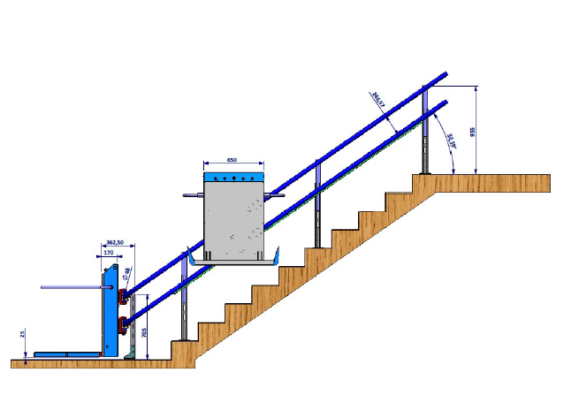

- Front view
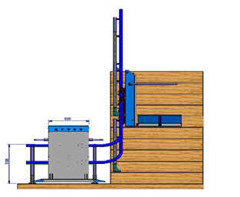
- Side View

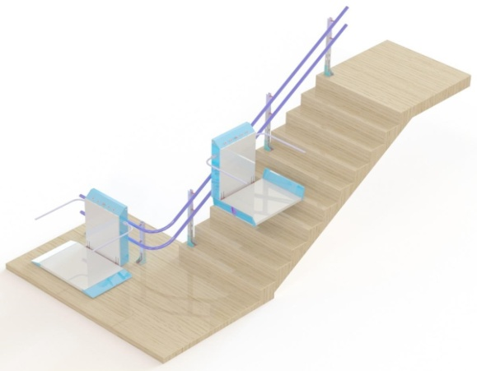

(c) Top view

Fig. 2. All View CAD Model of Stair Case

- WORKING PRINCIPLE

Stairs with escalator is a mechanical device for lifting peoples up and down. The project work on the basic principle of rope and pulley mechanism. When the electric supply is given to the AC single phase induction motor of start rotating at 1400 rotations per minute which is then coupled with the Oldham’s coupling the output shaft of coupling is given to the worm speed reducer which decreases the 1400 rpm into 72 rpm which is connected to another Oldham’s coupling and then to pedestal bearings and finally to wrench. The wrench winds the rope whose one end connected to it and another end is connected to platform. The winding of rope lifts up the platform and the person goes up. This process reversed by making the motor to rotates in anticlockwise direction and the wrench unwind the rope which makes the platform to go down and return back to its initial position and this is how the mechanism of stairs with escalators (stair lift) works and the person or an object is lifted

- ADVANTAGES

1) Safety – Prevents Injuries.
2) Easy to use.
3) Comfortable Ride.
4) Restores Independence.
5) Quickest & Most Affordable Aging in place option.
6) Allows you to stay at home.
7) Short term solution for an injury.
8) Offers the ability to “ Try Before You Buy

- RESULT

There are advancements in very fields like software technology, more safety feature, and manually operated, etc. If we want to develop our country, we must have to use stair lift which should be affordable and easily operated in our Homes, Hospitals, Apartments, Old – Age Homes, etc. Hence, we found the best way for climbing stairs through the stair lifts which is more beneficial for Old age or Handicapped people in their life. This Design of stairs with escalators (stair lift) enables the easier transporting and handling of person or a object in various places with very low price and low maintenance and can be fixed on any type of stairs. While in design if the platform is replaced by seat more comfort and safety is possible and can be used is instead of lifts in small houses
We analyzed the stress and deformation for full model and corresponding parts with the help of ANSYS. For full model 1000 N of load was applied over the cg of passenger travelling and it was found that maximum equivalent vonmisses stress is 216.93 N/mm2, and deformation is 2.465 mm. This lies within the permissible limits.

- CONCLUSION

Stair case slider can be adapted for its sheer use simplicity and economy. In our projects making a cost friendly Stair lift which is having some limitations but more advantage, it was a good and challenging project for us. Making a stair lift with roller bearing is not a complicated process and all the components are available in market we purchased it. DC motors with control box which is manufactured for auto rickshaw and this can be directly used in the stair lift. During the test run of this project, it was realized that it would capable of carrying heavy load without any difficulty and any deformation. Though the initial cost of the project seemed to be a little bit higher but it is accurate. Manufacturing would shorten this. Stair lift has distinguished advantages and benefits. In this case no one has alter the civil structure for installation thereafter shortest cost for installation procedure as compared to that of lift. So, future of such lifting system seems to be very bright. The design developed is strong enough to hold a human with wheelchair up to 80 to 100 kg with minimum stresses and deformation.

- FUTURE SCOPE

If used in any industry where emphasizing factor is time not cost, then using hydraulic jacks in place of pneumatic jacks are better option because they use costly oil but are better in performance.
With slight modification in mechanism, this device is also used to shift handicapped persons.
If used in a condition where availability of electricity is not an issue than with the help of solenoid valve and rotors, and compressor, we can achieve better efficiency.
By the use of high cost and better pressure storing air tank, we can improve the performance.
By the use of non-return valve in place of simple handle valve we can save the air up to maximum extent by giving the exhaust port air back to air cylinder.

- REFERENCES

1 Hirose, S., Yuan, J. and Konuma, Y. (2005). Development of the Stair Climbing Leg-Wheel Hybrid.
2 Vehicle. Journal of the Robotics Society of Japan, 23(3), pp.330-336.
3 Bijalwan, A. and Misra,A. (2016). Design and StructuralAnalysis of Flexible Wearable Chair Using Finite.
4 Element Method. Open Journal of Applied Sciences, 06(07),pp.465-477.
5 Mattie, J., Borisoff, J., Leland, D. and Miller, W. (2015). Development of an integrated staircase liftfor.
6 home access. Journal of Rehabilitation and Assistive Technologies Engineering, 2,p.205566831559407. 7 M. Hinderer, M., Friedrich, P. and Wolf, B. (2017). An autonomous stair-climbing wheelchair.Robotics 8 and Autonomous Systems, 94, pp.219-225.
9 Hansard, UK Parliament House of Commons Daily Debates record. References to stairlifts: 16 Mar 1990 :
10 Column 395; 7 May 2002 : Column 3WH; Westminster Hall, Sylvia Heal in the Chair; 14 Jun 2004:11 Column 744W
11 Anon, (2018). [online] Available at: https://www.sparkfun.com/products/8958. [Accessed 18 Mar.2018].
12 En.wikipedia.org. (2018). Limit switch. [online] Available at: https://en.wikipedia.org/wiki/Limit_switch.[Accessed 18 Mar. 2018].

