Heart Disease Prediction using Machine Learning and Data Mining techniques

K. shyamala murthy
Assistant Professor, Department of Electronics and communication engineering
HITS, Hyderabad
shyamuchelsia@gmail.com
M. Srilekha, Student, Department of
Electronics and communication engineering
HITS, Hyderabad,
India srilekhareddy882@gmail.com
Jakkula Raghavendra, Student, Department of Electronics and communication engineering
HITS, Hyderabad, India 1234jrky@gmail.c om

J. manikeshav
Student, Department of Electronics and communication engineering
HITS, Hyderabad,
India jemmalla.manikeshav@gmail.com

Abstract— Weighing only 300 grams,Heart is declining the mortality rate at a rapid pace from decades.The major factors that contribute to it are smoking,drinking,unbalanced diet,and many more.Even with these more technical advancements the analysis of the clinical data is a critical challenge.With the use of Machine Learning techniques,it is possible to analyse the data and interpret the cause that lead to heart diseases such as Coronary Heart Disease,Arrhythmia,and Dilated Cardiomyopathy.Many researchers are developing IOT enabled hardware to predict these diseases using various ML and DM techniques.In this study,we propose a novel method to determine the disease using Cleveland Heart Disease Dataset by combining the computational power of various ML and DM algorithms and conclude that among all the algorithms,K-Nearest Neighbors gives the highest accuracy of 81%.Along withthis, a web app is developed using flask in python with which the user can enter the attributes and predict the heart disease.

Keywords—svm; naive bayes; decision tree; random forest; logistic regression; adaboost; xgboost; python programming; confusion matrix; correlation matrix

- INTRODUCTION
.
According to the World Health Organization, every year 12 million deaths occur worldwide due to Heart Disease. Heart disease is one of the biggest causes of morbidity and mortality among the population of the world. Prediction of cardiovascular disease is regarded as one of the most important subjects in the section of data analysis. The load of cardiovascular disease is rapidly increasing all over the world from the past few years. Many researches have been conducted in attempt to pinpoint the most influential factors of heart disease as well as accurately predict the overall risk.
Heart Disease is even highlighted as a silent killer which leads to the death of the person without obvious symptoms. The
early diagnosis of heart disease plays a vital role in making decisions on lifestyle changes in high-risk
patients and in turn reduces the complications.
Machine learning proves to be effective in assisting in making decisions and predictions from the large quantity of data produced by the health care industry. This project aims to predict future Heart Disease by analyzing data of patients whichclassifies whether they have heart disease or not using machine-learning algorithm. Machine Learning techniques can be a boon in this regard. Even though heart disease can occur in different forms, there is a common set of core risk factors that influence whether someone will ultimately be at risk for heart disease or not. By collecting the data from various sources, classifying them under suitable headings & finally analysing to extract the desired data we can say that this technique can be very well adapted to do the prediction of heart disease.

- RELATED WORK
- The main motivation of doing this research is to present a heart disease prediction model for the prediction of occurrence of heart disease. Further, this research work is aimed towards identifying the best classification algorithm for identifying the possibility of heart disease in a patient. This work is justified by performing a comparative study and analysis using three classification algorithms namely Naïve Bayes, Decision Tree, and Random Forest are used at different levels of evaluations. Although these are commonly used machine learning algorithms, the heart disease prediction is a vital task involving highest possible accuracy. Hence, the three algorithms are evaluated at numerous levels and types of evaluation strategies. This will provide researchers and medical practitioners to establish a better.

values used are confidence.Its minimum confidence value is
0.25. The accuracy of the system is about 86.7%.

- Santhana Krishnan. J ,et ,al proposed a paper “Prediction of Heart Disease Using Machine Learning Algorithms” using decision tree and naive bayes algorithm for prediction of heart disease.In decision tree algorithm the tree is built using certain conditions which gives True or False decisions. The algorithms like SVM, KNN are results based on vertical or horizontal split conditions depends on dependent variables. But decision tree for a tree like structure having root node, leaves and branches base on the decision made in each of tree Decision tree also help in the understating the importance of the attributes in the dataset. They have also used Cleveland data set. Dataset splits in 70% training and 30% testing by using some methods. This algorithm gives 91% accuracy. The second algorithm is Naive Bayes,which is used for classification.It can handle complicated, nonlinear, dependent data so it is found suitable for heart disease dataset as this dataset is also complicated, dependent and nonlinear in nature. This algorithm gives an 87% accuracy.

- Sonam Nikhar et al proposed paper “ Prediction of Heart Disease Using Machine Learning Algorithms” their research gives point to point explanation of Naïve Bayes and decision tree classifier that are used especially in the prediction of Heart Disease. Some analysis has been led to think about the execution of prescient data mining strategy on the same dataset, and the result decided that Decision Tree
has highest accuracy than Bayesian classifier.

- Aditi Gavhane et al proposed a paper “Prediction of Heart Disease Using Machine Learning”,in which training and testing of dataset is performed by using neural network algorithm multi-layer perceptron. In this algorithm there will be one input layer and one output layer and one or more layers are hidden layers between these two input and output layers.Through hidden layers each input node is connected to output layer. This connection is assigned with some random weights.The other input is called bias which is assigned with weight b. Based
on requirement the connection between the nodes can be feedforwarded or feedback.

- Avinash Golande et al, proposed “Heart Disease Prediction Using Effective Machine Learning Techniques” in which few data mining techniques are used that support the doctors to differentiate the heart disease. Usually utilized methodologies are k-nearest neighbour ,Decision tree and Naïve Bayes. Other unique characterization-based strategies utilized are packing calculation, Part thickness, consecutive negligible streamlining and neural systems, straight Kernel self arranging guide and SVM (Bolster Vector Machine).
- Lakshmana Rao et al,proposed “Machine Learning Techniques for Heart Disease Prediction” in which the contributing elements for heart disease are more. So, it is difficult to distinguish heart disease.To find the seriousness of the heart disease among people different neural systems and data mining techniques are used.

- Abhay Kishore et al,,proposed “Heart Attack Prediction Using Deep Learning” in which heart attack prediction system by using Deep learning techniques and to predict
the probable aspects of heart related infections of the patient Recurrent Neural System is used.This model uses deep learning and data mining to give the best precise model and least blunders.This paper acts as strong reference model for another type of heart attack prediction models

- Senthil Kumar Mohan et al, proposed “Effective Heart Disease Prediction Using Hybrid Machine Learning Techniques” in which their main objective is to improve exactness in cardiovascular problems.The algorithms used are KNN, LR, SVM, NN to produce an improved exhibition level with a precision level of 88.7% through the prediction model for heart disease with hybrid random forest with linear model(HRFLM).

- Anjan N. Repaka et al,proposed a model stated the performance of prediction for two classification models, which is analyzed and compared to previous work. The Experimental results shows that accuracy is improved in finding the percentage of risk prediction of our proposed method in comparison with other models.

- Aakash Chauhan et al, proposed “Heart Disease Prediction using Evolutionary Rule Learning”. Data is directly retrieved from electronic records that reduces the manual tasks. The amount of services are decreased and shown major number of rules helps within the best prediction of heart disease.Frequent pattern growth association mining is performed on patient’s dataset to generate strong association rules.

- METHODOLOGY OF SYSTEM
The system architecture gives an overview of the working of the system. The working of the system starts with the collection of data and selecting the important attributes. Then the required data is preprocessed into the required format. The data is then divided into two parts training and testing data.
The algorithms are applied and the model is trained using the training data. The accuracy of the system is obtained by testing the system using the testing data.
This system is implemented using the following modules. 1.) Collection of Dataset
2.) Selection of attributes 3.) Data Pre-Processing
4.) Balancing of Data 5.) Disease Prediction
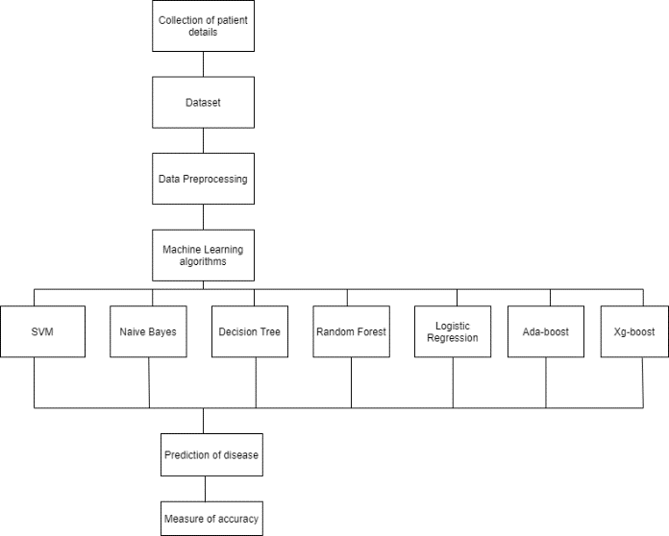
Fig: Architecture of Prediction System

- Collection of dataset:

Initially, we collect a dataset for our heart disease prediction system. After the collection of the dataset, we split the dataset into training data and testing data. The training dataset is used for prediction model learning and testing data is used for evaluating the prediction model. For this project, 70% of training data is used and 30% of data is used for testing.
The dataset used for this project is Heart Disease UCI. The dataset consists of 76 attributes; out of which, 14 attributes are used for the system.

- Selection of attributes

Attribute or Feature selection includes the selection of appropriate attributes for the prediction system. This is used to increase the efficiency of the system. Various attributes of the patient like gender, chest pain type, fasting blood pressure, serum cholesterol, exang, etc are selected for the prediction. The Correlation matrix is used for attribute selection for this model.

- Pre-processing of Data

Data pre-processing is an important step for the creation of a machine learning model. Initially, data may not be clean or in the required format for the model which can cause misleading outcomes. In pre-processing of data, we transform data into our required format.
It is used to deal with noises, duplicates, and missing values of the dataset. Data pre-processing has the activities like importing datasets, splitting datasets, attribute scaling, etc. Pre- processing of data is required for improving the accuracy of the model.
- Balancing of Data

Imbalanced datasets can be balanced in two ways. They are Under Sampling and Over Sampling

  - Under Sampling:
In Under Sampling, dataset balance is done by the reduction of the size of the ample class. This process is considered when the amount of data is adequate.

  - Over Sampling:
In Over Sampling, dataset balance is done by increasing the size of the scarce samples. This process is considered when the amount of data is inadequate.

- Prediction of Disease

Various machine learning algorithms like SVM, Naive Bayes, Decision Tree, Random Tree, Logistic Regression, Ada-boost, Xg-boost are used for classification. Comparative analysis is performed among algorithms and the algorithm that gives the highest accuracy is used for heart disease prediction.

- MACHINE LEARNING ALGORITHMS
Machine learning is a powerful technology that is a systematic study of various algorithms that provide the system with the potential to replicate human learning activities without being actually programmed. Machine learning is further divided into three types: Unsupervised Learning, Supervised Learning, and Reinforcement Learning.

- Naive Bayes

Naive Bayes algorithm is used to resolve classification problems. It is a supervised machine learning algorithm, which is based on the Bayes theorem. Naïve Bayes Classifier is one of the simple and most effective Classification algorithms which helps in building fast machine learning models that can make quick predictions. It is mainly used in data classification that includes a high-level training dataset. The Naive Bayes algorithm predicts the data based on probability, so it is also known as a probabilistic classifier. Naive Bayes classifier assumes that every particular feature in the dataset is independent of all other features.
P ( h|D ) = (P( D|h ))∗(P(h))
P(D)

- P (D): the probability of the data (regardless of the hypothesis). This is known as the marginal probability or probability of evidence.
- P (h): the probability of hypothesis h being true (regardless of the data). This is referred to as the prior probability of h.
- P (h|D): the probability of hypothesis h given the data D. This is known as posterior probability.
- P (D|h): the probability of data d given that the hypothesis h was true. This is known as likelihood probability.

- Logistic Regression:

Logistic regression is also a supervised learning classification algorithm that is used to solve both classification and regression problems. In classification problems, the target variable may be in a binary or discrete format either 0 or 1. Logistic regression algorithm works on the sigmoid function, so the categorical variable results as 0 or 1, Yes or No, True or False, etc. It is a predictive analysis algorithm that works on mathematical functions.
Logistic regression uses a sigmoid function or logistic function which is a complex cost function. The sigmoid functions return the value between 0 and 1. If the value less than 0.5 then it is considered as 0 and greater than 0.5 it is considered as 1. Thus to build a model using logistic regression sigmoid function is required.
There are three main types of logistic regression:
- Binomial: The target variable can have only 2 possibilities either “0” or “1” which may represent “win” or “loss”, “pass” or “fail”, “true” or “false”, etc.
- Multinomial: Here, the target variable can have 3 or more possibilities that are not ordered which means it has no measure in quantity like “disease A” or “disease B” or “disease C”.
- Ordinal: In this case, the target variables deal with ordered categories. For example, a test score can be categorized as: “poor”, “average”, “good”, and “excellent”. Here, each category can be given a score like 0, 1, 2, and 3.

1

decision tree, the random forest acquires the prediction from each tree, and based on the majority of votes for predictions, it predicts the final output. The higher number of trees in the forest leads to better accuracy and also prevents the problem of over fitting. The final output is taken by using the majority voting classifier for a classification problem while in the case of a regression problem the final output is the mean of all the outputs.

- Support Vector Machine

Support vector machine (SVM) is a supervised learning algorithm that is used to analyze data. It is used to resolve classification and regression problems. An SVM model is a delineation of the examples as points in space, mapped so that the examples of the discrete categories are divided by a clear gap. The points are separated by a plane which is known as a hyper plane. A set of training data is given to it to mark them as belonging to either one of two categories; an SVM training algorithm then builds a model that assigns new examples of the same space are mapped and then predicts to which category they belong, making it a non-probabilistic binary linear classifier. SVM can be of two types:
  - Linear SVM: Linear SVM is used for data that is linearly separable. It means if a dataset can be segregated into two different classes by using a single straight line, then such data is labelled as linearly separable data, and the classifier is used called a Linear SVM classifier.
  - Non-linear SVM: Non-Linear SVM is used for data

f(x) =
(1+𝑒X)
that cannot be separated linearly, which means if a
dataset cannot be sorted by using a straight line, then

f(x) = Output between the 0 and 1 value e = base of the natural logarithm
x = input to the function.

The value of the logistic regression must range from 0 to 1, does not go beyond this limit, so the only possible curve formed is S-shaped. The S-form curve formed is known as the sigmoid function or the logistic function. In logistic regression, the threshold value plays an important role, which defines the probability of either 0 or 1. The values above the threshold value reach 1, and a value below the threshold value reaches 0.

3. Random Forest

Random Forest classifier is a supervised learning technique in machine learning. It can be used to solve both Classification and Regression problems in machine learning. It is based on the process of combining multiple classifiers to solve a complex problem and to improve the performance of the model, which is known as ensemble learning. Random Forest consists of several decision trees on various subsets of the given dataset and takes the average to improve the predictive accuracy of that dataset. Rather than relying on a single
such data is referred to as non-linear data and the classifier used is called a Non-linear SVM classifier.

- Decision Tree

Decision Tree algorithm is also a supervised learning technique, mostly preferred for solving Classification problems but can be used for both classification and regression problems. The decision tree is a tree-structured classifier, where branches represent the decision rules which are used to make any decision and have multiple branches, internal nodes represent the features of a dataset, and each leaf node represents the outcome of the decisions and does not contain any further branches. It is a graphical representation for getting all the possible solutions to a problem/decision based on given constraints. The decisions or the analysis are performed based on features of the given dataset. A decision tree simply asks a question and based on the answer, it further splits the tree into sub trees.

- Ada-boost

AdaBoost is short for Adaptive Boosting and is a widely accepted boosting technique that combines multiple weak classifiers to build a strong classifier. It is done by building a

model using a series of weak models. AdaBoost was developed for binary classification. It selects a training subset randomly and builds a model. It then iteratively trains the AdaBoost machine learning model by selecting the training set based on the accurate prediction of the last training. It assigns the higher weight to the erroneously classified observations so that in the next iteration these observations would have a higher prospect for classification. This is done to correct the errors present in the first model. It also assigns weight to the trained classifier in every iteration according to the accuracy of the classifier. The more accurate classifier will get high weight. This process iterates until the entire training data fits without any error or until it reaches the specified maximum number of models are added.

- Xg-boost

Xgboost is short for Extreme Gradient Boosting. XgBoost is an ensemble method based on decision trees that build out a strong learner from several weak learners. XgBoost algorithm is used to boost the performance of the model and is used to provide better accuracy. In this, decision trees are built sequentially. Weights are randomly assigned to all the features which are independent of each other and fed to the decision tree which predicts the results. The weights of wrongly predicted features by the decision trees are increased and these features are sent to the next decision tree. The correctly predicted weights of features by the decision trees are reduced. This process continues sequentially until correct results are predicted. These individual classifiers then combine to produce a strong and more precise model. Xgboost is used for solving both regression and classification problems.

- PERFORMANCE ANALYSIS
In this project, various machine learning algorithms like SVM, Naive Bayes, Decision Tree, Random Forest, Logistic Regression, Adaboost, Xgboost are used to predict heart disease. Heart Disease UCI dataset, has a total of 76 attributes, out of those only 14 attributes are considered for the prediction of heart disease. Various attributes of the patient like gender, chest pain type, fasting blood pressure, serum cholesterol, exang, etc are considered for this project. The accuracy for individual algorithms has to measure and whichever algorithm is giving the best accuracy, that is considered for the heart disease prediction. For evaluating the experiment, various evaluation metrics like accuracy, confusion matrix, precision, recall, and f1-score are considered.
Accuracy- Accuracy is the ratio of the number of correct predictions to the total number of inputs in the dataset.
It is expressed as:
Accuracy = (𝑇𝑃+𝑇𝑁)
(𝑇𝑃+𝐹𝑃+𝐹𝑁+𝑇𝑁)
Confusion Matrix- It gives us a matrix as output and gives the total performance of the system.
Fig: Confusion Matrix

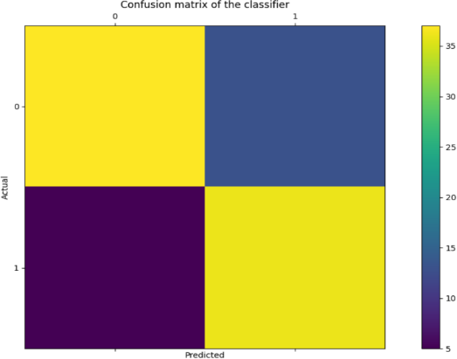

Where TP: True positive
FP: False Positive FN: False Negative TN: True Negative

Correlation Matrix:
The correlation matrix in machine learning is used for feature selection. It represents dependency between various attributes.
Fig: Correlation matrix
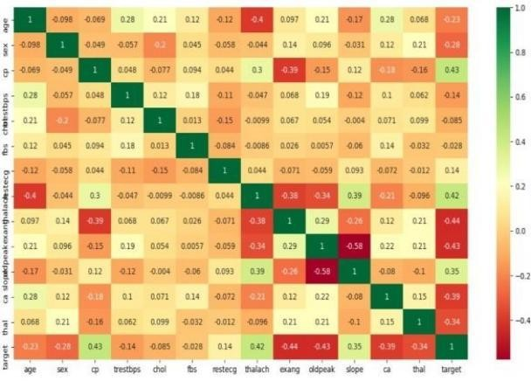

Precision- It is the ratio of correct positive results to the total number of positive results predicted by the system.
It is expressed as: 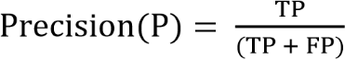
Recall- It is the ratio of correct positive results to the total number of positive results predicted by the system.
It is expressed as: 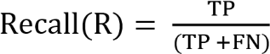
F1 score- It is the harmonic mean of Precision and Recall. It measures the test accuracy. The range of this metric is 0 to 1.
It is expressed as:

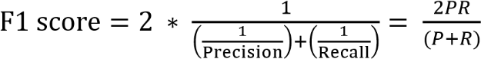

- RESULT
After performing the machine learning approach for training and testing we find that accuracy of the xgboost is better compared to other algorithms. Accuracy is calculated with the support of the confusion matrix of each algorithm, here the number count of TP, TN, FP, FN is given and using the equation of accuracy, value has been calculated and it is concluded that extreme gradient boosting is best with 81% accuracy and the comparison is shown below.

TABLE: Accuracy comparison of algorithms

Algorithm | Accuracy
XGBoost | 81.3%
SVM | 80.2%
Logistic Regression | 79.1%
Random Forest | 79.1%
Naive Bayes | 76.9%
Decision Tree | 75.8%
Adaboost | 73.6%

The highest accuracy is given by the XGBoost algorithm

- CONCLUSION AND FUTURE SCOPE
Heart diseases are a major killer in India and throughout the world, application of promising technology like machine learning to the initial prediction of heart diseases will have a profound impact on society. The early prognosis of heart disease can aid in making decisions on lifestyle changes in high-risk patients and in turn reduce the complications, which can be a great milestone in the field of medicine. The number of people facing heart diseases is on a raise each year. This prompts for its early diagnosis and treatment. The utilization of suitable technology support in this regard can prove to be highly beneficial to the medical fraternity and patients. In this paper, the seven different machine learning algorithms used to measure the performance are SVM, Decision Tree, Random Forest, Naïve Bayes, Logistic Regression, Adaptive Boosting, and Extreme Gradient Boosting applied on the dataset. The expected attributes leading to heart disease in patients are
available in the dataset which contains 76 features and 14 important features that are useful to evaluate the system are selected among them. If all the features taken into the consideration then the efficiency of the system the author gets is less. To increase efficiency, attribute selection is done. In this n features have to be selected for evaluating the model which gives more accuracy. The correlation of some features in the dataset is almost equal and so they are removed. If all the attributes present in the dataset are taken into account then the efficiency decreases considerably. All the seven machine learning methods accuracies are compared based on which one prediction model is generated. Hence, the aim is to use various evaluation metrics like confusion matrix, accuracy, precision, recall, and f1-score which predicts the disease efficiently. Comparing all seven the extreme gradient boosting classifier gives the highest accuracy of 81%.

- REFERENCES

- Soni J, Ansari U, Sharma D & Soni S (2011). Predictive data mining for medical diagnosis: an overview of heart disease prediction. International Journal of Computer Applications, 17(8), 43-8

- Dangare C S & Apte S S (2012). Improved study of heart disease prediction system using data mining classification techniques. International Journal of Computer Applications, 47(10), 44-8.

- Ordonez C (2006). Association rule discovery with the train and test approach for heart disease prediction. IEEE Transactions on Information Technology in Biomedicine, 10(2), 334-43.

- Shinde R, Arjun S, Patil P & Waghmare J (2015). An intelligent heart disease prediction system using k-means clustering and Naïve Bayes algorithm. International Journal of Computer Science and Information Technologies, 6(1), 637-9.

- Bashir S, Qamar U & Javed M Y (2014, November). An ensemble-based decision support framework for intelligent heart disease diagnosis. In International Conference on Information Society (i-Society 2014) (pp. 259- 64). IEEE. ICCRDA 2020 IOP Conf. Series: Materials Science and Engineering 1022 (2021) 012072 IOP Publishing doi:10.1088/1757- 899X/1022/1/012072 9

- Jee S H, Jang Y, Oh D J, Oh B H, Lee S H, Park S W & Yun Y D (2014). A coronary heart disease prediction model: the Korean Heart Study. BMJ open, 4(5), e005025.

- Ganna A, Magnusson P K, Pedersen N L, de Faire U, Reilly M, Ärnlöv J & Ingelsson E (2013). Multilocus genetic risk scores for coronary heart disease prediction. Arteriosclerosis, thrombosis, and vascular biology, 33(9), 2267-72.

- Jabbar M A, Deekshatulu B L & Chandra P (2013, March). Heart disease prediction using lazy associative classification. In 2013 International Mutli- Conference on Automation, Computing,Communication, Control and Compressed Sensing (iMac4s) (pp. 40- 6). IEEE.

- Brown N, Young T, Gray D, Skene A M & Hampton J R (1997). Inpatient deaths from acute myocardial infarction, 1982-92: analysis of data in the Nottingham heart attack register. BMJ, 315(7101), 159-64.

- Folsom A R, Prineas R J, Kaye S A & Soler J T (1989). Body fat distribution and self-reported prevalence of hypertension, heart attack, and other heart disease in older women. International journal of epidemiologyy, 18(2), 361-7.

- Chen A H, Huang S Y, Hong P S, Cheng C H & Lin E J (2011, September). HDPS: Heart disease prediction system. In 2011 Computing in Cardiology (pp. 557-60). IEEE.

- Parthiban, Latha and R Subramanian. "Intelligent heart disease prediction system using CANFIS and genetic algorithm." International Journal of Biological, Biomedical and Medical Sciences 3.3 (2008).

- Wolgast G, Ehrenborg C, Israelsson A, Helander J, Johansson E & Manefjord H (2016). Wireless body area network for heart attack detection [Education Corner]. IEEE antennas and propagation magazine, 58(5), 84-92.

- Patel S & Chauhan Y (2014). Heart attack detection and medical attention using motion sensing device -kinect. International Journal of Scientific and Research Publications, 4(1), 1-4.

- Piller L B, Davis B R, Cutler J A, Cushman W C, Wright J T, Williamson J D & Haywood L J (2002). Validation of heart failure events in the Antihypertensive and Lipid Lowering Treatment to Prevent Heart Attack Trial (ALLHAT) participants assigned to doxazosin and chlorthalidone. Current controlled trials in cardiovascular medicine

- Raihan M, Mondal S, More A, Sagor M O F, Sikder G, Majumder M A & Ghosh K (2016, December). Smartphone based ischemic heart disease (heart attack) risk prediction using clinical data and data mining approaches, a prototype design. In 2016 19th International Conference on Computer and Information Technology (ICCIT) (pp. 299-303). IEEE.

- A. Aldallal and A. A. A. Al-Moosa, "Using Data Mining Techniques to Predict Diabetes and Heart Diseases", 2018 4th International Conference on Frontiers of Signal Processing (ICFSP), pp. 150-154, 2018, September.

- Takci H (2018). Improvement of heart attack prediction by the feature selection methods. Turkish Journal of Electrical Engineering & Computer Sciences, 26(1), 1-10.

- Ankita Dewan and Meghna Sharma, "Prediction of heart disease using a hybrid technique in data mining classification", 2015 2nd International Conference on Computing for Sustainable Global Development (INDIACom)

- Aditya Methaila, Prince Kansal, Himanshu Arya and Pankaj Kumar, PAGFE"Early heart disease prediction using data mining techniques", Computer Science & Information Technology Journal, pp. 53-59, 2014.

