PERFORMANCE EVALUATION OF LIGHTWEIGHT CONCRETE MIXTURES INCORPORATING EPS BEADS AND ADDITIVES
Arjun P*¹, Dharmesh N², Madhusudhana Y B³
^{1,2,3}Assistant Professor, Department of Civil Engineering, RNS Institute of Technology, Bengaluru, Karnataka, India
*Corresponding Author: arjunp68@gmail.com
ABSTRACT: This study investigates the performance of different concrete mixtures, with a particular focus on the use of Expanded Polystyrene (EPS) beads and additives, such as silica fumes and fibers. The primary objective is to assess how these materials influence the weight and strength characteristics of concrete specimens. Three types of concrete specimens were examined: Conventional Concrete, Concrete with a 40% Replacement of Coarse Aggregate by EPS beads, and Concrete with a 40% Replacement of Coarse Aggregate by EPS beads along with Silica Fumes and Fibers. The results demonstrate a significant reduction in the weight of concrete specimens with the inclusion of EPS beads. A 40% replacement of coarse aggregate with EPS beads led to a weight reduction of approximately 13%, while the addition of silica fumes and fibers further increased the weight reduction to approximately 16%. This reduction in weight is advantageous in applications where lightweight construction materials are preferred, such as for ease of handling, transportation, and load-bearing considerations. However, it's important to note that the inclusion of EPS beads also resulted in a decrease in flexural strength. The flexural strength was inversely proportional to the weight reduction, highlighting the trade-off between weight reduction and structural performance. The study underscores the potential of EPS concrete and the impact of additives on weight and strength properties. It also raises questions regarding the optimization of mix designs to achieve a balance between weight reduction and other essential properties for specific construction applications. These findings contribute to the body of knowledge on sustainable construction materials and their practical applications in the construction industry. Further research is encouraged to explore tailored solutions for various construction scenarios, considering both sustainability and performance requirements.
Keywords: EPS Concrete, Weight Reduction, Flexural Strength, Silica Fumes, Fibers, Sustainability
INTRODUCTION

The construction industry is undergoing a transformative shift towards sustainable and environmentally responsible practices. One significant aspect of this transformation is the exploration of innovative materials and techniques to enhance construction efficiency while minimizing environmental impact. In this context, the incorporation of Expanded Polystyrene (EPS) beads into concrete mixtures has emerged as a promising avenue. EPS concrete, known for its lightweight and insulating properties, presents a unique opportunity to address two critical concerns in construction: weight reduction and energy efficiency. By replacing a portion of conventional coarse aggregates with EPS beads, concrete can achieve substantial weight reduction, making it an attractive option for applications where reduced structural weight is advantageous. This reduction not only facilitates easier handling and transportation but also contributes to energy savings in construction and reduced environmental footprints.

However, the introduction of EPS beads into concrete can also introduce challenges, particularly concerning strength properties. The trade-off between weight reduction and maintaining adequate strength is a crucial consideration in evaluating the feasibility and applicability of EPS concrete in various construction scenarios. Additionally, the study explores the impact of incorporating additives, such as silica fumes and fibers, in EPS concrete. These additives have the potential to enhance certain properties while addressing the limitations associated with weight reduction.

This research aims to comprehensively assess the effects of EPS beads and additives on the weight and strength characteristics of concrete. It presents a comparative analysis of conventional concrete, EPS concrete, and EPS concrete with additives, shedding light on their suitability for different construction applications. Moreover, the study contributes to the growing body of knowledge on sustainable construction materials and their role in achieving the delicate balance between structural performance and environmental responsibility.

METHODOLOGY

1) Styrofoam is utilized as a partial replacement for coarse aggregates in concrete mixtures, offering its lightweight insulation properties suitable for engineering applications.

2) Mix design adheres to IS 10262 standards to achieve M25 grade concrete, determining the appropriate ratios of cement, sand, aggregate, and the water-cement (w/c) ratio.

3) Comprehensive testing includes assessments of fresh concrete workability, as well as the strength properties of hardened concrete, with specimens created under various conditions for comparison.

MATERIAL
The materials used to manufacture EPS concrete are Ordinary Portland Cement of 53 grades, M-sand as fine aggregate, 20mm size coarse aggregates, EPS beads and water.

1. EXPANDED POLYSTYRENE BEADS (EPS)
Expanded polystyrene (EPS) is a versatile closed-cell foam, with a density range typically between 11 to 32 kg/m³. It appears as a white material and is crafted from pre-expanded polystyrene beads. EPS finds applications in food containers, insulation sheets for construction, and protective packaging, either in the form of solid blocks or loose-fill "peanuts" for safeguarding delicate items during shipping.
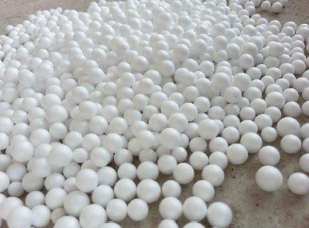
Fig. 1: Expanded Polystyrene Beads (EPS)

2. SILICA FUMES (SF)
Silica fume is a by-product from the production of elemental silicon or alloys containing silicon in electric arc furnaces. Silica fume particles are spherically shaped and very fine, having a mean size of 0.1–0.3 µm. Silica fumes plays very important role in improving the physical and chemical properties of concrete. Silica fume is addition benefits to concrete in two ways, firstly, the minute particles physically decrease the void space in the cement matrix, and secondly, silica fume works as very effective pozzolan, it chemically reacts to produce calcium silicate hydrate which results in the increase of compressive strength of concrete.
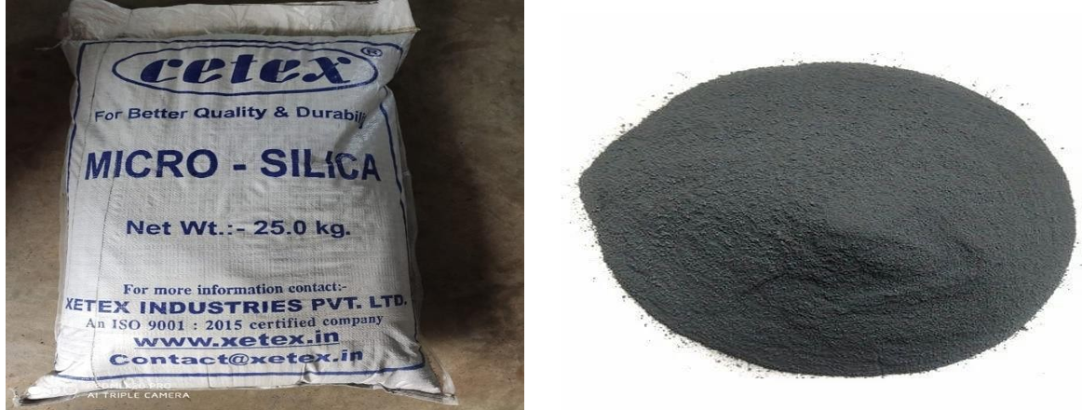
Fig. 2: Silica Fumes

3. POLYPROPYLENE FIBERS (PPF)
Polypropylene fibers can be divided into microfibers and macrofibers depending on their length and the function that they perform in the concrete. An overview of selected polypropylene fibers available on the market was presented. Furthermore, this study investigates the impact of polypropylene fibers on various physical and mechanical properties of concrete, including workability, elasticity modulus, compressive strength, flexural strength, and tensile strength.
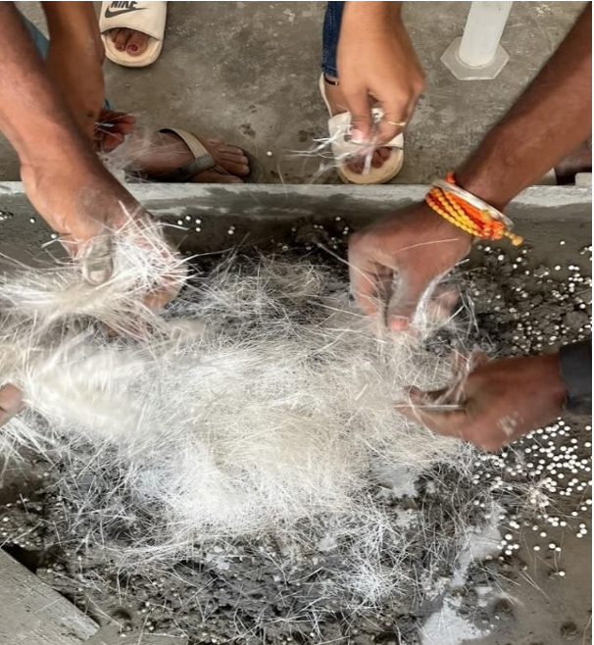

Fig. 3: Polypropylene Fibers

TESTING OF MATERIALS

Table 1: Description of materials
Sl. No. | Description
1 | Specific gravity of cement | 2.8
2 | Specific gravity of fine aggregate | 2.58
3 | Specific gravity of coarse aggregate by wire basket method | 2.84
4 | Compaction factor test for conventional concrete | 0.94

Materials required for casting Conventional Concrete of grade M25 (1:1:2), 40% EPS concrete and 40% EPS concrete cubes with silica fumes and Polypropylene Fibers

The experiment involved the preparation of three distinct concrete mixtures. The first mixture was a traditional concrete or conventional concrete (CC) blend comprising cement, coarse aggregate, fine aggregate, and water.

In the second mixture, cement was combined with a 40% substitution of coarse aggregate with EPS beads, along with fine aggregate and water.

The third mixture consisted of cement, a 40% replacement of coarse aggregate with EPS beads, fine aggregate, silica fumes, Polypropylene fibers, and water.

The specific proportions used for all three mixtures are documented in the Table 2.

Table 2: Specific Proportions Used For All Three Mixtures for One Cube
Sl. No. | Materials | CC | EPS 40 | EPS 40 + SF + PPF
1 | Cement (kg) | 2.25 | 1.882 | 1.882
2 | Fine Aggregate (kg) | 2.25 | 3.012 | 3.012
3 | Coarse Aggregate (kg) | 4.5 | 2.462 | 2.462
4 | Water (litres) | 1.0125 | 0.846 | 0.846
5 | EPS (grams) |  | 6 | 6
6 | Silica Fumes (grams) |  |  | 95
7 | Polypropylene fibers (grams) |  |  | 135

RESULTS AND DISCUSSION

1. Compressive Strength

Table 3: Compressive strength of Conventional Concrete cubes for 7 days
Specimen No. | Compression load ‘P’ kN | Area of cube  A (mm2) | Strength =P/A (N/mm2) | Average strength (N/mm2)
Cube 1 | 565 | 22500 | 25.11 | 25.77
Cube 2 | 650 | 22500 | 28.88 | 25.77
Cube 3 | 525 | 22500 | 28.33 | 25.77

Table 4: Compressive strength of Conventional Concrete cubes for 14 days
Specimen No. | Compression load ‘P’ kN | Area of cube A (mm2) | Strength =P/A (N/mm2) | Average strength (N/mm2)
Cube 4 | 700 | 22500 | 31.11 | 30.74
Cube 5 | 655 | 22500 | 29.11 | 30.74
Cube 6 | 720 | 22500 | 32 | 30.74

Table 5: Compressive strength of Conventional Concrete cubes for 28 days
Specimen No. | Compression load ‘P’ kN | Area of cube A(mm2) | Strength =P/A (N/mm2) | Average strength (N/mm2)
Cube 7 | 810 | 22500 | 36 | 35.33
Cube 8 | 775 | 22500 | 34.45 | 35.33
Cube 9 | 800 | 22500 | 35.56 | 35.33

Table 3 demonstrates 25.77 N/mm² average compressive strength after 7 days. In Table 4, this reaches 30.74 N/mm² at 14 days. Table 5 shows 35.33 N/mm² after 28 days.

The results presented indicate that the concrete mix utilized for these cubes has attained significant strength throughout the 28-day curing period. These strength values are characteristic of high-quality concrete at this stage, surpassing requirements for numerous construction applications. With an average strength of 35.33 N/mm², this batch of concrete showcases robust performance, making it well-suited for structural applications demanding substantial strength. It's important to recognize that the concrete's performance and strength development can differ based on factors such as mix design, curing conditions, and material quality. To summarize, Table 5 highlights the impressive compressive strength of conventional concrete cubes after 28 days of curing, underlining its suitability for a variety of construction purposes.

Table 6: Compressive strength of EPS 40 Concrete cubes for 7 days
Specimen No. | Compression load ‘P’ kN | Area of cube A(mm2) | Strength =P/A (N/mm2) | Average strength (N/mm2)
Cube 1 | 370 | 22500 | 16.44 | 15.84
Cube 2 | 350 | 22500 | 15.55 | 15.84
Cube 3 | 350 | 22500 | 15.55 | 15.84

Table 7: Compressive strength of EPS 40 Concrete cubes for 14 days
Specimen No. | Compression load ‘P’ kN | Area of cube A(mm2) | Strength =P/A (N/mm2) | Average strength (N/mm2)
Cube 5 | 370 | 22500 | 16.44 | 16.96
Cube 6 | 375 | 22500 | 16.67 | 16.96
Cube 7 | 400 | 22500 | 17.78 | 16.96

Table 8: Compressive strength of EPS 40 Concrete cubes for 28 days
Specimen No. | Compression load ‘P’ kN | Area of cube A(mm2) | Strength =P/A (N/mm2) | Average strength (N/mm2)
Cube 8 | 380 | 22500 | 16.88 | 17.78
Cube 9 | 400 | 22500 | 17.78 | 17.78
Cube 10 | 420 | 22500 | 18.67 | 17.78

Table 6 illustrates an average compressive strength of 15.84 N/mm2 for EPS 40 concrete cubes following 7 days of curing. This value increases to 16.96 N/mm2 after 14 days, as shown in Table 7. Furthermore, Table 8 indicates a further increase to 17.78 N/mm2 after 28 days of curing. These results collectively demonstrate the progressive enhancement in the compressive strength of EPS 40 concrete over the curing period, highlighting its suitability for diverse construction applications.

Table 9: Compressive strength of EPS40 concrete cubes with silica fumes and fibers for 7 days
Specimen No. | Compression load ‘P’ kN | Area of cube A(mm2) | Strength =P/A (N/mm2) | Average strength (N/mm2)
Cube 1 | 260 | 22500 | 11.56 | 10.89
Cube 2 | 225 | 22500 | 10 | 10.89
Cube 3 | 250 | 22500 | 11.11 | 10.89

Table 10: Compressive strength of EPS40 concrete cubes with silica fumes and fibers for 14 days
Specimen No. | Compression load ‘P’ kN | Area of cube A(mm2) | Strength =P/A (N/mm2) | Average strength (N/mm2)
Cube 4 | 320 | 22500 | 14.22 | 13.85
Cube 5 | 300 | 22500 | 13.33 | 13.85
Cube 6 | 315 | 22500 | 14.0 | 13.85

Table 11: Compressive strength of EPS40 concrete cubes with silica fumes and fibers for 28 days
Specimen No. | Compression load ‘P’ kN | Area of cube A(mm2) | Strength =P/A (N/mm2) | Average strength (N/mm2)
Cube 7 | 350 | 22500 | 15.55 | 15.85
Cube 8 | 360 | 22500 | 16 | 15.85
Cube 9 | 360 | 22500 | 16 | 15.85

Table 9 presents the compressive strength outcomes for EPS40 concrete cubes incorporating silica fumes and fibers, indicating a value of 10.89 N/mm² after 7 days of curing. The corresponding value increases to 13.85 N/mm² after 14 days, as observed in Table 10 and further to 15.85 N/mm² after 28 days of curing as shown in Table 11. These findings reflect the progressive strength enhancement in EPS40 concrete when supplemented with silica fumes and fibers, underscoring its potential suitability for various construction applications.

Overall, the tables showcase the importance of curing time on concrete strength development, with longer curing periods generally resulting in higher strengths. Additionally, the tables highlight the potential of alternative materials like EPS beads, silica fumes, and fibers to enhance concrete properties, opening opportunities for sustainable construction practices.

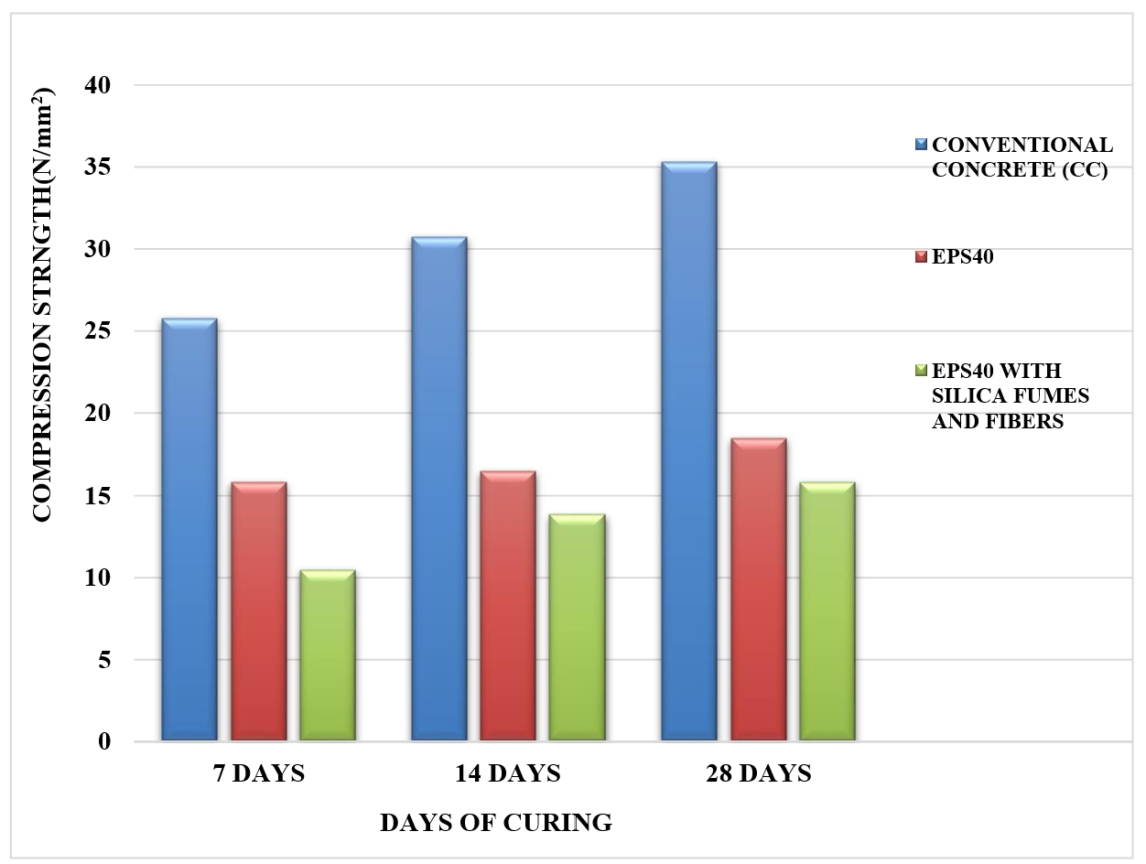
Fig. 4: Comparison of Compression Strength between Conventional Concrete, EPS40 and EPS40 with Silica Fumes and Fibers

2. Split tensile strength on concrete cylinders
Dimensions of mould used for casting cylinders for this test are,
- Diameter of mould (D) – 150mm
- Length of mould (L) – 300mm.

Table 12: Comparison of Flexural Strength between Conventional Concrete, EPS40 and EPS40 with Silica Fumes and Fibers

Sl. No. | Specimen Type | Flexural Strength in N/mm2 |  |  | Strength reduction (%)
Sl. No. | Specimen Type | 7 Days | 14 Days | 28 Days | Strength reduction (%)
1 | Conventional Concrete | 2.21 | 2.58 | 3.31 | -
2 | EPS40 | 1.53 | 1.80 | 2.35 | 29
3 | EPS40 with Silica Fumes and Fibers | 0.937 | 1.12 | 1.43 | 56

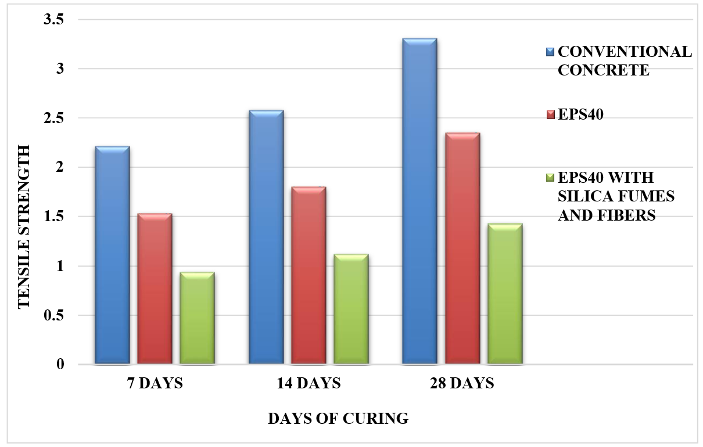
Fig. 5: Comparison of Split Tensile Strength between Conventional Concrete, EPS40 and EPS40 with Silica Fumes and Fibers

Conventional Concrete: The data shows that conventional concrete exhibited the highest flexural strength at all curing durations. At 28 days, it reached 3.31 N/mm², indicating its suitability for applications that require good bending resistance. However, it's important to note that as with most concrete types, there's a gradual increase in strength with longer curing periods.

EPS40: EPS40 concrete, which incorporates expanded polystyrene beads, demonstrated lower flexural strength compared to conventional concrete at all curing periods. However, it's essential to recognize that this reduction in strength is expected due to the lightweight and insulating properties of EPS beads. The reduction in flexural strength from 28 days to 7 days was 29%, indicating some improvement with prolonged curing.

EPS40 with Silica Fumes and Fibers: This variant of EPS40 concrete, enhanced with silica fumes and fibers, exhibited the lowest flexural strength among the tested specimens. At 28 days, it reached 1.43 N/mm². The significant reduction in strength (56%) compared to the 28-day strength is notable. This suggests that while additives like silica fumes and fibers may enhance other properties, they might have a trade-off in terms of flexural strength.

In summary, the table highlights the trade-offs associated with different concrete mixtures. Conventional concrete offers the highest flexural strength but is heavier. EPS40 concrete, with its lightweight properties, shows lower flexural strength, which can be partially improved with extended curing. The introduction of additives like silica fumes and fibers, while enhancing certain properties, may lead to a substantial reduction in flexural strength. The choice of concrete type should be based on the specific requirements of the intended application.
3. Weight reduction in cubes
The weight of specimen decreases as the replacement of the EPS beads in the concrete increases. When compared to the conventional concrete, the EPS specimen had significantly reduced their dead weight.
During the experimental study, the specimens lost their weight up to 13% and 16% for EPS40 and EPS40 with silica fumes and fibers respectively. This showed that using of cubes containing EPS40 with silica fumes and fibers significantly reduces the dead weight and light weight concrete factor is achieved.
Following is the table showing results in weight reduction of average of 10 cubes.

Table 13: Weight Reduction
Sl. No. | Specimen | Weight of concrete  (In kgs) | Weight reduction  (In kgs)
1 | Conventional Concrete | 8.240 | -
2 | 40%Replacement by EPS | 7.160 | 1.080  (13%)
3 | 40%Replacement by EPS with silica  fumes and fibers | 6.920 | 1.320  (16%)

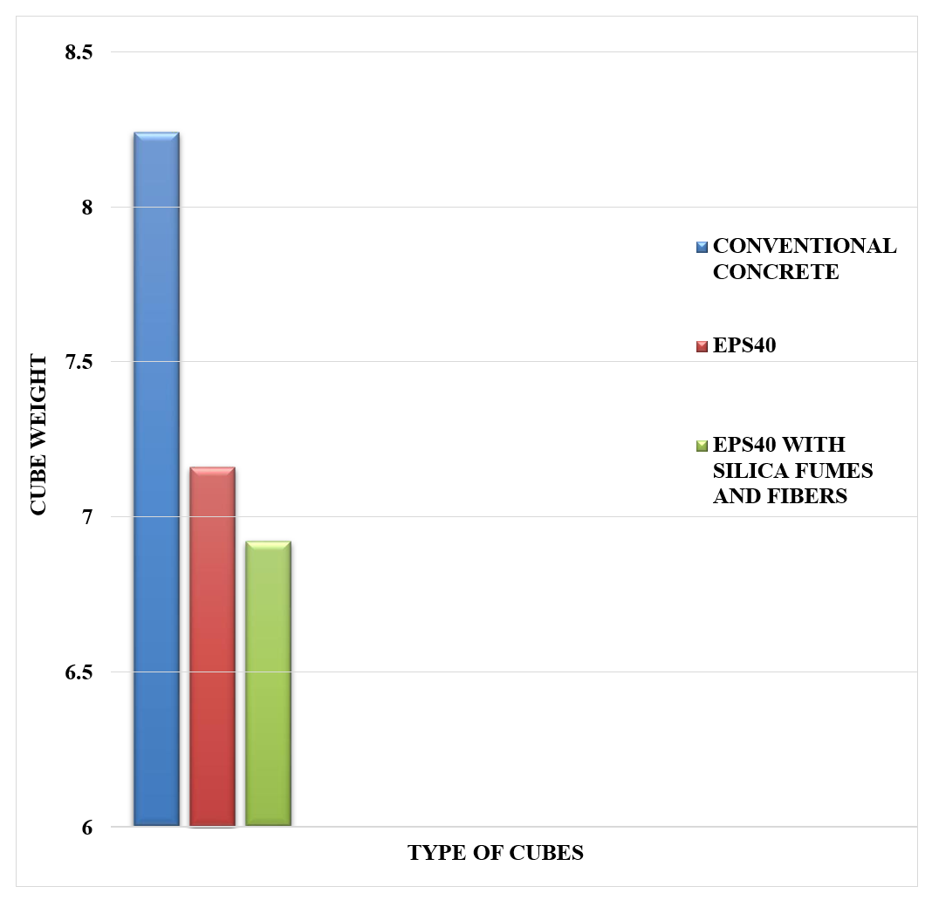

Fig 9.1 shows the Weight comparison between conventional concrete, EPS40 and EPS40 with fumes and fiber.

Conventional Concrete: The data shows that the weight of conventional concrete is 8.24 kgs. This serves as the baseline weight for comparison.

40% Replacement by EPS: In this case, where 40% of the coarse aggregate is replaced by Expanded Polystyrene (EPS) beads, the weight of the concrete reduces to 7.16 kgs. This represents a weight reduction of approximately 13% compared to conventional concrete.

40% Replacement by EPS with Silica Fumes and Fibers: For this variant of concrete, which includes both EPS beads and additives like silica fumes and fibers, the weight further decreases to 6.92 kgs. These results in a weight reduction of approximately 16% compared to conventional concrete.

CONCLUSIONS
The following are the conclusion obtained from the work,
1. EPS Beads Reduce Concrete Weight: The incorporation of Expanded Polystyrene (EPS) beads in concrete significantly reduces its weight. A 40% replacement of coarse aggregate with EPS beads resulted in a weight reduction of approximately 13%, while adding silica fumes and fibers increased the weight reduction to about 16%.
2. Trade-off Between Weight and Flexural Strength: While EPS beads contribute to weight reduction, they also lead to a decrease in flexural strength, as seen in the flexural strength data. Therefore, the choice of concrete type should be based on a careful balance between weight reduction and structural requirements.
3. Enhancement with Additives: The introduction of silica fumes and fibers into EPS concrete can enhance certain properties but may have a trade-off with flexural strength. Engineers and builders should carefully evaluate the specific benefits and trade-offs when considering these additives.
4. Applications of Lightweight Concrete: Lightweight concrete, such as that achieved with EPS beads, is advantageous in applications where weight reduction is critical, such as in precast elements, transportation infrastructure, and situations where ease of handling is essential.
5. Sustainability Considerations: The use of lightweight materials like EPS in concrete may align with sustainability goals, as it can reduce transportation energy and associated emissions. Additionally, recycling EPS waste for use in construction contributes to waste reduction and environmental sustainability.
In summary, the study provides valuable insights into the effects of EPS beads and additives on concrete weight and properties. It emphasizes the importance of considering both the advantages and limitations of lightweight concrete options when selecting materials for construction projects.

REFERENCES

- Dupuguntala Lakshmi, Pranahita, Punkesh Kumar, “Experimental study on partial replacement of coarse aggregate by EPS beads in concrete blocks”, International journal of research publications and reviews. Vol. 3, Issue-7, pp 477-485, July 2022.
- Diyang He, Wukui Zheng and Zili Chen, “Influence of paste strength on the strength of expanded polystyrene (EPS) concrete with different densities”. University of Architecture and Technology. Polymers 2022, Vol. 14, 2529.
- Adeniran Jolaade, “Structural use of expanded polystyrene concrete”. Department of Civil Engineering, The Federal Polytechnic IIaro, Ogun State Nigeria. Vol. 5, Issue 6, June-2020 International Journal of Innovative Science and Research Technology.
- N. Shifu Jahan, CH Sangitha, “Partial use Of coarse aggregate by EPS beads in concrete blocks”. Department of civil engineering, Prathyusha engineering college, Tamil Nadu, India. Vol. 6 Issue-5, 2020 IJARIIE-ISSN(O)- 2395-439.
- Fayez Moutassem, “Ultra-light weight EPS concrete mixing procedure and predictive models for compressive strength” Department of Civil Engineering, American University of Ras AIK haimah, United ARAB Emirates. Vol. 8(5): 963-972, 2020.
- Rajesh Varma, Ms. Nikita Jain, “Partial replacement of coarse aggregate by EPS” IOSR Journal of Mechanical and Civil Engineering (IOSR-JMCE), e-ISSN:2278-1684, P-ISSSN:2320-334X, Vol. 17, Issue 4 ser.4, pp42-52.

AUTHORS PROFILE

 Arjun P currently serves as an Assistant Professor in the Department of Civil Engineering at RNS Institute of Technology, Bengaluru. He earned his undergraduate degree in Civil Engineering from The National Institute of Engineering (NIE), Mysore, in 2012, and later completed his Masters in Structural Engineering from R V College of Engineering (RVCE), Bengaluru, in 2014. With a decade of combined experience in teaching both undergraduate and postgraduate students and substantial industrial exposure, he has demonstrated an exceptional career trajectory. He has also contributed significantly to academia through the publication of numerous research papers. His professional interests encompass the fields of Structural Engineering and Earthquake Engineering.

 Dharmesh N currently holds the position of Assistant Professor in the Department of Civil Engineering at RNS Institute of Technology, Bengaluru. He earned his Bachelor's degree in Civil Engineering from Ghousia College of Engineering, Ramanagara, in 2010. Subsequently, he pursued a Masters in Earthquake Engineering from the esteemed University Visvesvaraya College of Engineering (UVCE), Bengaluru, in 2013. Presently, he is actively engaged in pursuing a Ph.D. at UVCE, Bangalore University. With a decade-long professional journey, he has excelled in both teaching undergraduate and postgraduate students and garnered valuable industrial experience. Notably, he has contributed significantly to academia, having authored several books and research papers. He is a proud member of esteemed professional bodies MIEI and MICI. His academic pursuits and accomplishments revolve around his keen interests in Structural Dynamics and Earthquake Engineering, making him a notable figure in the field.

 Madhusudhana Y B is currently serving as an Assistant Professor in the Department of Civil Engineering at RNS Institute of Technology, Bengaluru. He earned his Bachelor's degree in Civil Engineering from the University of Visvesvaraya College of Engineering (UVCE), Bengaluru, in 2011. Furthering his education, he completed his Masters in Earthquake Engineering from UVCE in 2013 and is presently pursuing a Ph.D. from Bangalore University. His academic interests encompass Structural Dynamics and Earthquake Engineering. With a remarkable tenure in academia spanning both undergraduate and postgraduate instruction, as well as a decade of valuable industrial exposure, he has demonstrated excellence in teaching. His significant contributions extend to publish research papers, and his memberships in professional bodies include MIEI and MICI, underscoring his commitment to the field.

