Development of Magnesium and Magnesium alloys for Biomedical Application: Critical Review
M. Venkatesh ¹ A.Johnson ^{2, *}

¹ Assistant Professor, ² Sr.Assitant Professor,
Department of Mechanical Engineering, Department of Mechanical Engineering,
Kamala Institute of Technology and Science, Kamala Institute of Technology and Science,
Singapur,Telangana,505468, India Singapur,Telangana,505468, India 505468, India

ABSTRACT
The repair of bony defects and the replacement of hard tissue have gained significant attention in the field of biomedical materials. Among the materials under investigation, magnesium (Mg) alloys hold promise due to their potential for biocompatibility, osteoconductivity, and biodegradability within the body. These alloys offer mechanical properties akin to natural bone, actively facilitating new bone growth. In contrast to commonly used stainless steel, Co-Cr-Ni alloys, and titanium implants, Mg alloys exhibit several advantages.
However, the rapid degradation of Mg alloys in physiological environments can lead to challenges such as gas cavities, hemolysis, and osteolysis, which limit their application in clinical orthopaedics. To address these concerns, numerous strategies have been developed, encompassing novel alloy formulations, composite materials, advanced surface coatings, and microstructural modifications. This article explores into the latest research on the utilization of Mg alloy implants for bone repair and a comprehensive analysis of recent advancements in alloy design, surface enhancement techniques, and the biological performance of Mg alloys.
Keywords: Magnesium Alloys,Biomedical applications,Biomaterials,Orthopedic implants,Cardivascular implants
I. INTRODUCTION
Bones, the body's largest complex biological tissue, are made up of inorganic minerals and metabolically active cells surrounded by a large volume of extracellular matrix, and they form a rigid structure that plays an essential role in sustaining life activities such as body support and organ protection [1, 2]. In today's world, surgical treatment for bone injuries has become commonplace, with millions of patients seeking care in emergency departments globally every year due to various factors like strenuous sports activities, social incidents, road accidents, and the extended human lifespan [3,4]. Among these cases, bone defects represent a significant challenge for reconstruction, often resulting from traumatic avulsions, infection-induced bony sequestration, congenital abnormalities, or neoplastic resections. Addressing the imperative to stimulate bone regeneration for the structural repair of such defects has led to the development of a wide array of bone repair materials [2, 5].
The process of bone repair is a complex physiological mechanism influenced by biomechanical, biochemical, cellular, hormonal, and pathological factors. Successful bone repair relies on continuous cycles of bone deposition, resorption, and remodeling, as well as the availability of adequate blood supply [7]. Various bone repair materials have been devised, grounded in the fundamental principles of bone tissue healing. Autograft bones have long held the status of the gold standard in bone repair materials, as they possess the essential characteristics of osteoconductivity, osteogenicity, and osteoinductivity needed to foster new bone growth. However, the supply of these autografts is limited, and patients often endure additional surgeries that exacerbate their pain. As a result, alternatives to autografts, such as bone substitutes, are increasingly being employed to replace damaged or weakened bones.
Commonly used materials for this purpose include calcium phosphate ceramics, calcium sulfate, bioactive glass, natural substances, and biological/synthetic composites [8]. However, the clinical performance of these materials is often unsatisfactory; some have weak mechanical properties and limited osteoinductive capabilities in clinical practice [9, 10].
Another approach to repair or replace diseased or damaged bone tissue involves the use of metallic materials. Stainless steel and titanium alloys are currently prevalent in orthopedic applications due to their mechanical strength and resistance to fractures [11]. Nevertheless, corrosion and wear in these materials can lead to the release of metallic ions or particles, triggering inflammatory responses, reducing biocompatibility, and contributing to tissue loss. Moreover, the significant disparity in elastic moduli and tensile forces between metals and bone can result in stress shielding and weakening of the surrounding bone. Frequently, these inert implants need to be removed through invasive secondary surgeries once the bone fracture has fully healed.
To address these challenges, biodegradable implants have emerged as a potential solution, replacing traditional metal implants and eliminating the necessity for secondary procedures. This approach not only reduces patient discomfort but also lowers healthcare costs [12–14].

Magnesium (Mg) alloys have garnered considerable attention in the realm of orthopaedic applications due to their impressive biocompatibility, biodegradability, and favourable mechanical properties [15–17]. Mg is the fourth most abundant cation found in the human body, primarily residing within bone tissue and playing a pivotal role in various metabolic processes. This mineral is regularly and substantially consumed by the body, facilitating the growth of bone cells and expediting bone tissue healing. Notably, Mg alloys degrade in vivo, eliminating the need for secondary implant removal surgeries, a remarkable advantage owed to the physiological presence of Cl- ions. Furthermore, the excess Mg cations are readily excreted in urine, preventing unexpected complications from the corrosion agent, Mg2+ [17,18].
One of the standout features of Mg alloys is their mechanical properties, closely mirroring those of natural bone. In contrast to the relatively high densities of titanium alloys (Ti-6Al-4V, approximately 4.47 g/cm3) and stainless steel (about 7.8 g/cm3), Mg alloys exhibit a lightweight nature, with densities ranging from 1.7 to 1.9 g/cm3, remarkably similar to that of human cortical bone (1.75 g/cm3). Additionally, the elastic modulus of Mg alloys, approximately 45 GPa, closely aligns with the range of natural bone (3–20 GPa) and mitigates the stress shielding effect often observed with the substantial mechanical mismatch between natural bone and metal implants [19, 20].
As a result, Mg alloys present a compelling choice for orthopedic implants, combining biocompatibility, biodegradability, lightweight properties, and load-bearing capacity [12, 21].
While research on the utilization of magnesium (Mg) alloys as bone implants has made substantial progress over the past two decades, the persistent challenge lies in their rapid degradation when implanted within the human body. The clinical applicability of these materials hinges on achieving a balance between implant degradation and the pace of bone tissue healing, a process that typically encompasses an initial inflammatory phase (3–7 days), followed by a reparative stage leading to robust healing (3–4 months), and culminating in a remodeling phase spanning months to years [22]. Consequently, a minimum of 12 weeks of implant stability is imperative [12]. Unfortunately, the presently available Mg alloys degrade too swiftly during implantation to be considered practical.
The manufacture of magnesium alloys for bone repair has presented both opportunities and challenges, necessitating a comprehensive summary of the research findings in this domain. Distinguishing itself from recent reviews [15, 23], this paper maintains a sharper focus on biodegradable Mg alloys tailored for bone repair applications. It delves into the in vitro and in vivo biological performance of Mg in the context of bone repair, scrutinizing alloy design, surface modifications, and their respective impacts on in vitro and in vivo biological responses. Moreover, this paper explores innovative insights that have been harnessed to enhance the compatibility and mechanical strength of Mg alloys within the realm of bone reconstruction.

II. MAGNESIUM ALLOYS: ALLOYING DEVELOPMENT
In the realm of orthopedic applications, biodegradable implants must possess a specific set of attributes to be deemed suitable. These include adequate strength, ductility, fatigue resistance, and biocorrosion resistance. To meet these stringent criteria, numerous magnesium (Mg) alloys have been meticulously developed for use as materials in bone repair implants. The incorporation of alloying elements plays a pivotal role in enhancing mechanical properties and reducing the corrosion rate of Mg by inducing structural and phase alterations [17, 30].

A. Alloying Elements:
The initial step in crafting magnesium (Mg) alloys is a meticulous selection of alloying elements. The introduction of elements such as Al, Zn, Ca, Ag, Ce, and Th into Mg-based materials yields diverse microstructures and enhances mechanical properties [32, 33]. In terms of corrosion resistance, the choice of alloying elements with electrochemical potentials akin to Mg (2.37 V), including Y (2.37 V), Nd (2.43), and Ce (2.48), as well as those with substantial solid solubility in Mg like Sc (up to 25.9%), Gd (up to 23.5 wt. percent), and Dy (up to 25.3 wt. percent), proves instrumental in minimizing internal galvanic corrosion within physiological environments [20, 34, 35].
Comprehending biocompatibility is equally paramount. Extensive research has shown that the inclusion of essential biological nutrients (e.g., Ca, Sr, Zn, Si, and Mn) and trace, non-toxic elements (e.g., Zr, Nd, and Y) into the Mg matrix, either individually or in combination, does not incite adverse local tissue responses and can be readily absorbed by surrounding tissues [16, 19, 36]. In the pursuit of advancing biodegradable Mg alloys, researchers have embarked on a journey to confer novel biomedical functionalities through alloying. Elements like Ca, Sr, Ag, and Cu have demonstrated the capacity to stimulate bone cell activation and foster new bone formation as biofunctional trace metallic components. In addition to promoting osteogenesis, these components also exhibit antimicrobial properties after implantation, thereby reducing infection risks by alkalizing the implant environment and releasing antimicrobial metallic ions [37,39].

B. Alloy Structures:
In the quest for suitable materials for orthopedic applications, several commercial magnesium (Mg) alloy systems have emerged, chosen for their blend of robust mechanical properties and corrosion resistance. Notable among these are the AZ (Mg-Al-Zn), WE (Mg-RE-Zr), and ZK (Mg-Zn-Zr) sequence alloys, which have found application in biological research. In recent years, extensive research has been dedicated to AZ series alloys, particularly AZ31 (Mg-3Al-1Zn) and AZ91 (Mg-9Al-1Zn), with comprehensive in vitro and in vivo investigations [40]. These alloys have been shown to release hydrogen in physiological environments, resulting in a notable increase in pH and Mg ion concentration [41]. While AZ31 degrades more slowly in Hank's solution compared to AZ91, there is no discernible difference in vivo [42]. A biocompatible calcium phosphate protective film coating on the surfaces of AZ31 and AZ91 alloys has been observed to stimulate the formation of new bone mass around the implants in short-term in vivo studies [42, 43].
WE series alloys, on the other hand, demonstrate excellent biocorrosion resistance due to the formation of rare-earth (RE) oxide films in aqueous environments. WE54 (containing Nd, Y, Zr, Ce, Gd, Er, Yb, and balanced Mg in wt. percent) has exhibited slightly better resistance to degradation in vitro than pure Mg, with heat treatment affecting its degradation [44]. Research by Witte et al. regarding the in vivo biocompatibility of four different Mg alloys found that WE43 (containing Y, RE, Zr, Zn, and Mn in wt. percent) emerged as the most biocompatible option [43]. However, it's worth noting that increased Al ion concentration in the brain has been associated with Alzheimer's disease, and hepatotoxicity has been reported following the administration of RE elements like Y, Ce, and Pr [5].
Turning to ZK series alloys, especially ZK40 (Mg-4Zn-0.5Zr) and ZK60 (Mg-6Zn-0.5Zr), these alloys have recently garnered research attention due to the favorable biocompatibility of their constituent elements [45]. In terms of element biocompatibility and biosafety, Mg-Zn-Zr alloys offer distinct advantages over Mg-Al-Zn and Mg-RE-Zr alloys, positioning them as potential biodegradable metals for use in bone repair devices [14]. These alloys are particularly attractive considering the permissible daily consumption of 11 mg Zn and 50 µg Zr. However, it's essential to address the challenge of their relatively high degradation rates, which currently limit their widespread use.
In addition to the aforementioned commercial Mg alloy systems, newer Mg alloys like Mg-Ca, Mg-Sr, Mg-Zn, and Mg-RE have been developed for orthopedic applications. For instance, the addition of calcium (Ca) as a grain-refining agent in Mg alloys has demonstrated the ability to stabilize grain size, with the Ca content exerting a predictable influence [46]. Mg-1Ca alloy has exhibited excellent biocompatibility and bioactivity, as observed with active osteoblasts and osteocytes around implanted Mg-1Ca alloy pins in rabbit femoral shafts [38].
Strontium (Sr), a sibling element to calcium (Ca), shares numerous physical, chemical, and biological properties. Studies on Mg-x wt. percent Sr alloys have revealed that Mg-0.5Sr alloy exhibits relatively slower degradation [19]. Researchers have observed that as-extruded Mg-0.5Sr and as-rolled Mg-2Sr alloys offer an optimal combination of corrosion resistance, high strength, and in vivo biocompatibility [39].
Zinc (Zn), a crucial nutrient in the human body, has found application in biomedical contexts owing to its favorable health profile [47]. Combining Zn with Mg can reduce the rate of Mg corrosion while enhancing Mg's mechanical properties through solid solution hardening [48]. Mg alloys containing up to 5 wt.% Zn have demonstrated grain boundary, solid solution, and secondary phase strengthening, resulting in improved corrosion resistance and mechanical properties [49]. In vitro studies have indicated good biocompatibility for Mg-6Zn alloy, based on hemolysis and MC3T3-E1 cell adhesion assays [55].
Lastly, new Mg-RE alloys such as Mg-Y, Mg-Nd, Mg-Gd, Mg-Ce, and Mg-Ld have garnered attention due to their robust mechanical properties and corrosion resistance. Among these, Mg-Nd alloy has shown significantly slower corrosion rates compared to others [33]. The development of Mg-Y alloy, utilizing a zone solidification method, has resulted in improved corrosion resistance and mechanical properties [56]. Mg-Y-Zn alloy, characterized by an array of favorable microstructural, mechanical, electrochemical, and biological properties, holds great promise as a biodegradable implant material [57].

C. Microstructures of Alloys:
In Magnesium (Mg) Alloys, alloying elements can manifest as secondary-phase particles that precipitate within the grains or along grain boundaries, significantly enhancing mechanical properties through second-phase strengthening. Figure 1 illustrates the typical morphologies of second phases found in Mg alloys, while Table 1 provides an overview of the second phases commonly observed in biodegradable Mg alloys. These secondary phases possess higher electrochemical potentials than the Mg matrix, potentially facilitating corrosion and the release of their constituents into the physiological environment, thereby contributing to matrix degradation.
A study conducted by Kannan employed electrochemical measurements to assess the degradability of Mg17Al12 in a simulated body fluid (SBF) environment. Surprisingly, the degradation rate of Mg17Al12 was observed to be lower than that of pure, unalloyed Mg.

Table 1. Typical Secondary Phases in Biodegradable Magnesium Alloys [65, 66]
Biodegradable Magnesium alloys | Secondary Phases in the Magnesium Matrix
AZ31B [61], AZ61D | Mg17Al12
Mg-Ca | Mg17Al12, Al8Mn5
Mg-Sr | Mg2Ca
Mg-Zn | Mg17Sr2, Mg2Sr
Mg-Zn-Ca | MgZn2
Mg-Si | Mg2Zn3
Mg-Al-Si | Mg2Si
WE43 | Mg2Si
WE43 [69] | Mg24Y5, Mg41Nd5, Mg12Nd
ZK60 [70] | MgZn, MgZn2

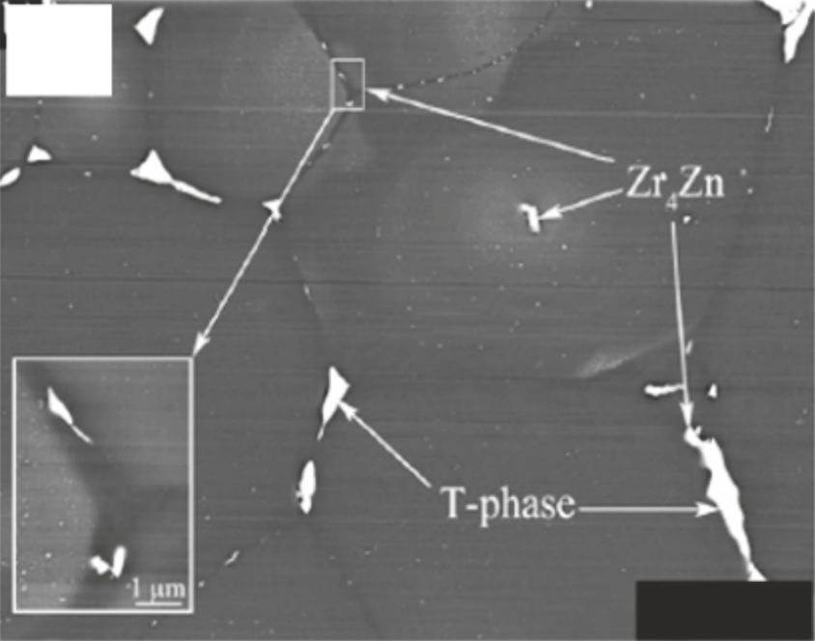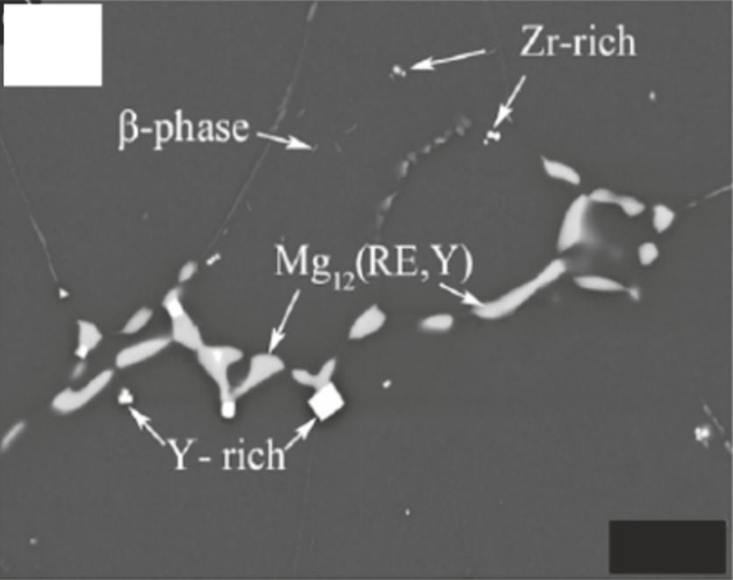
(a)
20 Ｇ
(b)
10 Ｇ
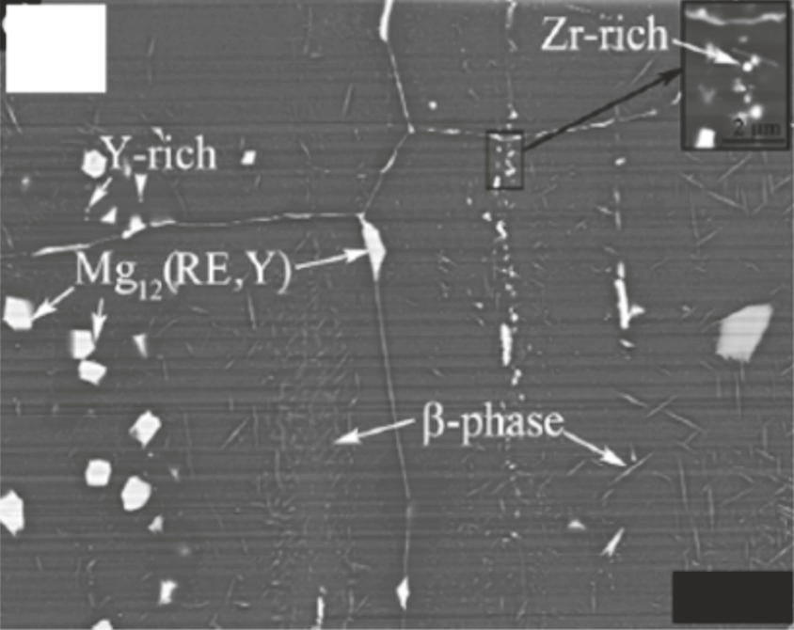
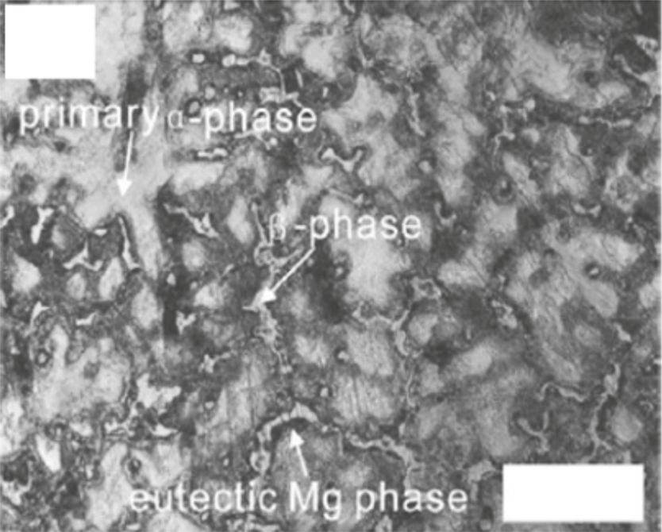
(c)
10 Ｇ
(d)
50 Ｇ

Figure 1. Common Secondary Phase Structures in (a) Cast ZE41, (b) Cast WE43, (c) Forged WE43 [24], and (d) AZ91D Alloys [25].
When assessing magnesium (Mg) alloy implants for potential use in bone repair, the durability of secondary phases and the Mg matrix under various conditions plays a crucial role in understanding degradation and biological responses within the body. In a study employing the Dmol3 measurement tool, Yang et al. conducted theoretical investigations into the thermodynamic stability of four conventional second phases found in Mg-Zn-Zr, Mg-Ca, Mg-Sr, and Mg-Al-Zn alloys, as well as the Mg matrix within bioabsorbable Mg alloys. It was observed that the phase stability of these second phases exceeded that of the Mg matrix. However, this stability exhibited significant variation across different forms of second phases and second-phase-4H₂O systems [32].
For instance, the second phase Mg17Al12, derived from Mg-Al-Zn alloys, underwent examination regarding in vitro biocompatibility and phagocytosis by macrophages. This investigation aimed to assess the impact of second phases on the biological compatibility of biodegradable Mg alloy implants. The results indicated that the presence of Mg17Al12 did not induce hemolysis and exhibited cytocompatibility. Furthermore, endolysosomal compartments played a pivotal role in processing Mg17Al12 particles, with lysosomes being crucial in the digestion of these particles [58].
It's noteworthy that not all alloying elements in Mg alloys give rise to second-phase particles. As previously mentioned, certain alloy constituents such as Y (with a 12 wt. percent limit), Sc (with a 25.9% limit), Gd (with a 23.5 wt. percent limit), and Dy (with a 25.3 wt. percent limit) possess relatively high solid solubility in Mg and manifest as solid solutions, resulting in solid solution strengthening. While the original crystal structure of magnesium remains unaltered in the solution, lattice distortion occurs, impeding dislocation motion and enhancing the strength of Mg. Gao et al. examined the influence of solid solutions on the mechanical behavior of binary Mg-Y single-phase alloys and found that an increase in Y content at room temperature led to heightened hardness due to substantial differences in atomic radii between Y and Mg, coupled with a reasonably broad range of solubilities [59].
Moreover, solid solution alloying has the potential to bolster the corrosion resistance of Mg alloys by mitigating internal galvanic corrosion between the second phase and the Mg matrix. Zhang et al. explored the effects of solid solution treatment on the corrosion and electrochemical behaviors of Mg-15Y alloy, revealing that solution treatment diminished galvanic corrosion due to the dissolution of Mg24Y5 second-phase particles into the matrix [60]. As a result, solid solution strengthening may offer a promising avenue for creating single-phase Mg alloys and enhancing the corrosion resistance of Mg alloys intended for orthopedic applications.

D. Magnesium Alloy Impurities:
Magnesium (Mg) alloys often exhibit an introduction of excess impurity elements during their casting and processing stages. Among the most prevalent impurities encountered in Mg alloys are iron (Fe), nickel (Ni), and copper (Cu) [31]. Established standards for impurity elements in Mg alloys specify tolerances of 35–50 ppm for Fe, 20–50 ppm for Ni, and 100–300 ppm for Cu (wt. percent). When impurity levels are maintained below these tolerance limits, they do not give rise to the production of impurity particles. Consequently, there are no electrochemically active cathodic sites to exacerbate corrosive attacks, resulting in a slower corrosion rate. However, when Fe, Ni, and Cu in Mg alloys exceed these tolerance limits, their low solubility and distinct positions in the electrochemical sequence significantly elevate the corrosion rate [31].
Furthermore, the addition of silicon (Si) to reactive impurity elements like Fe, Ni, and Cu has been found to exacerbate corrosion. This occurs because Si promotes the formation and growth of Fe-rich particles. Research by Lee et al. has highlighted that the ratio of impurities, such as the Fe/Mn ratio, holds greater significance than their absolute content in determining the corrosion behavior of Mg. As the Fe/Mn ratio increases, the high-rate corrosion phase extends [4.].
Due to the highly reactive nature of Mg alloys, they tend to generate numerous nonmetallic inclusions during the casting and processing phases, serving as prominent impurities within the alloys [62]. Principal nonmetallic inclusions encompass MgO, Mg3N2, MgF2, MgS2, and AlF3. These nonmetallic impurities originate from the oxidation of magnesium alloys in atmospheric conditions. For instance, the reaction between Mg and atmospheric oxygen yields MgO, a commonly observed inclusion in Mg alloys. Figure 2 illustrates various morphologies of MgO impurities within the Mg-Gd-Y-Zr alloy [26]. Additionally, when magnesium combines with nitrogen in the atmosphere, it results in the formation of Mg3N2. To address the adverse impact of nonmetallic impurities, ongoing purification techniques are continually evolving. Popular methods for purifying Mg alloys encompass gas purge, flux purification, filtering purification, rare-earth (RE) purification, and electromagnetic purification [62].

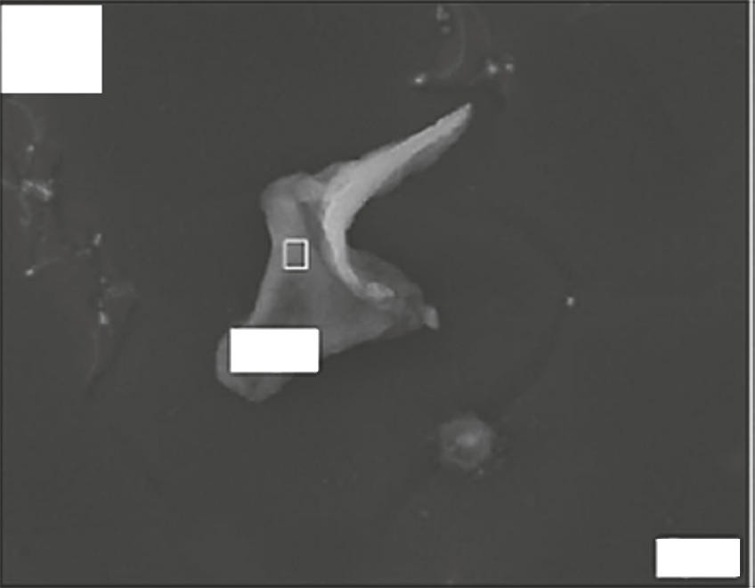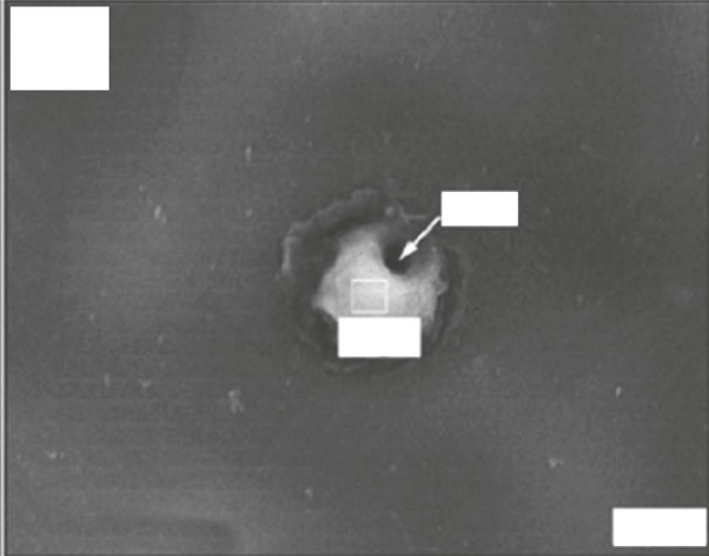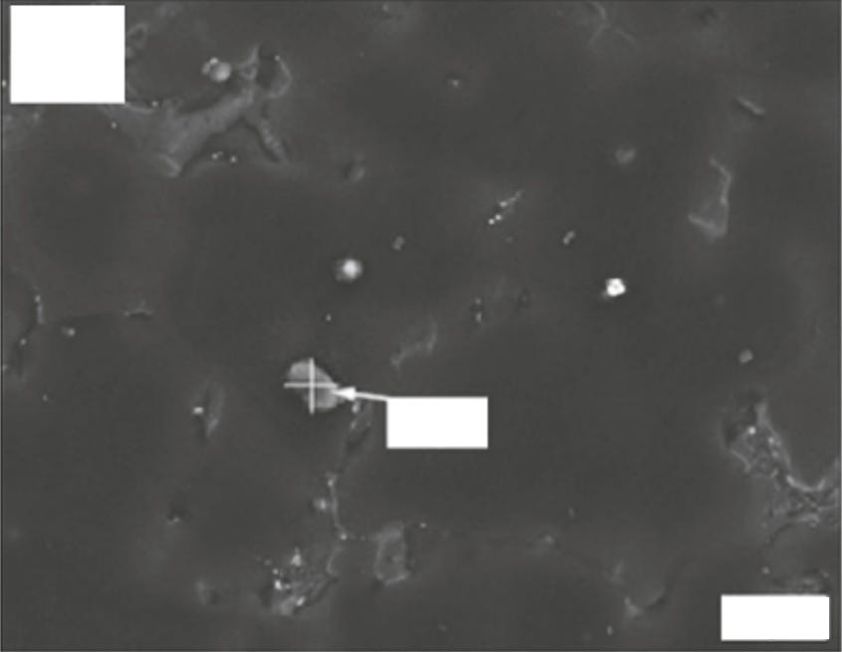
(a
MgO
5 Ｇ
(b
Pore
MgO
5 Ｇ
(c)
MgO
10 Ｇ
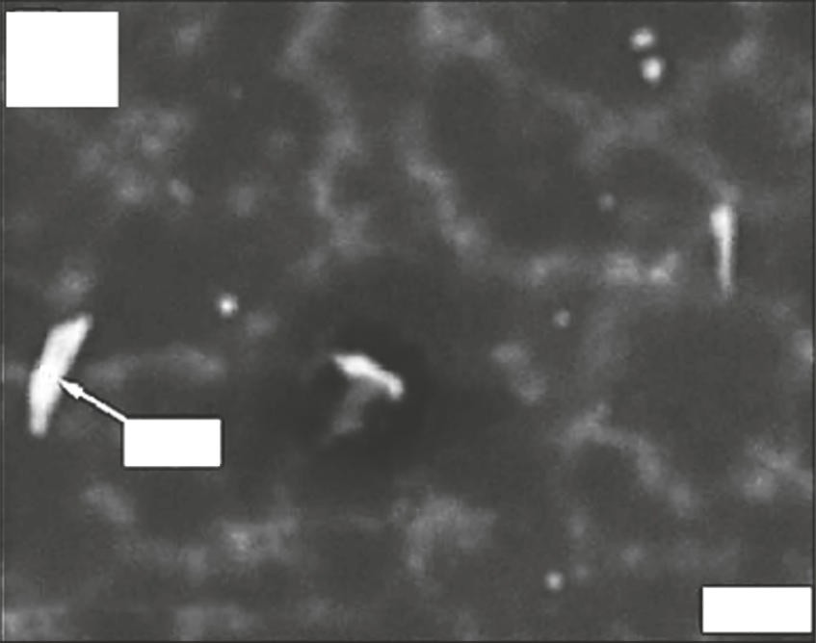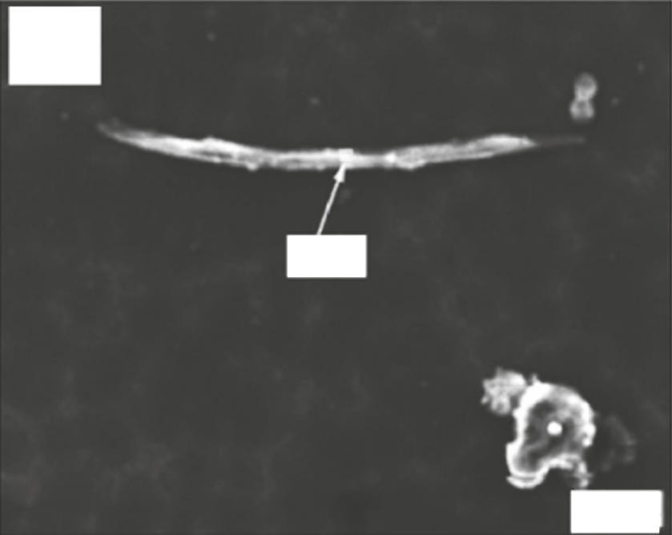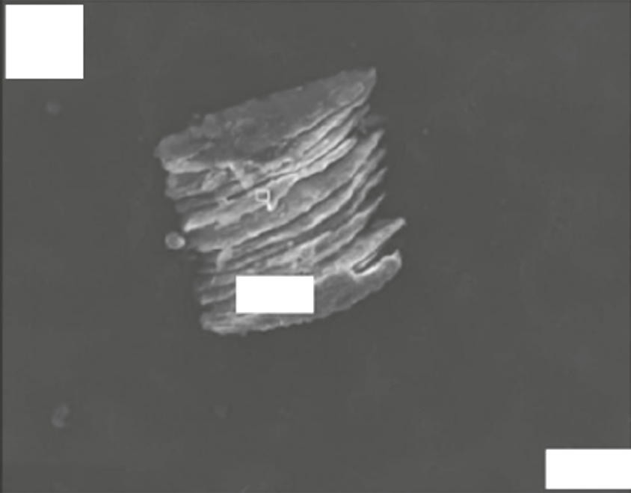
(d)
MgO
20 Ｇ
(e)
MgO
20 Ｇ
(f)
MgO
20 Ｇ
Figure 2. MgO Inclusions in Mg-Gd-Y-Zr: Scanning Electron Microscope (SEM) Images Depicting Various Morphologies (a) Z-shaped MgO inclusion (b) Spherical MgO inclusion (c) Block-shaped MgO inclusion (d) Rod-like MgO inclusion (e) Needle-like MgO inclusion (f) Lamellar MgO inclusion[26].

- MAGNESIUM ALLOYS SURFACE MODIFICATIONS

In the pursuit of bolstering the corrosion resistance of magnesium (Mg) alloys in physiological settings while preserving their mechanical integrity and improving interfacial biocompatibility, various surface modification techniques have been developed. Unlike alloying methods, surface modifications serve the specific purpose of creating a protective barrier between Mg alloys and the biological environment, preventing the penetration of body fluids into the substrate [47, 64]. These surface modification methods can be categorized into three main groups based on whether they result in the formation of a new phase on the surface of Mg alloys: chemical alterations, physical modifications, and a combination of both techniques [65].

A. Chemical alterations:
Chemical Alterations involve the creation of new surface phases on magnesium alloys through chemical or electrochemical reactions. This approach aims to replace the native oxide layer, which possesses limited passivating properties due to its inability to effectively safeguard against corrosion, although it forms readily owing to the high reactivity of the Mg matrix.
Examples of chemical modifications include acid etching, alkaline heat treatment, fluoride treatment, anodic oxidation, and microarc oxidation (MAO) [65]. Turhan et al. have reported that acid etching using a 2.5 percent H2SO4 solution significantly enhances the corrosion resistance of AZ91D alloys [67]. Additionally, alkaline heat treatment, a straightforward and cost-effective process, generates a Mg(OH)2 barrier layer on the substrate surface, thereby retarding the corrosion rate of the Mg alloy [68]. Sodium hydroxide (NaOH) treatment has also been documented to reduce the corrosion rate of Mg, with a concentration of 1 M NaOH resulting in the slowest corrosion rate. Moreover, fluoride treatment leads to the replacement of the original oxide film on magnesium alloys with a thin and uniform MgF2 coating, characterized by higher polarisation resistance.

.
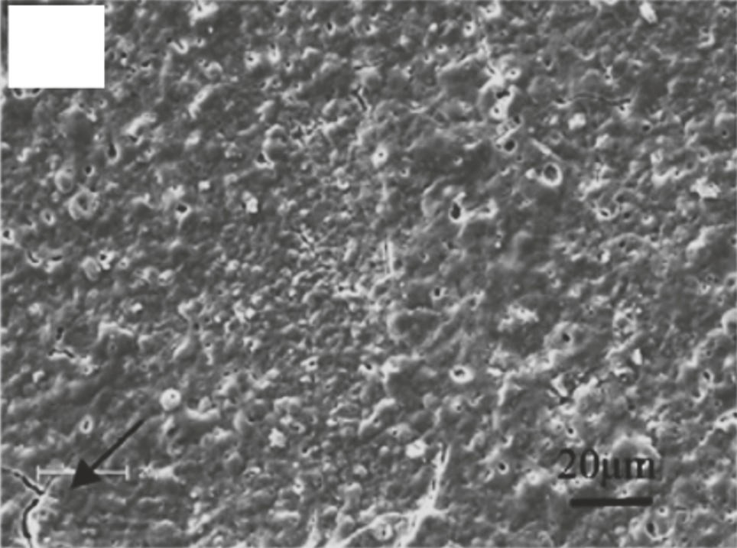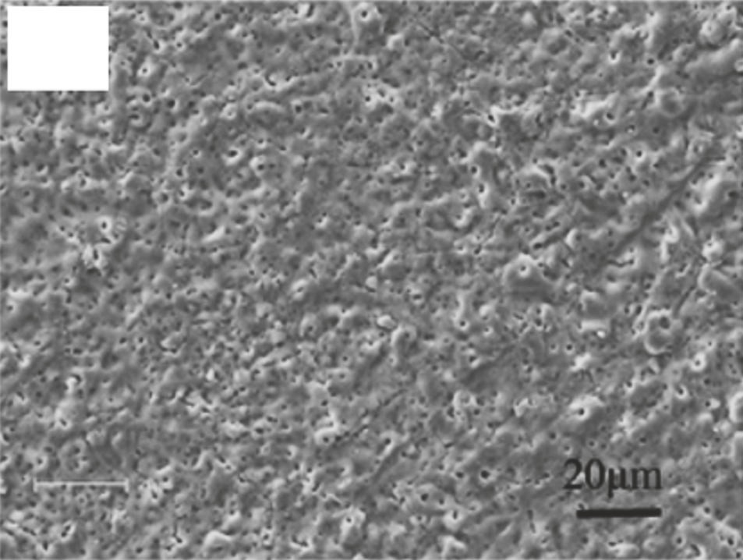
(a)
(b)
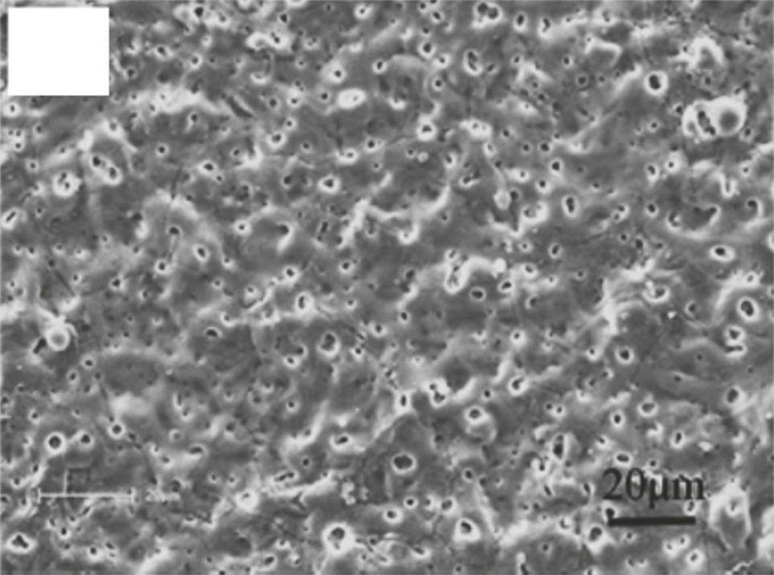
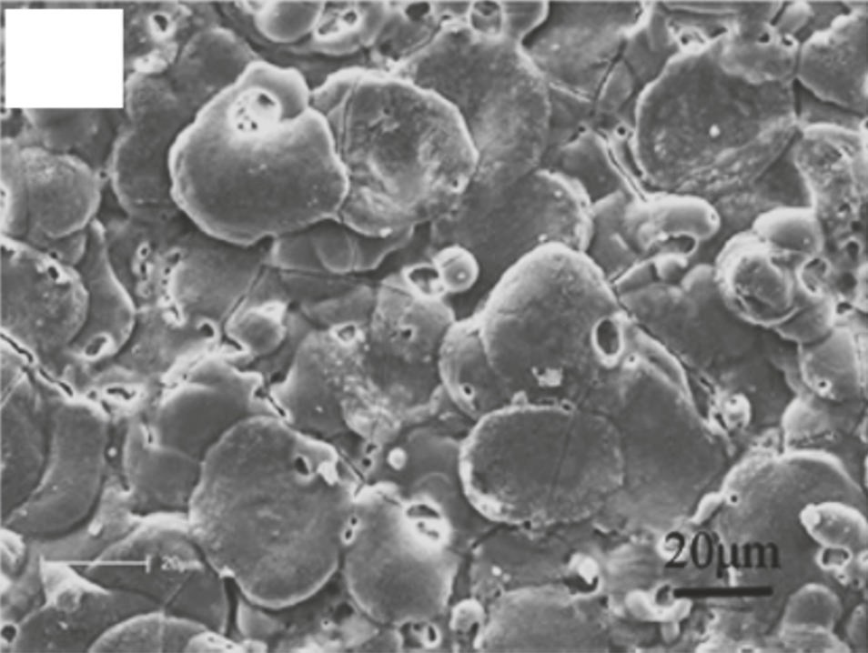
Figure 3.Microarc oxidation Surface Morphologies of ZK60 Alloy Coated at Different Voltages: (a) 230 V (b) 300 V (c) 370 V (d) 450 V [16]. The 230 V coating has several micro cracks, as shown by the black arrow in the diagram (a).
(c)
(d)

Acid etching is a widely employed pre-treatment process aimed at removing coarse-scale residues generated during manufacturing and replacing them with a more compact, passivated layer [66]. The advantages of a MgF2 layer encompass high density, low water solubility, and non-toxicity when fluorine ions are released into the host organism. According to Witte's findings, the MgF2 coating effectively retards in vivo corrosion of the LAE442 alloy without elevating fluoride concentrations in the adjacent bone [69]. Furthermore, the incorporation of fluoride into bone tissue may stimulate osteoblast proliferation, augment new mineral deposition in cancellous bones, and reduce the solubility of the bone tissue [70]. Experimental studies in dogs suggest that fluoride-modified implant surfaces promote osteointegration during the initial stages of healing following implant placement [70].
Anodic oxidation, an electrochemical process, forms a dense, solid oxide film on metal surfaces. Lei et al. utilized constant-current anodic oxidation to produce a magnesium oxide film on AZ31B Mg alloy. This oxide film effectively retards the degradation of AZ31B Mg alloy without negatively impacting osteoblast proliferation or new bone formation [71]. Meanwhile, microarc oxidation (MAO) is a plasma-assisted anodic oxidation technique utilized to modify the surfaces of biodegradable magnesium alloys. MAO coatings exhibit remarkable stiffness, good wear resistance, moderate corrosion resistance, and improved thermal and dielectric properties [72]. In an effort to delay degradation and enhance biological properties, Lin et al. applied forsterite-containing MAO coatings to ZK60 Mg alloy. The resistance to corrosion from the MAO coating increased with higher preparation voltages. Notably, MAO-coated ZK60 Mg alloy demonstrated a significantly lower hemolytic ratio and no cytotoxicity in L929 cells when compared to bare ZK60 Mg alloy. Figure 3 illustrates the surface morphologies of ZK60 alloy with MAO coatings produced at various voltages [16].

B. Physical Modifications:
Physical modifications, unlike chemical methods, do not involve the formation of chemical bonds between the surface and the substrates. Instead, these alterations are designed to establish a physical barrier that enhances the corrosion resistance of magnesium substrates. Some physical modification techniques include apatite coatings, polymer coatings, laser surface processing, and cold spray coatings [65, 73].
Natural bone inherently contains apatite, an inorganic mineral with exceptional bioactivity that can significantly accelerate bone fracture healing. Additionally, apatite possesses low solubility and high thermal stability, making it an ideal protective layer to enhance the degradation resistance of implants [74].
Hydroxyapatite (HA), a prominent member of the apatite family, mirrors the chemical composition of bone mineral and is frequently used to coat magnesium alloys for bone repair [65]. Wang et al. successfully generated a HA coating on ZK60 Mg alloy, observing that it effectively prevented alloy degradation and enhanced cytocompatibility for L929 cells, rendering ZK60 alloy more suitable for orthopaedic applications.
Modifications of Mg alloys through polymer coatings also hold promise for orthopaedic applications. Gray-Munro et al. explored the impact of PLA, a semicrystalline biodegradable polymer, on the corrosion rate of AZ31 Mg alloy in simulated body fluid (SBF) and found that the coating mitigated corrosion, particularly during the initial stages of implantation [41].
Laser surface processing, involving the use of a high-energy laser beam to control the biodegradation of magnesium alloys, has been observed to induce secondary phase dissolution and the development of a fine-grained structure. When employing laser surface processing, Coy et al. reported significant dissolution of the Mg17Al12 second phase in AZ91D [74]. Similarly, Guo et al. and Khalfaui et al. reported analogous outcomes when utilizing laser processing for WE43 and ZE41 alloys [75, 76]. These modified alloys have demonstrated substantial improvements in corrosion resistance [77].
Surface engineering of Mg alloys via cold spray technology presents another viable option. This technique involves the ballistic impingement of particles, typically ranging in size from 1 to 100 µm, onto the substrate surface using a high-velocity gas stream. Cold spray is a low-temperature process that can be employed to deposit bioactive coatings on Mg alloys, preventing substrate oxidation and phase alterations. Recent investigations by Noorakma et al. explored the deposition of HA on an AZ51 alloy using a modified cold spray process, revealing improved retention of HA characteristics [73].
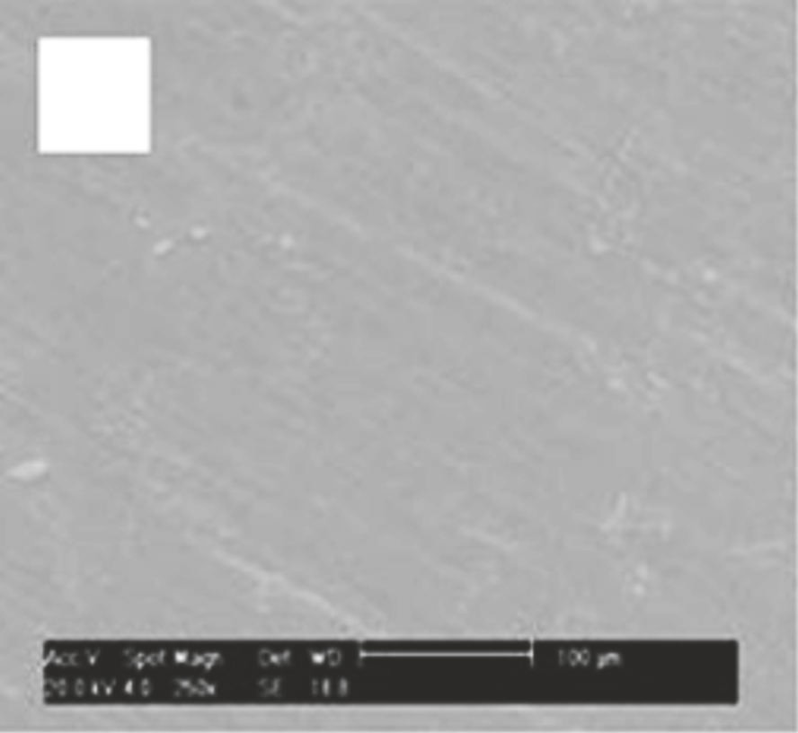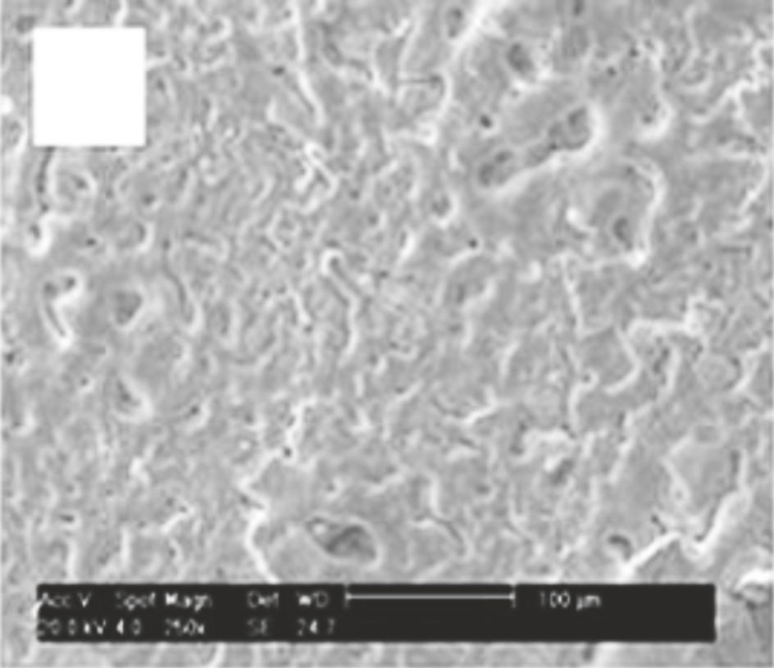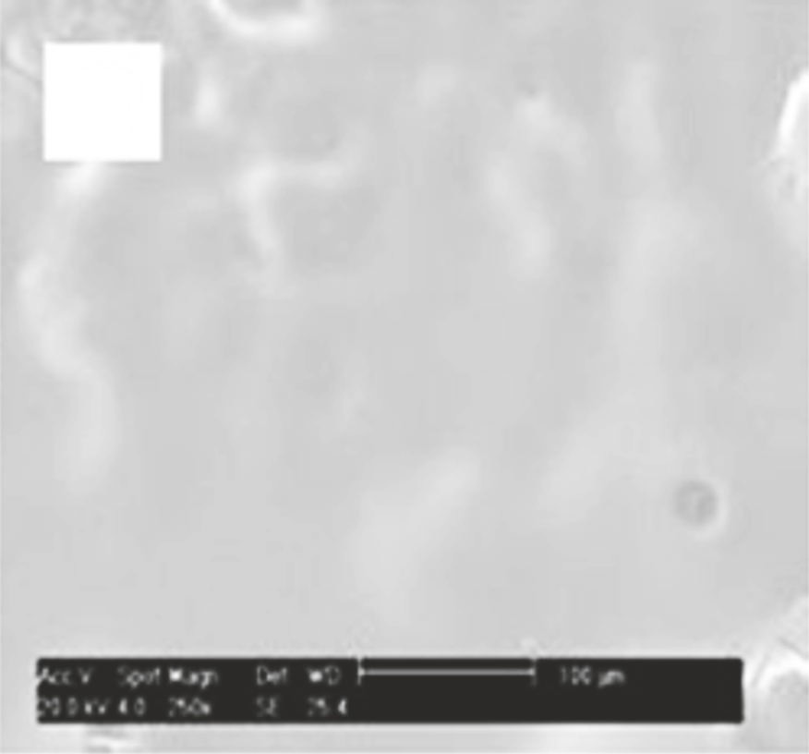
(a
(b
(c

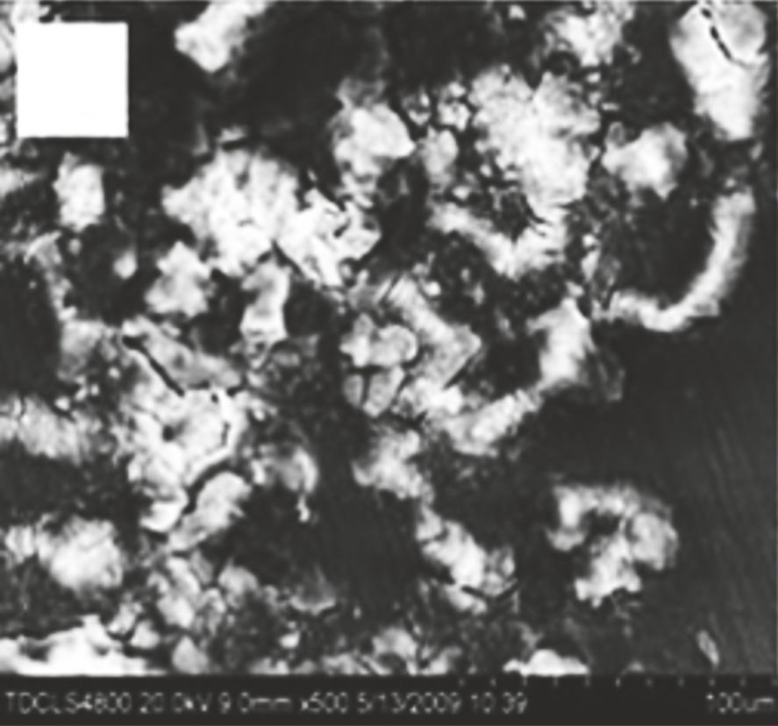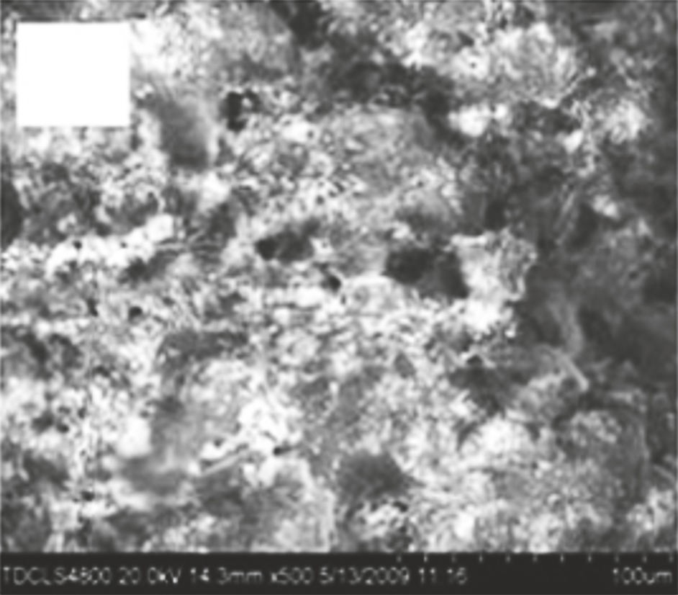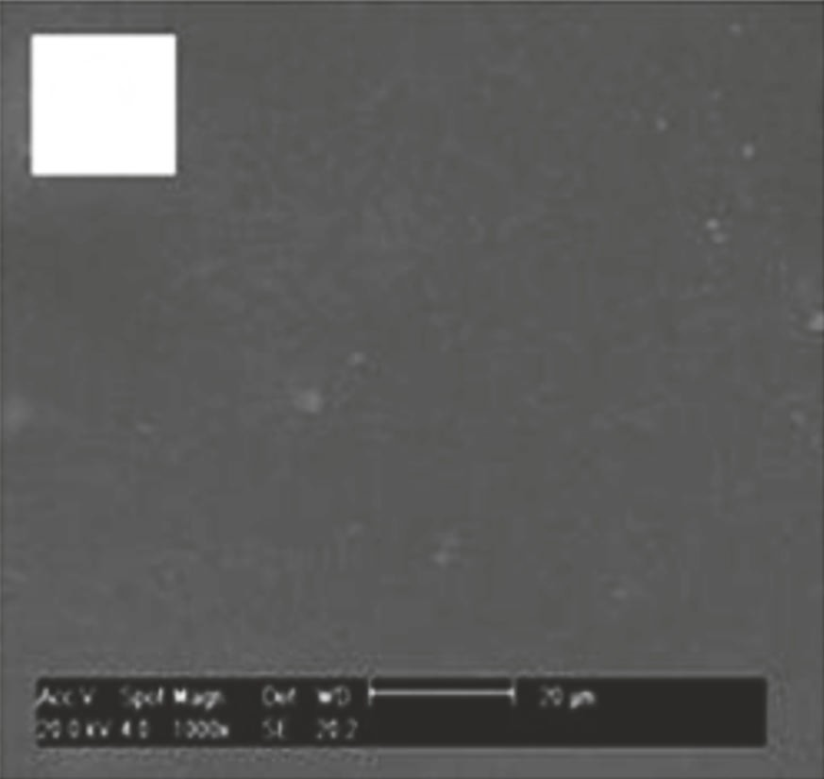
(d
(e
(f

Figure 4. SEM Images of Sample Surface Morphology Before (a) WE42, (b) WE42-MAO, and (c) WE42-MAO/PLLA Submersion in Hank's Solution at 37°C (pH = 7.4) [57] and After (d) WE42, (e) WE42-MAO, and (f) WE42-MAO/PLLA Submersion in Hank's Solution at 37°C (pH = 7.4) [27].
C. Modifications in terms of chemical and physical properties:
Composite modifications involving both chemical and physical treatments are gaining popularity due to the limitations of single chemical and physical approaches. Double-modified layers have demonstrated the ability to enhance biodegradation resistance and regulate degradation rates across a broader spectrum of substrates [65]. In a study by Guo et al., physical interlocking was employed to affix PLLA to the MAO coating on WE42 alloy surfaces. This dual modification approach resulted in fine-tuned corrosion resistance and excellent cytocompatibility for the MAO/PLLA-modified WE42 alloy. Figure 4 illustrates the surface morphologies of WE42, WE42-MAO, and WE42-MAO/PLLA before and after immersion in Hank's solution for four days [57]. Notably, Hank's solution induced severe corrosion of the WE42 Mg alloy, as evident in Figures 4(a) and 4(d). Figure 4(d) depicts the extensive corrosion on the WE42's surface, characterized by deeper and wider cracks, holes, and the deposition of white flocculent accumulations. On the MAO coating's surface, micropores and microcracks were randomly distributed (Figure 4(b)). Following immersion, the MAO coating exhibited corrosion with small white flocculent deposits on the surface (Figure 4(e)). The biocompatible PLLA sealing layer provided a smooth and uniform cover on the surface of the MAO coating, concealing cracks and pores (Figure 4(c)). The surface of the MAO/PLLA sample exhibited minimal change, as illustrated in Figure 4(f), while the WE42-MAO/PLLA sample's surface remained covered by an intact layer, displaying no signs of corrosion.
Top of Form
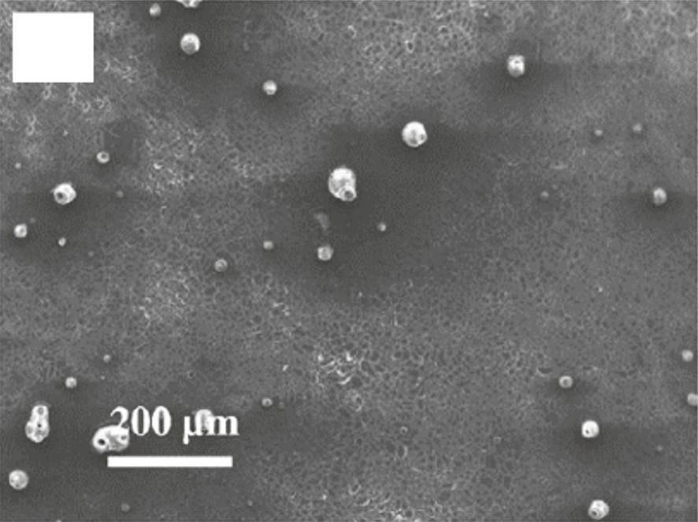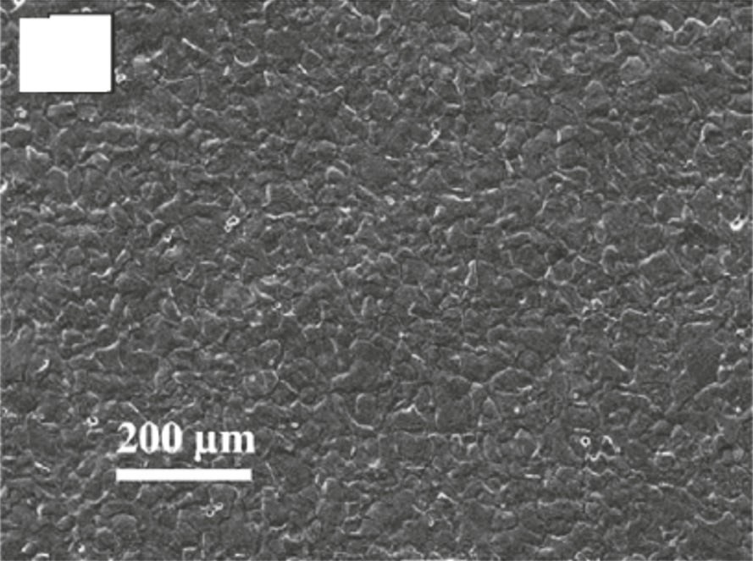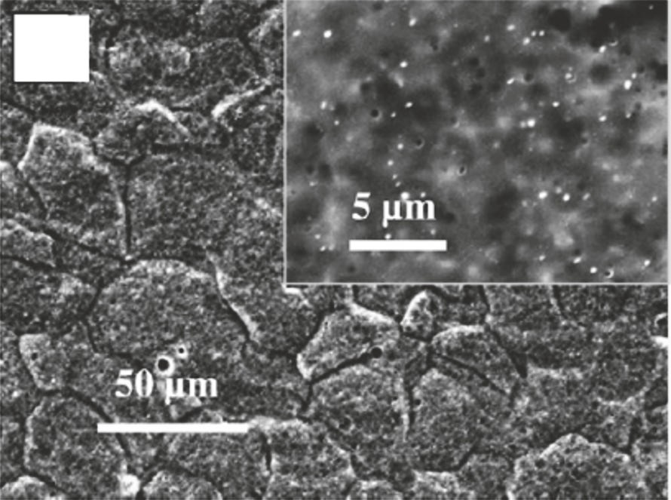
(a
(b)
(c

Figure 5. M1A Surface Morphology Following 30 Minutes in A-SBF: (a) Initial Surface, (b) Surface After Cleaning, and (c) High-Magnification Image of the Surface After Cleaning [58].

- BIODEGRADABLE MAGNESIUM ALLOYS AS BONE IMPLANTS: BIOLOGICAL PERFORMANCE
In order for biodegradable Mg alloys to be deemed suitable for clinical applications, they must exhibit adequate biocompatibility within the human body [74]. Consequently, researchers have extensively investigated the biological performance of biodegradable Mg alloys, both in vitro and in vivo, over the course of several years [28].
A. Biological Performance in Vitro:
In vitro studies are valuable for predicting the corrosion and biocompatibility of Mg alloys in an in vivo setting [138]. These studies offer a convenient and efficient means of obtaining rapid and accurate feedback on effectiveness when compared to in vivo experiments [81]. Researchers have employed a range of techniques, including SEM, X-ray diffraction, tensile tests, immersion tests, electrochemical corrosion tests, cell culture, and platelet adhesion, to investigate the in vitro corrosion and biocompatibility of nine binary Mg-1X (wt. percent, X = Al, Ag, In, Mn, Si, Sn, Y, Zn, and Zr) alloys.
The incorporation of alloying elements significantly influenced the strength and corrosion resistance of magnesium. In both simulated body fluid (SBF) and Hank's solutions, elements such as Al, Si, Sn, Zn, and Zr were found to enhance the strength of Mg, while Al, In, Mn, Zn, and Zr slowed down the corrosion rates of as-cast Mg-X alloys. Conversely, Si and Y were observed to inhibit Mg corrosion.
Moreover, alloy extracts from Mg-1Al, Mg-1Sn, Mg-1Y, Mg-1Zn, and Mg-1Zr alloys showed no significant toxicity against fibroblasts (L-929 and NIH3T3), osteoblasts (MC3T3-E1), and Mg (ECV304 and VSMC). Hemolysis assays revealed low hemolysis ratios of less than 5% for Mg-1In, Mg-1Mn, Mg-1Si, and Mg-1Y alloys. Adhered platelets exhibited nearly circular shapes with minimal pseudopodia spreading, and fewer platelets adhered to the alloys compared to pure Mg [82].
Further studies investigated the in vitro cellular responses and degradation of the Mg alloy M1A (Mg-1.42 wt. percent Mn) in both SBF and albumin-containing SBF (A-SBF, 40 g/L). The presence of albumin was found to significantly affect M1A corrosion due to synergistic effects of albumin adsorption and chelation. Notably, M1A Mg alloy samples displayed well-spread cells and good cell viability, suggesting their potential for use in biodegradable implants. Figure 5 illustrates the surface morphology of M1A after 30 minutes of immersion in A-SBF [28]. Initially, albumin did not substantially impact passivation layer development within the first 0.5 hours of immersion (Figure 5(a)). However, post-cleaning examinations of the surface (Figures 5(b) and 5(c)) revealed that corrosion initiation remained favored at grain boundaries, resulting in relatively uniform corrosion across the test surface [83].
Additionally, Witte et al. conducted a study on the effects of in vitro and in vivo corrosion conditions on the corrosion rates of gravity-cast AZ91D and LAE442 Mg alloys. They found that in vivo corrosion rates were four orders of magnitude slower than in vitro corrosion [42].

B

Biological Performance in Vivo: Before advancing to clinical trials, it is imperative to conduct in vivo animal studies that closely mimic the physiological conditions of the human body. These studies involve comprehensive follow-up monitoring, encompassing serum analysis, radiographic inspection, micro-CT investigations, histology analysis, and implant examination. The objective is to thoroughly characterize local tissue reactions to Mg-based implants [84].
Local bone responses are intricately linked to several factors, including the rate of degradation, the composition of corrosion materials, and the overall stability of biodegradable Mg alloys
C. In vivo animal studies:
In a study conducted by Ratna Sunil et al., rabbits were implanted with commercially available AZ31 Mg alloy that had undergone equal channel angular pressing (ECAP) to investigate the influence of grain size on bioactivity and degradation. The research included comprehensive follow-up monitoring through serum analysis, radiographic inspection, micro-CT investigations, histology analysis, and implant examination.
Remarkably, the ECAPed samples exhibited rapid bio-mineralization, contributing to a reduction in AZ31 Mg alloy degradation compared to annealed samples. Additionally, the histopathology analysis of bone tissue from the rabbit implanted with the ECAPed sample indicated the early formation of cartilaginous tissue, suggesting the development of new bone. Notably, in vivo experiments showed that magnesium degradation had no adverse effects on the health of the rabbits.
This study underscores the significant impact of smaller grain sizes in magnesium alloys on the regulation of degradation rates in physiological environments, mainly by promoting rapid mineralization. Such findings hold promise for the advancement of magnesium-based degradable implants [50].

β -TCP-coated Mg alloy Naked Mg alloy Ti alloy
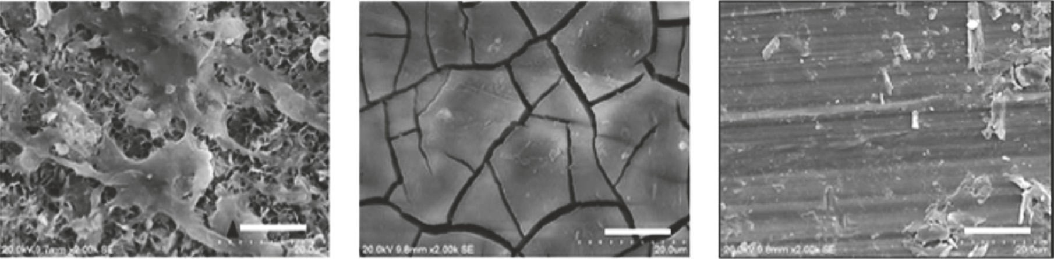

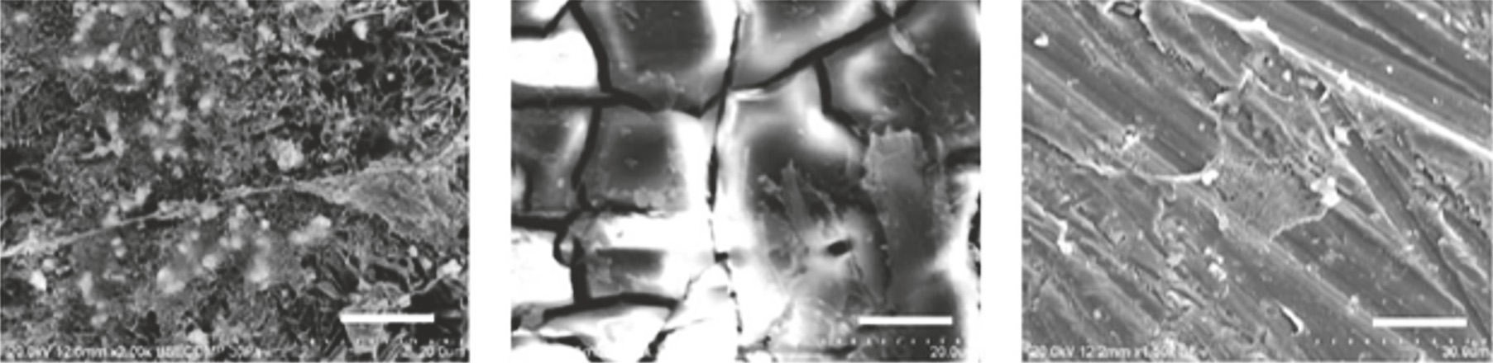

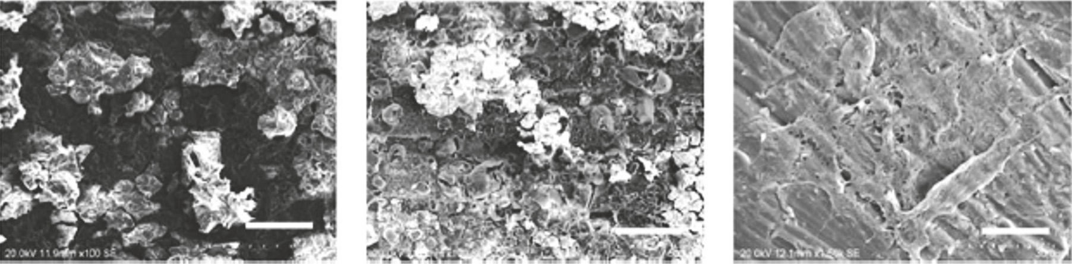

Figure 6. SEM images were captured at 1, 4, and 12 weeks post-implantation for three types of samples: β-tricalcium phosphate-coated AZ31, uncoated AZ31, and Ti-6Al-4V alloy rods. [29] Scale bar = 5 m.
Zhang et al. conducted an implantation study using Mg-Zn-Mn alloy in rats to investigate in vivo Mg alloy degradation, bone response to the biodegradable Mg implant, and the effects of Mg alloy degradation on blood composition and organs. They observed varying degradation rates of the Mg-Zn-Mn alloy in the marrow cavity and cortical bone. After six weeks, new bone tissue began developing around the Mg implants without the formation of a fibrous capsule. At 10 and 26 weeks post-implantation, even more new bone tissue and a surrounding membrane were observed. Importantly, the study found that blood chemistry, liver, and kidney parameters remained relatively stable as the Mg-Zn-Mn implant degraded [85].
Dziuba et al. developed a novel degradable Mg alloy called ZEK100 and conducted tests on its biocompatibility and long-term degradation in adult female New Zealand white rabbits. The study revealed that ZEK100 degrades slowly in vivo. However, it's worth noting that while in vivo degradation is important, it doesn't necessarily imply good biocompatibility. In the case of ZEK100, it led to various local pathological effects and significant bone alterations in the tested samples [84].
In another investigation by Chai et al., β-tricalcium phosphate (TCP)-coated AZ31 Mg alloy rod samples were implanted into the femurs of rats after predrilling with 1 mm hand-operated drills. Figure 6 shows SEM images of these samples at different time points, including 1, 4, and 12 weeks after implantation. The images revealed interesting findings. For the β-TCP-coated Mg alloy, cells and cell secretion proteins were already present on the surface after one week. By the fourth week, a substantial amount of organic proteins had coated the rod implant. After 12 weeks, degradation products and cracks on the surface had become more prominent. In contrast, the naked Mg alloy exhibited visible cracks after one week, with cell secretion proteins appearing after four weeks. However, after 12 weeks, a thin excreted matrix layer nearly covered the naked Mg alloy surface. The Ti alloy surface morphology remained consistent over time. These observations indicated that the β-TCP coating delayed the initial degradation of the naked Mg alloy during the early stages of implantation and significantly improved osteoconductivity and osteogenesis within the first 12 weeks post-surgery [29].

V. CONCLUSION AND FUTURE RESEARCH
This review aimed to provide an overview of recent research and developments related to magnesium alloys for bone repair applications. Extensive efforts have been directed towards improving the mechanical properties, corrosion resistance, and biocompatibility of magnesium alloys through alloying design and surface modifications. In conclusion, magnesium alloys hold significant promise as materials for surgical implants in bone repair procedures. While substantial research has been conducted on biodegradable magnesium alloy implants, which have the potential to reduce the need for follow-up surgeries and enhance the safety and efficacy of bone repair, further investigations are warranted. This article offers several suggestions for potential future research directions.
One area of future research involves the development of specific animal models that better replicate the performance of magnesium alloys within physiological environments. For instance, an ovariectomized rat model has been employed to explore the effects of 10% SrHA coatings on implant fixation and the prevention of postmenopausal osteoporosis [86]. Similarly, utilizing a Y-shaped osteotomy model in horses, Waselau et al. assessed the impact of biodegradable Mg phosphate cement, Ca phosphate cement, and no cement on bone repair, biocompatibility, and bone adhesion [87]. Utilizing such animal models, as well as established bone damage models, could enhance our understanding of the potential of magnesium alloys for bone repair.
Biomechanical testing is another crucial aspect that needs further exploration. Assessing the interlocking of bone implants, such as nails, screws, needles, and plates, with the surrounding bone is essential for determining the feasibility of using biodegradable magnesium alloys in bone repair surgery. Comparative studies between the implant of interest and commonly used implants are necessary to evaluate the extent of bone-implant fixation in vivo. For example, Erdmann et al. conducted uniaxial pull-out tests to compare the biomechanical properties of a degradable Mg-0.8Ca alloy with a widely used stainless steel (S316L) screw. Results indicated that Mg-0.8Ca had similar tolerability and biomechanical properties to S316L in the initial weeks after implantation, suggesting its potential as a biodegradable implant [13]. Similarly, Castellani et al. compared a novel biodegradable Mg alloy (Mg-Y-Nd-HRE, based on WE43) to a titanium control (Ti-6Al-7Nb) to assess bone response and interfacial properties. Mg-Y-Nd-HRE alloy not only improved bone response but also exhibited excellent interfacial compatibility, meeting important criteria for bone implant applications [88]. Establishing a mechanically stable bone-implant interface is crucial for the clinical effectiveness of bone repair implants, necessitating further biomechanical research in the future.
Additionally, long-term studies are essential to investigate the in vivo degradation and biocompatibility of biodegradable magnesium alloys due to the complex physiological environment of the human body. Future research should also focus on the following areas in addition to the aforementioned suggestions:
Controllable Degradation: Developing methods for precisely controlling the degradation of biodegradable magnesium alloys using novel or conventional techniques, including processing control and bio-inspired coatings. For instance, the incorporation of human essential nutrients as alloying agents is one avenue of exploration [37].
Angiogenesis: Investigating the angiogenic properties of Mg-based implants, as bone vasculature plays a crucial role in bone growth, remodeling, and homeostasis [89].
Long-Term Effects: Studying the extended effects of Mg alloy implants on tissues and organs to acquire comprehensive biosafety data and prepare for clinical trials.
In the foreseeable future, the in vivo performance of biodegradable magnesium alloy implants is expected to improve significantly, solidifying their role in the treatment of orthopedic conditions.

References

[1] | I. H. Kalfas,2001 “Principles of bone healing,” Neurosurgical Focus, vol. 10, no. 4, p. E1, .
[2] | K. M. Nuss and B. V. Rechenberg, 2008“Biocompatibility Issues with Modern Implants in Bone - A Review for Clinical Orthopedics,” The Open Orthopaedics Journal , vol. 2, no. 1, pp. 66–78,.
[3] | R. W. Westerman and B. E. Scammell, 2012“Principles of bone and joint injuries and their healing,” Surgery, vol. 30, no. 2, pp. 54– 60, .
[4] | J.-Y. Lee, G. Han, Y.-C. Kim et al.,2009 “Effects of impurities on the biodegradation behavior of pure magnesium,” Metals and Materials International, vol. 15, no. 6, pp. 955–961, .
[5] | L. Tan, X. Yu, P. Wan, and K. Yang,2013 “Biodegradable Materials for Bone Repairs: A Review,” Journal of Materials Science and Technology, vol. 29, no. 6, pp. 503–513, .
[6] | J. G. Stark, 2001 “Use of selective estrogen receptor modulator for joint fusion and other healing,” WO 136956,.
[7] | J. Van der Stok, E. M. M. Van Lieshout, Y. El-Massoudi,G. H. Van Kralingen, and P. Patka, 2011“Bone substitutes in the Netherlands—a systematic literature review,” Acta Biomateri- alia, vol. 7, no. 2, pp. 739–750, .
[8] | J. A. Auer, B. V. Rechenberg, M. Bohner, and M. Hofmann- Amtenbrink, 2012 “Bone Grafts and Bone Replacements,” Equine Surgery, pp. 1081–1096,.
[9] | P. V. Giannoudis, H. Dinopoulos, and E. Tsiridis,2005 “Bone sub- stitutes: an update,” Injury, vol. 36, supplement 3, pp. S20–S27, .
[10] | O. Bo¨stman and H. Pihlajama¨ki,2000 “Clinical biocompatibility of biodegradable orthopaedic implants for internal fixation: a review,” Biomaterials, vol. 21, no. 24, pp. 2615–2621, .
[11] | H. Chai, L. Guo, X. Wang et al., 2011 “Antibacterial effect of 317L stainless steel contained copper in prevention of implant-related infection in vitro and in vivo,” Journal of Materials Science: Materials in Medicine, vol. 22, no. 11, pp. 2525–2535,.
[12] | M. P. Staiger, A. M. Pietak, J. Huadmai, and G. Dias,2006 “Magnesium and its alloys as orthopedic biomaterials: a review,” Biomaterials, vol. 27, no. 9, pp. 1728–1734, .
[13] | N. Erdmann, N. Angrisani, J. Reifenrath et al., 2011“Biomechanical testing and degradation analysis of MgCa0.8 alloy screws: a comparative in vivo study in rabbits,” Acta Biomaterialia, vol. 7, no. 3, pp. 1421–1428, .
[14] | D. Hong, P. Saha, D.-T. Chou et al.,2013 “In vitro degradation and cytotoxicity response of Mg-4% Zn-0.5% Zr (ZK40) alloy as a potential biodegradable material,” Acta Biomaterialia, vol. 9, no. 10, pp. 8534–8547, .
[15] | S. Shadanbaz and G. J. Dias,2012 “Calcium phosphate coatings on magnesium alloys for biomedical applications: a review,” Acta Biomaterialia, vol. 8, no. 1, pp. 20–30, .
[16] | X. Lin, L. Tan, Q. Zhang et al.,2013 “The in vitro degradation process and biocompatibility of a ZK60 magnesium alloy with a forsterite-containing micro-arc oxidation coating,” Acta Biomaterialia, vol. 9, no. 10, pp. 8631–8642, .
[17] | M. Bornapour, M. Celikin, M. Cerruti, and M. Pekguleryuz,2014 “Magnesium implant alloy with low levels of strontium and cal- cium: The third element effect and phase selection improve bio- corrosion resistance and mechanical performance,” Materials Science and Engineering C: Materials for Biological Applications, vol. 35, no. 1, pp. 267–282,
[18] | C. K. Seal, K. Vince, and M. A. Hodgson, 2009“Biodegradable surgical implants based on magnesium alloys - A review of current research,” in Proceedings of the IOP Conference Series: Materials Science and Engineering, IOP Publishing, .
[19] | H. S. Brar, J. Wong, and M. V. Manuel, 2012“Investigation of the mechanical and degradation properties of Mg-Sr and Mg-Zn- Sr alloys for use as potential biodegradable implant materials,” Journal of the Mechanical Behavior of Biomedical Materials, vol. 7, pp. 87–95, .
[20] | Y. Chen, Z. Xu, C. Smith, and J. Sankar, 2014“Recent advances on the development of magnesium alloys for biodegradable implants,” Acta Biomaterialia, vol. 10, no. 11, pp. 4561–4573, .
[21] | Y. Yun, Z. Dong, D. Yang et al.,2009 “Biodegradable Mg corrosion and osteoblast cell culture studies,” Materials Science and Engineering C: Materials for Biological Applications, vol. 29, no. 6, pp. 1814–1821, .
[22] | X. N. Gu, W. Zheng, Y. Cheng, and Y. F. Zheng, 2009 “A study on alkaline heat treated Mg-Ca alloy for the control of the biocorrosion rate,” Acta Biomaterialia, vol. 5, no. 7, pp. 2790– 2799,.
[23] | J. J. Huang and K. Yang,2006 “Research on magnesium alloys for bio-medical applications,” Materials Review, vol. 20, pp. 67–69, .
[24] | A. E. Coy, F. Viejo, P. Skeldon, and G. E. Thompson, 2010 “Sus- ceptibility of rare-earth-magnesium alloys to micro-galvanic corrosion,” Corrosion Science, vol. 52, no. 12, pp. 3896–3906,.
[25] | L. Wang, B.-P. Zhang, and T. Shinohara,2010 “Corrosion behavior of AZ91 magnesium alloy in dilute NaCl solutions,” Materials and Corrosion, vol. 31, no. 2, pp. 857–863, .
[26] | M.-J. Liang, G.-H. Wu, W.-J. Ding, and W. Wang,2011 “Effect of inclusion on service properties of GW103K magnesium alloy,” Transactions of Nonferrous Metals Society of China, vol. 21, no. 4, pp. 717–724, .
[27] | M. Guo, L. Cao, P. Lu, Y. Liu, and X. Xu, 2011“Anticorrosion and cytocompatibility behavior of MAO/PLLA modified magne- sium alloy WE42,” Journal of Materials Science: Materials in Medicine, vol. 22, no. 7, pp. 1735–1740, .
[28] | Y. Wang, C. S. Lim, C. V. Lim, M. S. Yong, E. K. Teo, and L. N. Moh, 2011“In vitro degradation behavior of M1A magnesium alloy in protein-containing simulated body fluid,” Materials Science and Engineering C: Materials for Biological Applications, vol. 31, no. 3, pp. 579–587, .
[29] | H. Chai, L. Guo, X. Wang et al.,2012 “In vitro and in vivo evaluations on osteogenesis and biodegradability of a β-tricalcium phos- phate coated magnesium alloy,” Journal of Biomedical Materials Research Part A, vol. 100, no. 2, pp. 293–304, .
[30] | Q. Li, Q. Wang, Y. Wang, X. Zeng, and W. Ding, 2007 “Effect of Nd and Y addition on microstructure and mechanical properties of as-cast Mg-Zn-Zr alloy,” Journal of Alloys and Compounds, vol. 427, no. 1-2, pp. 115–123,.
[31] | A. D. Su¨dholz, N. T. Kirkland, R. G. Buchheit, and N. Birbilis, 2011 “Electrochemical properties of intermetallic phases and com- mon impurity elements in magnesium alloys,” Electrochemical and Solid-State Letters, vol. 14, no. 2, pp. C5–C7,.
[32] | H. Yang, C. Liu, P. Wan, L. Tan, and K. Yang, 2013“Study of second phase in bioabsorbable magnesium alloys: Phase stability evalu- ation via Dmol3 calculation,” APL Materials, vol. 1, no. 5, Article ID 052104, .
[33] | Y. Zheng and X. Gu,2011 “Research activities of biomedical magne- sium alloys in China,” JOM: The Journal of The Minerals, Metals & Materials Society (TMS), vol. 63, no. 4, pp. 105–108, .
[34] | L. Yang, Y. Huang, F. Feyerabend et al.,2013 “Microstructure, mechanical and corrosion properties of Mg-Dy-Gd-Zr alloys for medical applications,” Acta Biomaterialia, vol. 9, no. 10, pp. 8499–8508, .
[35] | N. Hort, Y. Huang, D. Fechner et al.,2010 “Magnesium alloys as implant materials–principles of property design for Mg-RE alloys,” Acta Biomaterialia, vol. 6, no. 5, pp. 1714–1725, .
[36] | H. R. B. Rad, M. H. Idris, M. R. A. Kadir, and S. Farahany,2012 “Microstructure analysis and corrosion behavior of biodegrad- able Mg-Ca implant alloys,” Materials and Corrosion, vol. 33, no. 1, pp. 88–97, .
[37] | C. Liu, X. Fu, H. Pan et al., 2016“Biodegradable Mg-Cu alloys with enhanced osteogenesis, angiogenesis, and long-lasting antibacterial effects,” Scientific Reports, vol. 6, Article ID 27374,.
[38] | Z. Li, X. Gu, S. Lou, and Y. Zheng,2008 “The development of binary Mg-Ca alloys for use as biodegradable materials within bone,” Biomaterials, vol. 29, no. 10, pp. 1329–1344, .
[39] | C. Zhao, F. Pan, L. Zhang, H. Pan, K. Song, and A. Tang,2017 “Microstructure, mechanical properties, bio-corrosion proper- ties and cytotoxicity of as-extruded Mg-Sr alloys,” Materials Science and Engineering C: Materials for Biological Applications, vol. 70, pp. 1081–1088, .
[40] | T. Yan, L. Tan, D. Xiong, X. Liu, B. Zhang, and K. Yang,2010 “Fluoride treatment and in vitro corrosion behavior of an AZ31B magnesium alloy,” Materials Science and Engineering C: Materials for Biological Applications, vol. 30, no. 5, pp. 740–748, .
[41] | J. E. Gray-Munro, C. Seguin, and M. Strong, 2009 “Influence of sur- face modification on the in vitro corrosion rate of magnesium alloy AZ31,” Journal of Biomedical Materials Research Part A, vol. 91, no. 1, pp. 221–230,.
[42] | F. Witte, J. Fischer, J. Nellesen et al.,2006 “In vitro and in vivo corrosion measurements of magnesium alloys,” Biomaterials, vol. 27, no. 7, pp. 1013–1018, .
[43] | F. Witte, V. Kaese, H. Haferkamp et al.,2005 “In vivo corrosion of four magnesium alloys and the associated bone response,” Biomaterials, vol. 26, no. 17, pp. 3557–3563, .
[44] | R. Walter and M. B. Kannan,2011 “In-vitro degradation behaviour of WE54 magnesium alloy in simulated body fluid,” Materials Letters, vol. 65, no. 4, pp. 748–750, .
[45] | M. Shahzad and L. Wagner, 2009“The role of Zr-rich cores in strength differential effect in an extruded Mg-Zn-Zr alloy,” Journal of Alloys and Compounds, vol. 486, no. 1-2, pp. 103–108, .
[46] | Y. Li, M. Li, W. Hu, P. Hodgson, and C. Wen,2010 “Biodegradable Mg-Ca and Mg-Ca-Y alloys for regenerative medicine,” Materi- als Science Forum, vol. 654-656, pp. 2192–2195, .
[47] | J. Li, Y. Song, S. Zhang et al.,2010 “In vitro responses of human bone marrow stromal cells to a fluoridated hydroxyapatite coated biodegradable Mg-Zn alloy,” Biomaterials, vol. 31, no. 22, pp. 5782–5788, .
[48] | S. Zhang, X. Zhang, C. Zhao et al.,2010 “Research on an Mg-Zn alloy as a degradable biomaterial,” Acta Biomaterialia, vol. 6, no. 2, pp. 626–640, .
[49] | S. Cai, T. Lei, N. Li, and F. Feng, 2012“Effects of Zn on microstruc- ture, mechanical properties and corrosion behavior of Mg- Zn alloys,” Materials Science and Engineering C: Materials for Biological Applications, vol. 32, no. 8, pp. 2570–2577,.
[50] | B. Ratna Sunil, T.S. Sampath Kumar, Uday Chakkingal, V. Nandakumar, Mukesh Doble,V. Devi Prasad , M. Raghunath, 2016, "In vitro and in vivo studies of biodegradable fine grained AZ31 magnesium alloy produced by equal channel angular pressing"Materials Science and Engineering C59,pp.356-367
[51] | B. Ratna Sunil, T.S. Sampath Kumar, U. Chakkingal, V. Nandakumar, M. Doble,2014 "Friction stir processing of magnesium–nanohydroxyapatite composites with controlledin vitro degradation behaviour", Mater. Sci. Eng. C 39 () 315–324.
[52] | B. Ratna Sunil, T.S. Sampath Kumar, U. Chakkingal, V. Nandakumar, M. Doble,2014 " Nanohydroxyapatite reinforced AZ31 magnesium alloy by friction stir processing: a solid state processing for biodegradable metal matrix composites", J. Mater. Sci. Mater.Med. 25 () 975–988.
[53] | B. Ratna Sunil, C. Ganapathy, T.S. Sampath Kumar, U. Chakkingal, "Processing and evaluating mechanical behavior of lamellar structured degradable magnesiumhydroxyapatite"implants, J. Mech. Behav. Biomed. Mater. 40 (2014) 178–189.
[54] | B. Ratna Sunil, A.A. Kumar, T.S. Sampath Kumar, U. Chakkingal, 2013 "Role of biomineralization on the degradation of fine grained AZ31 magnesium alloy processed by groove pressing," Mater. Sci. Eng. C 33 pp.1607–1615 .
[55] | S. Zhang, J. Li, Y. Song et al., 2009“In vitro degradation, hemolysis and MC3T3-E1 cell adhesion of biodegradable Mg-Zn alloy,” Materials Science and Engineering C: Materials for Biological Applications, vol. 29, no. 6, pp. 1907–1912,.
[56] | Q. Peng, Y. Huang, L. Zhou, N. Hort, and K. U. Kainer,2010 “Preparation and properties of high purity Mg-Y biomaterials,” Biomaterials, vol. 31, no. 3, pp. 398–403, .
[57] | A. C. Ha¨nzi, I. Gerber, M. Schinhammer, J. F. Lo¨ffler, andP. J. Uggowitzer, 2010“On the in vitro and in vivo degradation performance and biological response of new biodegradable Mg- Y-Zn alloys,” Acta Biomaterialia, vol. 6, no. 5, pp. 1824–1833, .
[58] | C. Liu, P. He, P. Wan et al., 2015 “The in vitro biocompatibility and macrophage phagocytosis of Mg17Al12 phase in Mg-Al-Zn alloys,” Journal of Biomedical Materials Research Part A, vol. 103, no. 7, pp. 2405–2415,.
[59] | L. Gao, R. S. Chen, and E. H. Han,2009 “Solid solution strengthening behaviors in binary Mg-Y single phase alloys,” Journal of Alloys and Compounds, vol. 472, no. 1-2, pp. 234–240, .
[60] | X. Zhang, K. Zhang, X. Li et al., 2012 “Effect of solid-solution treatment on corrosion and electrochemical behaviors of Mg- 15Y alloy in 3.5 wt.% NaCl solution,” Journal of Rare Earths, vol. 30, no. 11, pp. 1158–1167,.
[61] | A. Atrens, M. Liu, and N. I. Zainal Abidin, 2011 “Corrosion mechanism applicable to biodegradable magnesium implants,” Materials Science and Engineering: B Advanced Functional Solid- State Materials, vol. 176, no. 20, pp. 1609–1636,.
[62] | G. H. Wu, M. Sun, Wang. W. et al., 2010“New research development on purification technology of magnesium alloys,” International Journal of Nonferrous Metallurgy, vol. 20, pp. 1021–1031, .
[63] | H. L. Li, R. Hu, W. T. Qu et al.,2001“The high purification of magnesium and its alloys,” Special Casting & Nonferrous Alloys, 1, pp. 88-89, .
[64] | J.-C. Gao, L.-Y. Qiao, and R.-L. Xin, 2010“Corrosion and bone response of magnesium implants after surface modification by heat-self-assembled monolayer,” Frontiers of Materials Science in China, vol. 4, no. 2, pp. 120–125, .
[65] | J. Wang, J. Tang, P. Zhang et al., 2012“Surface modification of magne- sium alloys developed for bioabsorbable orthopedic implants: a general review,” Journal of Biomedical Materials Research Part B: Applied Biomaterials, vol. 100, no. 6, pp. 1691–1701, .
[66] | J. E. Gray and B. Luan, 2002“ChemInform Abstract: Protective Coatings on Magnesium and Its Alloys - A Critical Review,” ChemInform, vol. 33, no. 26, pp. no–no, .
[67] | M. C. Turhan, R. Lynch, M. S. Killian, and S. Virtanen,2009 “Effect of acidic etching and fluoride treatment on corrosion performance in Mg alloy AZ91D (MgAlZn),” Electrochimica Acta, vol. 55, no. 1, pp. 250–257, .
[68] | M. Assadian, M. H. Idris, M. M. Taheri,2015 M. Rezazadeh Shirdar, and D. Almasi, “Effects of Alkaline Treatment on Corrosion Behavior of Biodegradable Magnesium,” Advanced Materials Research, vol. 1125, pp. 441–444, .
[69] | F. Witte,2010 “The history of biodegradable magnesium implants: a review,” Acta Biomaterialia, vol. 6, no. 5, pp. 1680–1692, .
[70] | T. Berglundh, I. Abrahamsson, J.-P. Albouy, and J. Lindhe,2007 “Bone healing at implants with a fluoride-modified surface: an experimental study in dogs,” Clinical Oral Implants Research, vol. 18, no. 2, pp. 147–152, .
[71] | G. Lei, K. Liu, S. Zhang et al., 2008“Cytotoxicity of AZ31B mag- nesium alloy covering with magnesium oxide,” Rare Metal Materials and Engineering, vol. 37, no. 6, pp. 1027–1031, .
[72] | T. S. N. Sankara Narayanan, I. S. Park, and M. H. Lee,2014 “Strategies to improve the corrosion resistance of microarc oxidation (MAO) coated magnesium alloys for degradable implants: Prospects and challenges,” Progress in Materials Science, vol. 60, no. 1, pp. 1–71, .
[73] | S. N. Tsn, I. S. Park, and H. L. Min, 2015 “Surface modification of magnesium and its alloys for biomedical applications: oppor- tunities and challenges,” in Surface Modification of Magnesium and its Alloys for Biomedical Applications, pp. 29–87,.
[74] | R. Narayanan, S. K. Seshadri, T. Y. Kwon, and K. H. Kim,2007 “Calcium phosphate-based coatings on titanium and its alloys,” Journal of Biomedical Materials Research Part B: Applied Bioma- terials, vol. 85, no. 1, pp. 279–299, .
[75] | A. E. Coy, F. Viejo, F. J. Garcia-Garcia, Z. Liu, P. Skeldon, andG. E. Thompson,2010 “Effect of excimer laser surface melting on the microstructure and corrosion performance of the die cast AZ91D magnesium alloy,” Corrosion Science, vol. 52, no. 2, pp. 387–397, .
[76] | L. F. Guo, T. M. Yue, and H. C. Man,2005 “Excimer laser surface treatment of magnesium alloy WE43 for corrosion resistance improvement,” Journal of Materials Science, vol. 40, no. 13, pp. 3531–3533, .
[77] | M. A. Melia, D. C. Florian, F. W. Steuer et al., 2017 “Investigation of critical processing parameters for laser surface processing of AZ31B-H24,” Surface and Coatings Technology, vol. 325, pp. 157– 165,.
[78] | [A. C. W. Noorakma, H. Zuhailawati, V. Aishvarya, and B. K. Dhindaw,2013 “Hydroxyapatite-coated magnesium-based biodegradable alloy: Cold spray deposition and simulated body fluid studies,” Journal of Materials Engineering and Performance, vol. 22, no. 10, pp. 2997–3004, .
[79] | D. F. Williams, “On the mechanisms of biocompatibility,2008”Biomaterials, vol. 29, no. 20, pp. 2941–2953, .
[80] | F. L. Nie, Y. F. Zheng, S. C. Wei, C. Hu, and G. Yang, 2010“In vitro corrosion, cytotoxicity and hemocompatibility of bulk nanocrystalline pure iron,” Biomedical Materials, vol. 5, no. 6, Article ID 065015, .
[81] | Y. Xin, T. Hu, and P. K. Chu,2009. “In vitro studies of biomedical magnesium alloys in a simulated physiological environment: A review,” Acta Biomaterialia, vol. 7, no. 4, pp. 1452–1459, 2011.
[82] | X. Gu, Y. Zheng, Y. Cheng, S. Zhong, and T. Xi, “In vitro corrosion and biocompatibility of binary magnesium alloys,” Biomaterials, vol. 30, no. 4, pp. 484–498,
[83] | A. H. M. Sanchez, B. J. C. Luthringer, F. Feyerabend, and R. Willumeit, 2015“Mg and Mg alloys: How comparable are in vitro and in vivo corrosion rates? A review,” Acta Biomaterialia, vol. 13, pp. 16–31, .
[84] | D. Dziuba, A. Meyer-Lindenberg, J. M. Seitz, H. Waizy, N. Angrisani, and J. Reifenrath, 2013“Long-term in vivo degradation behaviour and biocompatibility of the magnesium alloy ZEK100 for use as a biodegradable bone implant,” Acta Biomaterialia, vol. 9, no. 10, pp. 8548–8560,.
[85] | E. L. Zhang, L. P. Xu, G. N. Yu et al.,2009 “In vivo evaluation of biodegradable magnesium alloy bone implant in the first 6 months implantation,” Journal of Biomedical Materials Research Part A, vol. 90A, no. 3, pp. 882–893, .
[86] | Y. Li, Q. Li, S. Zhu et al.,2010 “The effect of strontium-substituted hydroxyapatite coating on implant fixation in ovariectomized rats,” Biomaterials, vol. 31, no. 34, pp. 9006–9014, .
[87] | M. Waselau, V. F. Samii, S. E. Weisbrode, A. S. Litsky, and A. L. Bertone,2007 “Effects of a magnesium adhesive cement on bone stability and healing following a metatarsal osteotomy in horses,” American Journal of Veterinary Research, vol. 68, no. 4, pp. 370–378, .
[88] | C. Castellani, R. A. Lindtner, P. Hausbrandt et al.,2011 “Bone- implant interface strength and osseointegration: biodegradable magnesium alloy versus standard titanium control,” Acta Bio- materialia, vol. 7, no. 1, pp. 432–440, .
[89] | U. Saran, S. G. Piperni, and S. Chatterjee,2014 “Role of angiogenesis in bone repair,” Archives of Biochemistry and Biophysics, vol. 561, pp. 109–117, .

