**Assessment of Groundwater Potential Zones by using Geospatial Techniques in Nandani River Basin, Western Maharashtra, India**

**Pavan Lokare1, Abhijit Zende2**

*1Assistant Professor, Dept. of Civil Engineering, Dr. Daulatrao Aher college of Engineering,*

*Karad, India*

*2Head of Department and Professor, Dept. of Civil Engineering, Dr. Daulatrao Aher college of Engineering,* *Karad, India*

[*zenabhi31@yahoo.co.in*](mailto:zenabhi31@yahoo.co.in)

Acknowledgement:

The author is grateful to the Indian Metrological Department (IMD) and Survey of India (SOI) for the supply of precipitation record and toposheet.

**Abstract**

The present study focused on the groundwater assessment for Nandani watershed using remote sensing and GIS techniques. The Nandani watershed has covered an area of 492 km2. For this study, all the satellite data is obtained from Bhuvan website and analyzed in ArcGIS software. The groundwater potential zones have been delineated using remote sensing and GIS techniques. About 48% area comes under high potential zone, 43% area comes under moderate potential zone and 9% area comes under poor and very poor potential zone. Survey of India toposheets and LISS III satellite imageries are used to prepare various thematic layers viz. lithology, slope, land-use, lineament, drainage, soil, and rainfall were transformed to raster data using feature to raster converter tool in ArcGIS. The raster maps of these factors are allocated a fixed score and weight computed from multi influencing factor (MIF) technique. This output is very useful for the watershed development and planning of water resources effectively.

**Keywords :-** Watershed, ArcGIS, Groundwater assessment.

**1. Introduction**

Groundwater is a vital natural resource for the secure and economic availability of drinking water in both urban and rural areas. It therefore plays a central role, as well as that of some aquatic and terrestrial ecosystems, in human well-being. At present, groundwater contributes around 34% of the total annual water supply and is an important fresh water resource. So, an assessment for this resource is extremely significant for the sustainable management of groundwater systems. GIS and remote sensing tools are widely used for the management of various natural resources (Magesh et al., 2011). Delineating the potential groundwater zones using remote sensing and GIS is an effective tool. In recent years, extensive use of satellite data along with conventional maps and rectified ground truth data, has made it easier to establish the base line information for groundwater potential zones (Tiwari and Rai, 1996; Thomas et al., 1999; Chowdhury et al., 2010). Remote sensing not only provides a wide-range scale of the space-time distribution of observations, but also saves time and money ( Tweed et al., 2007). In addition it is widely used to characterize the earth surface (such as lineaments, drainage patterns and lithology) as well as to examine the groundwater recharge zones (Sener et al., 2005).

Applications of remote sensing and GIS for the exploration of groundwater potential zones are carried out by a number of researchers around the world, and it was found that the involved factors in determining the groundwater potential zones were different, and hence the results vary accordingly. Teeuw (1995) relied only on the lineaments for groundwater exploration and others merged different factors apart from lineaments like drainage density, geomorphology, geology, slope, land-use, rainfall intensity and soil texture. The derived results are found to be satisfactory based on field survey and it varies from one region to another because of varied geo-environmental conditions.

Development of groundwater in the study area is through construction of dug wells, dug-cum-bore wells and bore wells. However, recharging those groundwater sources is curtailed by frequent dry seasons and failure of monsoons.

Exploitation of groundwater resources has increased in the past decades, leading to the over-consumption of groundwater, which eventually causes ecological problems such as decreased groundwater levels, water exhaustion, water pollution and deterioration of water quality. Integration of remote sensing with GIS for preparing various thematic layers, such as lithology, drainage density, lineament density, rainfall, slope, soil, and land-use with assigned weightage in a spatial domain will support the identification of potential groundwater zones. Therefore, the present study focuses on the identification of groundwater potential zones in Theni district, Tamil Nadu using the advanced technology of remote sensing, MIF and GIS for the planning, utilization, administration, and management of groundwater resources.

**2. Study Area**

The Nandani River is a major tributary of Yerala River. It originates from the hilly regions of Aundh, Maharashtra-India. It flows through rain shadow region of Satara and Sangli districts, which is confluence to Yerala at village Shivni near Kadepur, Sangli. The Latitude study area is 16º 55’ to 17º 28’ N and Longitude 74º 20’ to 74º 40’ E. It covers total area of 492 km² (Figure 1). The watershed experiences tropical monsoon climate with normal temperature, humidity and evaporation throughout the year. The study area receives the rainfall during South-West monsoon from June to September. The distribution of rainfall is not even all over the area. During July and August rainfall is more and significant runoff takes place. The rainfall stations are Karad, Kadegaon, Vita, Palus & Vaduj. It has been observed that about 20% rainfall of total rainfall is received during post-monsoon and by thunder showers in the month of May. The temperature may rise up to 44ºC in summer and may fall down to 20ºC during winter. The climate of the region is defined as subtropical with hot and dry weather in the summer.

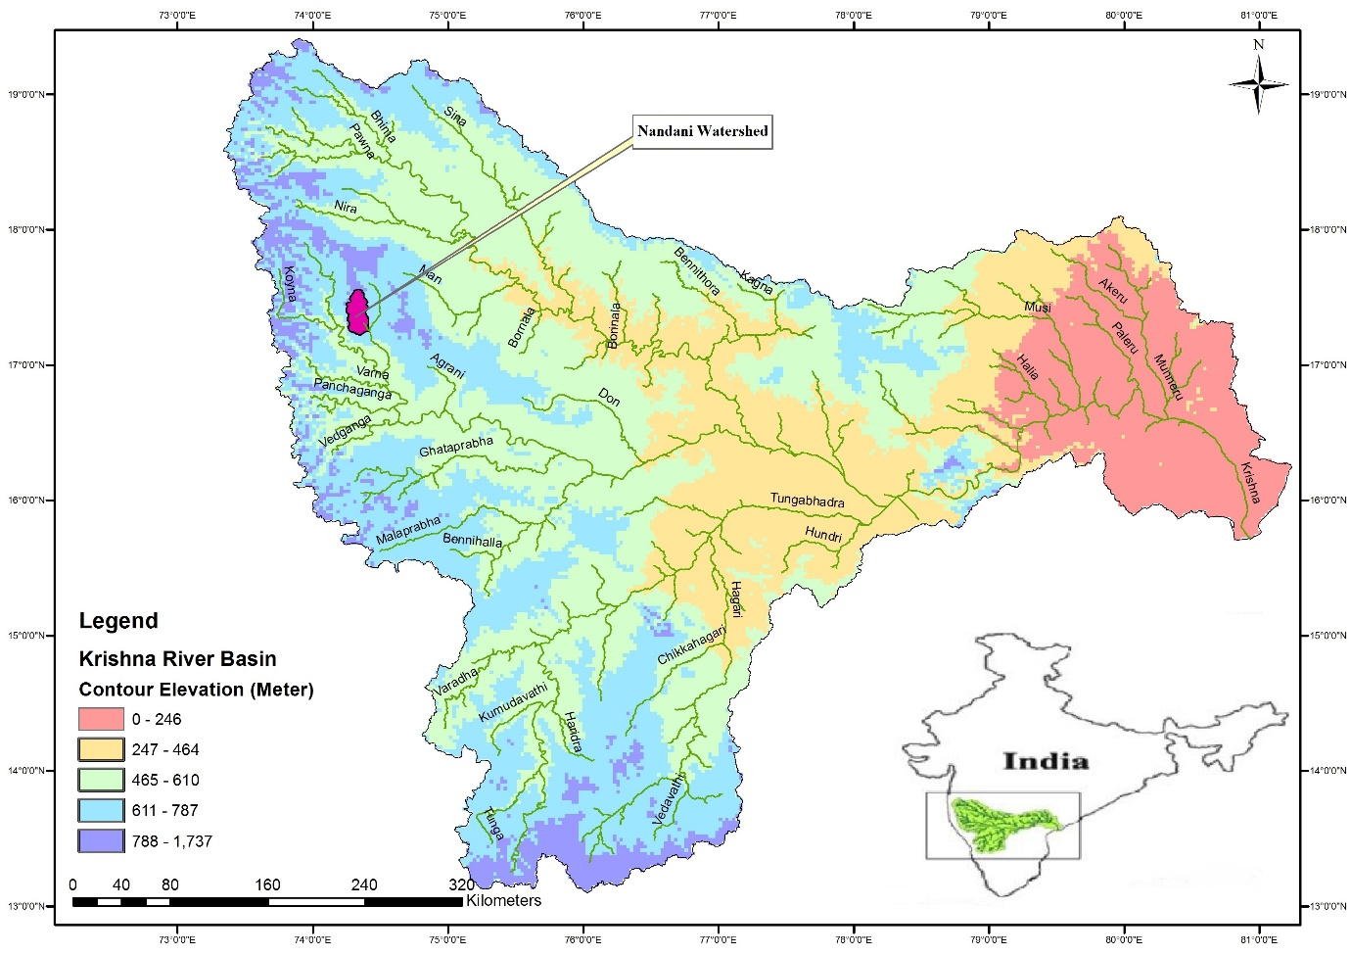

**Figure 1** Location Map of Nandani watershed

**3. Methodology**

**3.1 Generation of Spatial Database**

Inputting the spatial data generated from various sources is first important step for GIS analysis. In the present analysis, drainage network, drainage density, flow direction, flow accumulation, contour map, slope, Land Use/ Land Cover, soil, geomorphology and watershed boundary maps were produced from the survey of India toposheets in scale of 1:50,000. By using satellite data drainage network map and surface water bodies were updated. The drainage network map was prepared using satellite data (Pandey et al., 2008) and is presented in Figure 10. The drainage is typically dendritic type there by reflecting almost homogeneity of lithology. Further, stream ordering suggested by Strahler (1964) was carried out, as it is important parameter in planning of soil conservation measures. A Digital Elevation Model (DEM) with a spatial resolution of 200 X 200m was generated from the digitized contour and spot height coverage for the entire watershed. Subsequently, slope map was generated from the DEM. The study area was divided into seven sub-watersheds using DEM and drainage network. The soil map of the study area was collected from the Bhuvan.in and digitized using ARC-GIS and is presented in Figure 7.

In the present study, land use/land cover map was generated using the LISS-III satellite. The analysis was carried out using ERDAS IMAGINE-10.0 digital image processing software. Initially, the satellite data was geo-referenced with Survey of India topographical maps of the study area after matching some of the identifiable features like crossing of roads, railways, canals, bridges, etc. on both the base map as well as on the satellite data. The land use/cover map are generated from supervised classification in ERDAS IMAGINE 10.0. All these maps were encoded as GIS layers and standardized for integrated analysis under GIS environment. The GIS spatially organised all encoded digital data and coverage with the same resolution and co-ordinate system. The IRS-1C LISS-III (Linear Imaging Self Scanner) satellite image was classified in ERDAS IMAGINE software using supervised classification (after several ground truth verifications) with the maximum likelihood classification algorithm. The study area's major land use classes are upland crop, forest, and wasteland/fallow land. The study area's land use/cover classes are shown in Figure 7. For generation of land use/cover map, supervised classification was performed using FCC ( False Colour composite).

**3.2 Groundwater Potential Zone**

In groundwater resource mapping and planning, integrated remote sensing and geographic information systems (GIS) can provide an appropriate platform for convergent analysis of diverse data sets. By merging information gained by analysing multi-source remotely sensed data in a GIS framework, this effort intends to create and deploy integrated methodologies for better understanding groundwater resources. Satellite data products are much varied depending upon the spectra considered. The high-resolution satellite images are interpreted (visually or digitally) to identify potential groundwater zones. Hydrogeomorphic units, land-use/landcover/lineaments, rock types, structures, and a variety of other features are used to create thematic layers. The methodology entails the delineation of hydrogeomorphic units that are influenced by the area's hydrogeological conditions. Lithology, geomorphology, and structures such as lineaments, faults, and fractures all influence hydrogeological conditions. Priority zones will be the focus of visual interpretation of satellite data, as well as limited field verification of these features. In the present study, For the delineation of groundwater prospective zone maps of the study area, hydrological and geomorphological information obtained through the visual and digital analysis of the enhanced satellite products were used. Evaluation of groundwater potential zones in the study area will be done by preparing and integrating various thematic layers using GIS. Thematic layers pertaining to lithology, geomorphology, drainage density lineaments and slope are prepare from satellite imagery, together with the Survey of India (SOI) maps. Raw satellite images do not have the coordinate information. As a result, they were georeferenced using actual ground reference points from GPS instruments or published survey maps.

The groundwater potential zones were created by using the spatial analysis tool in ArcGIS 10.0 to overlay all of the thematic maps using weighted overlay methods. Each individual parameter of each thematic map was ranked and weights were assigned based on the multi influencing factor (MIF) of that specific feature on the hydro-geological environment of the study area during weighted overlay analysis (Shaban et al., 2006). A potential zone factor's representative weight is the sum of all weights from each factor. A factor with a higher weight value has a greater impact on groundwater potential zones, while a factor with a lower weight value has a smaller impact. Weighted overlay analysis in ArcGIS software is used to compute the integration of these factors with their potential weights. The multiple influencing factors for groundwater potential zones, namely lineaments, drainage, lithology, slope, land-use, and soil, were examined and assigned an appropriate weight, as shown in Table 1 and the detailed methodology is shown in Figure 2.

**Table 1** Rank and weightage of different parameters for Groundwater potential zones

|  |  |  |  |  |
| --- | --- | --- | --- | --- |
| Sr. No. | Criteria | Classes | Rank | Weightage (%) |
| 1. | Geology | Phyric Basalt | 1 | 10% |
| Megacryst Flow | 2 |
| Highly Porphytric Basalt | 3 |
| 2. | General Soil Group | Gravelly Clay | 1 | 25% |
| Gravelly Clay Loam | 2 |
| Sandy Clay Loam | 3 |
| 3. | Land Use | Agricultural land | 1 | 25% |
| Fallow Land | 2 |
| Open Scrub Land | 3 |
| 4. | Slope | 0o - 15o | 1 | 15% |
| 15o – 33o | 2 |
| > 33o | 3 |
| 5. | Lineament | Present | 1 | 5% |
| Not Present | 2 |
| 6. | Drainage | First order – Second order | 1 | 20% |
| Second order – Fourth order | 2 |
| Fourth order – Sixth Order | 3 |

GIS overlay analysis

Criteria definition, composite, Assigning weightage

GIS data base

Slope map

DEM

Raster map

Thematic/Vector map

Contour map

Geo-referencing and Digitization of Base maps

Soil, Geomorphology, Geohydrology, Land use

Collection of Various Maps

SOI Toposheet

Groundwater potential zones

**Figure 2** Methodology Flowchart

**4. Results and Discussions**

**4.1 Geology**

Geology of the area is dominantly covered by basaltic rock as shown in Figure 4.1. Tectonic movement has caused significant damage to the area in the past, as evidenced by varying fold, fault, and lineament associations with hills located on the western side of the study area. Basaltic flows associated with Cretaceous to Eocene Deccan Volcanic activity cover the area. They are known as Deccan Trap because they have step-like topography. Individual flows range in thickness from a few metres to 40 metres. They stretch for a long distance. The mineralogical and chemical composition of basaltic lava flows is nearly uniform throughout the study area.

The basaltic flow is classified as compact, fine-grained, massive basalt and vesicular, amygdaloidal basalt, with vesicles filled with secondary minerals such as quartz, chalcedony, and calcite, etc. The 81% area covered by phyric basalt, 12% area is covered by megacryst flow, 7% area is covered by highly porphyritic basalt and less than 1% area is covered by basaltic lava as shown in Figure 3. The presence of red beds, changes in jointing and weathering pattern, ropy surface, and other characteristics have been used to identify the boundaries of basalt flows. The development of flat surfaces at various altitudes is another criterion that can be used to identify various basaltic flows. These flat surfaces can be thought of as flow tops. Basaltic flows are frequently separated by red to brown clayey rock known as ‘red beds’. The thickness of the red bed ranges from a few centimetres to more than two metres. It also has a gradational relationship with the underlying flow's top section. These rocks have negligible primary porosity but are porous and permeable as a result of secondary porosity caused by fracturing and weathering.

Laterite is formed during the weathering of basalt in areas with high rainfall and good drainage. During the weathering process, silica, alkalis, and alkaline earths were leached away, leaving alumina, iron, manganese, and titanium behind. The structure of laterite is vermiculite or pisolite. Alluviums deposited are more or less stratified deposits of gravel, sand, silt and clays deposited by streams and river. In these districts alluvial deposits are well developed along the bank of the main rivers. These deposits commonly show features like graded beeding, current bedding and cross bedding. At the base of these deposits fine graded sand and silt is present along with kankar nodules locally known as Mann.

**4.2 Geomorphology**

Geomorphology is a form of soil that serves as an imprint for the identification of subsurface groundwater conditions. In the study area three distinct geomorphic units were identified as shown in Figure 4. Geomorphology of Nandani Basin is mainly coverd by Denudational hills and valley, Denudatinal origion & Older Flood Plain. About 11% (54 km2) of the area in Nandani Basin is Denudational hills and valley, 56% (275.5 km2) is Denudatinal origion & 33% (162.5 km2) is Older Flood Plain. There are 7 designated sub watersheds in Nandani Watershed. Geomorphology is the study of landform forms and processes as the result of various exogenetic and endogenetic forces. Landforms are important in mapping land resources, watershed studies, terrain evaluation, and soil classification.

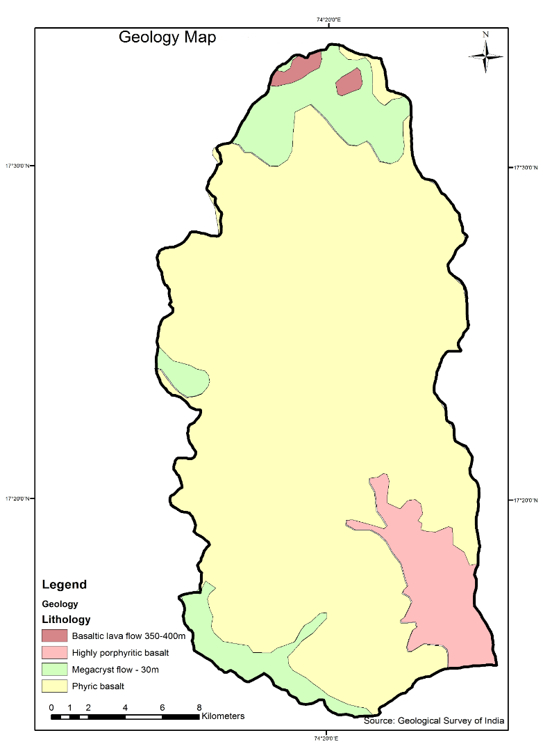

**Figure 3** Geology Map of Nandani Watershed

A major portion of the basin is developed on the Deccan Plateau, which is bounded by the Western and Eastern Ghats and is the largest geomorphic sub-unit of the Indian Peninsula. The western and central India experienced the Deccan volcanic events mostly during late Cretaceous-Eocene, where the extensive outpourings of basalts not only buried the low-relief, pre-Trappean landscape but also created a youth-stage topography over which sub-aerial processes started operating and new drainage network was established. Erosion commenced on the newly formed rifted margin and operated to the then existing erosional base level, which gave rise to the present-day landforms including the Deccan Plateau and the Western Ghats.

All of the mountain areas are made up of metamorphosed volcanic rock layers in various colours such as red, brown, yellow, grey, and white. The western part of study area covered by Denudational hills and valley and the middle and eastern part of study area covered by Denudatinal origion & Older Flood Plain. The general slope of the region is towards the east, and the region consists of undulating plains. A few parallel ridges of sand, pebble and shells are situated at relatively higher elevations and the depressions between them are occupied by swamps, silts etc. The distribution of these geomorphological features and their extent are highly variable in accordance with the geological settings.

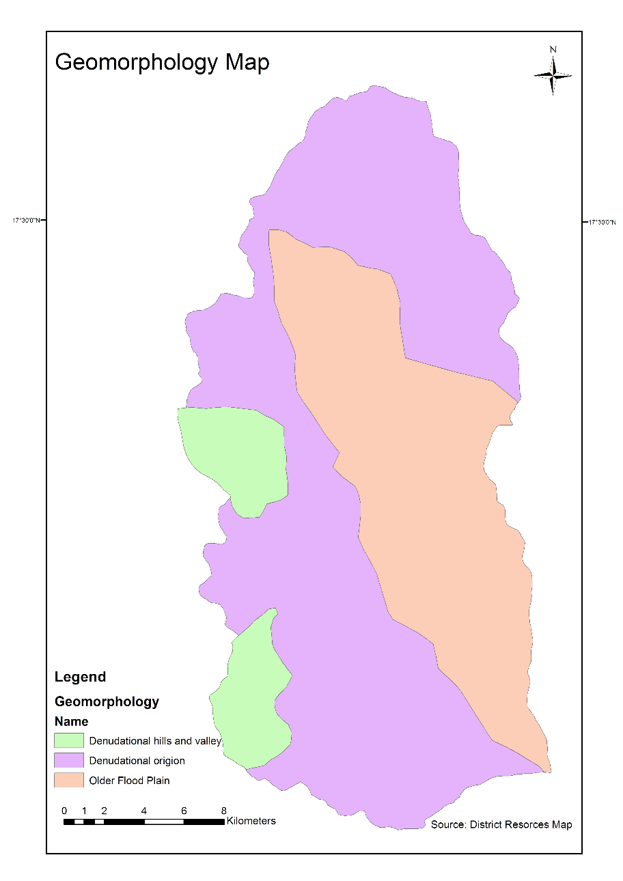

**Figure 4** Geomorphogical Map of Nandani Watershed

**4.3 Hydrological soil group (HSG)**

The soil consists different classes viz., gravelly clay soil, gravelly clay loam, sandy clay loam, and gravelly sandy loam. The hydrologic soil group (HSG) is prepared from soil map considering the infiltration rate of various soil textures. Accordingly, the above soil classes were grouped under three categories viz. B, C and D (Figure 5). The B type soil spread over the 31% basin area, C type soil covers the 33% basin area and D type soil covers the 36% of basin area. Western part of basin area surrounded by D type of soil and north east part is covered by B type of soil. From total area of 492 km2 about 152.5 km2 area is covered by B type of soil, 162 km2 area is covered by C type of soil and 177.5 km2 area is covered by D type of soil.

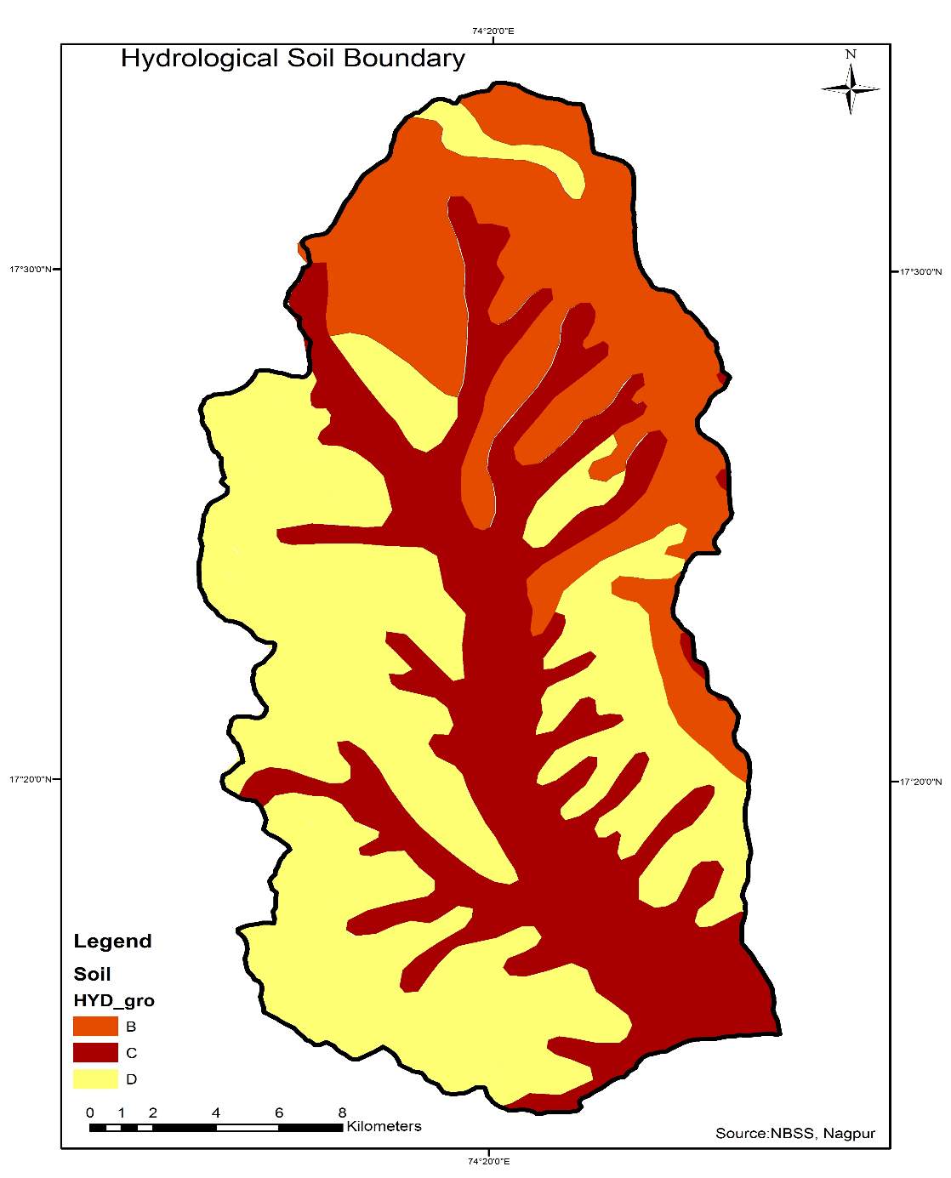

**Figure 5** Hydrological Soil map of Nandani Watershed

**4.4 Land use/ Land Cover**

Multi date satellite images expose the surface conditions such as natural vegetation, cropped areas, water spread of reservoirs and other land cover and land use features. According to land use and land covered, the area of five categories was found out in Arc GIS software tool. The major land-use type in the study area are agricultural land, open scrub land, fallow land and waterbodies. These land use classes are delineated from IRS-P6, LISS-III satellite data and intense field verification. Five land use/cover classes viz. agricultural land, water bodies, open scrub land, fallow land and natural vegetation (Figure 7) were defined from all four IRS P6 LISS-III satellite images of the year 1990, 2015 2017 and 2018.

About 60.57% of the area is occupied by agricultural land, 6.10% area covers forest land, 18.09% area of dry land and remaining 15.24% of the area is occupied by others such as water body, hills, settlement and tanks. For the interpretation of False Colour Composite, and preparation of user friendly land use land cover, four different years FCCs are downloaded from Bhuvan.Org website which are clear and without any disturbance of cloud images. Satellite images were processed using ERDAS IMAGINE 10 software for visual interpretation and digital image classification and change detection studies and in addition to water assessment analysis. Figure 4.4 shows the False colour composite of Nandani watershed on 4 Jan 2018 and Figure 6 shows the Land use/ Land cover map on 4 Jan 2018.

The total area of Nandani watershed is 492 km2 from which about 298 km2 area is occupied by agricultural land, 30 km2 area covers forest land, 89 km2 area covers dry land and remaining 75 km2 area is occupied by others such as water body, hills, settlement and tanks.

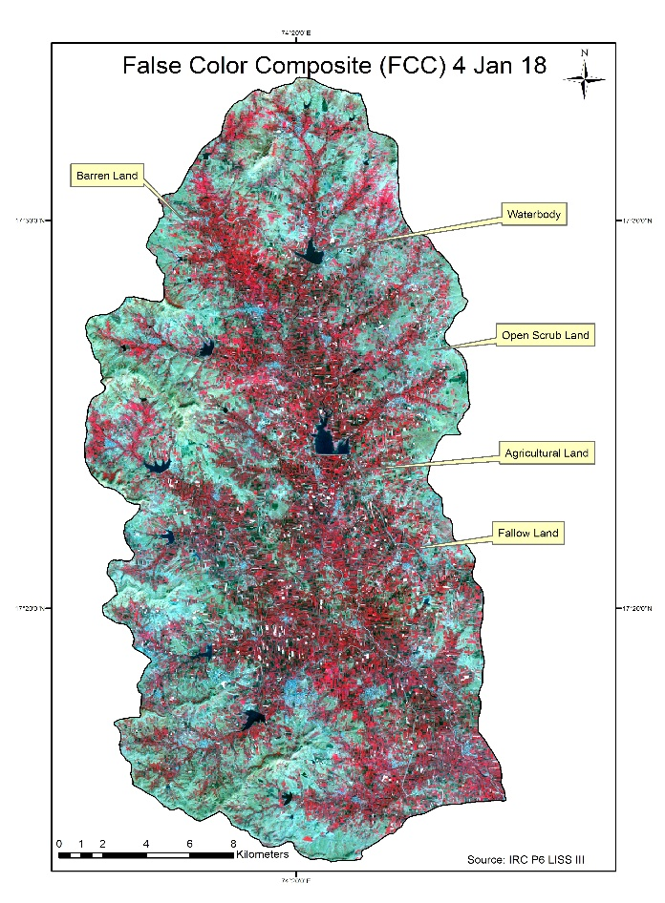

**Figure 6** False colour composite of Nandani Watershed, 4 Jan 2018

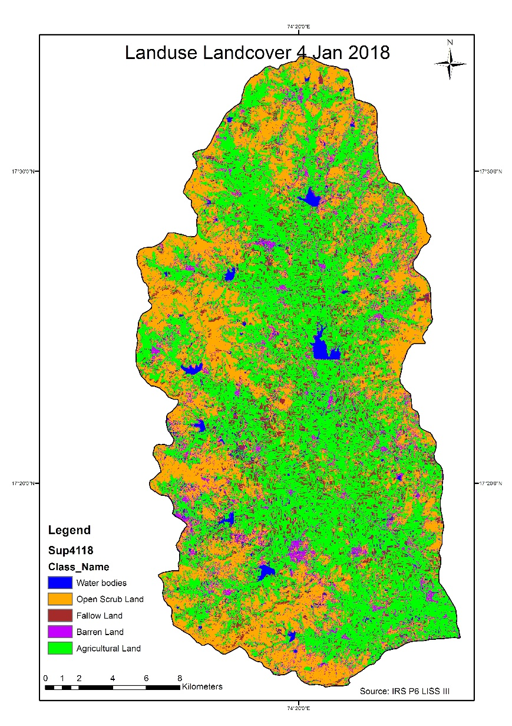

**Figure 7** Land use land cover of Nandani Watershed, 4 Jan 2018

**4.5 Slope**

The slope map is prepared from the Digital Elevation Model (DEM). The contour map is first converted to the DEM and then the slope map (Figure 8). The slope map is further classified for exploring potential suitable sites for several water harvesting structures. From slope map, suitability and location of structure can be checked for parameters like runoff rate, sedimentation deposition etc. The study area can be classified into five slope classes based on the slope. Because of the virtually flat topography and reasonably high infiltration rate, locations with an 0-8 slope are classified as ‘very good’. Because of the somewhat undulating topography and considerable runoff, regions with a 9-15 slope are considered as ‘good’ for groundwater storage. The areas having a slope of 16-33 cause relatively high runoff and low infiltration, and hence are categorized as ‘poor’ and the areas having a slope >33 are considered as ‘very poor’ due to higher slope and runoff.

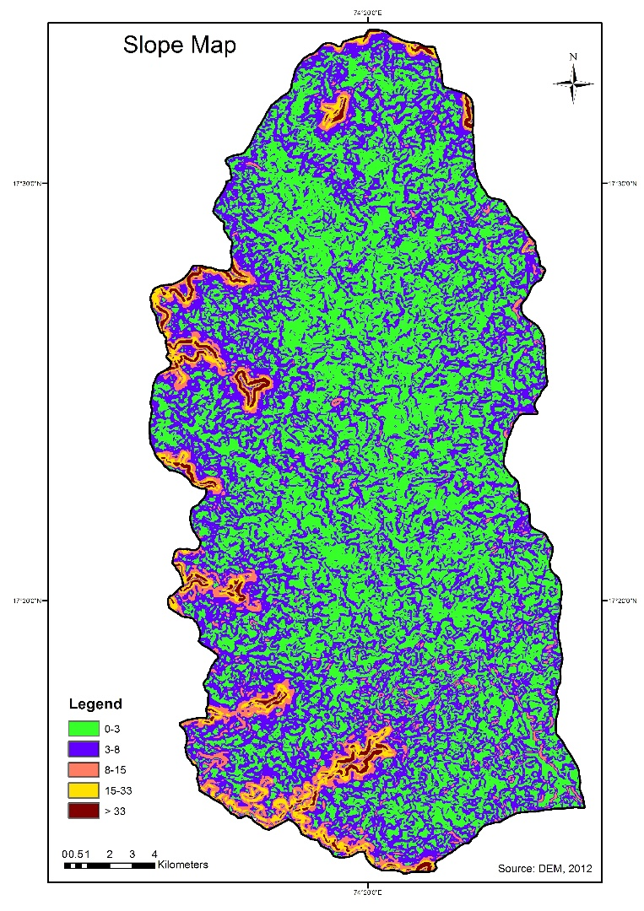

**Figure 8** Slope map of Nandani Watershed

**4.6 Lineament**

Another important parameter to consider for artificial recharge systems is lineament. A lineament is a landscape element that reflects an underlying geological structure, such as a fault, fracture, or joint. Lineaments are widely used in the study of fractures or structures using remote sensing. The lineaments are interpreted using district resource map and geological map in the study area. Lineament map of Nandani Watershed in shown in Figure 9. Lineament shows that the study area divided in two parts viz eastern part and western part. The lineament present in study area indicates the location of main stream which is flowing through north to south.

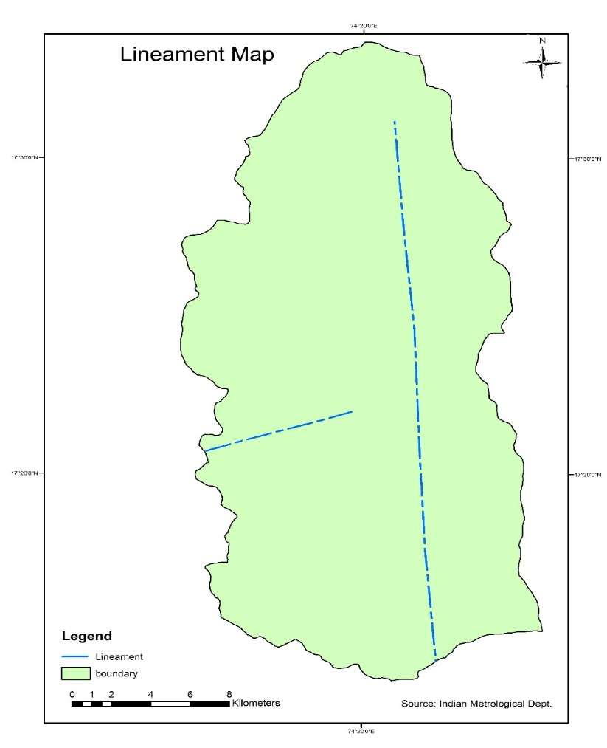

**Figure 9** Lineament map of Nandani Watershed

**4.7 Drainage**

The Krishna River and its tributaries, the warna, Morna, Yerala, and Agrani rivers, drain the majority of the Sangli district. Man and Bor rivers, tributaries of the Bhima river, drain parts of Atpadi, Kawthe Mahankal, and Jat taluka. All other rivers and streams are seasonal, with the exception of the Krishna, warna, and Morna rivers, which are perennial.  Although the predominant drainage pattern is dendritic, trellis, rectangular, angulate, and subparallel drainage patterns can be found locally.

The total drainage area of the Nandani basin is 492 km2. The drainage pattern is dendritic and is influenced by the geography of the area. It is found that Nandani river tributaries are of 6th order. In all 1655 streams were identified of which 1219 are first order, 332 are second order, 77 are third order, 18 in fourth order and 8 of the fifth order and 1 of sixth order. The drainage map is shown in Figure 10.

Drainage map is prepared by digitizing the individual streams from the Survey of India topographic sheets on scale of 1:50000 and assigned stream orders using Strahler’s law of stream order (1964). When two first-order streams come together they form a second-order stream. When two secondorder streams come together they form a third-order stream. Nandani Watershed is a 6th order watershed having dendritic to sub-dendritic drainage pattern. The Nandani watershed is further divided into seven sub watersheds according to morphology and drainage pattern.

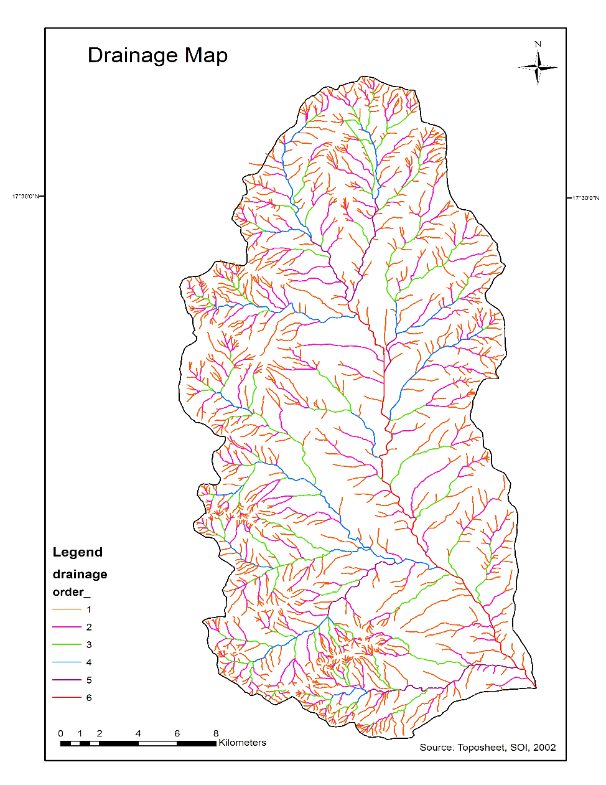

**Figure 10** Drainage Map of Nandani Watershed

**4.8 Groundwater potential zoning**

Since groundwater cannot be seen directly from remotely sensed data, its existence must be inferred by identifying surface features that function as groundwater indicators (Das et al. 1997; Ravindran and Jeyaram 1997). Hence in the present study, hydro-geomorphological details derived through the visual and digital interpretation of the enhanced satellite products were used for delineating the groundwater prospective zone maps of the study area. Hydro geomorphological maps depict important geomorphic units, landforms, and underlying geology in order to provide an understanding of the processes, materials/lithology, structures, and geologic controls relating to groundwater occurrence and prospects. Such maps, which depict prospective zones for groundwater targeting, are critical as a foundation for planning and carrying out area-specific activities. The groundwater potential zone map categorized as High, Moderate, Poor, Very Poor as shown in Figure 11. High and moderate groundwater prospect zones are mainly dominated by geomorphic units like valley fill and pediplains respectively. Lineaments are the visible surface manifestations of linear features such as joints and fractures. They have been delineated as linear features from the imagery and are confirmed after ground truthing. A higher order of groundwater potentiality is indicated where lineaments run along and across the alluvial zone. The criteria for delineation of groundwater potential zones was adopted from Krishnamurthy et al. (1992), Panigrahi et al. (1995), and Rao and Jugran (2003).

Figure 11 shows the variation of groundwater potential zones in study area. The maximum part of middle portion of watershed is combined with high and moderate groundwater potential zones. The western boundary of study area showing poor groundwater potential zones because this area is mostly covered by hills. About 48% area comes under high potential zone, 43% area comes under moderate potential zone and 9% area comes under poor and very poor potential zone. The groundwater potential map demonstrates that the excellent groundwater potential zone is concentrated in the north-eastern and north-western region of the study area due to the distribution of alluvial plains and agricultural land with high infiltration ability. This is an empirical method for the exploration of groundwater potential zones using remote sensing and GIS, and it succeeds in proposing potential sites for groundwater zones. This method can be widely applied to a vast area with rugged topography for the exploration of suitable sites.

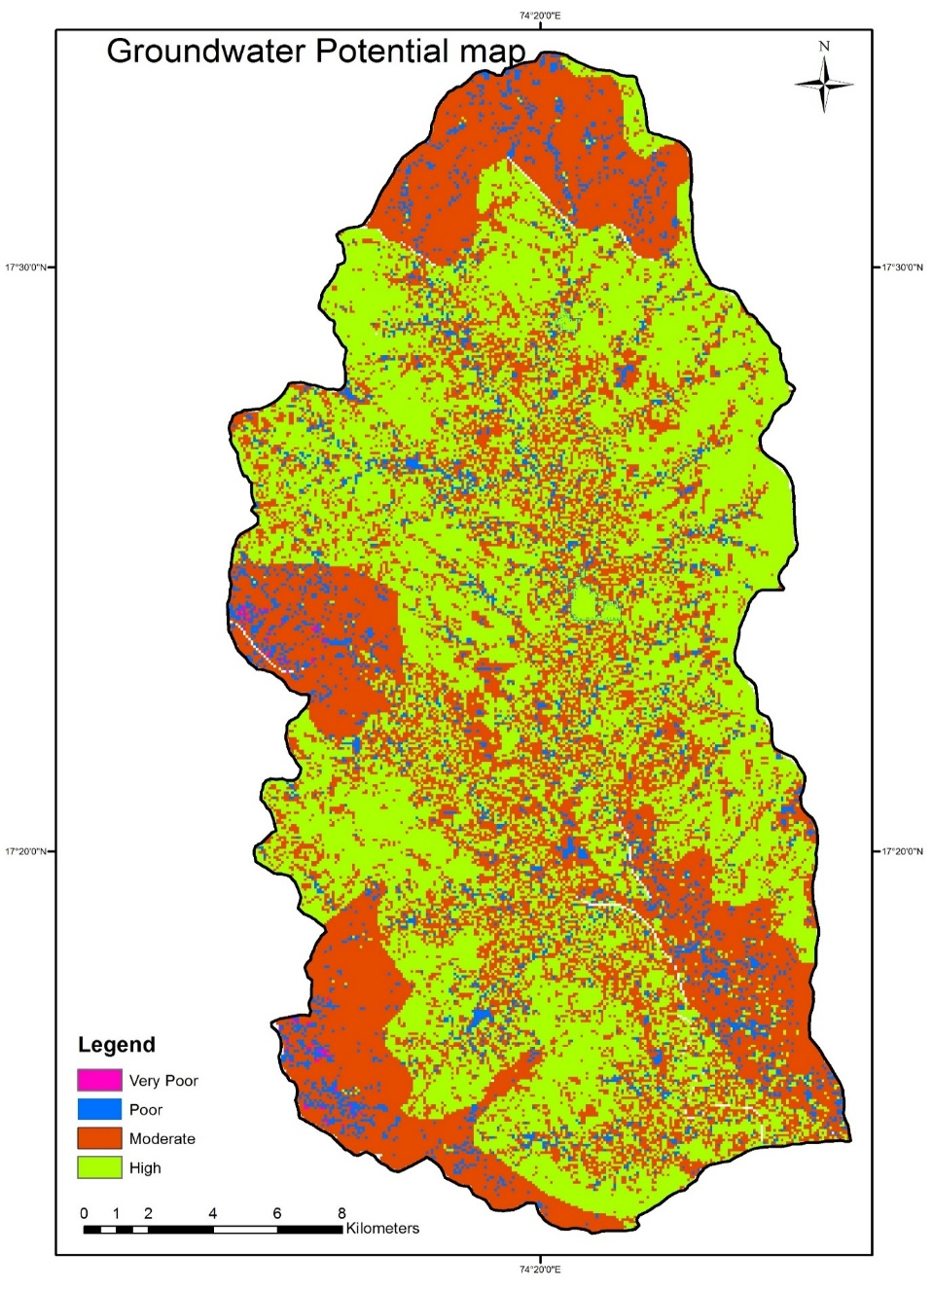

**Figure 11** Groundwater potential map of the study area

**5. Conclusions**

The aim of study is to assessment of groundwater potential zones in Nandani watershed To achieve the objective, detailed study of Nandani watershed is done in all possible aspect. The groundwater potential zone map categorized as High, Moderate, Poor, Very Poor as shown in Figure 4.9. About 48% area comes under high potential zone, 43% area comes under moderate potential zone and 9% area comes under poor and very poor potential zone. The groundwater potential map demonstrates that the excellent groundwater potential zone is concentrated in the north-eastern and north-western region of the study area due to the distribution of alluvial plains and agricultural land with high infiltration ability. This is an empirical method for the exploration of groundwater potential zones using remote sensing and GIS, and it succeeds in proposing potential sites for groundwater zones. This method can be widely applied to a vast area with rugged topography for the exploration of suitable sites.

#### **Statements and Declarations**

The authors declare that they have no known competing financial interests or personal relationships that could have appeared to influence the work reported in this paper.

**References**

1. Abdul-Aziz Hussein. Vanum Govindu.Amare Gebre Medhin Nigusse (2016), ‘Evaluation of groundwater potential using geospatial techniques’, *Appl Water Sci*, pp. 1-15.
2. Abhijit M. Zende, R. Nagarajan, K. R. Atal (2012), ‘Assessment of Groundwater Potential Zones by using GIS Techniques in Yerala River Basin, Western Maharashtra, India’, *International Journal of Advance Civil Engineering*,pp. 9-17.
3. Krishnamurthy, N. Venkatesa Kumar,V. Jayaraman And M. Manivel (1995), ‘An approach to demarcate ground water potential zones through remote sensing and a geographical information system’, *International Journal of Remote Sensing*, pp. 1867-1884.
4. M. Kavitha Mayilvaganan, P. Mohana and K.B. Naidu (2011),‘Delineating groundwater potential zones in Thurinjapuram watershed using geospatial techniques’, *Indian Journal of Science and Technology Vol. 4 No. 11*, pp. 1470-1476.
5. N.S. Magesh, N. Chandrasekar, John Prince Soundranayagam (2012), ‘Delineation of groundwater potential zones in Theni district, Tamil Nadu, using remote sensing, GIS and MIF techniques’, *Geoscience Frontiers 3(2)*, pp. 189-196.
6. Prafull Singh, Jay Krishana Thakur & Suyash Kumar (2014), ‘Delineating groundwater potential zones in a hardrock terrain using geospatial tool’, *Hydrological Sciences Journal, 58:1*, pp. 213-223.
7. Ravindran, K.V., Jeyaram, A.(1997), ‘Groundwater prospects of shahbad tehsil, baran district, eastern rajasthan: a remote sensing approach’, *J Indian Soc Remote Sens 25*, pp.239–246.
8. S. K. Nag and Anindita Kundu (2016), ‘Delineation of Groundwater Potential Zones in Hard Rock Terrain in Kashipur Block, Purulia District, West Bengal, using Geospatial Techniques’, *International Journal of Waste Resources vol.6 Issue 1*, pp. 1-8.
9. Tesfa Gebrie Andualema, Girum Getachew Demekeb (2019), ‘Groundwater potential assessment using GIS and remote sensing: A case study of Guna tana landscape, upper blue Nile Basin, Ethiopia’, *Journal of Hydrology: Regional Studies 24*, pp.1-13.
10. Tiwari, A., Rai, B.(1996), ‘Hydromorphogeological Mapping for Groundwater Prospecting Using Landsat-MSS Images — A Case Study of Part of Dhanbad District, Bihar’, *J Indian Soc Remote Sens* 24, pp.281–285.
11. Tweed, S.O., Leblanc, M., Webb, J.A. et al.(2007), ‘Remote sensing and GIS for mapping groundwater recharge and discharge areas in salinity prone catchments, southeastern Australia’, *Hydrogeol J 15*, pp.75–96.
12. Teeuw, R.(1995), ‘Groundwater Exploration Using Remote Sensing And A Low-Cost Geographical Information System’, *HYJO 3*, pp.21–30.
13. Y. SRINIVASA RAO & D. K. JUGRAN (2003), ‘Delineation of groundwater potential zones and zones of groundwater quality suitable for domestic purposes using remote sensing and GIS’, *Hydrological Sciences Journal, 48:5*, pp.821-833.