Drying Conduct of Osmo-convective Drying of Daucus carota and Mangifera indica: Quality Attributes of Dehydrated Products
Arnab Bhowmik, Prasenjit Guchhait, Sathish Sundararaman*, Supriya Subrahmanian**

*Department of Chemical Engineering, Sathyabama Institute of Science and Technology, Chennai - 600 119, India
**Department of Chemistry, Sathyabama Institute of Science and Technology, Chennai – 600 119.

__________________________________
*Address correspondence at: Department of Chemical Engineering,
Sathyabama Institute of Science and Technology, Chennai - 600 119, India
Tel: 9841558768
E-mail:sathish.chemical@sathyabama.ac.in

Abstract
Drying seasonal fruit and vegetables are essential for safe storage and preservation by reducing the moisture content to a certain level. In this study, green mangoes and carrots were treated with an osmotic solution and followed by drying in a micro oven-assisted convective dryer. The green mangoes sample was treated with 10 % (w/w) NaCl solution for 4 h, and carrot slices were osmotically dehydrated with 30 % honey (w/w) for 10 h. The moisture content was reduced after osmotic treatment was 5.2 and 5 % for green mangoes and carrots, respectively. Moreover, the behavior of convective and osmo-convective drying was investigated. Furthermore, the curve for moisture %, drying rate, and convective drying were plotted. The results show that the osmo-convective process reduced the time consumption for drying than regular convective drying at the same temperature. It was reduced to 70 and 20 min for green mangoes and carrots, respectively.Additionally, the fresh samples of carrots and green mangoes that were osmotically dried had much higher nutritional value. Altogether, osmotic dehydration followed by convective drying is a commercially acceptable process for the preservation of fruits and vegetables without altering the nutrition value.
Keywords: Convective drying, Osmotic dehydration, Carrots and mangoes, Micro oven assisted convective dryer, Nutrient retention

- Introduction
In the typical human diet, fruits and vegetables play a significant role as sources of nutraceuticals. The term "nutraceuticals" refers to substances that are naturally present in foods or other ingestible forms and that have been shown to be advantageous to the human body in terms of either improving physiological performance beyond the effects of adequate nutrition or preventing or treating one or more diseases in a way that is relevant to both an improved stage of health and well-being and a decreased risk of disease. These ingredients may include advantageous antioxidants, natural colourants (such carotenoids), minerals, and vitamins, many of which may have additional benefits ^{1,2}. India offers a diverse spectrum of climatic and physio-geographical conditions, ensuring the availability of most fruits and vegetables. An estimated 486 million tonnes of vegetables and 392 million tonnes of fruits are produced worldwide each year. India is the second-largest producer of fruits and vegetables in the world, producing 90.534 million tonnes every year (National Horticulture Board 2015–2016).
Although fruits and vegetables are produced during peak seasons, there are insufficient preservation and storage facilities at those times, thus the market becomes overstocked and gets rotten before it reaches the consumer. A lack of postharvest handling up to consumption causes between 30–40% of the overall yield in affluent countries to perish. However, postharvest losses in developing nations like India were close to 50% of the total production of fruits and vegetables, which has a negative impact on the consumers' access to fresh produce ³. Transforming it into a variety of commodities for sale, such as slices, powder, juice, or concentrate, would be one efficient way to lessen this enormous waste. The advantages of processed products include a longer shelf life, greater bacterial resistance, and less expensive handling, transportation, and storage. As a result, it is essential to produce a finished product that is both healthful and of acceptable quality for consumers ⁴. Food products are frequently preserved using a variety of techniques, including smoking, dehydration, and minimal processing. It is dried to remove moisture, preserving and extending shelf life so that dried goods can be sold year-round and, in the places, where these are not produced. Moreover, drying lowers the price of packaging, handling, and transportation in addition to reducing bulk and weight. However, food quality alterations in terms of physical, sensory, nutritional, and microbiological aspects could potentially result from drying ⁵.
Drying is a mass transfer technique used to reduce the bulk of agricultural output by removing moisture from food products ⁶. Since drying requires the transfer of heat, modern drying methods are focused on the use of less energy, improve drying efficiency, and produce high-quality items at the lowest cost ⁷. There has been extensive research on the processing of vegetables and fruits using air, sun, convection-microwave, and combinations of freeze drying, microwave heating, air or vacuum drying, and solar drying; however, few have attempted to combine different levels of pre-treatments prior to drying and the impact on the nutritional quality and sensory acceptance⁸.
In the food processing industry, osmotic dehydration is a supplementary treatment and food preservation method. It lessens heat-related flavour and colour loss and stops enzymes from browning. As it can be done at low or ambient temperatures, it requires less energy than air or vacuum drying. Osmotic dehydration might not produce a product with a low enough moisture content to make it shelf-stable, thus additional processing, like air drying, vacuum drying, or freeze-drying, is required.Therefore, an innovative method of drying that combines osmosis (which causes partial dehydration of the fruit) has drawn attention in recent years as a method for producing foods with intermediate moisture levels and foods that are shelf-stable, as well as a pre-treatment before drying to minimise energy use and heat damage⁹. In this experiment green mangoes and carrots were selected as model fruit and vegetable. Mango is a well-known tropical fruit that is widely grown. The fruit is high in antioxidants and should be included in one's daily diet because of its health benefits, which include a lower risk of cardiovascular disease, anti-cancer, and anti-viral properties¹⁰. It also contains a large quantity of β-carotene, a carotenoid, that are responsible for the typical yellow colour of the mangoes¹¹. Furthermore, as a provitamin A and antioxidant, β -carotene is extremely beneficial for human consumption¹². On the other hand, Carrot is one of the most important root vegetable crops and is extremely nutritious, containing significant amounts of vitamins B1, B2, B6, and B12¹³. It also contains a variety of essential minerals. Carrots have the largest β-carotene content of any human nutrition, with approximately 5-8 mg of β -carotene per 100 g. Carrot pigment β-carotene is a precursor to vitamin A. Carrots also have a high fibre content, which helps to maintain a balanced diet¹⁴. This research involves a combination of convective and osmo-convective drying of mangoes and carrots. This study includes osmotic treatment with salt solution and honey solution followed by drying. The specific objectives of this research include, (i) to study the drying characteristics of mango and carrot without treating osmotic solution, (ii) to study the osmotic behavior of mango and carrot, (iii) to study the drying characteristics of mango and carrot treated with osmotic solution.
2. Material and method
2.1 Materials
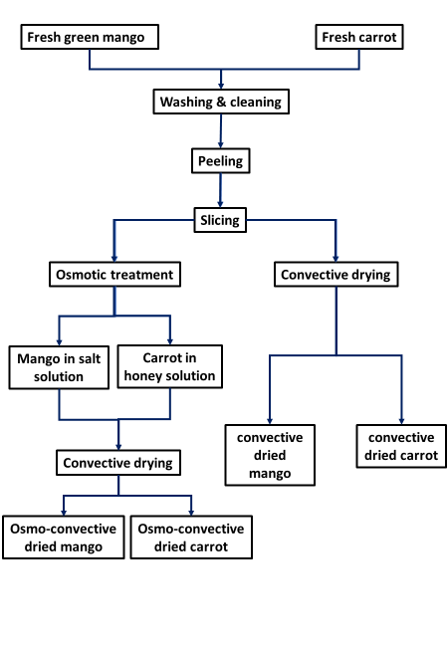
Freshgreen mangoes (Mangiferaindica) and carrots (Daucus carota) were procured from the local vegetable market at Madhavaram, Chennai, India (13.09º N, 80.13ºE). The reagents used in the experiments were NaCl (purity: 99%) and Honey (purity: 100%). These were supplied by Merck India Ltd., Mumbai and local supermarket at Chennai, India. All experimental solutions were prepared with purified drinking water, which was obtained from the Livpure Smart Water Purifier unit.
Figure 1: Process flow diagram of convective and osmo-convective drying of mango and carrot

2.2 Sample preparation
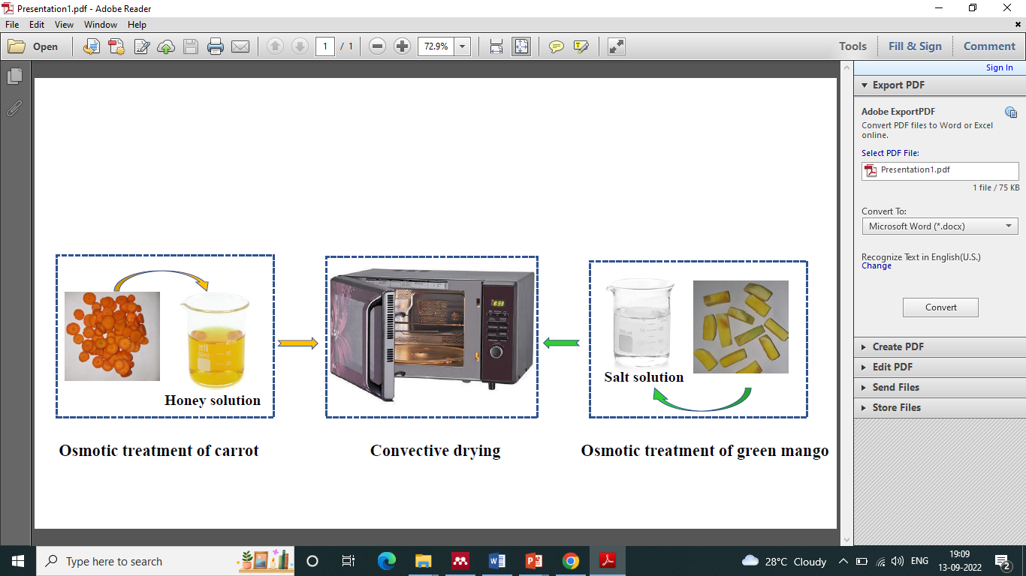
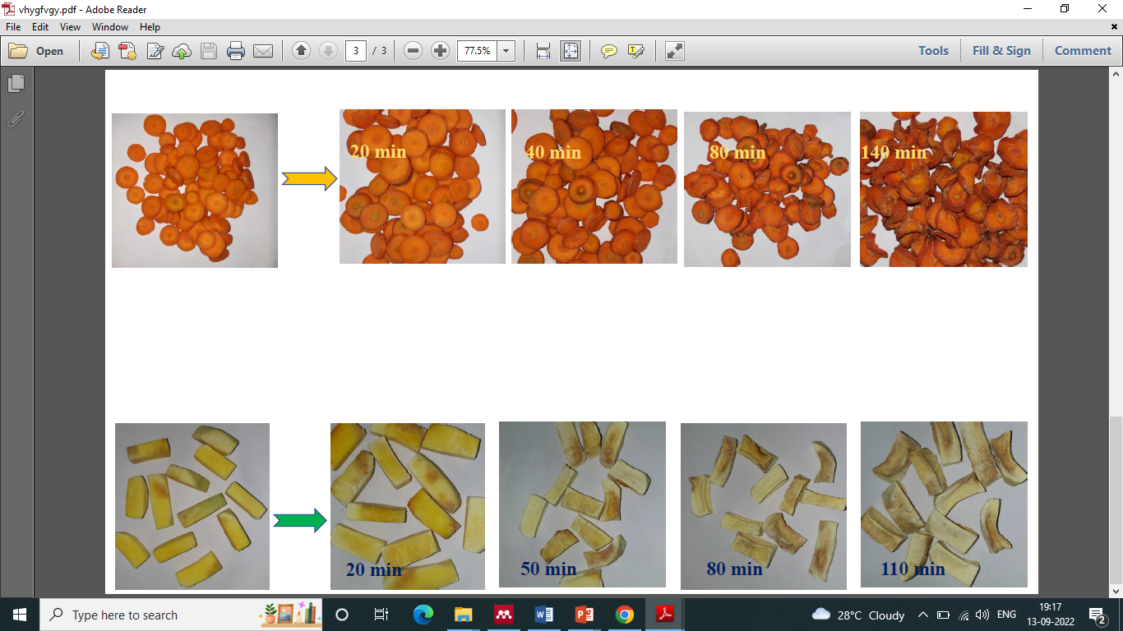
The mangoes and carrots were washed thoroughly with tap water to remove all the dirt and debris. These were peeled off and cut in small pieces with a sharp knife. The average size of the mangoes and carrots were 30*10*10 mm and 5mm slices respectively. These samples were weighted and used for further convective drying and osmo-convective drying. A stock solution of osmotic agent was prepared by dissolving accurately weighed amounts of NaCl and honey in purified drinking water. The desirable experimental concentrations of solutions were prepared by diluting the stock solution with purified water according to necessity.
Figure 2: Experimental setup for osmo-convective drying of green mangoes and carrots
2.3 Osmotic treatment
Previously weighted mango pieces were subjected to osmotic treatment in 10 % NaCl solution, at room temperature of 30±5°C. Moreover, the material to solution ratio was 1:10 (w/w) and samples were kept submerged for 4 h. Similarly, the slices of carrots were immersed into 30% of honey solution for 10 h with a ratio of 1:10 (w/w) sample to osmotic solution. The solution containing samples was stirred manually at a regular interval to make it uniform. Furthermore, the solutions were drained after osmotic treatment. The samples were blotted with tissue paper to remove the excess of osmotic solution from their surface and weighed.
2.4 Convective drying
Convective drying of the samples without osmotic treatment and with osmotic treatment was carried out in micro oven assisted convective dryer. The samples were placed in one layer on a tray and dried at 110 °C for 180 min.
2.5 Quality evalution
All the samples including before and after osmotic treatment, and the dehydrated product quality was evaluated in Scientific Food Testing Services Pvt Ltd. (13.07 ºN, 80.15 ºE). The different testing was carried out by using specific method to determine the moisture and nutritive parameters for mango and carrot samples. All the testing methods are listed in Table 1.
Table 1: Test methods applied for quality evalution
Sl no. | Test parameters | Test method
1. | Moisture | FSSAI Lab Manual, Fruits & Veg Products 4.1
2. | Fat | SFTS/FCL/SOP/003 Issue No: 01  Issue date: 03.01.2015
3. | Crude Fiber | IS 10226 (Part-1)
4. | Protein | SFTS/FCL/SOP/002 Issue No: 01  Issue date: 03.01.2015
5. | Carbohydrates | IS 1656
6. | Energy | Food Energy Method of analysis and Conversion Factor (FAO)
2.6 Drying characteristics
2.6.1 Moisture content
The moisture content of fresh and osmotically dehydrated green mango and carrot samples was determined using the AOAC (1984) method. It was obtained by taking a small amount sample and estimating the moisture content by recording the weights using the equation below,
 | (1)
Where, W₁ and W₂ indicates mass of original sample and dry sample.
2.6.2 Drying rate
The moisture content of this study was analysed to determine the amount of moisture lost from a sample of green mango and carrot over a specific time interval. The drying rate of the samples was calculated using the mass balance equation,
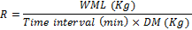 | (2)
Where, WML signifies [Initial weight of sample – Weight of sample after time (t)] and DM implies Dry material.
2.6.3 Water content
The following equation is used to estimate the water content of green mango and carrot during dehydration at a specific temperature,
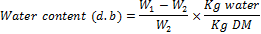 | (3)
3. Result and discussions
3.1 Drying characteristics
3.1.1 Effect of moisture percentage of convective and osmo-convective drying
The variation of moisture percentage with time for green mango is duplicates is shown in Figure 3 (a). It has been found that the initial moisture content in green mango was 75%. After osmotic treatment the moisture content was reduced to5.2%. In case of convective drying, moisture removed was up to 2% in 180 min. However, in osmo-convective drying 1.6% sample moisture was left behind after drying within 110 min. On the other hand, moisture percentage during convective and osmo-convective drying are given in Figure 3 (b). Initial moisture content in carrot was tested 88 %. Whereas, after osmotic dehydration in honey solution the moisture content reduction was 5%. In convective drying, moisture was removed up to 2 % in 160 min. Nevertheless, in osmo-convective drying 0.5 % sample moisture remained after drying within 140 min. In comparison to direct convective drying, osmotic pre-treatments reduced the rate of complementary convective drying and increased the total dehydration time.
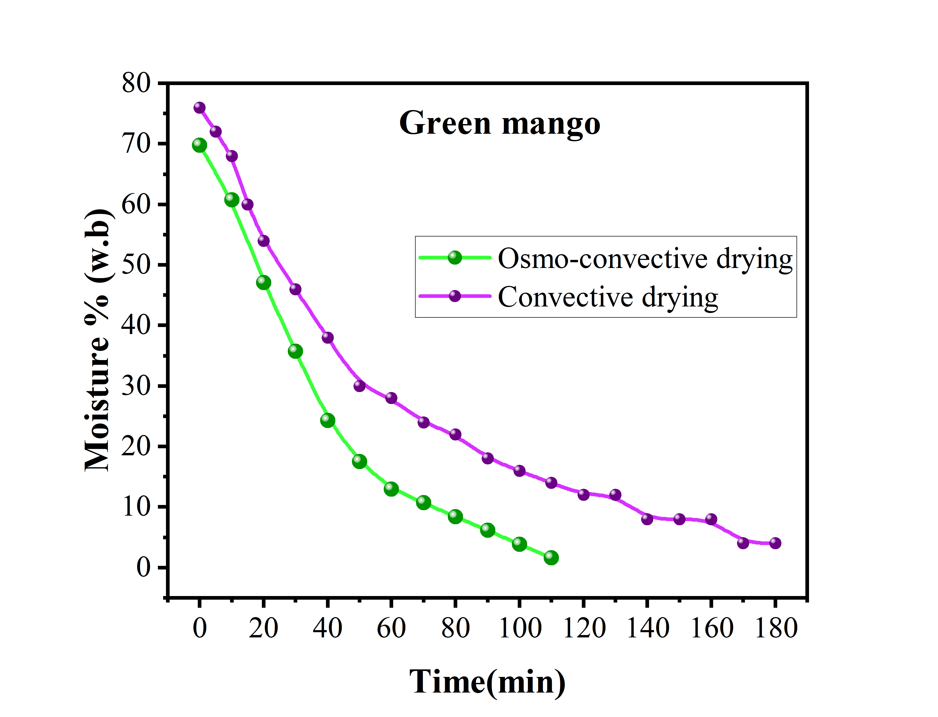
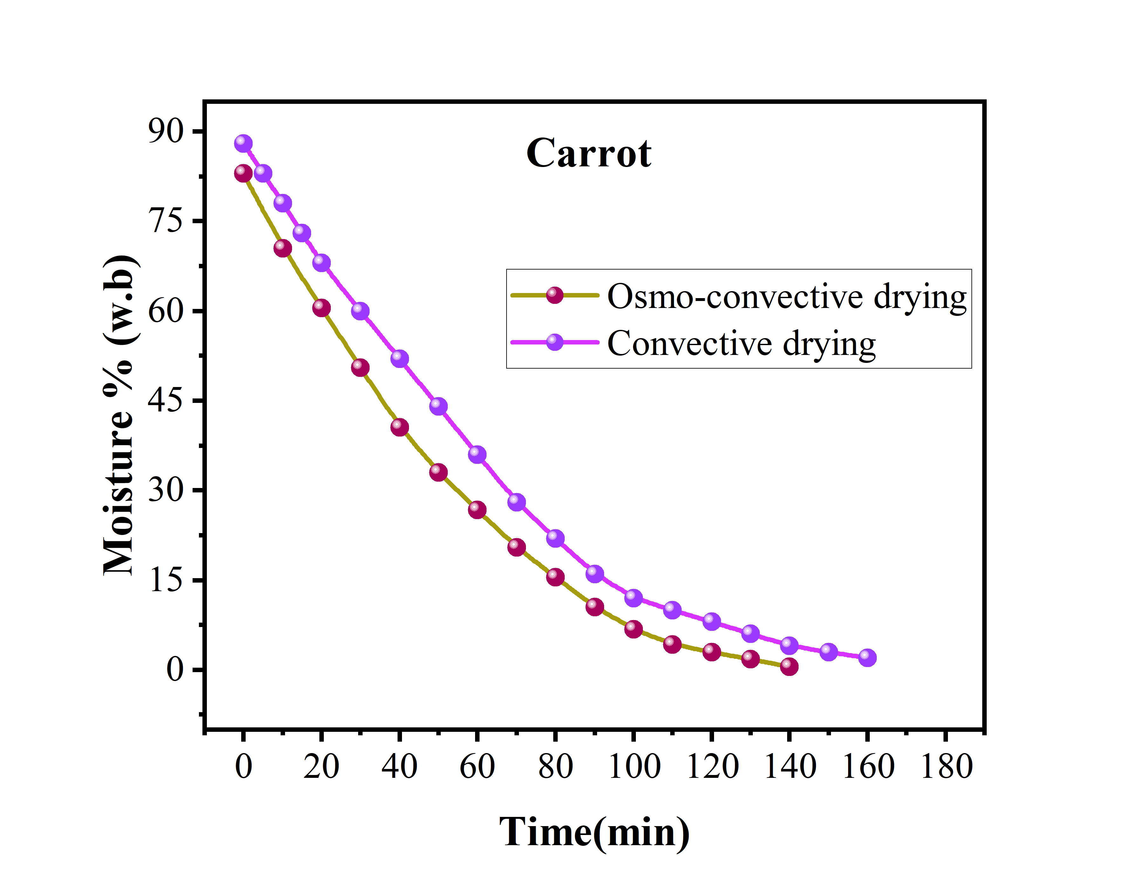
Figure 3:Moisture percentage (w.b) during osmo-convective drying and convective drying for (a) green mango and, (b) carrot
a)
b)
3.1.2 Drying rate curve for convective and osmo-convective drying
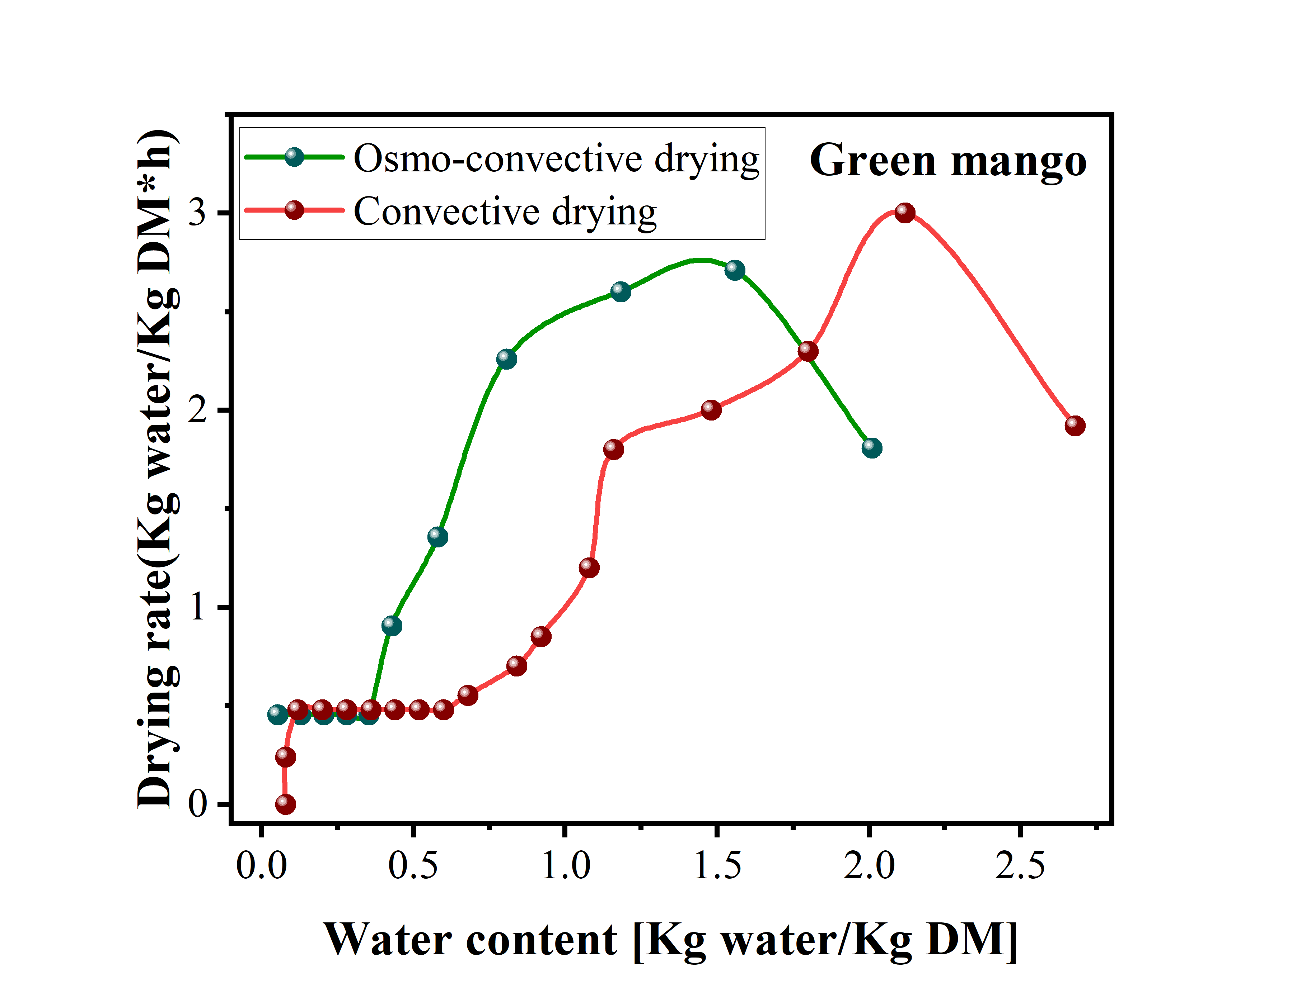
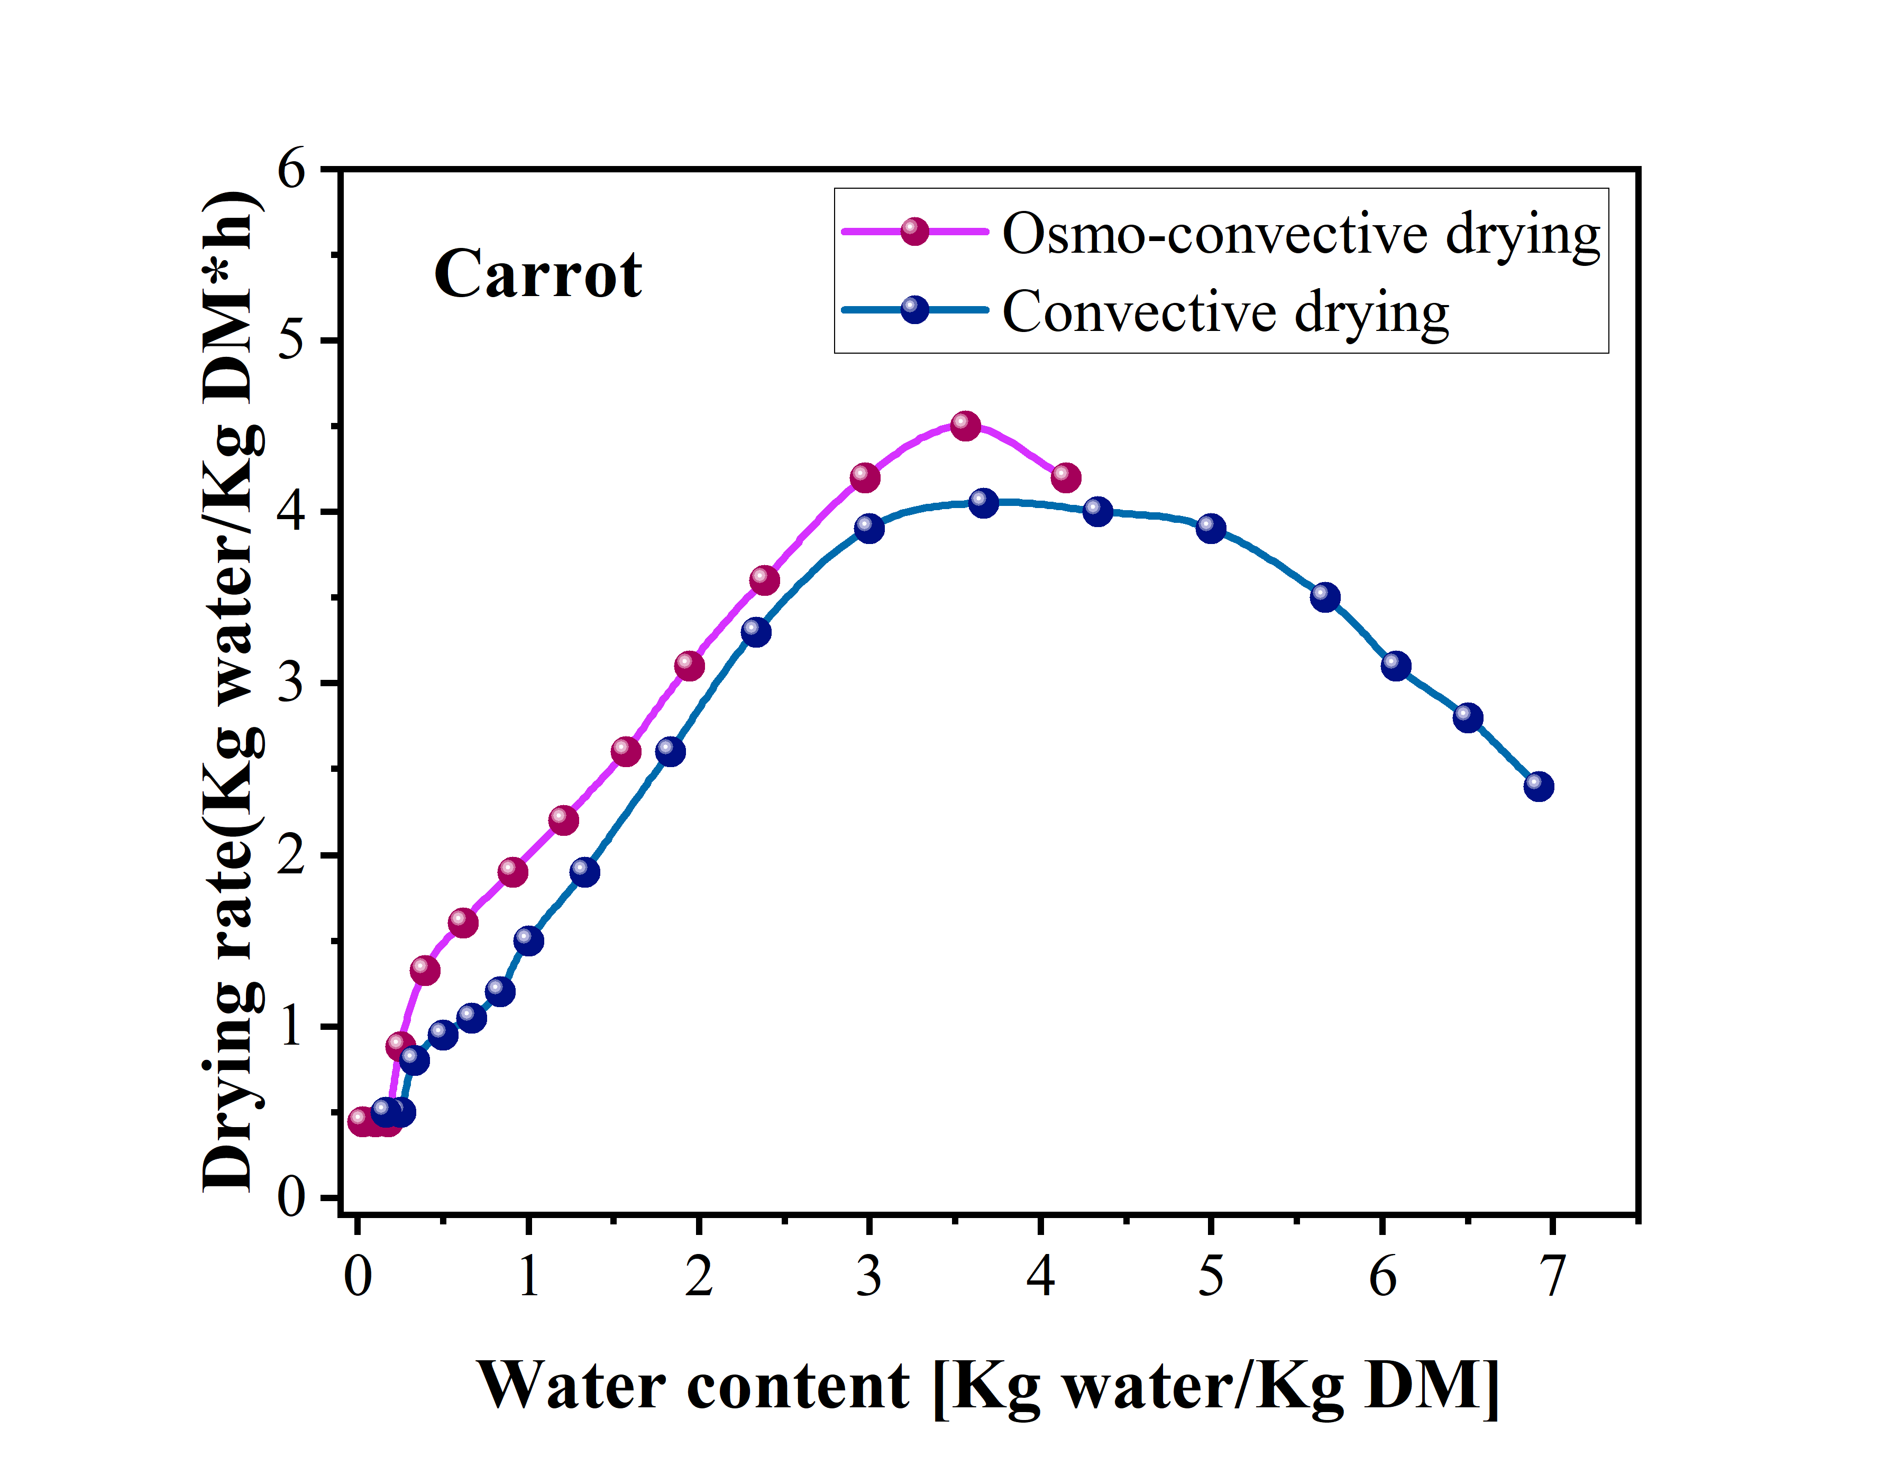
The weight of green mango slices was determined after a subsequent time interval. The drying rate at different time was evaluated by using water content, amount of moisture removed and the drying rate equation. Here, the drying rate curve was plotted against water content [Kg water/Kg DM] which is represented in Figure 4(a). From the drying rate curve, it can be justified that the green mango pieces were dried in falling rate period. A constant rate period was unidentified in both the convective and osmo-convective drying. The falling rate period drying implies that the internal mass transfer was done by diffusion. Similarly, the weight of carrot slices was evaluated after a regular time interval. From the drying rate curve in Figure 4(b) it can be justified that the carrot pieces were also dried in falling rate period. Again, a constant rate period was unidentified for both the convective and osmo-convective drying of carrots. Moreover, falling rate period drying here again implies that the internal mass transfer was done by diffusion.
a)
b)
Figure 4:Osmo-convective and convective drying rate curve for (a) green mango and, (b) carot
3.1.3 Drying curve for convective and osmo-convective drying
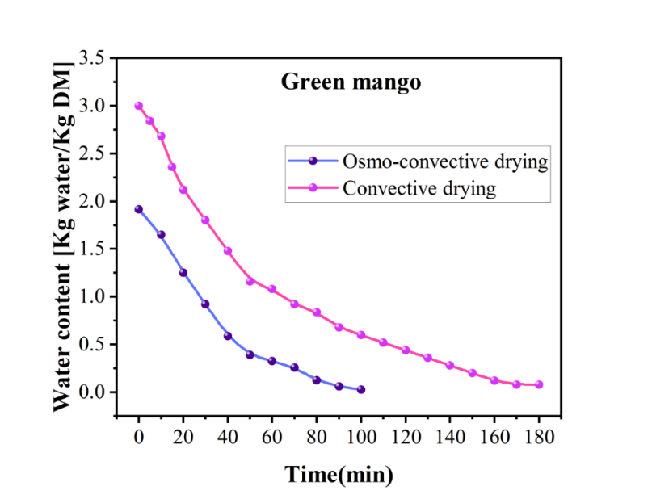
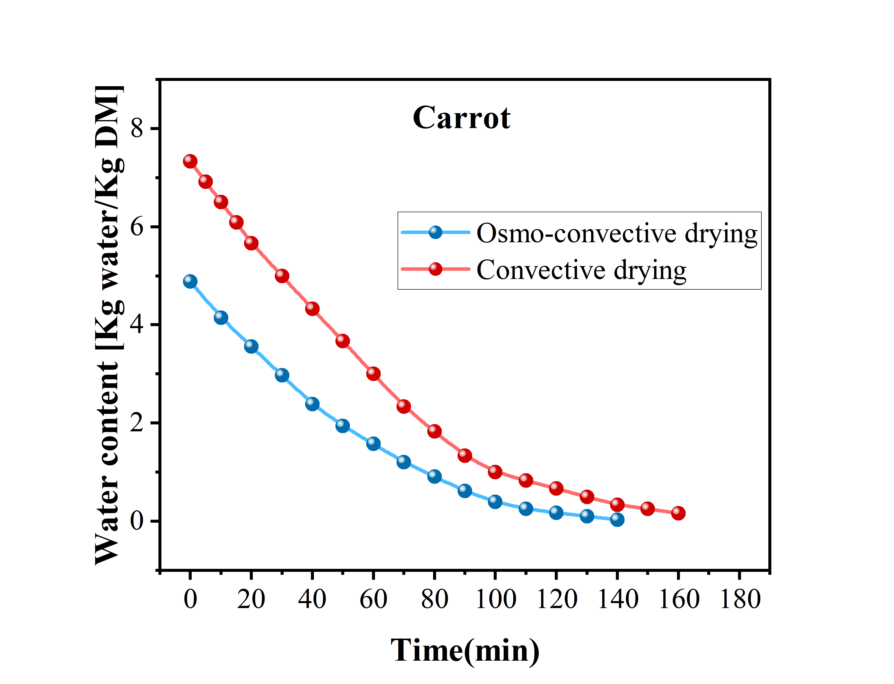
The drying curve of green mango for convective and osmo-convective drying are presented in Figure 5 (a). It shows that the water content in the sample decreases with the increase in the initial time period and slows down after a certain period of time and finally approached an almost constant value. For convective drying the water content reached a constant value of 0.08 Kg Water/Kg DM at 180min. On the other hand, in osmo-convective drying the water content was 0.053 Kg Water/Kg DM in 110min. The drying curve of carrot for convective and osmo-convective drying are shown in Figure 5(b). It also displays a decrease in water content with the increase in the initial time period. After a certain time period, the moisture removal was found to slow down and finally became almost constant. For convective drying the water content reached a constant value of 0.166 Kg Water/Kg DM at 160min. Whereas, in osmo-convective drying the water content was 0.029 Kg
a)
b)
Figure 5: Osmo-convective and convective drying curve for(a) green mango and, (b) carrot
Water/Kg DM in 140min.
3.2 Nutrition value analysis
In general, the retention of ascorbic acid is used to gauge the overall nutritional quality of processed foods. Due to its high water solubility, sensitivity to heat, and oxidation state, this nutrient is quite prone to degradation¹⁵. The nutritional value of osmo-convective dried mango and carrot were evaluated by measuring different nutrient constituents viz. Fat, Crude Fiber, Protein, Carbohydrates and energy. According to USAD the nutritional quality of fresh mango and carrot were compared with the osmo-convective dried products. It is represented in Table 2. It has been shown that all the nutrients value of processed product remains almost unchanged or increased. Therefore, it could be of help to meet the normal vegetable diet. In fresh mango, the value of Fat and Crude Fiber was found to be 0.4 and 0.94 g/100g. Whereas, there is an increase of about 17.5% Fat, 18.1% of Crude Fiber in osmo-convective dried mango. Also, protein and carbohydrate content of the processed mango was increased by 2 which is 4.1 times greater than that of the fresh samples. Again, the energy content of the samples after osmotically dehydrated was 260 Kcal/100g, which is significantly higher than the same quantity of fresh mango (0.6 Kcal/100g).
Similarly, the nutritional quantity of the processed carrots was also increased than the fresh carrots. It has been observed that the carrots after drying contains 0.26 g/100 g of Fat and 1.94 g/100 g of Crude Fiber, which is 30 and 74% more than the fresh carrots. Additionally, the processed samples had 2.78 and 5.99 % increase in protein (2.50 g/100 g) and carbohydrates (59.9 g/100 g) respectively, compared to the fresh samples. The carrots in fresh condition had 0.41kcal/ 100g of energy. However, the energy in carrots after osmo-convective drying had increased to 252 Kcal/100 g. This results for both mangoes and carrots clearly indicates that osmo-convective drying is a useful technique for preservation without altering the quality and quantity of the nutrients.
Table 2: Nutritive value of fresh and osmo-convective dried mango and carrot
Sl no. | Nutrients | Fresh sample |  | Osmo-convective dried sample |  | Unit
Sl no. | Nutrients | Mango | Carrot | Mango | Carrot | Unit
1. | Fat | 0.40 | 0.2 | 0.47 | 0.26 | g/100g
2. | Crude Fiber | 0.94 | 1.2 | 1.11 | 1.94 | g/100g
3. | Protein | 0.82 | 0.9 | 1.64 | 2.50 | g/100g
4. | Carbohydrates | 15 | 10 | 62.3 | 59.9 | g/100g
5. | Energy | 0.60 | 0.41 | 260 | 252 | Kcal/100g

4. Conclusion
Osmotic dehydration is a quick and efficient method for treating and preserving mangoes and carrots for long-term storage. In this research work, osmotic solution of salt and honey were used for green mangoes and carrots respectively, followed by drying in microwave assisted convective dryer. The quality and nutritional value of the food product were evaluated by various testing (Moisture, Fat, Crude Fiber, Protein, Carbohydrates and Energy) and experimental results. Both the convective and osmo-convective data of green mango and carrot from the experiment are used to plot the moisture% curve, drying rate curve, and drying curve. For mango, without osmotic dehydration, the sample is dried at 110°C for 180min, whereas in osmo-convective drying it was only for 110 min. For carrot, convective drying required 160 min whereas osmo-convective drying is completed within 140 min. Therefore, osmo-convective drying enhances the cost effectiveness by utilizing less energy than convective drying. Moreover, osmotically dried samples gets significant improvement in the nutritional value compared to the quality of the fresh samples of green mangoes and carrots. Overall, the osmo-convective drying using salt and honey solution is most suitable for commercial purposes to preserve mangoes and carrots during off-season. Therefore, this method could be applied to other vegetables and fruits also for extending their shelf life and preservation.

References
1. Bellary, A. N., Sowbhagya, H. B. & Rastogi, N. K. Osmotic dehydration assisted impregnation of curcuminoids in coconut slices. J. Food Eng.105, 453–459 (2011).
2. Ramya, V. & Jain, N. K. A Review on Osmotic Dehydration of Fruits and Vegetables: An Integrated Approach. J. Food Process Eng.40, 1–22 (2017).
3. Singh, V., Hedayetullah, M., Zaman, P. & Meher, J. Postharvest Technology of Fruits and Vegetables: An Overview. J. Post-Harvest Technol.2, 124–135 (2014).
4. Xu, J., Li, T., Yan, T., Chao, J. & Wang, R. Dehydration kinetics and thermodynamics of magnesium chloride hexahydrate for thermal energy storage. Sol. Energy Mater. Sol. Cells 219, 110819 (2021).
5. Gatea, A. A. Design and construction of a solar drying system , a cylindrical section and analysis of the performance of the thermal drying system. (2018) doi:10.5897/AJAR10.347.
6. Darvishi, H., Zarein, M., Minaei, S. & Khafajeh, H. Exergy and energy analysis, drying kinetics and mathematical modeling of white mulberry drying process. Int. J. Food Eng.10, 269–280 (2014).
7. Radhika, G. B., Satyanarayana, S. V. & Rao, D. G. Mathematical model on thin layer drying of finger millet (Eluesine coracana). Adv. J. Food Sci. Technol.3, 127–131 (2011).
8. Tadesse, T. F., Abera, S. & Worku, S. Nutritional and Sensory Properties of Solar-Dried Carrot Slices as Affected by Blanching and Osmotic Pre-Treatments. (2015) doi:10.5923/j.food.20150501.04.
9. Verma, R. C., Nagajjanavar, K. & Yadachi, S. Osmo-convective drying characteristics of sapota ( Chikko ) slices. 11, 959–969 (2022).
10. Harnkarnsujarit, N. & Charoenrein, S. Influence of collapsed structure on stability of β-carotene in freeze-dried mangoes. Food Res. Int.44, 3188–3194 (2011).
11. Jaubert-Garibay, S. et al. Assessing the product quality of mango slices treated with osmotic and microwave drying by means of image, microstructural, and multivariate analyses. Dry. Technol. 1–15 (2022) doi:10.1080/07373937.2022.2092493.
12. Zongo, A., Khalloufi, S., Mikhaylin, S. Ratti C. Pulsed Electric Field and Freeze-Thawing Pretreatments for Sugar Uptake Modulation during Osmotic Dehydration of Mango. Foods 11(17) 2551 (2022).
13. Wadso, L. Effect of long-term storage and blanching pre-treatments on the osmotic dehydration kinetics of carrots ( Daucus carota L . cv . Nerac ). 81, 313–317 (2007).
14. Singh, S. K. & Gangwar, V. Drying Behavior of Osmo-convective Drying of Carrot Slices and Quality Characteristics of Dehydrated Products. Int. J. Curr. Microbiol. Appl. Sci. 9, 1424–1431 (2020).
15. Mohammadi, X, Deng, Y, Matinfar, G, Anika, Singh, Ronit, M., Anubhav P. Singh. Impact of three different dehydration methods on nutritional values and sensory quality of dried broccoli, oranges, and carrots Foods, 9(10) 1464 (2020).

.

