Applications of Microwave Ferrites

Ms. Smita Tolani
Assistant Professor, Applied Physics,
St. Vincent Pallotti College of Engineering & Technology, Nagpur-441108.

Dr. Kishorchandra Rewatkar
Professor, Dept. of Physics,
Vidya Vikas College,
Samudrapur, Dist Wardha-442305

ABSTRACT
In this review, we have focused on reciprocal and non- reciprocal wave new generation ferrite microwave devices which are low cost, smaller in size, efficient, with enhanced compatibility. Ferrite-based microwave components, such as isolators, circulators, filters, phase shifters, etc., will be in high demand in the coming years. These electronic components lead to improved assembly integration, planar circuit designs and enhanced systems.
Keywords— Microwave Ferrites, Phase Shifters, Isolators, Circulators, Magnetic loss, Microwave devices.

1. INTRODUCTION

For decades Microwave devices have been employing ferrite materials in different components. Ferrites are high resistivity ceramics with low eddy currents. They have fairly good values of dielectric constants ranging from 10 to 20.[

] These materials exhibit high degree of anisotropy and magnetic properties with transparency to electromagnetic waves. All these properties are useful in various applications such as antenna rods, microwave absorbers, radio frequency transformers. These materials are ferromagnetic in nature exhibiting magnetism just like ferromagnetic materials below Curie Temperature Tc.[] Ferrites basically are of three types namely Spinels , Hexagonal Ferrites and Garnets. The structure of Spinels and Garnets is cubic while hexaferrites have hexagonal crystal lattice. [] The microwave gets attenuated by electromagnetic wave absorbing materials due to its energy getting dissipated into thermal energy by effect of interference. [] Parameters like permeability and permittivity are important for reflection and transmission of microwaves. [] There exist two types of Ferrite Microwave devices. The first type comprises of Phase Shifter filters, switches, delay lines and attenuators. The second type includes isolators, signal control devices such as circulators. [] The devices of the first type don’t require non-reciprocal wave propagation while devices of second type do need non –reciprocal nature of propagation of electromagnetic wave. It is a challenge to select the ferrite material for microwave applications and uses as many parameters may be used and the devices need to be produced with wide range. For examples in devices like circulators, phase shifters and isolators, the parameter which is used by microwave appliances is the permeability of the ferrite material. Permeability is a parameters which depends on several values like applied magnetic field, magnetization, frequency of the EM wave and also on the state of polarization of the wave. Hence various parameters are to be considered. Table 1 shows the Parameters require fulfill the needs of the device users.

APPLICATIONS | REQUIREMENTS
Isolator | Low Insertion Loss  Narrow Frequency Band
High Level Circulator | Low Insertion Loss  Power Induced Behavior  Stable Saturation Magnetization
Low Level Circulator | Low Insertion Loss  Wide Frequency Band  Wide Temperature Range
Table 1: The Parameters requires fulfill the needs of the device users.

In ferrites, losses are mainly of two types: Magnetic loss and Dielectric Loss. The use of ferrite material in microwave devices requires the desired frequency. Hence, low magnetic and dielectric loss is most sought after properties of ferrites in microwave devices.[] A reliable material for microwave use should have suitable power levels, desirable frequency and a good saturation magnetization. Another important property of a suitable ferrite is its ability to handle power. Ferrite materials would be able to able to withstand high power levels if their thermal conductivity is high. But that is a limitation. It is in addition of great value if the ferrite material has high M_{R}/M_{S} (Residual Magnetization to Saturation Magnetization) ratio.

2. APPLICATIONS OF MICROWAVE FERRITES
The dielectric properties of ferrites makes them desirable for use in various microwave devices like phase shifters, circulators, isolators, couplers etc. Ferrites have enhanced magnetic anisotropy which makes them suitable for high frequency microwave bands.

2.1 PHASE SHIFTERS
Phase shifters at the microwave range are usually made use of in switches and also to control signals. The microwave ferrite phase shifters are designed in both reciprocal and non-reciprocal types developed to operate in both analog and digital modes. [] Ferrite material based phase shifter devices are developed to optimize temperature variations, insertion losses, sizes and shift in the phase. Phase shifters employing ferrite materials have change in the phase due to variation in EM wave propagation constant in the phase shifter.
Phase shifters are basically classified as
- Ferrite Phase Shifters
- Semiconductor Phase Shifters
Figure 1 shows classification of Ferrite Phase shifters. It is observed that if the signal is propagating in the same direction then reciprocal phase shifter is identical.

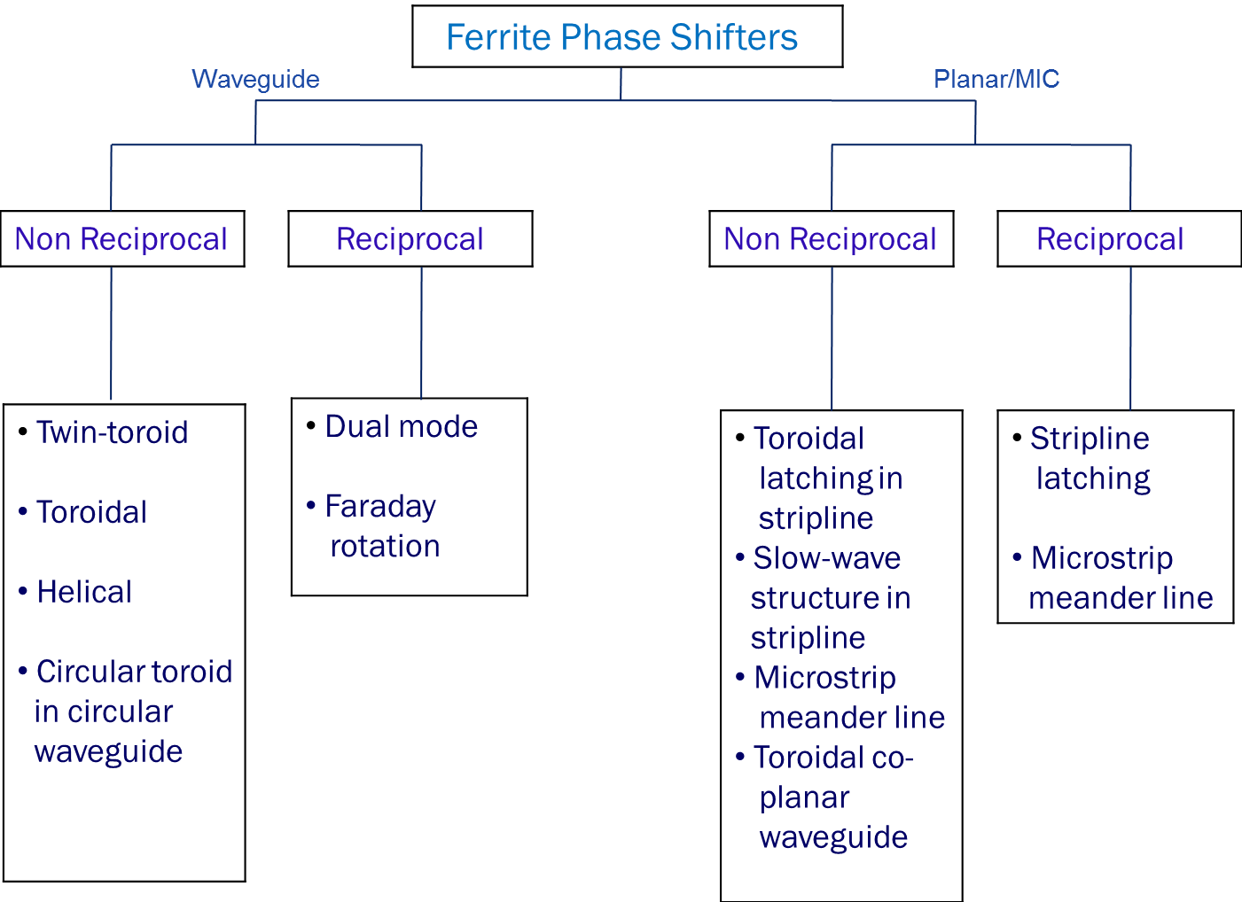
Figure. 1 Classification of Ferrite Phase shifters.
The ferrite phase shifters can very well be constructed in form of dielectric waveguides or metal waveguides and planar transmission lines.[]
Depending on the flow of current, phase shifters are categorized as;
1. Latched type phase shifter
2. Driven type phase shifter
Latched type phase shifters need a momentary pulse of current to store a command of phase. Latched phase shifters have a closed magnetic path; hence do not require continuous current for control. Whereas, driven type phase shifter need a continuous current control. ^{[9]}
Phase shifters are available in both analog and digital types where insertion phase is continuously varied by current control in analog type and in digital type the insertion phase has sections of discrete phase shifts. ^{[9]}
It has been observed that Semiconductor Phase shifters possess better insertion loss, less capacity of power and less switching time. The applications of semiconductor phase shifters are different than that of ferrite phase shifters and both are used for various applications. Ferrite Phase shifters are used extensively in communication systems. Figure 2 shows the ferrite phase shifter antenna for communication purposes representing phase array.
Figure.2 Ferrite Phase Shifter Antenna ^{[9]}
2.2 CIRCULATORS
Circulators are devices which come handy when variations in load conditions affect high power radio frequency devise. They are versatile devices which can be used as switch, duplexer or isolator.^{[1]}
There are various circulators available as listed below:
1. Differential phase shift circulators
2. Waveguide circulator
3. Strip line and micro strip circulators
4. Lumped element circulator
Figure 3 depicts the Y- Junction circulator of the waveguide type. Circulators employing ferrite materials find applications in microwave transmission and reception. Modern microwave systems extensively use circulators and isolator components.

Figure. 3 Y- Junction Circulator of Waveguide type. []
Circulators have three ports and electromagnetic power is averted from one port to another while the third port is isolated. The Y – junction circulators come under the category of non- reciprocal devices. They dissociate all the other ports while transmitting the energy from one port to the adjacent one. The junction comprises of various ferrite circulators which make it compact and uneven. They are of microstrip, strip line and waveguide type depending on how terminals are connected. ^{[1]}
Figure.4 Strip line Y-junction circulator[]
2.3 ISOLATORS
Isolator consists of a conductor mounted on the ferrite material. It is applied with external magnetic field in the direction perpendicular to the plane of the device. There exist three basic components of ferrite isolators. Isolators employing ferrite function on principles of Resonance absorption, Faraday rotation and field displacement.[11] Majority isolators employ Ferromagnetic Resonance (FMR).

Figure.4 Edge-Mode isolator. ^{[6]}

3. CONCLUSION
Microwave ferrite devices will continue to play a very crucial role in future technologies. Modern technologies focus on developing microwave techniques to higher frequencies. In recent years, communication phase array systems and radar platforms are being developed under STAR( Simultaneous transmit and receive) technology. To transmit and receive signals, STAR technologies use identical aperture. Circulators employing ferrite materials are non – reciprocal in nature which is a crucial property of STAR technology. In coming years microwave device components like phase shifters, isolators and circulators will be in high demand for practical systems.

REFERENCES

[?]K K Jain and Pran Kishan, Microwave Ferrite Devices, IETE Technical Review, Vol 14, No.6, November-December 1997, pp 373- 386.
[?] Smita C. Tolani, A. R. Golhar, and K. G. Rewatkar, A review of morphological, structural behaviour and technological applications of ferrites, AIP Conference Proceedings 2104, 030032 (2019); https://doi.org/10.1063/1.5100459.
[?] TOLANI & REWATKAR, Magnetic and Structural Behaviour of Cobalt & Nickel Substituted Calcium W-Type Nanosize Hexaferrites, Mat. Sci. Res. India, Vol. 18(3), pg. 298-304 (2021).
[?] J. Liu et al., Facile synthesis of ellipsoid-like MgCo2O4/Co3O4 composites for strong wideband microwave absorption application, Compos. Part B 176, 107240 (2019). DOI: 10.1016/j.compositesb.2019.107240.
[?] Pengfei Yin, Limin Zhang, Xing Feng, Jian Wang, Jianwu Dai & Yuting Tang (2020) Recent Progress in Ferrite Microwave Absorbing Composites, Integrated Ferroelectrics, 211:1, 82-101, DOI: 10.1080/10584587.2020.1803677.
[?] E. Schloemann, Advances in ferrite microwave materials and devices,Journal of Magnetism and Magnetic Materials 209 (2000) 15-20.
[?] E. SCHLOMANN, BEHAVIBR OF FERRITES IN THE MICROWAVE FREQUENCY RANGE, for Colloque C, supplement au no 2-3, Times 3 2, Fevrier-Mars 1971, page C 1 – 443, http://dx.doi.org/10.1051/jphyscol:19711153.
[?] Pran Kishan, Microwave ferrites for phase shifters, Bull. Mater. Sci., Vol. 18, No. 6, October 1995, pp. 679 692.
[?]W. Che & E. K.-N. Yung (2005) Application of Microwave Ferrite Phase Shifter for Wireless Communication, Journal of Electromagnetic Waves and Applications, 19:12, 1655-1670, DOI: 10.1163/156939305775537429.
[?] C E Fay & R L Comstock, Operation of ferrite circulator, IEEE Trans on Microwave Theory and Tech, vol MTT- magnetostatic waves, 13, pp 15-27, Jan 1965.
[?] Vincent G. Harris, Microwave Ferrites and Applications, First Edition,Edited by Mailadil T. Sebastian, Rick Ubic and Heli Jantunen ,Published 2017 by John Wiley & Sons, Ltd.

