"Sports Tourism in Tamil Nadu: Celebrating Culture through Sporting Diversity"

Parveen Kumar Sharma, PhD (Part-Time) Research Scholar Department of Tourism and Hospitality Management Bharath Institute of Higher Education and Research (BIHER) Selaiyur Chennai. Pin Code – 600 073 Tamil Nadu State, India
Dr T. Milton Research Supervisor & Dean Department of Tourism and Hospitality Management Bharath Institute of Higher Education and Research (BIHER) Selaiyur Chennai. Pin Code – 600 073 Tamil Nadu State, India

ABSTRACT
This study explores the relationship between Sports, Culture and Tourism in Tamil Nadu, India, as well as the expanding impact of sports tourism there. The study examines the various forms of sports tourism that are popular in the area, including traditional sports like Jallikattu, Kabaddi, Silambam, and Kho-Kho as well as international sports like cricket, football, hockey, badminton, and tennis. The article explores the value of sports tourism for safeguarding the state's cultural heritage and promoting regional culture.
A Google Form survey was used to gather information from 104 participants of various ages and genders about their favourite sports, preferences, and opinions on Tamil Nadu's sports tourism and cultural preservation. The results show that participants are more drawn to international sports, while traditional sports are appreciated for their cultural significance. The majority of respondents believed the Traditional sports of Tamil Nadu as more important for Celebrating Culture through Sporting Diversity.
The study highlights Tamil Nadu's potential for sports tourism, highlighting how the state's varied topography and climatic features add to its appeal. The state's sports tourism business has a bright future thanks to the government's efforts to build sports infrastructure including a mega sports city and adventure sports facilities.
Overall, Tamil Nadu's sports tourism sector has the ability to draw visitors from inside the country and outside by presenting the state's rich cultural legacy and distinctive sporting opportunities. Tamil Nadu may establish itself as a significant sports centre in India by supporting both modern and traditional sports, which will boost the local economy and protect the region's cultural heritage.

- INTRODUCTION

A rapidly expanding economic industry, tourism substantially impacts commerce, investment, job creation, infrastructure development, and social inclusion. Tourism can positively impact sustainable development goals, such as the preservation of cultural and natural assets, as it is a multifaceted industry. The World Travel and Tourism Council (WTTC) estimates that between 2022 and 2032, Travel and Tourism’s contribution to the global economy is expected to grow at an average annual rate of 5.8%, more than double the growth rate estimated for the global economy [Tourism, Culture, And Religious Endowments Department, Government of Tamil Nadu, page – no – 1] With millions of people employed, India's tourism sector is one of the major contributors to the nation's economy.
With a proportion of 21.31% and 21.86% of domestic and international visitor arrivals respectively, Tamil Nadu has India's largest tourism industry. According to the 2020 Ministry of Tourism report, the total number of domestic arrivals was 494.8 million making the state the second most popular tourist destination in the country, and foreign arrivals numbered 6.86 million, the highest in the country, making it the most popular state for tourism in the country.
According to INDIA TOURISM STATISTICS 2022, the Government of India Ministry of Tourism, in 2021 Tamil Nadu has the highest number of domestic tourists visiting the state with 140.65 million. With share percentage of 17.02% makes Tamil Nadu rank 1st in Domestic Tourist Visit, which was ranked 2nd in 2020. However, Tamil Nadu has lost its place from rank 2 to rank 6 in Foreign tourist visits with a share percentage of 5.46% which was 21.86% in 2020.

- ABOUT TAMIL NADU TOURISM
Tamil Nadu is one of the most popular tourist destinations in the world, and sports tourism is booming there. Tamil Nadu has everything for domestic and foreign tourists.
The State provides diverse tourist attractions catering to visitors' varied interests and preferences [Tourism, Culture, And Religious Endowments Department, Government of Tamil Nadu, page – no – 1]
The State is home to:
- There are more than 36,627 temples, including the Ramanathaswamy Temple in Rameswaram, the Nataraja Temple in Chidambaram, the Meenakshi Amman Temple in Madurai, and the Arunachaleswarar Temple in Thiruvannamalai.
- A 1,076 km coastal line, or more than 13% of all the coastline in India
- Carnatic music, Bharatanatyam, and 100 other folk arts
- 5 national parks, 17 bird sanctuaries, 17 wildlife refuges, and 5 tiger reserves.
- 6 UNESCO World Heritage Sites, namely

    - Group of Monuments at Mamallapuram
    - Brahadeeswarar Temple at Thanjavur
    - Gangaikonda Cholapuram at Ariyalur
    - Airavatheeswarar Temple at Darasuram
    - Nilgiris Mountain Railway
    - Western Ghats

In addition to the diverse tourist attractions mentioned above, Tamil Nadu has an excellent sports infrastructure, making it one of the country's sports hubs. This makes sports tourism a main segment of Tourism in the state.
During the Chennai Chess Olympiad closing ceremony in 2022, Tamil Nadu Chief Minister M.K. Stalin said “We will continue making Tamil Nadu a global destination for sports. We are also focused on taking traditional sports to the global forum. (10)

- SPORTS TOURISM
According to UNWTO (6), Sports tourism is one of the fastest-growing sectors in tourism. More and more tourists are interested in sports activities during their trips whether sports are the main objective of travel or not. Sports events of various kinds and sizes attract tourists as participants, spectators, and destinations try to add local flavours to them to distinguish themselves and provide authentic local experiences. Mega sports events such as the Olympics and World Cups can be a catalyst for tourism development if successfully leveraged in terms of destination branding, infrastructure development, and other economic and social benefits.⁷

Sports tourism [Dr Debajyoti Haldar, P-ISSN: 2394-1685, International Journal of Physical Education, Sports and Health 2017; 4(4): 292-297] refers to the experience of travel to engage in or view sport-related activities. The term ‘Sports Tourism’ basically means tourism that is based on the theme of sports. It refers to a specific journey outside the usual environment for either passive or active involvement in competitive sports. Sport is the primary reason for travel whereas the leisure element may reinforce the overall experience. Another school of thought explains it as a combination of sports activities and travel wherein it consists of two broad categories.
1. Active Sports Tourism i.e., Travel to participate in a sport, leisure or recreational activity.
2. Passive Sports Tourism i.e., Travel to visit a sport, leisure or recreational activity or an event.
According to Zauhar (2003), “Sports tourism involves several activities. In addition to either participating and or observing sporting events, persons who travel for sports tourism may also have a vested interest in visiting state-of-the-art sporting facilities such as stadiums.”
This may include for example, Visitors that come to the M. A. Chidambaram Stadium in Chennai to attend an IPL game would undoubtedly visit the nearby beaches, shopping centres, and museums, as well as the heritage sites in Mahabalipuram. The M.A. Chidambaram Stadium holds 50,000 spectators for a single game. Therefore, based on one game, we can predict how much tourism will grow even if only 5% of people go to the local attractions.
Sports in Tamil Nadu can be divided into two categories: global sports and traditional sports.
Global sports are games that are popular all over the world and are played in two or more countries. Global sports include Baseball, Basketball, Cricket, Football, Ice Hockey, etc.

Traditional sports
According to TAFISA (The ASSOCIATION FOR INTERNATIONAL SPORT FOR ALL) in the purest sense, They are the dances, ball games, and aquatic sports that are part of our nations' traditions. However, they go beyond that. TSG (Traditional Sports and Games) are an important aspect of our history and contribute to the diversity of our cultures and who we are todayTSG is unique in its ability to cross genders, decades, and personal differences in order to communicate the tale of our past. TSG, along with language, music, literature, and architecture, should be acknowledged as the vital counterpoints to today's globalised mass sports and culture because of their inherent localization and regionalization. In a world that is becoming more and more globalised, TSG offers a chance to appreciate diversity and community.
According to IGI Global, traditional sport is interactive games that have their own history and strict rules to be followed for centuries.
Traditional Sports of Tamil Nadu - Since each county or state has its sports, Tamil Nadu also has a list of sports. Sports played in Tamil Nadu demonstrate strength, knowledge, and willpower to all who participate in the sport.
Some examples of evergreen and traditional sports of Tamil Nadu are given below.
  - Jallikattu
  - Kabaddi
  - Uriyadi
  - Kittipulla
  - Kho-kho
  - Malyutham
  - Sathurangam
  - Rekla
  - Seval Sandai
  - Silambam

- REVIEW OF LITERATURE
According to Morrison (2005), Mega-sporting events offer a venue for incorporating social and cultural aspects of the host community, city, or nation into the general visitor experience. These occasions are great for showcasing the nation's rich cultural legacy, including its history, historical landmarks, cuisine, music, art, and architecture—basically, everything that makes the country special and intriguing and makes visitors want to come back soon.
Dr Jaswant Saini, in his research paper, titled - SPORTS TOURISM IN INDIA: A CRITICAL STUDY, published in March 2018 in IJLRS, focused on the benefits of sports tourism to the community's culture. He focused on three primary ideas. 1. As locals band together to promote their culture, sports tourism may improve national heritage, identity, and community spirit. 2. Sports tourism can offer a platform for travellers to learn about foreigners and their cultures. 3. The revitalization and maintenance of cultural traditions can be sparked by sports tourism.
S. Josephine Arulmozhi1 and Dr G. Vinayagamoorthi, in their research article titled MARKETING SPORT TOURISM IN INDIA, published in the International Journal of Advance and Innovative Research, June 2019, concluded by mentioning The promotion of sports tourism can be a powerful tool for promoting international harmony, better communication, and interdependence. Sports tourism has the potential to help close the growing economic gap between established and developing sports tourist nations by assisting in the creation of a new international economic order.
Matondkar& Bagchi (2020), in their research paper titled IPL as a catalyst for sports tourism, published in ATMPH Nov 2020 Vol. 23 Issue 17 explains: In India, cricket tourism is still in its infancy and is regarded as a subcategory of sports tourism. IPL games played on weekends have been in high demand, with fans eager to travel across cities to watch their preferred side play.

- OBJECTIVES OF THE STUDY
1. To understand the Sports and Tourism sector in Tamil Nadu.
2. To study the types of Sport Tourism in Tamil Nadu.
3. To explore the future of cultural and global sports tourism in Tamil Nadu.
4. To find out the popularity of cultural and global sports in Tamil Nadu.

- METHODOLOGY OF THE STUDY
The data for the current study were collected from primary and secondary sources. The secondary data was gathered from several references that were already published in Journals books and websites. The selected papers that would form the basis of this review study were given a primary reading attempt by the researcher. In order to accumulate comprehensive data on sports preferences and their impact on sports tourism and cultural heritage in Tamil Nadu, a Google Form questionnaire was framed. Multiple social media platforms and email lists were used to distribute the questionnaire, ensuring a diverse pool of respondents. We surveyed 104 individuals from different age groups and genders, providing valuable insights into their favourite sports and opinions on the role of cultural and global sports in the state.

- SPORTS AND TOURISM SECTOR IN TAMIL NADU
There are numerous tourist attractions and religious sites in Tamilnadu. People from all over the world, including those from Tamilnadu, India, visit these locations in large numbers to have fun and find mental calm. Tamilnadu is well-known for its sports tourism industry. Traditional and international sports are already well-liked in the state. A few additional adventure sports in Tamil Nadu include Kayaking, rock climbing, rappelling, jungle hiking, and mountaineering. Tamil Nadu is a great location for sports tourism because of its varied temperature and abundance of tourist attractions.
Tamil Nadu has cricket in its blood. M. A. Chidambaram Stadium is located a few hundred meters from Marina Beach along the Bay of Bengal. Formerly known as Madras Cricket Club Ground or Chepauk Stadium in Chennai. Chennai Super Kings, the IPL team captained by cricket legend MS Dhoni, call this stadium home. Seven of the CSK home games for the MS Dhoni-led IPL 2023 team were played at Chepauk or MA Chidambaram Stadium. As per The Times of India⁹, the ticket priced ₹750 is sold for ₹4,000-₹5,000, based on the huge demand. While the online tickets are being sold out in no time, a limited number of tickets are also being sold at the counters. But, not all can get their hands on it, with a few waiting all night, only to return home empty. The analysis of this report helps us to understand why cricket is so popular in Tamil Nadu. There will be a total of 5 matches of the ODI Cricket World Cup 2023 at MA Chidambaram, Chennai, which will also grow sports Tourism in the state.
The 44th Chess Olympiad- 2023 has brought festive cheers to the hospitality players in Chennai as rooms in leading hotels and resorts in and around the city have been fully sold.¹⁰
There are numerous more international sports, like badminton, hockey, tennis, and football, which boost tourism in the state. Adventure sports are also significantly influencing the development of sports tourism and international sports.
On 26 Aug 2022, Sandeep Nanduri, Managing Director, of Tamil Nadu Tourism Development Corporation told The Citizen: "A lot of segments haven't been given much attention. People are not aware that we have one of the longest coastlines in the country. Similarly, the possibilities of adventure tourism are not fully discovered. Last year the government decided to promote adventure and eco-tourism in a big way… Various beach sites and hill sites have been selected to promote camping, glamping, and adventure activities like zip lining, zip cycling, rope courses, ATVs, mountain climbing, etc." These sports fans are willing to pay a lot of money to go across the world and watch their favorite game live in a stadium to experience the excitement of sports and national pride. These followers also enjoy living it up by traveling to these places at the same time.
In addition to international sports, Tamil Nadu's traditional sports are also gaining worldwide recognition and becoming international sports. One of the examples is Chess. One of the Tamil traditional sports that is currently popular worldwide is chess. The game of Sathurangam12, which originated in Tamil Nadu, is today known as Chess. They employ four distinct military force divisions in the game: infantry, cavalry, elephants, and chariots. The pawn, knight, bishop, and rook were all replaced in this contemporary age. Chess is one of Tamil Nadu's most well-known games, and the region has produced a number of grandmasters in the game. A talented chess player from Tamil Nadu named Viswanathan Anand has five times won the world championship.
Other traditional sports like Jallikattu, Kabaddi, Uriyad, Kittipulla, Kho-kho, Malyutham, Rekla, Seval Sandai, and Silambam are also becoming more popular, and soon, certain regional games will spread over the world.
- FUTURE OF CULTURAL SPORTS AND GLOBAL SPORTS TOURISM IN TAMIL NADU
Due to Tamil Nadu’s various geography and climatic conditions, the scope and future of sports tourism are not going to stop. In India, you can engage in any type of adventure sport on land, in the sea, in the air, or underwater. The future of adventure sports and sports tourism in the state is quite promising. The government is also working to establish Tamil Nadu as a major sports centre. During the Chennai Chess Olympiad closing ceremony in 2022, Tamil Nadu Chief Minister M.K. Stalin said “We will continue making Tamil Nadu a global destination for sports. We are also focused on taking traditional sports to the global forum.⁵
The state's government must first create a bright future for sports before creating one for sports tourism, and the administration has already begun to address it.
According to the Hindu article published on October 01, 2022¹³, The Tamil Nadu Tourism Department has identified revenue land close to forests in 10 districts for glamping and adventure sports. A government order has been issued recently for acquiring 3-5 acres at Mannavanur in Kodaikanal for ₹2.75 crore-₹3 crore and the same amount of land in the Kolli Hills. The land transfer process in 10 districts across the State is underway; thereafter, glamping, trekking, eco-camping, and adventure sports will be started, Mr Mathiventhan, Minister for Tourism told The Hindu.
According to the ET GOVERNMENT article published on Jan 27, 2022, ¹⁴ A 500-acre Rs 700-crore mega sports city is set to take shape on the Chennai outskirts, with such swanky facilities like the finest athletic tracks, indoor cycling velodrome, hockey stadium, a multipurpose indoor stadium for basketball, volleyball and boxing.
Finance Minister Palanivel Thiaga Rajan, while presenting the State Budget 2023 in the Assembly, said the sports city would be set up through the Chennai Metropolitan Development Authority (CMDA) and for this purpose, a detailed project report would be prepared by engaging international experts.
Along with promoting international sports, Tamil Nadu's cm is also concentrating on promoting traditional sports in the state. According to the Hindu article published on April 22, 2022¹⁵, the CM of Tamil Nadu announced that an arena exclusively for ‘jallikattu’ (bull-taming) events would be built at Alanganallur, Madurai. “An Olympic Gold Quest will be implemented for Rs 25 crore to guide sportspersons from Tamil Nadu to win medals in international sports competitions like the Olympics,” the Chief Minister told the Assembly. he also said a modern boxing complex would be established in north Chennai for Rs 10 crore with facilities for volleyball, badminton, basketball, kabaddi, indoor games, and a gym. Apart from providing the three percent reservation in employment for silambam champions, the State government would take steps to resume the Chennai Open ATP tennis tournament and organize Beach Olympics, he said.
The future of sports and sports tourism in Tamil Nadu is promising with the correct actions of government officials.

- The popularity of global and traditional sports in Tamil Nadu
The cultural character and tourism potential of an area is significantly shaped by sports. A distinctive setting for examining the preferences and views of sports lovers is provided by Tamil Nadu, a state in India known for its rich cultural legacy and variety of sporting activities. The preliminary findings from 104 responses to a carefully developed Google Form questionnaire are presented in this research report. The purpose of the questionnaire was to learn about the participants' favourite sports and how they felt about the value of the regional and global competition for Tamil Nadu's sports tourism industry and cultural preservation. A variety of data was collected regarding the participants' age, gender, favourite sports (both global and traditional), the frequency of playing and watching global and traditional sports, and their perceptions regarding the importance of sports for sports tourism and cultural heritage in Tamil Nadu. Using the data, we will be able to gain crucial insight into respondents' perceptions and preferences regarding sports.
- Findings of the study
Following are the few findings of the research study.
    - Gender Distribution: Male: The majority of participants are male.
Female: Only a few participants identified themselves as female.
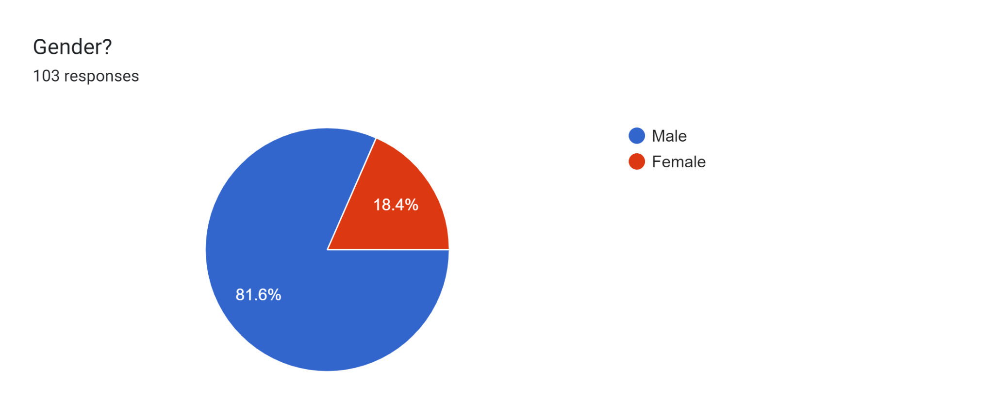
    - Age Distribution: Participants aged 16 to 24 are the most common respondents, followed by the 30 to 40 age group. Few participants are 25 to 30 years old, while even fewer are 50 or older. The focus of the researcher was on the young crowd.
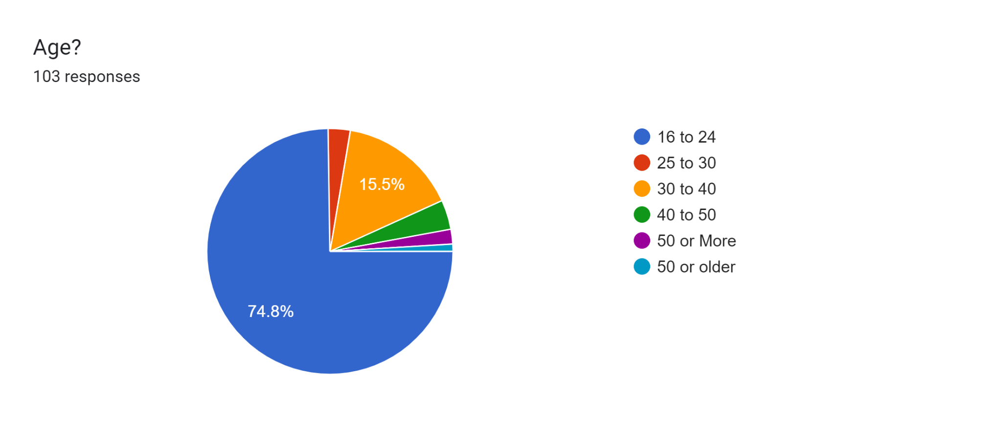
    - Preference of sports in Tamil Nadu: Global sports (Cricket, Football, Hockey, Badminton, Tennis) are more popular among the participants. Traditional sports of Tamil Nadu (Jallikattu, Silambam, Kabaddi, Kho-Kho, Seval Sanadi) are also preferred, but to a lesser extent.
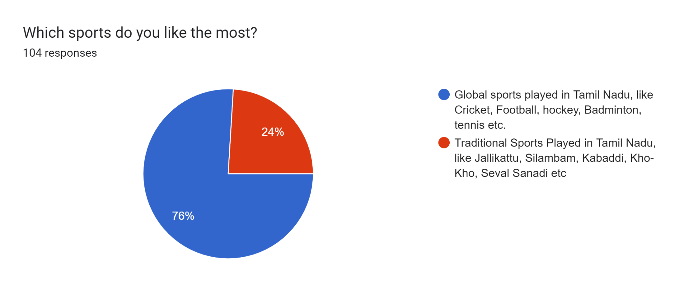
    - Importance of Sports for Sports Tourism: The majority of respondents believed that both Global and Traditional sports are important for the positive growth of sports tourism in Tamil Nadu. However, Global sports were considered more crucial than Traditional sports.
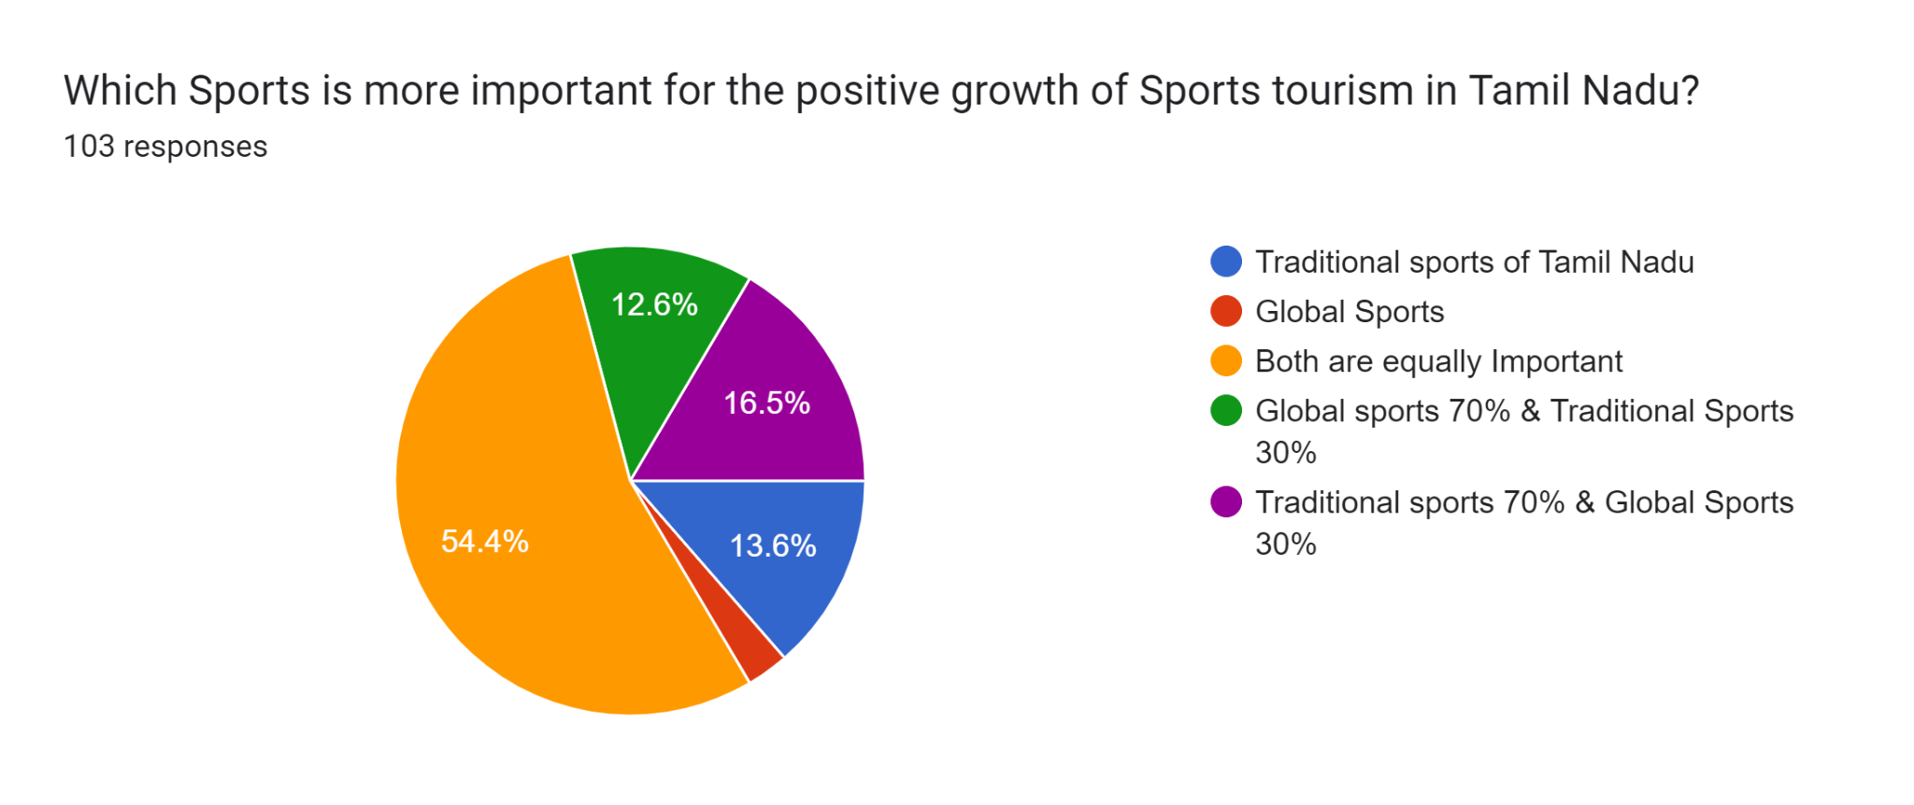

    - Importance of Sports for Tamil Nadu's Traditional Culture: The majority of respondents believed the Traditional sports of Tamil Nadu as more important for preserving the state's traditional culture. Global sports, while acknowledged for their significance, were not as highly regarded in this aspect.
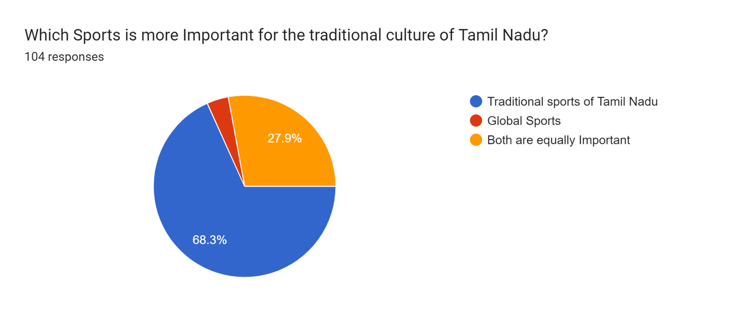
    - Frequency of Playing and Watching Sports, Playing.
      - Most participants do not play global sports frequently.
      - The majority of participants watch global sports occasionally.

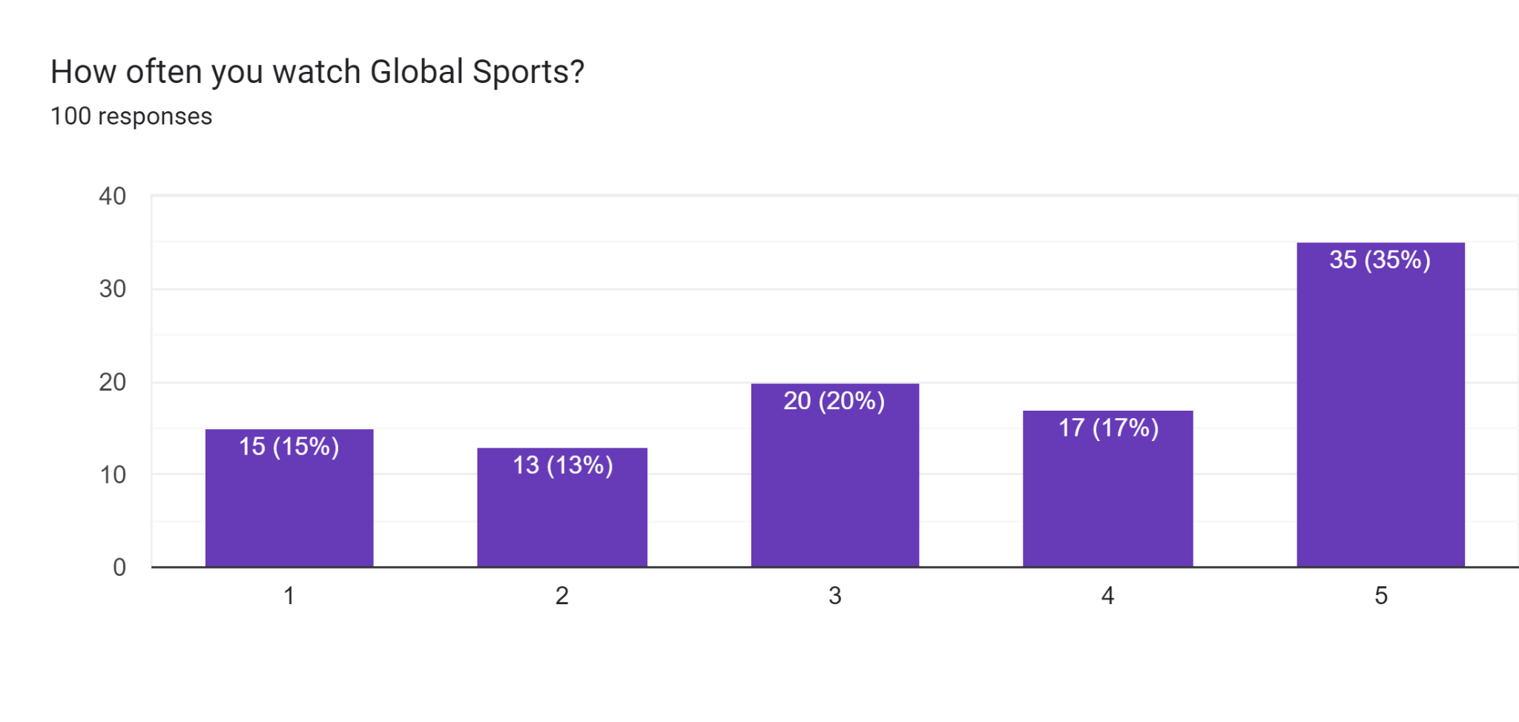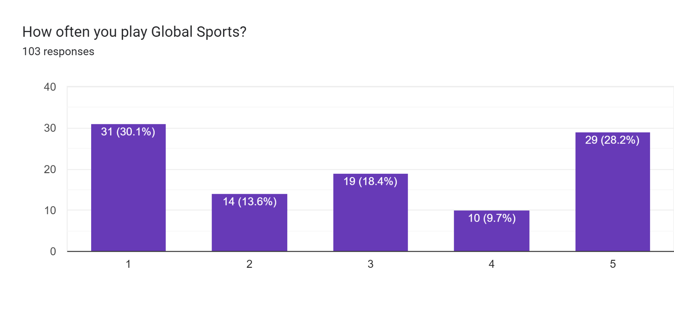
    - Playing and watching Traditional Sports of Tamil Nadu: Few participants play traditional sports frequently. Some participants watch traditional sports occasionally.
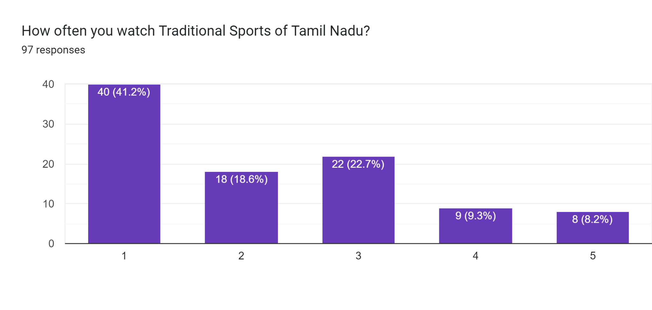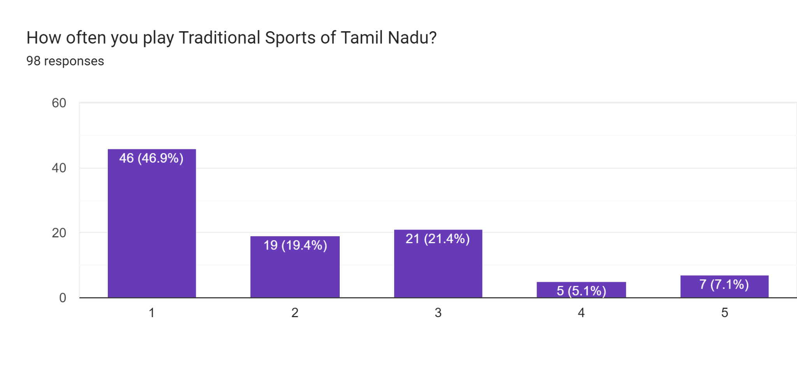
    - Favourite Global Sports: Participants were asked to rate their favourite global sports in order of preference. The data show their preferences for Cricket, Football, Hockey, and Tennis by using a bar graph.

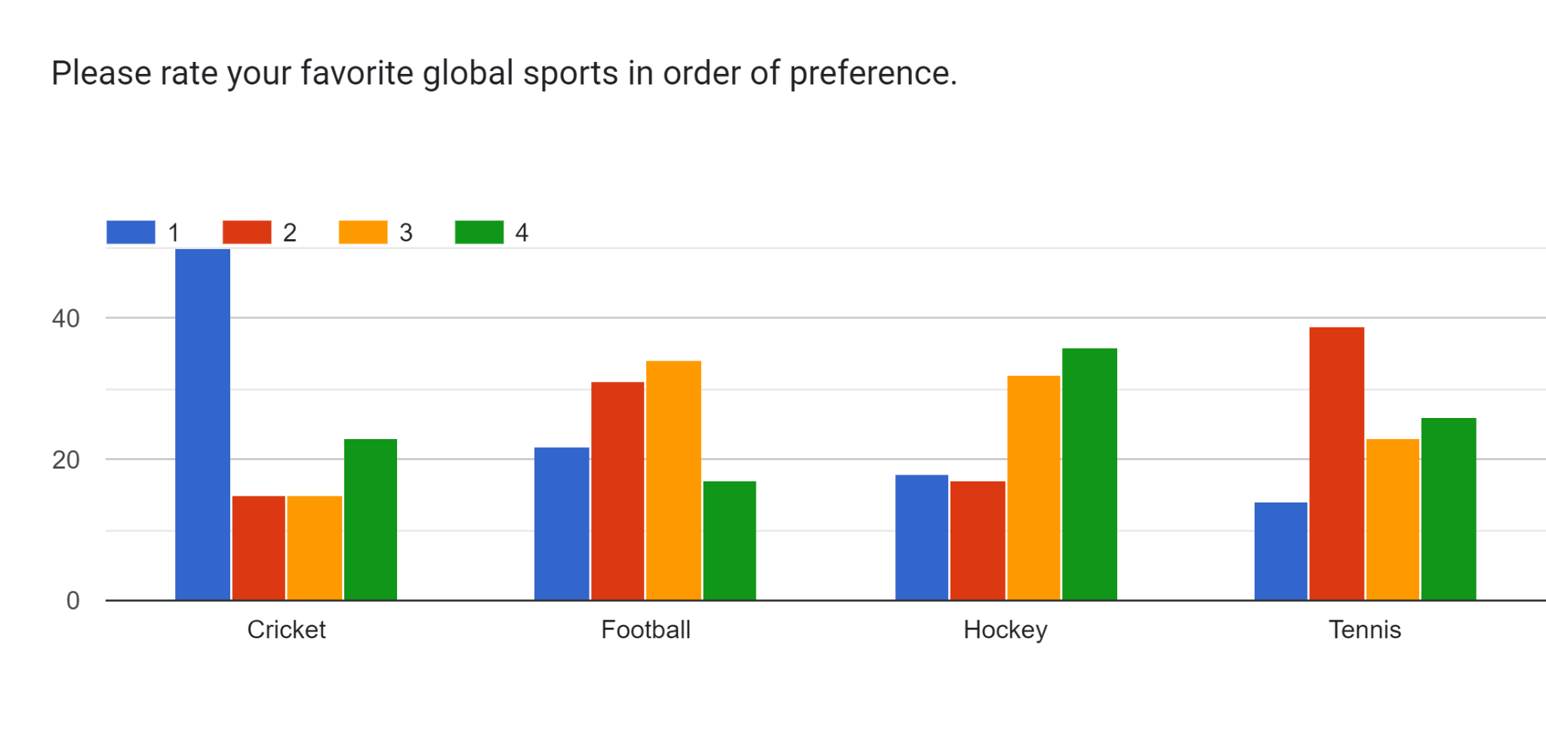

    - Favourite Traditional Sports of Tamil Nadu: Participants were asked to rate their favourite traditional sports of Tamil Nadu in order of preference. With the help of bar graphs, the data show their preferences for Jallikattu (Bull taming), Kabaddi, Chess (Sathurangam), and Silambam (Tamil martial art).

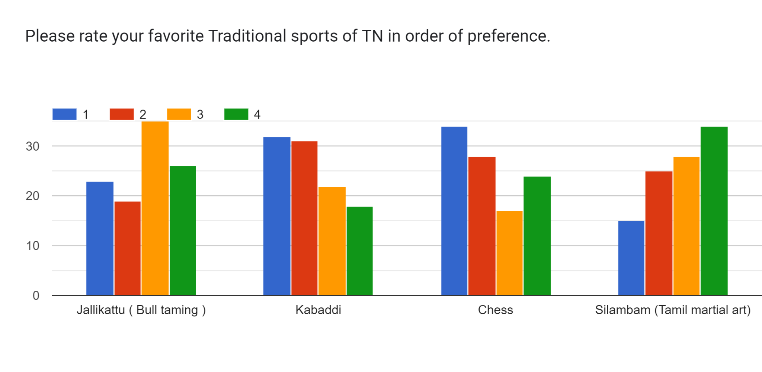

- CONCLUSION
The research study on Tamil Nadu's Sporting Diversity offers important insights into the preferences and views of the state's sports enthusiasts. The research underlines the importance of both traditional and international sports in influencing the sports tourism sector and safeguarding Tamil Nadu's cultural heritage.
One of the main conclusions is that Tamil Nadu has a flourishing sports tourism sector that draws both domestic and foreign visitors. The state is a popular travel destination for sports fans due to its unique landscape and climate, which offer plenty of opportunities for a variety of adventure activities. The future of sports tourism in Tamil Nadu appears bright because of the government's initiatives to build sports infrastructure, including the mega sports city that has been suggested.
The study also shows that popular international sports among participants include cricket, football, hockey, badminton, and tennis. These sports—Cricket in particular—have a large following in Tamil Nadu and help fuel the expansion of sports tourism in the region. However, it is significant that respondents also preferred traditional sports like Jallikattu, Kabaddi, Silambam, and Kho-Kho, highlighting the significance of preserving and fostering regional culture sports.
The study highlights how sporting diversity benefits the preservation of Tamil Nadu's traditional culture and history. The state's identity and individuality are considered as being maintained by traditional sports. Tamil Nadu can demonstrate its rich history and cultural relevance to both domestic and foreign audiences through festivals like Jallikattu and Silambam.
According to the study, international sports are seen as being more important for sports tourism than traditional sports. While both are important, global sports have a larger potential to draw tourists and improve the state's economy because of their greater reputation and appeal on a worldwide scale.
As a result of its wide variety of sports offerings, which include both traditional and international sports, Tamil Nadu is primed to experience expansion in the sports tourism sector. The state is well-positioned to develop into a significant sports hub in India with the help of the government's support and investments in sports infrastructure. Tamil Nadu can further strengthen its position as a top tourist destination by leveraging the popularity of international sports and maintaining and promoting indigenous sports, which offer a distinctive blend of cultural history and sporting experiences for visitors from around the world.

REFERENCE
- Tourism, Culture, And Religious Endowments Department, Government of Tamil Nadu, page – no – 1
- https://en.wikipedia.org/wiki/Tourism_in_Tamil_Nadu
- INDIA TOURISM STATISTICS 2022, Government of India Ministry of Tourism, page no- 141
- TOURISM, CULTURE, AND RELIGIOUS ENDOWMENTS DEPARTMENT, Government of Tamil Nadu, PAGE – NO – 4
- https://www.thehindu.com/news/national/tamil-nadu/chennai-chess-olympiad-closing-ceremony-live-updates/article65749993.ece (August 09, 2022, 06:12 pm | Updated August 10, 2022, 05:15 pm IST Chennai Chess Olympiad closing ceremony | Updates)
- https://www.unwto.org/sport-tourism sports tourism
- http://tafisa.org/traditional-sports-and-games ts
- Dr Debajyoti Haldar, P-ISSN: 2394-1685, International Journal of Physical Education, Sports and Health 2017; 4(4): 292-297
- https://timesofindia.indiatimes.com/city/chennai/rs-750-csk-match-ticket-goes-for-rs-5000-in-black-market-in-chennai/articleshow/99391875.cms?from=mdr
- https://www.thehindubusinessline.com/news/chess-olympiad-brings-festive-cheers-to-hospitality-players-in-chennai/article65647393.ece
- https://www.thecitizen.in/life/coastal-tourism-and-adventure-sports-in-tamil-nadu-334956
- https://www.newsbugz.com/list-of-tamil-nadu-sports/
- https://www.thehindu.com/news/cities/Coimbatore/tamil-nadu-to-introduce-glamping-adventure-sports-to-revive-tourism-says-minister/article65954703.ece
- https://government.economictimes.indiatimes.com/news/smart-infra/tamil-nadu-to-develop-mega-sports-city-on-east-coast-road-500-acres-identified/89153056
- https://indianexpress.com/article/cities/chennai/tamil-nadu-cm-mk-stalin-announces-mega-sports-city-in-chennai-7881275/

