**International Quality Standards: Prospects and Challenges**

**Of Indian Agro-Food Processing Industry**

**Dharavath Poolsingh1\***

*1Department of Applied Agriculture, Central University of Punjab, Bathinda, Punjab State-151401, India.* [*poolsingh987@gmail.com*](mailto:poolsingh987@gmail.com)

**Introduction:**

India is currently the world's second-largest food producer after China and has the potential to overtake it. Food and food-related products comprise India's largest consumption category and around 21% of its GDP. By 2025, the domestic food market in India is projected to increase by about 40% of its current size (World of Food India, 2011; Merchant, 2008). India has a good agricultural basis, yet there is a lot of food waste and very little food processing. While some wealthy nations prepare up to 80% of their food to consumable standards, India's overall processing level has lately dipped to 10%. As a result, India's food processing industry is relatively tiny, and its proportion of processed food exports to the global market has stayed at approximately 1.5%.

One of India's largest industries, the Argo food processing sector ranks 5th in terms of production, consumption, export, and predicted growth (Merchant, 2008). It also employs around 18% of the nation's industrial labour force. Additionally, a wide range of temperate to tropical fruits, vegetables, and other culinary items are produced in India. Fruits and vegetables may be preserved and used effectively thanks in large part to food processing. In the food processing sector in India has a lot of potential because of the country's robust agricultural base, diversity of climate zones, and rapid economic expansion. This business serves as a vital link between farmers and consumers. In this essay, I'll look at the difficulties and future prospects of India's agro-food processing industry.

**Quality Control & Standards**:

The range of items processed by the food industry includes both products with animal and plant origins. Both the domestic and international markets require a consistent level of quality. In this regard, a number of organisations have emerged to help with standardisation and quality control. These can be divided into two categories: mandatory laws and voluntary standards.

**Bureau of Indian Standards (BIS)**:

BIS's agro processing-related efforts fall into two categories: developing Indian standards and putting them into practice through its voluntary, third-party certification system.

Over 700 Indian Standards about food grains and their products are on file with 1BIS. These standards generally encompass the permissible raw materials and their quality characteristics, the hygienic conditions of the manufacturing process, and the packaging and labelling requirements. The guidelines also specify independence from pollutants and dangerous chemicals as necessary. Limits are gradually being set in several standards to ensure that processed foods are free of harmful or rotting microorganisms.

**Gatt and Sanitary/Phytosanitary Measures**:

In order to assure consumer food safety and prevent the spread of pests and diseases in animals and plants, the Sanitary and Phytosanitary Measures Agreement (SPS Agreement), which was negotiated under the GATT in 1994, came into effect in 1995. These precautions shield human and animal life from the dangers posed by food additive pollutants, poisons, or disease-causing organisms. The methods listed below can be used to achieve the SPS goals.

**International Quality Standards:**

A business must document its degree of quality after making an effort to make its processes capable of advertising its services or goods more effectively. In international trade, this quality documentation is particularly crucial. However, companies selling in worldwide markets would find it challenging to meet the requirements for high-quality documentation in every nation where they conducted business if each had its own set of criteria. For businesses operating in the European Union, the International Organisation for Standardisation developed the ISO 9000 family of standards as a solution to this issue. Following this, ISO 14000 for environmental management systems and ISO 26000 for social responsibility guidelines were developed.

**The ISO 9001:2008** The most recent revision to the ISO 9000 standards controlling the documentation of a quality programme is ISO 9001:2008. The International Organisation for Standardisation states that the ISO 9001:2008 standards for quality management deal with quality management by defining what the business does to meet the customer's quality requirements and applicable regulatory requirements, while aiming to raise customer satisfaction and achieve continuous performance improvement in pursuit of these goals. Companies that have achieved certification are included in a directory so that potential clients may know which businesses have achieved certification and at what level. Whether a product complies with ISO 9001:2008 criteria has no bearing on its real quality. Instead, it tells customers that businesses can offer proof of any claims they make about the calibre of their products. More than a million businesses worldwide had received ISO 9000 certification as of 2009.

**The ISO 140001:2004** (Environmental Management System) The ISO 140001:2004 family of standards, according to the International Organisation for Standardisation, addresses environmental management by describing what the business does to minimise any adverse environmental effects brought on by its operations and to continuously improve its environmental performance.(2021; Bailey & Communications). Participating businesses are required under the documentation criteria to maintain records of the raw materials they utilise as well as the creation, handling, and disposal of hazardous wastes. Although the rules do not specify the amount of emissions that each company is permitted to produce, they do mandate that businesses create a plan for continuous environmental performance improvement.

ISO 140001:2004 covers the following areas:

**Structure and Composition of Indian Food Processing Industry**

Businesses in the food processing or food manufacturing sector turn animal and agricultural products into goods for secondary or tertiary use. Foods that have undergone some type of processing—whether it is minimal, as in the case of canned fruit, or extensive, as in the case of snack foods—are referred to as processed foods. The agricultural or horticultural production adds value during food processing by applying a number of processes, such as grading, sorting, packaging, etc., which lengthen the shelf life of food products. Strong and thriving food processing industries have a tremendous impact on a nation's overall economic structure. Rajesh Dahiya and Bharti, 2023. The industry facilitates crucial connections and synergies between industry and agriculture, and it has been seen as a sector with immediate room for economic expansion. In addition to creating jobs in rural areas, processing also helps produce fruits and vegetables that may be sold for foreign currency. The level of processing in India can be divided into the following categories:

**Primary Processing** includes cleaning, sorting, powdering, and refining agricultural products, such as flourizing wheat.

**Secondary processing:** Basic value addition, such as the processing of animal products, ground coffee, and tomato puree.

Products with a high level of value addition, such as jams, sauces, biscuits and other baked goods that are prepared for consumption, fall under the category of **tertiary processing**.

Agriculture, horticulture, plantations, animal husbandry, and fisheries are just a few of the sectors that make up India's major food processing sector. It also covers other industries that use agricultural inputs to make food commodities. The Ministry of Food Processing of the Indian government divides the market into the following six categories:

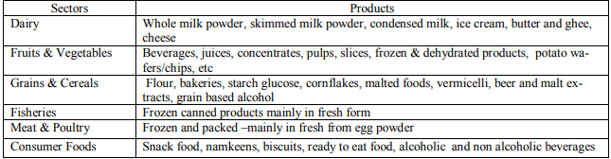

Despite being a massive industry, food processing in India is still in its early stages of growth. Only 2% of the country's agricultural and food production is processed. The food processing industry produced 6% of all industrial production and 9% of India's GDP. Food products are expected to add 35% more value by the end of 2025 compared to the present 8%. By 2025, fruit and vegetable processing, which currently makes up around 2% of total production, is expected to increase to 25%. The unorganised sector dominates India's severely fragmented processing industry. There are many tiny businesses in this market. The unorganised sector contributes about 42% of the output, the organised sector 25%, and small-scale operators the remaining 75%. Although the unorganised portion varies among categories, it still makes up about 75% of the market. In comparison to the primary processing segment, the organised sector is comparatively larger in the secondary processing segment. Additionally, the primary processing portion is very fragmented. A significant industry, primary food processing has a highly fragmented structure with hundreds of thousands of rice mills and hullers, flour mills and oil seeds mills, several thousand traditional bakeries, food units, and unorganised sector fruits, vegetable, and spice processing units. The most prevalent types of food processing facilities that make up the organised sector include flour mills, fish processing facilities, fruit and vegetable processing facilities, meat processing facilities, non-alcoholic and aerated beverage facilities, sugar units (mills), and modernised rice processing facilities. India has a sizable agricultural output base, but the food processing sector is still in its early stages of development. The dairy industry accounts for the biggest percentage of processed food at 37% of total produce, just 15% of which is processed by the organised sector. About 2.2% of fruits and vegetables, 21% of meat, and 6% of poultry products are processed. Only 48% of the 2.2% of fruits and vegetables processed are done so in the organised sector; the rest is done so in the unorganised sector (Service, n.d.).

**(Source: Food Processing Strategies for Quality. https://ae.ukessays.com/essays/biology/food-processing-and-food-preservation-biology-essay.php, 2014-15)**

**Factors Affecting Food Processing Industry in India:**

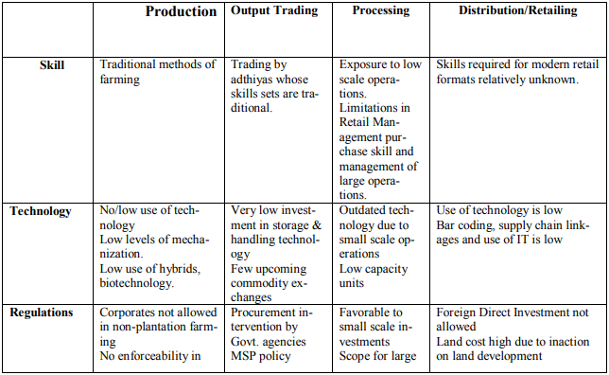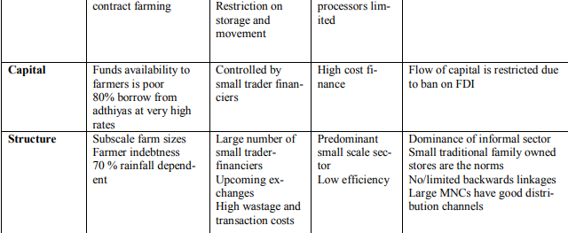

**Major Obstacles in the Way of Food Processing Sector Development:**

Similar to other economic sectors, the food processing industry faces several limitations. The following constraints, which require immediate adjustment to smooth the sector's growth path, have been identified after reviewing several reports from various government and non-government organisations.

1. **Inadequate infrastructural facilities**: The infrastructure for the Indian food business is lacking. Various plans to supply the sector with infrastructural facilities have been mentioned in policy papers. The supply chain in the Indian food business is extensive and disjointed. The supply chains still do not have last-mile connectivity. This is clear from the fact that the majority of costs incurred by the food business are attributable to transportation losses. According to a 2010 MOFPI research, harvest and postharvest losses of the nation's key agricultural products amount to about Rs. 44,143 crore annually at wholesale rates. (MOFPI, Indian government, 2015)
2. **Lack of skilled and trained manpower:** Despite being a significant employer, the food processing industry still struggles with a lack of skilled and semi-skilled labour. This has grown to be a significant barrier to the sector's future growth. The sector now has a requirement for value chain management in addition to supply chain management. This calls for both trained and semi-skilled labour.
3. **Quality of Raw Materials:** India is the second-largest food producer in the world, which is a well-known fact. Despite providing a sizable base of raw materials to the food processing industry, the quality of the goods the sector receives falls short of the international norm. (FICCI, 2010) As a result, a significant portion of the produce had to be sold at a cheaper price on the domestic market because it could not be exported. There aren't enough types grown in India that can be processed; the country lacks processable varieties.
4. **Seasonal Availability of raw materials:** Agriculture in India is dependent on the monsoon. The production of crops is never completely certain. In addition, the fact that raw materials are seasonal, particularly fruits and vegetables, presents a significant barrier to the industry's expansion.

In addition to the restrictions already mentioned, there are a few other restrictions that the industry's many stakeholders need to pay attention to.

• Pricing and taxes in the Indian processed food industry are not comparable to those in other developed and developing countries, making it less competitive in the global market.

• Lack of consumer education regarding the nutritional importance of processed food.

The entry of MNCs into the domestic market has increased competition for domestic producers in terms of quality, standard, and price, as well as a shadowing effect on indigenous products due to the MNCs' aggressive marketing tactics.

The need for better technology is changing along with technology's rapid evolution, but in reality, research and development could not keep up with the industry's need. This is turning into a significant threat for the industry.

**Infrastructure for the Indian Agro-Processing Industry: SWOT Analysis**

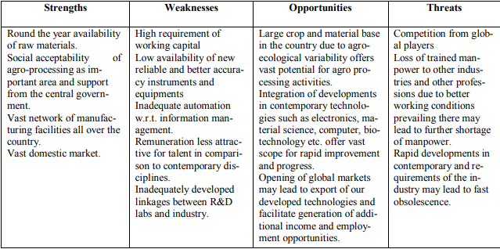

**International issues:**

**Why International Standards:**

* They encourage commerce and collaboration.
* Due to product standards, consumers can buy products from many producers with confidence that they will perform the same way.
* Standards for management systems encourage standardised methods for managing quality and the environment. They advocate for the accuracy and regular application of statistics.

|  |  |  |  |
| --- | --- | --- | --- |
| **ISO 9000 Series** | **ISO 10000 Series** | **New ISO 9001:2000** | **The Grand Vision: 2000** |
| ISO 9000 assists businesses in determining which of the ISO 9001, 9002, and 9003 standards to apply | ISO-10011 Quality system auditing guide | Quality management system: Give your actions structure | 9000-Fundamentals and Vocabulary |
| The ISO 9001 standard provides standards for businesses involved in the design, development, production, installation, and maintenance of goods and services. | ISO 10013 Quality manual development guide | Management responsibility - Put someone in charge | 9001 Requirements |
| ISO 9002 comparable to 9001, but does not include businesses involved in design and development |  | Resource management: Allocating resources to meet objectives | 9004 Guidelines for Performance Improvements |
| Companies involved in final inspection and testing are covered by ISO 9003. |  | Product realization - Design and make it to requirements | 10012 Measurement Control |
|  |  | Know where you are and improve using measurement, analysis, and improvement. | 19011 QMS/EMS Auditing |

**Conclusion:**

Even though this industry is seeing considerable growth appreciation to several hopeful characteristics, there are still several important obstacles that, if not removed sooner rather than later, could harm India's food processing industry's future prospects. The fact that this industry requires much capital is one of the main obstacles. Fewer players can enter the market because of the high entry barrier it imposes—players simply compete, which lessens efforts to raise the bar for quality. Educating consumers about how processed foods can be more nutritious, dealing with the low price elasticity of processed food products, developing marketing channels, streamlining food laws, raising food quality standards, and strengthening the food testing network are some of the major challenges facing the Indian food processing industry; enhancing the institutional structure to increase human resources for enhancing research and development capacities to address global problems. To realize the full potential of the Indian food processing industry, several issues must be resolved.

**References:**

Bailey, R., & Communications, L. S. (2021). *Upcoming Webinar on May 24 th : Disaster Recovery and Control Room Management with Matrox Video*.

Bharti and Rajesh Dahiya. (2023). *Home / International Journal of Education and Management Studies / Volume 11, 2021 / Issue 2, June / Perception of rural women towards RKVY Trainings on post-harvest interventions and value addition*. *2023*.

Service, E. W. (n.d.). *Modern food processing has three major aims :*

Mohammad Zia. “Prospects and Problems of Food Processing Sector in India: In the Light of Make in India Initiative.” Sept. 2016, www.researchgate.net/publication/299579043_Prospects_and_Problems_of_Food_Processing_SBailey, R., & Communications, L. S. (2021). *Upcoming Webinar on May 24 th : Disaster Recovery and Control Room Management with Matrox Video*.

Bharti and Rajesh Dahiya. (2023). *Home / International Journal of Education and Management Studies / Volume 11, 2021 / Issue 2, June / Perception of rural women towards RKVY Trainings on post-harvest interventions and value addition*. *2023*.

Service, E. W. (n.d.). *Modern food processing has three major aims :*

ector_in_India_In_the_Light_of_Make_in_India_Initiative.

Kachru, R P. “Agro-Processing Industries in India—Growth, Status and Prospects.” pdfs.www.semanticscholar.org/e7ae/6958f6c7d4f4cccf46d31f82d515f777df19.pdf.

**Website:**

1. [Wanted Distributors for Food & Beverage Products in India ~ Take Distributorship](https://www.takedistributorship.com/2020/12/wanted-distributors-for-food-beverage.html)
2. [About Us - 8th Annual INNOPACK F&B 2020 CONFEX (innopackfood.com)](https://www.innopackfood.com/about-us)
3. [Wanted Distributors for Food & Beverage Products in India ~ Take Distributorship](https://www.takedistributorship.com/2020/12/wanted-distributors-for-food-beverage.html)