**Sustainable Filter Media of Coconut Fiber and Rice Husk**

**\*,1K.K. Sivakumar, 2S. Kumar and 3S. Nandhini**

Department of Chemistry, AMET University, Chennai.

Department of Mechanical Engineering, Wollega University, Ethiopia.

Department of Public Health, SRIHER University, Chennai.

# ABSTRACT

As the population is increasing, the effluent from domestic applications rapidly increasing throughout the countries in specific fast developing countries like India since water is the most vigorous and tremendous element required for the survival of all living beings on the earth. By looking all the challenges and to look over the newer water demands, the effluent from domestic applications treatment is a feasible alternative for fresh water make up either in industrial and domestic reuse pattern. The main objective of this study is to identify the pollutants qualitatively and quantitatively present in The effluent from domestic applications as well as to bring of the effectiveness of using the waste agricultural byproducts of raw coconut fiber and raw rice husk combination with sand and stone pebbles for the filtration of collected The effluent from domestic applications. The study of the effluent from domestic applications is collected from the residential hall of Marine institute, Chennai. All physico-chemical quality parameters are measured for collected samples in respect of its inflow and outflow through the filter media. The tested parameters in this study include Total, dissolved and suspended solids, Chemical Oxygen Demand (COD), Phosphate, Chloride, Nitrate, pH, Turbidity, Total coliform and Faecal coliform. It has been found that, both raw coconut fiber and raw rice husk can be used as an effective filter media for the removal of pollutants available in the effluent from domestic applications samples. In parallel Raw Rice husk acts as an adsorbent for removal of chemical pollutants including heavy metals from The effluent from domestic applications and coconut fiber removes fungus as there are huge amount of micro-pores to standard surface area.

**Key Word**: Adsorption, Agricultural byproducts, Effluent management, Pollutants, Raw Coconut fiber, Raw Rice husk.

# INTRODUCTION

The environmental condition in the globe is undergoing threat to its earlier level which is mainly on water cycle. But water is not an unmixed blessing when it is turned into effluent due to various manmade activities. The untreated or partially treated The effluent from domestic applications can pose an environmental and health risk for humans. If the presence in certain levels, fecal coliform bacteria, which are found in human intestines, are indicators of untreated or minimally treated sewage. The bacteria presence in water is considered an indicator of recent fecal contamination. Faecal coliform bacteria are not usually harmful, but are easily detected and may indicate the presence of other disease-causing organisms carried in the human intestine such as cholera, diphtheria, E. coli and streptococcal diseases. Domestic water/Drinking water sources in fast developing and developing countries are facing serious threat from contamination due to both man-made industrial and agricultural activities. In many countries, ground water is used for drinking purposes and it is polluted with toxic cations, anions, heavy metals, organic compounds and dyes due to effluents from industries [1]. The fast population growth in the amount of the effluent from domestic applications has been increasing rapidly all over the countries. The required qualities in water is highly essential to a healthy ecosystem. The effluent from domestic applications containing high nitrogen and phosphorus concentration leads the growth of aquatic flora and fauna that thrive in nutrient-rich conditions, and over time this can have a negative impact on marine life. The effluent from domestic applications from septic systems can seep into the surrounding porous limestone and pollute the groundwater, introducing excessive nutrients and even harmful bacteria into surface waters. The effluent from domestic applications is still the vital cause of ecological damage. For the last few decades it has been burning issue for the scientist to select a viable filter media for domestic effluent treatment. The natural fresh water resource is high crisis and becoming a global issue for the experts as extensive use of ground water for decades after decades has led to unannounced recent emergency of natural fresh water resources. Treatment of the effluent from domestic applications can serve two purposes at the same time. Firstly, purpose of treatment should be fulfilled and secondly, recent crisis of fresh water resources can be solved to meet the regulatory bodies suggestion. So the treatment of effluent from domestic applications has turned into an indispensable issue considering the ecological sector. Several researchers have developed many methods such as microbial degradation, chemical oxidation, photolysis and adsorption are used for the treatment of effluent from domestic applications [2,3,4]. The recent developments in the effluent treatment disfavor due to high capital and operational cost and there are problems in disposal of the residual sludge mixed with heavy metals [5]. This has led ultimately to search for the cheaper, handy in operation and high efficient substituent methods. The utilization of local available natural biomass resources as a natural biofilm provision media for the effluent treatment is of an increasing attention for solicitation due to its low cost and low technology.

Agricultural by-product is one of the major sources of activated carbons. The use of activated carbons to remove organic and inorganic pollutants from waters is widely extended, because of their high surface area, micro porous character and the chemical nature of their surface [6]. The production of activated carbon from agricultural by-products serves two purposes. Firstly, it converts agricultural waste to useful adsorbents. Secondly, activated carbons are being used in water for removing organic chemical and metals of environmental or economic concern [7]. In this research without using activated carbon a new substituent has been searched for which should be purely natural. Both as a pure natural substituent and agricultural waste, coconut fiber and rice husk can be considered. Because in India coconut fiber is available everywhere and it is cheap. India is an agricultural country where rice is produced in a large amount. As the main by-product of rice, rice husk accounts for approximately 20% of its content [8].

The presence of hard organic matters in coconut such as cellulose and lignin material with high specific surface area and wetting ability, it seems appropriate choice for microorganism’s adhesion and biofilm [9]. Raw Coconut fiber biofilm treatment system has been introduced at some local authorities in Island countries like Sri Lanka to treat the collected sewage and leachate at waste disposal sites [10]. There are huge amount of micro-pores with standard surface area are existing in coconut fibers. The more headstrong lignocelluloses can simultaneously function as a support material because of its slower degradation rates as organic material can perform a dual activity by providing substrate for the bacterial metabolism [11]. Raw Rice husk comprises of lignin, cellulose, hemicelluloses and minerals with 22%, 324%, 21% and 15% respectively [12]. Raw Rice husk has a granular structure, good chemical stability, high mechanical strength, unique chemical composition and low cost [13]. Raw Rice husk, if it is used as filter media, after the expiration of efficiency of filter media, the disposal of the used rice husk might not cause any negative damage to the environment. Moreover it can be used as natural fertilizer. For these reasons, the study is subjected with raw coconut fiber and raw rice husk.

The main objectives of this study include developing the low cost alternative filter media for the conventional effluent management from domestic applications to investigate the efficiency of the developed raw coconut fiber and raw rice husk filter, determining selected physical and adsorptive properties of such natural materials. Moreover, to assess the operation and maintenance difficulties arising in filter media as well as filter operation running time and performance of filtration rate of a developed filter and providing some recommendation for sustainable use of the developed filter is also the main goals of this study.

# METHODOLOGY

# Materials

(i) Raw Coconut fiber, (ii) Raw rice husk, (iii) ½” stone pebbles and (iv)Ssand is used as the materials of filter media.

Grain size analysis of coconut fiber, rice husk and stone chips is represented in Figure 1 to Figure 6. Besides, fineness modulus of sand is presented in Table 1.

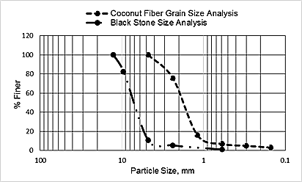

Figure 1: Grain Size analysis of coconut fiber and stone chips

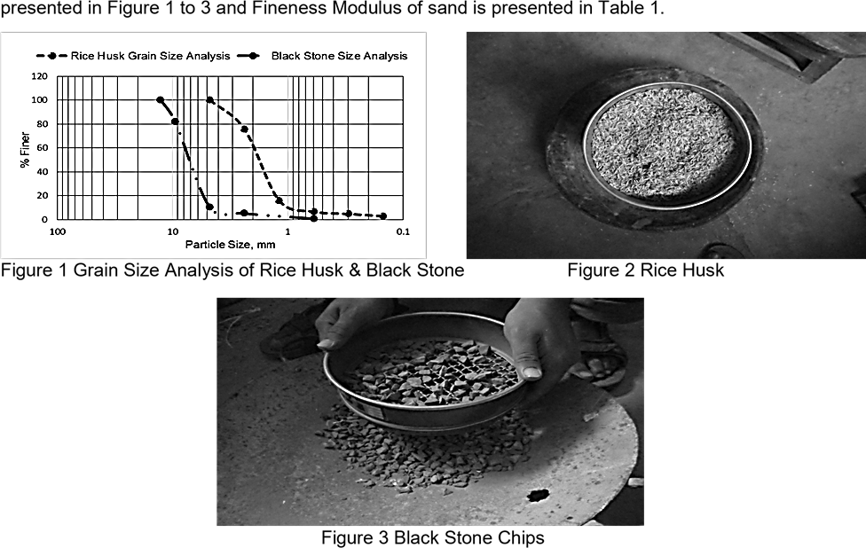

Figure 2: Grain Size analysis of rice husk and stone chips

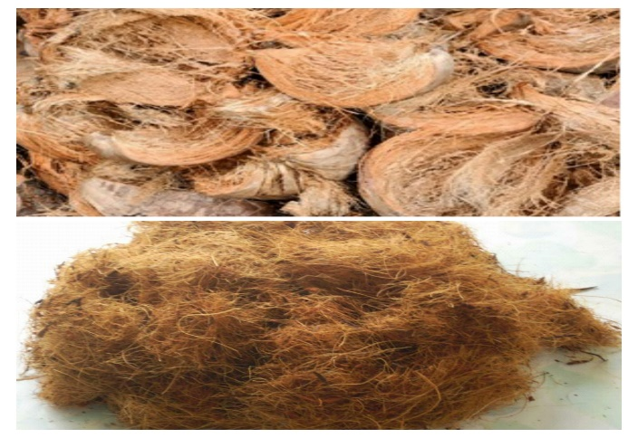 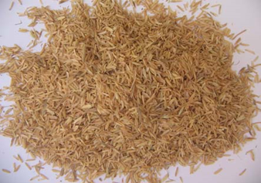

Figure 3: Coconut fiber Figure 4: Rice husk

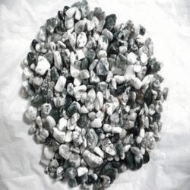 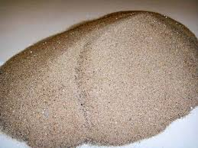

Figure 5: Stone chips Figure 6: Sand

Table 1: Fineness modulus of sand

|  |  |  |  |  |  |
| --- | --- | --- | --- | --- | --- |
| **Sl. No.** | **Sieve No.** | **Weight retained (gm.)** | **Cumulative Weight retained (gm.)** | **Percent cumulative weight retain** | **FM value** |
| 1 | 4 | 12.5 | 12.5 | 2.6 | 2.86 |
| 2 | 8 | 31.8 | 44.3 | 9.25 |
| 3 | 16 | 97.7 | 142 | 29.64 |
| 4 | 30 | 143.4 | 285.4 | 59.58 |
| 5 | 50 | 121.1 | 406.5 | 84.86 |
| 6 | 100 | 72.5 | 479 | 100 |

# Filter Media Aseembly

The experiment procedure consists of two different set up which is shown in Figure 7. First stage is of all a bucket was taken which had a diameter of 40.50 cm and a height of 40 cm. The instrumental set up has given below. In every phase 2.5 cm sand and 5 cm stone pebbles was provided. Coconut fiber and rice husk were provided in mid layer with 20 cm thickness.

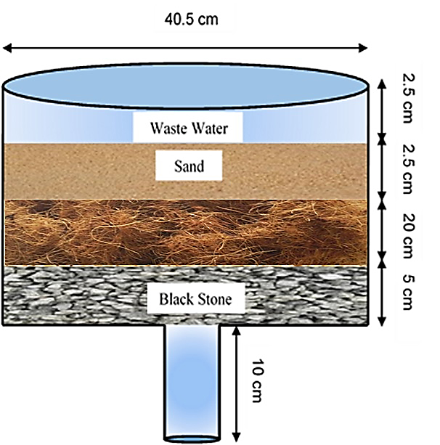 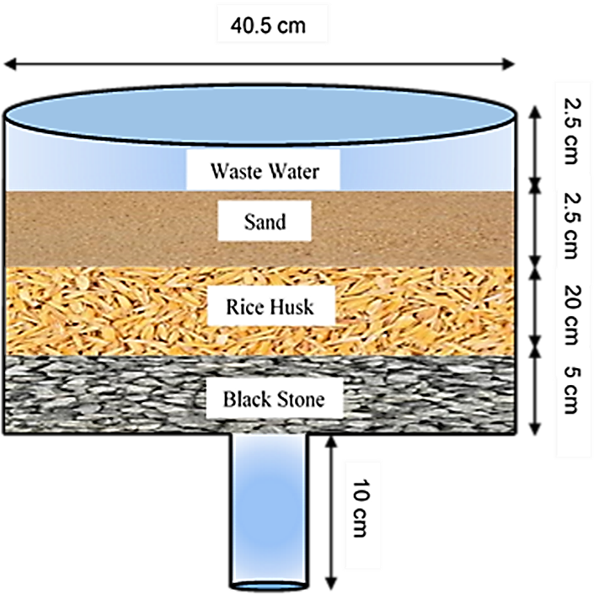

Coconut Fiber

Figure 7: Experimental set up of filter media

# RESULTS AND DISCUSSION

Many attempts of the effluent from domestic applications parameters were measured for collected samples with inflow water as well as outflow water through filter media. The physicochemical parameters in this study include chemical oxygen demand (COD), pH, turbidity, phosphate, chloride, nitrate, total suspended solids (TSS), total dissolved solids (TDS), Total coliform and faecal coliform, were measured for collected samples with inflow water as well as outflow water through filter media which is shown in Table 2.

**Table 2: Filter efficiency t**

|  |  |  |  |  |  |
| --- | --- | --- | --- | --- | --- |
| Parameters | Unit | Effluent characteristics | Coconut Fiber Media | Rice Husk Media | Indian Standard for Discharge  (Irrigated land) |
| COD | mg/L | 1920 | 1860 | 1790 | 600 |
| pH | -- | 7.69 | 7.71 | 7.57 | 6.5 - 8.5 |
| Turbity | NTU | 223 | 59 | 74 | 50 |
| Phosphate | mg/L | 60.5 | 53.5 | 38.5 | - |
| Chloride | mg/L | 850 | 845 | 830 | 600 |
| Nitrate | mg/L | 70 | 46 | 45 | 10 |
| Total suspended solids (TSS) | mg/L | 2870 | 1395 | 1480 | - |
| Total dissolved solids (TDS) | mg/L | 2890 | 1420 | 1500 | 2100 |
| Total Coliform | Nos. | 31 | 7 | 5 | 1000 |
| Faecal Coliform | Nos. | 26 | 0 | 5 | 200 |

It has been observed that the state of chemical oxygen demand (COD) in filtered water in both case has decreased. In both cases, pH was in allowable range because according to India water quality standards for surface water for water supply, the allowable range of pH is between 6.5 to 8.5. Turbidity has also reduced from the initial condition. The presence of nitrate and phosphate in filtered water has also decreased from the initial condition. In this investigation the amount of total suspended solids (TSS) and total dissolved solids (TDS) have been reduced. Increased level of faecal coliform provides a warning of failure in water treatment, a break in the integrity of the distribution system, possible contamination with pathogens. The amount of total coliform and faecal coliform have reduced in both filter media. The variation of result between the two different set up has shown here by some graphical representation in Figure 8.

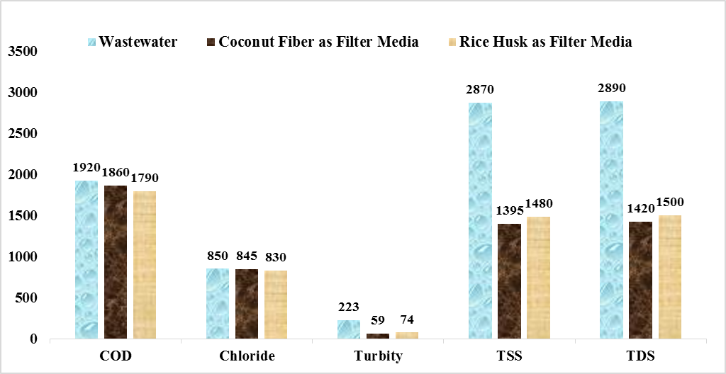

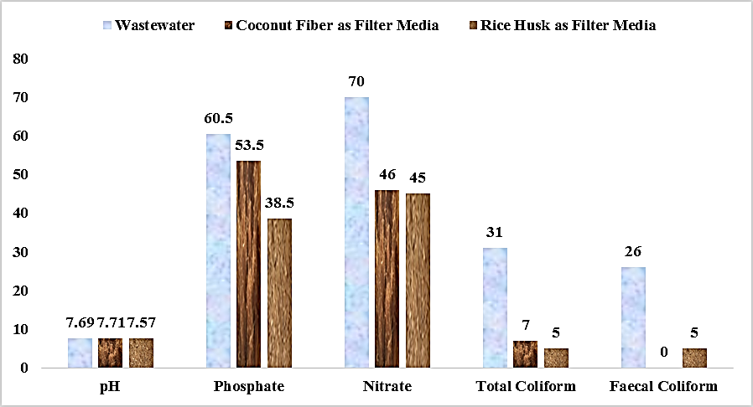

Figure 8: Variation of waste water testing parameters for different filter media

# CONCLUSION

The study broadly includes the inspection of pollutants present in the effluent from domestic applications as well as evaluation of the effectiveness of using raw coconut fiber and raw rice husk combination with sand and stone pebbles for the filtration of collected domestic effluent sample. The pH value and total coliform value is well suited according to Indian water quality standards for surface water. The amount of total suspended solids and total dissolved solids have been decreased from the initial condition of the effluent from domestic applications. Moreover, the growth of total coliform and fecal coliform has reduced perfectly. So, both raw coconut fiber and raw rice husk are mostly suitable for the effluent management as filter media.

# RECOMMENDATION

Eventhough some investigative parameters in this study is quite good, some parameters have taken under further investigation for their improvement and some other parameters also should investigate like

* Biochemical Oxygen Demand (BOD)
* Dissolved Oxygen (DO)
* Heavy metals

Ultimately the experimental results shows the better adoption in terms of cost, affordability and easy availability of raw coconut fiber and raw rice husk may be used together as filter media with stone pebbles and sand in domestic effluent management.

# REFERENCES

1. Namasivayam, C. and Sangeetha, D. Recycling of agricultural solid waste, coir pith: Removal of anions, heavy metals, organics and dyes from water by adsorption onto ZnCl2 activated coir pith carbon. *Journal of Hazardous Materials*. **2006**, *135*, 449–452.

2. Lankford, P.W. and Eckenfelder, W.W. Toxicity Reduction in Industrial Effluents, Van NostrandReinhold, **1990**.

3. Kim, D.H. and Anderson, M.A.. Photoelectrocatalytic degradation of formic acid using a porous titanium dioxide thin-film electrode. *Environmental Science and Technology*. **1994**, *28.3*, 479-483.

4. Daifullah, A.A.M. and Girgis, B.S. Removal of some substituted phenols by activated carbon obtained from agricultural waste. *Water Research*. **1998**, *32.4*, 1169–1177.

5. Sharma, D.C. and Forester, C.F.. A preliminary examination into the adsorption of hexavalent chromium using low-cost adsorbents. *Bioresource* Technology. **1994**, 47*.3*,257-264.

6. Sivakumar K.K., Mohamed Haroon Basha and Nandhini, ZnO/UV induced photocatalytic degradation of textile dyes, Research Journal of Chemistry and Environment, 25(5), 2021, 160-165.

7. Daifullah, A.A.M., Girgis, B.S., and Gad H.M.H.. Utilization of agro-residues (rice husk) in small The effluent from domestic applications treatment plans. *Materials Letters*. **2003**, *57.11*, 1723–1731.

8. Mansaray, K.G., and Ghaly, A.E.. Thermogravimetric analysis of rice husks in an air atmosphere. *Energy Source*. **1998**, *20.7*, 653-663.

9. Sivakumar K.K. and M.S. Dheenadayalan, Utilization of environmental waste materials in the removal of heavy metals from industrial effluents, European Chemical Bulletin, 1(5), 2012.

10. Sato, N., Kawamoto K., Sato H., Lokuliyanaga M., Koide T. and Tanaka N.. Utilization of a localavailable biomass resource for The effluent from domestic applications treatment in Sri Lanka: Comparison between initial and current performance of coconut-fiber biofilm treatment system (COTS). *Proceedings of 14th International Waste Management and Landfill Symposium*. **2013**.

11. Chanakya, H.N., Ramamurthy, N., Shanmukhappa, V., Vinutha, D. and Deepa, G.B.. Biomassbiofilm bioreactors for liquid and solid wastes of agro processingfield performance studies. *International Conference on Advances in Industrial The effluent from domestic applications Treatment*. **2004**, 441-450.

12. Grover, P.D. Thermochemical characterization of biomass residues for gasification. *Indian Institute of Technology*. **1989**.

13. Abdel-Ghani, N., Hefny, M. and ElChaghaby, G. A. Removal of lead from aqueous solution using low cost abundantly available adsorbents. *International Journal of Environmental Science and Technology*. **2007**, *4.1*, 67-73.