CONTAMINATED BIOPLANTS ARE UTILIZED ON LAKES AS A RENEWABLE SOURCE.
Dr.G.PRABHAKARAN,Ph.D¹, R.VenkadaLakshmi,M.E², S.Brindha M.E³, P.D.Reshma, M.E⁴
1.Prof, Siddharath Institute Of Engineering&Technology,Andrapradesh
2.Asst.Prof,SRM Madurai college for Engineering&Technology
3. Asst.Prof, Nehru institute of Technology
4.Asst.Prof, JCT college of Engineering&Technology
ABSTRACT:
In many countries over a century ago, water hyacinth was offered as a lavish harvest due to its attractive appearance and aesthetic appeal. Tragically, due of their adaptability to a variety of crisp water ecological communities and their resistance to human activity, the blooms developed into invasive species. They were viewed as an alternative to petroleum derivatives in the twenty-first century, with the same number of experts finding them capable of converting their substance into fuel energy at a lower cost and regarded as an environmentally friendly product. Given that water hyacinths are among the group of plants that grow the fastest, their biomass may one day replace conventional petroleum derivatives as a source of sustainable energy, probably within the next 10 years. This is a fundamental task to overcome the depletion of energy supplies and, in addition, to satiate the growing demand for energy around the world. The dried biomass can also be made into briquettes, which are suitable for use as co-terminating operators in coal control plants, rather than fuel energy. Future compacted biomass buildups delivered as briquettes may reduce the reliance on coal to provide more energy. Another use of water hyacinth as a co-manure material, such as soil improvement for sandy soil, can improve hydro-physical, concoction parameters of soil and will provide the growing yields with some supplements. Because of its ability to bioremediate, or remove poisons from home and modern waste water effluents, water hyacinth has also received attention. As a result, the water hyacinth problem needs to be evaluated from a variety of perspectives, including ecological, building, and vitality. In this study, potential uses for water hyacinth are organised and discussed.
WATER HYACINTH
The specific term for the aquatic plant is Eichhornia crassipes. The water plant that flows freely, rising at still or slower water sources. Water Hyacinth develops massive biomass and doubles its population in two weeks by fast-growing. Water hyacinth is blamed for many issues. These entail a loss of biodiversity, water pollution, water loss, agriculture, infrastructure damage and negatively affect on public safety, and water species. During this research project, organic wastes are used to substitute cement in construction.

CHARACTERISTICS OF WATER HYACINTH
Normally water hyacinth is found in a stagnated pool or lake. The plant's height is 100 to 200 mm and it can reach up to 1 m in height. It consists of long, comfortable roots and leaves are look glossy green. Petioles have looked like an erect swollen bladder. Flowers look like pale violet or blue in color and size of around 50 mm in breadth. Water hyacinth is found in both types of water, i.e. alkaline and acidic. The plant increase rate is evaluated at 1.15% every day.
PROBLEM OF WATER HYACINTH
- River distribution barrier,
- Irrigation Intakes blocking, Water supplies and power supplies,
- Canals blocking and floods causing rivers
- Reduction of Biodiversity
- Oxygen degradation and Water quality decreased,
- Effects on human health
- Fishing problem,
- Nutrient input in water reduced

CONTROL MECHANISMS OF WATER HYACINTH
Water hyacinth growth rapidly and indigenous plants. To control freshwater weeds, the following methods are used.
  - Chemical control - safe environmental herbicides are used.
  - Mechanical control - Machine extraction or hand picking of weeds.
  - Genetic management – the use of organisms for aquatic plant development regulation.
- Integrated control – Combination of the above three
EFFECTUAL PURPOSE OF WATER HYACINTH
- Production of a paper sheet.
- Fibreboard production
- Yarn and rope
- Briquetting,
- Processing of biogas,
- Purification of water
- Fish feed
- Fertilizers
IMPORTANCE OF THE STUDY
The study's major purpose is to substitute cement with WHA without affecting its physical or mechanical properties. It may be useful for the following
- Environment: By replacement of cement by WHA, the emission of CO2 is reduced and provides a healthy environment for the community. By utilizing WHA, clogging of water bodies will be reduced. It will help for fishing, transportation and improve the quality of water, etc.
- Consumers: Due to the replacement of cement by WHA, the cost of cement is reduced and it is utilized as cost-effective materials.
- Researchers: Further Research works to be done for effectively utilizing of the WHA.

COUNTRIES AFFECTED BY WATER HYANCINTH
Water hyacinth is first originated in North America, Asia, Australia, Africa, and New Zealand. It can be found only in the larger water area or stagnated pools. The first water hyacinth was found on the Northside of America in the year 1884. In New Guinea, water hyacinth plays a major problem and it was uncontrollable. The most common species of water hyacinth are Eichhornia Crassipes found in the 1980s at a Victoria lake in Africa. Water hyacinth plants in southern USA, North and South Africa, South Asia and Australia thrive under humid climates. The plant has spread all the region for the past century and creates various social issues. The water hyacinth is sold for ornamental use and imported from South America and Brazil. Plants were distributed in the 1900s in the Eastern area of the United States and Pacific until 2008. Water hyacinth in the part of Oregon state is not officially declared to be hazardous weeds.
Gopal (1987) states that the huge number of water hyacinth was found in Egypt during the period 1889-92 and it was recorded first. At first, it was assumed to be a decorative plant and is sited in the Delta area. Slowly it starts spreading southwards due to the building of the Aswan Dam.The second record was found in southern Africa in the year1908. The plants grow easily in these years and look like an ornamental aquatic crop for garden lakes. (Stent 1913). During the early period of the year 1913 (Jacot 1979) water hyacinth plant is not announced legally as a toxic plant.
The third record for a huge mass of water hyacinth plants in Zimbabwe in the year 1937. The plant attains harmful to the environment during 1950 at the river basin of the Mukuvisi in Harare. From 1941 to 1960, ten African countries are recorded. At the end of the year 1900, water hyacinth plants are well known in Asia by Japan and Indonesia. (Uekietal,1975). The water hyacinth plant is grown for ornamental purposes in the Botanical gardens in Asia (Backer 1951).
In India, the plant was well-known in the area of Bengal during the 19th century. Now it has spread throughout the country of all types of water bodies and occupies 2, 00,000 hectares of water surface. Veeranum Lake supplies water in Tamilnadu and acts as a source of rice irrigation for the 18,000-hectare area. At present, it was seriously affected by Eichhornia crassipes (Gnanvel and Kathiresan 2007). Following the river, Brahmaputra was seriously affected by water hyacinth plants (Patel 2012).Gates (2000) reported in a written document that water hyacinth plants are toxic and pollute the river water. The uncontrollable development of plants is exponential and Africa has been badly affected. In Mexico during the year 2007, 40000 hectares of reservoirs, lakes, and canals are affected by the weeds of water hyacinth (Jimenez and Balandra 2017) and shown in fig 2.1. Khanna 2011 State, in the river delta region of the San Joaquin, that water hyacinth weed creates ecological effects.

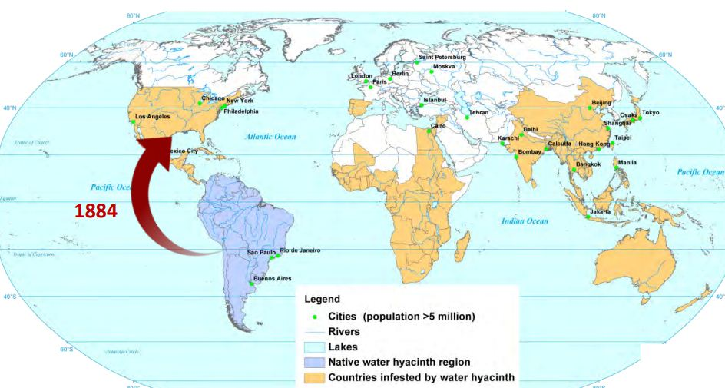
. COUNTRIES AFFECTED BY WATER HYACINTH PLANTS
NOMENCLATURE OF WATER HYACINTH:
The classification of an organism is termed as Nomenclature. The taxonomy is arranged hierarchically from plant to animal. Species is the term denotes a group of individuals does not interbreed with an individual of other groups. A closely related species is called a genius.
- Cronquist (1988), Thorne (1992) and Takhtajan (1997) (Center et al., 2002) suggests a Taxonomy Of Water Hyacinth:
- It belongs to Plantae monarch and sub monarch of Tracheobionta
- It is a member of the organism Eichhornia crassipes
- It belongs to pontederiales category.
CHEMISTRY OF WATER HYACINTH
Jafari (2010) describes
- The Water hyacinth plant has 95.5% wetness, 0,04%N,0.06%P2O5, 1.0% ash, and consists of organic matter around 3.5%.
- Water hyacinth is dried completely without any moisture it contains organic matter of75. 8%, Nitrogen-1.5%, and content of ash-24.2% .
- Water hyacinth made into ash and contains K₂O about 28.7%, Na₂O of 1.8%, CaO of12. 8%, Cl of 21.0%, and P2O5 of 7.0%. When the plant is dried completely.
- Water hyacinth plant roots absorbed chemicals present in the water like lead, Hg, and Sr 90. It increases the quality of water from class IV to class III and II due to the reduction of parameters from 38% to 96 %.
- Water hyacinth had less density around 10 kg/m2 and high density around 50 kg/m2
The Plant has a ph value of around 14.4 MJ/Kg

BIO PLANT AS RENEWABLE SOURCE
Globally, concrete is the best composite product produced in the construction sector every year. Concrete has been just a combination of aggregates, cement, and water. Cement is known to be expensive material compared with all other construction materials. This is because of the energy-intensive process in the processing of cement. Among 150 countries, India at the second position next to china for producing million tons of cement. Cement is the main source of climate change and a major carbon dioxide producer (Barceloet., al; 2014). The formation of clinker can only be accomplished when the cement is being heated at very high temperatures during the cement process. It leads to enormous carbon pollution into the environment. As per International Energy Agency Fig 1.1 indicates 488 metric tons of cement for the low supply in India and 835 metric tons of cement in 2050 for the large supply sector. The major climate variations have been reported. Specific initiatives are initiated to reduce the cost of building by using part and total substitute products for cement with some of its local material. Concrete structures are impaired in the present environment by numerous contaminants which contain chloride, sulphate, and carbonation. In the world 40 per cent of the capital is spent on building renovation.
A lot of research is being undertaken into an innovative material for cement replacement that must not affect the environment. In recent decades the products supported are fly ash, rice husk, particles of silica, eggshell, groundnut shell, etc. Many new products also fulfill the concrete's construction needs. Exploring novel raw materials for cement alternative without impacting concrete properties. Concentrate plants contain a variety of natural segments. Concentrates of plant-based materials have been utilized as admixtures in changing the different properties of concrete and numerous inquiries about this point of convergence have been always attempted. Many research exercises are attempted somewhere else on potential methods for improving the nature of cement. On one hand, bio-concrete quickening admixture is created as an option in contrast to the calcium chloride segment in bond. Then again, inquire about the bio-based impeding admixture of cement for a tropical situation is in progress.
REFERENCES
- Neelu Das and Shashikant Singh (2016), Evaluation of water hyacinth stem ash as pozzolanic material for use in blended cement.
- A. Sathya, P. Bhuvaneshwari, G. Niranjan and M. Vishveswaran (2004), Influence of Bio Admixture on Mechanical Properties of Cement and Concrete.
- Ahamed Shaban Abdel Hay And Yasser Abdel Ghany Fawzykji (2015), Impact Of Water Hyacinth on Properties of Concrete Made with Various Gravel to Dolomite Ratios.
- M.F. Abdel- Sabour, A.S. Abdel – Haleem and E.E. Zohny (1996), Chemical
- Composition of Water Hyacinth (Eichhornia Crassipes), A Comparison Indication of Heavy Metal Pollution in Egyptian Water Bodies.
- Aliyu Kangiwa and Ibrahim (1993), Preliminary Study on the Impacts of Locust Bean Pods Powder and Fruits Pulp as Bio-Admixtures for the Inhibition of Chloride Ingression into Portland Limestone Cement Paste-In Average Sea Water.
- Maria Cecilia Galvez et al, Sem/Edx (2016). Analysis Of The Roots Of Water Hyacinths (Eichornia Crassipes) Collected Along Pasig River In Manila, Philippines
- SA Aremu and O.A. Ige (1990), Effects of sludge ash on short-term compressive strength of hardened concrete.
- IS 383-1970, Specification for Coarse and Fine Aggregates from Natural Sources for Concrete, Bureau of Indian Standards, New Delhi, India.
- IS:1727-1967, Methods of Test for Pozzolanic Materials, Bureau of Indian Standards, New Delhi, India
- IS:4031(Part-4)-1995, Methods of Physical Tests for Hydraulic Cement-Determination of Consistency of Standard Cement Paste, Bureau of Indian Standards, New Delhi, India.
- IS:4031(Part-5)-1988, Methods of Physical Tests for Hydraulic Cement-Determination of Initial and Final Setting Times, Bureau of Indian Standards, New Delhi, India.
- IS:4031(Part-6)-1988, Methods of Physical Tests for Hydraulic Cement – Determination of Compressive Strength of Hydraulic Cement other than Masonry Cement, Bureau of Indian Standards, New Delhi, India.
- IS 10262 and IS 456 - For Mix Design, Bureau of Indian Standards, New Delhi, India
- Harshit Sharma and M.S. Chauhan Water Hyacinth: Control and Utilization. International Journal of Civil Engineering and Technology pp. 765–772.

