Evaluation of the Mechanical Characteristics of B4C and Aluminium Oxide Reinforced Hybrid Aluminium Composites for the automobile, aerospace application in future
M. Prem Ananth¹, J. Sivaramapandian²
¹Associate Professor, Dept. of Mechanical Engineering, Sri Venkateswara College of Engineering, Sriperumbudur - 602117, Tamil Nadu, India.
² Assistant Professor, Dept. of Mechanical Engineering, Sri Venkateswara College of Engineering, Sriperumbudur - 602117, Tamil Nadu, India.
¹ premananth@svce.ac.in, ²sivaramapandian@svce.ac.in
Corresponding author: sivaramapandian@svce.ac.in
Abstract
In this century we are in a position to think about alternate material for all the application. Based on this ideology, we started to work on the ‘Aluminum Metal Matrix Composites(AMMC) because of its many good and essential characteristics. AMMC are widely favored in industries like marine, aerospace and automotive due to its exceptional properties, including strength-to-weight ratio is high and excellent resistance to wear. Furthermore, the incorporation of nano-sized particles is gaining momentum as it improves the strength of the Metal Matrix Composites (MMC) while. These studies focuses on the production and assess the characteristics of mechanical of an Aluminium Matrix composites (AMC) reinforced with ‘micro-sized Boron Carbide (B₄C) and nano-sized aluminum oxide’ using stir casting technique.
Keywords: MMC, B₄C, Nano Aluminum oxide, Stir casting, Mechanical properties
1. Introduction
1.1. Composites
Generally considered, composite materials are defined as entities produced by combining two or more component materials, each of which has distinctly different physical or chemical properties. Materials are melded together, they create a composite with characteristics that diverge from those of its individual components. Importantly, the individual constituents retain their separate and distinct identities within the final composite structure. The allure of composite materials lies in their ability to offer advantages in terms of strength, weight, or cost-effectiveness when juxtaposed with traditional materials.
Composite materials find a wide array of applications, including in the construction of buildings, bridges, and various structures. Remarkably, cutting-edge composite materials even find routine use in spacecraft, enduring the rigors of demanding environments in outer space. There are many different types of composite materials, in that we focusing on the MMC (MMC).
1.2. ‘Metal Matrix Composites’
A composite material that has at least two components, one of which is a metal, is known as a MMC. The second component may be made of a different substance, such as a ceramic or organic compound, or it may be made of a different metal. A hybrid composite is one that contains at least three different types of materials.
MMC find wide-ranging applications thanks to their remarkable characteristics, including exceptional strength, lightweight nature, and high stiffness. Among the various materials used as matrices in MMCs, aluminum is the material preference for many applications because of its beneficial attributes, such as minimal density, easiness in manufacturing, and durable technical features. Particle-reinforced AMC have recently attracted a lot of interest from the automobile industry. These materials are utilized in crucial parts like braking discs, cylinder liners, and engine pistons.
MMC materials are offered in a wide variety. These composites' reinforcing elements can be fibrous, plate-like, or equiaxed—that is, they have equal lengths in all directions—and they vary in size from around 0.1micrometer to more than 100 micrometer. Engineering metals such as magnesium, aluminum, aluminum, copper, zinc, titanium, cobalt, copper, nickel, iron, and different aluminides all have been the focus of research into matrices. These materials now have a wide range of characteristics and can be produced using a wide range of processing methods thanks to the wide variety of systems that have been used to create them.
The advantages of MMCs metals are,
- Enhanced strength-to-density ratios
- Improved stiffness-to-density ratios
- Enhanced resistance to fatigue
- Superior properties at elevated temperatures, including higher strength and lower creep rate
- Reduced coefficient of thermal expansion
- Enhanced wear resistance
Commonly used reinforcing materials in MMCs are as follows,
- Carbon fibers
- Silicon carbide fibers
- Alumina or aluminium oxide
- Silicon carbide
- Graphite
- Titanium boride
- B4C
- Titanium carbide
- Molybdenum disulfide
- Fly ash, Rice husk ash and so on
2. Material Selection
2.1. A study on material selection
Abhishekkumar et explored the optimal predicted outcomes and conducted experimental setups for the electromagnetic stir casting process in composite materials. Additionally, their research highlighted the substantial influence on mechanical properties, particularly the hardness and tensile strength of A359/Al₂O₃. They reinforced A359 with 2, 4, 6, 8 weight percentage of Al₂O₃ particles having average size of 30µm. The processing temperature had been kept at 7500C and the stirring speed is 300rpm. The researchers came to the conclusion that increasing the weight percentage of Al2O3 particles increases both the tensile and hardness of the cast composites, and the microstructural observation confirmed that there is good particulate matrix interface bonding.
Auradi et al produced composite materials consisting of a 6061 Al matrix reinforced with 11wt.% B₄C particulates using the conventional melt stirring method. This process was conducted at a temperature of 750°C and involved a two-stage addition approach. In the first stage, they introduced preheated B₄C particles with an average size of 88µm, along with K₂TiF₆ halide salt (at a ratio of 0.3), in two separate steps rather than all at once. The stirring was carried out at an average speed of 250rpm. The researchers characterized the prepared composites through SEM and XRD studies, which confirmed the even distribution of B₄C particulates within the 6061 Al matrix without clustering. Additionally, they noted that the inclusion of B₄C particulates in the 6061 Al matrix led to enhancements in the mechanical properties of the base alloy.
Dinesh Kumar Koli analysed on properties, behavior and processing methods for aluminium alloy and nano Al₂O₃ particulate reinforced MMC. The researchers assured that the addition of nano Al₂O₃ particles will give greater tensile strength, high modulus of elasticity and reduced weight for the same performance. Also they added that it will give improved fracture toughness of the metal matrix composite.
Himanshukala reviewed the mechanical and tribological behaviors of stir cast AMC. Their results showed that adding Al₂O₃, SiC, and B₄C particles to an aluminum matrix increases its hardness, tensile strength, and yield strength, but at the expense of ductility. Additionally, they noticed that adding graphite to the aluminum matrix causes a drop in hardness while increasing tensile strength and elastic modulus.
Siddesh Kumar and team develop the Utilizing the stir casting technique, try to create Al 2219 that is reinforced with B₄C and MoS₂ for hybrid composites. The authors added the preheated B₄C (3 wt.% constant) and MoS₂ particles of 3, 4, 5 wt.% into the semi liquid molten aluminium alloy, which is heated at 7500C, in steps and mixed together with an average stirrer speed of 400-450rpm for about 5mins. The researchers reported that the density and MMC micro hardness increases with increase in reinforcement particle B₄C wt.% whereas tensile and yield strengths decreases by increasing the secondary reinforcement MoS₂.
2.2 About Aluminum Matrix Composites
2.2.1 ALUMINIUM ALLOY (LM25)
MMC use aluminum and its alloys as their main matrix material, which has attracted a lot of interest. Among the different aluminum alloys, LM25 is a popular alloy that is used in applications where having good mechanical qualities is crucial. Good corrosion resistance and high strength qualities are displayed by LM25. Furthermore, it responds well to heat treatment and is offered in four different conditions.
The nominal LM25 aluminum alloy Composition in chemical is listed in the table [11]. From the table LM25 alloy, it is clear that aluminium content occupies the major amount of the alloy LM25 followed by silicon content.
Elements | S_{i} | F_{e} | C_{u} | M_{n} | M_{g} | C_{r} | N_{i} | Z_{n} | S_{n} | T_{i} | P_{b} | C_{a} | AL
Percentage (%) | 6.731 | 0.391 | 0.043 | 0.043 | 0.504 | 0.009 | 0.015 | 0.001 | 0.002 | 0.007 | 0.004 | 0.005 | Bal
Table 2.1. Chemical compositions of Aluminium alloy LM25
The LM25 alloy has a broad range of applications across various industries, including the food, chemical, marine, and electrical sectors. Additionally, it plays a crucial role in the automotive industry, particularly in road transport vehicles, where it is employed for manufacturing cylinder blocks, heads, and various engine and body castings. Notably, LM25 alloys exhibit remarkable resistance to corrosion, making them well-suited for use in environments exposed to seawater and marine atmospheres.
2.2.2. ‘ALUMINIUM OXIDE (Al₂O₃)
Aluminum oxide, also known as alumina, is a chemical compound composed of aluminum and oxygen. It possesses electrical insulating properties, yet it exhibits a relatively high thermal conductivity (approximately 30 Wm-1K-1), resembling ceramic materials in this regard. Its hardness makes it well-suited for applications as an abrasive material and as a cutting tool. The nano aluminium oxide particle which is used in this study is shown below.
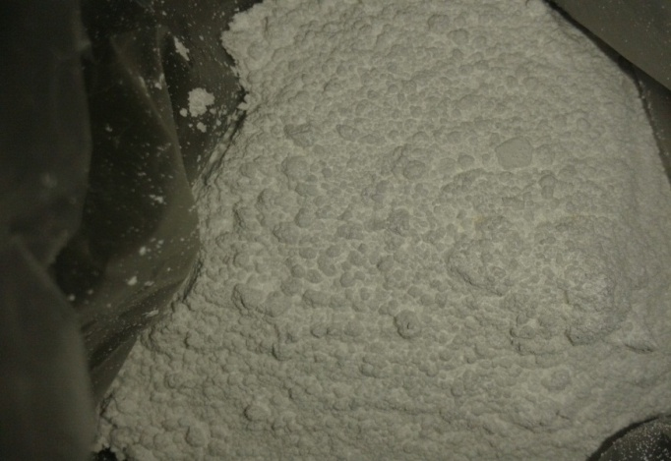
Figure 2.1 Nano Aluminium oxide particles
In this study, Al₂O₃ having 20nm-30nm average size has been used as a reinforcement material. According to Rajmohan et al. (2014), using nanoparticles can increase the MMCs' strength.
2.2.3. Boron Carbide (B₄C)
B4C is one of the most likely future ceramic materials because of its desirable characteristics, such as high strength, low density, exceptionally high hardness, outstanding chemical stability, and neutron absorption capacity.
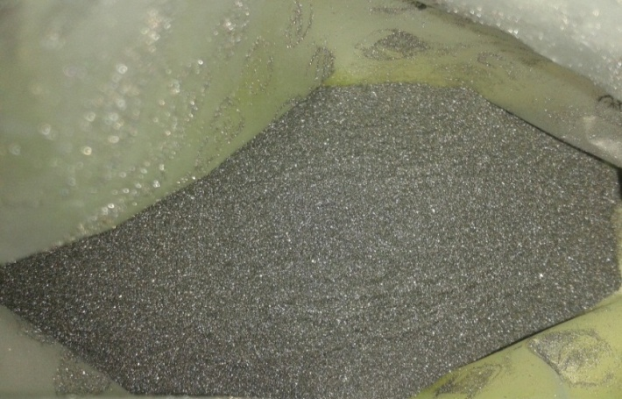
Figure 2.2: B4C particles
B₄C wettability is poor. Zhiwei Liu (2014) and Suresh (2012) et al said that the addition of Ti and TiB₂ can improve the interfacial bonding. Potassium hexafluorotitanate(K₂TiF₆), a halide salt, is used to increase the wettability between B₄C and molten aluminum alloy. is used [4, 5, 12] and it is shown below.

Figure 2.3: Potassium hexa fluorotitanate salt
2.2.4. MATERIAL PROPERTIES
The mechanical characteristics of the selected materials such as Aluminium alloy of grade LM25, B4C particles (B₄C) and Aluminium oxide particles (Al₂O₃) are shown in table
Materials | Tensile Strength MPa | Density g/cm³ | Thermal expansion Coefficient (10⁻⁶/ ⁰C) | Youngs Modulus GPa
LM 25 | 190 – 250 MPa | 2.68 g/cm³ | 2.2 | 71 GPa
B₄C | 261 MPa | 2.3 – 2.55 g/cm³ | 3.2 | 362 GPa
Al₂O₃ | 255.2 MPa | 3.98 g/cm³ | 7.4 | 380 GPa
Table2.2: Properties of the selected materials

3. Fabrication and testing procedure
The experimental setup to fabricate the MMCs comprises of crucible and a stirrer; crucible and stirrer are made up of cast iron and mild steel respectively. In the fabricating procedure, preheating is the first process, so that the void crucible was preheated up to 450 to 5500C, whereas the die which is used to solidify the melt was preheated up to 2000C. The reinforcement particles such as nano aluminium oxide particles and micro particles of B₄C and the equal weight of K₂TiF₆ flux were separately preheated up to 400 to 5500C. At a temperature of about 8000C, the crucible melted the base metal, LM25. A degasser agent was employed to release all of the trapped gases from the mixture in the crucibleThe reinforcement particles were then added one at a time and mechanically stirred into the 1000 g matrix alloy. Instead of doing it all at once, the particles that strengthened it were added to the molten Al alloy here in two steps. it gives the advantage of avoiding agglomeration. So that the nano Al2O3 particles were divided into two equal amounts and added on the individual basis with the molten alloy.
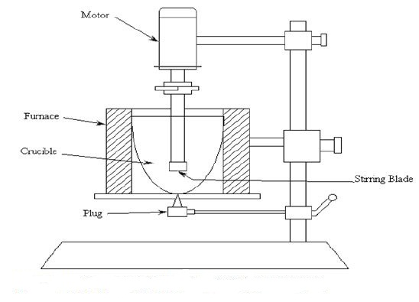
Figure 3.1: Stir casting-line diagram
After adding the each amount of particles into the liquid aluminium alloy, that mixture was mechanically stirred at the speed of 200rpm for 2 min and the temperature was maintained at 7500C.
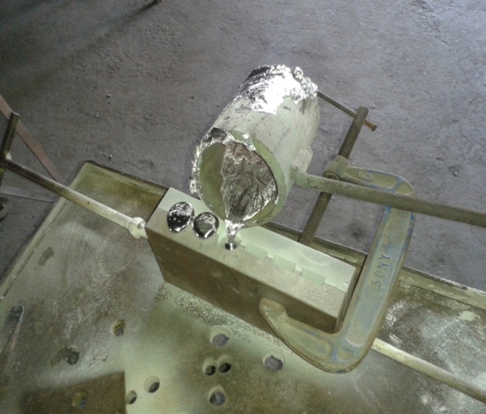
Figure 3.2: Pouring of melt

At some point, 7000C of the melt was put into the heated die, where it was allowed to harden. This experiment was repeatedly executed by keeping the weight % of B₄C particles as constant and varying the weight % of nano Al2O3. Besides the base alloy LM25 alone was melted and solidified in the die. After the fabrication, the specimens were prepared to evaluate the physical characteristics of the composites.
Testing the material in tension or compression can reveal whether it can resist a static load. Tensile tests were performed on the samples in this study using an ultimate tensile testing machine at room temperature (28 to 50C) in accordance with ASTM E8M standards.
A hardness test can be used to gauge a solid's resistance to permanently changing shape when a force is applied. In this study, Brinell hardness tests were done to find out how the metal matrix composite will deform when subjected to a steady compressive stress from a sharp object.
Impact testing involves applying the load to the composite specimen in an abrupt and dynamic manner. The charpy test was used in this investigation to calculate the energy in joules that the composite specimen absorbed for the specified load. The specimen was developed for this in accordance with ASTM E23 standard.

4. EVALUATION OF MECHANICAL PROPERTIES OF AMCs
In this investigation, the following tests are performed in order to assess the mechanical qualities of the Al matrix composites.: Tensile, Impact, Hardness tests and SEM analysis.
4.1. ‘Tensile test’
The specimens for the tensile test were prepared in accordance with ASTM E8M standard, and the test was performed using the universal testing machine. The comparison of Load vs. Cross head displacement for all samples is shown in Fig. 4.1. It is evident that as the weight percentage of the reinforcing particles is raised, the tensile strength rises and becomes noticeably higher than
that of the base alloy.
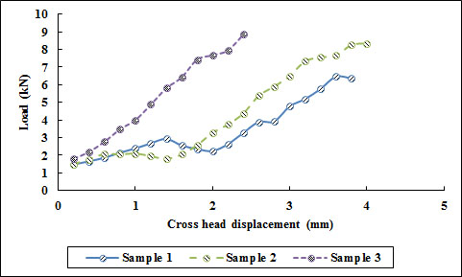
Figure 4.1. Load vs. Cross head displacement
The increased tensile strength observed after the addition of reinforcement particles may be the result of the matrix material's integration of higher strength, which increases its resistance to tensile stresses. The tensile strength of the composite specimens was raised as a result of shifting the load from the matrix material to the reinforcement particles. The increased strength of the reinforcement particles, such as B4C and aluminum oxide, is what causes this rise in tensile strength.
Only the tensile strength of the sample 2 is lower than the sample 3 and higher than the sample 1, as the particles in the nano scale level will typically get more dispersed in the matrix material than the particles in the micro scale level.
From Fig 2 Fig. 2. Sample 1 exceeded the break load maximum more than Sample 2, however Sample 2 has a higher break load value than Sample 3. But sample 1 has the lower value of displacement than other samples; this is due to whenever the wt.% of reinforcement particles were increased, the tensile stress applied to the composite specimen undergone more resistance due to motion dislocation.
A combination of B₄C and nano-sized Al₂O₃ particles, which operate as barriers to moving of dislocations, and the extremely strong connection between the matrix of material and the particles that provide reinforcement are ultimately give composites greater strength.
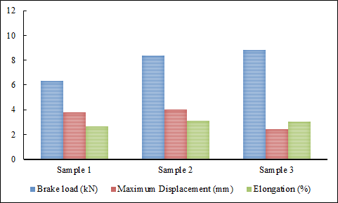

Figure 4.2. Comparison of parameters for three samples.

3.2 ‘Hardness test’
All of the composite samples performed the "Brinell hardness test". Ball shaped intender having diameter of 2.5 mm and made up of tungsten is used for this test. The load employed is 62.5 Kgf.
The Fig 4.3. reveals the combined hardness of the three composite samples. It should be observed that sample 3 has the highest average hardness value, followed by samples 2 and 3.
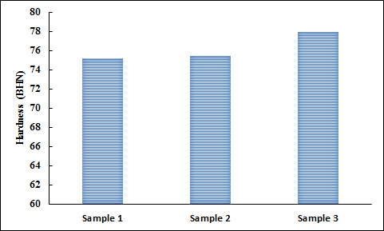
Figure 4.3. Comparison of Hardness values for three samples

But the increase in hardness value of the sample 2 and sample 3 is very minimal than the base material sample 1. This could have taken place as an outcome of the specimen having an uneven distribution of reinforcing particles.

3.3. ‘Impact test’

The specimen was developed in accordance with ASTM E23 specification to conduct the Charpy test.

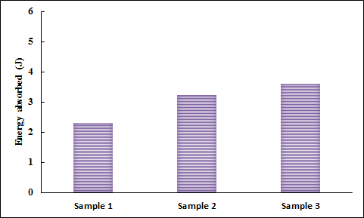
Figure 4.4. Comparison of energy absorbed for three samples

It is obvious that sample 3 absorbs the most energy, followed by samples 2 and 1. According to Fig. 4.4, the energy absorption of composites increases as the weight percentage of the reinforcing particles rises.

5.conclusion

Aluminum-based MMCs were fabricated using the stir casting technique. The composition included a constant 3% weight fraction of micro B₄C and varying weight fractions (4% and 5%) of nano Al₂O₃. To enhance the wettability and interfacial bonding between the B₄C particles and the molten aluminum alloy, K2TiF6 flux was employed. Subsequently, mechanical properties were assessed through tensile, hardness, and impact tests, leading to the following conclusions based on the test results.
- The alloys' tensile strengths were greater than those of the base alloy. The addition of micro B₄C and nano Al₂O₃ particles, which function as barriers to the motion of dislocation and also because of the excellent bonding between the matrix material and the reinforcement particles, increases the strength of composite materials.
- According to the impact test results, the energy consumed by the composite materials was greater than the energy absorbed by the base alloy.
- When compared to the base alloy, the hardness value of the composites showed only a slight improvement after the hardness test.

- It has been determined that when the weight percentage of these reinforcing particles grew, so did the composite materials' mechanical characteristics.

REFERENCES
- Modi OP, Prasad BK, Yegnewaran AH, Vaidya ML. Dry sliding wear behavior of squeeze cast aluminium alloy – silicon carbide composites. Mater Sci Eng A;151:235–44, 1992.
- Kemal Aldas, Mahmut D. Mat. Experimental and theoretical analysis of particle distribution in particulate metal matrix composites. Journal of material processing technology 160: 289-295, 2005.
- K.K. Alaneme, A.O. Aluko. Fracture toughness (K1C) and tensile properties of as-cast and age-hardened aluminium (6063) – silicon carbide particulate composites. Scientia iranica A: 19(4):992 – 996, 2012.
- K.M. Shorowordi, T. Laoui, ASMA. Haseeb, JP Celis, L. Froyen. Microstructure and interface characteristics of B4C, SiC and Al2O3 reinforced Al matrix composites: a comparative study. Journal of material processing technology 142: 738-743, 2003.
- Ramesh CS, Keshavamurthy R, Channabasappa BH. Friction and wear behavior of Ni–P coated Si3N4 reinforced Al6061 composites. Tribol Int;43:623–34, 2001.
- Ali Mazahery, Mohsen Ostad Shabani. Nano-sized silicon carbide reinforced commercial casting aluminium alloy matrix: Experimental and novel modeling evaluation. Powder technology 217:558-565, 2012.
- T. Rajmohan, K. Palanikumar, S. Arumugam. Synthesis and characterization of sintered hybrid aluminium matrix composites reinforced with nanocopper oxide particles and microsilicon carbide particles. Composites: Part B 59: 43-49, 2014.
- A. Baradeswaran, A. Elaya perumal. Study on mechanical and wear properties of Al 7075/Al2O3/graphite hybrid composites. Composites: Part B 56: 464-471, 2014.
- Abhishek kumar, Shyam lal, Sudhir kumar. Fabrication and characterization of A359/Al2O3 metal matrix composite using electromagnetic stir casting method. J MATER RES TECHNOL: 2(3):250-254, 2013.
- B. Vijaya ramnath, C.Elanchezhiyan, M. Jaivignesh, S. Rajesh, C. Parswajinan, A. Siddique ahmed ghias. Evaluation of mechanical properties of aluminium alloy-alumina-B4C metal matrix composites. Materials and design 58:332-338, 2014.
- M. Kok. Production and mechanical properties of Al2O3 particle reinforced 2024 aluminium alloy composites. Journal of material processing technology 161: 381-387, 2005.
- V. Auradi, Rajesh GL, SA. Kori. Processing of B4C particulate reinforced 6061 aluminium matrix composites by melt stirring involving two step addition. Procedia materials science 6:1068-1076, 2014.
- Fatih Toptan, Ayfer Kilicarslan, Ahmet Karaaslan, Mustafa cigdem, Isil Kerti. Processing amd microstructural characterization of AA 1070 and AA 6063 matrix B4Cp reinforced composites. Materials and design 31:S87-S91, 2010.
- Hosseini N, Karimzadeh F, Abbasi MH, Enayati MH. Tribological properties of Al6061–Al2O3 nanocomposite prepared by milling and hot pressing. Mater Des;31:4777–85, 2010.

