Numerical Simulation of atmospheric turbulence using Fourier transform and sub-harmonics methods

Dr. M. Mohamed Ismail,
Department of Computer Applications,
V. H. N. Senthikumara Nadar College (Autonomous), Virudhunagar, India
Email: mohammedismi@gmail.com
INTRODUCTION
Observations with ground- based telescopes suffer from atmospheric turbulence while looking through the sky. The best option to minimize the atmosphere effects is to launch a telescope into space to avoid the atmospheric problems altogether, but it has its own limitations of launching technology for big telescopes and cost of operation. The more economical solution is to build an Adaptive Optics (AO) system that senses the distortions and compensates them in a ground based telescope.
1.1 Effect of Atmospheric Turbulence
When a light beam from the stars propagates through the turbulent atmosphere the wavefront of the beam is distorted that affect the image quality of telescopes. Earth’s atmosphere is made up of many layers having different temperature gradient, different velocity gradient and also different density gradient. The chaotic and stochastic changes in these properties of the atmosphere cause a fluid called turbulence or turbulent flow. Turbulence causes the formation of eddies in many different length scales.
The atmospheric turbulence can be considered as a random process and can be estimated by means of variances and co-variances of local refractive index fluctuations [1]. Due to change in the refractive indices of the different layers, the planar wavefront, from the distant star, propagating through the turbulent atmosphere, gets distorted. So, both the amplitude and phase of the incoming beam fluctuate during its passage and changes with time. Thus, the random process of the atmospheric turbulence, affect the image forming capabilities of a telescope.
The effects of turbulence on light that passes through the atmosphere are three types.
a. It creates intensity fluctuations or scintillations which are observed as the twinkling of the stars.
b. The position of the star wanders when the varying refractive index of the atmosphere alters the angle of arrival of the star light.
c. There is a spreading effect created by the higher order aberrations which causes stars to appear as small discs of light and not sharply defined point sources.
The Figure 1.1 shows the simulated point source images of a diffraction limited case and in the presence of strong turbulence. The intensity is normalized to the peak intensity of Point Spread Function (PSF) in the absence of turbulence. This light spreads over a larger area and demonstrates high resolution, high contrast imaging difficult.
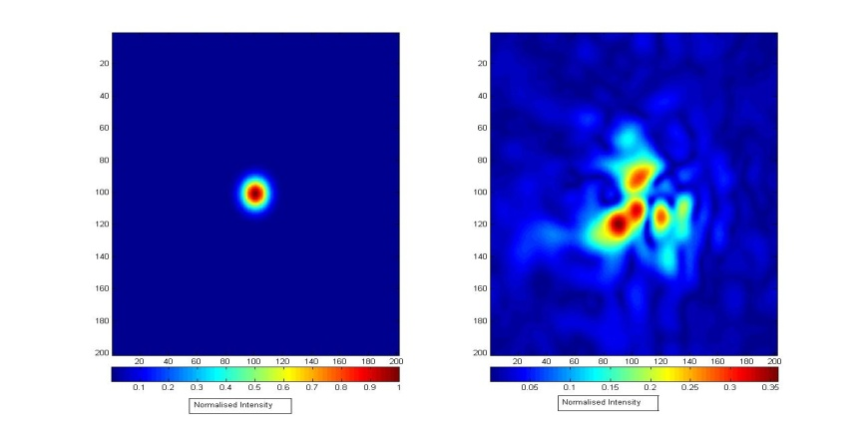
Figure 1.1.A: No Turbulence B: Strong Turbulence
1.2 Adaptive Optics Technology
The distortion induced by the turbulent atmosphere on the incoming wavefront from the stars can be corrected which enables telescope to reach the diffraction-limited image quality, thereby improving the resolution of the ground-based telescopes. This real-time correcting system is called as Adaptive Optics (AO). It is a technique which measures the wavefront phase errors generated by the variations of the index of refraction in the atmosphere and corrects the resulting image in real time to achieve an angular resolution close to the diffraction limits of the telescope. Designing of an Adaptive Optics system requires a better understanding of the characteristics of the atmospheric turbulence and the effects on the Wavefront Sensor.

The major components involved in a simple Adaptive Optics system are Wavefront Sensor which measures phase variations, Wavefront Correction device (usually a flexible Deformable Mirror), control algorithm and hardware which must be very fast to correct real-time variations. A Wavefront Sensor is a device that helps in determining the shape of the incoming beam. Wavefront Corrector is a phase distortion compensation tool. The control algorithm takes the input from the Wavefront Sensor and translates the information into command values that can be addressed to the Wavefront Corrector. A portion of the beam from the telescope is diverted to the Wavefront Sensor to estimate the aberrations induced in the beam due to atmospheric turbulence. The wavefront control system computes the control signals for the wavefront corrector and sends it to the correcting device. The first solution to be implemented was tilt-tip correction, the tilting of a secondary mirror several times a second to eliminate or reduce the dancing motion of an image. A Deformable Mirror (DM) is used to correct high frequency errors and it is made of a very thin mirror whose shape can be changed by the force applied by many actuators stacked behind the mirror. The schematic of an Adaptive Optics system is shown in Figure1. 2.
Figure. 1.2: Schematic of an Adaptive Optics System
1.3 Wavefront Correcting System
Adaptive Optics is the adaptation of the telescope optical system and it works in such a way that it measures the incoming light from natural stars and gives information on the nature of the atmosphere at a certain point in time. A distorted wavefront comes into the system through telescope aperture. It is reflected from a Deformable Mirror to a beam splitter that divides the beam to a WFS and a scientific camera. The measurements from WFS are fed into computers to compute the required instructions for the DM. The mirror is deformed using actuators, each of them having its own control voltage. After calculating wavefront errors with WFS, they can be appropriately corrected with spatial correction devices such as Tip Tilt and Deformable Mirror.
1.3.1 Tip-tilt Mirror
The simplest form of Adaptive Optics is Tip-Tilt correction [2,3]. Tip-Tilt mirror is an Opto-Electronic device used to correct the tilts of the wavefront in two dimensions. In Adaptive optics, Tip-Tilt mirror can correct 87% of distortion which is introduced by the atmosphere.
1.3.2 Deformable Mirror
Once the wavefront aberrations are measured with a Wavefront Sensor, they have to be somehow corrected. A mirror with its surface locally bent is called Deformable Mirror (DM), which is usually used for this purpose. DM is an important component in a wavefront compensation system [4]. A DM is a flexible structure and its surface can be shaped dynamically into a custom form. The incoming light falls onto the mirror which in turn is deformed into the shape producing a straight wavefront leaving the mirror. A DM is also an Opto-Electronic device which corrects the distortions in wavefront by deforming the mirror. It consists of array of actuators which control the mirror such that it is perfectly conjugate to the incoming aberrated wavefront.

1.4 Chapter Description
Various Wavefront Sensing techniques have been developed for use in a variety of applications ranging from measuring the wavefront aberrations of human eyes [5] to Adaptive Optics in astronomy [6]. The most commonly used Wavefront Sensors are the Shack-Hartmann (SH) [7, 8], Curvature sensing [9], Lateral Shearing Interferometry (LSI) [10, 11 and 12], Phase Retrieval methods [13] and Pyramid Wavefront Sensor [14]. Among the Wavefront Sensors, the Shack-Hartmann Wavefront Sensor (SHWS) is the most commonly used technique for measurement of turbulence induced phase distortions for various applications in atmospheric studies and Adaptive Optics. But the dynamic range of the SHWS is limited by the optical parameters of its micro lenses, namely, the spacing and the focal length of the microlens array.
Development of AO requires better understanding of the characteristics of turbulent atmosphere and its effects on the wavefront aberrations. So, simulation of atmospheric turbulence carried out numerically using Kolmogorov turbulence model with LabVIEW routines for different D/ro ratio with Fourier transform method and sub harmonics method.
1.5 Shack Hartmann Wavefront Sensor
Shack-Hartmann Wavefront Sensor is an optical instrument which senses local gradients through aperture sub-division with a lenslet array. This is the most common Wavefront Sensor in Astronomy and Ophthalmology. In SHWS an image of telescope exit pupil is projected onto a lenslet array of small identical lenses. Each lens takes a small part of the aperture, called a sub-pupil, and forms an image of the source on back focal plane of array. A CCD detector is placed at the back focal plane of the lenslet array. An array of images is formed at the detected plane. In order to measure the positional accuracy of each image spot, the centre of mass method is used. A reference source is introduced in the optical path to record reference co-ordinate. Measuring the difference from the reference position, the local slopes are calculated and from these slopes the wavefront is reconstructed.
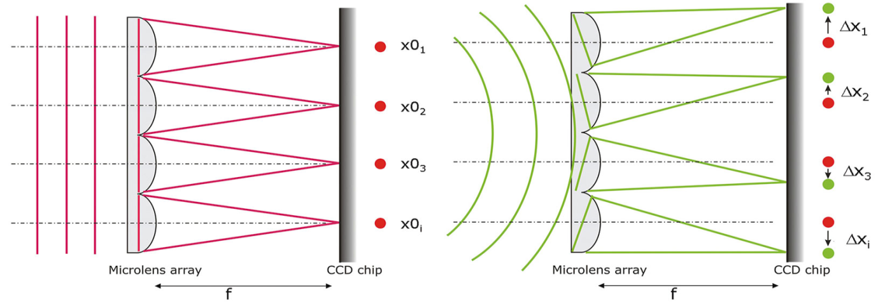
Figure 1.3: Schematic of Shack Hartmann Wavefront Sensor
Deviation of spot position from a perfectly square grid measures the shape of incoming wavefront. The shift may be in x direction or y direction or in both the directions. From the knowledge of the focal length of the Shack- Hartmann lens and the distance of the centroid, the slope can be determined. Centroid algorithms are used to determine the spot centroids. The accuracy of SHWS is mainly depending on the centroid calculation accuracy and reconstruction accuracy.

1.6 Numerical simulation of atmospheric turbulence:
To understand the adaptive optics technology, it is essential to simulate atmospheric turbulence numerically and experimentally. For testing and calibrating a complex adaptive optics (AO) system it is useful to have an artificial turbulence generator with known, realistic, and repeatable characteristics.
Turbulent flow is very complicated and still it is not entirely understood. The most widely accepted theory of turbulence flow, due to consistent agreement with observation and statistical model of the wavefront aberrations induced by the turbulent atmosphere was first put forward by Andrei Kolmogorov [15]. Kolmogorov statistics provide a suitable theoretical model for atmospheric turbulence. This model is based on the idea that energy is fed into the system at large scales and propagates down to smaller structures, where it eventually dissipates into heat. Kolmogorov turbulence model is valid for atmospheric turbulence and it is experimentally proved [16]. However, the Kolmogorov model is only useful between the largest (the outer scale L₀), and the smallest structures (the inner scale ) of the turbulence. The theory based on Kolmogorov turbulence has been reviewed by Roddier [17].
1.7 Kolmogorov Model of Atmospheric Turbulence
Kolmogorov model suggested that the energy injected into turbulent medium on large spatial scales (outer scale, is of the order of a few tens of meters) [18] forms eddies. The outer scale limits the contribution of low spatial frequencies to the wavefront aberrations. Since these spatial frequencies dominate the overall wavefront distortions, has a significant influence on the achievable performance and image quality of telescope [19].
These large eddies cascade the energy into small scale eddies until they become small enough (small scale) that the energy is dissipated by the viscous properties of the medium. For the inertial range between inner and outer scales, Kolmogorov predicted a power law distribution of the turbulent power with spatial frequency. The outer scale is denoted by, the inner scale by. Eddies between these limits form the inertial subrange. Energy is injected by wind shear and convection is transferred until it is dissipated to heat. Atmospheric turbulence is a random process. Tatarski [20] shows the three dimensional power spectrums, of the refractive index variations is,
(1.1)
where 𝜅 is the scalar wave number vector (
The outer scale is an important parameter in turbulence statistics and its range of values are much debated in astronomical databases [21]. The standard spectrum of Kolmogorov turbulence is usually written with infinite outer scale and the effect of infinite outer scales is to reduce the lower spatial frequency contributions.

1.8 Fourier Transform - based Phase Screen
Fourier Transform (FT) method proposed by McGlamery [22, 23] has been used to simulate the phase screens numerically. The FT methods are most common since very large phase screens can be generated quickly. One way of describing the phase statistically is by means of its power spectrum.
The phases of the Fourier Transform of the phase map are independent with frequency, uniformly randomly distributed in – to + interval. Based on these the phase map is generated using a complex array of Gaussian random numbers and the array are multiplied by the square root of the power spectrum. The array is subjected to a discrete Fourier Transform and the resulting complex array is separated into its real and imaginary components, each of these arrays represent an independent instantaneous phase map realization.
The power spectrum is only valid within the inertial range between the inner and outer scale as it tends to infinity at larger spatial separations. There are other modified models for the atmospheric power spectral density, like the Tatarski [20], Von Karman [24], and modified Von Karman [25] which are commonly used. These models are much more sophisticated and include various inner-scale and outer-scale factors that improve the agreement between theory and experimental measurements. In order to accommodate the finite inner and outer scales, the Kolmogorov power spectrum was modified by Von Karman power spectrum [26] which is given by,
(1.2)
Where , and . It can be expressed in another form with Fried parameter,
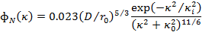
(1.3)
For infinite outer scale and zero inner scale above equation reduces to,
(1.4)

The Power spectral density (PSD) and phase screen are related as,
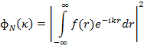 (1.5)
From the above equation phase screen is derived by:
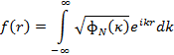
(1.6)
where is the 2D - Kolmogorov phase screen. It is obtained from Inverse Fourier Transform (IFT) of square root of Von Karman power spectrum of turbulent atmosphere. The randomness of atmospheric turbulence is implemented with random numerical function. The Figure 1.4. A presents the typical atmospheric phase screen simulated by Fourier Transform method with D/r_{o}=2, where D is the telescope diameter, is the Fried’s parameter, = and . The Figure 1.4. B demonstrate 3D representation of phase screen. In this Figure one can observe that the low spatial frequencies are not sampled well (i.e., no tip / tilt).
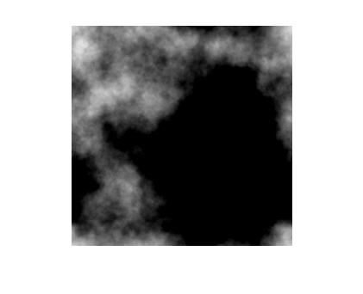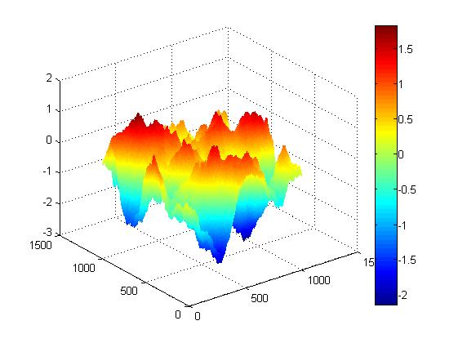
(a) (b)
Figure 1.4: Sample Phase Screens obtained by Fourier Transform Method

This method has a disadvantage of under sampling at low spatial frequencies due to limited low sampling of Fourier Transform technique. This leads to lower-order aberrations such as tilt which are often under-represented. These lower-order aberrations contribute a majority of the atmospheric energy spectrum and must be included to produce realistic models.
1.9 Sub-Harmonics Method - based Phase Screen
Sub - Harmonics method [27, 28,29] is a simple technique for modelling the effects of lower frequencies by generating additional random frequencies and adds their effects to the sampled frequencies using equation 1.7. It modifies the usual Fourier Transform method of generating phase screens for atmospheric propagation to allow low-frequency turbulence effects. This method consists of generating realizations of turbulence on two different size grids and uses a trigonometric interpolation to introduce low frequency effects on the smaller (propagation) grid. It is proved that the phase screens generated by this method give a better representation of Kolmogorov turbulence since they include effects from the low spatial frequency part of the spectrum. This method can be considerably more efficient than direct implementation of the FT method on a very large grid. It provides a low frequency screen p(x, y) generated by a sum of different number (Np) of phase screens. The low frequency screen as a Fourier series is given by,
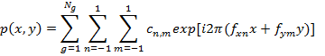 (1.7)
where the sums over n and m are over discrete frequencies and each value of the index g corresponds to a different grid. The phase screen generated in this simulation is derived by addition of two-phase screens obtained with Fourier Transform method and Sub-Harmonics method.
The sample phase screens thus simulated are shown in Figure 1.5. A presents the typical atmospheric phase screen simulated by Sub-Harmonics method with D/r_{o} =5 1, 2, = 50 m and 0.01 m. The Figures 1.5 B demonstrate 3D representations of phase screen. In these Figures it is clearly seen that low spatial frequencies are well sampled.
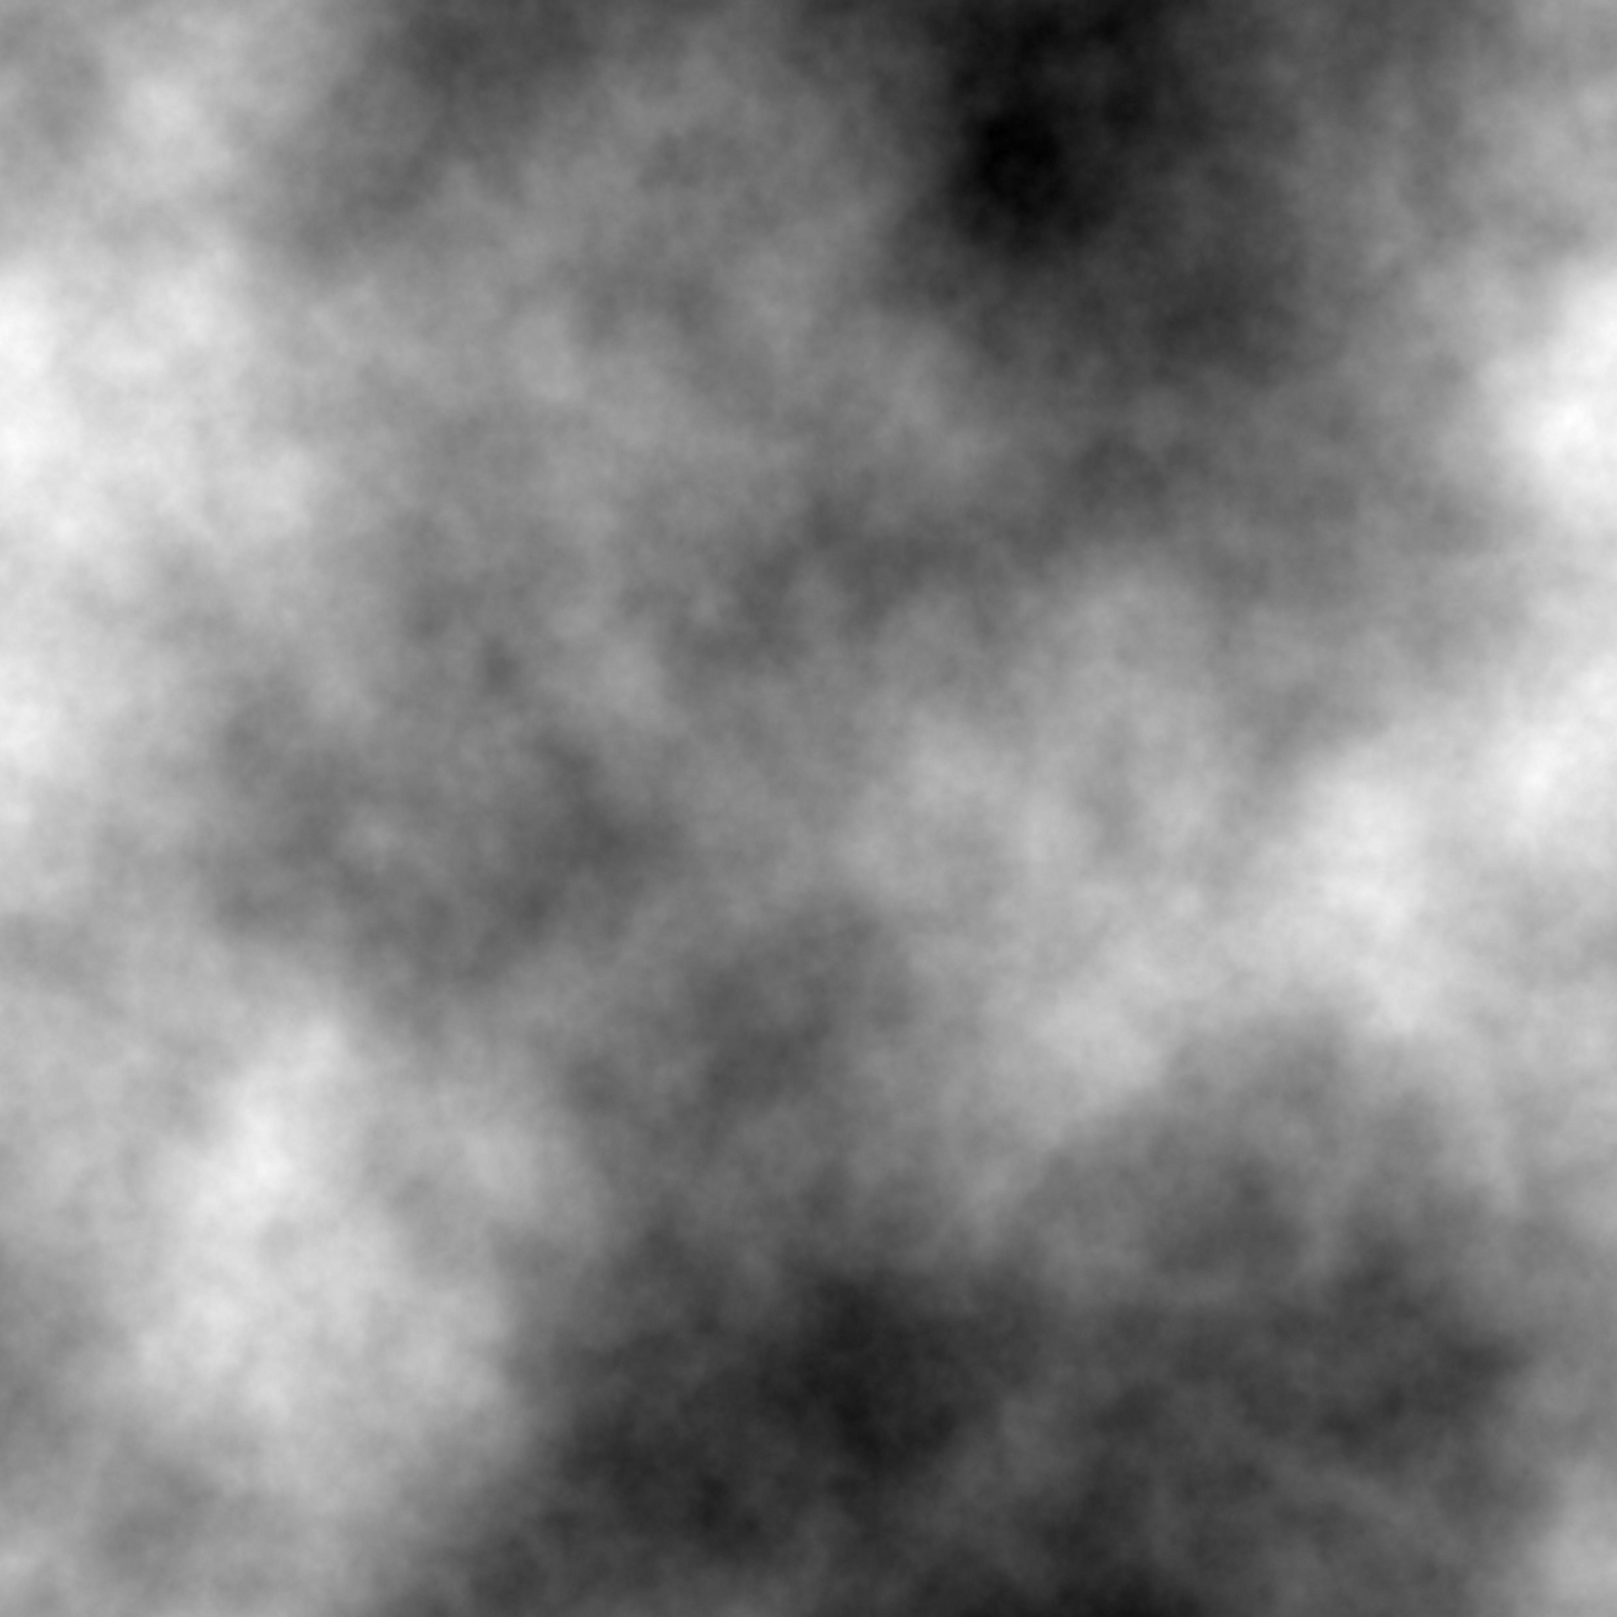 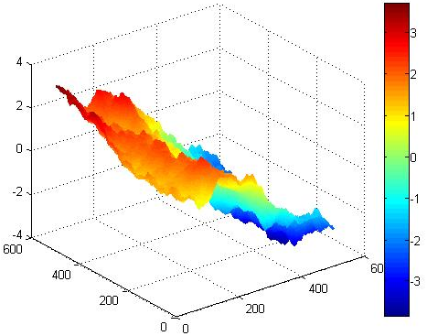 (a) (b)
Figure 1.5: Sample Phase Screens obtained by Sub-Harmonics Method

1.10. Numerical Simulation of Shack Hartman in the presence of noise.
The atmospheric turbulence affected Shack-Hartmann spot patterns are generated. Initially Airy pattern spots are generated by considering pre-fixed sub lenslet diameter. The generated Airy spot intensity array multiplied with phase screen array exponentially as phase information. Then the resulted image is Fourier transformed. As a result, we get the turbulence distorted SH spot pattern. The spot pattern (7×7) at the focal plane of a Shack Hartmann sensor is simulated. In figure 1.6 , the Shack Hartmann back focal plane spot intensities is shown when the turbulence at the order of D/r_{o} =15. This images are generated with the Airy array spot pattren which is corrupted by Kolmogorov atmospheric turbulence.
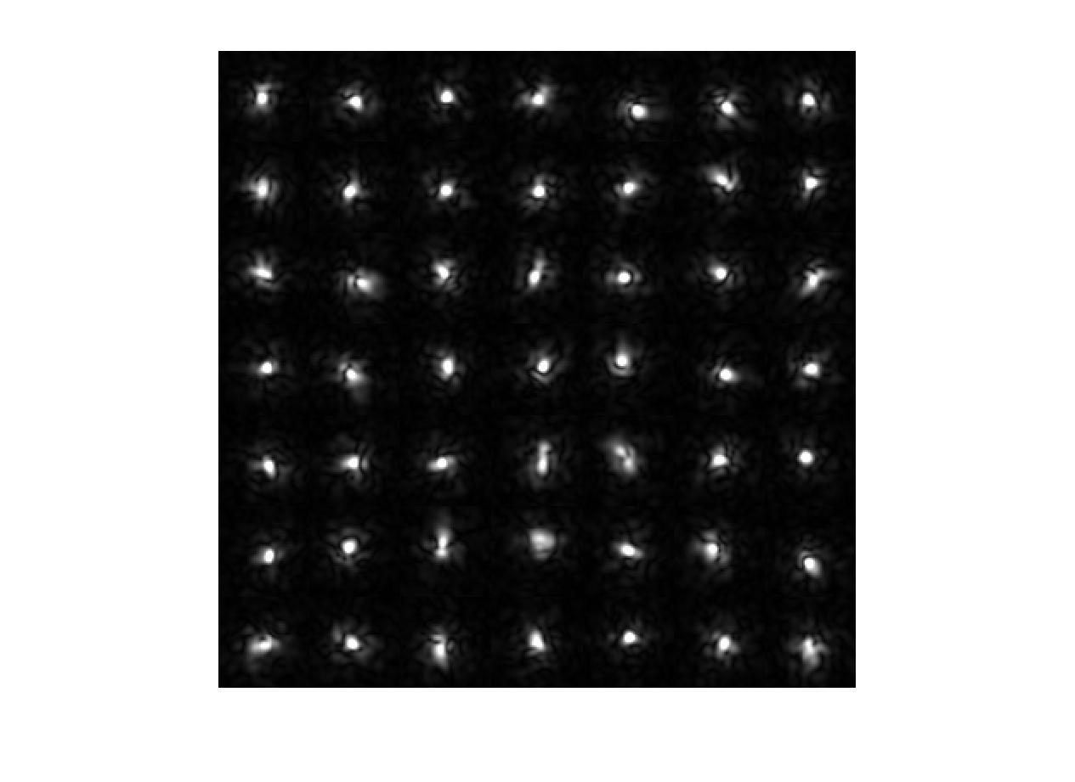
Figure 1.6: Airy pattern in the presence of turbulence (at D/r_{o} =15)
1.11 Centroid algorithms
The Center of Gravity (CoG) is the simplest and most direct way to calculate the position of a symmetric spot:
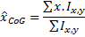 (1.8)
1.12 Wavefront reconstruction:
After finding out the centroid of each spot, the slope of the wavefront at each subaperture is calculated with the knowledge of focal length of the Shack-Hartmann sensor and the deviation of the centroid of each spot from the reference image. From this slope the wavefront is reconstructed using modal approach. Reference and distorted centroid points are compared for slope determination. The wavefront is calculated with modal approach using Zernike [30] basis functions using 21 modes. The figure 1.7 shows the wavefront is reconstructed from the distorted wavefront at Turbulence D/r_{o}=5. One can clearly see that distorted wavefront leading to speckles and centroid positions also shifted.
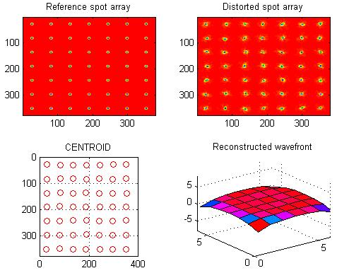
Figure 1.7: Shack Hartmann sensor Top left one is reference array pattern; Top right one is distorted array pattern, bottom left one is calculated centroid positions; bottom right one is wavefront constructed at D/r_{o} =5.
In figure 1.8, Zernike coefficients are plotted for Zernike index up to 21 modes. (Except piston). It is clearly seen that the values of the lower order terms are much higher than the higher orders ones.
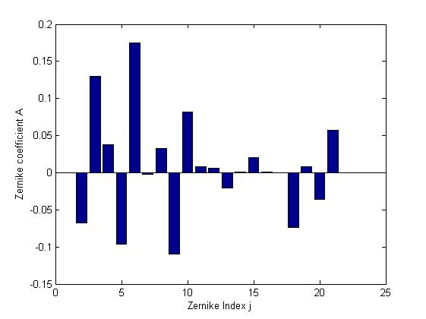
Figure 1.8: Zernike coefficients are plotted against Zernike index number
CONCLUSION
Estimation of the wavefront errors is a very important aspect in adaptive optics. Besides the telescope system errors, the atmospheric turbulence also accounts for the major contribution to the errors. The atmospheric turbulence is characterized by the Kolmogorov model. It is essential to accurately estimate these aberrations in the dynamic situations, in order to apply, real time corrections. A phased screen based of Fourier transform and sub harmonics method has been tested and reconstructed the wavefront using Zernike polynomials.

REFERENCE
[1] Hardy, J.W.: Adaptive Optics for Astronomical Telescopes, 1998.
[2]. J. C. Christu “Image quality tip-tilt correction and shift and add infrared imaging” Publication of the Astronomical Society of Pacific 103:1040- 1048 Sep. 1991.
[3] Watson, Jim. “Tip-Tilt Correction for Astronomical Telescopes using Adaptive Control”, Wescon - Integrated Circuit Expo 1997, Santa Clara, California, November 5-6, 1997.
[4] M. Sechaud, ”Wavefront compensation devices “, Adaptive Optics in Astronomy, 1999.
[5] Lombardo, M. and Lombardo, G. (2009). New methods and techniques for sensing the wave aberrations of human eyes, Clinical and Experimental Optometry, Vol. 92: 176–186.
[6] Roddier, F. (1999). Adaptive Optics in astronomy, Cambridge university press, Cambridge, United Kingdom.
[7] Platt, B. C. and Shack, R. V. (2001). History and principles of ShackHartmann wavefront sensing, Journal of Refractive Surgery, Vol. 17: S573–S577.
[8] Shack, R. V. and Platt, B. C. (1971). Production and use of a lenticular Hartmann screen, J. Opt. Soc. Am., Vol. 61: 656.
[9] Roddier, E. (1988). Curvature sensing and compensation: a new concept in adaptive optics, Appl. Opt., Vol. 27: 1223–1225.
[10] Hardy, J.W. and Alan J. MacGovern., “Shearing interferometry: a flexible technique for wavefront measurement” SPIE, Vol. 816, “Interferometric Metrology”, 180 – 195 (1987).
[11] Greivenkamp, J.E., and Bruning, J.H., “ Phase shifting interferometers” in Optical Shop Testing, Ed., Malacara, D., Wiley Series, 501 – 598 (1992).
[12] Atad E; John W. Harris; Colin M. Humphries; Victoria C. Salter, “Lateral Shearing interferometry: evaluation and control of the performance of astronomical telescopes” SPIE 1236, “Advanced Technology Optical Telescopes IV”, Lawrence D. Barr, Editors, 1990.
[13] Gonsalves, R. A. (1982). Phase retrieval and diversity in adaptive optics, Opt. Eng., Vol. 21: 829–832.
[14] Ragazzoni, R. and Farinato, J. (1999). Phase retrieval and diversity in adaptive optics, Opt. Eng., Vol. 350: L23–L26.
[15] A. N. Kolmogorov. The local structure of turbulence in incompressible viscous fluid for very large Reynolds numbers (translation). Proceedings of the Royal Society of London A, 434:9-13, 1991.
[16] N. S. Nightingale and D. F. Buscher. Interferometric seeing measurements at the La Palma Observatory. MNRAS, 251, July 1991.
[17] Roddier, F. “Imaging through the atmosphere” in “Adaptive Optics in Astronomy” Cambridge University Press. 9 – 22 (1999).
[18] J.M.Conan,Gerard Rousset and P-Y Madec, Wavefront temporal spectra in high resolution imaging through turbulence., J Opt. Soc. Am A, 12:1559-1570,1995.
[19] D. F. Buscher, J. T. Armstrong, C. A. Hummel, A. Quirrenbach, D. Mozurkewich, K. J. Johnston, C. S. Denison, M. M. Colavita, and M. Shao, Interferometric seeing measurements on Mt. Wilson: power spectra and outer scales, OSA Publishing , Applied Optics , Volume 34 , Issue 6 , Page 1081 , 1995 Optical Society of America.
[20] V.I. Tatarski. Wave Propagation in a Turbulent Medium. McGrawHill, 1961.
[21] A. Ziad, M. Schock, G. Chanan, M. Troy, R. G. Dekany, B. F. Lane, J. Borgnino, and F. Martin. Comparison of measurements of the outer scale of turbulence by three different techniques. Appl. Opt., 43(11):2316–2324, 2004.
[22] B.L. McGlamery, Computer simulation studies of compensation of turbulence degraded images, Image Processing, SPIE /OSA Vol. 74, 225– 233 (1976).
[23] E.M. Johansson, D.T. Gavel, Simulation of stellar speckle imaging, ed. by J.B. Breckinridge. Amplitude and intensity spatial interferometry II, Proc. SPIE 2200, 372–383 (1994).
[24] C. Rao, W. Jiang, and N. Ling. Spatial and temporal characterization of phase fluctuations in non-kolmogorov atmospheric turbulence. Journal of Modern Optics, 47(6):1111–1126, 2000.
[25] F. Roddier. The effects of atmospheric turbulence in optical astronomy. In Progress in Optics, volume 19, pages 281–376, 1981.
[26] M.C. Roggemann, B.M. Welsh, Imaging through turbulence,(CRC Press, Laser and Optical Science and Technology Series,1996).
[27] B.J. Herman, L.A. Strugala, Method for inclusion of low frequency contributions in numerical representation of atmospheric turbulence, ed. by P.B. Ulrich, E. Wilson. Propagation of high-energy laser beams through the earth’s atmosphere, Proc. SPIE 1221, 183–192 (1990).
[28]. R.G. Lane, A. Glindermann, J.C. Dainty, Simulation of a Kolmogorov phase screen. Waves Random Media 2(3), 209–224 (1992).
[29] D.J.Butler ,E.Marchetti , J.Bahr,W.Xu and S.Hippler , ‘’ Phase screens for astronomical multi-conjugate adaptive optics‘, Proc SPIE,4839,p.623-634 2003 .
[30] R.J.Noll, “Zernike Polynomials and atmospheric turbulence” J.Opt.Soc.Am., 66, 207211 (1976).

