ISOLATION OF PHYTOCONSTITUENTS FROM Myxopyrum serratulum A.W Hill
T.Sheelarani ¹* and V. Gopal ²
1. Assistant Professor, Sri Ramachandra Faculty of Pharmacy
Sri Ramachandra Institute of Higher Education and Research (DU), Porur, Chennai.
2. Professor, Mother Teresa Post graduate institute of Health sciences, Pondicherry.

ABSTRACT
The Present work was done in 70% ethanolic extract to isolate the isolate the phytoconstituents from Myxopyrum serratulum A.W Hill using column chromatography. It belongs to the family of Oleaceae and it’s a climbing shrub. The roots are used to treat wounds, inflammation, scabies etc. Using the single leaf of herbarium, iridiod glycosides have been isolated. Pentacyclic terpenoid like Ursolic acid was isolated and re-crystallized. Sophisticated instrumentation techniques were used to illustrate and identify the phytoconstituents. HPTLC finger printing was also carried out to determine Rf value of the compound and compared with reference standard.
Keywords - Ursolic acid, UV, IR, NMR, MASS, HPTLC

I. Introduction
Natural products produced from different materials have a greater significance and amazing source for new drug chemical entities for drug development process ^{[1]} . Major source of any pharmacological action may be due to the incidence of phytoconstituents.
Medicinal herbs generate an wide range of products with divergent structures. These are termed as “secondary metabolites” in contrast to the “primary metabolites” which are essential for the development of plant growth. About 30 years ago based on chemical ecology, it became evident that these medicinal herb fulfill essential functions by contact between plants and their environment. Natural products have an impact on human civilization in count to physiological function and used throughout human history ^{[2]}.
Secondary metabolites such as terpenoids, steroids, fatty acid derivatives, alkaloids, phenyl propanoids, non ribozomal polypeptides, enzyme cofactors etc. To isolate phytoconstituents, chromatography plays a vital role. Compound are seperated from the mixture and purified by column method. Separation of components purely depends upon the extent of adsorption to adsorbent. Adsorbent is a solid material packed in a vertical column made of glass /metal with a knob at the bottom end.
Characterization of isolated constituent can be carried out using UV, IR, NMR and Mass spectroscopic methods. UV method is widely used because it can analyze organic compound containing one or more chromophoric group, because organic compound can absorb radiation in UV region.
In IR, different bonds (C–C, C=C, C≡C, C–O, C=O, O–H and N–H) have various vibrational frequencies. In an organic molecule various kinds of bonds are present, they can be detected in the characteristic frequency range.
NMR is related to the magnetic properties of the hydrogen atom. It gives a clear picture about the positions of the nuclei present in the structure.
Mass Spectrometer is used to detect the mass of the compound .HPTLC finger printing is useful for the characterization identifier for that particular entity.

II. Materials and Methods
Good collection practices was followed and fresh aerial parts of Myxopyrum serratulum were collected in September 2012 from Tirunelveli, Tamil Nadu, India. Authentication was done by Botanist Prof. Jayaraman, Director, Plant Anatomical Research Centre, Chennai. A voucher Document has been deposited in our college for further reference. (PARC/2013/3604). The medicinal herb were shade dried and coarsely powdered (Sieve No 40)
Column was carried out using silica gel 60-120 mesh while TLC was performed by s. gel 60 F₂₅₄.
Melting points were recorded by means of Sunbim melting point apparatus. UV was recorded using Perkin Elmer UV spectrophotometer.IR spectra were done on Perkin Elmer FTIR spectrophotometer. ¹H and ¹³C NMR spectra were recorded on JEOL spectrometer using DMSO as solvent. Mass techniques were recorded by using Agilent MSD VL mass spectrometer.
2.1 Extraction of plant materials
Extraction procedure was done in about (800 g) of Powdered material using 70 % ethanol. The obtained extract was concentrated and the residue was suspended in water. Partition was done done with petroleum ether and ethyl acetate. The presence of terpenoids was identified in ethyl acetate fraction using TLC with corresponding spray reagents.

2.2 Isolation of Compound
Adsorbent is suitably moistened with solvent and packed in the column with a cotton at the bottom. Components to be separated is positioned on the top of packed adsorbent with a second cotton in between. Solvent system is poured into the column over the sample mixture. To collect the fractions a collecting beaker is placed at the bottom of column .
In column, ethyl acetate fraction was suspended on s/phase using chloroform-methanol (10: 8) as the eluting solvent to produce thirty five fractions (F₁-F₃₅). Fractions between (F₁₆-F₂₄) contained the major compound with a few minor constituents. The similar fractions were combined and the resultant product was washed with hexane. Recrystallization was done using methanol. Compound obtained was white powder (65 mg) with the melting point of about 282-284ºC.
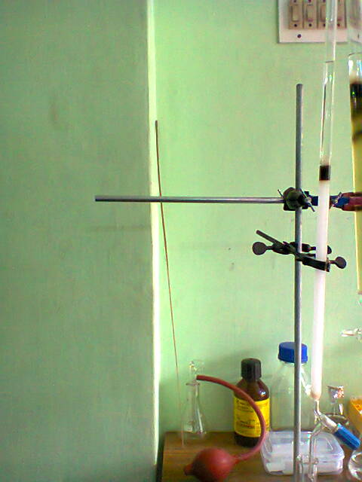
Figure 1 Isolation process using column chromatography
2.3 TLC PROFILE
Sample : 70 % Ethanol extract
Stationary phase : Silica gel 60 mesh
Mobile phase : Toluene: Ethyl acetate: Formic acid (9: 1: 0.5)
R_{f} value : 0.7
Detecting Agent : Vanillin in sulphuric acid
2.4 Chemical Test
- Test for triterpenoids: Take 1 ml of sample in a clean test tube to it add tin (one bit) and thionyl chloride. Presence of triterpenoids is indicated by presence of pink color.
- Liebermann Burchard Test: To the sample and add chloroform mix well.Then add acetic anhydride followed by sulphuric acid. Presence of terpenoids is indicated by presence of pink color

2.5 HPTLC analysis
It was carried out on a 10 x 10 cm pre activated silica gel 60GF 254 plate. Extract were applied to the plate as 6 mm wide band with an automatic TLC applicator Linomat. Densitometric scanning was carried out on CAMAG scanner. Prewashing of the plates were done by methanol and activation process was done at 60°C. Scanning speed was employed of 20 mm/s was employed. The mobile phase was fixed by running various solvent system (Toluene, toluene: ethyl acetate and ethyl acetate: methanol). Ascending development was carried out in(20 x 10 cm) twin glass chamber equilibrated with the mobile phase at 60°C ^{[3]} and represented in Table 1.

2.6 Chromatographic Condition

Standard | Ursolic acid (Sigma Aldrich, Chennai)
Stationary phase | Silica gel GF₂₅₄
Solvent system | CHCl3: CH3OH(9.5 : 0.5)
Derivatizing agent | 5 % sulphuric acid in methanol
Scanning wavelength | 510 nm
Sample concentration | Myxopyrum serratulum (50 mg/ml  Isolated compound (2 mg/ml)  Ursolic acid (0.1 mg/ml)
Development mode | Ascending mode
Table 1 Chromatographic condition of HPTLC

III. Results and Discussion
Terpenoids are the significant secondary metabolites with more than 30,000 recognized compounds including steroids ^{[4].} Terpenes have biological activities and are used to treat human ailments. Anticancer drug like Taxol & antimalarial drug like Artemisinin are the most recognized terpene-based drugs ^{[5]}

3.1 Examination of Isolated Compound
The 70 % ethanolic extract was subjected to column chromatography. From the collective fractions, a white powder was isolated and re-crystallized.
Description - White powder
Solvent system - Toluene: Ethyl acetate: Formic acid (9:1:0.5)
Detecting Agent - Vanillin-Sulphuric acid
Melting Point - 282-284ºC
R_{f} Value - 0.7

3.2 Characterization of the isolated compound
Characterization of isolated compound was done by using sophisticated techniques.
UV spectroscopy
Isolated sample was dissolved in methanol and scanned between 200-400 nm. Spectrum of the isolated sample was given in the Figure 2.

Infrared Spectroscopy
The isolated compound showed the following absorption peaks, 3434 cm⁻¹ which corresponds to OH stretching, 2931 & 1694 cm⁻¹ corresponds to carboxylic acid (carbonyl group), 2931 cm⁻¹ corresponds to CH (Str) Superimposed on OH (Str), 1385 cm⁻¹ corresponds to Gem dimethyl group C(CH₃)₂, 1043 cm⁻¹ corresponds to the C-O (Str), 1043 & 998 cm⁻¹ corresponds to C-OH band and 998 & 663 cm⁻¹ corresponds to OH (def) it is represented in Figure 3.

Nuclear Magnetic Resonance Spectroscopy (NMR)
¹H NMR : δ 5.13 (t, J=3.5Hz, 1 H), 4.36 (t, J=5 Hz, 1 H), 4.30 (d, J=5.5 Hz, 1 H), 3.47-3.39 (m, 1 H), 3.02-2.98 (m, 1 H), 2.11 (d, J= 11Hz, 1H), 1.92 (qd, J=13, 4.5Hz, 1H), 1.89-1.77 (m, 3 H), 1.60-1.43 (m, 10 H), 1.34-1.25 (m, 4 H), 1.08-0.99 (m, 5 H), 0.95-0.87 (m, 11 H), 0.82 (d, J=6.5Hz 1 H), 0.75 (s, 3 H), 0.68 (s, 3 H) represented in Figure 4
¹H NMR spectrum of the sample showed one proton broad signal at δ 5.12 assigned to Vinylic proton. One proton singlet at δ 2.5 attributed to OH of COOH. One proton doublet at δ 2.1 represents the presence of hydroxyl group. The signals below indicate the presence of 7 methyl protons in the structure.

¹³C-NMR : δ ppm: 178.99 (C-28); 138.58 (C-13); 125.21 (C-12); 77.31 (C-3); 55.24 (C-5); 52.84 (C-18); 47.48 (C-9); 47.29 (C-17); 42.11 (C-14); 40.47 (C-8); 39.97 (C-20); 39.81 (C-19); 39.64 (C-4); 39.56 (C-1); 38.70 (C-10); 36.99 (C-22); 33.17 (C-15); 30.65 (C-7); 28.72 (C-23); 28.00 (C-21); 2745 (C-2); 24.36 (C-11); 23.73 (C-27); 23.33 (C-16); 21.53 (C-30); 18.47 (C-6); 17.47 (C-29); 17.38 (C-24); 16.54 (C-25); 15.68 (C-26)

In ¹³C-NMR, a peak at δ 178.99 attributed to carboxylic group at the position C-28. The chemical shift value at δ 125.21 and δ 138.58 represented resonance olefinic carbons in C-12 and C-13. The chemical shift value at δ 77.31 represented carbinol carbon in the structure (Figure 5).

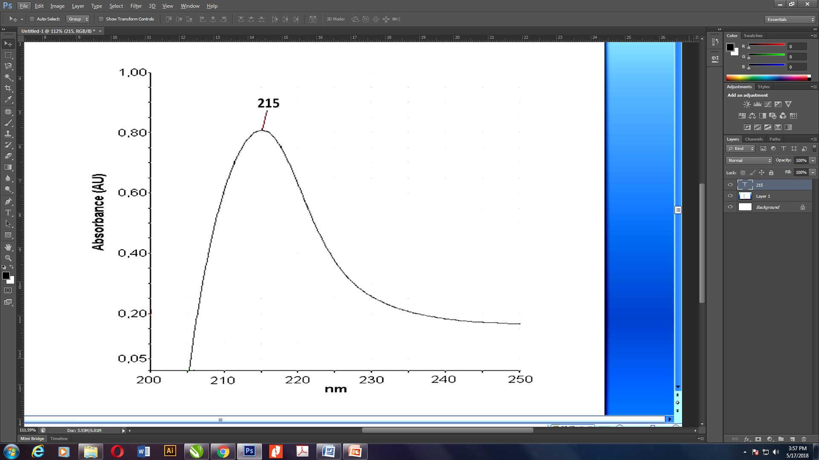
Figure 2 UV Spectra of isolated 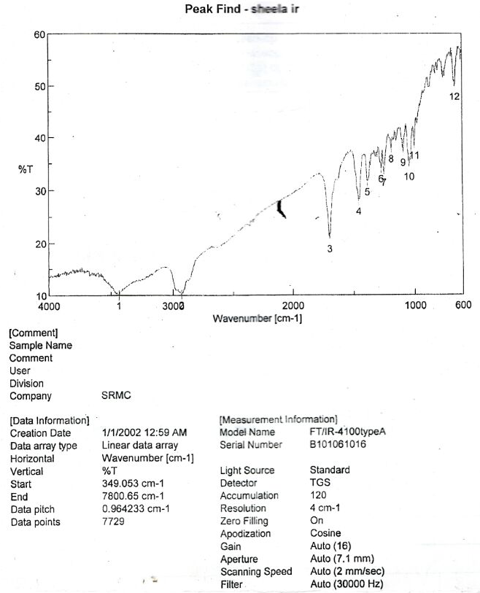
Figure 3 IR Spectra of Isolated Compound

WAVE NUMBER (cm⁻¹) | FUNCTIONAL GROUP
3434 | OH (Str)
2931 & 1694 | Carboxylic acid(carbonyl group)
2931 | CH (Str) Superimposed on OH (Str)
1385 | Gem dimethyl group, C(CH₃)₂
1043 | C-O (Str)
1043 & 998 | C-OH Band
998 & 663 | OH (def)

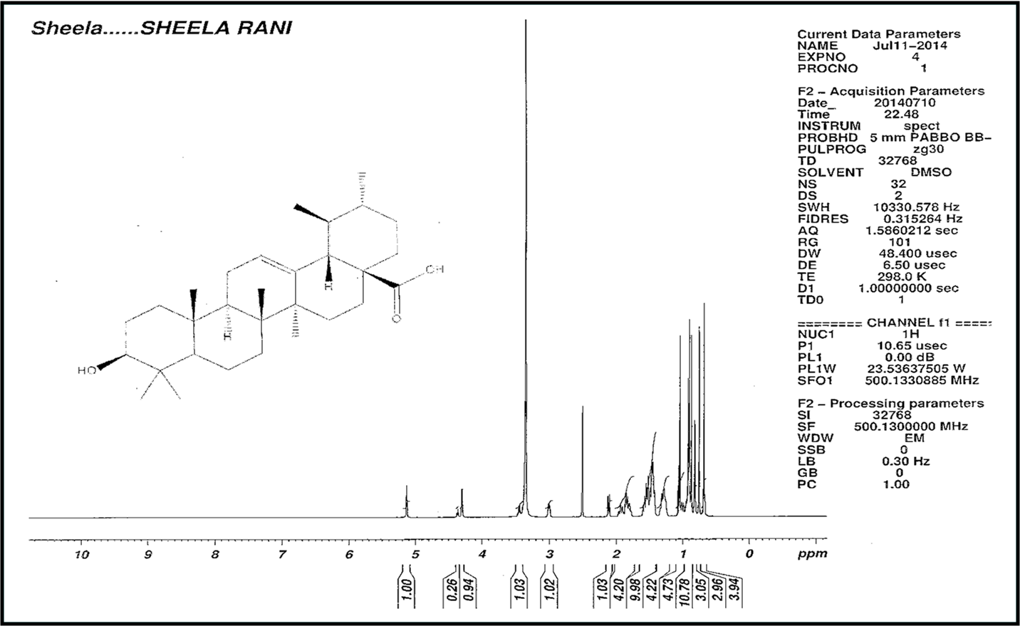
Figure 4 ¹H NMR of Isolated Compound

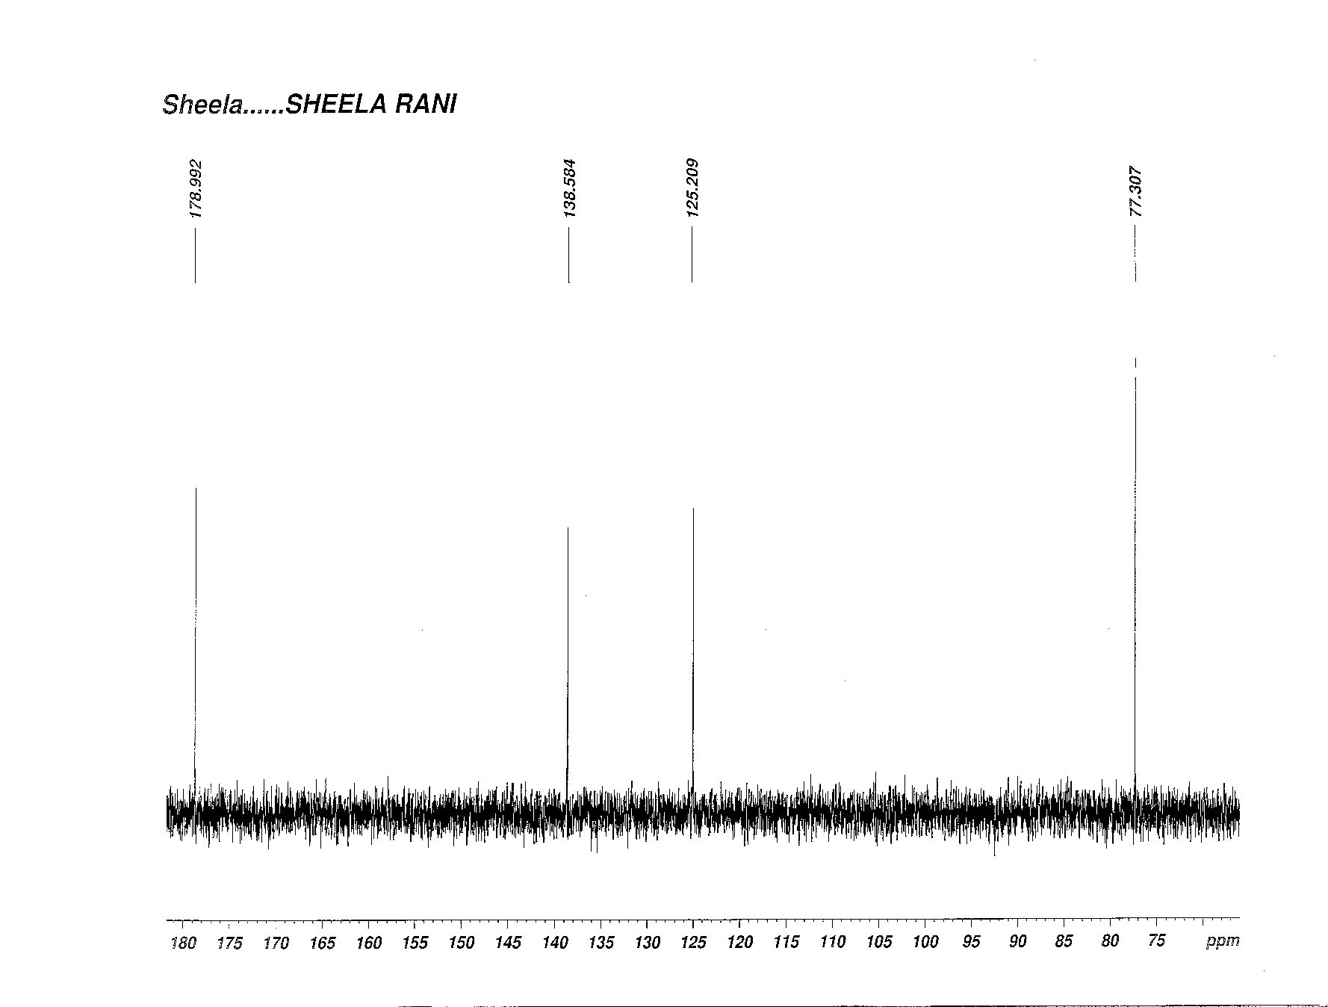
Figure 5 ¹³C NMR of Isolated Compound

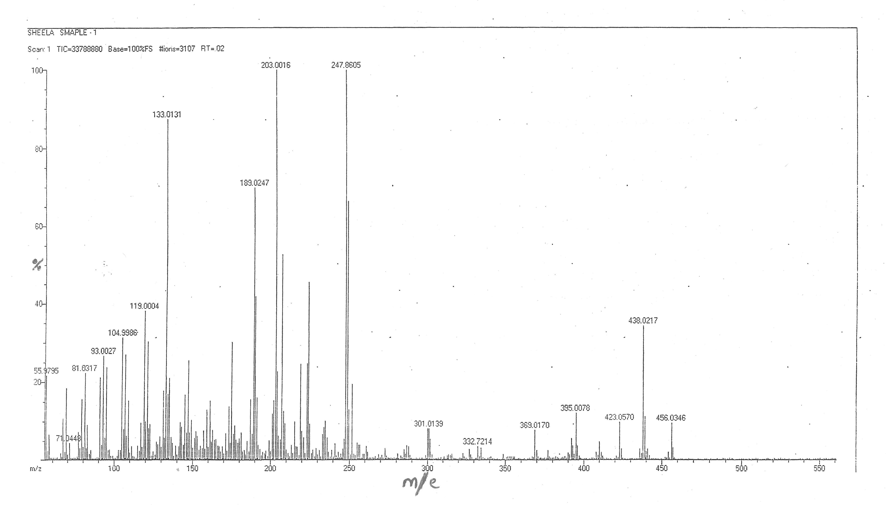
Figure 6 Mass Spectra of Isolated Compound

Mass spectrometry
Mass spectra of isolated sample was shown in Figure 6. Mass spectrum showed the M+ peak at m/e 456.03 that corresponds to molecular formula C₃₀H₄₈O₃ and fragmented peaks at 438.02, 423.05, 247.86, 203.00, 189.02 and 133.01.
Structure of isolated constituent was found out by spectroscopic techniques. Characterization indicates that the compound is a pentacyclic triterpenoid, Ursolic acid.

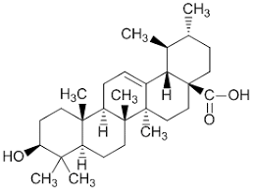
Figure 7 Structure of Isolated Compound -Ursolic acid
Molecular Formula : C₃₀ H₄₈ O₃
IUPAC NAME : 3β-Hydroxy-urs-12-ene-28-oic acid.

HPTLC finger printing of standard, isolated compound and extract
HPTLC finger print of Ursolic acid was taken and the R_{f} value was found to be 0.4. Similarly the HPTLC finger print of 70 % ethanolic extract & isolated sample were taken. The chromatogram of 70 % ethanolic extract showed 8 peaks in the range of R_{f} value 0.12 to 0.76. Among the peaks the 6th peak with R_{f} value of 0.4 with percentage area of 69.3 confirms the occurrence of Ursolic acid in ethanolic extract.
HPTLC finger print of isolated sample showed 4 peaks with the range of R_{f} values from 0.16 to 0.77. Among the peaks the 3rd peak at R_{f} value 0.42 corresponds to the standard Ursolic acid (R_{f} value - 0.4) with percentage area of 86.55. It confirmed that the isolated compound is Ursolic acid (Table 2).

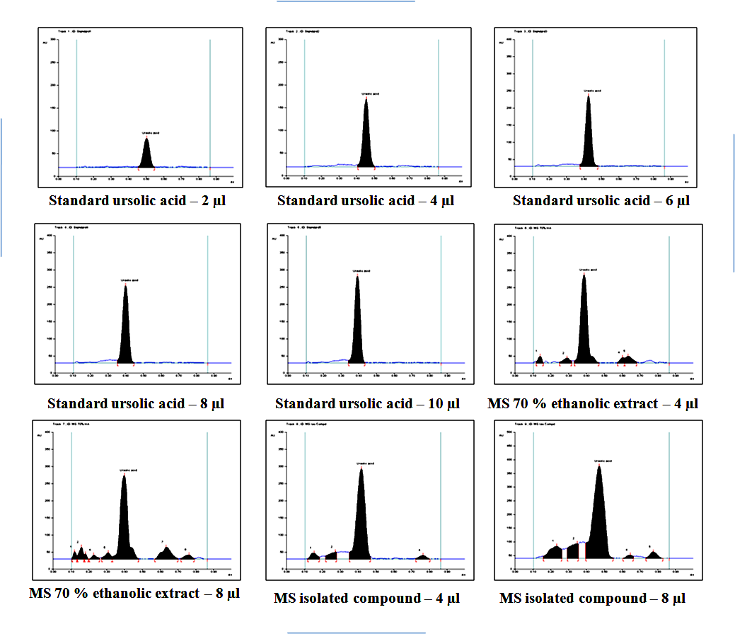

Figure 8 HPTLC chromatogram of standard, isolated compound and extract

Track | Peak | Start  R_{f} | Start  Height | Max R_{f} | Max  Height | Height % | End R_{f} | End  Height | Area | Area %
4 | 1 | 0.35 | 7.9 | 0.4 | 225.1 | 100 | 0.45 | 0.4 | 6770.7 | 100
7 | 6 | 0.33 | 6.5 | 0.4 | 243.9 | 62.5 | 0.48 | 1 | 9322 | 69.3
8 | 3 | 0.35 | 19.6 | 0.42 | 263.7 | 84.5 | 0.47 | 7 | 11087.6 | 86.55

Table 2 HPTLC profile of extract and isolated compound

IV. Conclusion

Isolation of phytoconstituents was done in ethanolic extract using column and they found to have significant pharmacological activity when compared to other extracts . Spectral studies confirmed that the isolated constituent is Ursolic acid. Ursolic acid is a pentacyclic terpene compound that has various pharmacological activities such as anti-inflammatory ^{[6,7]} antitumor ^{[8,9]} antioxidant ^{[10]} hypoglycemic, antiulcer and anti-lipidemic activity.

Ursolic acid was reported to be isolated from various plants including Malus domestica^{[11],} Ocimum sanctum ^{[12],} Diospyros melanoxylon, Vitex negundo^{[13],} Cornus officinalis ^{[14 ]} and Thymus vulgaris ^{[15]}

Isolation of Ursolic acid and characterisation by spectral studies is the significant outcome of this work.

References
[1] McCurdy CR, Scully SS. Analgesic substances derived from natural products (natureceuticals). Life Sciences. 2005 Dec 22;78(5):476-84.
[2] Dayan FE, Duke SO. Biological activity of allelochemicals. Plant-derived natural products: synthesis, function, and application. 2009:361-84.
[3] Rai S, Mukherjee K, Mal M, Wahile A, Saha BP, Mukherjee PK. Determination of 6‐gingerol in ginger (Zingiber officinale) using high‐performance thin‐layer chromatography. Journal of separation science. 2006 Oct;29(15):2292-5
[4] Wang G, Tang W, Bidigare RR. Terpenoids as therapeutic drugs and pharmaceutical agents. Natural products: drug discovery and therapeutic medicine. 2005:197-227.
[5]Çitoğlu GS, Acıkara ÖB. Column chromatography for terpenoids and flavonoids. Chromatography and its applications: INTECH Rijeka. 2012 Mar 16:13-49
[6] Safayhi H, Sailer ER. Anti-inflammatory actions of pentacyclic triterpenes. Planta medica. 1997 Dec;63(06):487-93.
[7] Baricevic D, Sosa S, Della Loggia R, Tubaro A, Simonovska B, Krasna A, Zupancic A. Topical anti-inflammatory activity of Salvia officinalis L. leaves: the relevance of ursolic acid. Journal of ethnopharmacology. 2001 May 1;75(2-3):125-32.
[8] Tu HY, Huang AM, Wei BL, Gan KH, Hour TC, Yang SC, Pu YS, Lin CN. Ursolic acid derivatives induce cell cycle arrest and apoptosis in NTUB1 cells associated with reactive oxygen species. Bioorganic & medicinal chemistry. 2009 Oct 15;17(20):7265-74.
[9] Yamaguchi H, Noshita T, Kidachi Y, Umetsu H, Hayashi M, Komiyama K, Funayama S, Ryoyama K. Isolation of ursolic acid from apple peels and its specific efficacy as a potent antitumor agent. Journal of Health Science. 2008;54(6):654-60.
[10] Saraswat B, Visen PK, Agarwal DP. Ursolic acid isolated from Eucalyptus tereticornis protects against ethanoltoxicity in isolated rat hepatocytes. Phytotherapy Research. 2000 May;14(3):163-6.
[11] Frighetto RT, Welendorf RM, Nigro EN, Frighetto N, Siani AC. Isolation of ursolic acid from apple peels by high speed counter-current chromatography. Food Chemistry. 2008 Jan 15;106(2):767-71.
[12] Vetal MD, Lade VG, Rathod VK. Extraction of ursolic acid from Ocimum sanctum leaves: Kinetics and modeling. Food and bioproducts processing. 2012 Oct 1;90(4):793-8.
[13]Chandramu C, Manohar RD, Krupadanam DG, Dashavantha RV. Isolation, characterization and biological activity of betulinic acid and ursolic acid from Vitex negundo L. Phytotherapy Research: An International Journal Devoted to Pharmacological and Toxicological Evaluation of Natural Product Derivatives. 2003 Feb;17(2):129-34.
[14] Jang SE, Jeong JJ, Hyam SR, Han MJ, Kim DH. Ursolic acid isolated from the seed of Cornus officinalis ameliorates colitis in mice by inhibiting the binding of lipopolysaccharide to Toll-like receptor 4 on macrophages. Journal of agricultural and food chemistry. 2014 Oct 8;62(40):9711-21.
[15] Rowe EJ, Orr JE, Uhl AH, Parks LM. Isolation of oleanolic acid and ursolic acid from Thymus vulgaris, L. Journal of the American Pharmaceutical Association (Scientific ed.)1949 Mar 1;38(3):122-4.

