SAP – LAP ANALYSIS
Er.Ramkumar. R¹, Er.P Prajeeth², Dr.B.Ravinder³
1,2 QSCM NICMAR, 3 Associate professor NICMAR
1,2 ramkumarravi@yahoo.com
3 bravinder@nicmar.ac.in

ABSTRACT
A research is conducted to know more strategies which can be adopted for increasing the core competency of an organization in global. The methodology adopted is Situations, Actors, and Processes - Learning, Action, and Performance (SAP-LAP) framework. In the competitive industrial environment the situations are changing very fast so the actors must be flexible enough to change the process in bringing out new and improved products with new features at competitive rates. By adopting new technologies, an ideal footprint is paved in this research. In SAP-LAP framework those situations in which there are resources of learning has been identified. The roles played by different actors in each situation have been described. The learning issues in each situation has been outlined, possible actions has been suggested and the performance is monitored. The above method is implemented in the case studies and the results are discussed in the findings.
1. INTRODUCTION:
Globalization has brought increased pressure on Indian manufacturing Small, Medium Enterprises to continually reduce prices against a backdrop of improving quality and service. Other major challenges for Small, Medium Enterprises are to continuously provide innovative and customized products using the best available process technologies, reducing delivery lead time and product life cycle etc. improvements in competitor’s capabilities have elevated product complexity and expanded accessibility to new technical breakthroughs.
In this project we have discussed the Supply Chain Management implementation in Small and Medium Enterprises in construction industry by using SAP – LAP analysis.
A Situation-Actor-Process (SAP)-Learning-Action-Performance (LAP) model has been applied for this case study. The situation represents the present scenario of the organization. Actors are the participants, influencing the situation to evolve different business processes. Based on SAP, various learning issues have been analyzed which will help in identifying suitable action for improving the performance.
1.1 METHODLOGY:
A case study has been developed by collecting data from primary and secondary sources. Primary data and information have been collected, mainly through semi structured interviews of the concerned managers in each department. Secondary information has been collected through published sources.
The SAP–LAP methodology (Sushil, 2000)¹ is used to analyze supply chain issues in manufacturing sector in this study. It does in-depth study of an organization and there is interplay between SAP and LAP. A framework of SAP-LAP is shown in Figure 1.

Interplay of SAP - LAP
P: Process
(Overall Transformation)
L: Learning
(Learning issues about SAP)
Strategy, Structure & systems
Climate & culture
A: Actor
(People, Tasks)

Response to change

S: Situation (External & internal environment, Performance)

P: Performance
(Effectiveness of improved SAP)
A: Action
(As per learning act on SAP)

Figure 1: SAP-LAP framework
It considers three basic entities in any management context, viz., situation, actor and process. A situation is to be dealt with by an actor or a set of actors via a process or a set of processes. Out of the three basic entities, the freedom of choice exists with the actor, who can be an individual, a group, a department, or the whole organization.
Depending up on the context, the relevant actors need to be identified. The situation for different actors can be different. What is a process for an actor can be situation for the other actor or vice versa. For example, execution of a project will be a process for the project manager, whereas it can be the situation in the light of which the top management will formulate the strategies. The freedom of choice provided by the situation to the actor is termed as “external flexibility”, which varies from organization to organization.
An interplay of situation, actor and process (SAP) leads to learning, action and performance (LAP). Rather than the traditional management syndrome of planning, organizing and controlling the flexible systems management works through a dynamic interplay of learning, action and performance. In any managerial inquiry the insight or learning is gained about the situation, actor and the process. The learning obtained would direct the possible actions to be taken for handling the impending situation, which will result into the performance of the system.
The feedback from the performance will on the one hand provide additional learning, whereas on the other hand it will identify the control actions that need to be taken. With new learning’s and actions the situation, actor and process might change to a new level. Such a dynamic interplay of SAP and LAP will act as the basis of ongoing managerial inquiry.
The SAP-LAP synthesizes the analytical as well as synthetic modes of system inquiry. In an analytic mode the whole is divided into parts (analysis), which are then synthesized back in the whole. This answers the question on how the system works. On the other hand, the synthetic mode of inquiry tries to answer the question of why a system should exist or what is its purpose.
2 CASE I: xxx Limited – Concrete Product Division:
In this case study we will be discussing the SAP – LAP analysis done by xxx Limited– Concrete Product Division (Company name changed) with conventional manufacturing of the following elements. (i) Concrete poles and (ii) Telecom towers.
2.1 CONCRETE POLE:
a) SITUATION:
The demand for Pre-cast/Reinforced concrete-cement (PCC) poles directly depends on the growth of electric power sector. These poles are solely meant for overhead transmission and distribution of power to consumer units. As the electricity generation increases, there will be the need to expand & re-strengthen the distribution network. This new challenge will call for fresh supplies for transmission towers, PCC poles & other materials. India is a developing country where availability of infrastructural facilities is of paramount importance for rapid development of national economy & general status. A large network of electricity distribution for rural electrifications, agricultural & irrigational consumptions can be catered to only by establishing an efficient generation & distribution standards. Electrical transmission towers, steel poles and PCC poles serve the base for overhead power transmission & distribution. All the existing transmission grids are either in a bad condition or inefficient. These networks require renovation. Their energy carrying capacities can't be increased unless & until those are replaced by a new transmission line. Then, there is the need to reach electrical light/power to all those areas where presently this facility is missing. All these factors are essentially going to raise the demand for not only electrical equipment’s but also distribution materials including poles.
b) ACTORS:
- Manchukonda Prakasham Industries India Private Limited, Punjagutta, Hyderabad, Telangana – Manufacturing of flat Concrete Poles for Power Transmission.
- XXX Limited – Concrete Product Division, Laxmapur Road, Aliabad Village, Shameerpet Mandal, Rangareddy Dist, and Hyderabad. – Manufacturing of Precast Pre-stressed Spun Concrete Poles for Power Transmission.
c) PROCESS:
P.C.C. Poles (as shown in Figure 3) are essentially made of concrete which are inevitably less costly and more economically maintainable than the conventional steel poles. They are of two types depending upon the end use of the pole-Low tensile and High Tensile Line. The latter is primarily used for transmission of electricity. Precast Cement Concrete Poles are essentially made of concrete. High tensile steel is placed into the pre-designed moulds. Galvanized wire is fixed inside the mould for earthing following which a right proportion of concrete mix is poured. Then, the concrete is compacted through vibration to produce high strength concrete poles. After 72 hours, the demoulding is done and the poles are put under water sprinkler system for a period of 28 days.
(Concrete cubes are tested to ascertain the strength before they are offered for inspection)
d) LEARNING:
As the conventional flat PCC poles doesn’t have good stability against high winds during cyclone (especially in coastal areas) XXX Limited – Concrete Products Division offers state-of-the-art technology Precast Pre-stressed Spun Concrete Poles (as shown in Figure 4) for Power Transmission.
e) ACTION:
XXX Limited – Concrete Products Division produces spun concrete transmission poles that offer best utility and value for money. Spun Concrete Transmission Pole is the result of technological expertise using centrifugal casting and spinning to produce a dense, durable concrete, slender & elegant Spun Poles.
Spun Concrete Poles is an excellent option for Wind Energy projects due to its circular form and absence of edges/angles, the magnitude of wind forces acting on it is less than on rectangular pole for the same projected area and wind forces are diffused because of circular structure. These poles are available in the height of 11-13Mtr single segment, hence can be used for double & triple circuit also. The applications of spun concrete poles (as shown in Figure 2) of various heights are given in the Table.1
TABLE 1: APPLICATIONS OF SPUN CONCRETE POLES OF VARIOUS HEIGHTS
S.No. | Length (m) | Application | Top End Diameter(mm) | Bottom End Diameter(mm)
1 | 11 | Street Lighting | 160 | 307
2 | 11 | 11/33 KV Lines | 190 | 337
3 | 11 | 11/33 KV Lines | 230 | 377
4 | 12 | 11/33 KV Lines | 190 | 350
5 | 12.5 | 11/33 KV Lines | 190 | 357
6 | 12.9 | 33 KV Lines | 190 | 362
7 | 13 | 33 KV Lines | 230 | 404
8 | 13 | 33 KV Lines | 250 | 424

Length

Bottom End Diameter
Top End Diameter
Figure 2: Spun Concrete Pole Sketch

f) PERFORMANCE:
The following are some superior features of Concrete Spun Poles over the flat PCC poles.
- Cost Saving.
- Easy Availability.
- Pilferage proof.
- Maintenance free.
- Easy to Handle & Transportation.
- Stronger & uniform.
- Better Aesthetic.
- Equal strength in all directions.
- Stay anchors are considerably reduced.
The cost of manufacturing of Spun Concrete poles will be Rs. 8,000 – 22,000 (rates are specified by Mr. Phanikumar, Operation Manager, XXX Limited) for sizes varying from 9m to 30 m whereas the cost of manufacturing of flat PCC poles will be Rs. 2,000 – 4,000. Even though the cost of spun concrete poles is costlier they are more durable, has good stability against high winds and no maintenance is required after the installation is done but the flat PCC poles are less durable, has poor stability against high winds, it has to be replaced frequently when the damage occurs. A SAP – LAP model has been developed as shown in Figure 5.
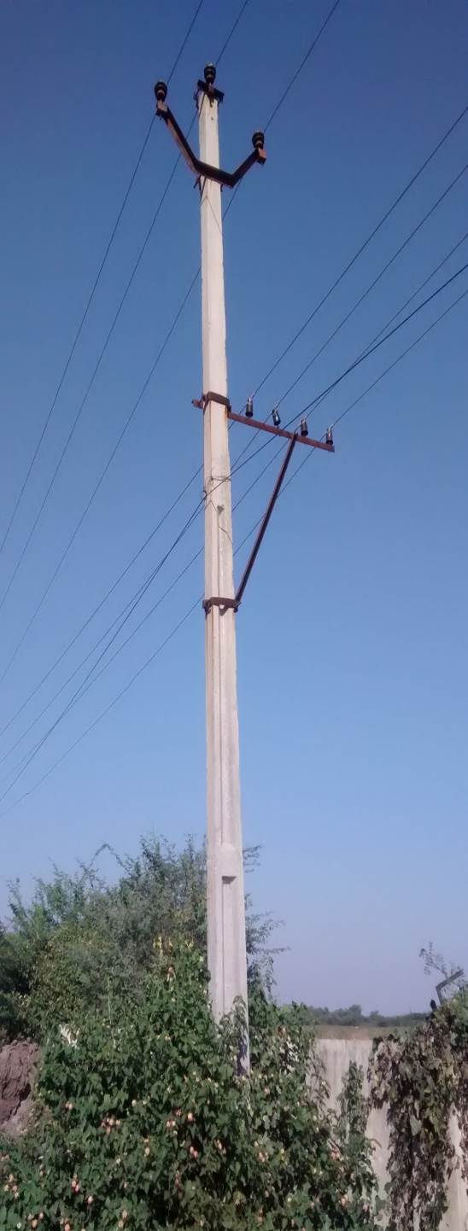 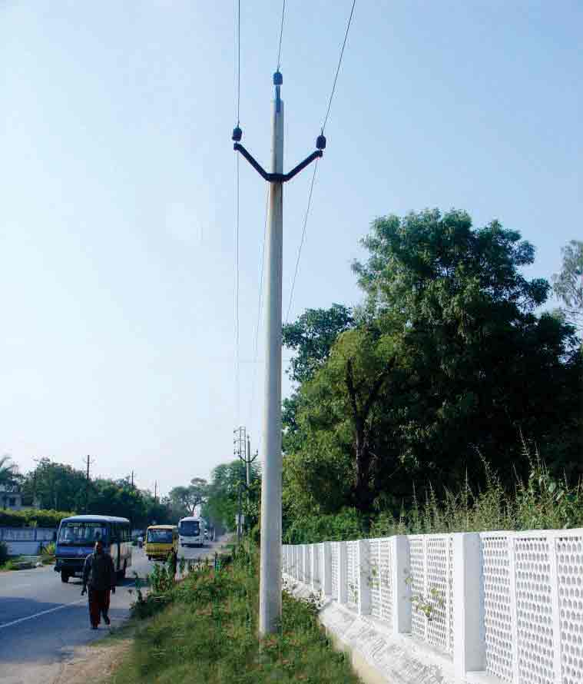 Figure 3: Flat Concrete Pole Figure 4: Spun Concrete Pole

SIUTATION:
The demand for Pre-cast/Reinforced concrete-cement (PCC) poles is high.
Infrastructural facilities are of paramount importance for rapid development of national economy.
All the existing transmission grids are either in a bad condition or inefficient.
These networks require renovation.
These factors are essential for raising demand in distribution materials including poles.
ACTORS:
Manchukonda Prakasham Industries India Private Limited, Punjagutta, Hyderabad, Telangana – Manufacturing of flat Concrete Poles for Power Transmission.
XXX Ltd – Concrete Product Division, Laxmapur Road, Aliabad Village, Shameerpet Mandal, Rangareddy Dist, and Hyderabad. – Manufacturing of Precast Pre-stressed Spun Concrete Poles for Power Transmission.

PROCESS:
P.C.C. Poles are essentially made of concrete.
They are of two types depending upon the end use of the pole-Low tensile and High Tensile Line.
The latter is primarily used for transmission of electricity.
High tensile steel is placed into the pre-designed moulds.
Galvanized wire is fixed inside the mould for earthing following which a right proportion of concrete mix is poured.
Then, the concrete is compacted through vibration to produce high strength concrete poles.
After 72 hours, the demoulding is done and the poles are put under water sprinkler system for a period of 28 days.
LEARNING:
As the conventional flat PCC poles doesn’t have good stability against high winds during cyclone (especially in coastal areas)

Hyderabad Batteries Ltd offers state-of-the-art technology Precast Pre-stressed Spun Concrete Poles for Power Transmission.

ACTION:
XXX Limited produces spun concrete transmission poles that offer best utility and value for money.
Spun Concrete Transmission Pole is the result of technological expertise using centrifugal casting and spinning to produce a dense, durable concrete, slender & elegant Spun Poles.
Spun Concrete Poles is an excellent option for Wind Energy projects due to its circular form and absence of edges/angles.
The magnitude of wind forces acting on it is less than on rectangular pole for the same projected area and wind forces are diffused because of circular structure.

PERFORMANCE:
The following are some superior features of Concrete Spun Poles over the flat PCC poles. Cost Saving, Easy Availability, Pilferage proof, Maintenance free, Easy to Handle & Transportation, Stronger & uniform, Better Aesthetic, Equal strength in all directions, Stay anchors are considerably reduced. The cost of manufacturing of Spun Concrete poles will be Rs. 8,000 – 22,000 for sizes varying from 9m to 30 m whereas the cost of manufacturing of flat PCC poles will be Rs.2, 000 – 4,000.

Even though the cost of spun concrete poles is costlier they are more durable, has good stability against high winds and no maintenance is required after the installation is done but the flat PCC poles are less durable, has poor stability against high winds, it has to be replaced frequently when the damage occurs.

Figure 5: SAP – LAP Model for Concrete Poles
2.2 TELECOM TOWERS:

a) SITUATION:
Telecommunication towers are used for communication purposes among people. All the wireless communication, mobile networking, radio broadcasting and television antennas are connected via these towers. A full telecommunication tower is a whole set of mechanical structures and electronic signal processing unit which is used to connect people via telecommunications. All the telephone lines and mobile phone services are connected through these towers. These towers are also used for radar system and other armed forces purposes. Different heights of towers are used in different places and purposes. They can vary from 15 to 60 meters and sometime more if required. For example in the land areas towers are higher in hill area so 15 to 30 meters high towers can be used but in land areas they are 30 to 60 meters in height. There are different types of the telecommunication towers which are used i.e. monopole, self-supporting and guyed etc. The most used are the self-supporting towers in the field of telecommunication. Telecommunication towers are manufactured in the factory and later erected on the site area. A tower takes up to two weeks to be completed and sometime even more, depends on the site and the height of the telecommunication towers.
b) ACTORS:
- Savitek Engineering Private Limited, Bollarum, Hyderabad, Telangana – Manufacturing of Steel Telecom Towers.
- XXX Limited – Concrete Product Division, Laxmapur Road, Aliabad Village, Shameerpet Mandal, Rangareddy Dist, and Hyderabad. – Manufacturing of Precast Pre-stressed Spun Concrete Telecom Towers.
c) PROCESS:
The manufacturing processes of telecommunication towers can easily be understood by the following flow chart in figure 6.
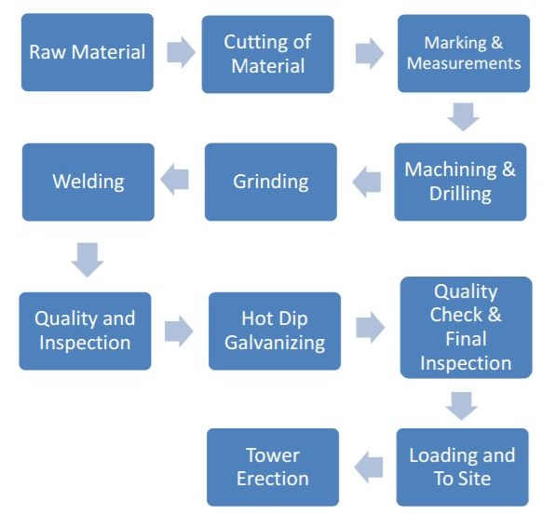
Figure 6: Flow Chart of manufacturing process of Telecom Towers
d) LEARNING:
The fabricated steel telecom towers (as shown in Figure 7) require more land area for installation and they are likely to get damaged during cyclones causing communication failure. In order to overcome this issue, XXX Limited has started manufacturing Spun Concrete Towers (as shown in Figure 8) for telecom industries. Spun Concrete Monopole is suitable for installations at Prime Locations to improve visual impacts and at locations with space constraints. Metro Cities, parks, even road dividers in city area and at highways can accommodate this tower easily. Long elevated flyways with- in the city area experiences major signal breaks during travelling through them, the reason could be the shortage of ground space. Monopole is the only solution for this problem for its requirement of extremely low ground space.

e) ACTION:
The Spun Concrete Towers are produced in varying length like 8m, 10m and 12m. Based on the requirement the pieces are connected by welding. It produces a tower of length 50m and customized length based on the client requirements. The design is carried out with reference to Indian Standard IS 875: 1987 (Part III) for telecom towers. The raw material required are cement, sand or /robo sand, coarse aggregate of 12mm and 20mm size which should have smooth edges and a customized type of steel which is specially manufactured and supplied by the steel manufacturing plants. The Micro silica is used as admixture to produce a grade of M50 concrete. SP430 is used as the retarder. The raw materials are mixed in the batching plants and the concrete is transported through conveyor into the manufacturing plant. The moulds are prepared and the reinforcement is placed inside the moulds and prestressed before placing the concrete. As soon as the concrete is poured the moulds are tightened with bolts and nuts and the moulds are transported to spinning machine where the moulds are spinned for a certain period of time to compact the concrete. Later the moulds are shifted to curing tanks. First the stream curing is done at 65⁰C for 6 – 8 hrs. Later the top cover slab of curing tank is kept opened for 2 – 3 hrs to bring done the temperature to 35⁰C – 25⁰C. Then the demoulding is done and the precast member is immersed into water curing tank for 3 - 7 days. Later the precast member is stacked at the yard. The top diameter ranges are 190mm, 160mm, 230mm, 250mm and 400mm. The bottom diameter varies with the slope of 13.5mm for top. The 1/6th of height of the tower is placed in foundation. The ends of each member would be fixed with circular steel plates which has a provision for bolting. While erecting the tower the plates are aligned and the jointing is done by welding through the perimeter. Spun Concrete towers have designed for varied usage such as:
- Telecom Towers.
- Radio Communication E.g., TETRA projects, installation of FM radio antennas etc.
- Disaster management - Installation of security equipment in high wind and cyclone prone areas.
- Electrical Transmission (132KV, 66KV lines).

f) PERFORMANCE - TELECOM TOWERS:
The following are some superior features of Concrete Spun telecom towers over the fabricated steel towers.
- Extremely slender and sleek design.
- Cost Effective & Pilferage Proof.
- Occupies much less ground space (Bottom dia. 1.2Mtr).
- Easy to Erect & Install in a very short span of time.
- Extremely durable with a very long life (No corrosion, No Chemical reaction, No deterioration). There is virtually no degradation even in the most severe weather conditions & long lasting.
- Completely maintenance frees.
- Much better wind withstands capacity.
- Suitable for Cyclone Prone Areas (withstand high gale and wind loads).
- Eco Friendly, Aesthetic and can be tailored to meet the specific application.
- Solar panels can also be installed on tower to generate renewable energy.
- Meets all safety Standards/ requirements.
- Camouflaging best suited.
- Proven Technology world over.
The cost of manufacturing of Spun Concrete telecom towers will be Rs. 8, 00,000 (rates are specified by Mr. Phanikumar, Operation Manager, XXX Limited) for length of 30 m whereas the cost of manufacturing of fabricated steel towers will be Rs.2, 00,000 – 4, 00,000. Even though the cost of spun concrete telecom towers is costlier they are more durable, has good stability against high winds, require less ground space and no maintenance is required after the installation is done but the fabricated steel towers has poor stability against high winds, and if any damage occurs to the telecom towers, there will be a huge communication failure which causes inconvenience to the people. A SAP – LAP model has been developed as shown in Figure 9.
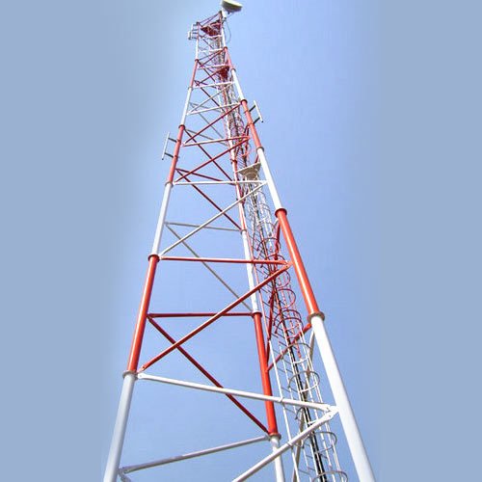 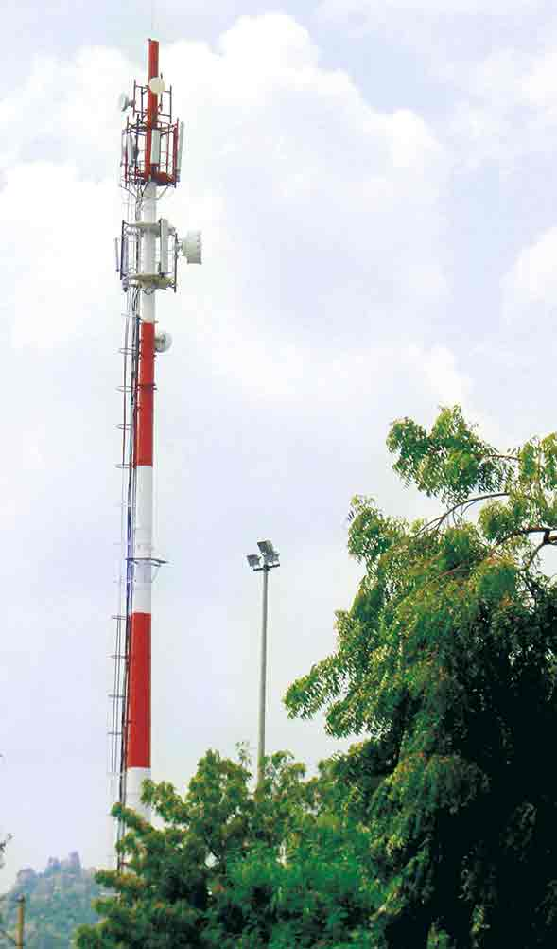 Figure 7: Fabricated Steel Tower Figure 8: Spun Concrete Tower

Figure 9: SAP – LAP Model for Concrete Tower
SIUTATION:

Telecommunication towers are used for communication purposes among people. All the telephone lines and mobile phone services are connected through these towers.
These towers are also used for radar system and other armed forces purposes. The most used are the self-supporting towers in the field of telecommunication.
Telecommunication towers are manufactured in the factory and later erected on the site area. A tower takes up to two weeks to be completed and sometime even more, depends on the site and the height of the telecommunication towers.
ACTORS:
Savitek Engineering Private Limited, Bollarum, Hyderabad, Telangana – Manufacturing of Steel Telecom Towers.

XXX Ltd– Concrete Product Division, Laxmapur Road, Aliabad Village, Shameerpet Mandal, Rangareddy Dist, and Hyderabad. – Manufacturing of Precast Pre-stressed Spun Concrete Telecom Towers.

PROCESS:
The raw material used for manufacturing of self-supported telecommunication towers are steel angle bars.
The first operation of manufacturing is cutting of angle bars that are done with the presses.
When marking is finished, the marks are ready and points are located the holes in angle parts need to be done by drilling process. Grinding process is done after the cutting and drilling process. The next process is Hot Dip Galvanizing.
The last process after Hot Dip Galvanizing and before sending it to storage is quality check and final inspection where all the galvanized parts of tower are finally inspected by QC department. The last operation after manufacturing is erection of towers. The foundation consists of concrete works as base of tower. Heavy cranes are used for the handling the tower members in the erection process.
LEARNING:
The fabricated steel telecom towers require more land area for installation and they are likely to get damaged during cyclones causing communication failure. In order to overcome this issue, XXX Ltd has started manufacturing Spun Concrete Towers for telecom industries.
Spun Concrete Monopole is suitable for installations at Prime Locations to improve visual impacts and at locations with space constraints.
ACTION:
The Spun Concrete Towers are produced in varying length like 8m, 10m and 12m. Based on the requirement the pieces are connected by welding. It produces a tower of length 50m and customized length based on the client requirements.
The top diameter ranges are 190mm, 160mm, 230mm, 250mm and 400mm. The bottom diameter varies with the slope of 13.5mm for top. The 1/6th of height of the tower is placed in foundation. The ends of each member would be fixed with circular steel plates which has a provision for bolting. While erecting the tower the plates are aligned and the jointing is done by welding through the perimeter.
PERFORMANCE:
The following are some superior features of Concrete Spun Poles over the fabricated steel towers.
Extremely slender and sleek design, Cost Effective & Pilferage Proof, Occupies much less ground space (Bottom dia. 1.2Mtr), Easy to Erect & Install in a very short span of time, Extremely durable with a very long life (No corrosion, No Chemical reaction, No deterioration), There is virtually no degradation even in the most severe weather conditions & long lasting, Completely maintenance frees. The cost of manufacturing of Spun Concrete telecom towers will be Rs. 8, 00,000 for length of 30 m whereas the cost of manufacturing of fabricated steel towers will be Rs.2, 00,000 – 4, 00,000. Even though the cost of spun concrete telecom towers is costlier they are more durable, has good stability against high winds, require less ground space and no maintenance is required after the installation is done but the fabricated steel towers has poor stability against high winds, and if any damage occurs to the telecom towers, there will be a huge communication failure which causes inconvenience to the people.

3. CASE - II: Comparison of clay bricks and cement blocks, cement mortar plastering with Plaster of Paris punning and gypsum plastering.

a) SITUATION:
In this case study use of clay bricks (190*90*90 mm) for brick work and Cement Mortar (1:6) for walls in construction of a building is considered.

- Availability of Raw materials: Availability of clay bricks is difficult than cement bricks as for making clay bricks good quality of clay is required and for manufacturing cement bricks - 43 grade cement, robo sand with by product from crushing plant of size 4mm which are easily available are used.

- For cement mortar - cement, natural sand (to avoid shrinkage cracks) are required, Plaster of Paris is used after plastering to give good even and finishing surface before painting, so gypsum can replace both cement mortar plastering and POP punning for better finishing. Availability of natural sand is also difficult.

- Labor Requirement: Skilled and Un-skilled labors for block work masonry and plastering are required.

- Time involved: Manufacturing of clay bricks require more than 2 weeks, plastering with cement mortar including curing, finishing with Plaster of Paris requires 8 days.
Cost incurred: Each clay brick cost Rs.6.

b) ACTORS:
Employer, contractor, Clay Bricks, Cement bricks, Cement, Natural Sand, Robo sand, gypsum suppliers

c) PROCESS:
The processes identified are
- Manufacturing time of clay bricks.
- Deficiency of materials like clay, natural sand is studied
- Labor requirement for block work, plastering, finishing works
- Calculation of cost involved in using clay bricks and plastering & finishing with cement mortar & Plaster of Paris.
- The Rate Analysis for Cement Mortar (1:6) is given in Table 2.
- The Rate Analysis for Cement Mortar (1:3) is given in Table 3.
- The Rate Analysis for Clay Brickwork (1:6) is given in Table 4.
- The Rate Analysis for plastering works is given in Table 5.
- The Rate Analysis for POP punning is given in Table 6.
TABLE 2: RATE ANALYSIS FOR CEMENT MORTAR (1:6)
S.No | Description CM(1:6) | Units | Constant/Unit | Rate/Unit  (Rs) | Amount (Rs)
Materials
1 | Cement | Kg | 254.2 | 7.00 | 1779.40
2 | Sand | Kg | 1.096 | 2560.00 | 2805.76
3 | Water | Lit | 140 | 0.10 | 14.00
Total Cost for Cement Mortar (1:6) per Cum |  |  |  |  | 4599.16

TABLE 3: RATE ANALYSIS FOR CEMENT MORTAR (1:3)

S.No | Description CM(1:3) | Units | Constant/Unit | Rate/Unit  (Rs) | Amount (Rs)
Materials
1 | Cement | Kg | 493.03 | 7.00 | 3451.21
2 | Sand | Kg | 1.096 | 2560.00 | 2805.76
3 | Water | Lit | 140 | 0.10 | 14.00
Total Cost for Cement Mortar (1:3) per Cum |  |  |  |  | 6270.97
CLAY BRICK MASONRY:
TABLE 4: RATE ANALYSIS FOR CLAY BRICKWORK CM (1:6)
S.No. | Description | Units | Constant / Unit | Rate/Unit  (Rs) | Amount (Rs)
1 | Materials
a) | Bricks | Nos | 525 | 6.00 | 3150.00
b) | CM(1:6) | Cum | 0.229 | 4599.16 | 1053.21
2 | Labour
a) | Mason | Cum | 0.92 | 500.00 | 460.00
b) | Mazdoor | Cum | 1.81 | 350.00 | 633.50
c) | Bhisti | Cum | 0.20 | 330.00 | 66.00
Total Basic Cost (1+2) |  |  |  |  | 5362.71
Overhead Charges (2.5%) |  |  |  |  | 134.07
Establishment Charges (5%) |  |  |  |  | 268.14
Total Cost without profit |  |  |  |  | 5764.91
Profit (10%) |  |  |  |  | 576.49
Rate to be quoted for Clay Brickwork CM (1:6) per Cum |  |  |  |  | 6341.40

TABLE 5: RATE ANALYSIS OF PLASTERING TWO COATS (9+4) mm THICK:
S.No. | Description | Units | Constant / Unit | Rate/Unit(Rs) | Amount (Rs)
1 | Materials
a) | CM(1:6) – FIRST COAT | Cum / 10 Sqm | 0.133 | 4599.16 | 611.69
b) | CM(1:3) – SECOND COAT | Cum / 10 Sqm | 0.037 | 6270.97 | 232.03
2 | Labor
2.1 | First Coat
a) | Plasterer | 10 Sqm | 0.52 | 500.00 | 260.00
b) | Mazdoor | 10 Sqm | 0.92 | 350.00 | 322.00
c) | Bhisti | 10 Sqm | 0.4 | 330.00 | 132.00
2.2 | Second Coat
a) | Plasterer | 10 Sqm | 0.34 | 500.00 | 170.00
b) | Mazdoor | 10 Sqm | 0.74 | 350.00 | 259.00
c) | Bhisti | 10 Sqm | 0.2 | 330.00 | 66.00
Total Basic Cost (1+2) |  |  |  |  | 2052.72
Overhead Charges (2.5%) |  |  |  |  | 51.32
Establishment Charges (5%) |  |  |  |  | 102.64
Total Cost without profit |  |  |  |  | 2206.68
Profit (10%) |  |  |  |  | 220.67
Rate to be quoted for Plastering of Two Coats per 10 Sqm |  |  |  |  | 2427.35

TABLE 6: RATE ANALYSIS OF POP PUNNING WITH 20 MM THICKNESS:
S.No. | Description | Units | Constant / Unit | Rate/Unit(Rs) | Amount (Rs)
1 | Material
A | POP | Kgs | 1600 | 6.50 | 10400.00
B | Water | Lts | 283.2 | 0.10 | 28.32
2 | Labor
A | Plasterer | Sqm | 0.052 | 500.00 | 26.00
B | Mazdoor | Sqm | 0.092 | 350.00 | 32.20
C | Bhisti | Sqm | 0.04 | 330.00 | 13.20
Total Cost (1+2) |  |  |  |  | 10499.72
Overhead Charges (2.5%) |  |  |  |  | 262.49
Establishment Charges (5%) |  |  |  |  | 524.98
Total Cost without profit |  |  |  |  | 11287.19
Profit (10%) |  |  |  |  | 1128.72
Rate to be quoted for POP Punning with 20 mm Thickness per Sqm |  |  |  |  | 12415.91
d) LEARNING:

- Manufacturing of clay bricks takes more than 14 days but cement bricks can be used after 7 days from manufacturing.
- Clay bricks can be replaced with cement bricks of good quality and are easily available in market.
- Cement mortar plastering and finishing with Plaster of Paris can be replaced with gypsum plastering.
- No special labor is required for working with cement bricks or no special training is required for labors.
- Training should be given for labors for using gypsum like safety standards followed while doing gypsum works, mixing proportions.
- Comparison of cost of clay bricks with cement bricks and cement mortar plastering with gypsum plastering.
- The Rate Analysis for Cement Block Masonry (1:6) is given in Table 7.
- The Rate Analysis for Gypsum Plastering is given in Table 8.
- The details of the materials are given in Table 9.
- The Comparison of Clay Bricks and Cement Blocks are given in Table 10.

e) ACTIONS:
- Clay bricks are replaced with Cement blocks.
- Gypsum is used in place of cement mortar and POP finishing.
- Training is given for labors on how to use Gypsum in plastering.

f) PERFORMANCE:
- Time incurred in construction of brickwork using clay bricks is more than the time required in constructing wall with cement blocks.
- The cost incurred in cement block work is cheaper than clay brick work.
- Gypsum plastering comprising of gypsum powder and water comparatively is better than conventional plastering which comprises of cement and sand (robo sand).
- Gypsum plastering is cheaper than conventional cement mortar plastering.
- Cement and sand plaster is applied with level patches which do not ensure line & level surfaces and it requires minimum of 7 days of curing. If POP is used for leveling purpose it requires 3 days for complete drying.
- Gypsum plaster is applied within level strips which ensure line & level surfaces and it does not require curing. So gypsum plaster replaces two coat processes i.e., cement mortar plastering & POP punning with a single coat gypsum plaster.

CEMENT BLOCK MASONRY:
TABLE 7: RATE ANALYSIS OF BLOCK MASONRY (290mm*200mm*190mm)
[FULL BRICK WALLS]:
S.No. | Description | Unit | Constant / Unit | Rate/Unit(Rs.) | Amount (Rs.)
1 | Material
A | Bricks | Nos | 96 | 31.00 | 2914.00
B | CM(1:6) | Cum | 0.096 | 4599.16 | 441.52
2 | Labor
A | Mason | Cum | 1.48 | 500.00 | 740.00
B | Mazdoor | Cum | 2.18 | 350.00 | 763.00
Total Cost (1+2) |  |  |  |  | 4920.52
Overhead Charges (2.5%) |  |  |  |  | 123.01
Establishment Charges (5%) |  |  |  |  | 246.02
Total Cost without profit |  |  |  |  | 5289.55
Profit (10%) |  |  |  |  | 528.96
Rate to be quoted for Block masonry of per Cum |  |  |  |  | 5818.50
TABLE 8: RATE ANALYSIS OF GYPSUM PLASTERING WITH 20 MM THICKNESS:
S.No. | Description | Units | Constant / Unit | Rate/Unit(Rs) | Amount(Rs)
1 | Material
A | Gypsum | Kgs | 472 | 11.00 | 5192.00
B | Water | Lts | 283.2 | 0.10 | 28.32
2 | Labor
A | Plasterer | Sqm | 0.052 | 500.00 | 26.00
B | Mazdoor | Sqm | 0.092 | 350.00 | 32.20
C | Bhisti | Sqm | 0.04 | 330.00 | 13.20
Total Cost (1+2) |  |  |  |  | 5291.72
Overhead Charges (2.5%) |  |  |  |  | 132.29
Establishment Charges (5%) |  |  |  |  | 264.58
Total Cost without profit |  |  |  |  | 5688.60
Profit (10%) |  |  |  |  | 568.86
Rate to be quoted for gypsum plastering with 20 mm thickness per Sqm |  |  |  |  | 6257.46

TABLE 9: DETAILS OF GYPSUM MATERIAL:
Material name | Gyproc
Company | Saint-Gobain
Rate | 275 Rs/25Kgs
Coverage Area | 90 Sqm/1000 Kgs

TABLE 10: COMPARISON OF CLAY BRICKS AND CEMENT BLOCKS:
S.No | Parameter | Cement Blocks | Clay Bricks
1 | Size(mm) | 300*200*200 | 230*115*75
2 | Variations in  Dimensions | +/-2mm | +/-5mm
3 | Compressive Strength(Kg/cm²) | 25-35 | 25-30
4 | Fire Resistance | 4-5 Hrs | 2-3 Hrs
5 | Sound reduction (DB) | 37-42 depends on  thickness | 40
6 | Thermal conductivity  (w/mk) | 0.15-2.08 depends on thickness | 0.8
7 | Water absorption | Less than 20% | High
8 | Ageing | Gains strength with age | No
9 | Eco friendliness | Pollution Free, Low CO₂ releases | High

4. FINDINGS:
CASE I: XXX Limited – Concrete Product Division:
In this case study, the XXX Limited – Concreter Product Division has done a SAP – LAP analysis in the conventional manufacturing of Concrete poles and Telecommunication Towers and they have learned the possibilities of improvement which resulted them to start a Precast Spun concrete Poles and Spun Concrete Towers which has most performance than the conventional products.

CASE II: Comparison of cement blocks with gypsum plastering instead of clay bricks with cement mortar plastering and pop punning:

The total brick masonry work costed Rs. 6341.40 when clay bricks are used, it costed to Rs. 5818.50 by using cement blocks. So that Rs. 522.90 per cum can be saved if cement blocks are used rather than clay bricks. Similarly we have done comparison for costs of cement plastering with POP punning and gypsum plastering. It revealed that it costed Rs. 12658.65 per Sqm for cement mortar plastering with POP punning and it costed Rs. 6257.46 per Sqm for plastering with gypsum. So, Rs. 6401.18 per Sqm can be saved if gypsum is used for plastering instead of cement mortar and POP.

5. CONCLUSION:
While analyzing various situations it was evident that certain change management scheme could be implemented. By means of actor process matrix, quantification and SAP-LAP analysis clear and distinct results were formed.
From the case – I, we have understood how the XXX Limited – Concrete Product Division has studied the conventional manufacturing of transmission poles and telecommunication towers by implementing the SAP – LAP analysis and based on the analysis, they started to the manufacture the precast poles and piles which can be used as an alternate of conventional transmission poles and telecommunication towers.
From the case – III, we have understood the cost impact of replacing the conventional clay brick masonry, cement mortar plastering and POP punning with cement block masonry and gypsum plastering by implementing the SAP – LAP analysis. An equation has been arrived to get the cost savings by replacing the conventional clay brick masonry, cement mortar plastering and POP punning with cement block masonry and gypsum plastering for any quantity.
REFERENCES:

- Sushil, IIT New Delhi, SAP-LAP models of Inquiry, Management Decision (pg. no.:347-353)
- Ravinder Kumar, Rajesh K Singh, Ravi Shankar, Supply Chain Management Issues in an Indian SME: A Sap-Lap Analysis, Journal of Supply Chain Management Systems, Volume 1 Issue 2 April 2012.
- http://www.hbl.in/
- http://www.dudhigypsum.com/technological.php
- http://www.constructionweekonline.in/gypsum-plaster-a-solution-of-choice/

