A Contemporary Study on Influenza: The Most Common Infectious Disease
Chitra Bag
Assistant Professor
BMLT Department
The Neotia University, West Bengal, India

Introduction:
Influenza, one of the most common infectious diseases, is a highly contagious airborne disease that occurs in seasonal epidemics and manifests as an acute febrile illness with variable degrees of systemic symptoms, ranging from mild fatigue to respiratory failure and death. Influenza causes significant loss of workdays, human suffering, and mortality. Influenza is a communicable viral disease that affects the upper and lower respiratory tract[1]. A wide spectrum of influenza viruses causes it. Some of these viruses can infect humans, and some are specific to different species. These viruses are transmissible through respiratory droplets expelled from the mouth and respiratory system during coughing, talking, and sneezing. The influenza viruses can be transmitted by touching inanimate objects soiled with the virus and touching the nose or eye. Influenza can be transmitted before the patient is symptomatic and until 5 to 7 days after infection[3].

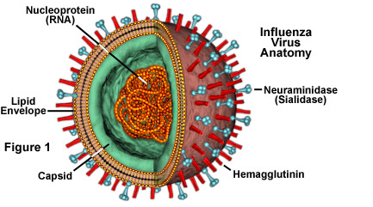

Fig1: Influenza Virus

Investigators in the Department of Molecular Virology and Microbiology (MVM) have been studying influenza for several decades, with an Influenza Research Center first established in 1974. A major focus of the work is directed towards the development and testing of influenza vaccines to find the most effective vaccination dosages, methods, and strategies to protect the population against this deadly disease[5]. Other projects involve studying the structure and function of important influenza proteins.
Previous Research :
Research is ongoing on both epidemic influenza (also referred to as seasonal or inter pandemic influenza) and pandemic influenza. Epidemic influenza occurs annually and is attributable to minor changes in genes that encode proteins on the surface of circulating influenza viruses. Pandemic influenza occurs when more significant changes in the influenza A virus arise as a result of the acquisition of genes from influenza viruses of other animal species by a human virus strain, thus creating a novel virus[7]. The latter carries a greater risk for the human population.
Notably, the department is home to the BCM Vaccine and Treatment Evaluation Unit (VTEU), one of nine federally funded centers in the nation established by the National Institute of Allergy and Infectious Diseases. It was previously led by Dr. Wendy Keitel and is currently under the direction of Dr. Hana El-Sahly. The VTEU network conducts clinical trials that evaluate vaccines and treatments for a wide array of infectious diseases. An important strength of this established network is that it is able to efficiently and safely test new vaccines within a rapid time frame[9].
The VTEU research group in the department has been involved in important studies that led to the licensure of live attenuated and high dose inactivated influenza virus vaccines. They have tested vaccines to seasonal influenza and they have performed many studies evaluating vaccines targeting pandemic influenza, including the swine-origin H1N1, and the H5N1, H9N2, and H7N9 viruses, among others[10]. They have evaluated methods to improve vaccine immunogenicity, including delivery of vaccine by different routes of administration, different dosages, and with different adjuvant preparations.
Researchers involved in these studies include Drs. Robert Atmar, Robert Couch, Hana El Sahly, Paul Glezen, Wendy Keitel, Innocent Mbawuike, Flor Munoz-Rivas, Shital Patel, and Pedro (Tony) Piedra. Their hope is that the results of these studies will identify the optimal and most effective dosages of vaccine to protect the public from seasonal influenza, as well as from a possible influenza pandemic.
Flu (influenza) is an infection of the nose, throat and lungs, which are part of the respiratory system. Influenza is commonly called the flu, but it's not the same as stomach "flu" viruses that cause diarrhea and vomiting[11].
Preliminary in-season burden estimates for the 2022-2023 flu seasons were updated for the final time this season on May 26, 2023. An estimated 19,000 to 58,000 deaths have been attributed to influenza since October 2022. The CDC documented that seasonal influenza was responsible for 5,000 to 14,000 deaths during the 2021-2022 season.

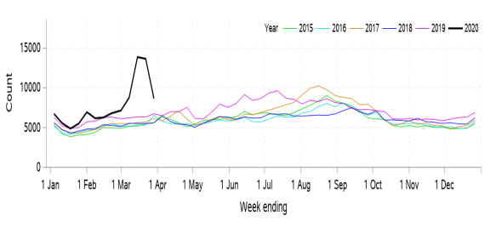

Fig2: Influenza count / week
Classification:
There are three types of flu viruses: A, B, and C. Type A and B cause the annual influenza epidemics that have up to 20% of the population sniffling, aching, coughing, and running high fevers. Type C also causes flu; however, type C flu symptoms are much less severe. Type A flu or influenza A viruses are capable of infecting animals, although it is more common for people to suffer the ailments associated with this type of flu. Wild birds commonly act as the hosts for this flu virus [12].
Type A flu virus is constantly changing and is generally responsible for the large flu epidemics. The influenza A2 virus (and other variants of influenza) is spread by people who are already infected. The most common flu hot spots are those surfaces that an infected person has touched and rooms where they have been recently, especially areas where they have been sneezing[6].
Unlike type A flu viruses, type B flu is found only in humans. Type B flu may cause a less severe reaction than type A flu virus, but occasionally, type B flu can still be extremely harmful. Influenza type B viruses are not classified by subtype and do not cause pandemics. Influenza C viruses are also found in people. They are, however, milder than either type A or B. People generally do not become very ill from the influenza type C viruses. Type C flu viruses do not cause epidemics[4].

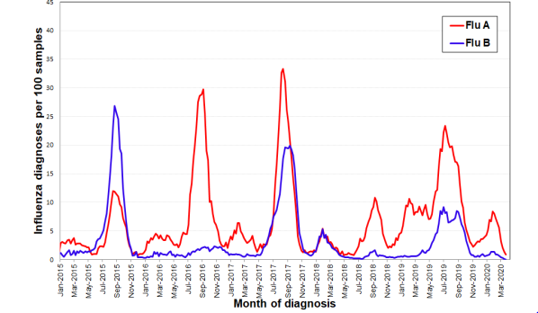
Fig3: Influenza samples / diagnosis

Signs and symptoms :
The presentation of influenza virus infection varies, but it usually includes many of the following signs and symptoms:
- Fever
- Sore throat
- Myalgias
- Frontal or retro-orbital headache
- Nasal discharge
- Weakness and severe fatigue
- Cough and other respiratory symptoms
- Tachycardia
- Red, watery eyes

The incubation period of influenza is 2 days on average but may range from 1 to 4 days. Aerosol transmission may occur 1 day before the onset of symptoms ; thus, it may be possible for transmission to occur via asymptomatic persons or persons with subclinical disease, who may be unaware that they have been exposed to the infection.
A receptor as a key to infection:
The scientists first identified cell surface proteins present in the vicinity of the viral haemagglutinin, the protein used by the influenza A virus to enter the cell. One of these proteins stood out: transferring receptor 1. This acts as a revolving door transporting iron molecules into the cell, which are essential for many physiological functions.
''The influenza virus takes advantage of the continuous recycling of the transferring receptor 1 to enter the cell and infect it,'' explains Béryl Mazel-Sanchez, a former post-doctoral researcher in Mirco Schmolke's laboratory and first author of this work. ''To confirm our discovery, we genetically engineered human lung cells to remove the transferring receptor 1, or on the contrary to over express it. By deleting it in cells normally susceptible to infection, we prevented influenza A from entering. Conversely, by over expressing it in cells normally resistant to infection, we made them easier to infect''.
The research team then succeeded in reproducing this mechanism by inhibiting the transferring receptor 1 using a chemical molecule. ''We tested it successfully on human lung cells, on human lung tissue samples and on mice with several viral strains,'' says Béryl Mazel-Sanchez. ''In the presence of this inhibitor, the virus replicated much less. However, in view of its potentially oncogenic characteristics, this product cannot be used to treat humans.'' On the other hand, anti-cancer therapies based on the inhibition of the transferring receptor are under development and could also be interesting in this context.

Difference between COVID-19 and the Influenza:
Compared with flu, COVID-19 can cause more severe illness in some people. Compared to people with flu, people infected with COVID-19 may take longer to show symptoms and may be contagious for longer periods of time. It is not easy to tell the difference between flu and COVID-19 by the symptoms alone because they have some of the same signs and symptoms. Specific testing is needed to tell what the illness is and to confirm a diagnosis. Having a medical professional administer a specific test that detects both flu and COVID-19 allows us to get diagnosed and treated for the specific virus you have more quickly. Getting treated early for COVID-19 and flu can reduce your risk of getting very sick. Testing can also reveal if someone has both flu and COVID-19 at the same time, although this is uncommon. COVID-19 and the flu are caused by different viruses. COVID-19 is caused by a coronavirus called SARS-CoV-2, while flu is caused by influenza A and B viruses.Symptoms of COVID-19 and the flu appear at different times and have some differences. COVID-19 symptoms generally appear 2 to 14 days after exposure. Flu symptoms usually appear about 1 to 4 days after exposure.COVID-19 appears to be contagious for a longer time and to spread more quickly than the flu. With COVID-19, you may be more likely to experience loss of taste or smell.Severe illness is more frequent with COVID-19 than with the flu. Compared with historical flu cases, COVID-19 may cause more hospital stays and death for people age 18 and older, even those who have no other health challenges.
Pathophysiology:
Influenza is an acute disease that targets the upper respiratory tract and causes inflammation of the upper respiratory tree and trachea. The acute symptoms persist for seven to ten days, and the disease is self-limited in most healthy individuals. The immune reaction to the viral infection and the interferon response are responsible for the viral syndrome that includes high fever, coryza, and body aches. High-risk groups who have chronic lung diseases, cardiac disease, and pregnancy are more prone to severe complications such as primary viral pneumonia, secondary bacterial pneumonia, hemorrhagic bronchitis, and death. These severe complications can develop in as little as 48 hours from the beginning of symptoms. The virus replicates in the upper and lower respiratory passages starting from the time of inoculation and peaking after 48 hours, on average.
For virulence, both neuraminidase and hemagglutinin are vital as they are the key targets by the neutralizing antibodies. Hemagglutinin adheres to the epithelial cells in the respiratory tract allowing for the progression of the infection. Neuraminidase cleaves the bond that holds the virus together and helps to spread the virions. Their H and N proteins identify influenza viruses.
An important aspect of influenza A virus is that it is a genetically labile virus with a high rate of mutations. This results in major changes in antigenic and functional proteins.
Conclusion:
Although the basic biology and genetics of influenza viruses are fairly well understood, heading off future pandemics requires a better understanding of past pandemics and the factors that contribute to virulence, as well as a thorough commitment to tracking the viruses that are circulating in the population by way of focused public health efforts. Flu viruses constantly change, and the changes can happen slowly over time or suddenly. Sometimes, the changes result in viruses that spread more easily from animals to humans. Flu viruses can change through antigenic drift or antigenic shift. According to the latest data available on IDSP-IHIP (integrated health Information Platform), a total of 3038 laboratory confirmed cases of various subtypes of Influenza including H3N2 have been reported till 9th March 2023 by the States. This includes 1245 cases in January, 1307 in February and 486 cases in March (till 9th March).Further, the IDSP-IHIP data from health facilities indicate that during the month of January 2023, a total of 397,814 cases of Acute Respiratory Illness/Influenza Like Illness (ARI/ILI) were reported from the country that increased slightly to 436,523 during February, 2023. In the first 9 days of March 2023, this number stands at 133,412 cases.The corresponding data for admitted cases of severe acute respiratory illness (SARI) is 7041 cases in January 2023, 6919 during February 2023 and 1866 during the first 9 days of March 20.
References:
1.Fabian P, McDevitt JJ, DeHaan WH, Fung RO, Cowling BJ, et al. (2008) Influenza virus in human exhaled breath: an observational study. PLoS ONE 3: e2691.
2. Johnson GR, Morawska L (2009) The Mechanism of Breath Aerosol Formation. J Aerosol Med Pulm Drug Deliv 22: 229–37.
3. Brankston G, Gitterman L, Hirji Z, Lemieux C, Gardam M (2007) Transmission of influenza A in human beings. Lancet Infect Dis 7: 257–265.
4. Killingley B, Enstone JE, Greatorex J, Gilbert AS, Lambkin-Williams R, et al. (2012) Use of a human influenza challenge model to assess person-to-person transmission: proof-of-concept study. J Infect Dis 205: 35–43.
5. Johnson DF, Druce JD, Birch C, Grayson ML (2009) A quantitative assessment of the efficacy of surgical and N95 masks to filter influenza virus in patients with acute influenza infection. Clin Infect Dis 49: 275–277.
6. Boelle PY, Ansart S, Cori A, Valleron AJ (2011) Transmission parameters of the A/H1N1 (2009) influenza virus pandemic: a review. Influenza Other Respi Viruses 5: 306–316.
7. Cowling BJ, Chan KH, Fang VJ, Cheng CK, Fung RO, et al. (2009) Facemasks and Hand Hygiene to Prevent Influenza Transmission in Households: A Randomized Trial. Ann Intern Med 151: 437–46
8. Fabian P, McDevitt JJ, Houseman EA, Milton DK (2009) Airborne influenza virus detection with four aerosol samplers using molecular and infectivity assays: considerations for a new infectious virus aerosol sampler. Indoor Air 19: 433–441
9. Carrat F, Vergu E, Ferguson NM, Lemaitre M, Cauchemez S, et al. (2008) Time lines of infection and disease in human influenza: a review of volunteer challenge studies. Am J Epidemiol 167: 775–785
10. Fabian P, McDevitt JJ, Lee WM, Houseman EA, Milton DK (2009) An optimized method to detect influenza virus and human rhinovirus from exhaled breath and the airborne environment. J Environ Monit 11: 314–317
11. Chemaly RF, Ghosh S, Bodey GP, et al: Respiratory viral infections in adults with hematologic malignancies and human stem cell transplantation recipients: A retrospective study at a major cancer center. Medicine (Baltimore) 85:278-287, 2006
12. Mauad T, Hajjar LA, Callegari GD, et al: Lung pathology in fatal novel human influenza A (H1N1) infection. Am J Respir Crit Care Med 181:72-79, 2010

