AONLA (EMBLICA OFFICINALIS GAERTN): THE COMPREHENSIVELY USED MEDICINAL PLANT OF MIZORAM

K. Lalchawiliana¹, Laltlankimi Khiangte¹ , H. Lalhruaitluanga¹
¹Department of Biotechnology, Mizoram University,
Aizawl, Mizoram 796004
kcchawia07@gmail.com, khiangtekk@gmail.com , mahruaia123@gmail.com

Alex Zohmachhuana²,

²Department of Botany, Mizoram University,

Aizawl, Mizoram 796004

alexzohma92@gmail.com

Vabeiryureilai Mathipi³,
³Department of Zoology, Mizoram University,
Aizawl, Mizoram 796004
dr.vb2021@gmail.com

ABSTRACT

The locally available fruit Aonla possesses many usages ethnically in Mizoram. Inference can be made from this study that the size of the plants, fruits as well as its moisture content showed no variation from different places. It contains various phytochemicals such as tannins, saponin, flavanoids, steroids, terpenoids, and cardiac glycosides. The results showed that the total phenolic content and flavonoid content of₊ different plant extracts exhibit no significant variation ranging from 68.92±1.1 to 71.8±1.2 mg GAE/g, and total flavonoid content was estimated at the range of 25.25± 3.00 to 35.14± 1.53 mg QUE/g dried tissue though there were slight variations. The DPPH radical scavenging activity depends on the concentration of the extracts. The scavenging activity increases with the increase in concentration with an optimum concentration at 40 µg/ml for all the plants extracts. The antimicrobial activity revealed that the E. officinalis has potential property to inhibit the growth of S. aureus and P. aeruginosa. However, it was found ineffective against E. coli. The molecular identification was performed based on NCBI.

Keywords: Antioxidant, Emblica officinalis, Mizoram, Phytochemicals.
- Introduction

Aonla (Emblica officinalis Gaertn) belongs to the family Euphorbiaceae and is found in the subtropical and tropical areas of South-east Asian countries. Its fruit is widely consumed for its special taste. It is found to possess an ample amount of vitamin C and superoxide dismutase (Verma and Gupta, 2004) and is employed in many ethnomedicinal systems like herbal medicine of Chinese, Tibetan medicine and Ayurvedic medicine (Zhang et al., 2000). This plant is known to be antihyperlipidemic and hypoglycemic (Anila and Vijayalakshmi, 2000; Abesundara et al., 2004), and is an important component of many of the presently used hepato-protective formulations (Panda and Kar, 2003). It is also used as an antimicrobial, anticancer, and anti-inflammatory agent (Dutta et al., 1998; Jeena et al., 2001; Asmawi et al., 1993) and can remedy the - clastogenic effects induced by heavy metals (Biswas et al., 1999). E. officinalis was reported to have a strong antioxidant activity (Bafna and Balaraman, 2004), this could be related to the presence of flavonoids and numerous gallic acid derivatives, such as epigallocatachingallate. (Anila and Vijayalakshmi, 2002).
Aonla branchlets are not smooth, feel furry due to the small hair projections and are about 10–20 cm long. The leaves are simple, feathery, linear oblong in shape and closely arranged branchlets, light green in colour, resembling pinnate leaves. The flowers range from greenish to yellow which appears with the commencing of spring season. When ripe, the fruit is nearly spherical, pale greenish to yellow in colour, smooth and hard to the touch, with six vertical stripes or furrows, and a sour or bitter taste. (Indian Medicinal Plants, 1997).
The Euphorbiaceae are medium to large deciduous plants. E. officinalis is commonly known as Amla or Emblic myrobalon. The tree is found throughout tropical and sub-tropical India. It is a medium-sized deciduous tree and can reach upto 18 m in height and is native to India. It bears grayish brown bark which grows well in different agro-climatic and different soil conditions (Warrier et al., 2019; Rekha et al., 2019).
Mizoram, a state of north-east India covers an area between latitude 21°58'–24° 35' N and longitude 92° 15'–93° 29' E with 86.27% forest coverage (Rintluanga, 2019). The elevation varies from 500 to 2157 metres. Mizoram has a moderate and mild climate, with temperatures ranging from 20°C to 290°C (68°F to 840°F) in the summer and 7°C to 22°C (45°F to 720°F) in the winter. The rainy season has an impact on the region, which sees strong rains during the Monsoon.The geographical condition is attributed with a mixed climatic condition ranging from moist tropical to moist sub-tropical, with an average rainfall of 254 centimeters (100 in) per annum. The average rainfall in Aizawl, the capital is approximately 215 centimeters (85 in) (Geological Survey of India, 2011; Champion and Seth, 1968).
The people of Mizoram largely rely on herbal drugs which have been passed down for generations traditionally. The crushed bark of Aonla is applied to wounds and cuts. The decoction of bark is used to treat diarrhea and dysentery (Bhardwaj and Gakhar, 2005; Rai and Lalramnghinglova, 2010; Lalramnghinglova, 2016). Its fruits were reported to possess a laxative effect. A liquid of fermented fruits are used to improve digestion, anaemia, jaundice, liver disorder, urination and also for certain heart ailments. After childbirth, fruit decoction is used to discharge retained placenta and cure skin eruptions due to food allergy. Mizoram is immensely blessed with Aonla tree (Lalzarzovi and Lalramnghinglova, 2016). Therefore, it was desired to undertake the scientific study on their ethno-medicinal properties.

- Materials and methods

  - Collection and physical parameters of plants

The E. officinalis from different locations based on height, girth (50 cm above the ground) and canopy of 10 plants from Aizawl District were collected. The E. officinalis was authenticated by Prof. H. Lalramnghinglova with voucher number MZU-HAMP001241, MZU-HAMP001245, MZU-HAMP001246, MZU-HAMP001248. The weight of fruit and seed of the plants were also measured and recorded. The leaves of four most distinct plants were taken from Sihphir, Tuirial, Tanhril and Falkawn for different tests.

  - Estimation of moisture content

The fresh leaves of E. officinalis were collected and the weight was measured. Then the known weight of the sample was subjected for heat treatment at 70ᵒC for 48 hrs. The moisture content was calculated using the formula (Allen et al., 1974).

% MC = (MF - MD) x 100
MD

Where, MC - moisture content, MF- fresh weight, MD - weight after drying, % MC - percent of moisture.

  - Preparation of extracts

The fresh E. officinalis leaves were washed, air-dried at room temperature for 24h and grinded to powder using a grinder. 250g of the powder was extracted in 500 ml of methanol and chloroform for 24h at 25°C, in a glass conical flask using a shaker and filtered using a 0.45 µm filter paper. The residue was then extracted twice with solvents such as 100 ml methanol and chloroform as described above. Both the methanol and chloroform extracts were concentrated at 40°C, using a rotary evaporator under low pressure. The extracts were dried and then stored in air-tight containers at 4°C until further use.

  - Preliminary phytochemical screening

The phytochemicals such as saponin, flavanoids, terpenoids, cardiac glycosides, tannins and phlobatannins were carried out using standard protocols to identify the constituents as described by (Sofowara, 1993; Trease and Evans, 1998; Harborne, 1998).

  - Determination of the total phenolic and flavonoids contents
    - Total Phenol contents

The total phenols were determined by Folin-Ciocalteau reagent (McDonald and Prenzler, 2001). A dilute extract of the leaves 0.5 ml (1 mg/ml) was reacted with Folin-Ciocalteau reagent (5ml, 1:10 diluted with distilled water) and aqueous Na₂CO₃ (4ml, 1M). The mixture was incubated for 15 mins and the phenol content was measured at 756 nm using a UV/Visible double beam spectrophotometer. The total phenolic content was expressed in terms of gallic acid equivalent (mg/gm of dry weight), which is a common reference compound.
    - Total flavonoids contents.

Aluminium chloride technique was used for determining flavonoids (Chang et al., 2002). 0.5 ml (1 mg/ml) leaf extract was combined with 1.5 ml methanol, 0.1 ml 1 M potassium acetate, 0.1 ml 10% aluminium chloride, and 2.8 ml distilled water for each concentration. It was then incubated for 30 minutes at room temperature. The amount of flavonoid was quantified through the optical density at 415 nm with a UV/Visible double beam spectrophotometer.

  - Antioxidants Activities

    - DPPH scavenging activity

The scavenging activity of DPPH free radical was performed (Leong and Shui, 2002) with minor modifications. 0.5 ml of each of the different concentrations (5, 10, 20, 40 and 80 µg/ml) of the E. officinalis extract was added to 1 ml solution of 0.1 mM DPPH. It was mixed thoroughly and incubated in the dark for 30 mins and the absorbance at 523 nm was taken using methanol for the baseline correction. The results were compared with that of the control prepared as above without sample. Radical scavenging activity was expressed as a percentage and was calculated using the following formula:

% Scavenging = (Acontrol – Asample ) x100
Acontrol

Where, A_{sample} is the absorbance of the test sample and A_{control} is the absorbance of the control.

    - Antibacterial activity (Agar diffusion method)

Antibacterial activities of the four plant extracts were tested against three pathogenic microbial strain viz Escherichia coli , Staphylococcus aureus and Pseudomonas aeruginosa. Muller – Hinton agar media (Hi-Media) was used for performing the test. After the preparation of the media, it was poured onto the petri plates and allowed to solidify. Then 4 bores (3 mm depth, 4 mm diameter) were made using a sterile borer. The three pathogenic microbial strains were spread onto the plates using sterile spreaders. The crude plant extract were loaded on the bores (100 µl). The petriplates were incubated at 37ᵒC for 24 h. Evaluation of Antimicrobial activity was performed by measuring the diameter of the growth inhibition zones using zone scale.

  - Molecular identification using Matk gene

The DNA was isolated from the leaves of four selected E. officinalis plant using Qiagen DNeasy Plant Mini Kit following the instruction given. The commonly used primer; matK390F (5’CGA TCT ATT CAT TCA ATA TTT C-3’) and 1326R (5’-TCT AGC ACA CGA AAG TCG AAG T-3’) (Schmitz-Linneweber et al., 2002) was used for molecular identification of the plants.

- Statistical Analysis

Microsoft excel 2010 was used for analysis of the data and graph pad prism for significant test. The laboratory experiments data were obtained in triplicates results, n=3. A p<0.05 value was considered significant.

- Results

The results are presented in tables (4) and figures (3).
There was no significant difference among the selected plants regarding the physical factors such as height, girth, fruit weight and seed weight. However, the canopies were found to differ based on the location where Thingsulthliah, Falkawn, Tuirial, Tanhril, Saikhamakawn, Hualngohmun and Sihphir were lower as compared to the plants found in Muthi, Hlimen, Seling were more elevated from the ground. This could be due to the effect of geographic location. (Fig 1).

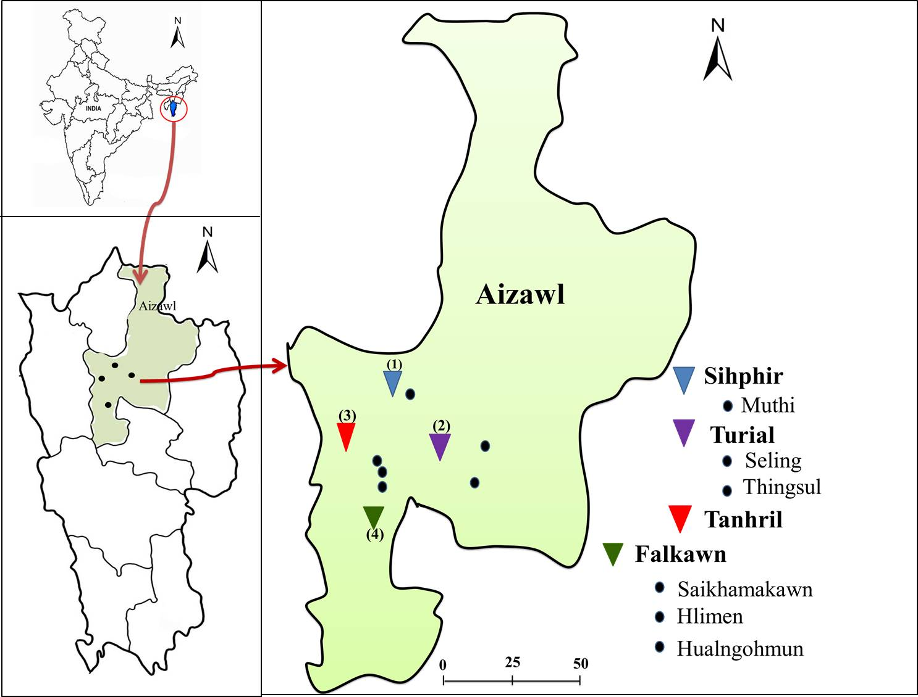
Sihphir
Tuirial
Tanhril
Falkawn

Figure 1:Black spot in the Map indicates sampling the location. There were 10 site or plants collected and catagorised into 4 different sites based on location. These four representative samples were further investigated.

The moisture content of E. officinalis in different locations did not show significant variation. The moisture content was highest in the plant collected from Tanhril (Plant 3) with 52.26% (Table 2). The phytochemicals such as tannins, saponin, flavanoids, steroids, terpenoids, cardiac glycosides were present but phlobatannins and alkaloid were absent in all the plants (Table 3). Likewise, total phenolic and flavonoid content in different plant extracts exhibited no significant variation. Both the total phenol and flavonoid content were found to increase with increase in concentration. The total phenol content ranged from 68.92±1.1 to 71.8±1.2 mg GAE/g with the highest content found in Tuirial (Plant 2) with 71.8 g/g tissue (Figure 2).
The total flavonoid content was estimated in the range from 25.25± 3.00 to 35.14± 1.53 mg QUE/g tissue and the highest flavonoid content was found in Falkawn (Plant 4) with 35.14 mg/g tissue. The reduction of DPPH radical was dependent on the concentration of the extracts. Increase in concentration of the sample showed rise in the scavenging activity. The optimum concentration was obtained at the concentration of 40 µg/ml for all the extracts and decreased hereafter. The maximum scavenging activity observed were- Sihphir (Plant 1) – 89.02%, Tuirial (Plant-2) – 89.07%, Tanhril (Plant -3) – 92.07% and Falkawn (Plant - 4) -92.12% respectively (Figure 3). Hence, the E. officinalis collected from Falkawn (Plant 4) was found to exhibit the highest scavenging activity among the four different locations. The antimicrobial activity revealed that the E. officinalis extract has potential property to inhibit the growth of S. aureus and P. aeruginosa at certain concentrations. However, there was no activity against E. coli (Table 4).

Table 1: Physical parameters of different Emblica officinalis Gaertn plant
Location | Height (Ft.) | Girth (Inches) | Canopy (Ft.) | Fruit weight (5Fruits)(g) | Seed weight (5Seeds)(g)
Sihphir (Plant 1) | 20 | 28 | 13 | 41.56 | 3.42
Tuirial (Plant 2) | 32 | 26 | 10 | 28.56 | 2.57
Tanhril (Plant 3) | 16 | 20 | 08 | 35.23 | 3.96
Falkawn (Plant 4) | 15 | 18 | 08 | 09.53 | 1.67

Table 2: Moisture content of different samples of Emblica officinalis Gaertn leaves
Plant | Sample weight (g) |  | Moisture content (g) | Moisture  (%)
Plant | Fresh | Dried | Moisture content (g) | Moisture  (%)
Sihphir (Plant 1) | 250 | 111.64 | 138.64 | 44.65
Tuirial (Plant 2) | 250 | 120.92 | 129.08 | 51.60
Tanhril (Plant 3) | 250 | 119.35 | 130.65 | 52.26
Falkawn (Plant 4) | 250 | 121.06 | 128.94 | 51.57

Table 3: Quantitative phytochemical analysis of Emblica officinalis Gaertn leaves extract.
Sample | Tannins | Phlobatannis | Saponin | Flavonoids | Steroid | Terpenoid | Glycosides | Alkaloids
Sihphir (Plant 1) | + | - | + | + | + | + | + | -
Tuirial (Plant 2) | + | - | + | + | + | + | + | -
Tanhril (Plant 3) | + | - | + | + | + | + | + | -
Falkawn (Plant 4) | + | - | + | + | + | + | + | -
+ indicates presence of phytochemicals and
- indicates absence of phytochemicals.

Table 4: Antimicrobial activity Emblica officinalis Gaertn leave extract
Extracts | Antimicrobial activity against selected microbes
Extracts | S. aureus | P. aeruginosa | E. coli
Sihphir (Plant 1) | 19 mm | 14 mm | Extract do not show  any activity
Tuirial (Plant 2) | 22 mm | 16 mm | Extract do not show  any activity
Tanhril (Plant 3) | 21 mm | 13 mm | Extract do not show  any activity
Falkawn (Plant 4) | No clear zone | No clear zone | Extract do not show  any activity

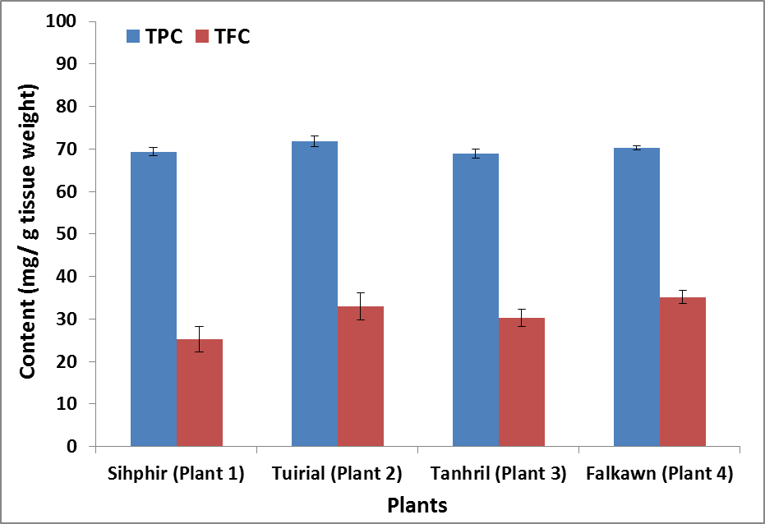
Figure 2: Total phenols and flavonoid content of Aonla leaves extracts. The results were expressed as Mean± SD, n=3.

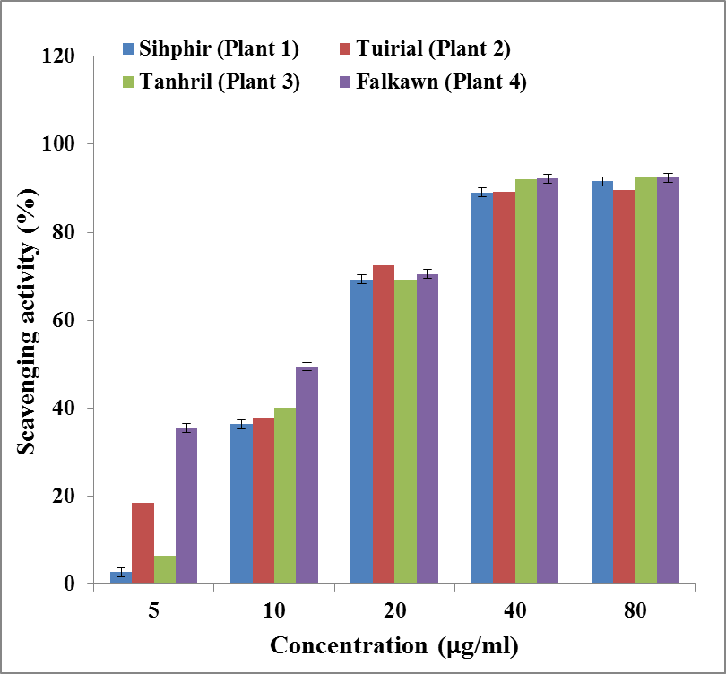
Figure 3: DPPH radical scavenging activity of Aonla leaves extracts. The results were expressed as Mean± SD, n=3.

However, the raw sequence obtained was edited and analysed using MEGA7, the sequenced were submitted to Genbank, NCBI (www.ncbi.nlm.nih.gov). The genetic analysis and phylogenetic tree was constructed.
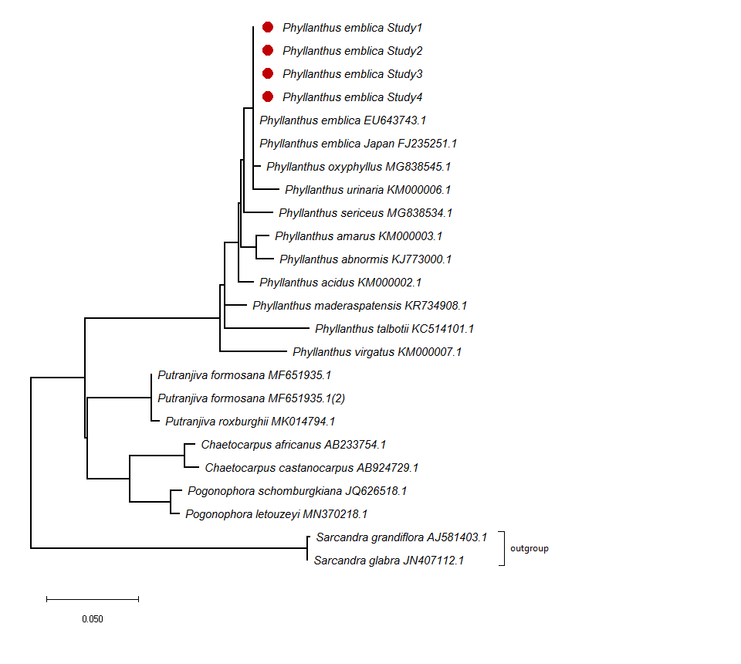
Figure 4: Molecular Phylogenetic analysis by Maximum Likelihood method

Using the Maximum Likelihood approach and the General Time Reversible model, the evolutionary history was inferred. It is shown the tree with the highest log likelihood (-3318.91). The initial tree(s) for the heuristic search were automatically generated by applying the Neighbour-Joining Method and BioNJ algorithms to a matrix of pairwise distances calculated using the Maximum Composite Likelihood (MCL) approach, and then selecting the topology with the highest log likelihood value. The rate variation model allowed for some sites to be evolutionarily invariable ([+I], 34.83% sites). The number of substitutions per site is used to calculate branch lengths, and the tree is depicted to scale. There were 24 nucleotide sequences in this study. 1st+2nd+3rd+Noncoding codon locations were included. The total number of positions in the final dataset was 877. Evolutionary analyses were conducted in MEGA X ( Schmitz-Linneweber et al.,2002).

- Discussion

In developed countries, many people turn to herbal therapy and spend a large sum of money since it is largely believed that it promotes healthier living. Herbal medicines are, therefore, often viewed as a more mild and moderate approach balancing to healing for individuals who use them as home remedies as compared to over-the-counter drugs. This could be the reason for the increase in sales of herbal medicines which represents a substantial proportion of the global drug market (Ekor, 2013; Leong and Shui, 2002). Therefore, it was decided to analyse the phytochemical constituents of Aonla (E. officinalis) plants which have been used extensively for various medications in Mizoram. The Aonla plants from different locations within Aizawl district did not show significant variation in terms of physical parameters such as height, girth, fruit weight and seed weight (Table 1). Moreover, the moisture content of E. officinalis Gaertn in different locations was found to be within the range of 44.65 to 52.26 % (Table 2). The phytochemical analysis revealed that various secondary metabolites including tannins, saponin, flavanoids, steroids, terpenoids and cardiac glycosides were present (Table 3). The antimicrobial activity against S. aureus and P. aeruginosa showed good activity (Table 4). The phenolics and flavonoid content were comparatively high in terms of percentage (Fig 2) with high DPPH scavenging activity (Fig 3). Plant phenols have a strong antioxidant potential and are a common dietary supplement. It has been found that the DPPH free radical's scavenging effect increases with the concentration of the sample and standard to a certain extent, and so is highly dependent on the extract concentration. (Patel et al., 2010; Chanda et al., 2010; Ullah et al., 2016). Several other plants such as Aporosa octandra, Castanopsis indica, Dysoxylum gobara, Eleagnus caudata, Milletia pachycarpa, Oroxylum indicum and Schima wallichi which contain high phenolic and flavonoid content have also been found to exhibit DPPH scavenging activity (Vabeiryureilai et al., 2014; Lalrinzuali et al., 2015). Phenolics have been a center of attraction as potential agents to prevent and treat many oxidative stress-related diseases (Lalrinzuali et al., 2015; Gu and Weng, 2001; Pyo et al., 2001). There was slight variation in the phenolic and flavonoid content as well as the DPPH scavenging activity in the leaves extract of E. officinalis plants collected from different locations. A similar result have been observed in Moringa olifera collected from different places. The molecular analysis confirmed the species which has similarity 99.4 with 100% query coverage (Fig 4) (An-Na et al., 2014; Panche et al., 2016; Ndhala et al., 2014). In addition to this, a previous study conducted in relation to pharmaco phylogenetic on the essential oil of M. biflora Benth and C. reticulata Blanco showed good inhibitory activity against the tested water-borne bacterial pathogens (Kumar et.al., 2012). The medication of Aonla as ethno-medicine might be due to the fact that its phytoceutical content is of biological origin and have also been investigated since the advent of human history (Jagetia et al., 2005; Lalrinzuali et al., 2016). The Aonla contained high flavonoid. It was reported that more than 8000 flavonoids have been isolated from various plants. The flavonoids have a major contribution for the attractive colours of flowers with anthocyanins (Ghasemzadeh and Ghasemzadeh, 2011; Iwashina, 2015). They are also a vital component in stimulus, defense, taste, pigmentation and in plant-microorganisms relationship (Hasan et al., 2009). The antioxidant activity depends mostly on the compounds present in the plants. It expresses the amount of antioxidant needed to neutralize the unstable free radicals in the system (Pratt and Hudson, 1990). The assessment of the ability to scavenge DPPH is a very useful method to estimate the antioxidant activity. It is violet colour and has an unpaired electron in the outermost shell which turns yellow after accepting electron from any antioxidant (Goldschmidt and Renn, 1922). The leaf extracts of E. officinalis was found to scavenge DPPH free radical and the activity was found to increase with increasing concentration of flavonoids. A similar result has been observed earlier (Lalrinzuali et al., 2015). E. officinalis can also be used as a possible food-additive or in neutraceuticals and biopharmaceutical industries. Several other reports have also revealed that the various extracts and herbal formulations of Aonla showed potential therapeutic benefits against various diseases and the results are similar to those drugs in use (Grover et al., 2015).

- Conclusion

The Aonla (Emblica officinalis) leaf holds many applications ethnically. It contains various phytochemicals like tannins, saponin, flavanoids, steroids, terpenoids and cardiac glycosides, shown high phenolic and flavonoid content and increased scavenging activity. Moreover, it can be a suitable candidate for the antimicrobial activity against S. aureus and P. aeruginosa. Therefore, it can be used as a possible food-additive or biopharmaceutical or herbal formulation industries in the future.

- Conflict of interest

The authors have conflict of interest to disclose.

- Acknowledgement

The authors thanked Advanced Level State Biotech Hub, Department of Biotechnology, Mizoram University, for providing necessary facilities to carry out the experiments.
- References

- Abesundara KJM., Matsui T., Matsumoto K. A-glucosidase inhibitory activity of some Sri Lanka plant extracts, one of which, Cassia auriculata, exerts a strong anti-hyperglycemic effect in rats comparable to the therapeutic drug acarbose. J Agri Food Chem. 2004; 52: 2541–2545.
- Allen S.E., Grimshaw H.M., Parkinson J.A., Quarmby, C. Chemical analysis of ecological materials, Blackwell Scientific Publications. Osney, Oxford, London. 1974.
- Anila L., Vijayalakshmi N.R. 2000. Beneficial effects of flavonoids from Sesamum indicum, Emblica officinalis and Momordica charantia. Phytother. 2000; 14: 1–4.
- Anila L., Vijayalakshmi N.R. 2002. Flavonoids from Emblica officinalis and Mangifera indica— effectiveness for dyslipidemia. J Ethnopharmacol, 2002; 79: 81–87.
- An-Na Li., Sha Li., Zhang Y., Xu X.R., Chen Y.M., Li H.B. Resources and Biological Activities of Natural Polyphenols. Nutrients. 2014; 6(12): 6020–6047.
- Asmawi M.Z., Kankaanranta H., Moilanen E., Vapaatalo H. Anti-inflammatory activities of Emblica officinalis Gaertn. Leaf extracts. J Pharm Pharmaco. 1993; 45: 581–584.
- Bafna P.A., Balaraman R. Anti-ulcer and antioxidant activity of DHC-1, a herbal formulation. J Ethnopharmacol. 2004; 90: 123–127.
- Bhardwaj S., Gakhar SK. 2005. Ethnomedicinal plants used by the tribals of Mizoram to cure cuts & wounds. Ind J Trad Knowl, 4(1): 75-80.
- Biswas, S., Talukder, G., Sharma A. 1999. Protection against cytotoxic effects of arsenic by dietary supplementation with crude extract of Emblica officinalis fruit. Phytother Res. 1999; 13: 513–516.
- Champion S.H., Seth S.K. 2005. A revised survey of the forest types of India,. Delhi, Manager of Publications.
- Chanda S.V., Nagani K.V. Antioxidant capacity of Manilkara zapota L. leaves extracts evaluated by four in vitro methods. Nature Science. 2010; 8(10): 260-266.
- Chang C., Yang M., Wen H., Chern J.. Estimation of total flavonoid content in propolis by two complementary colorimetric methods. J Food Drug Anal. 2002; 10: 178-182.
- Dutta B.K., Rahman, I., Das T.K. Antifungal activity of Indian plant extracts. Mycoses. 1998; 41: 535–536.
- Ekor M. The growing use of herbal medicines: issues relating to adverse reactions and challenges in monitoring safety. Frontiers in Pharmacology. 2013; 4: 177.
- Geological Survey of India, Government of India. Geology and mineral resources of Manipur, Mizoram, Nagaland and Tripura: Miscellaneous publication No. 30 Part IV. 1 (Part-2). 2011.
- Ghasemzadeh A., Ghasemzadeh N. Flavonoids and phenolic acids: Role and biochemical activity in plants and human, J Med Plant Res. 2011; 5: 6697-6703.
- Goldschmidt S., Renn, K. Amine oxidation IV.Diphenyl-trinitrophenylhydrazy. ChemBer. 1992; 55: 628-643.
- Grover H.S., Deswal, H., Singh Y., Bhardwaj A. Therapeutic effects of amla in medicine and dentistry: A review. J Oral Res Rev. 2015; 7: 65-8.
- Gu L.W., Weng X.C. Antioxidant activity and components of Salvia plebeian R.Br. ‒ a Chinese herb. Food Chem. 2001; 73: 299-305.
- Harborne J.B. Phytochemical methods. A guide to modern techniques of plant analysis. Springer Netherlands. (3rd Edn), 60. 1998.
- Hasan S.R., Hossain M.M., Akter R., Jamila M., Mazumder M.E., Rahman S. DPPH free radical scavenging activity of some Bangladeshi medicinal plants. J Med Plants Res. 2009; 3(11): 875-9.
- Prakash B., Indian Medicinal Plants, Department of ISM and Homeopathy, Indian Security Press, Nasik, 1997.
- Iwashina T. Contribution to flower colors of flavonoids including anthocyanins: areview. Nat Prod Comm. 2015; 10: 529-544.
- Jagetia G.C., Venkatesha V.A. Effect of mangiferin on radiation induced micronucleus formation in cultured human peripheral blood lymphocytes. Environ Mol Mutagen. 2005; 46: 12-21.
- Jeena K.J., Kuttan G., Kuttan R. Antitumour activity of Emblica officinalis. J Ethnopharmacol. 2001; 75: 65–69.
- Kumar S., Stecher G., Tamura K. MEGA7: Molecular Evolutionary Genetics Analysis version 7.0 for bigger datasets. Mol Biol Evolution. 2016; 33: 1870-1874.
- Lalramnghinglova H. Documentation of Medicinal Plants based on Traditional Practices in the Indo-Burma Hotspots Region of Mizoram, North East India. Emer Life Sci Res. 2016; 2(1): 10-45.
- Lalrinzuali K., Vabeiryureilai M., Jagetia G.C. The analysis of antioxidant activity and phenolic contents of selected medicinal plants of Mizoram. Genomics and Applied Biology. 2015; Vol.6: No.11 1-12.
- Lalrinzuali K., Vabeiryureilai M., Jagetia G.C., Lalawmpuii P.C. Free radical scavenging and antioxidant potential of different extracts of Oroxylum indicum in vitro. Adv. Biomed. Pharma. 2015; 2(3): 120-130.
- Lalzarzovi S.T., Lalramnghinglova H. Traditional use of medicinal plants found within Aizawl city in Mizoram, India. Pleione. 2016; 10(2): 269 -277.
- Leong LP., Shui G. An investigation of antioxidant capacity of fruits in Singapore markets. Food Chem. 2002; 76: 69-75.
- McDonald S., Prenzler P.D. Autolovich M, Robards K. Phenolic content and antioxidant activity of olive extracts. Food Chem. 2001; 73: 73-84.
- Ndhlala A.R., Mulaudzi R., Ncube B., Abdelgadir H.A., Plooy C.P., Staden J.V. Antioxidant, Antimicrobial and Phytochemical Variations in Thirteen Moringa oleifera Lam. Cultivars. Molecules. 2014; 19: 10480-10494.
- Panche A.N., Diwan A.D., Chandra S.R. Flavonoids: an overview. J Nutr Sci. 2016; 5: e47.
- Panda S., Kar, A. Fruit extract of Emblica officinalis ameliorates hyperthyroidism and hepatic lipid peroxidation in mice. Pharmazie. 2003; 58(2003): 753–761.
- Patel V.R., Patel P.R., Kajal S.S. Antioxidant activity of some selected medicinal plants in western region of India. Adv Biol Res. 2010; 4(1): 23-26.
- Pratt D.E., Hudson B.J. Natural antioxidants not exploited commercially. In Food antioxidants. Springer. Dordrecht. 1990; 171-191.
- Pyo Y.H., Lee T.C., Logendrac R.T. Antioxidant activity and phenolic compounds of Swiss chard (Beta vulgaris subspecies cycla) extracts. Food Chem. 2004; 85: 19-26.
- Rai P.K., Lalramnghinglova, H. Ethnomedicinal plant resources of Mizoram, India: Implication of traditional knowledge in health care system. Ethnobot Leaflets. 2010; 14: 274-305.
- Rekha R.W., Joshi, G., Arunkumar, A.N. DNA fingerprinting in industrially important medicinal trees. Annals of Phytomedicine. 2019; 8(1): 19-35.
- Rintluanga P. Mizoram: A Study in Comprehensive Geography, ISBN 978-81-7211-264-6. 2019.
- Schmitz-Linneweber C., Maier R.M., Alcaraz J.P., Cottet A., Herrmann R.G., Mache R. The plastid chromosome of spinach (Spinacia oleracea): complete nucleotide sequence and gene organization. Plant Mol Biol. 2002; 45(3): 307-15.
- Sofowara A. Medicinal plants and Traditional medicine in Africa. Spectrum Books Ltd. Ibadan. Nigeria, 289. 1993.
- Tamura K. Estimation of the number of nucleotide substitutions when there are strong transition-transversion and G + C-content biases. Mol Biol Evolution. 1992; 9: 678-687.
- Trease G.E., Evans W.C. Pharmacognosy. (11th ed) Brailliar Tiridel Can. McMillian publishers. 1989.
- Ullah F., Ayaz M., Sadiq A., Hussain A., Ahmad S., Imran M., Zeb A. 2016. Phenolic, flavonoid contents, anticholinesterase and antioxidant evaluation of Iris germanica var; florentina. Nat Product Res, 30(12) 1440-4.
- Vabeiryureilai M., Lalrinzuali K., Rosangkima G., Jagetia G.C. Qualitative phytochemical analysis and antioxidant activity of Aporosa octandra (Buch.-Ham. ex D. Don) Extracts. Int J Pharmaceut Res. 2014; 6(4): 69.
- Verma R.C., Gupta A. Effect of pre-treatments on quality of solar-dried Amla. J Food Engineer. 2004; 65:397–402.
- Warrier R.R., Joshi G., Arunkumar AN. DNA fingerprinting in industrially important medicinal trees. Annals of Phytomedicine. 2019; 8(1): 19-35.
- Zhang Y.J., Tanaka T., Iwamoto Y., Yang C.R., Kouno I. Phyllaemblic acid, a novel highly oxygenated norbisabolane from the roots of Phyllanthus Emblica. Tetrahedron Lett. 2000; 41: 1781–1784.
- Kumar A., Gupta R., Mishra R.K., Shukla A.C., Dikshit A. Pharmaco-Phylogenetic Investigation of Micromeria biflora Benth and Citrus reticulata Blanco. Natl. Acad. Sci. Lett. 2012; 35(4):253–257.

