Analysis and Design of Solar PV System Using Pvsyst Software

Dr. Raja Mohamed Sumsudeen, CEng (IET-UK)
Electrical and Electronics Engineering
University of Bahrain
Isa-town, Bahrain
rsumsudeen@uob.edu.bh

ABSTRACT
The design, simulation, and performance analysis of a solar energy system utilizing PVsyst software are presented in this chapter. This chapter highlights the procedures necessary to build an optimized solar energy system as well as the significance of regular maintenance and monitoring to ensure the system's best performance and efficiency. Energy-management methods such as the unity power factor and the P50-P90 estimator are also investigated. This chapter also discusses the PVsyst software results, which emphasizes the solar energy system's remarkable performance in terms of energy generation and conversion efficiency. The findings show that solar energy has the potential to be a viable alternative to traditional energy sources, as well as the significance of regular maintenance and monitoring to ensure optimal system performance.

Keywords—Solar PV system; Energy management; hot-arid region; P50-P90 esitmater; PV syst

INTRODUCTION

A previous literature analysis of implementing solar systems using the PVsyst software in too many solar system areas was completed, and it highlighted too many studies that indicate the benefits of employing this software in solar system constructions. In 2021, Gina and Peter Anderson [1] conducted a study that demonstrated the importance of building solar systems and how they will positively impact the global environment. The study also provided the growing trend of implementing PV systems in the United States of America, and finally, the study demonstrated how the PV system can be done based on energy demand and site analysis.
Another study conducted by Kristen Chapple in May 2021 [2] revealed that the most common issue for building solar systems in houses, and the study also provided several information's about each issue that was mentioned, so by simply reading this study, we can estimate the issues that we may face after implementing the solar system in reality, and thus, we can think about how we can get rid of those issues before the construction.

Finally, a study conducted by Taryn Holowka in April 2017 [3] revealed the benefits of building a solar system for a residential house. The study included a lot of useful information, such as how building a solar system can help you reduce your electricity bills, and finally, the study provides information about the benefits of building a solar system based on the environment. Overall, the analysis of literature demonstrates prior studies concerning establishing solar systems and how they might benefit your monthly expenses or even the environment.

PVsyst is a powerful software tool [4] for designing, simulating, and optimizing solar systems that is widely used in the photovoltaic sector. PVsyst SA created the program, which includes a variety of features and tools for modelling the behavior of solar systems, such as calculating energy output, analyzing system performance, and optimizing system design. PVsyst software is generally recognized for its accuracy and reliability in projecting solar system performance, and it is used by industry experts, researchers, and policymakers to assess the feasibility and economic viability of photovoltaic projects. With its user-friendly design and comprehensive capabilities, PVsyst software has become a vital instrument in the renewable energy industry, assisting in the adoption of solar energy and contributing to the transition to a more sustainable energy system.

After reading this chapter and readers can understand the following topics.

▪ Design a solar PV model that meets the energy needs of the house load demand using PVsyst software.
▪ How to select the appropriate components for the solar PV system, including the solar panels, inverters, mounting system, and wiring.
▪ How build the model and simulate the performance of the solar PV system using PVsyst software and calculate the losses in the system due module mismatch, wiring losses, inverter losses, and temperature losses.
▪ How to analyze the energy management results of the solar PV system, including the amount of energy produced, the energy savings achieved, and the economic benefits of the system.
▪ How to optimize the performance of the solar PV system by minimizing losses and maximizing energy output.
▪ How to evaluate the feasibility and sustainability of the solar PV system and its potential impact on the environment and the community.
Overall, this chapter focuses on the design and construction of a solar PV system that satisfies the energy demands of the house load while minimizing losses and maximizing energy output in an efficient and sustainable way. The following case study delves deeper into the system design using the PVsyst tool.

CASE STUDY

A. House load demand
Based on the electricity usage statistics received from the monthly electricity bill for a year given in fig.1 for the house, the solar PV system will be developed to suit the electricity needs of house in Bahrain Sitra. The following steps were conducted to calculate the PV solar system's planned power in KWp under standard test condition (STC).

Fig.1 Load demand

- The kWh usage for each month was obtained from the provided monthly electricity usage figure and added up to obtain the total kWh usage over a year.
- The total kWh usage was divided by the number of months to obtain the average monthly electricity usage.
- Any seasonal variations in electricity usage were identified based on the provided monthly electricity data.
- The peak demand was determined by identifying the highest amount of electricity used in any given month.
- The load demand was calculated by adding up the average monthly electricity usage and any seasonal variations, and then adding a margin for growth or unexpected usage.
- The planned power in KWp under STC was calculated using the load demand and assuming a module efficiency of 18%.
Based on the provided monthly electricity usage data, the planned power in KWp under STC for the PV solar system is estimated as follows,
Step 1:
Total kWh per year = 3337 + 2986 + 4171 + 5523 + 4588 + 4403 + 3887 + 3220 + 2378 + 2014 + 1730 + 1736 = 42163 kWh
Step 2:
Average monthly electricity usage = 42163 kWh ÷ 12 months = 3513.58 kWh/month
Step 3:
Peak demand = 5523 kWh (in the fourth month)
Step 4:
Load demand = (3513.58 kWh/month x 1.2) + 5523 kWh = 9975.3 kWh
Step 5:
Planned power in STC = 9975.3 kWh / (30 days x 1000 W/m² x 0.8 x 24 hours/day x 0.18) = 7.8 KWp

It should be noted that this is just an estimate, and the actual planned power may vary depending on the specific conditions of the installation site and other factors.
Based on the location and other site-specific criteria, the PV solar system will be constructed to match the predicted planned power requirement and will comprise the relevant components, such as solar panels, inverters, mounting system, and wiring. The PVsyst software will be used to optimize the system design to minimize losses and maximize energy output while assuring feasibility and sustainability.
Based on estimates, the planned output for the PV solar system under STC would be 7.8 KWp given that the house rooftop has a total area of 200 m2. However, with only 60 m2 of usable space, the available space for the PV solar system is limited. As a result, the exact size and components of the PV solar system will be determined by a variety of factors, including available space, solar panel orientation and tilt angle, shading, and other site-specific characteristics. To ensure that the PV solar system is suited to individual conditions and produces the most energy. This chapter provided the necessary information regarding the location and energy requirements, as well as simulated and optimized the system design using software such as PVsyst [4].

B. System Sizing
Show the figures, facts, and calculations involved in choosing the geographical place, orientation, and system specification in this section. Discuss the losses accounted for in the simulation, the energy management tactics used, and the user's need for precise electricity usage data. The steps are follows.

C. Choosing the geographical site, Orientation & System Definition
Because there were no sites in the built-in database for Bahrain during the PVsyst simulation, a new site called "Bahrain Sitra" was created, as shown in fig.2.

Figure 2: Choosing the geographical site.
The tilt angle was then set to 25 degrees to maximize the output of the solar PV system, as illustrated in fig.3.

Fig 3: Choosing the tilt angle.

Although initial calculations revealed a planned power output of 7.8 KWp, a higher figure of 9 KWp was chosen for the system. Entering the projected power of 9 kW into the pre-sizing help section, PVsyst advised an area of 49 m² for this power output. Select the "Generic - Mono 300 W/p 60 cells" module and the "Generic - 7.5 kWac inverter" with a single-phase output voltage of 230 V in the "Module and Inverter" section and selected the "Generic - Mono 300 W/p 60 cells" module and the "Generic - 7.5 kWac inverter" with a single-phase output voltage of 230 V and a power output of 7.5 kW. PVsyst recommended a setup of 28 modules in two strings, each with 14 modules connected in series, based on these choices. Fig .4 depicts the total module area required for this arrangement. The generated "Global System Summary" contained data on nominal PV power, nominal AC power, the number of modules and strings, and overload loss. Overall, the PVsyst simulation enabled me to construct an optimized solar PV system for my personal needs, taking elements like tilt angle, module selection, and inverter selection into account [5]. The ultimate layout included 28 modules in two strings of 14 modules each, with a total module size of 46 m2 and an anticipated power output of 9 kW.

D. System Loss Analysis

The PVsys suggest a default value of 29.0 W/m²K for Uc and 0.0 W/m²K*m/s for Uv since only considering the free mounting configuration with air circulation for the PV modules (Fig.5).To build and analysis the house design, the PVsyst is used to model the performance of a mono 300 W 60-cell collector field with 14 modules in series and 2 strings in parallel, accounting for parameters like as the Field Thermal Loss Factor, Yearly Soiling Loss Factor, Ageing, and different forms of losses. When evaluating the free mounting configuration with air circulation for the PV modules, PVsyst offers default values of 29.0 W/m2K for Uc and 0.0 W/m²K*m/s for Uv for the Field Thermal Loss Factor, see fig.6. As shown in fig 7, the Yearly Soiling Loss Factor was estimated using monthly values from October to May of 1.4% and June to September of 0.7%. Over a 25-year period, ageing was modelled with an average degradation factor of 0.4%.
Unavailability was also considered, with the system configured to a random number and three periods of unavailability lasting 56 hours each, beginning on particular days and times%, as shown in fig 9. Finally, PVsyst was used to calculate several sorts of losses such as module quality loss, module mismatch loss, incidence angle modifier (IAM) loss, temperature loss, wiring resistance loss, and series diode loss. In addition to these considerations, spectral correction was considered to account for changes in the spectral distribution of sunlight at the PV module and reference conditions. I can estimate the power production and efficiency of the PV system over time by simulating its performance with software such as PVsyst. This can assist in optimising the the system design [6]

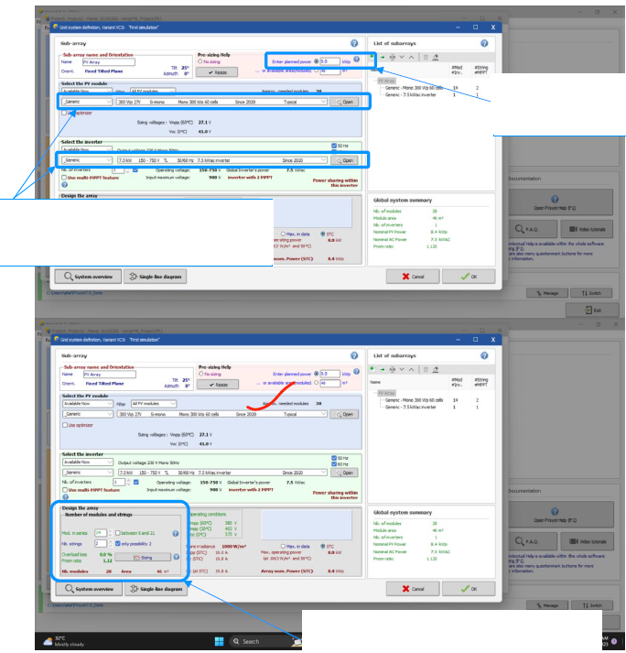

Figure 4: Grid system definition dialog

Figure 5: Thermal Parameters

Figure 6: Ohmic Losses

Figure 7 according to research, the rate of soiling in Bahrain is higher during the winter months and lower during the summer months, with monthly values of 1.4% from October to May and 0.7% from June to September. To account for ageing, the Imp and Vmp parameters were simulated over a 25-year period with an average deterioration factor of 0.4% per year and an RMS dispersion of 0.4% per year is shown in Fig.8. In fig.9, Set the system's unavailability to a random amount and select three periods of unavailability, each lasting 56 hours and beginning on certain days and times. PV Array behavior for each loss effect is as shown in Fig.10.

Fig 7: Soiling Loss

Figure 8: Ageing

Figure 9: Unavailability

Figure 10: Losses graph

E. Energy management
When considering the power factor (Cos(phi)) for grid injection, a unity power factor of 1.000 was chosen, as shown in fig.11. This signifies that the power sent to the grid is just active power, or power used to accomplish beneficial work. By using a unity power factor, all the power generated by the PV system is used efficiently, with no reactive power given to the grid. This can lead to increased energy efficiency and lower energy expenses.
Furthermore, the P50-P90 estimator [7] was used to estimate the variability in power output due to various factors such as meteo variability, climate change, simulation and parameter uncertainties, PV module modeling/parameters, inverter efficiency, soiling, mismatch, degradation estimation, and custom variability. Overall, using a unity power factor can result in increased energy efficiency and lower energy expenses. We can estimate the variability in power output owing to various factors using the P50-P90 estimator and optimise the design and operation of the PV system accordingly.

Actual monthly data were entered into the system to produce a more accurate report on my electricity usage. These figures indicate the house's electricity use data. This data will help us better understand energy consumption patterns and find potential for optimisation. The average monthly value for electricity usage based on the numbers entered is 3255 kWh/mth, with a total of 39056 kWh for the year, as shown in fig.12. These data provide a more realistic depiction of actual electricity use and can be used to inform decisions about energy saving measures or the installation of a solar energy system. It is crucial to note, however, that these statistics provide no context or explanation for why different months may have higher or lower consumption. To completely understand and optimise energy use, additional study and consideration of external factors such as weather patterns or lifestyle changes may be required.

Figure 11: Energy management

Figure 12: Average power consumption

III. RESULTS AND DISCUSSION

According to the PVsyst software report included in Fig.13, the solar energy system that will be installed in my home has an impressive specific production of 1455 kWh/kWp/year, showing that it produces energy effectively. The system's performance ratio (PR) is 69.51%, indicating how well the system turns available solar energy into useful energy. Fig.13. A higher PR implies better performance, and a PR of 75% or more is regarded good for a well-designed and well-maintained solar energy system.
Figure 13: The main results from PVsyst Software report

The PVsyst software report analyses the performance of the solar energy system in detail, identifying its strengths and opportunities for development. The loss diagram in fig.14 shows that the system suffers a variety of losses, including a 7.5% rise in worldwide horizontal irradiation, a 1.85% decrease in global incidence in coll. plane, and a 1.14% decrease in IAM factor on global. Most of these losses are caused by external factors such as weather, which can lower the quantity of solar energy reaching the collectors. The soiling loss factor reduces the system's effective irradiation on collectors, resulting in an array nominal energy of 17065 kWh and an efficiency of 18.45% at STC. However, the system suffers many losses, including a 9.78% loss due to module degradation in year #25, a 0.46% loss due to irradiance level, and a 9.10% loss due to temperature. These losses are mostly caused by the natural deterioration of solar panels as well as the effect of temperature on their performance. The system additionally has 0.75% module quality loss, 2.00% LID loss, and 6.55% mismatch loss (including 4.4% for degradation dispersion) due to manufacturing and installation difficulties.

The system's ohmic wiring loss is 1.08%, which is caused by the resistance of the wires connecting the solar panels to the inverter. During operation, inverter losses are negligible, with losses over nominal inverter power of 0.03%, losses owing to maximum input current, and losses due to power threshold all at 0%. However, the system suffers a 0.0% loss over the nominal inverter voltage and a 0% loss due to voltage threshold. With a specified production of 1455 kWh/kWp/year and a performance ratio of 69.51%, the system generates a large amount of energy. However, losses caused by numerous factors such as deterioration, temperature, and irradiance level can have a substantial impact on the system's energy output. Regular maintenance and monitoring of the solar energy system are essential for ensuring peak performance and mitigating the effects of these losses. The PVsyst software report results provide significant insights for future maintenance and optimization efforts to ensure the solar energy system's efficient and sustainable operation. The daily input and output diagram is shown in fig 15. The system output power distribution is shown in Fig.16.

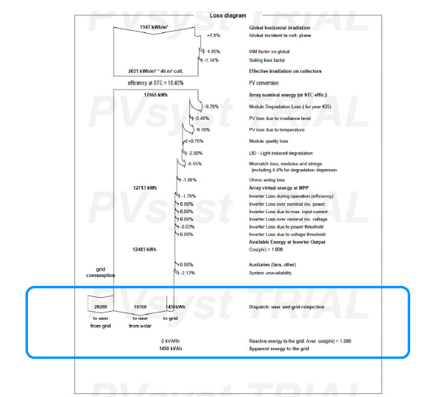

Figure 14: The loss diagram from PVsyst software report

Figure 15. Daily input and output diagram

Figure 16: System output power distribution

Figure 17: P50-90 Estimator
Figure. 17 shows the P50-90 estimator, it clearly indicates the probability distribution E_grid system production (kWh). The single line diagram of the overall designed system is shown in Fig.18.

Figure 18: Single line diagram of the designed system

The system's solar fraction (SF) is 27.57%, which is the percentage of total energy consumption covered by solar energy. The system's normalized production is 12218.45 kWh/year, which is its actual energy output. The solar energy system produced 12218.45 kWh of electricity at the end of the production year, which is a large amount of energy that can assist lessen choose house reliance on traditional energy sources. The system's performance ratio of 69.51% indicates that it effectively converts available solar energy into useful energy.

The system also generated 39056.00 kWh of energy over the span of the year, which can assist offset my house's energy consumption and cut my electricity bills. Overall, the PVsyst software report emphasizes the solar energy system's good performance in terms of energy output and conversion efficiency. The system's high-performance ratio and specific production show that it produces energy efficiently, and the amazing energy creation can assist reduce the house's reliance on traditional energy sources and minimize electricity bills.

Figure19: CO₂ emissions balance

Figure 19 shows the CO₂ emission balance of the designed system. The system lifecycle emission details in modules, supports and inverters are 1713 kg CO₂/kWp, 4.35 kg CO₂/kWp431 kg CO₂/kWp respectively. The lifetime of the system is 30 years and annual degradation is 1 % as per the NREL standards.

CONCLUSIONS

Finally, this chapter highlights solar energy's promise as a dependable and cost-effective alternative to traditional energy sources. PVsyst software was used to design, simulate, and analyze the performance of a solar energy system, emphasizing the significance of careful planning, frequent maintenance, and energy management strategies to optimize system performance and efficiency. The simulation results emphasize the importance of site selection, component selection, and accounting for various losses when estimating energy production. Regular maintenance and monitoring are required to ensure optimal performance and efficiency, as even little changes in system performance can have a substantial influence on energy production over time. Energy management measures, such as a unity power factor and a P50-P90 estimate, can increase system performance, and save energy expenditures.

This report's solar energy system produced 1455 kWh/kWp/year and a performance ratio of 69.51%, suggesting its potential to reduce reliance on traditional energy sources and lower energy expenditures. However, depending on weather conditions, system maintenance, and energy management tactics, the actual energy production of any system may vary. Overall, using PVsyst software can assist people and organizations in optimizing the design and performance of their solar energy systems, so helping to the transition to a more sustainable energy system. Individuals and organizations can maximize the energy production and efficiency of their solar energy systems by considering the aspects listed in this chapter, thereby contributing to a cleaner and more sustainable future.

REFERENCES

[1] Gina Carminati , Peter Anderson , Tania Pulido , Tyler Owens , Collin O'Connor (April 22, 2021), Implementation of Solar Energy.
[2] Kristen Chapple, (Tuesday, May 4, 2021), The Most Common Issues with a Solar Powered House.
[3] Taryn Holowka, (Apr 05, 2017), Top four benefits of installing solar panels on your home.
[4]PVsyst tutorial PVsyst_Tutorials_V7_Grid_Connected.
https://www.pvsyst.com/wpcontent/ uploads/2020/10/PVsyst_Tutorials_V7_Grid_Connected.pdf (Accessed: April 20, 2023).
[5] 06-pvsyst tutorials -user needs (2021). https://www.youtube.com/watch?v=l_3TXPjWZ8o (Accessed: April 20, 2023).
[6] 04-PVSYST tutorial-detailed losses (2021). https://www.youtube.com/watch?v=2Lw6kK1-IuU (Accessed: April 21, 2023).
[7] 05-PVSYST tutorials -detailed losses 2 & Energy Management (2021). https://www.youtube.com/watch?v=eJwqnBZMtlY (Accessed: April 21, 2023).

