INTRODUCTIONTOMACHINE AND MECHANISM

The definition of a machine in layman's words is "a device that takes energy of some way and utilizes it to perform a particular kind of function" or "a machine may be considered a medium for transferring or modifying energy."

THE MACHINE
A machine is a set of parts with the ability to convey power in a regulated way and the ability to carry out productive work. A machine is composed of several kinematically connected linkages.
The combination of resilient elements (links or parts) with effectively restrained relative motions is referred to as a machine. A machine is used to transform other forms of energy into mechanical energy or to transfer and transform available energy to carry out a particular sort of job.

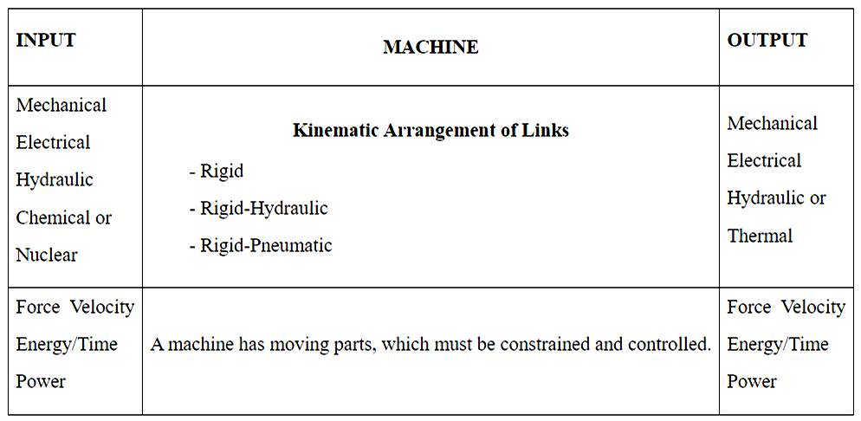

MachineArrangement
It will be discovered that every machine consists of a system of linked components (links or elements) that, when one is forced to move, they all get a motion, the relationship of which to the first relies on the kind of connections (i.e. joints).

The linkages might be pneumatic, hydraulic, or rigid. The source of power might be nuclear, mechanical, electrical, hydraulic, or chemical. Mechanical, electrical, hydraulic, or thermal power may be produced.

Machines that include:

Receives thermal energy and converts it into mechanical energy.

Electric motor-Changes electric energy into mechanical energy.

A pump-Input electric power and output hydraulic power.

Most machines take mechanical energy and modify it so that it may be utilised to do a specific purpose for which it was created; popular examples of such machines are hoists, lathes, screw jacks, etc.

It should be noted that a machine must be capable of performing useful functions. A chain of kinematically linked links placed at work with no output link and just converts the energy input to friction heat is not a machine, unless the original purpose was solely to produce heat.
MACHINES' CLASSIFICATION
1. Devices that use mechanical energy to generate mechanical work from a variety of energy sources
Think about IC engines, steam turbines, turbines for gases, turbines for water, engines for steam, steam turbines, etc.
2. Commonly referred to as conversion machines, these devices change mechanical power into other types of energy.
Examples include pneumatic or hydraulic pumps, generators, etc.
3. Machinesforutilizingmechanicalenergyintheperformanceofusefulwork.
Examples include a lathe and other machinery.
There must be a number of pieces (links or components) for energy to transfer and change inside the machine. These parts are chosen to effectively complete the machine's purpose by supplying the required motion and securely transmitting the forces placed upon them.
The field of "Concept of Machines," often referred to as "The Science of Machines," focuses on the analysis of the relative movement of the various pieces of mechanical equipment and the forces that are acting on them."
DISTINCTION OF MECHANISMS AND MACHINES
A mechanism in kinematics is a method for communicating, regulating, or restricting relative movement. Rigid bodies joined by joints are the main component of mechanics. It may alternatively be described as a group of resilient bodies that are joined and fashioned in a way that allows them to move in definite relation to one another.A machine is made up of a number of hard or resistant bodies that are arranged and linked to move.
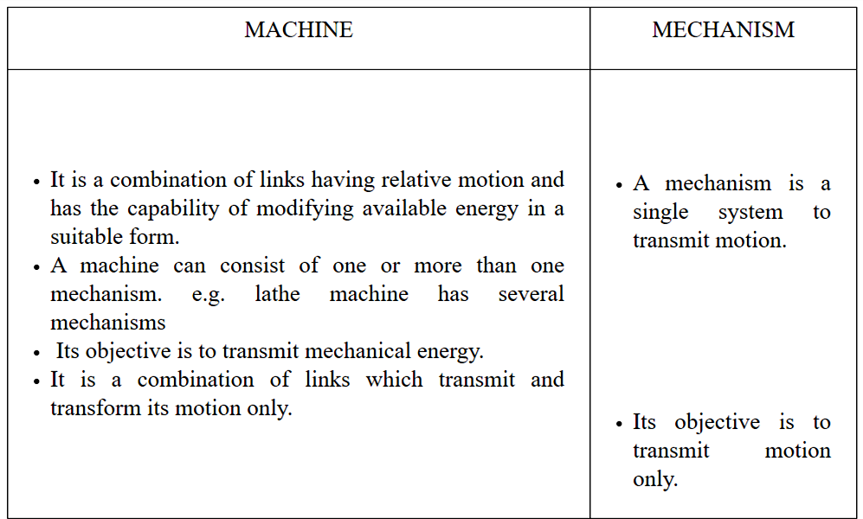

The IC engine and slider crank mechanism serve as a straightforward illustration of a machine and mechanism. Using a slider crank mechanism, a crank's rotating action is transformed into a slider's sliding motion. However, in an internal combustion engine, a similar process is employed to transform the mechanical energy present in the piston into the necessary torque at the crank shaft.

MECHANSIM KINEMATIC ANALYSIS
When implemented, several mechanisms each provide a distinct set of results. The mechanism may be examined by calculating the position, speed, and acceleration at various locations on the mechanism. The analysis of acceleration and velocity at any position on the mechanism does not need computing the stresses and forces acting on the different mechanisms parts. In other words, while examining the motion of a particular mechanism, we do not need to consider the cross-sectional dimension or strength of the individual components. Furthermore, whether parts are cast is irrelevant. the use of any substance, including wood, iron, or wood, for motion analysis

Pictorial AND ANALYTICAL METHOD:
Two different approaches, referred to as graphical and analytical techniques, may be used to analyse the Mechanism. Each strategy has benefits and cons of its own.The graphical technique is simple to use and provides a visual representation of how a system operates. But analytical approaches are better suited to issues that are more complicated. We may decide how we wish to approach the issue at hand. High-speed computers has made analytical approaches a particularly effective tool for resolving difficult issues. Due to their convenience and simplicity, we will focus on graphic approaches in this course.
DESIGN SYNTHESIS
To determine the size of the pieces, we will use stress analysis together with other design criteria like bending, fatigue, etc.A mechanism can be synthesised using one of two methods. In the first method, the dimensions of a mechanism's pieces are determined by taking into account the load, stress, bending, etc. in each component.In the second method, the components' dimensions are first presummated before the analysis is completed to determine the strength of the component. The majority of engineers choose the second synthesis approach.

KINEMATICS OF MECHANISM

It comprises examining the relative motions of various mechanisms' parts without considering the forces influencing those motions.It is a study from a geometric perspective that allows us to calculate the amounts of acceleration, velocity, and displacement at various places on a mechanism's component parts.

DYNAMICSOFMECHANISM
It entails computations of the forces applied to different mechanisms' component elements. The forces exerted on a machine can be divided into static forces and kinetic forces. Forces are investigated in static when all of the system's component parts are in equilibrium. While in kinetics, inertia forces associated with the combination of the parts' mass and velocity are investigated.

LINK

PLANER MECHANISM

A link is described as a single component that can be a single resistant body or a collection of resistant bodies connected by rigid joints and moving in relation to other components of the machine. Kinematic link and element are additional terms for links. Links and component pieces of a mechanism are two different things. If there is no relative motion between any two sections of the mechanism, then those portions can be viewed as one link.
Example: Any machine's frame is regarded as a single link since its diverse components do not move relative to one another. There is no relative motion in the frame itself, as can be seen in the slider crankmechanism below, thus it is regarded as one link (link 1). Here, the connecting rod is at link 3 and the crank is in link 2. Since link 4 has no relative motion, it is the slider or piston. By taking into account the concept of a connection, many complicated systems may therefore be described by a straightforward configuration diagram.

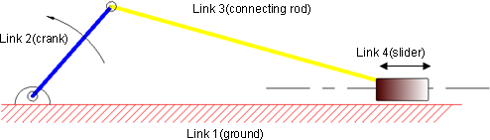

Fig:2.1Slidercrankmechanism

TYPESOFLINKS:Links can be classified into Binary,Ternary,andQuaternaryetc.dependinguponitsendsonwhichrevoluteorturningpairscanbeplaced.

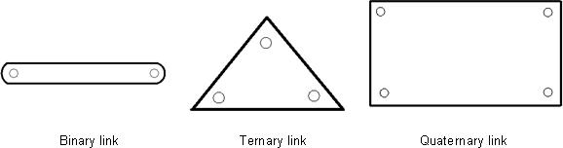

Fig.2.2Typesoflinks
According to their nature, the linkages can also be divided into rigid, flexible, and fluid categories.suchas
Rigidlinkisthelinkwhichdonotdeformwhiletransmittingthemotion
Belts, chains, and other types of flexible links can deform while transferring motion without impairing their ability to do so.
Fluid links, including hydraulic jacks, brakes, and lifts, convey motion using fluid pressure.
RIGID BODY
Whenever a force is applied, a body is said to be rigid if it does not flex or if the distance between two points on the body does not change. In order to facilitate our study, we assume that no body is totally rigid in practice.
RESISITANT BODY
A body that isn't rigid yet behaves like one while operating in a machine is said to be resistant. In actuality, there is no such thing as a stiff body.
KINEMATIC PAIR
A link between rigid entities that allows for relative motion between them is known as a kinematic pair. The relative locations of any two selected points on the chosen link cannot vary if the links are intended to be stiff in kinematics. In other words, it is viewed as one connection and the relative positions of any two points remain unchanged. This rigidity enables the placement of several complicated shaped linkages with straightforward schematic representations for kinematic and synthesis study of mechanisms.

CLASSIFICATION OF PAIRS
Kinematic pairs can be categorized based on the following factors: a) Kind of contact between elements; b) Type of relative motion; and c) Type of constraints or Type of closure.
Lower Pairs: Surfaces or region contact between the elements defines a lower pair of links. Similar surfaces are in touch on the two linkages.
Examples include a universal joint, a shaft spinning within a bearing, and a nut revolving on a screw.
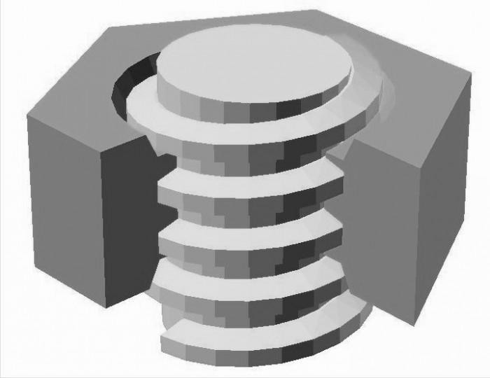

Fig.2.3Nut and screw
Higher Pair: A pair is referred to as a higher pair if there is some sort of point or linear joints contact between the links. The contact surfaces of the two links are dissimilar.
Rolling wheels, cam and followers pairs, toothed gears, ball & roller bearings, etc. were few examples.
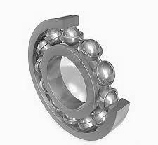

Fig.2.4 Roller Bearing

a) Relative motion type
Sliding Pair:
The two pairs which are sliding back and forth in relation to one another are referred to as sliding pairs.
Two examples include the piston's and cylinder as well as a rod inserted into a rectangular hole.
Turning Pair: A turning pair is created when two components revolve around one another.
The shaft in the bearing and a revolving cranks at a crankpin are two examples.
Screw Pair: Another name for this is helical pair. When two pieces are united, their relative motion results in a helical curve.
For instance, see Figure 2.3's Screwjack-Assisted Nut-and-Screw
Whenever one of the components is allowed to rolling over the other, the pair is said to be rolling.
Figure 2.4 shows an illustration of a wheel rotating on a level surface as an illustration of a spherical pair.
Example: Ball and socket joint

Explanation
In the slider crank mechanism (Fig. 2.6), the ground (link 1) and the crank (link 2) create a turning pair. Similarly, the connecting rod (link 3), slider (link 4), and crank (link 2) similarly create turning pairs. In relation to the ground (link 1), the slider (link 4) reciprocates and forms a sliding pair.

Fig.2.5Slider crank mechanism

The slider crank system shown here is just for the sake of kinematic analysis and synthesis; the actual external appearance of the mechanism will look different and be more sophisticated than that shown. The machine component will be created using a novel method.
a) Type of closure or Nature of Constraint

Closed pair: Both components of a pair are entirely encircled by one another.
Examples: A screw and nut pair.

Open Pair: When an external force has been used to keep them together and prevent separation.
examples: a pair of cams and followers

DEGREES OF FREEDOM

DOF
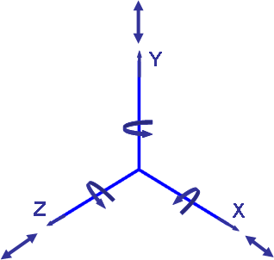
There are 6 degrees of freedom for an object in space. (3D.O.F.) translation along the X, Y, and Z axes(3D.O.F.) Rotary motion around the X, Y, and Z axes

Fig.2.6 DOF

The rigid body possesses six degrees of freedom (DOF) in space, but owing to linkage formation, one or more DOFs are lost since there is a restriction on the body.Since the body must be fixed in some manner in order for the connection to be conceivable, the total number of constraints cannot be zero.As a result, freedom is granted by

DOF=6-(Numbers of Restraints)

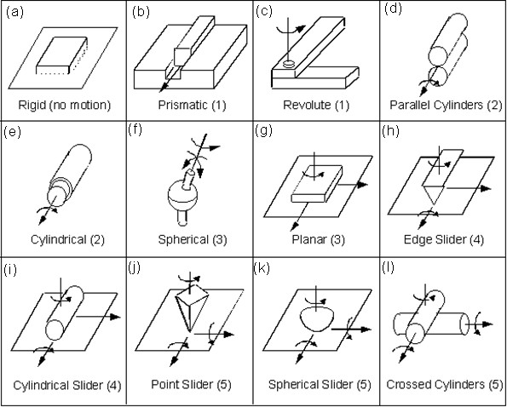

Fig.2.7Pairs having varying DOF

S.  No. | GeometricalShapesinvolved | Restraintson |  | Degree of freedom | Totalrestraints
S.  No. | GeometricalShapesinvolved | Translatorymotion | Rotarymotion
(a) | Rigid | 0 | 0 | 0 | 6
(b) | Prismatic | 2 | 3 | 1 | 5
(c) | Revolute | 3 | 2 | 1 | 5
(d) | Parallelcylinders | 2 | 2 | 2 | 4
(e) | Cylindrical | 2 | 2 | 2 | 4
(f) | Spherical | 3 | 0 | 3 | 3
(g) | Planer | 1 | 2 | 3 | 3
(h) | Edgeslider | 1 | 1 | 4 | 2
(i) | Cylindricalslider | 1 | 1 | 4 | 2
(j) | Pointslider | 1 | 0 | 5 | 1
(k) | Sphericalslider | 1 | 0 | 5 | 1
(l) | Crossedcylinder | 1 | 0 | 5 | 1

Table2.1

Figure | ExplanationforDOF
2.9 a | (0) AsthereisnomotionhenceDOFiszero
2.9 b | (1)Asmovement ispossibleonlyinZdirection.
2.9 c | (1) AsitcanrevolvearoundYaxis
2.9 d | (2) AsoneelementcanmoveinZaxis&alsorevolvearoundZaxis
2.9 e | (2) AselementinsidecanrevolvearoundZaxisandalsomoveinZaxis
2.9 f | (3) AselementcanrevolvearoundX,Y&Zaxis
2.9 g | (3) AselementcanrevolvearoundYaxis&canmoveinZ&Xaxis
2.9 h | (4)AselementcanrevolvearoundZ&Yaxis&canmoveinYaxis
2.9 i | (4)AselementcanrevolvearoundZ&Yaxis&canmoveinZ&Xaxis
2.9 j | (5)AsanelementcanrevolvearoundX,Y&Zaxis&canmoveinX&Zaxis
2.9 k | (5)AselementcanrevolvearoundX,Y&Zaxis &canmoveinX&Zaxis
2.9 l | (5)As elementcanrevolvearoundX,Y&Zaxis&canmoveinX&Zaxis
Table2.2

KINEMATIC CHAIN
a) Kinematic chain: A kinematic chain is an arrangement of links joined by joints or pairs, where relative movements between the links are both feasible and defined.

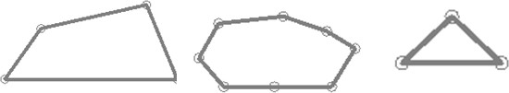

a. kinematicchain b.nonkinematicchain c.redundantchainFig.2.8 kinematicchains

- Non-kinematic chain: A chain is considered non-kinematic if the motion of one link causes the motion of further links to continue indefinitely. Due to the fact that if we move one link in the chain, the other links might move into an endless position, this indefinite motion is necessary.
- Redundant chain: The duplicate chain cannot move in either direction. Figure 2.9c shows that this link is locked as a result of its shape.

DEGREEOF FREEDOM IN A MECHANISM

Following are some explanations for a mechanism's degrees of freedom in space:

Let N be the overall mechanism's number of linkages.

Degrees of freedom = F

J1 is the quantity of pairs with a single degree of freedom.

J2 is the quantity of pairs with 2 degrees of freedom. When one of a mechanism's linkages is fixed

Then, the number of the movable links are = N-1
Degrees of freedom of (N-1) movable links =6(N-1)

The mechanism's degrees of freedom are reduced by five for every pair of single degree-of-freedom links (because each movable link has six degrees of freedom). This is because any of the linkages may be restricted without affecting the system. The mechanism to lessen its degree of freedom is constrained by other pairs with 2, 3, 4, and 5 degrees of freedom.

Then, the DOF can be given by
F=6(N-1)-5J₁-4J₂-3J₃-2J₄-1J₅
The bulk of the mechanisms we frequently study are of a two-dimensional kind, such as the slider-crank mechanism, which permits lateral movement along two axes with only one restriction and rotational motion around just one axis with two restraints. Consequently, there are three main limitations for a two-dimensional system. A connection has three degrees of freedom in two dimensions, which may be seen with the help of Figure 2.10.
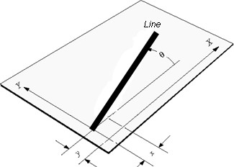

Fig.2.9alineinaplanehasthreeDOF:x, y,θ
Therefore, for plane mechanism, the following relation can be used for degrees offreedom,

F=3(N-1)-2J₁-1J₂
This formula is referred to as the "Grueseler Criteria for Degrees of Freedom of Plane Mechanism." It should be noted that Gruebler's criteria does not account for the geometry of the mechanism, which might lead to inaccurate predictions. Inspection is thus advised in some instances to determine the levels of freedom.
Example:2.1 Determine the mechanism's degree of freedom from the one shown below.
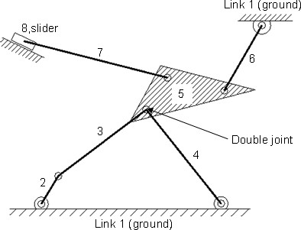

Fig.2.10
Solution:
Number of links=8

There are 8 connections.

Pairs of numbers with one degree of freedom equal 10 by counting Pair calculation techniques
Link 1(ground) & link 2 together make up the first turning pair.
Pair2 Link 2 along with Link 3 make up a single rotating pair.
Link 3 and link 5 together make up a single turning pair.
Link 4 & Link 5 together make up a single rotating pair.
Link 5 & Link 6 together make up a single rotating pair.
Pair6 The ground (link1) and link 6 together make up a turning pair.
Link 5 & link 7 together make up a turning pair.
Link7 & Link 8 together make up a turning pair.
A sliding pair is made up of Link 8 with ground (Link 1) in pair 9.
Pair10 Ground (link1) and Link 4 together make up a turning pair.

As all the pair calculated have one degree of freedom so there is only termJ₁ is used as it denotes the pair having single degree of freedom.
J₁=10 (as all pairs have one degree of freedom)
F=3(N-1)-2J₁-1J₂

DOF=3(8-1)-2×10=1
The degree of freedom is1 for this mechanism.
Example2.2 Find the mechanism's degree of freedom from the one shown below.

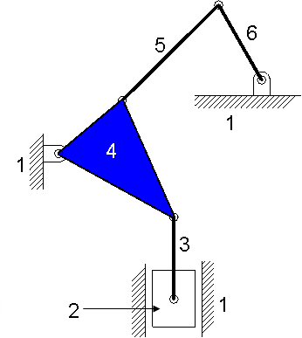

Fig.2.11
Solution:
Number of links = 6
Number of Pairs = 7
J₁ = 7 (six turning pairs & one sliding pair)

DOF=3(6-1)-2×7=1
The degree of freedom is 1.
Example2.3: Determine the flexibility or DOF of the given mechanism.

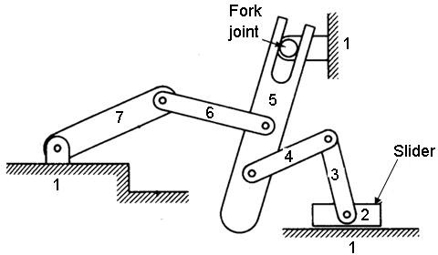

Fig.2.12
Solution:
Number of links = 7
Number of Pairs = 8
J₁ = 7 (six turning pairs & one sliding pair)
J₂ = 1 (Fork joint is two DOF joint)

DOF=3(7-1)-2×7-1×1=3
The degree of freedom is 3.

FOUR BAR MECHANISM
The four bar connection, shown in figure 2.13 below, is a straightforward and often used mechanism. Additionally, nearly every planar a single degree of freedom (DOF) mechanism has "equivalent" four bar mechanisms. On the 4 bar construction, the pivots for the two spinning links (2 and 4) are fixed. The input rotation lever would be the other lever, and the output tilt lever would be the first. For the two levers, the link that attaches the coupler serves as the connection (3), and the ground link acts as their fixed pivot.
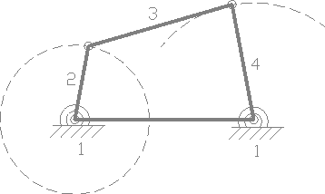

Fig.2.13fourbarmechanism
Continually rotatable ground-pivoted connection named "Crank" (2).
A ground-pivoted link known as a "rocker" (4) is unable to spin continuously and can only oscillate between two limit positions.
An opposing link to the immovable link is a coupler (3).

1. A link cannot function as a four bar linkage if its length is more than the total of the lengths of the other three connections.

2. If the total of the scales of the largest and shortest connections is smaller than the sum of all of the dimensions of the other two links, the connection is referred to as a class-1 4 bar connection.

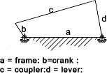

Fig.2.14 crank rocker
The links next to the shortest connection, b, in figure 2.14, are fixed. Cranked-lever or crank rocker mechanisms are the names given to the resulting mechanism.
The resulting mechanism is a cranked-crank or double crank mechanism if the shortest link, b, is fixed.
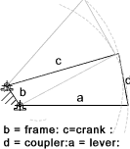

Fig.2.15 Double Crank

The mechanism is referred regarded as a double-rocker or double lever mechanism if the link directly across from the shortest link is fixed.
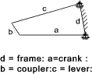

Fig.2.16 Double Crank
INVERSIONS OF SLIDER CRANK MECHANISM
When we set various Kinematic Chain links, we receive distinct mechanisms, and this phenomena is referred to as mechanism inversion. An inversion of a slider crank mechanism is as follows:

1st Inversion
Link 1 has been fixed (as seen in fig. 2.17) & links 2 and 4 are made the crank and the slider, respectively, to achieve this inversion.
Application: I.C. engines, steam engines, and reciprocating compressor mechanisms all frequently utilize this mechanism.
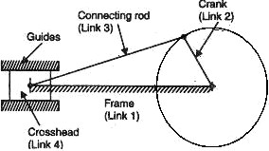

Fig.2.17 Reciprocating Engine
2nd Inversion

A slider mechanism's second inversion is produced by fixing link 2. The second inversion is used in the gnome engine or rotary engine mechanism. It is an internal combustion engine with rotating cylinders of the V design that is utilised as an aviation engine. Seven cylinders are commonly found in a single plane of a rotary engine. At this stage, every piston's connecting rod is connected to the fixed crank (link 2). The complete configuration of cylinders, pistons, and connecting rods of a mechanism revolves around axis O when the pistons that move in the cylinders reciprocate. The crankshaft spins as a result of the total mechanical system rotating.
Application: Rotary engine mechanism or gnome engine

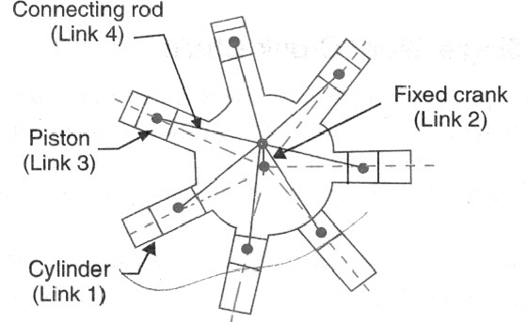

Fig.2.18 Rotary Engine
3rd Inversion

We may get the 3rd inversion (as shown in fig.2.19) by repairing the slider crank mechanism's link 3 (connecting rod). It is utilized in toys as well as lifting engine mechanisms. Its construction's primary benefits for hoisting applications are that it provides for a straightforward means of providing steam to the cylinder.
Application: It is utilized in toys as well as lifting engine mechanisms.
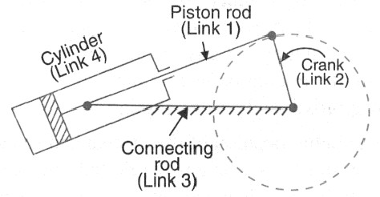

Fig.2.19 Oscillating Cylinder Engine
4th Inversion
We can get the fourth inversion of the slider crank by repairing link 4 of the slider crank mechanism. Fixing a slider entails both a fixation of its location and a fixation of its rotation. The cylinder will need to be slotted in this situation so that the piston pin of the connecting rod may pass through when the cylinder glides over the piston. Due to this challenge, the cylinder and piston forms are switched as seen in the image below.
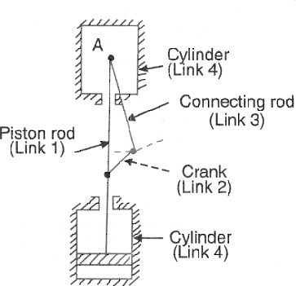

Fig.2.2 open Pendulum pump
Application: hand pump

