GREEN NANOTECHNOLOGY: NEW PATHWAY IN SCIENCE

Introduction
Nanotechnology refers to reading of the size of Substance at the atomic or molecular level. It refers to sizes from 1 to 100 nanometers in at least one dimension and includes many variations in material size. Nanomaterials have various properties such as: B. It is durable, lightweight, very strong and has very good properties. Nanotechnology requires the ability to design molecular-sized works and specific machines. Simply put, nanotechnology is the simple ability to build things from scratch. This nanotechnology was first described by a scientist named R. Feynman and had a variety of uses. The National Science Foundation can describe nanotechnology as understanding molecules as individual atoms and molecules. Science, engineering and technology play an important role in global competition. Modern science has in large part one of nature's revolutionary qualities as a form of nanoscale technological excellence.
Today, nanotechnology is recognized as one of the tools for the development of all sectors of society and most industries. The convergence and divergence of vertical developments, especially in the natural and engineering sciences. From the 18th century to his 19th century, science made great progress. Nanoscale Convergence Arrived in Science in 2000 and Has Delivered New Developments in Science Over the Past Decades
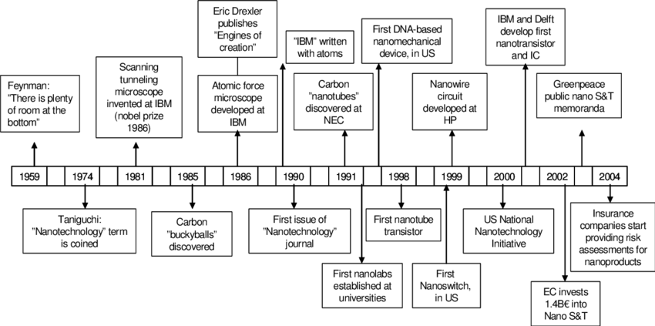

Fig.1 Development of the nanotechnology
Figure 2. Reaching at the Nano world (about 2000)

Branches of the Nanotechnology
It is a very large development and incorporates products that serve the faculty and universities for the improvement of various industrial and residential purposes. There are many fields of nanotechnology that could be targeted for global markets, such as agricultural non-petroleum commodities, minerals, etc. Nanotechnology is viewed as a continual punishment in rapports of its impression on commercial programs. The Nano science sector proposals answers to a variety of problems, including business and family issues. Based on the sturdy inner sheet of nanotechnology, there are many areas that can be defined within Decision 3.

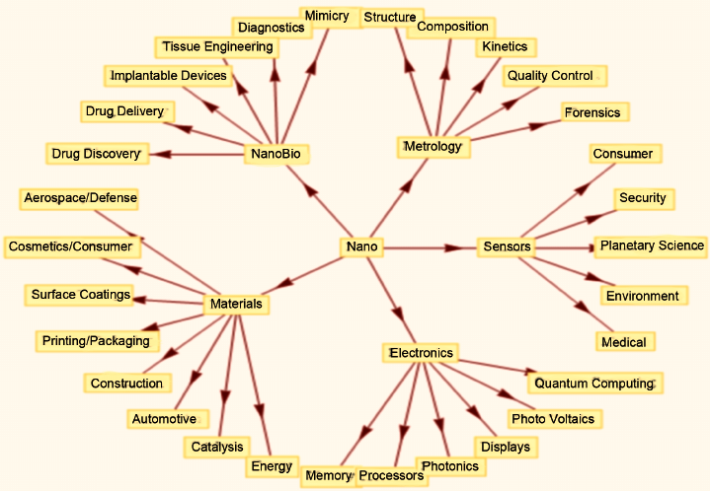
Fig. (3) Curtsy by M. Amin Bhat
1. Nano engineering
This nanotechnology is a very important area of ​​Nano scale nanotechnology practice. The term Nano engineering comes from the nanometer, a part equal to one billionth of a meter, in the field of engineering rather than applied science. The most common techniques are scanning tunneling microscopy and other molecular assembly techniques used to study individual atoms in nanotechnology, which can be used to study many biological structures. Most often, scanning tunneling microscopy and molecular self-assembly tunneling microscopy are the main techniques in nanotechnology used for microscopy (STM), and molecular self-assembly is his two systems in nanotechnology . While STM is used to create constructions as small as sole atoms, molecular self-assembly allows the synthesis of arbitrary DNA sequences to generate tradition proteins or unvarying outlines of amino acids. [5].

2. Nano Science by green approch
Nano Science by green approach is a outlet of nanotechnology that improves the environmental performance of processes that produce adverse aspects. This includes the production of eco-friendly nanoproducts and the subsequent use of these nanoproducts to support sustainability [6]. The area of emerald nanotechnology is to abate impending risks to the environment and anthropoid healthiness connected with the habit of nanotechnology produces to facilitate the standby of present products with more environmentally friendly Nano harvests. Planetary cells [7], Nano remediation, aquatic treatment – ​​all submissions are grounded on avocado Nano Science [8].
Green Nano Science is a subdivision of nanotechnology that improves the conservational performance of developments that produce undesirable aspects. This contains the production of eco-friendly nanoproducts and the subsequent use of these nanoproducts to support sustainability [6]. The goalmouth of green nanotechnology is to curtail forthcoming risks to the environment and hominid wellbeing allied with the use of nanotechnology products and to facilitate the standby of present harvests with more environmentally friendly nanoproducts. Solar cells [7], nanoremediation, water treatment – ​​all submissions are based on green Nano Science [8].

3. Nanotechnology by Wet
refers to processing small to large masses [9]. O Eric Drexler came up with the idea of ​​dry running his nano his assembler. Wet nanotechnology appears to be the first area where Nano assemblers have achieved commercial success. His science of medicine and life is a key feature of wet nanotechnology [10]. Sci.,brings fragments of natural nanotechnology into bio-eclectic nanotechnology synthetic structures. Tons of nanotech robots have been developed using the basic principles of biomimetic nanotechnology. These robots, similar in their structural properties to bacteria, enter the human bloodstream to perform medical procedures such as cancer [11].

Uses of Nano Science

Over the past dual times, geniuses and wangles have learned the intricacies of occupied without devices, and exploration is ongoing. Most products today are made from Nano scale materials. A sunscreen containing zinc oxide Nano scale and titanium dioxide that reflect UV rays to prevent sunburn. Nano scale dry powder can neutralize gases. Nano scale resources are rummage-sale, for example, to make batteries for gears that deliver more influence faster and emit less heat. Antimicrobial wound dressings use Nano-silver [11]. Additional applications of Nano Science include sports apparatus, automotive fragments, energy stowing in batteries, creaming effects in drug delivery, cosmetics, and many additional nanomaterial-based technologies work
1. Nano tubes of carbon
CNT are from carbon allotropes with cylindrical nanostructures. Nanotubes are designed to have -diameter to length to ratios of up to 280,00,000:1, abundant superior than some additional substantial. These tube-shaped carbon iotas own strange asset and exclusive electrical possessions. These new possessions make them very valuable for a diversity of applications in nanotechnology, optics, electronics, ingredients science, and architecture. However, their ultimate use might be partial by probable venomousness [11]. A nanotube is shown in Numeral 2.

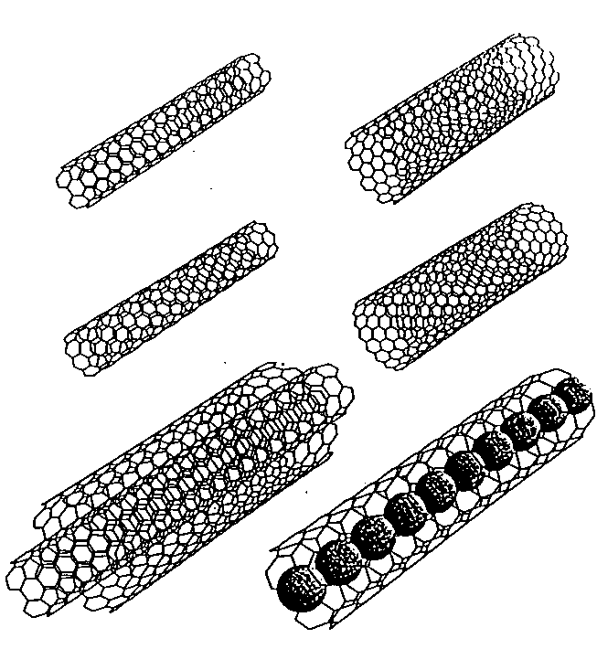
Fig.4. Carbon Nano Tubes (CNT) [Source 11]

2. Nano Films as thin
A variety of Nano scale supplies can be charity in thin films to be marine nauseating, Ultra Voilet or IR impervious, antireflective, antibacterial, self-cleaning, antifogging, scratch impervious, or electrically conductive. Nanofilm applications include mainframe monitors, cameras, and specs [11]. The nanofilm is revealed in Figure 3.

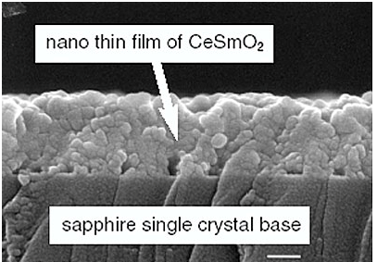

Fig.5. Thin Nano film [source 11]

3. Transistors using the Nano gage
A transistor is a semiconductor electronic device secondhand to amplify or switch electronic gestures or currents. A transistor uses a small quantity of current as a gate to control the flow of large amounts of current. The more transistors a computer have, the better its performance. Transistors are getting smaller every day and computers are getting more powerful. To date, the manufacturing's best profitable expertise produces processor fries with transistor characteristics as unimportant as 45 nanometers. Recent publications have shown that even smaller transistors are possible using nanotechnology [11]. A Nano scale transistor is shown in Character 4.

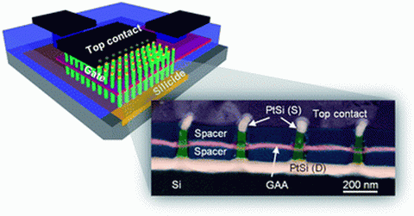
Fig.6 Transistors in Nano scale [ References 12]

4. Dendrimers in Drug-Transfer Method using
Dendrimers stand very extremely split, star-molded different macromolecules with nanoscale extents, as shown in Figure 5. Dendrimers remain explicitly designed and factory-made for a variability of bids, counting cancer therapy, treatment distribution, catalysis, gene fixation, besides liveliness and photoactivity harvesting. Dendrimers ringing changed materials and their twigs can do multiple effects at the same stretch: B. Recognize ailing cells, diagnose disease shapes (including cell expiry), administer drugs, describe locations, and report therapeutic events [11].

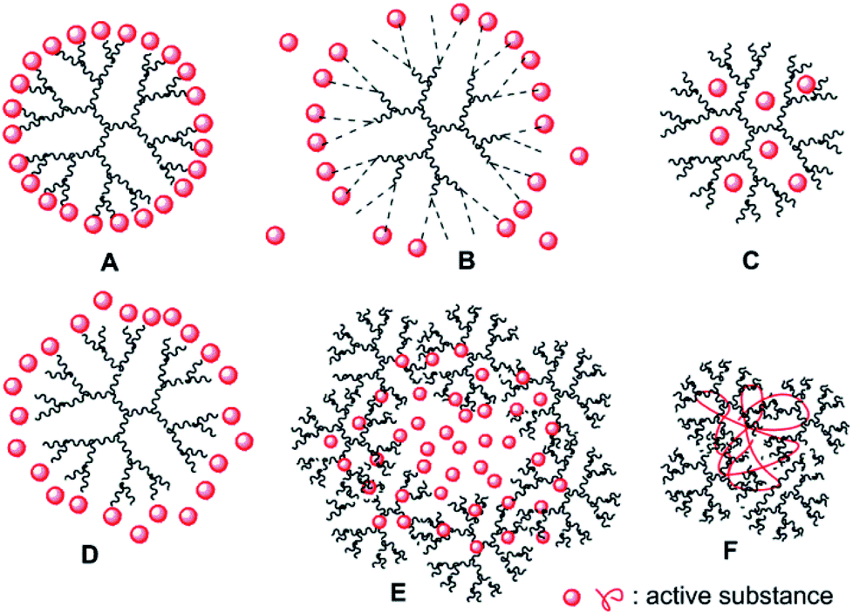

Fig.7. dendrimers Drug delivery [Reference 11]

5. Water Filtration technique
Carbon and doped carbon nanotube-built membranes stay used in water detoxification too Nano sensors for diagnosing contaminants in water systems. Figure 6 shows the water filtration process using carbon nanotubes. Nano scale titanium dioxide is another Nano scale material with great potential for filtration and purification of water systems, and is also recycled in sunblock creams to nullify bacteria [11].

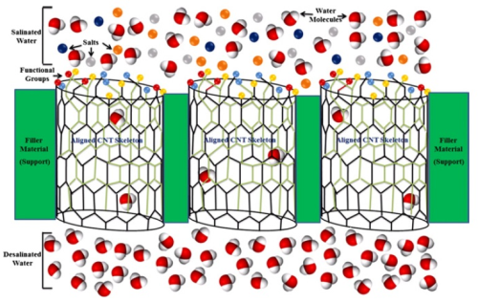
Fig.6. filtration technique for water [Reference 8]

Conclusion

Nanotechnology and Nano biotechnology is the discipline of minor subdivisions. Nano Science envisages a ecosphere where novel merchandises are developed at the different atomic and different molecular level. It provides a practical and cost-effective way to connect good renewable liveliness sources and keep the setting fresh. Today, countless scientists and wangles are finding newfangled ways to use Nano Science to make ecosphere a better place. Nanotechnology has many applications, including microchip technology, environmental science, chemical engineering, and robotics. Nanotechnology can help doctors detect disease earlier and treat conditions like malignancy, and diabetes heart disease, with more actual and benign drugs. Academics also envision new know-hows to protect in cooperation neutrals and soldierly personnel after conservative and organic missiles. While many research challenges remain, basic nanotechnology is even now making a wide variety of inexpensive resources, paving the way for progress in many areas. We have advanced scientific research at the nanoparticle level and opened up a biosphere of new possibilities.
References
[1] Handbook on Nanoscience, Engineeering and Technology, 2nd Ed., Taylor and Francis, 2007.
[2] Centre Responsible For Nanotechnology, http://www.crnano.org/whatis.html.
[3] D.Bhattacharyya1 et.al., “Nanotechnology, Big things from a Tiny World: a Review”, International Journal of u- and e- Service, Science and Technology, Vol. 2, No. 3, September, 2009.
[4] Nanotechnology: A Brief Literature Review M.Ellin Doyle, Ph.D Food Research Institute, University of Wisconsin–Madison, Madison, WI 53706.
[5] Lusk, Mark T., and Lincoln D. Carr. "Nanoengineering defect structures on graphene." Physical review letters 100.17 (2008): 175503.
[6] "Environment and Green Nano - Topics - Nanotechnology Project". Retrieved 11 September 2011
[7] National Nanotechnology Initiative. http://www.nano.gov
[8] "Nanotechnology in water treatment". Retrieved 3 November 2013.
[9] http://faculty.tamu-commerce.edu/dyeager/599/newtechnologyparti_files/v3_slide0205.htm Contemporary Tech
[10] http://www.questia.com/read/113729011?title=7%3A+Wet+Nanotech ; Book by William Illsey Atkinson "Nanocosm: Nanotechnology and the Big Changes Coming from the Inconceivably Small" (c) 2003.
[11] http://www.nottingham.ac.uk/physics/research/nano/pdfs/N15ND05.pdf Nanotechnology.
[12] Nanoelectronics:Nanotechnology in electronics. http://www.understandingnano.com

