IoT BASED MULTI LANGUAGE (ML) SMART NOTICE BOARD USING ANDROID APP

Dr. K. Rasadurai, M.E Ph.D
Professor, Department of ECE,
Kuppam Engineering College, Kuppam-517425, AP India.
* Email: krasadurai@gmail.com, https://orcid.org/0000-0003-4969-1845

Abstract: Notice Board is the most important thing in all schools, colleges, organization, offices and all other common public places like Mofussil Bus Terminus, Metro Station Railway Junctions and Air Ports, etc., but changing the data in the notice board daily and multiple languages are difficult process. More Manpower is required to manage notice boards. Most common issues are handling printing documents. In this paper presented novel model of smart notice board based on Internet of Things (IoT) and Wi-Fi, for multi language display. The proposed system support to minimize cost and workforce. In this system, the user can write the data from anywhere in the world to the Notice Board from an android mobile. The android application is supported by using Massachusetts Institute of Technology (MIT app) inventor. The user can send Multi language a text message or a voice message to display it in the IoT based Multilanguage smart Notice board. Whenever a new notice is updated the speaker announces an alert message “Hello everyone, a new message is displayed”. This will reduce the time to update the data as well as it will efficiently transfers the data to the notice board.
Keywords— IoT, MIT App, Smart Notice Board

Introduction (Heading 1)
The main purpose to design this IoT based smart notice board using android app is to interface it with user mobile phones for displaying the latest information. Now a day’s due to development Mobile Wireless Broadband communication Networks, an individual's interact with people easily and it require less time. This paper is to develop a IoT based Multi language smart notice board that display message sent from the user through Android app and to develop user friendly system, which may receive and display notice in a very specific manner which will help the user to simply keep the track of notice board each day and every time he/she uses the system.
The motivation behind an IoT-based smart notice board using an Android app is to provide an innovative solution for communication and information sharing in various settings such as offices, schools, hospitals, and public spaces. Traditional notice boards require manual updates, which can be time-consuming and inconvenient. They can also be limited in terms of space and may not be easily visible or accessible to everyone.
By leveraging IoT technology and an Android app, a smart notice board can provide a more efficient and flexible solution. Users can remotely update and manage the content of the notice board, eliminating the need for physical updates. Additionally, the app can provide scheduling options, ensuring that information is displayed at the appropriate times.
Furthermore, the use of IoT technology in this project can enable connectivity between the notice board and other devices or systems, allowing for more advanced features and integration. For example, the notice board could be integrated with a calendar system to automatically display upcoming events or appointments.
Overall, the proposed system is to provide a well-organized, flexible, and innovative solution for communication and information sharing that can be applied to various settings. The use of IoT technology and an Android app can provide a platform for advanced features and integrations, making it a highly customizable solution for different use cases.

LITERATURE SURVEY
"Smart Notice Board using Raspberry Pi" by B. L. Dhale and S. S. Wankhade, published in the 2015 IEEE International Conference on Computer, Communication and Control (IC4), explores the development of a smart notice board system using a Raspberry Pi single-board computer. The authors detail the hardware and software components of the system, as well as its functionality and potential applications.
"Smart Notice Board for Universities" by M. Saranya and V. S. Sathya, published in the 2015 IEEE International Conference on Engineering and Technology (ICETECH), describes a smart notice board system designed specifically for use in universities. The authors discuss the development of the system's hardware and software components, as well as its potential benefits for students and faculty.
"A Wireless Smart Notice Board System Based on ZigBee Technology" by X. Zhou and J. Ma, published in the 2012 IEEE International Conference on Information Science and Technology (ICIST), presents a wireless smart notice board system based on ZigBee technology. The authors describe the system's hardware and software components, as well as its communication protocol and message format.
"Smart Notice Board with Image Processing and SMS Alerting" by M. T. N. Karthik and K. Usha Rani, published in the 2014 IEEE International Conference on Emerging Trends in Communication, Control, Signal Processing & Computing Applications (C2SPCA), discusses a smart notice board system that uses image processing and SMS alerting to notify users of new notices. The authors detail the system's hardware and software components, as well as its image processing algorithms and SMS alerting mechanism.
"Development of a Smart Notice Board System for Shopping Malls" by S. K. Lee, J. H. Lee, and J. Y. Jeong, published in the 2014 IEEE International Conference on Information and Communication Technology Convergence (ICTC), describes the development of a smart notice board system for use in shopping malls. The authors discuss the system's hardware and software components, as well as its potential benefits for mall managers and customers.
"Smart notice board using GSM" by R. K. Vishwakarma, N. Kumar, and A. K. Singh (2011). This paper describes a smart notice board that uses a GSM modem to receive messages and display them on an LCD screen. The system also allows users to remotely update the messages using a mobile phone.
"Wireless based digital notice board with multi point receivers" by R. M. Damahe and S. D. Joshi (2012). This paper presents a wireless-based digital notice board that uses multiple receivers to display messages in different locations. The system uses a microcontroller and a wireless transceiver to transmit and receive messages.
"Smart notice board using Bluetooth technology" by A. V. Kulkarni and P. V. Jadhav (2013).This paper proposes a smart notice board that uses Bluetooth technology to receive messages from mobile devices. The system uses an Android application to send messages to the notice board, which is based on an AVR microcontroller.
"Design of smart notice board using Zigbee" by R. S. Reddy and K. R. Venugopal (2014). This paper presents a smart notice board that uses Zigbee technology to receive messages from a remote location. The system uses a microcontroller and a Zigbee transceiver to communicate with a PC, which is used to update the messages.
"Smart notice board using RFID technology" by S. S. Kadam and S. B. Gajre (2015). This paper describes a smart notice board that uses RFID technology to display personalized messages to users. The system uses an RFID reader to identify users and display messages tailored to their preferences.

Internet of Things (IoT)

IoT
The Internet of Things (IoT) is a system of interconnected sensors and actuators with Processor via various devices with each other over the internet. In this paper, IoT is used to connect the Smart Notice Board to the internet, enabling it to be remotely controlled and updated.
The ESP8266 is used as a Wi-Fi module that allows the notice board to connect to the internet. It provides a way to receive and send data between the notice board and the Android app. With IoT, the user can remotely update the notice board with important information and notifications without being physically present.
Moreover, the IoT technology in this project enables the notice board to receive data from external sources, such as weather forecasts or news updates. With this feature, the notice board can display real-time information and keep the user informed about the latest news and events.
The IoT technology used in this project provides an efficient way to manage and control the Smart Notice Board. With its connectivity features, the notice board can be updated and controlled from anytime, anywhere, making it easy solution for workplaces.
Improved Efficiency: IoT technology in the Smart Notice Board improves its efficiency as it can be controlled remotely. This eliminates the need for manual updates and makes the process more efficient.
Real-time Updates: IoT technology enables the notice board to receive real-time updates, such as weather updates or news alerts, which can be announced on the notice board. This helps keep the user informed and up-to-date on the latest updates and details .
Cost-Effective: IoT technology makes the Smart Notice Board cost-effective as it eliminates the need for a dedicated computer or a human operator to manage and update the notice board.
Enhanced User Experience: The IoT technology in the Smart Notice Board enhances the user experience by providing a user-friendly interface that allows the user to control the display settings and receive notifications. This makes the notice board more interactive and engaging.
Future-proofing: With IoT technology, the Smart Notice Board is future-proofed, as it can be updated and upgraded with new features and functionalities as technology advances. This ensures that the notice board remains relevant and useful for years to come.

Problem Statement
The problem statement for using an IoT-based smart notice board using an Android app is that traditional notice boards are inefficient and time-consuming to update, especially in large organizations. It is also challenging to ensure that the intended audience receives the message, leading to miscommunication and inefficiency. Additionally, traditional notice boards cannot be updated in real-time, leading to outdated information being displayed for an extended period.
The major problems are:
• Traditional notice boards are often ineffective due to various reasons such as the delay in updating notices, difficulty in accessing them, limited visibility, and the cost of printing and paper waste. This can result in miscommunication, missed deadlines, and a lack of awareness.
• Traditional notice boards are often static, require manual updating, and can be easily overlooked or ignored by the intended audience.
• Additionally, traditional notice boards may not be accessible to everyone, such as those with visual impairments.
The traditional notice boards are slowly losing their significance in the modern world. They lack the ability to convey real-time information and require manual efforts for updating them. In order to overcome these limitations, an IoT-based smart notice board using an Android app has been proposed. However, several challenges and issues need to be addressed to make this technology feasible and effective.

existing system
In the present status in the notice boards are being maintained by hand through papers or any other devices. This is a time taking processes to showed information on the notice board.

Wireless Notice Board Using Bluetooth And Arduino
The existing system is based on Global system for Mobile equipment so it requires mobile phone and SIM to send the post on notice board. The system is also holds global roaming capability of GSM, so we can send message to receiver from anywhere of the world and requires extra charges. The drawbacks of this type of systems are: as there is no password any one can send the message to display and also when there is a network problem the GSM doesn’t work.

Proposed System
An IoT-based smart notice board using an Android app system is a project that utilizes various hardware components such as Arduino Uno, ESP8266 NodeMCU, and P10 LED display to create a smart notice board that can be remotely operated through an Android app. It receives commands from the ESP8266 NodeMCU through a serial connection and controls the P10 LED display to display text. The ESP8266 NodeMCU is a Wi-Fi module that connects the notice board to the internet. It receives commands from the Android app through a Wi-Fi connection and sends them to the Arduino Uno.
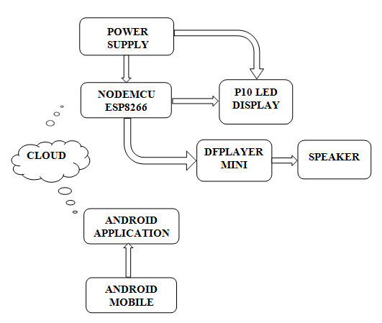
Fig.1. Block Diagram
The P10 LED display is a matrix of LED modules that can display text and graphics. It is controlled by the Arduino Uno through a protocol called the HUB75 interface.
The Android app is the user interface of the project. It allows the user to send text and graphics to the notice board from a remote location. The app sends the commands to the ESP8266 NodeMCU, which then relays them to the Arduino Uno.
The overall system architecture of the project involves the Android app communicating with the ESP8266 NodeMCU over Wi-Fi. The NodeMCU then sends the commands to the Arduino Uno, which controls the P10 LED display to show the desired text.
Overall, the IoT-based smart notice board using Android app system with Arduino Uno, ESP8266 NodeMCU, and P10 LED display is a useful and innovative project that can be used in a variety of colors, font size, different settings, including common utility place. It gives effective way to display information remotely, making it easy for users to keep up with important announcements and updates.

A. Simulators for Arduino .
The powerful simulators for Arduino is prospoed, Example: Proteus, Autodesk Circuits, Autodesk Eagle (recommended), and Virtronics Simulator, Electrify,Fritzing, VBB4 Arduino – Virtual Breadboard for Arduino.

INCLUDEPICTURE "E:\\var\\folders\\21\\qmt4cpvn3md2w4nlgszh905r0000gn\\T\\com.microsoft.Word\\WebArchiveCopyPasteTempFiles\\page12image12794288" \* MERGEFORMATINET INCLUDEPICTURE "E:\\var\\folders\\21\\qmt4cpvn3md2w4nlgszh905r0000gn\\T\\com.microsoft.Word\\WebArchiveCopyPasteTempFiles\\page12image12794288" \* MERGEFORMATINET INCLUDEPICTURE "E:\\var\\folders\\21\\qmt4cpvn3md2w4nlgszh905r0000gn\\T\\com.microsoft.Word\\WebArchiveCopyPasteTempFiles\\page12image12794288" \* MERGEFORMATINET INCLUDEPICTURE "E:\\var\\folders\\21\\qmt4cpvn3md2w4nlgszh905r0000gn\\T\\com.microsoft.Word\\WebArchiveCopyPasteTempFiles\\page12image12794288" \* MERGEFORMATINET INCLUDEPICTURE "E:\\var\\folders\\21\\qmt4cpvn3md2w4nlgszh905r0000gn\\T\\com.microsoft.Word\\WebArchiveCopyPasteTempFiles\\page12image12794288" \* MERGEFORMATINET INCLUDEPICTURE "E:\\var\\folders\\21\\qmt4cpvn3md2w4nlgszh905r0000gn\\T\\com.microsoft.Word\\WebArchiveCopyPasteTempFiles\\page12image12794288" \* MERGEFORMATINET INCLUDEPICTURE "E:\\var\\folders\\21\\qmt4cpvn3md2w4nlgszh905r0000gn\\T\\com.microsoft.Word\\WebArchiveCopyPasteTempFiles\\page12image12794288" \* MERGEFORMATINET INCLUDEPICTURE "E:\\var\\folders\\21\\qmt4cpvn3md2w4nlgszh905r0000gn\\T\\com.microsoft.Word\\WebArchiveCopyPasteTempFiles\\page12image12794288" \* MERGEFORMATINET INCLUDEPICTURE "E:\\var\\folders\\21\\qmt4cpvn3md2w4nlgszh905r0000gn\\T\\com.microsoft.Word\\WebArchiveCopyPasteTempFiles\\page12image12794288" \* MERGEFORMATINET INCLUDEPICTURE "E:\\var\\folders\\21\\qmt4cpvn3md2w4nlgszh905r0000gn\\T\\com.microsoft.Word\\WebArchiveCopyPasteTempFiles\\page12image12794288" \* MERGEFORMATINET INCLUDEPICTURE "E:\\var\\folders\\21\\qmt4cpvn3md2w4nlgszh905r0000gn\\T\\com.microsoft.Word\\WebArchiveCopyPasteTempFiles\\page12image12794288" \* MERGEFORMATINET INCLUDEPICTURE "E:\\var\\folders\\21\\qmt4cpvn3md2w4nlgszh905r0000gn\\T\\com.microsoft.Word\\WebArchiveCopyPasteTempFiles\\page12image12794288" \* MERGEFORMATINET INCLUDEPICTURE "E:\\var\\folders\\21\\qmt4cpvn3md2w4nlgszh905r0000gn\\T\\com.microsoft.Word\\WebArchiveCopyPasteTempFiles\\page12image12794288" \* MERGEFORMATINET INCLUDEPICTURE "E:\\var\\folders\\21\\qmt4cpvn3md2w4nlgszh905r0000gn\\T\\com.microsoft.Word\\WebArchiveCopyPasteTempFiles\\page12image12794288" \* MERGEFORMATINET INCLUDEPICTURE "E:\\var\\folders\\21\\qmt4cpvn3md2w4nlgszh905r0000gn\\T\\com.microsoft.Word\\WebArchiveCopyPasteTempFiles\\page12image12794288" \* MERGEFORMATINET INCLUDEPICTURE "E:\\var\\folders\\21\\qmt4cpvn3md2w4nlgszh905r0000gn\\T\\com.microsoft.Word\\WebArchiveCopyPasteTempFiles\\page12image12794288" \* MERGEFORMATINET 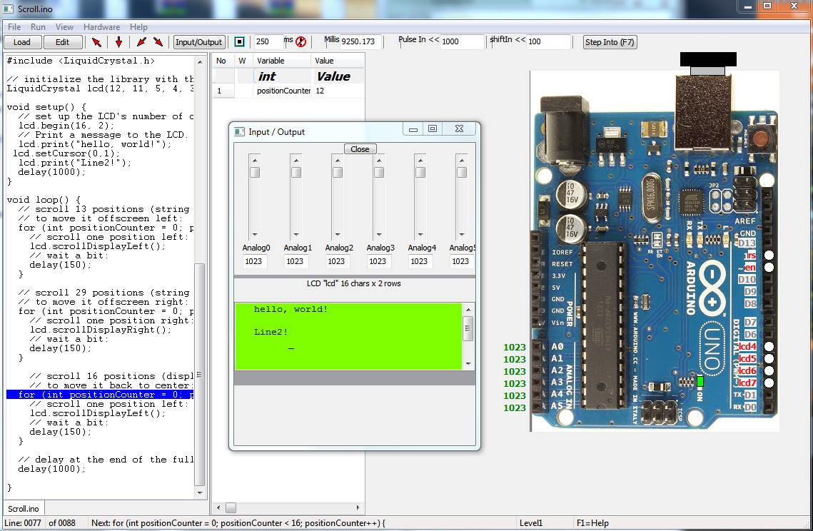

INCLUDEPICTURE "E:\\var\\folders\\21\\qmt4cpvn3md2w4nlgszh905r0000gn\\T\\com.microsoft.Word\\WebArchiveCopyPasteTempFiles\\page12image12794704" \* MERGEFORMATINET INCLUDEPICTURE "E:\\var\\folders\\21\\qmt4cpvn3md2w4nlgszh905r0000gn\\T\\com.microsoft.Word\\WebArchiveCopyPasteTempFiles\\page12image12794704" \* MERGEFORMATINET INCLUDEPICTURE "E:\\var\\folders\\21\\qmt4cpvn3md2w4nlgszh905r0000gn\\T\\com.microsoft.Word\\WebArchiveCopyPasteTempFiles\\page12image12794704" \* MERGEFORMATINET INCLUDEPICTURE "E:\\var\\folders\\21\\qmt4cpvn3md2w4nlgszh905r0000gn\\T\\com.microsoft.Word\\WebArchiveCopyPasteTempFiles\\page12image12794704" \* MERGEFORMATINET INCLUDEPICTURE "E:\\var\\folders\\21\\qmt4cpvn3md2w4nlgszh905r0000gn\\T\\com.microsoft.Word\\WebArchiveCopyPasteTempFiles\\page12image12794704" \* MERGEFORMATINET INCLUDEPICTURE "E:\\var\\folders\\21\\qmt4cpvn3md2w4nlgszh905r0000gn\\T\\com.microsoft.Word\\WebArchiveCopyPasteTempFiles\\page12image12794704" \* MERGEFORMATINET INCLUDEPICTURE "E:\\var\\folders\\21\\qmt4cpvn3md2w4nlgszh905r0000gn\\T\\com.microsoft.Word\\WebArchiveCopyPasteTempFiles\\page12image12794704" \* MERGEFORMATINET INCLUDEPICTURE "E:\\var\\folders\\21\\qmt4cpvn3md2w4nlgszh905r0000gn\\T\\com.microsoft.Word\\WebArchiveCopyPasteTempFiles\\page12image12794704" \* MERGEFORMATINET INCLUDEPICTURE "E:\\var\\folders\\21\\qmt4cpvn3md2w4nlgszh905r0000gn\\T\\com.microsoft.Word\\WebArchiveCopyPasteTempFiles\\page12image12794704" \* MERGEFORMATINET INCLUDEPICTURE "E:\\var\\folders\\21\\qmt4cpvn3md2w4nlgszh905r0000gn\\T\\com.microsoft.Word\\WebArchiveCopyPasteTempFiles\\page12image12794704" \* MERGEFORMATINET INCLUDEPICTURE "E:\\var\\folders\\21\\qmt4cpvn3md2w4nlgszh905r0000gn\\T\\com.microsoft.Word\\WebArchiveCopyPasteTempFiles\\page12image12794704" \* MERGEFORMATINET INCLUDEPICTURE "E:\\var\\folders\\21\\qmt4cpvn3md2w4nlgszh905r0000gn\\T\\com.microsoft.Word\\WebArchiveCopyPasteTempFiles\\page12image12794704" \* MERGEFORMATINET INCLUDEPICTURE "E:\\var\\folders\\21\\qmt4cpvn3md2w4nlgszh905r0000gn\\T\\com.microsoft.Word\\WebArchiveCopyPasteTempFiles\\page12image12794704" \* MERGEFORMATINET INCLUDEPICTURE "E:\\var\\folders\\21\\qmt4cpvn3md2w4nlgszh905r0000gn\\T\\com.microsoft.Word\\WebArchiveCopyPasteTempFiles\\page12image12794704" \* MERGEFORMATINET INCLUDEPICTURE "E:\\var\\folders\\21\\qmt4cpvn3md2w4nlgszh905r0000gn\\T\\com.microsoft.Word\\WebArchiveCopyPasteTempFiles\\page12image12794704" \* MERGEFORMATINET INCLUDEPICTURE "E:\\var\\folders\\21\\qmt4cpvn3md2w4nlgszh905r0000gn\\T\\com.microsoft.Word\\WebArchiveCopyPasteTempFiles\\page12image12794704" \* MERGEFORMATINET 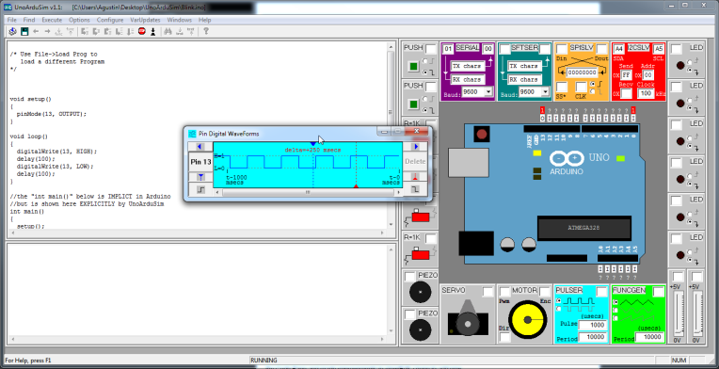
Fig.2. PIN & Output Waveforms

B. ThingSpeak
Thing Speak is an IoT analytic platform service that provides to aggregate, visualize and analyze current/present data streams in the AWS or cloud web service . With the ability to execute MATLAB code in ThingSpeak you can performon line analysis and processing of the data a sit comes in.

STEPS To Create Smart Notice Board App Using Mit App Inventor

Step 1: Open a Gmail account in case you don’t have one.
Step 2: Open the link https://appinventor.mit.edu/ and log in to your Gmail account.

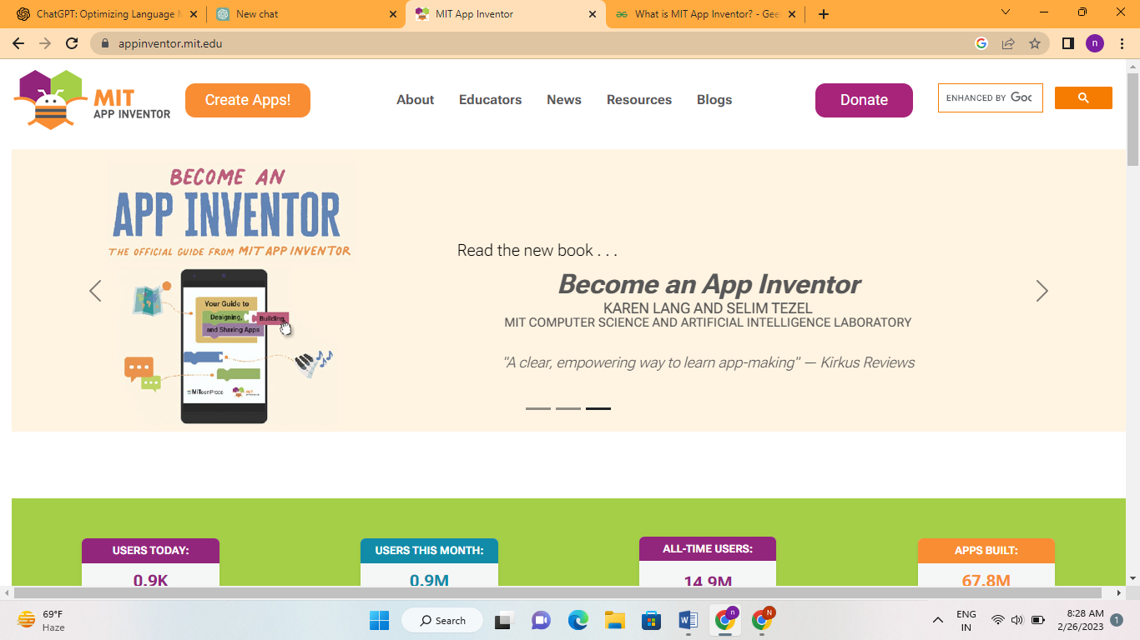
Fig 3: MIT app inventor

Step 3: Click on create new apps. The below interface opens.

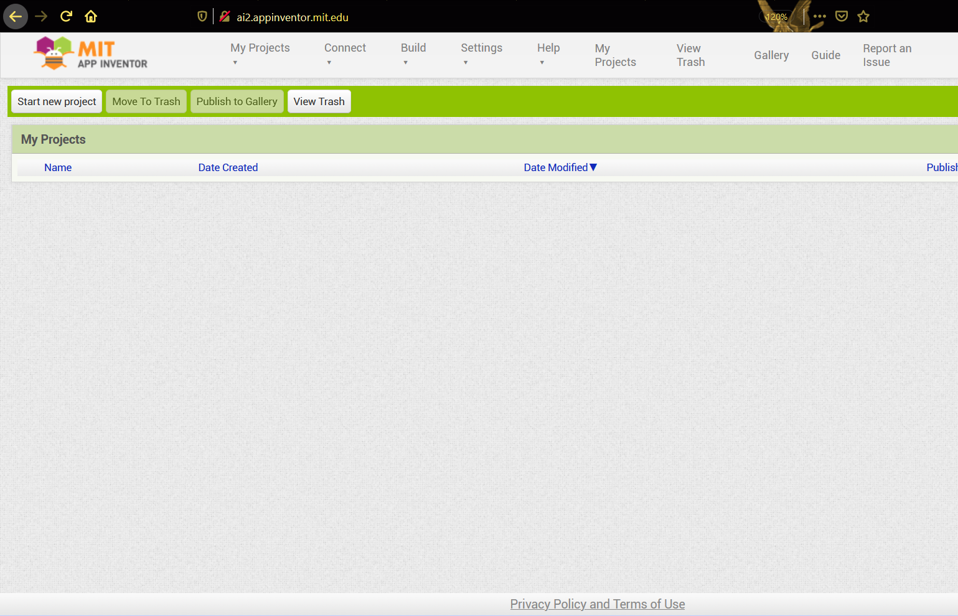
Fig 4: Starting a new project

Step 4: To start the android app-building click on “Start New Project” button. Give the title name and click on "OK". Here I given app name as “iNotify”.

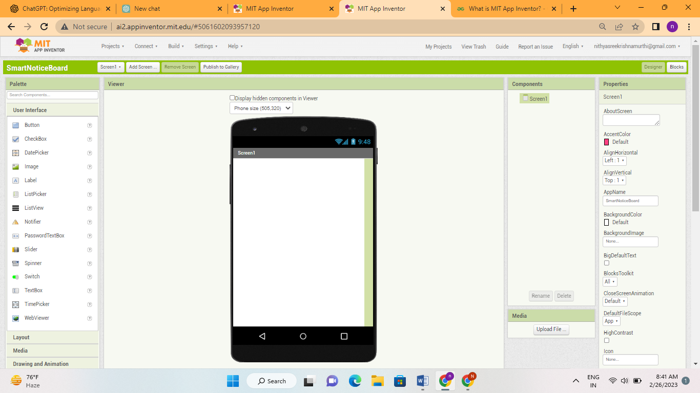
Fig 5: Layout of the application

Step 5: First add a background image as shown below from the Properties. Click on a background image and upload a required image.

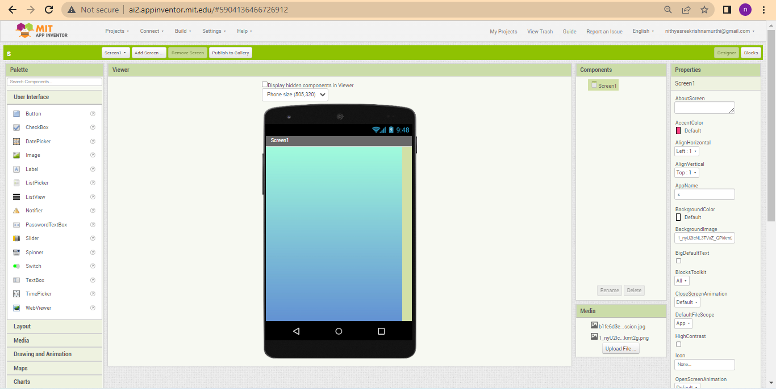
Fig 6: Adding a background image

Step 6: Creating a Home page i.e. Welcome To Smart Notice Board.
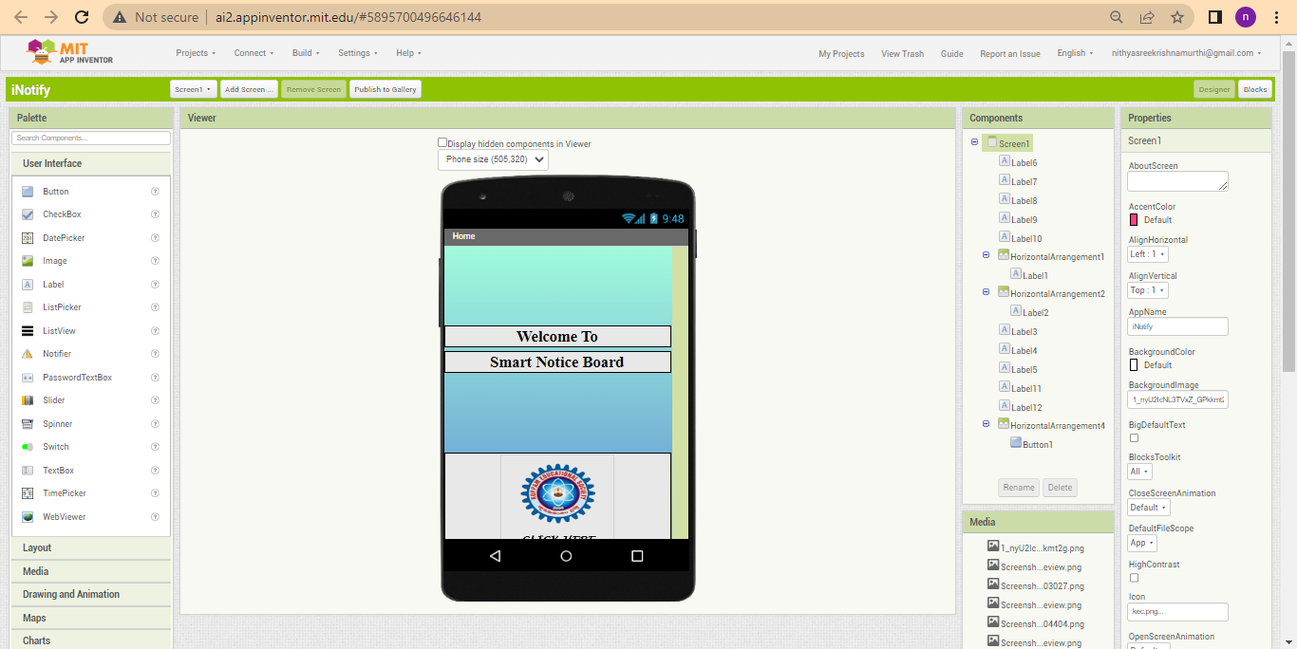
Fig7:Homepage

Step 7: Adding login and password for privacy protection.

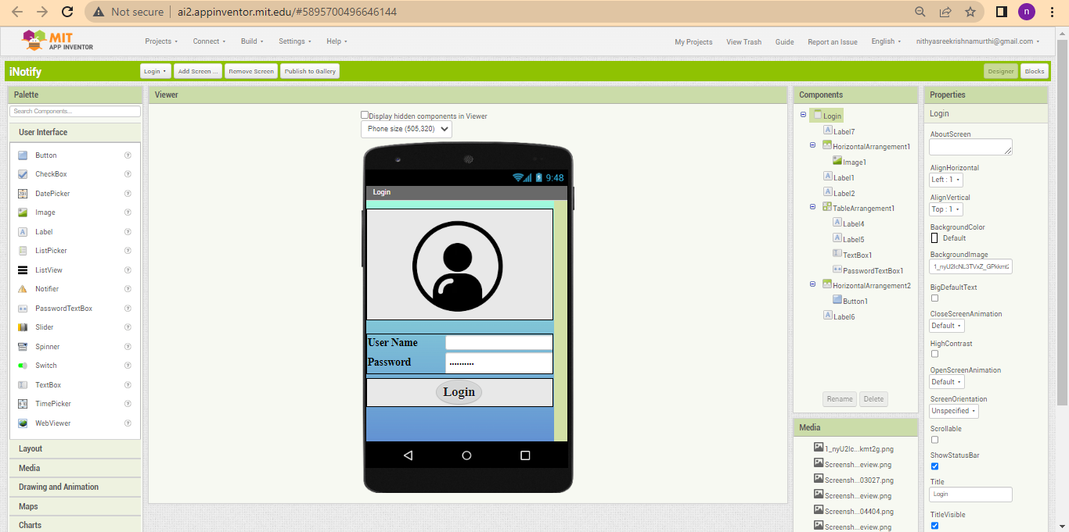
Fig 8:Login and password

Step 6: Add a label by dragginglabel from the user interface and type the label name as kuppam engineering college. Change the font style to serif, font size to 21 and text alignment to center and width to fill parent as shown in below figure.

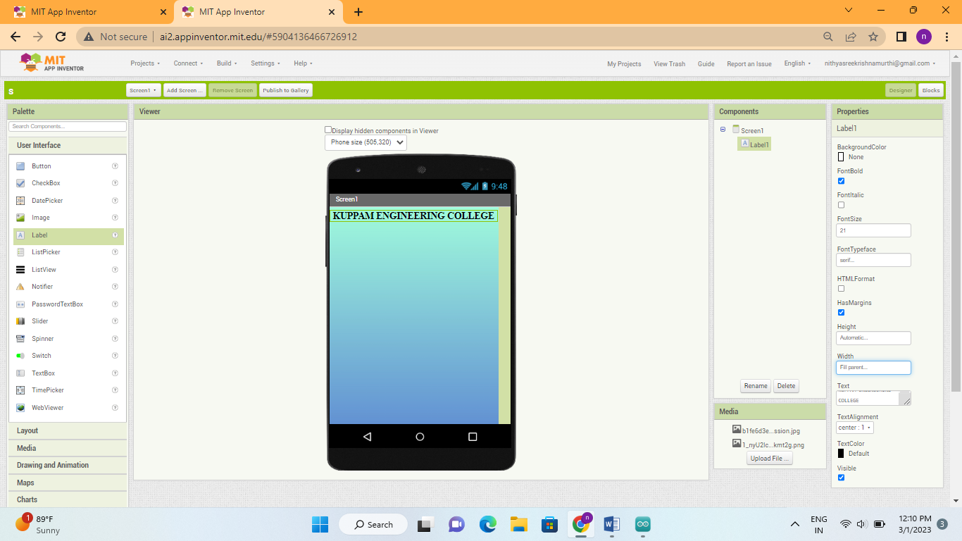
Fig9: Adding a label “KUPPAM ENGINEERING COLLEGE”

Step 7: Add two labels by dragging label from the user interface and type the label2 name as “IoT based smart notice board”, and label3 as “using android app” .Change the font style to serif, font size to 21 and text alignment to center and width to fill parent from properties as shown in below figure.

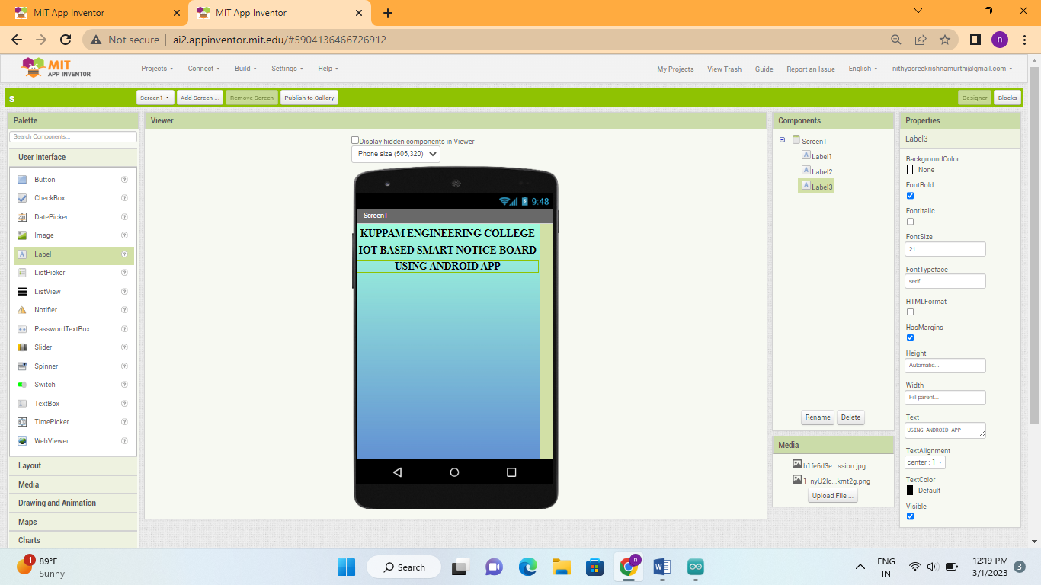
Fig 10: Adding a label “IoT BASED SMART NOTICE BOARD USING ANDROID APP”

Step 8: Add a label by dragging label from the user interface and type the label4 name as “Text message” .Change the font style to serif, font size to 18 and text alignment to left as shown in below figure.

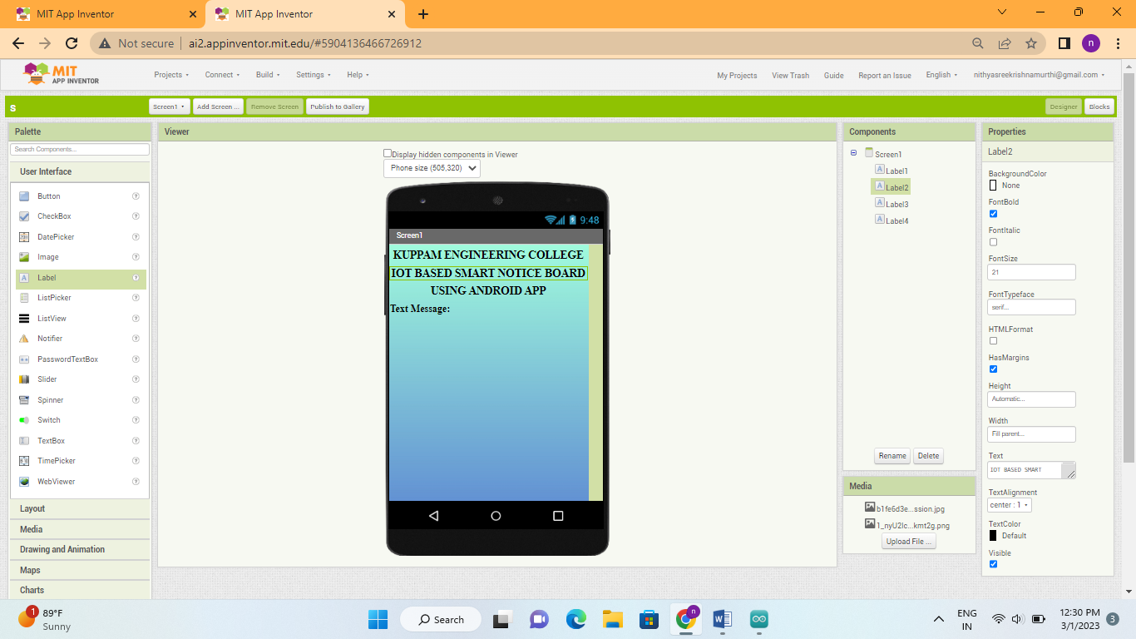
Fig 11: Adding a label “Text Message”

Step 9: Add a text box by dragging text box from the user interface. Change the width to fill parent, click on multi line check box, give height as 25% and hint as Enter a message to display as shown in below figure.

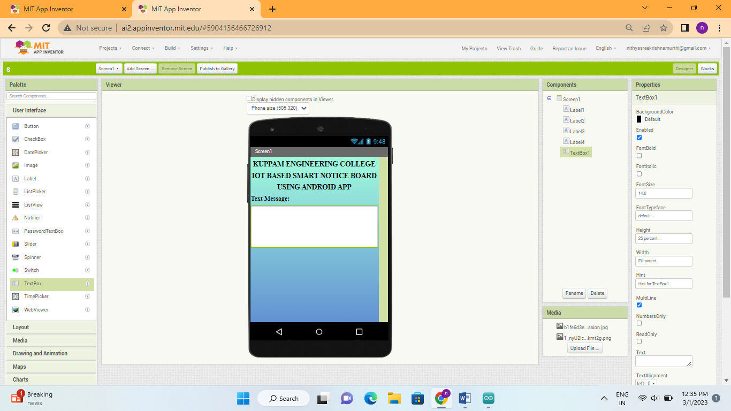
Fig 12: Adding a label “Text Box”

Step 10: Add a horizontal alignment and add a button by dragging button from the user interface and type the button name as “Send”. Change the horizontal align to center and width to fill parent, also change the button width as 50% and shape as rounded.

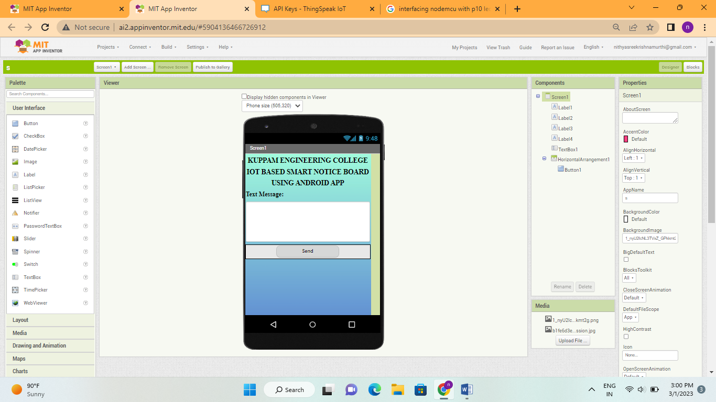
Fig 13: Adding a button to send data through IoT

Step 11: Add a label by dragging label from the user interface and type the label5 name as “Voice message” .Change the font style to serif, font size to 18 and text alignment to left as shown in below figure.
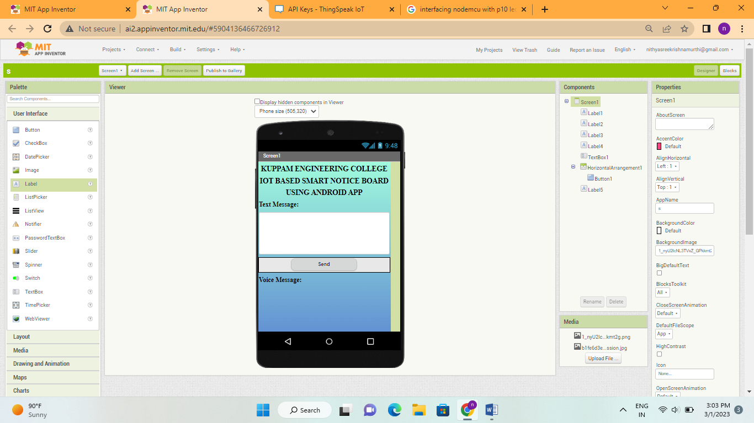
Fig 14: Adding a label “Voice Message”

Step 12: Add a horizontal alignment and add a button by dragging button from the user interface. Change the horizontal align to center, height to 25% and width to fill parent, also change the button height to 25%, width as 50% and add a microphone as an image for a symbolic recognition.

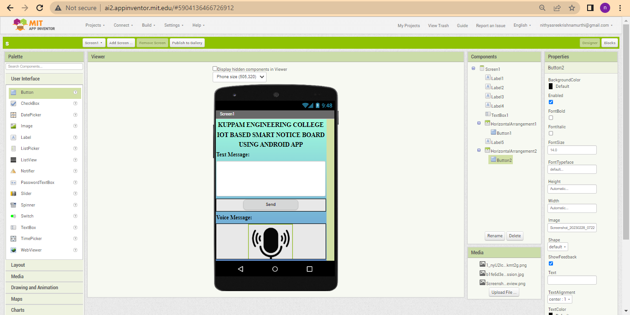
Fig 15: Adding a button and a microphone image for “Voice Message”

Step 13: For the proper functioning of app add the required blocks and write a channel feed API request from Thing Speak server to the buttons (calling the web url to get the text data and speech recognizer result) to access the given text data, voice data as shown in below figure.

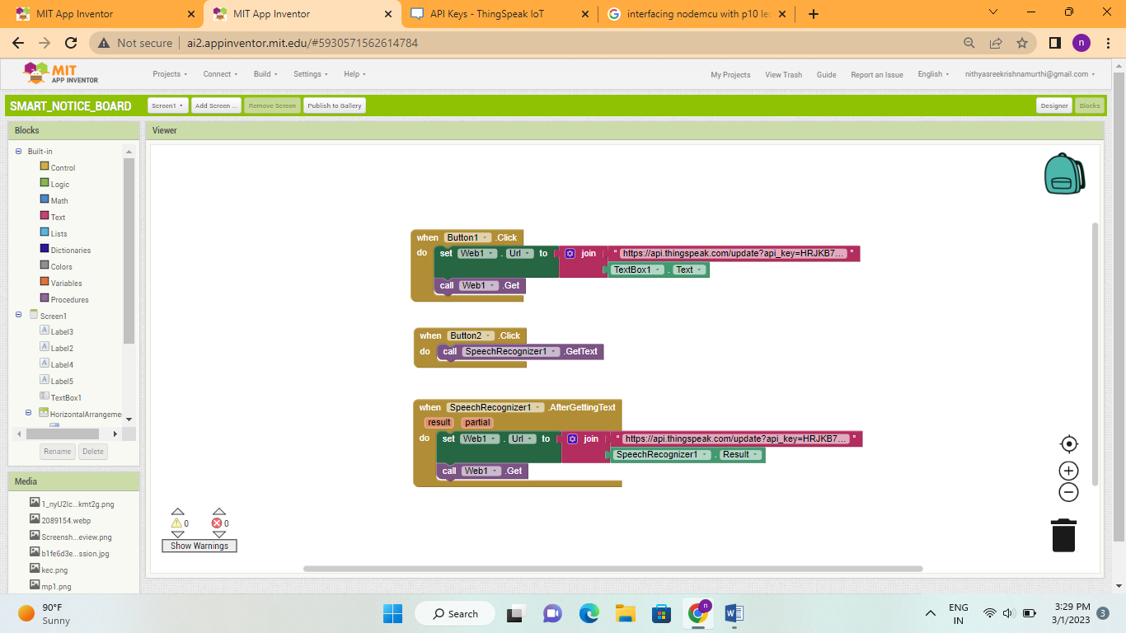
Fig 16: Adding necessary blocks for proper functioning

Step 14: To connect your mobile device, choose “Connect” and “AI Companion” from the top menu.

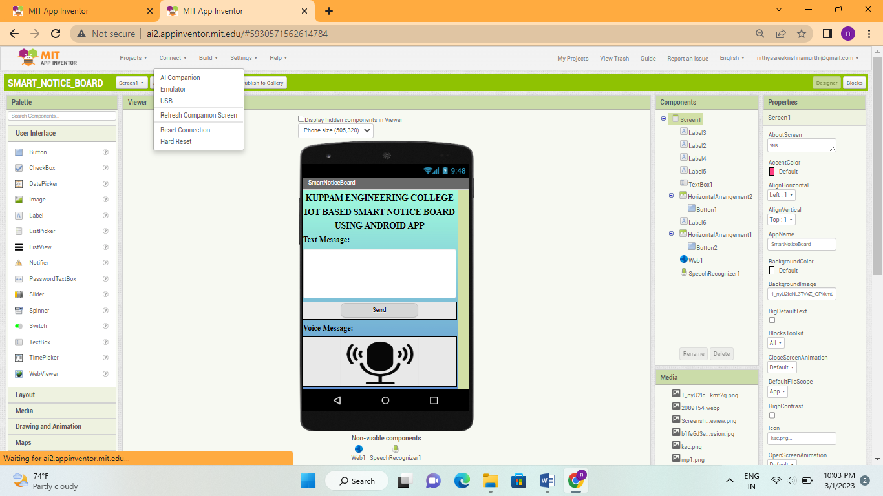
Fig .17: Open AI Companion

Step 15:Now to connect the MIT AI2 App on your device and desktop/laptop scan the QR code or type the 6-digit code which is appearing on your PC screen.

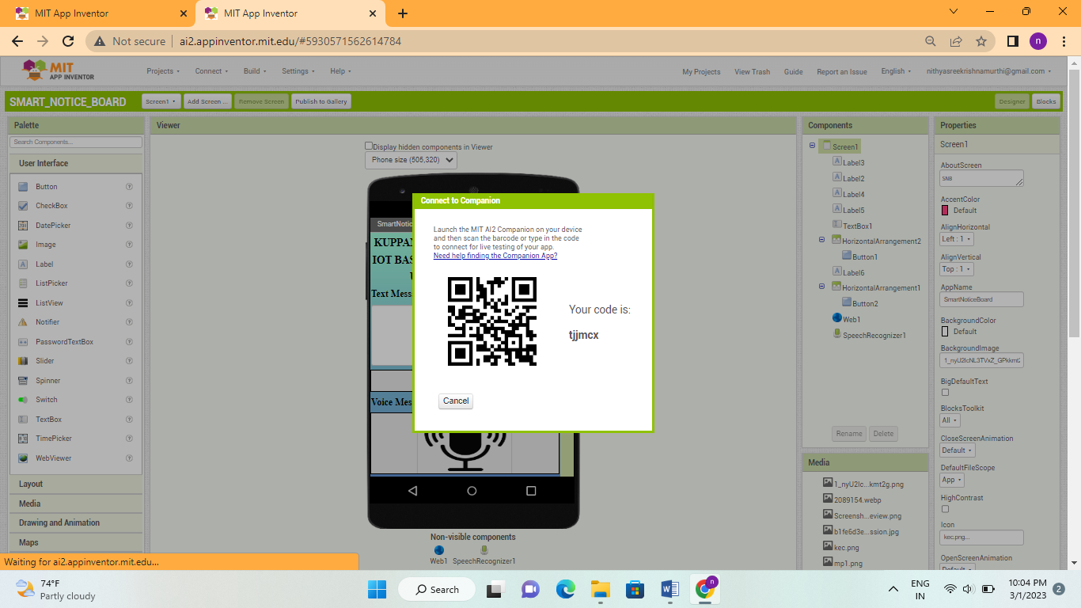
Fig 18: Use QR code

Step 16: Now you can see the “SMART NOTICE BOARD” app titled as “iNotify” in your smart phone.

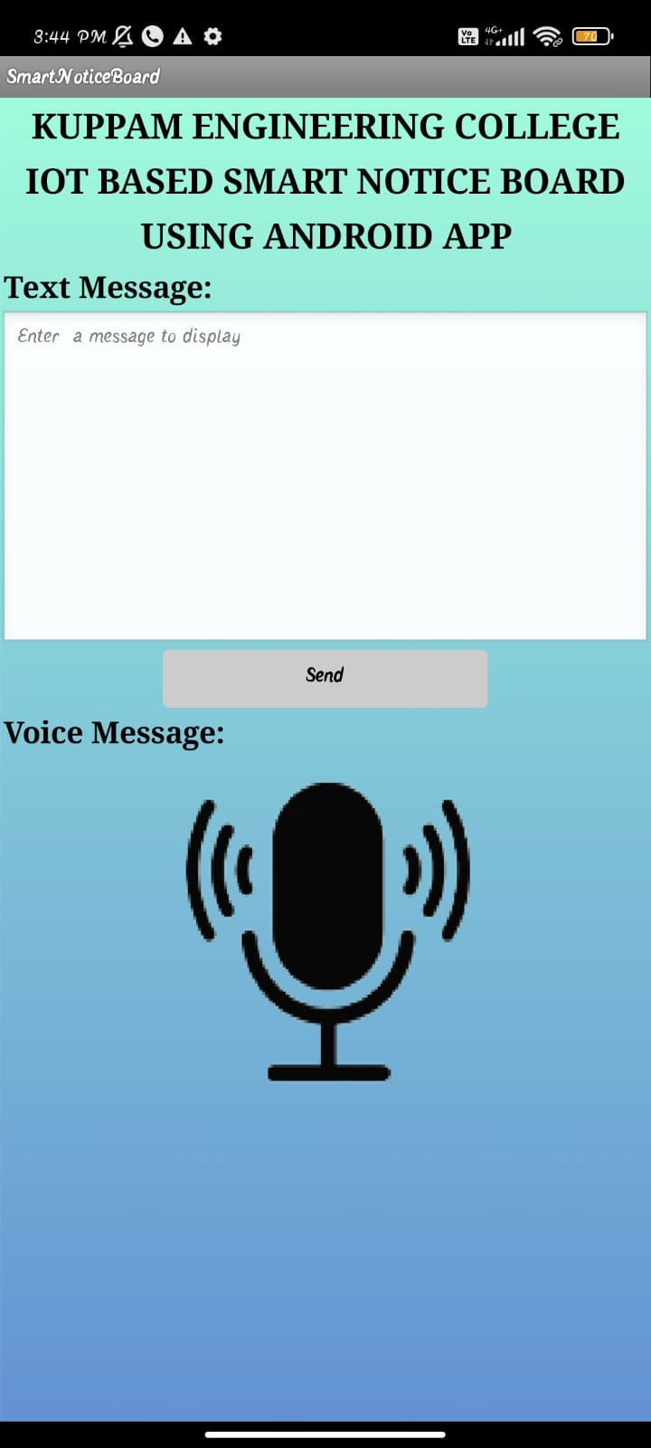
Fig 19: Smart Notice Board app(iNotify) in smart phone

V. RESULT OF ANDROID APPLICATION

The Android Application (iNotify) is designed by using MIT app inventor. The app can send both the text and voice messages. It is guarantee for high end security for login ID. So, that only authorized persons can send the data to the P10 LED display. The app consists of three screens named as Home, Login, and Message. The below figure shows the Home screen which has the welcome message as “Welcome To Smart Notice Board” and the college logo with CLICK HERE as text, when the user press the logo it will direct to the Login screen.

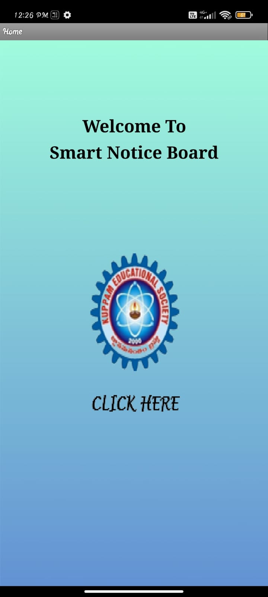
Fig 20: Home screen

The Login screen consists of User Name and Password. When the user name and password entered is correct it will direct to the Message screen. If the username and password is wrong then it will display “Wrong Username or Password”.

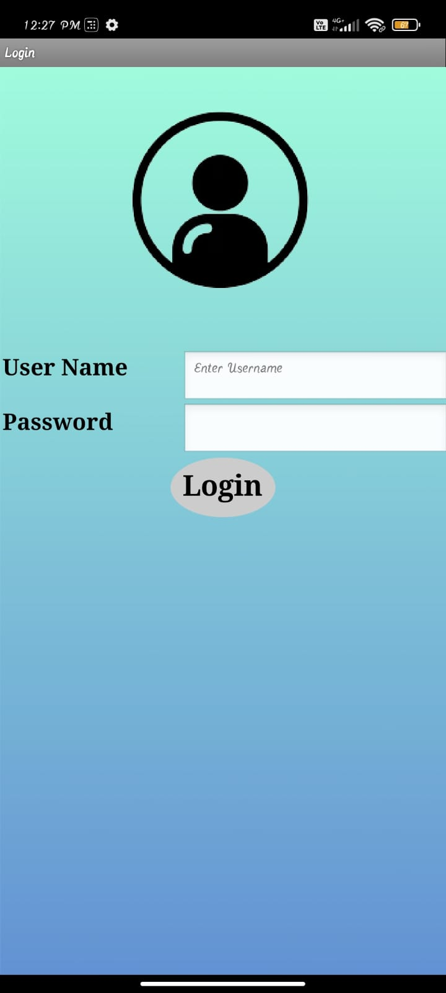
Fig 21: Login screen

In the message screen the user can send both the text message and voice message which should be displayed on the P10 LED display.

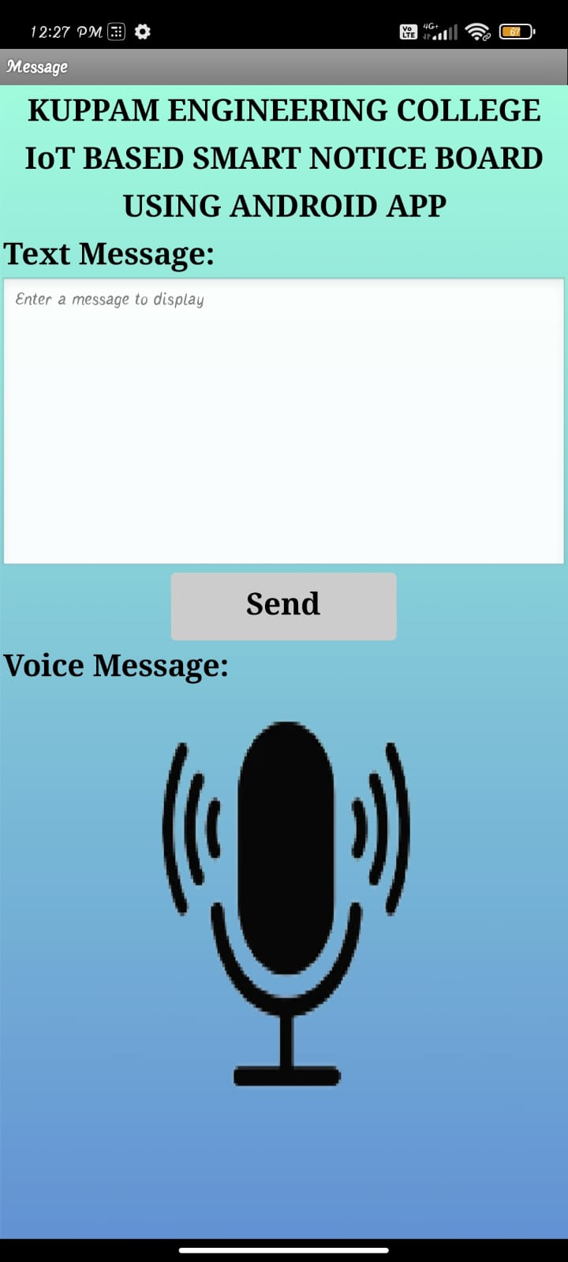
Fig 22: Message screen

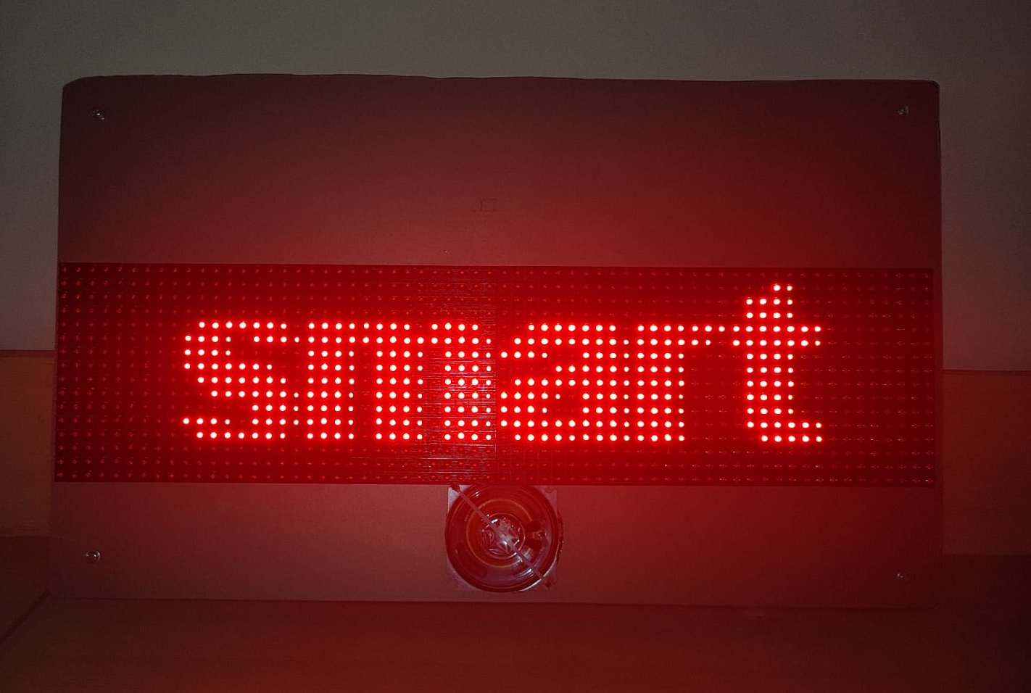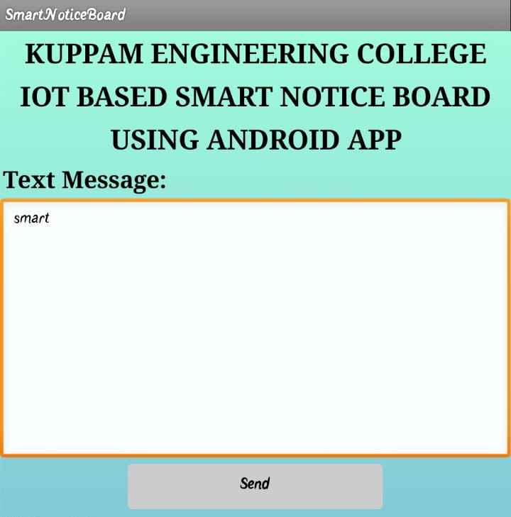
Fig 23: Updating the Notice Board with text message “smart”

Sending a text message “smart” through the android app iNotify.
Sending a voice message “ECE” through the android app iNotify. Whenever the data is sent from the android app it is updated on the LED display through the read API key given in the NODEMCU and write API key given in the android app.

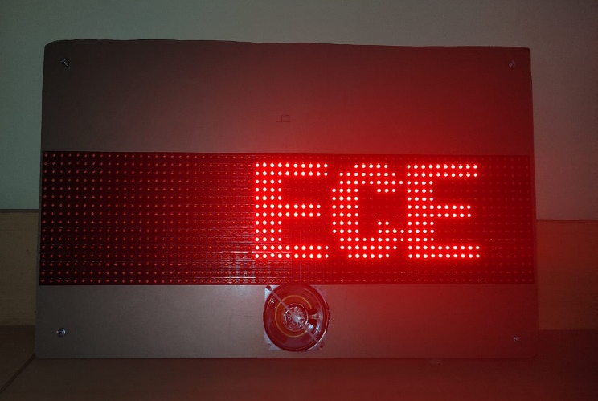
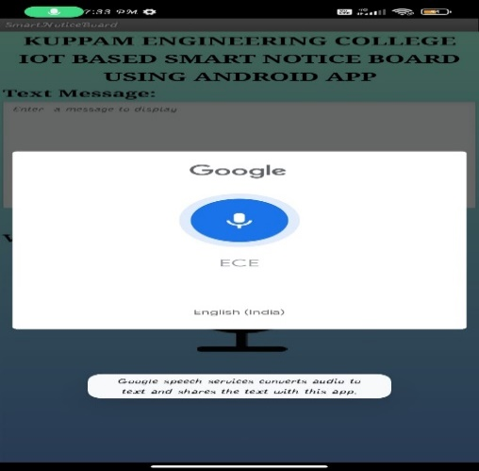
Fig 24: Updating the Notice Board with voice message “Engineering”

conclusion
An IoT-Based Smart Notice Board Using an Android App is a highly innovative and effective way of displaying information in public places such as schools, colleges, hospitals, and corporate offices. This system provides a highly interactive and user-friendly way of displaying information, announcements, and important messages to a large audience in real-time.The use of IoT technology allows for seamless communication between the notice board and the Android app, enabling users to easily update and manage the content on the board remotely. Overall, the IoT-based smart notice board using an Android app is an excellent example of the power of technology to improve communication and enhance the way we interact with information in public spaces.

Future Scope
The future scope for an IoT-based smart notice board using an Android app is vast and exciting. Here are a few potential future developments that could enhance the functionality and usefulness of this technology:

Integration with voice assistants: With the increasing popularity of Google and other voice assistants, such as Amazon's Alexa and Google Home, it is possible that smart notice boards could integrate with these devices to provide a hands-free, voice-controlled experience.

Text to Speech: The information displayed on the P10 LED display can be converted into the voice message, so that it is useful to the blind people.

References

- F. Kamdar, A. Malhotra, and P. Mahadik, “Display Message on Notice Board using GSM,”Ripublication.com.[Online].Available: https://www.ripublication.com/aeee/024_pp%20%20827-832.pdf.
- N. Jagan, M. Reddy, and G. Venkareshwarlu, “Wireless electronic display board using gsm technology,”Iraj.in.[Online].Available :http://www.iraj.in/journal/journal_file/journal_pdf/1-10-139036896650-54.pdf.
- Researchgate.net.[Online].Available:https://www.researchgate.net/publication/288313286_Design_and_implementation_of_digital_notice_board_using_power_line_communication.
- V. Ghumde, M. Taikar, D. Morey, and R. Waghmare, “Electronic Notice Board,” Ijariie.com. [Online].Available :http://ijariie.com/AdminUploadPdf/Electronic_Notice_Board_ijariie8048.pdf.
- Ijedr.org. [Online]. Available: https://www.ijedr.org/papers/IJEDR1702022.pdf.
- J. B. Upadhye and M. Karishma, “SMART NOTICE BOARD.” .
- S. Shah, “Message Displayed on LCD Screen using GSM and Bluetooth Technology.” .
- A. Gupta, R. Borkar, S. Gawas, S. Joshi, and B. E. Students, “Gsm based wireless notice board,” Ijtra.com.[Online].Available: https://www.ijtra.com/special-issuedownload.php?paper=gsm-based-wireless-notice-board.
- Researchgate.net.[Online].Available:https://www.researchgate.net/publication/305421736_GSM_based_Smart_home_and_digital_notice_board.
- M. Journals, “Gsm based led scrolling display board,” 2013.

