Distributional Records of Family Tubulicrinaceae from District Chamba of Himachal Pradesh
Dr. Poonam Sabrwal¹, Miss Sumit²
¹Assistant Professor Botany Government College Chamba, Himachal Pradesh
²Assistant Professor Botany Government College Chamba, Himachal Pradesh
¹Email of 1st and corresponding author: poonamriddham777@gmail.com
Keywords: Basidiomycota, Tubulicrinaceae, Western Himalayas, Corticioid Fungi
ABSTRACT
The aim of the present chapter is to describe and illustrate 10 taxa (Hyphodontia alutaria, H. arguta, H. pallidula, H. rimosissima, H. sambuci, Tubulicrinis chaetophorus, T. orientalis, T. strangulates, Xylodon asper and X.spathulata) belonging to 3 genera (Hyphodontia, Tubulicrinis and Xylodon) of family Tubulicrinaceae based on the specimens collected from various localities of Chamba district (Himachal Pradesh). Of the taxa recorded Hyphodontia rimosissima is new additions to the fungal diversity from Chamba district of Himachal Pradesh.
INTRODUCTION
Family Tubulicrinaceae an assemblage of corticioid fungi, is characterised by members with resupinate, adnate sporophores that are ceraceous to subceraceous to crustose to membranous. The hymenophore varies from smooth to tuberculate to grandinoid to odontoid to hydnoid. The sporophore’s hyphal system may be monomitic or dimitic. Generative hyphae with clamped septa. Skeletal hyphae thick-walled. The sporophores may or may not possess some kind of ancillary elements. The basidia vary from clavate to subclavate to subcylindrical to stalked, somewhat sinuous, 2 to 4–sterigmate, with clamp at the base.. The basidiospores range from ellipsoid to broadly ellipsoid to cylindrical to subcylindrical to globose to subglobose to allantoid, smooth,thin--walled. The basidiospore wall negative to both Melzer’s reagent and Cotton Blue.

During the fungal forays conducted in various sub divisions of Chamba district in the years 2013-2018 many specimens of family Tubulicrinaceae were collected. These were identified and described as 10 taxa belonging to ten genera of family Tubulicrinaceae on the basis of macro and micomorphological features and comparison with the literature (Rattan, 1977; Natrajan and Kolandvelu, 1998; Lalji, 2003;Dhingra, 2005; Singh, 2007; Kaur, 2012; Kaur, 2012; Sharma , 2012; Priyanka, 2012; Dhingra et al., 2011, 2014; Samita, 2014; Ranadive, 2013; Sharma, 2017; Kaur, 2018; and Devi, 2019.The present chapter provides an account of Family Tubulicrinaceae from Chamba district of Himachal Pradesh, based on 10 species spread over three genera. These 10 taxa include Hyphodontia alutaria, H. arguta, H. pallidula, H. rimosissima, H. sambuci, Tubulicrinis chaetophorus, T. orientalis, T. strangulates, Xylodon asper and X. spathulata).Of the ten taxa described H. rimosissima is new addition to Chamba district of Himachal Pradesh.
MATERIALS AND METHODS
Present studies are based on the collections made from different localities of district Chamba (Himachal Pradesh) during fungal forays conducted in various sub divisions of Chamba district in the years 2012-2018. The sporophores were collected along with a portion of the substrate with the help of a hammer and a chisel. The details pertaining to type of hymenial surface, colour, margins etc., were noted carefully with the help of a hand lens. A moist piece of the sporophore was used to get the spore print on a glass slide. These speciemens were dried either in sun or using an electric drier. The dried sporophores were packed in bond paper envelops carrying a standard herbarium label with required information. All the specimens have been deposited at the Herbarium, Department of Botany, Punjabi University, Patiala (PUN). The micromorphological details of the collected specimens were observed by making crush mounts/vertical sections of the sporophores in water, 3% KOH solution, 1% pholxine, 1% congo red, 1% cotton blue and Melzer’s reagent (0.5gm Iodine + 1.5gm KI + 20gm Chloral hydrate + 20ml Distilled water). The outline of the microscopic structures was drawn with the help of a camera lucida mounted on compound microscope at 100X, 400X and 1000X magnifications. All specimens have been deposited at the Herbarium, Department of Botany, Punjabi University, Patiala (PUN). The colour citations are as per Kornerup and Wanscher(1978).
TAXONOMIC DESCRIPTIONS
Family Tubulicrinaceae Jülich, Bibliotheca Mycologica 85: 392 (1981).
Sporophores resupinate, adnate, effused; hymenial surface smooth to porulose to pulveraceous to hispid to tuberculate to grandinoid to odontoid to sometimes inconspicuous. Hyphal system monomitic or dimitic. Generative hyphae with clamped septa. Skeletal hyphae thick-walled, aseptate. Ancillary elements present. Basidia clavate to subclavate to subcylindrical to stalked, somewhat sinuous, 2 to 4–sterigmate, with clamp at the base. Basidiospores ellipsoid to broadly ellipsoid to subglobose to allantoid to cylindrical, smooth, thin-walled, negative to both Melzer’s reagent and Cotton Blue.
Key to the genera:
1. Lycocystidia present.................................................................................. Tubulicrinis
1. Lycocystidia absent......................................................................................................2
2. Ancillary elements present..........................................................................Hyphodontia
2. Ancillary elements absent, but cystidioles present..............................................Xylodon

I. Hyphodontia J. Erikss., Symbolae Botanicae Upsalienses 16: 101 (1958).
Sporophores resupinate, adnate, effused; hymenial surface smooth to tuberculate to grandinoid to odontoid to hydnoid. Hyphal system monomitic or dimitic. Generative hyphae with or without clamped septa, thin- to thick-walled. Skeletal hyphae thick-walled, aseptate. Ancillary elements (capitates cystidia/septocystidia/spathulate cystidia/lagenocystidia/septocystidia) present or absent. Basidia clavate to subclavate to subcylindrical, sometimes with suburniform constriction, 4–sterigmate, with or without clamped septa at the base. Basidiospores ellipsoid to broadly ellipsoid to subglobose to allantoid to suballantoid, smooth, thin-walled, negative to both Melzer’s Reagent and Cotton Blue.
1. Hyphodontia alutaria (Burt) J. Erikss., Symbolae Botanicae Upsalienses 16 (1): 104 (1958). - Peniophora alutaria Burt, Annals of the Missouri Botanical Garden 12 (3): 332 (1926).
Plate–I
Sporophore annual, resupinate, adnate, effused, up to 200 µm thick in section; hymenial surface smooth to grandinoid both in fresh and dry states; grayish orange to brownish orange both in fresh and dry states, margins fibrillose, paler concolorous when determinate. Generative hyphae subhyaline, septate, clamped, smooth; horizontal, ≤ 4.2 µm wide, less branched, thin- to thick-walled in the subicular zone; ≤ 3 µm wide vertical, richly branched, thin-walled in the subhymenial zone. Cystidia of 2 types (i) Hyphoid cystidia capitate, with basal clamp, 37–78 × 4.9–6.1 µm, thick-walled, gradually thinning towards the apical part, smooth to encrusted with resinous encrustation; projecting up to 30 μm out of the hymenium (ii) Lagenocystidia consisting of hyphal ends abruptly narrowing into the needle like apical part, with basal clamp, 18–37 × 2.7–4.4 µm, thin-walled, encrusted apical part ≤ 3.9 µm; embedded or sometimes slightly projecting out of the hymenium. Basidia clavate to subcylindrical, with suburniform constriction, 13–18 × 4.9–5.5 µm; sterigma ≤ 4.9 µm long. Basidiospores 3.6–5.4 × 3–3.6 µm, broadly ellipsoid, thin-walled, smooth, acyanophilous, inamyloid.
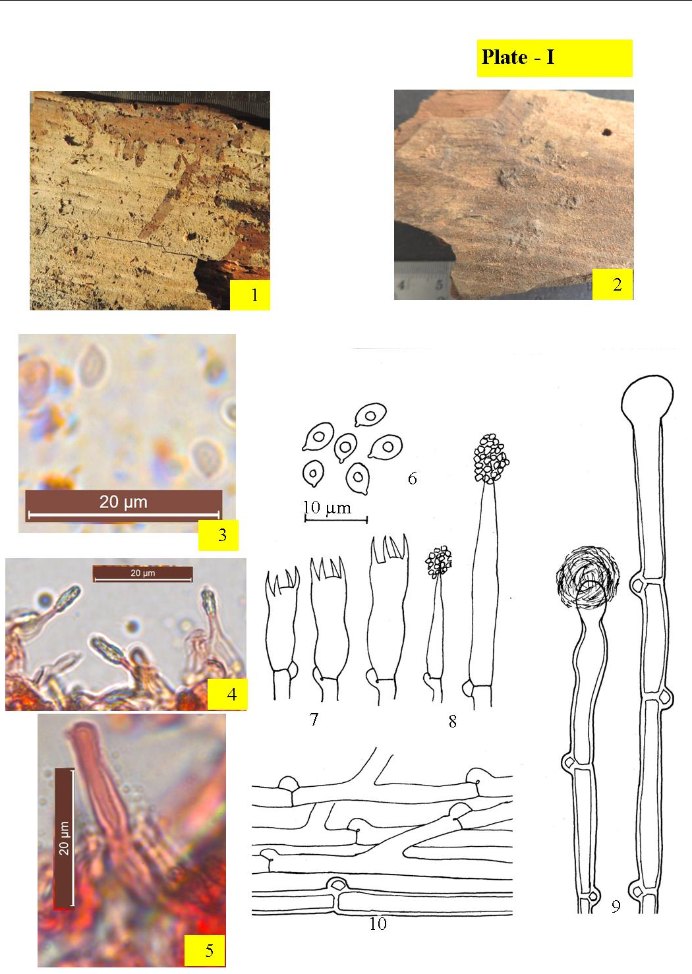
Figs. 1– 10. Hyphodontia alutaria :1-2. Sorophore showing hymenial surface (1. Fresh, 2. Dry); 3-5. Photomicrographs (3. Basidiospores, 4. Lagenocystidia, 5.Capitate cystidium); 6-10. Line diagrams [6. Basidiospores; 7. Basidia, 8. Lagenocystidia, 9. Capitate cystidia, 10.Generative hyphae]

Collections examined – India, Himachal Pradesh: Chamba, Churah, Bhandal, on stump of P. smithiana, Poonam 10134 (PUN), August 14, 2014; Churah, Bhandal, on stump of Cedrus. deodara, Poonam 10700 (PUN), August 15, 2014; ,Churah, Bhandal, on stump of Picea. smithiana, Poonam 10701 (PUN), August 14, 2014; Bharmour, Manimahesh, Tosh ka got, on log of Pinus. roxburghii, Poonam 10702 (PUN), September 2, 2016; Bharmour, Manimahesh, Tosh ka got, on angiospermous sticks, Poonam10703 (PUN), September 3, 2016; Bharmour, Manimahesh, Tosh ka got, on angiospermous sticks, Poonam 10706 (PUN), September 4, 2016.
Remarks – H. alutaria is being described for the first time from tehsils Churah and Bharmour in the study area. Earlier it was described by Rattan (1977) from district Districts Chamba and Shimla (H.P), Dhingra (2005) from Arunachal Pradesh, Singh (2007) from district Kullu (H.P.), Dhingra et al.(2011) from Eastern Himalyas, Kaur (2012) form district Shimla and Solan (H.P.), Sharma (2012) from district Uttarakhand and Dhingra et al. (2014) from different localities of H.P, Samita (2014) from Uttarakhand, Kaur (2017) from district Shimla (H.P.), Devi (2019) from district Kangra (H.P.).

2. Hyphodontia arguta (Fr.) J. Erikss., Symbolae Botanicae Upsalienses 16 (1): 104 (1958). - Hydnum argutum Fr., Systema Mycologicum 1: 424 (1821). Plate–II

Sporophore annual, resupinate, adnate, effused, up to 200 µm thick in section; hymenial surface odontoid both in fresh and dry states; grayish yellow to grayish orange, margins pruinose to fibrillose, paler concolorous when determinate. Generative hyphae ≤ 3.3 µm wide, subhyaline, septate, clamped, smooth; horizontal, less branched, thin- to thick-walled in the subicular zone; vertical, richly branched, thin-walled in the subhymenial zone. Cystidia of 2 types (i) Hyphoid capitate, with basal clamp, 61–75 × 3.8–6.1 µm, thick-walled, gradually thinning towards the apical part; enclosed to somewhat projecting. (ii) Lagenocystidia consisting of hyphal ends abruptly narrowing into a needle like portion, with basal clamp, 29–45 × 2.7–3.3 µm, encrusted apical part ≤ 3.5 µm, thin-walled. Basidia clavate to subcylindrical, with suburniform constriction, 13–18 × 4.9–5.5 µm; sterigma ≤ 4.9 µm long. Basidiospores 4.4–5.6 × 3–3.8 µm, ellipsoid to broadly ellipsoid, with oily contents, thin-walled, smooth, acyanophilous, inamyloid.

Collections examined – India, Himachal Pradesh: Chamba, Churah, Bhandal, on angiospermous stump, Poonam 10138 (PUN), August 15, 2014; Dalhousie canttt, on stump of Cedrus deodara, Poonam 10687 (PUN), September 14, 2014; Churah, Bhandal, on stump of Cedrus deodara, Poonam 10688 (PUN), August 15, 2014; Churah, Bhandal, on stump of C. deodara, Poonam 10689 (PUN), August 15, 2014; Churah, Bhandal, on stump of C. deodara, Poonam 10696 (PUN), August 15, 2014; Churah, Bhandal, on stump of C. deodara, Poonam 10697 (PUN), August 15, 2014; Churah, Bhandal, on stump of C. deodara, Poonam 10698 (PUN), August 15, 2014; Churah, Bhandal, on stump of C. deodara, Poonam 10694 (PUN), August 15, 2014; Chamba, Chaned, on stump of Pinus roxburghii, Poonam 10690 (PUN), September 25, 2016; Chamba, Chaned, on stump of P. roxburghii, Poonam 10691 (PUN), September 25, 2016; Chamba, Kandu, on stump of P. roxburghii, Poonam 10692 (PUN), September 25, 2016; Chamba, Kandu, on stump of P. roxburghii, Poonam 10693 (PUN), September 25, 2016; Chamba, Hardaspura, on stump of P. roxburghii, Poonam 10695 (PUN), September 27, 2016.
Remarks –It is being described for the first time from tehsils Bharmour, Churah and Pangi in the study area. Earlier it was described by Rattan (1977) from district Districts Chamba, Kullu and Shimla (H.P), Dhingra, Kaur (2012) form district Shimla (H.P.), Sharma (2012) from Uttarakhand, Ranadive (2013) from Maharashtra and Dhingra et al. (2014) from different localities of H.P, Samita (2014) from Uttarakhand, Sharma (2017) from J&K Devi (2019) from district Kangra (H.P.).
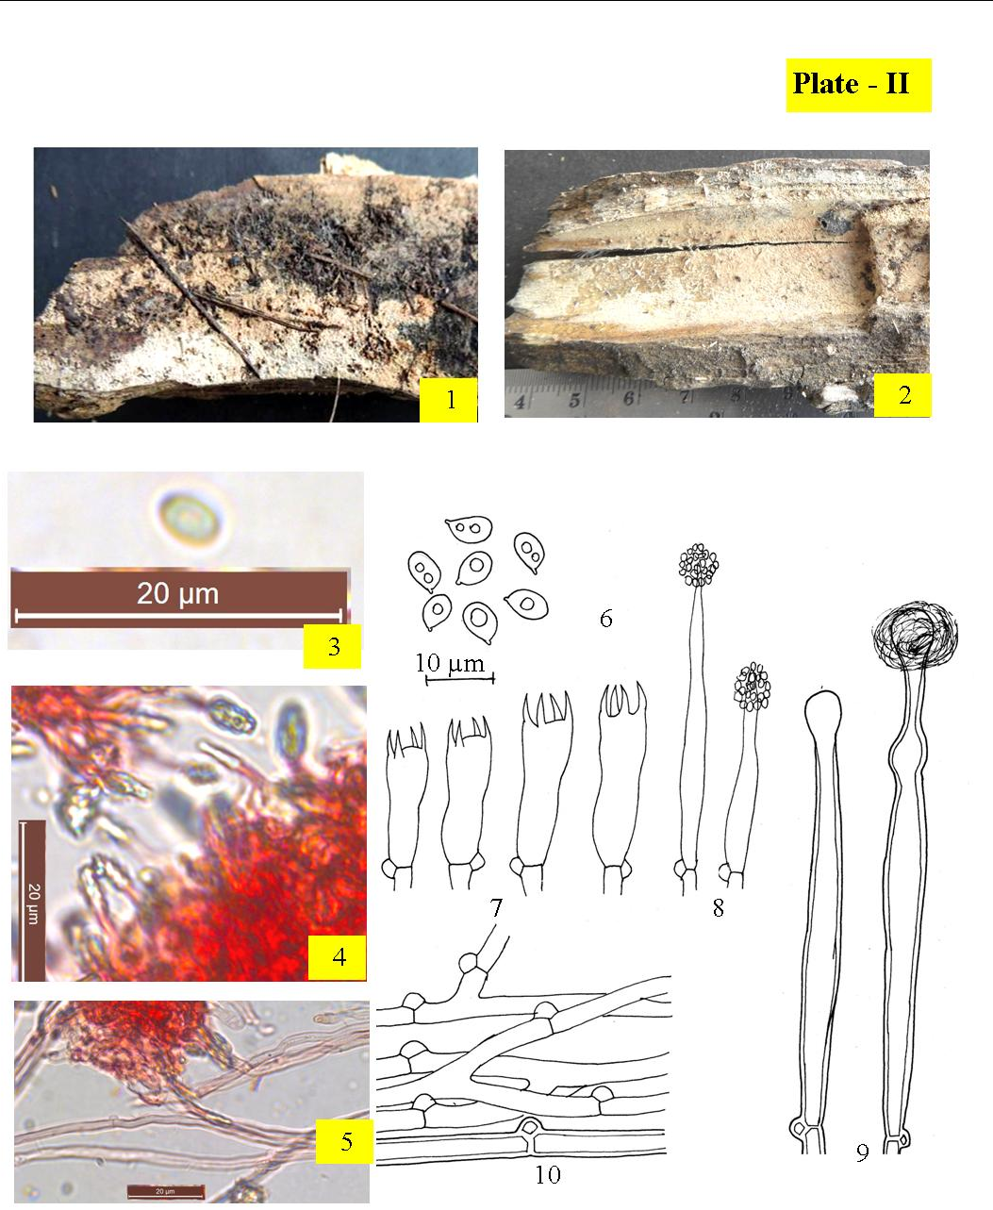
Figs. 1– 10. Hyphodontia arguta :1-2. Sporophore showing hymenial surface (1. Fresh, 2. Dry); 3-5. Photomicrographs (3. Basidiospore, 4. lagenocystidia; 5.Generative hyphae); 6-10. Line diagrams [6. Basidiospores; 7. Basidia, 8. lagenocystidia, 9. Capitate cystidia, 10.Generative hyphae].

3. Hyphodontia pallidula (Bres.) J. Erikss., Symbolae Botanicae Upsalienses 16 (1): 104 (1958). - Gonatobotrys pallidula Bres., Annales Mycologici 1 (2): 127 (1903).
Plate –III
Sporophore annual, resupinate, adnate, effused, up to 200 µm thick in section; hymenial surface smooth to tuberculate both in fresh and dry states; yellowish white to pale yellow to grayish orange when fresh, pale orange to grayish orange to brownish orange on drying, margins pruinose to fibrillose, paler concolorous when determinate. Generative hyphae subhyaline, septate, clamped, smooth; horizontal, ≤ 3.8 µm wide, richly branched thick-walled in the subicular zone; vertical, ≤ 2.2 µm wide, less branched, thin-walled in the subhymenial zone. Cystidia to subcylindrical, 57–81 × 11–12 µm, thick-walled hyphoid except at the apex, often with constrictions, apically obtuse or somewhat capitate, septate, clamped; projecting up to 30 μm out of the hymenium. Basidia clavate, somewhat sinuous, 13–18 × 3.8–5.5 µm; sterigma ≤ 4.4 µm long. Basidiospores 4.2–5.4 × 2.2–3.3 µm, ellipsoid to broadly ellipsoid, with oily contents, thin-walled, smooth, acyanophilous, inamyloid.
Collections examined – India, Himachal Pradesh: Chamba, Khajjiar, Kalatop, on sticks of Pinus roxburghii, Poonam 10710 (PUN), October 13, 2012; Khajjiar, Kalatop, on sticks of P. roxburghii, Poonam 10711 (PUN), October 13, 2012; Chamba, Kolhari, on sticks of Rosa macrophylla, Poonam 10712 (PUN), September 11, 2014; Chamba, Churah, Bhandal, on sticks of R. macrophylla, Poonam 10713 (PUN), August 15, 2014; Chamba, Churah, Bhandal, on sticks of R. macrophylla, Poonam 10714 (PUN), August 15, 2014; Chamba, Churah, Bhandal, on sticks of R. macrophylla, Poonam 10715 (PUN), August 15, 2014; Chamba, Bharmour, Manimahesh, Tosh ka got, on stick of Juglans regia, Poonam 10716 (PUN), September 4, 2016.
Remarks – H. pallidula is being described for the first time from tehsils Bharmour and Churah in the study area. Earlier it was described by Rattan (1977) from districts Chamba and Kullu (H.P), Lalji (2003) from Uttarakhand, Dhingra (2005) from Eastern Himalyas, Singh (2007) from district Sirmaur and Shimla (H.P.) Kaur (2012) form district Shimla and Kullu (H.P.), Ranadive (2013) from Maharashtra, Samita (2014) from Uttarakhand, Sharma (2017) from J&K Devi (2019) from district Kangra (H.P.).
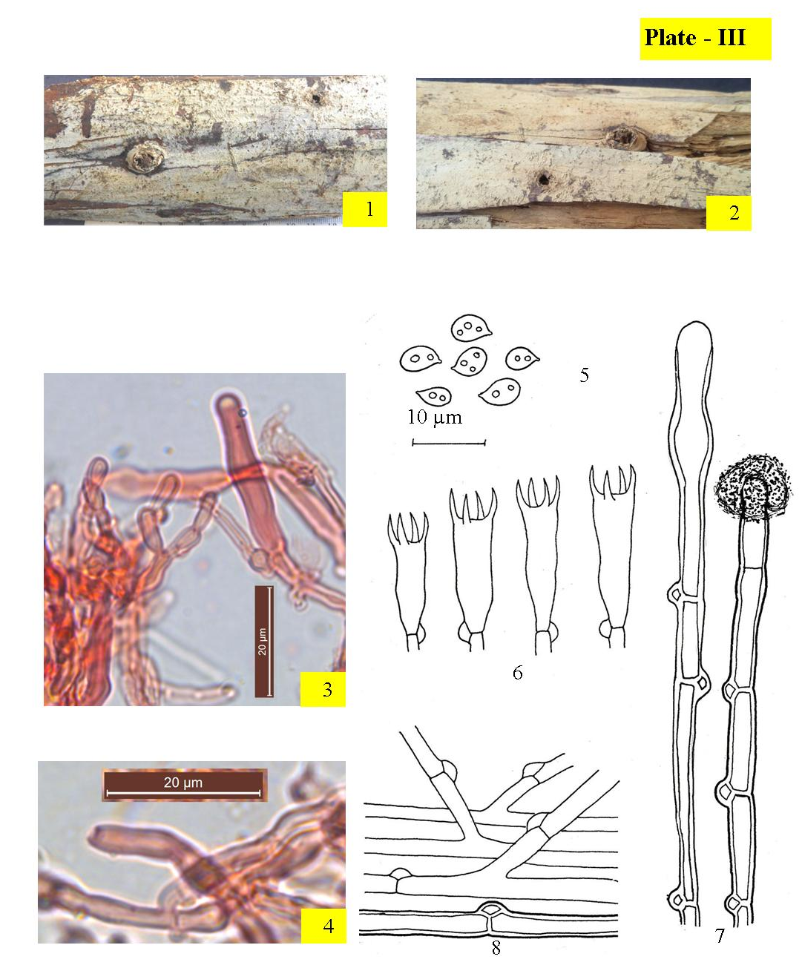
Figs. 1– 8. Hyphodontia pallidula :1-2. Sporophore showing hymenial surface (1. Fresh, 2. Dry); 3-4. Photomicrographs (3. Capitate cystidium, 4. Generative hyphae); 5.-8.Line diagrams [5. Basidiospores; 6. Basidia, 7. Cystidia ,8.Generative hyphae]

4. Hyphodontia rimosissima (Peck) Gilb., Evolution in the higher Basidiomycetes: 300 (1971). - Odontia rimosissima Peck, Annual Report on the New York State Museum of Natural History 50: 114 (1897). Plate –IV
Sporophore annual, resupinate, adnate, effused, up to 320 µm thick in section; hymenial surface smooth to odontoid both in fresh and dry states; yellowish white to pale yellow when fresh, pale yellowish gray to grayish yellow on drying, margins fibrillose, paler concolorous when determinate. Generative hyphae ≤ 2.3 µm wide, subhyaline, septate, clamped, with abundant crystalline encrustation that dissolves in 3% KOH solution, thin-walled; horizontal, less branched in the subicular zone; vertical, richly branched in the subhymenial zone. Cystidia absent. Numerous capitate hyphal ends present in hymenium, with basal clamp, 26–28 × 2.2–3.8 µm, resinous encrustation present at the apical part that dissolves in 3% KOH solution. Basidia subclavate to clavate, constricted to sinuous, with oliy contents, 16–21 × 4.4–5 µm; sterigma ≤ 3.8 µm long Basidiospores 4.4–6.1 × 3.5–5.µm, broadly ellipsoid, thin-walled, smooth, acyanophilous, inamyloid.
Collection examined – India, Himachal Pradesh: Chamba, Bharmour, Manimahesh, Tosh ka got, on Pinus roxburghii stump, Poonam 10137 (PUN), September 4, 2016.
Remarks – H. rimosissima is being described for the first time from district Chamba. Kaur and Dhingra et al. (2012) reported it from district Kangra (H.P.)

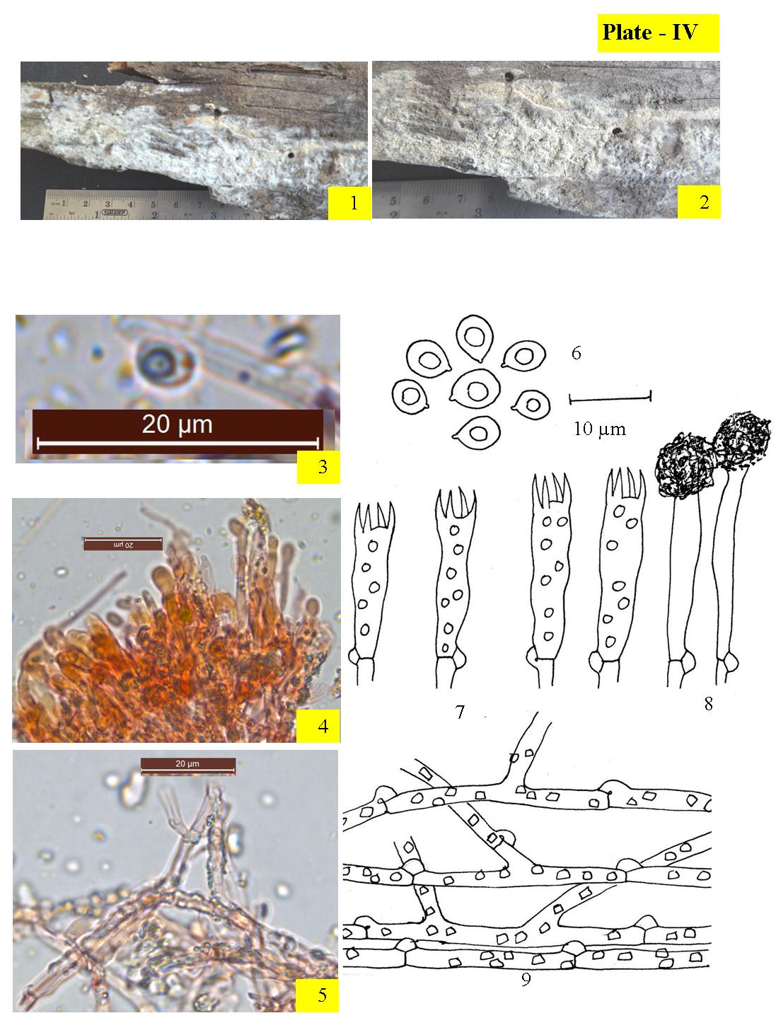
Figs. 1– 9. Hyphodontia rimosissima :1-2. Sporophore showing hymenial surface (1. Fresh; 2. Dry); 3-4. Photomicrographs (3. Basidiospore; 4. A portion of V.S. of sporophore, 5. Encrusted generative hyphae); 6-9. Line diagrams [6. Basidiospores, 7. Basidia,8. Encrusted capitate hyphal ends, 9. Generative hyphae]

5. Hyphodontia sambuci (Pers.) J. Erikss., Symbolae Botanicae Upsalienses 16 (1): 104 (1958). - Corticium sambuci Pers., Neues Magazin für die Botanik 1: 111 (1794). Plate–V

Sporophore annual, resupinate, adnate, effused, up to 240 µm thick in section; hymenial surface smooth to rough (due to rough substrate) both in fresh and dry states; chalky white to orange white when fresh, yellowish gray to grayish orange on drying, margins fibrillose, paler concolorous when determinate. Generative hyphae subhyaline, septate, clamped; horizontal, ≤ 3.5 µm wide, less branched, thick-walled, smooth in the subicular zone; vertical, ≤ 2.2 µm wide, richly branched, thin-walled, encrusted in the subhymenial zone. Cystidia capitate, with basal clamp, 27–37 × 4.4–5.5 µm, thin-walled, with crystalline encrustation. Basidia subclavate to clavate, 17–28 × 3.3–6.6 µm; sterigma ≤ 3.8 µm. Basidiospores 4.4–6.1 × 3.5–5 µm, broadly ellipsoid, thin-walled, smooth, acyanophilous, inamyloid.
Collections examined – India, Himachal Pradesh: Chamba, Khajjiar, on sticks of Cedrus deodara, Poonam 10140 (PUN), August 15, 2013; Churah, Langera, on sticks of Rosa macrophylla, Poonam 10705 (PUN), August 15, 2014; Churah, Manjeer, on sticks of R. macrophylla, Poonam 10707 (PUN), August 15, 2014; Churah, Salooni, on sticks of R. macrophylla, Poonam 10708 (PUN), August 15, 2014; Churah, Salooni, on sticks of R. macrophylla, 10709 (PUN), August 15, 2014; Bhalai, Sundla on sticks of Adhatoda vasica, Poonam 10704 (PUN), October 13, 2015.
Remarks __ It is being described for the first time from tehsils Bharmour and Pangi in the study area. Earlier it was described by Dhingra (1989) from Arunachal Pradesh, Natrajan and Kolandvelu (1998) from Tamil Nadu, Lalji (2003) from Uttarakhand, Dhingra (2005) from Eastern Himalayas, Singh (2007) from district Shimla, Solan and Kullu (H.P.), Priyanka (2012) from districts Chamba and Kangra (H.P.), Ranadive (2013) from Maharashtra, Samita (2014) from Uttarakhand, Dhingra et al. (2014) from various localities of H.P., Sharma (2017) from J&K, Kaur (2018) from from district Shimla (H.P.) and Devi (2019) from district Kangra (H.P.).
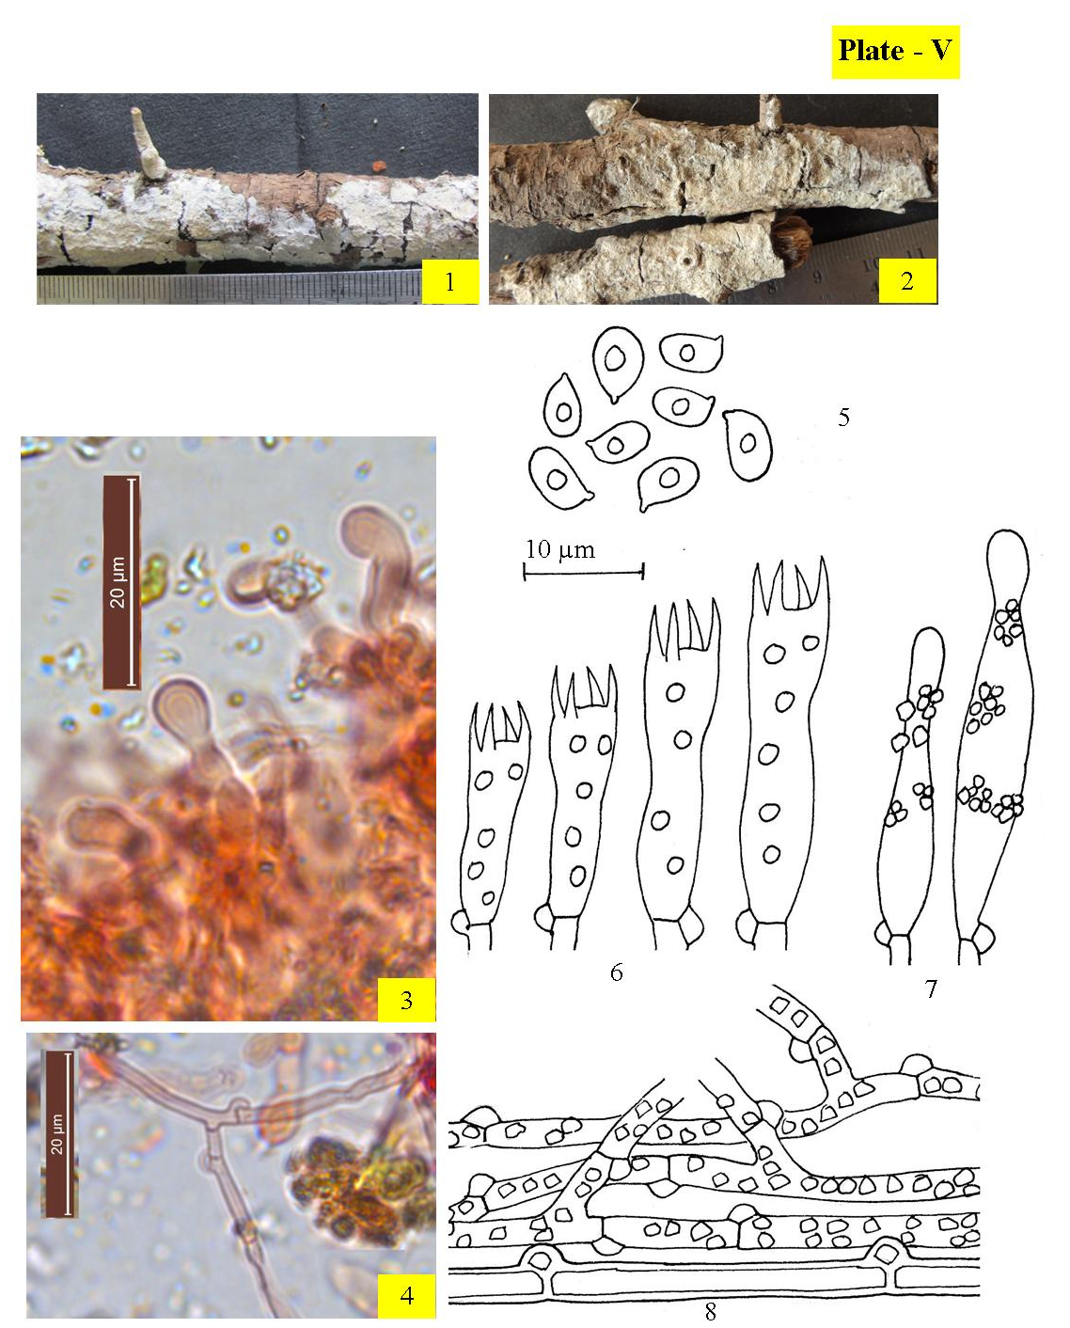
Figs. 1– 8. Hyphodontia sambuci :1-2. Sporophore showing hymenial surface (1. Fresh, 2. Dry); 3-4. Photomicrographs (3. Capitate cystidia, 4. Generative hyphae); 5-8. Line diagrams [5. Basidiospores; 6. Basidia, 7. Capitate cystidia, 8. Generative hyphae]
II. Tubulicrinis Donk, Fungus 26: 13 (1956).
Sporophores resupinate, loosely adnate to adnate, effused, sometimes inconspicuous; hymenial surface smooth to porulose to pulveraceous to hispid to tuberculate. Hyphal system monomitic. Generative hyphae with clamped septa, thin- to thick-walled. Ancillary elements (lyocystidia/hyphoids) present. Basidia clavate to subclavate, somewhat stalked, 4–sterigmate, with clamped septa at the base. Basidiospores ellipsoid to subglobose to cylindrical to allantoid to suballantoid, smooth, thin-walled, negative to both Melzer’s Reagent and Cotton Blue, with or without oily contents.

1. Tubulicrinis chaetophorus (Höhn.) Donk [as 'chaetophora'], Fungus, Wageningen 26: 14, (1956). - Hypochnus chaetophorus Höhn., Sber. Akad. Wiss. Wien, Math.-naturw. Kl., 111: 1007 (1902). Plate –VI
Sporophore annual, resupinate, adnate, effused, up to 320 µm thick in section; hymenial surface smooth to hispid both in fresh and dry states; yellowish white to pale yellow when fresh, yellowish gray to grayish orange on drying, margins fibrillose, paler concolorous when determinate. Generative hyphae subhyaline, septate, clamped, smooth; horizontal, ≤ 4 µm wide, thin- to thick-walled, less branched in the subicular zone; vertical, ≤ 2.8 µm wide, thin-walled, richly branched in the subhymenial zone. Ancillary elements of two kinds: (i) Lyocystidia cylindrical, gradually tapering to pointed tip, with rooted base, capillary lumen narrow, with basal clamp, 88–102 × 10–11 µm, slightly amyloid; projecting upto ≤ 30 µm out of the hymenium (ii) Capitate cystidia hyphoid, sinuous, with basal clamp, 20–22 × 2.7–3.8 µm, thin-walled; embedded in the hymenium. Basidia clavate to subclavate, somewhat sinuous, with oily contents, 16–21 × 5.5–6.1 µm; sterigma ≤ 5.5 µm long. Basidiospores 4–5.5 ×2.4–3.5 µm, ellipsoid to broadly ellipsoid, thin-walled, smooth, acyanophilous, inamyloid.
Collection examined – India, Himachal Pradesh: Chamba, Bharmour, Holi, on stick of Pinus roxburghii Poonam 10381 (PUN), August 23, 2015.
Remarks – It is being described for the first time from tehsil Bharmour in the study area.Previously it was reported by Thind and Rattan (1970) from district Chamba (H.P.), Rattan (1977) from J&K, Singh (2007), Priyanka (2012) and Kaur (2018) from district Shimla (H.P.)
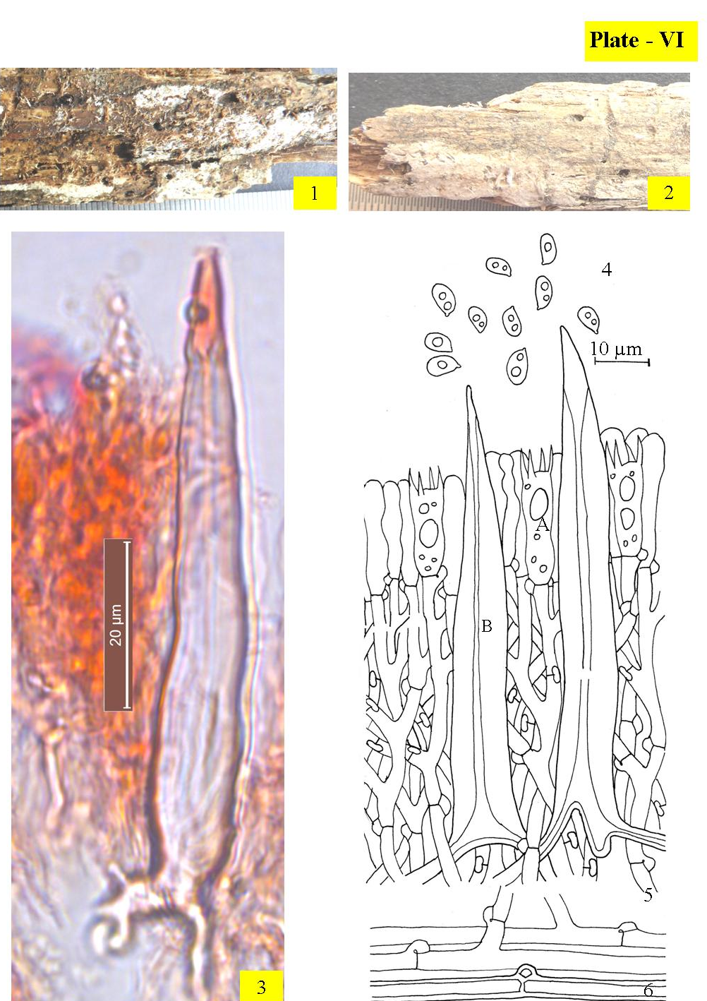
Figs. 1– 6. Tubulicrinis chaetophorus :1-2. Sporophore showing hymenial surface (1. Fresh, 2. Dry); 3. Photomicrograph showing lycocystidium; 4-6. Line diagrams [4. Basidiospores; 5. Reconstruction showing a portion of hymenium and subhymenium ( A. Basidium, B. lycocystidium); 6.Generative hyphae]
2. Tubulicrinis orientalis Parmasto, Eesti NSV Teaduste Akadeemia Toimetised 16: 393(1967). Plate –VII
Sporophore annual, resupinate, adnate, effused, up to 150 µm thick in section; hymenial surface smooth both in fresh and dry states; grayish orange to brownish orange both in fresh and dry states, margins fibrillose, paler concolorous when determinate. Generative hyphae ≤ 3 µm wide, subhyaline, septate, clamped, thin-walled, smooth; horizontal, less branched in the subicular zone; vertical, richly branched in the subhymenial zone. Lyocystidia cylindrical, capillary lumen narrow, with basal clamp, 79–89 × 6–9 µm, encrusted in the upper part except the apex, slightly amyloid; projecting ≤ 70 µm out of the hymenium. Basidia clavate, somewhat sinuous, 14–16 × 3–5 µm; sterigma ≤ 3.6 µm long. Basidiospores 4.1–6.3 × 2.1–3.5 µm, ellipsoid to suballantoid, thin-walled, smooth, acyanophilous, inamyloid.
Collection examined – India, Himachal Pradesh: Chamba, on way from Lakkar Mandi towards Khajjiar, on decaying gymnospermous wood, Poonam 10765 (PUN), November 4, 2013.
Remarks – It is being described here as as a rereported species from district Chamba. Priyanka (2012) and Dhingra et al. (2014) reported it earlier from district Chamba (H.P.)

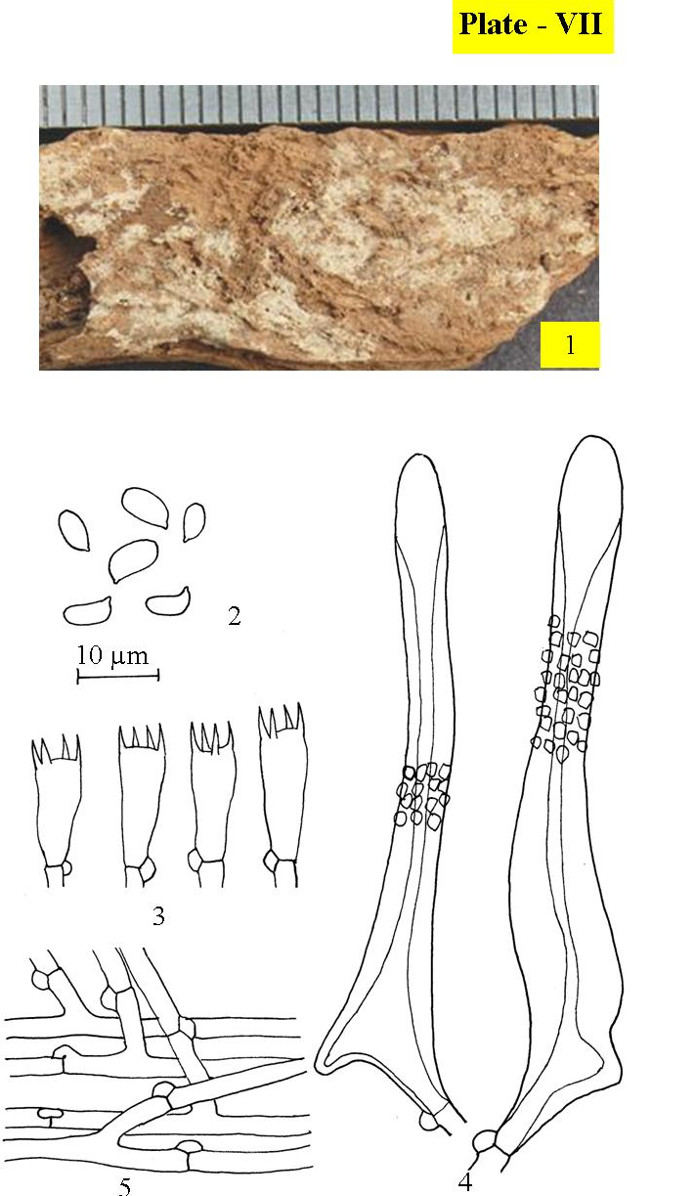
Figs. 1– 5. Tubulicrinis orientalis :1. Sporophore showing hymenial surface; 2-5. Line diagrams [2. Basidiospores; 3. Basidia, 4. Lycocystidia, 5.Generative hyphae

3. Tubulicrinis strangulatus K.H. Larsson & Hjortstam, Mycotaxon 26: 438, (1986).
Plate –VIII
Sporophore annual, resupinate, adnate, effused, up to 180 µm thick in section; hymenial surface porulose to smooth both in fresh and dry states; margins fibrillose, paler concolorous when determinate. Generative hyphae ≤ 3.3 µm wide, subhyaline, septate, clamped, smooth; horizontal, less branched in the subicular zone; vertical, richly branched, thin- to thick-walled in the subhymenial zone. Lyocystidia cylindrical, capillary lumen narrow, that widens towards the apex, with basal clamp, 56–119 × 6.3–9.1 µm, with crystalline ecrustation around neck, that dissolves in 3% KOH solution, slightly amyloid. Basidia clavate, somewhat stalked, constricted, 15–20 × 4.4–6.1 µm; sterigma ≤ 3.3 µm long. Basidiospore 4.9–7.7 × 2.2–3.5µm, allantoid to suballantoid, thin-walled, smooth, acyanophilous, inamyloid.

Collection examined – India, Himachal Pradesh: Chamba, Banikhet, on gymnospermous log, Poonam 10382 (PUN), August 16, 2014.
Remarks – It is a rereported species from tehsil Dalhousie of the district Chamba. Earlier it was described by Dhingra and Sood (1992) from district Chamba (H.P.), Singh (2007), Kaur (2012) and Kaur (2018) from district Shimla (H.P.), Dhingra et al. (2014) from districtsChamba and Shimla (H.P.)
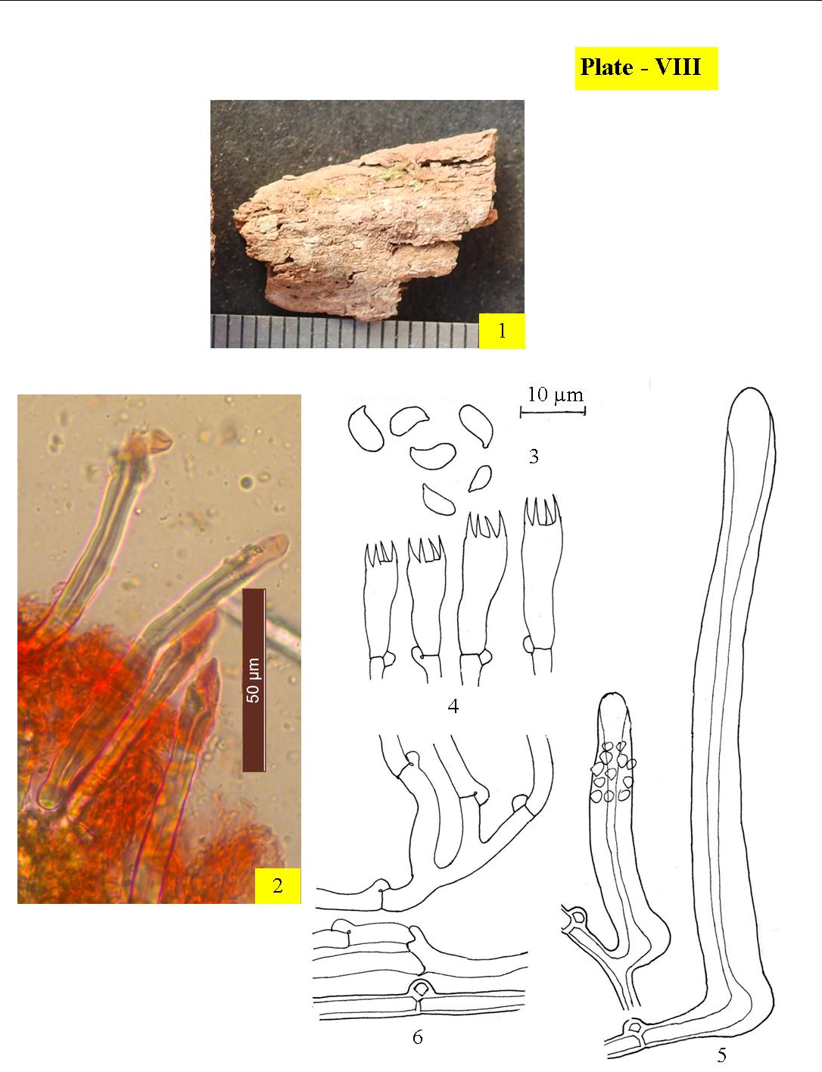
Figs. 1– 6. Tubulicrinis strangulatus :1. Sporophore showing hymenial surface; 2-3. Photomicrographs (2. Lycocystidia); 3-6. Line diagrams [3. Basidiospores; 4. Basidia, 5. Lycocystidia, 6.Generative hyphae]

III. Xylodon (Pers.) Gray, Observationes mycologicae 2: 267, (1818).
Sporophores resupinate, adnate, effused; hymenial surface smooth to odontoid. Hyphal system monomitic. Generative hyphae septate clamped. Hyphal ends capitate, spathulate or tubular. Basidia clavate to subclavate to subcylindrical, 4–sterigmate, with clamped septa at the base. Basidiospores ellipsoid to broadly ellipsoid to subglobose, smooth, thin-walled, negative to both Melzer’s Reagent and Cotton Blue, with or without oily contents.

1. Xylodon asper (Fr.) Hjortstam & Ryvarden, Synopsis Fungorum 26: 34 (2009).- Grandinia aspera Fr., Hymenomycetes europaei: 627(1874). Plate–IX
Sporophore annual, resupinate, adnate, effused, up to 320 µm thick in section; hymenial surface odontoid both in fresh and dry states; orange white to grayish orange both in fresh and dry state, margins fibrillose, paler concolorous when determinate. Generative hyphae subhyaline, septate, clamped, thin- to thick-walled, smooth; ≤ 3.2 µm wide, horizontal, less branched in the subicular zone; ≤ 2.3 µm wide, vertical, richly branched in the subhymenial zone. Cystidoles obtuse to capitate, up to 32 × 3.8 μm, with or without resinous encrustation. Basidia clavate, constricted to sinuous, 14–21 × 4.4–5.5 µm, sterigmata ≤ 4.4 µm long Basidiospore 4.9–6.4 × 4–4.8, broadly ellipsoid to subglobose, thin-walled, smooth, acyanophilous, inamyloid.

Collection examined – India, Himachal Pradesh: Chamba, Churah, Bhandal, on stump of Pinus smithiana, 10184 (PUN), August 17, 2014.
Remarks– Xylodon asper a rereport from the study area, has earlier been described/recorded from various districts of H.P. as well as other localities of India. Earlier it was described by Rattan (1977) from district Shimla (H.P.), Natrajan and Kolandvelu (1998) from Tamil Nadu, Singh (2007) from district Chamba and Sirmaur (H.P.), Sharma (2012) from Uttarakhand, Kaur (2012) District Shimla (H.P.), Ranadive (2013) from Maharashtra, Samita (2014) from Kaur (2018) from district Shimla (H.P), Dhingra et al. (2014) from various localities of H.P., Sharma (2017) from J&K,
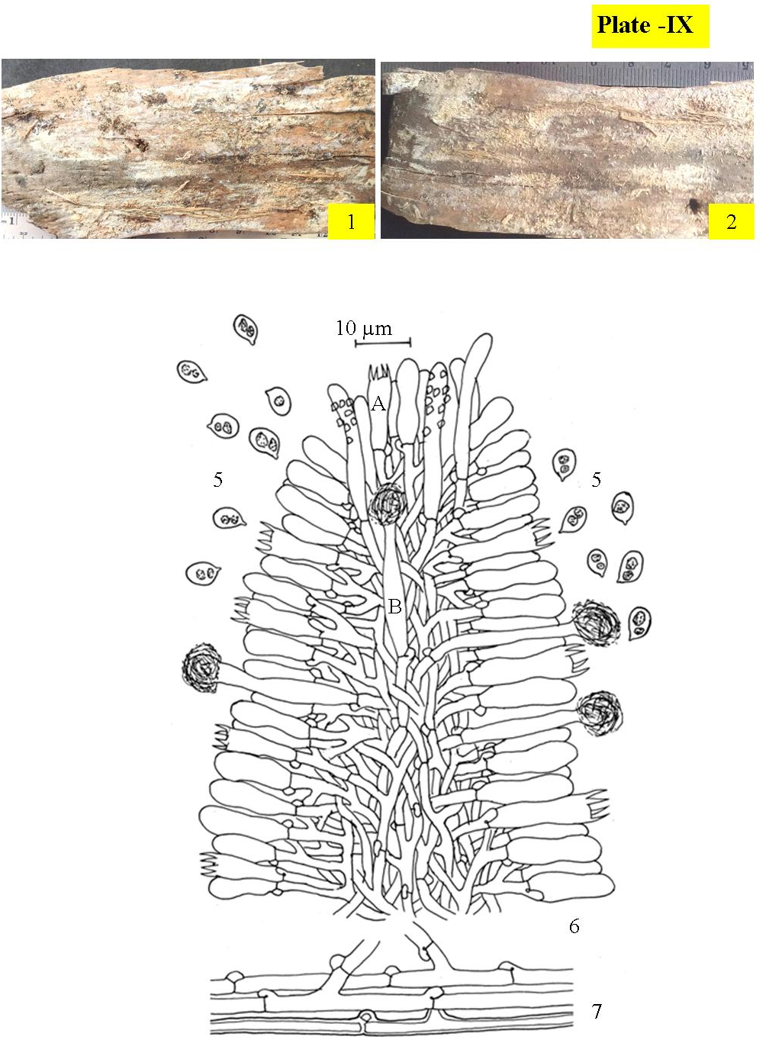
Figs. 1– 5. Xylodon asper :1-2. Sporophore showing hymenial surface (1. Fresh, 2. Dry); 3-5. Line diagrams [3. Basidiospores; 4. Reconstruction showing a portion of aculeus ( A. Basidium, B. Capitate hyphal ends); 5.Generative hyphae]
2. Xylodon spathulata (Schrad.) Kuntze, Revisio generum plantarum 3 (2): 541 (1898). - Hydnum spathulatum Schrad., Spicilegium Florae Germanicae: 178, t. 4:3 (194). Plate –X
Sporophore annual, resupinate, adnate, effused, up to160 µm thick in section; hymenial surface smooth to odontoid both in fresh and dry states; grayish orange to brownish orange both in fresh and dry states, margins fibrillose, paler concolorous when determinate. Generative hyphae ≤ 2.7 µm wide, subhyaline, septate, clamped; horizontal, less branched, thick-walled, smooth in the subicular zone; vertical, richly branched, thin-walled, with resinuous encrustation in the subhymenial zone. Ancillarry elements of two kinds: (i) Capitate hyphal ends with basal clamp, 24–32 × 3.3–4.4 µm, thick-walled, with resinous deposits at the apex; enclosed to somewhat projecting (ii) Spathulate gloeocystidia with basal clamp, 19–34 × 4–6.5 µm, thin-walled, tapering towards the tip, usually constricted, with oily contents negative to sulphovanillin
Basidia subclavate to clavate, with suburniform constriction, 14–18 × 4.4–5 µm; sterigma ≤ 3.3 µm long. Basidiospore 4–5.6 × 2.4–4, broadly, thin-walled, smooth, acyanophilous, inamyloid.
Collection examined – India, Himachal Pradesh: Chamba, on way to Lakkar Mandi from Kalatop, on stump of Cedrus deodara, Poonam 10554 (PUN), October 12, 2013.
Remarks – Hyphodontia spathulata is being described for the first time from tehsil Pangi in the study area. The only earlier report from district Chamba is by Kaur (2012).
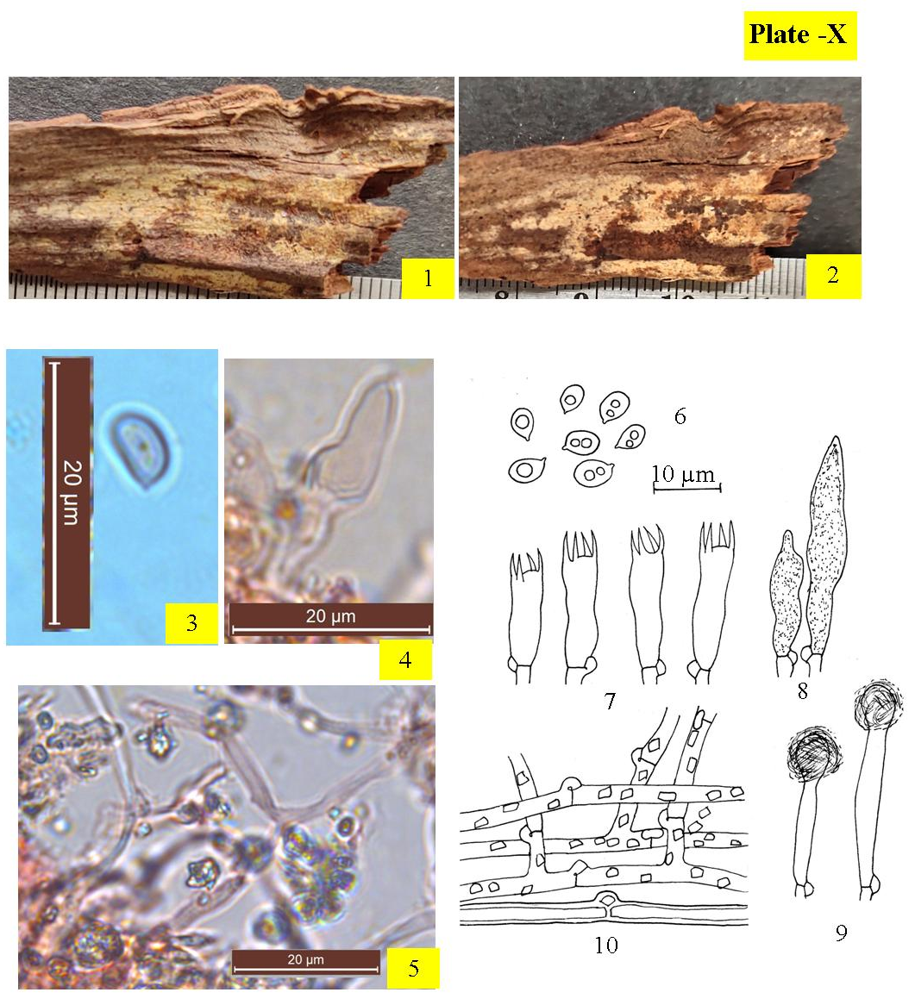
Figs. 1– 10. Xylodon spathulata:1-2. Sporophore showing hymenial surface (1. Fresh, 2. Dry); 3-5. Photomicrographs (3. Basidiospores, 4. Spathulate gloeocystidium, 5.Generative hyphae); 6-8. Line diagrams [6. Basidiospores; 7. Basidia, 8. Spathulate gloeocystidium, 9. Capitate Cystidia, 10.Generative hyphae]
ACKNOWLEDGEMENTS
The authors are grateful to the Head, Department of Botany, Punjabi University, Patiala for providing necessary laboratory facilities, University Grants Commission, New Delhi for financial assistance under DRS-SAP DSA level-I programme and Prof. Nils Hallenberg, Gothen burg for expert comments.
REFERENCES
Devi, R. 2019.Taxonomic studies on poroid and resupinate non-poroid Agaricomycetes of district Kangra (Himachal Pradsh). Ph.D. Thesis. Panjabi University, Patiala. 554pp.
Dhingra, G.S. 2005b. Genus Hyphodontia John Erkss. in the Eastern Himalaya. J. Ind. Bot. Soc. 84: 118–122.
Dhingra, G.S., Priyanka and Kaur, J. 2011. A checklist of resupinate, non–poroid Agaricomycetes fungi from North–East India and Bhutan. Synopsis Fungorum 29: 22–70.
Dhingra, G.S., Singh, A.P., Kaur, J., Priyanka, Kaur, H., Rani, M., Sood, S., Singla, N., Kaur, H., Jain, N., Gupta, S., Kaur, M., Sharma, J., Rajnish and Kaur, G. 2014. A checklist of resupinate, non–poroid Agaricomycetous fungi from Himachal Pradesh, India. Synopsis Fungorum 32: 8–37.
Kaur, J. 2012. Studies on resupinate, non–poroid Agaricomycetous fungi from Himachal Pradesh. Ph.D. Thesis. Panjabi University, Patiala. 256pp.
Kaur, G. 2017. Taxonomic studies on poroid and resupinate non–poroid Agaricomycetous fungi of Punjab and adjoining areas. Ph.D. Thesis. Punjabi University, Patiala. 256pp.
Kaur, M. 2018. Systematic Studies On Resupinate Non–Poroid Hymenomycetous Fungi From District Shimla (H.P.) & Evaluation of Selected Taxa for Ligninolytic Activity. Thesis. Punjabi University, Patiala. 303pp
Kornerup, A. and Wanscher, J.H. 1978. Metheun’s Handbook of colours, IIIrd Ed. Metheun and Co. Ltd. London. 252pp.
Lalji, K. 2003. Mycoflora associated with multipurpose tree species of North–West India. Ph.D. Thesis. Panjabi University, Patiala. 254pp.
Mycobank. 2023. Fungal databases. Nomenclature and species banks. [Accessed: 12/06/2023] http://www.mycobank.org.
Natrajan, K. and Kolandavelu, K. 1998. Resupinate Aphyllophorales of Tamil Nadu, India. 131pp.
Priyanka, 2012. Studies on resupinate Polyporales (Agaricomycetes) of Himachal Pradesh. Ph.D. Thesis. Punjabi University, Patiala. 226pp.
Ranadive, K.R. 2013. An overview of Aphyllophorales (wood rotting fungi) from India. Int. J. Curr. Microbiol. App. Sci. 2(12): 112–139.
Rattan, S.S. 1977. The resupinate Aphyllophorales of the North Western Himalaya. Bibliotheca Mycologica 60, Cramer, Germany. 427pp.
Singh, A.P. 2007. Resupinate Aphyllophoraceous Fungi associated with some tree species of Himachal Pradesh and Punjab. Ph.D. Thesis. Punjabi University, Patiala. 258pp.
Samita. 2014. Systematic studies on resupinate, non-poroid Agaricomycetes of Uttarakhand. Ph.D. Thesis. Punjabi University, Patiala. 331pp.
Sharma, J.R. 2012. Aphyllophorales of Himalaya. Botanical Survey of India, Calcutta. 590pp.
Sharma, J. 2017. Taxonomic studies on resupinate non-poroid Agaricomycetous fungi from Jammu division (J&K). Ph.D. Thesis, Punjabi University, Patiala. 270pp.

