PerformanceAnalysis of SI Engine using petrol and LPG as a fuel
Dr.Abhinav P. Ninawe
Department of Mechanical engineering
RTMNU
K.D.K College of Engineering, Nagpur

ABSTRACT
There has been a lot of research work under various initiatives going in the automobile sector for using the alternate fuel. With increase in time, many researchers are finding ways for better option for alternate fuel which will provide higher efficiency. Being focused more on fossil fuel, the focus is more on leading to fuels that are not only able to work like the conventional ones but also will yield lesser harmful elements. It should be first implement to start using of the alternating fuels like Liquid Petroleum Gas (LPG) and Compressed Natural Gas (CNG) which are readily available in market and also deliver same efficiency compared to petrol. This paper will show the outcome of the experiment that is carried out. Torque, engine speed, load on the engine and consumption of fuel were examined with using the universal dynamometer. In additional the fuel consumption has been measure to identify which fuel is more practical for SI internal combustion engine. Spark ignition engine working on LPG has slightly decreased on power output and decrease in brake power.
KEYWORD
Performance,Characteristics, LPG as fuel, LPG kit, Engine Efficiency.

1. INTRODUCTION
The market requirements have driven the need to reduce using of the fossil fuel while giving same performance. This put the researcher to make the engine more complex without changing the design. The main research objective for the automotive engineering community these days is to provide with petrol engine specific power with diesel-like efficiency based like power at a low cost of fuels.
Liquefied petroleum gas (LPG) is by-products of natural gas production and crude oil refineries. A powerful odorant, Ethyl Mercaptan is added, in order to detect leak on the container (tank), it made leaking can be easily detected. It is also comparably light weighted and have less cost. The important characteristics of LPG are, LPG has higher octane number of about 112, means it has higher compression ratios to be employed and gives more thermal efficiencies. As LPG is a fuel supplied, engine work smoothly. Fuel consumption is less as compared to petrol and is because of the high energy content in the LPG. Power output drops slightly in LPG operated engine as compared to petrol operated engine due to the poor volumetric efficiencies. Factor that can decrease power output is due to the spark ignition timing. LPG system on vehicle requires more safety.
LPG is the gaseous fuel as in physical condition in atmospheric pressure and temperature. Due to low maintenance cost, less market price and environment friendly characteristics LPG is one of the popular alternative for gasoline. The main purpose of carrying out this experimental test to make analytical comparisons between both the fuel and the variation of their output parameters on the graph.

2. METHODOLOGY
The experimental performance requires the instruments which held this test. As there is implementation of gas kit in the setup few modifications were made in the engine. Rather than safety measures were taken in case of fire or burns.

Fabrication of frame for performance testing and to install apparatus

The frame is strong enough to sustain all the vibration coming from the engine. the frame is made up of cast iron with angled section bar were welded for mounting the engine. Engine was bolted with the foundation bolt from beneath the frame. The bolt was welded to the angled section so as they couldn’t remove by the vibration. The spring weight dynamometer were placed at the rim section. the fuel burette is attach to the frame with the burette pipe attach to the carburetor. Frame is made for the performance testing of SI engine

Fitting of nozzle on intake manifold
The hole was drill using the drill bit of 9mm diameter. Nozzle of 9mm diameter were inserted to the inlet manifold section of engine. The fuel will directly open up into the intake manifold.

Implementation of gas kit
The gas kitcomprising LPG gas cylinder, vaporizer, regulator was installed into the setup.

- Vaporizer
Vaporizers convert liquid state LPG fuel into gas or vapor. It is called reducer as it reduces pressure of high pressurized liquid state fuel . Vaporizer consists of main body of metal by pressure die casting process subsequently followed by vacuum impregnation, shot blasting & hard anodizing process. For pressure drop & maintaining continuous flow requirement generally done either in 3 or 2 stages with the help of diaphragms & lever arrangement set in the main body. Quantity & quality of fuel flow is depending on port diameter of fine precision jet & the volume enclosed by diaphragms.

- Regulator
The LPG tank is of household purpose therefore the regulator is used to supply gas from the tank to the vaporizer via the LPG connecting pipes.

- LPG gas tank
Household gas tank was taken in the performance of experiment.

3. APPARATUS USED FOR PERFORMANCE TESTING

- Fuel Burette: - It is used for measuring the fuel supply which is feed in the carburetor.
- Digital Stopwatch: - It is used fuel flow rate in 30 second of time interval.
- Spring balance: - It is used for calculating load on engine attach to the frame.
- Rotary digital tachometer: - It is used measure the rpm of the output shaft.
- Digital weight machine: It is used to measure the weight of cylinder at 1 minute of time interval.

4. ENGINE SPECIFICATION

Displacement | 97 cc
Maximum Power | 7.5bhp@8000rpm
Maximum Torque | 0.73@5000rpm
Ground Clearance | 135.00 mm
Kerb/Wet Weight | 116.00 kg
Fuel Tank Capacity | 12.80 liters
Top Speed | 85 kmph

5. PROCEDURE OF TESTING
All the arrangement of experimental setup is checked and the engine is start at the load of 2 kg.The fuel in the burette is noted down at initial point or the start point. As the first gear is put on the speed is noted down. The load acting on engine is noted by the spring balance with the fuel consumption after 30 second of the fuel used. These same reading were taken on all the 4 gears. The load is increased up to the 4 kg and similar parameters and reading are noted down.
The LPG kit is now installed and all the parameters and reading were noted down at same load and at all 4 gears keeping throttle same as that of petrol. In case of LPG testing of cylinder weight is done by using digital weight balance.

Difficulties Faced and Limitations
- As the LPG tank is connected through pipes, the vibration of engines moves towards the cylinder. This causes the cylinder to shake from its base. As cylinder was mounted on weighing scale the reading wasdisturb.
- As the inlet manifold becomes hot. The nozzle attach to it loses grip and tends to move out.

6. SPECIFICATION

Dynamometer:
Rope brake dynamometer
Belt thickness= 0.005m
Diameter of drum = 0.1272m
Circumference of drum= 0.04m

7. OBSERVATION TABLE
The following observations were seen during the experimentations.
- Observation table for Petrol.
Gear NO.. | W1 | W2 | Wnet | Speed | Time require to consume 10 ml in minutes | Mf | Torque | BP
1 | 1.5 | 2.5 | 2 | 457 | 1:27 | 0.000093175 | 1.3459 | 64.41
2 | 1.7 | 2.5 | 2 | 741 | 1:15 | 0.00010289 | 1.3459 | 104.4328
3 | 1.7 | 2.5 | 2 | 1010 | 1:12 | 0.00010565 | 1.3459 | 142.3519
4 | 1.5 | 2.5 | 2 | 1386 | 0:39 | 0.00018047 | 1.3459 | 195.346

For 2 kg load

Gear no. | W1 | W2 | Wnet | Speed | Time require to consume 10 ml in minutes | Mf | Torque | BP
1 | 2 | 5.5 | 4 | 360 | 1:25 | 0.000094666 | 2.6918 | 101.4784
2 | 2 | 5.5 | 4 | 620 | 1:20 | 0.000098611 | 2.6918 | 174.7684
3 | 2 | 5.5 | 4 | 903 | 1:45 | 0.000081609 | 2.6918 | 254.5412
4 | 2 | 5.5 | 4 | 1120 | 1:27 | 0.000093175 | 2.6918 | 315.7107

For 4 kg load

- Observation table for LPG

Gear no. | W1 | W2 | Wnet | Speed | Volume flow in gram | Time in second | Mf | Torque | BP
1 | 1.5 | 2.5 | 2 | 345 | 9 | 30 | 0.0003 | 1.345 | 48.59
2 | 1.5 | 2.5 | 2 | 608 | 9 | 30 | 0.0003 | 1.345 | 85.63
3 | 1.5 | 2.5 | 2 | 784 | 13 | 30 | 0.000433 | 1.345 | 110.42
4 | 1.5 | 2.5 | 2 | 1258 | 16 | 30 | 0.000533 | 1.345 | 117.18
For 2 kg load

Gear no. | W1 | W2 | Wnet | Speed | Volume flow ingram | Time in second | Mf | Torque | BP
1 | 2 | 4.5 | 4 | 347 | 7 | 30 | 0.000233 | 2.6918 | 97.8139
2 | 2 | 5 | 4 | 602 | 4 | 30 | 0.000133 | 2.6918 | 169.6945
3 | 2 | 5 | 4 | 889 | 5 | 30 | 0.000167 | 2.6918 | 250.5945
4 | 2 | 5.5 | 4 | 1108 | 7 | 30 | 0.000233 | 2.6918 | 312.3281
For 4 kg load

8. FORMULAS USED IN CALCULATION
- W_{net} (in N) = W_{net} * g
- Torque (T) = W_{net} * (R+T)
- Brake power / B.P (W) = (2 * π * N * T) / (60)
- Mass fuel per second (m_{fuel}) = (ρ*V)/time
- Thermal efficiency (ƞ) =B.P/(mfuel* c.v_{fuel})
- c.v_{fuel} (petrol)=47300 J
- Density (ρ) (petrol) =710 kg/m³
- c.v_{fuel} (LPG)=46100
- Density (ρ) (LPG)= 495 kg/m³

Sample Calculations for petrol (for load 2 kg and 1st gear):

1. W_{net} (in N) = W_{net} * g
= 2 * 9.81
= 19.62 N
2. Torque (T) = W_{net} * (R+T)
= 19.62 * (0.0636+0.005)
= 1.3459 N-m
3. Brake power / B.P (W) = (2 * π * N * T) / (60)
= (2 * π * 457 * 1.3459) / (60)
= 64.4106 W
4. Mass fuel per second (m_{fuel}) = (ρ*V)/time
= (710 * 10 *10⁻³)/76.2
= 9.3175 * 10⁻⁵ kg/sec
5. Thermal efficiency (ƞ) =B.P/( m_{fuel} * c.v_{fuel})
= (64.4106 * 10⁻³/ (9.3175 * 10⁻⁵ * 47300)) *100
=1.46 %

Sample Calculations for LPG (for load 2 kg and 1st gear):

1. W_{net} (in N) = W_{net} * g
= 2 * 9.81
= 19.62 N
2. Torque (T) = W_{net} * (R+T)
= 19.62 * (0.0636+0.005)
= 1.3459 N-m
3. Brake power / B.P (W) = (2 * π * N * T) / (60)
= (2 * π * 345 * 1.3459) / (60)
= 48.59W
4. Mass fuel per second (m_{fuel}) = (ρ*V)/time
= (495 * 10 *10⁻³)/0.009
= 3 * 10⁻⁴ kg/sec
5. Thermal efficiency (ƞ) =B.P/( m_{fuel} * c.v_{fuel})
= (48.59 * 10⁻³/ (3 * 10⁻⁴ * 46100)) *100
=0.35%

9. RESULT AND DISCUSSION
The difference in the brake thermal efficiency is evident. With the increasing load, the fuel consumption is increasing. As load increases fuel consumption also increases.

(Gear NO. vs Brake power)
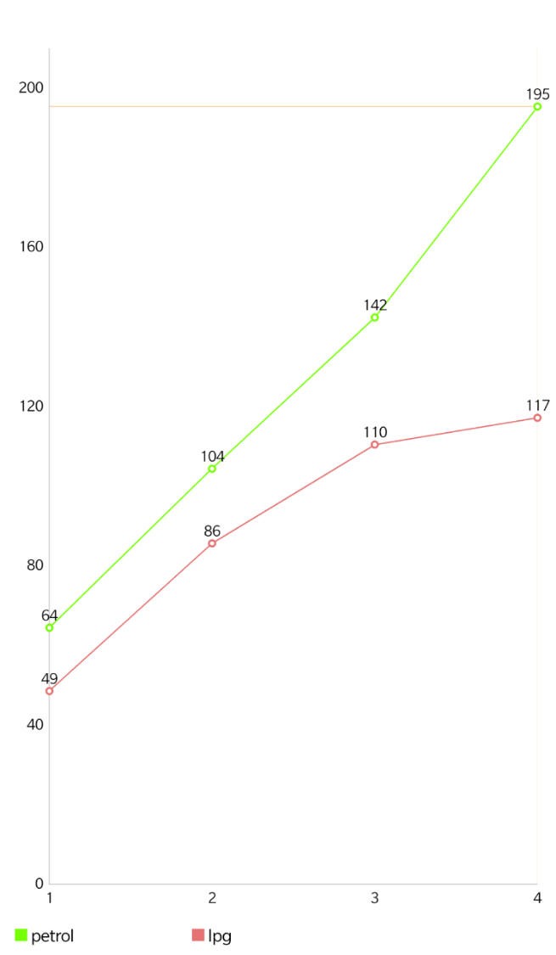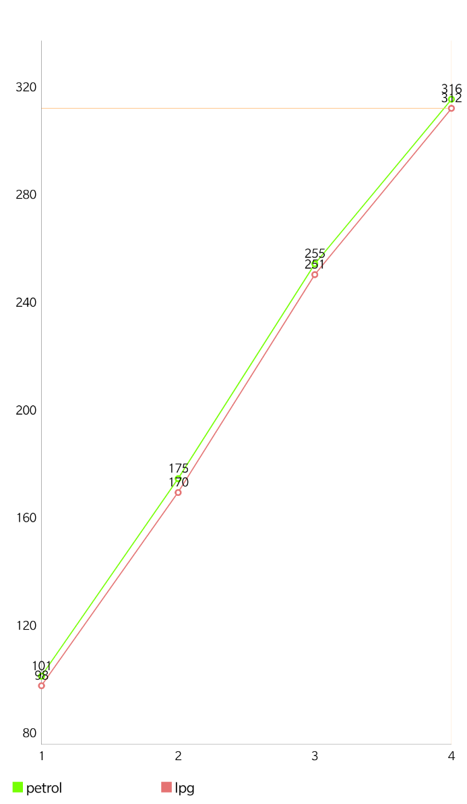
load 2 KG load 4 KG

(Gear NO. vs mass flow rate)
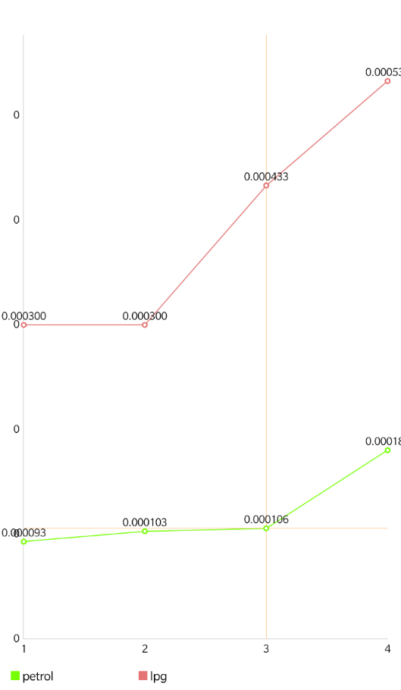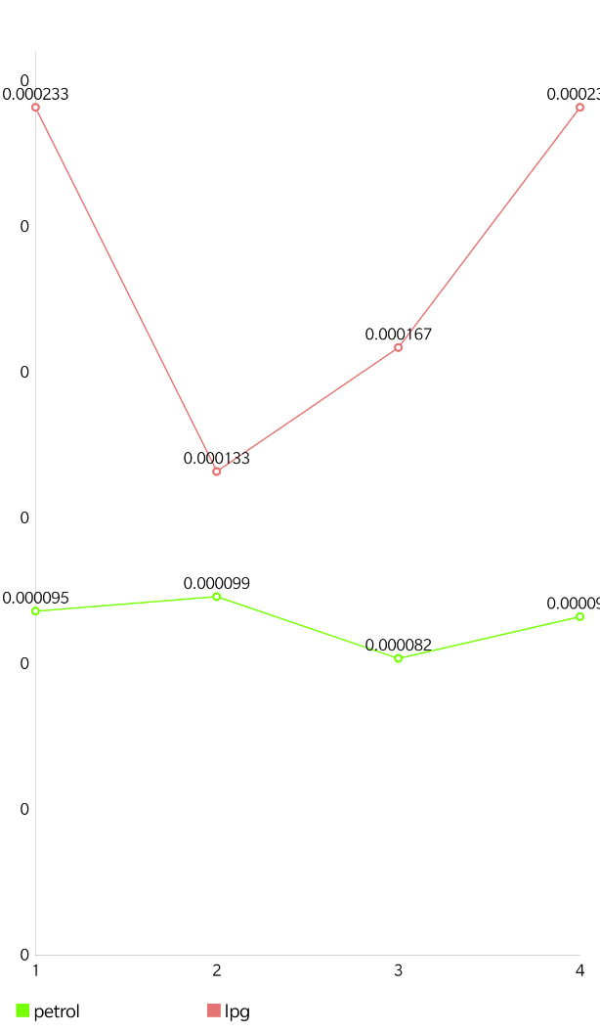
load 2 KG load 4 KG
(Gear NO. vs Efficiency)
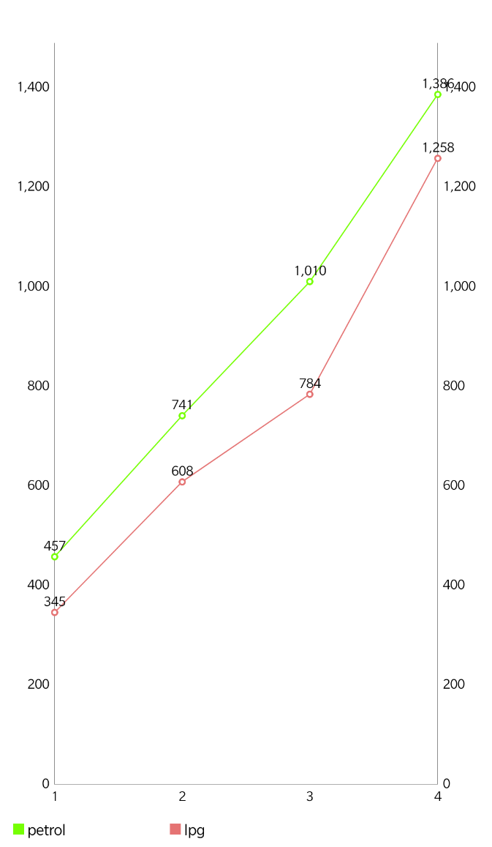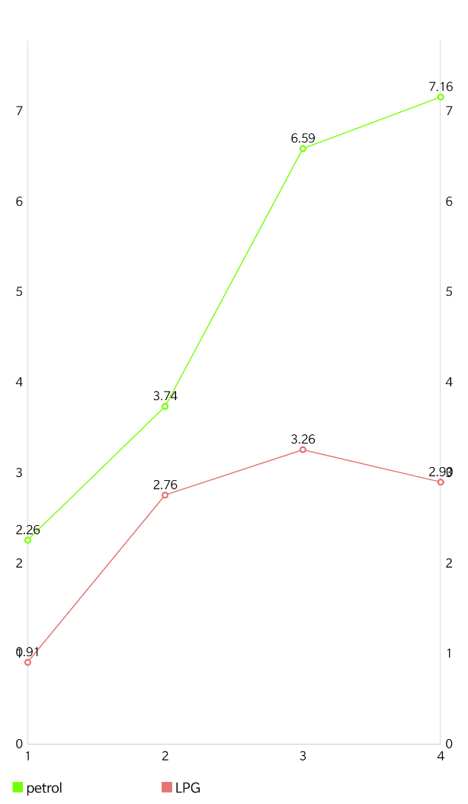
load 2 KG load 4 KG

(gear NO. vs speed in rpm)
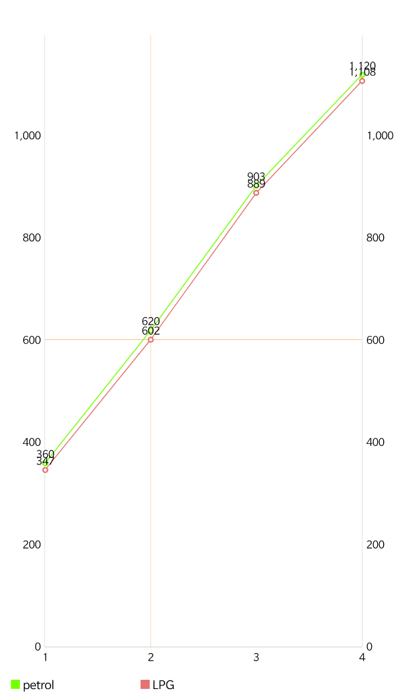
load 2 KG load 4 KG

10. CONCLUSIONS
Scope in this field of work is very important. It not only is an alternate fuel in compared to petrol but also has less emission pollutant content. The performance reading and its curve is as shown. Definitely we get higher efficiency and higher brake power as compared to petrol. Mass flow rate of LPG is high as compared to the petrol. But the difference in output can be decreased by installing the cooling system. He cooling system can increase the efficiency and can provide higher mileage.
This types of system are yet to be implement in the commercial areas. but as automobile sector increase the implementation will soon be seen. From the testing data we can conclude that brake thermal efficiency 5- 6% more than Petrol. By doing various test on our project we concluded following performance of LPG versus Petrol

REFERENCES
[1]World LP Gas Association and United Nation Environment Programme. Guidelines for Good Safety Practices in the LP Gas Industry. France, 2008.
[2]K. Owen andT. Coley. Automotive Fuels Reference Book: Second Edition. Society of Automotive Engineering, Inc. Warrendale PA, 1995.
[3]Mustafa K. F., Gitano-Briggs H. W. Liquid Petroleum Gas (LPG) as an alternative fuel in spark ignition engine: Performance and emission characteristics. IEEE Energy and Environment, 2009. ISBN 978-1-4244-5144-9, 2010, pp 189-194.
[3]Robert F. Klausmeier & Irwin F. Billick. Comparative analysis of the environmental impact of alternative transportation fuels. ACS Publication. Energy Fuels, vol. 7 (1), 1993, pp 27-32.
[4]D.Y. Wu, R.D. Matthews, J. Zheng, K. Shen, J. Chiu, C. Mock, S. Jaeger. Texas Project: Part 3–cycle emissions of light-duty vehicles operating on CNG, LPG, Federal Phase 1 reformulated gasoline and/or low sulphur certification gasoline. SAE Special Publications, vol. 1208, 1996, pp 385414.
[5]M.S. Newkirk, L.R. Smith, M.E. Payne, J.S. Segal. Reactivity and exhaust emissions from an EHC-equipped LPG conversion vehicle operating on butane/propane fuel blends. SAE Special Publications, vol. 1208, 1996, pp1 95 206.
[6]Snelgrove D.G., Dupont P., and Bonetto R. An investigation into the influence of LPG (Auto-gas) composition on the exhaust emissions and fuel consumption of 3 bi-fuelled Renault vehicles. SAE Paper No. 961170, 1996.
[7]Ali M. Pourkhesalian, Amir H. Shamekhi and Farhad Salimi. Alternative fuel and gasoline in an SI engine: A comparative study of performance and emissions characteristics. Elsevier, Fuel Vol. 89, Issue 5, 2009, pp 1056-1063.
[8]World LP Gas Association. LP Gas Exceptional Energy. International System and Communication Limited (ISC), 2009.
[9]O. A. Kutlar, H. Arslan, and A. T. Calik. Method to improve efficiency of four stroke, spark ignition engine at part load. Elsevier, Energy Conversion & Management vol 46, 2005, pp 3202-3220.
[10]M. A. Ceviz and F. Yuksel. Cyclic variation on LPG and gasoline fuelled lean burn SI engine. Elsevier, Renewable Energy vol 3, 2005, pp 1950-1960.
[11]L. Li, Z. Wang, B. Deng, Y. Han, and H. Wang. Combustion and Emissions Characteristics of a Small Spark Ignition LPG Engine. SAE International, Internal Spring Fuels & Lubricants, 2002.
[12]R. R. Saraf, S.S. Thipse, and P.K. Saxena. Comparative assessment on performance and emissions of LPG/Gasoline Bi-fuel Passenger car PFI Engines. SAE International, 2009.

