CONVERSION OF AMERICAN SIGN LANGUAGE TO TEXT USING DEEP LEARNING FOR FEATURE EXTRACTION

Abstract

In order to recognise people's hand gestures (Deaf people) and improve communication with non-Deaf people, this project proposes a vision-based strategy. This American Sign Language (ASL) movements used by deaf persons are intended to be recognised and translated into text using this technique. After careful consideration, the most effective method for applying the Transfer Learning Approach with the Alexnet and algorithms for classification in MATLab application to translate real-time American Sign Language into text is explained. AlexNet is a very common convolution neural network (CNN) for identifying objects. Comparatively to beginning from scratch and creating a set of networks with randomly created weights, transfer learning often accelerates and facilitates system fine-tuning. You are able to rapidly apply learnt characteristics to a new assignment by using less training photos. The accuracy of the three classification techniques (SVM, KNN, and Naive Bayes) will be assessed subsequently, and the technique that performs most efficiently for our work will be selected.

Existing System

1] Nelson, Ann, K. J. Price, and Rosalie Multari [2] demonstrated a web-based ASL interpreting system built with Convolutional Neural Networks (CNN) that offers an effective method for real-time comprehension of 29 ASL signs, which includes 26 alphabet indications and three extra signs ("space", "delete," and "nothing"). Automation sign interpretation requires two things to be true in order to obtain this level of accuracy: two requirements: a large number of input photographs that are of a good quality, and (2) use a pre-trained model (VGG16), and (3) modify the algorithm to the data collection.

2] The authors Bhumika Gupta, Pushkar Shukla, and Ankush Mittal [11] designed a method for identifying still pictures of Indian Sign Language letters that have been signed. In contrast to the alphabets of other sign languages, such as American Sign Language and Chinese Sign Language, the written form of the Indian sign language is both single-handed and double-handed. The model first classifies them into single-handed and double-handed groups to make them simpler to distinguish. Two features HOG and SIFT are collected for the training collection of images across all categories and concatenated into a single matrix.

Proposed System
As part of this project, we created a model that can translate American Sign Language into text in real time. They are categorised and divided into the appropriate categories using three classifiers. We determine the accuracy of each of the three types of classifiers with different calculations, and then, according to the highest accuracy, we choose which classifier to utilise in real time for rapid and precise results.

Methodology

The levels of the system model are covered in the following sections.
- Dataset Creation
- Feature Extraction using Alexnet
- Classification using Naive Bayes
- Classification using KNN
- Classification using SVM

1. Dataset Creation
The American Sign Language alphabets from A to Z and some extra signs used in daily life such as "Hello", "How are you", "Call me" etc,. are represented by images in the dataset. This image resolution is set to 227x227x3. This dataset serves as both test images as well as training data for the algorithm. To improve precision and results, the dataset size was increased to roughly 46000 images.

2. Feature Extraction using Alexnet
One of the most popular Convolution Neural Network (CNN) for object detection is Alexnet. Five convolutional layers, three max-pooling layers, two normalisation layers, two fully connected layers, and one SoftMax layer make up the design. Before the image is extracted, multiple factors are taken into account. In real-time applications, it is significant.

The following steps are followed to Reuse the Pretrained Network:
- Load data
- Load Pretrained Network
- Replace the Final Layers
- Train Network
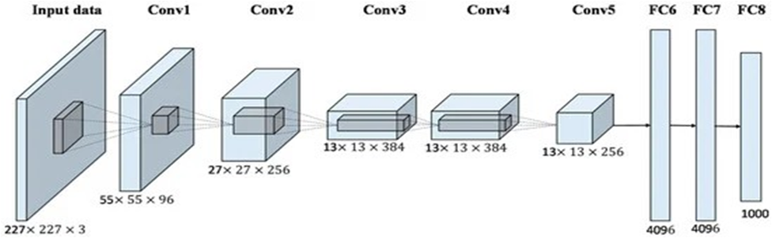

3. Classification using Naive Bayes
A supervised learning technique built on the Bayes theorem for issues with classification is the Naive Bayes algorithm. It makes predictions in the form of probabilistic classifiers based on the likelihood that a given event will occur. The Bayes theorem, often known as Bayes' law or Bayes' rule, is a mathematical formula used to determine how likely an assumption is given some prior knowledge. The concept of a conditional probability governs this.
The Bayes theorem's formula is given below:
P(A|B)= (P(B/A)P(A))÷P(B)

4. Classification using KNN
One of the easiest machine learning algorithms, using the supervised learning method, is K-Nearest Neighbour. The KNN approach compares the new case or data to the previous cases, and it places the latest case in the category that looks to match the current categories the closest. After all of the previous data has been recorded, a new data point is categorised based on similarities using the KNN algorithm. This indicates that new data can be reliably and quickly categorised using the KNN approach. The KNN technique can be used for regression even though issues with classification are where it is most typically applied. KNN does not make predictions about the real data because it is a non-parametric method. As a result of saving the data set used for training instead of instantly learning from it, the method is also referred to as a lazy learner. Instead, it performs an action while classifying data by using the data from the dataset.
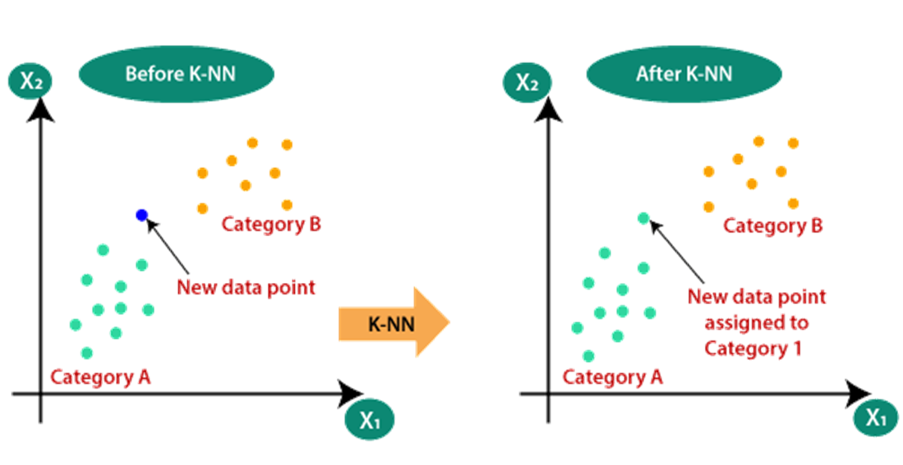
5. Classification using SVM
Classification and regression issues are resolved using Support Vector Machine is one of the most used supervised learning techniques. However, it is mostly used in Machine Learning issues related to classification. The goal of the SVM method is to identify the best decision boundary or line that can categorise the n-dimensional space into distinct groups, enabling us to easily categorise new data points in the future. The name of this best choice boundary is a hyperplane.
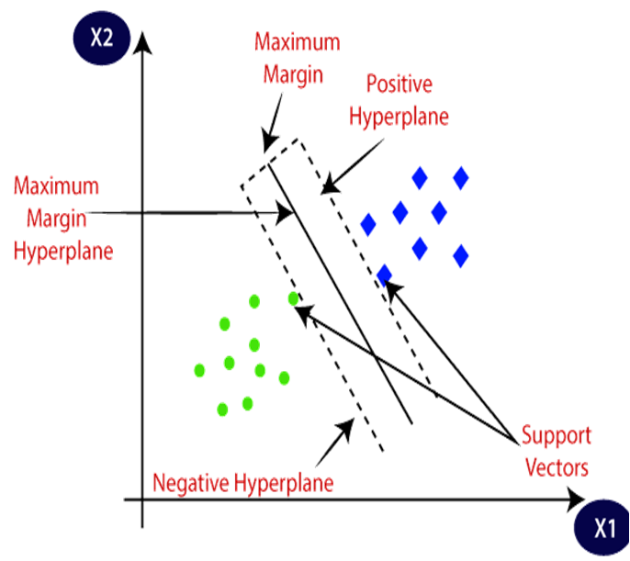
RESULTS



Fig 1 - Detecting the Sign letter “A” into Text by using Live input

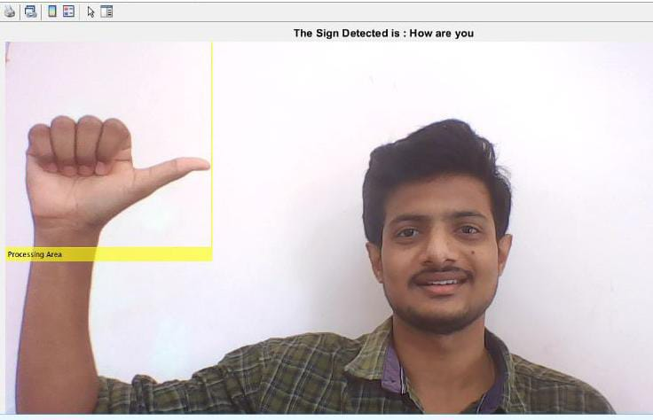
Fig 2 - Detecting the Sign Sentence “How are you” into Text by using Live input

CONCLUSION

We created a dataset for ASL Sign language by extracting features from the pretrained Alexnet network and utilising different machine learning models (SVM, KNN, and Logistic regression) for classification and training. We also created the software to test and refine the photographs in the collection. Additionally, the result was verified using dataset test images and input data gathered from live camera indicators.

The project's next improvements will use hardware tools to implement this paradigm. The conversion of sign language into spoken speech has to be trained.

REFERENCES

- Patwary, Muhammed J. A. & Parvin, Shahnaj & Akter, Subrina. (2015). Significant HOGHistogram of Oriented Gradient Feature Selection for Human Detection. International Journal of Computer Applications. 132. 20-24. 10.5120/ijca2015907704.
- Ann Nelson, KJ Price , Rosalie Multari (2019) ASL Reverse Dictionary - ASL Translation Using Deep Learning.
- Dumitrescu, & Boiangiu, Costin-Anton. (2019) A Study of Image Upsampling and Downsampling Filters. Computers. 8. 30. 10.3390/computers8020030.
- Saeed, Khalid & Tabedzki, Marek & Rybnik, Mariusz & Adamski, Marcin (2010) K3M: A universal algorithm for image skeletonization and a review of thinning techniques. Applied Mathematics and Computer Science. 20. 317-335. 10.2478/v10006-010-0024-4.
- Mohan, Vijayarani. (2013) Performance Analysis of Canny and Sobel Edge Detection Algorithms in Image Mining. International Journal of Innovative Research in Computer and Communication Engineering. 1760-1767. M. Young, The Technical Writer’s Handbook. Mill Valley, CA: University Science, 1989.
- Tzotsos, Angelos & Argialas, Demetre. (2008) Support Vector Machine Classification for Object-Based Image Analysis. 10.1007/978-3-540- 77058-9_36.
- Mishra, Sidharth & Sarkar, Uttam & Taraphder, Subhash & Datta, Sanjoy & Swain, Devi & Saikhom , Reshma & Panda, Sasmita & Laishram, Menalsh. (2017) Principal Component Analysis. International Journal of Livestock Research. 1. 10.5455/ijlr.20170415115235.
- Evgeniou, Theodoros & Pontil, Massimiliano. (2001) Support Vector Machines: Theory and Applications. 2049. 249-257. 10.1007/3-540- 44673-7_12

