Fabrication of biomarker based immunosensor- a detailed case study

Payal Gulati*¹ and Anil Kumar¹

¹Gene Regulation Laboratory, National Institute of Immunology, Aruna Asaf Ali Marg, New Delhi – 110067, India.
Corresponding Author*: payalgulati@nii.ac.in

Abstract— Myoglobin is important biomarker for the detection of cardiac abnormalities like acute myocardial infarction because it is the first to release after the damage. Accordingly, a label-free electrochemical immunosensor is fabricated to detect myoglobin based on three different electrodes like glassy carbon, Indium tin oxide glass and porous silicon. All the electrodes were functionalized with GPMS resulting in highly reactive epoxy groups on their surface which covalently binds with the amino group of Monoclonal Anti-Myoglobin Human antibody. Finally, sensing of the electrodes were done with Ag-Mb in a linear range from 0.01 to 1.00µg/ml in PBS buffer (pH 7.4) by using cyclic voltammetry technique. All the electrodes responded to the stepwise changes done on their surface but out of these, glassy carbon electrode was found to be highly sensitive as it showed more current change with respect to small change in the antigen concentration.
Keywords—Electrochemical immunosensing, cyclic voltammetry, GC, PS and ITO.

Introduction
Cardiovascular disease (CVD) [1] is a life-threatening disorder that affects heart and blood vessels. Coronary heart disease is a most common form of CVD, associated with two major clinical form that is heart attack (often known as Acute Myocardial Infarction) and angima. An Acute Myocardial Infarction (AMI) occurs when heart blood vessel is suddenly blocked, damaging the heart muscle and its function causing cell death. To predict CVD risk, cardiac biomarkers can be identified in the bloodstream which provides therapeutic value in medical applications. An ideal biomarker should have high sensitivity and specificity whereas on the other hand it should be quickly released in blood enabling early diagnosis.
Myoglobin [2] (17.8KDa) is an iron- and oxygen- binding protein found in the skeletal muscles and heart of vertebrates. Levels of myoglobin start to rise within 2-3 hours of heart attack or other muscle injury reach their highest level within 8-12 hours and generally fall back to normal within one day. Normal level of myoglobin in serum is 10-65ng/ml and elevates to 200ng/ml after onset of AMI.
Electrochemical biosensors [3] based detection offer sensitivity, selectivity and reliability, making them very attractive tools for biomarker protein detection. Due to their low cost, low power and ease of miniaturization, electrochemical biosensors hold great promise for sensing applications as compared to those tedious, time consuming multi-stage process used in hospitals like ELISA (Enzyme linked immuno sorbent assay), fluorescence, Radioimmunoassay.
ITO (Indium Tin Oxide) glass provides certain attractive properties like excellent adhesion properties to the substrate, surface stability under harsh condition and it has good conductivity. GC is used for electrochemical sensing purpose because of its low electrochemical resistivity, high chemical resistance, good electrical conductivity and it is biocompatibility. PS is the etched form of silicon wafer, which has high surface area to volume ratio in order to increase adherence to the large molecules about micrometer range and it also exhibits high biocompatibility. For immobilization of Antibodies, Enzymes or DNA on the electrode surface requires functional interlayer of organic SAM (Self- assembled monolayer) like GPMS (3-Glycidoxypropyl trimethoxy Silane) [4].
In this work, we report a planar ITO, Glassy Carbon and Porous Silicon based immunosensor functionalized with GPMS silane whose exposed epoxy groups readily reacts with amino groups of the antibody. Finally sensing of myoglobin was done by cyclic voltammetry in a range from 0.01µg/ml to 1µg/ml. In order to compare the sensitivity of all the electrode surfaces, Anodic peak Current v/s Myoglobin Conc. plot was made.

Experimental Procedure

Conditioning & development of electrode
The selected electrodes were conditioned for the immunosensor fabrication. Due to highly conductive nature of Indium- tin oxide coated glass electrode, it was taken as a planar surface for the bio-electrode formation. It is a high quality glass because it is not affected by moisture. The ITO coated glass was cut into (5cm × 0.8cm). Then electrodes were cleaned ultrasonically with acetone, ethanol and water for 10 min each respectively and dried. Further, they were immersed into 1M HCl for 10 min. Then wash with De-ionised water. Then immersed in solution (1:1:5) v/v H₂O₂ (30%) / NH₄OH (30%) /H₂O (Pirhana solution). Finally, rinse with DI water and Dried under the steam of N₂.
Similarly, glassy carbon having high conductivity was also used as planar surface for the bio-electrode formation. The glassy carbon electrode (5mm in diameter), was cut into 1cm length pieces. Then electrodes were polished with rough and smooth sandpaper. Further, they were boiled in HNO₃ for 1 hour. Then wash with DI-water and air dried.
In the same way, the p-Si wafer [5,6] (100) with a resistivity: 1-10Ωcm, thickness: 356-406 µm was anodized in Teflon cell using HF: DMF (1:3) electrolyte with current density: 30mA/cm² for 40 min etching time⁶ to obtain porous silicon of high surface to volume ratio.

Fabrication of immunosensor
These activated electrodes were silanized with 10 ml of 5% (3-Glycidoxypropyl) trimethoxysilane (GPMS) in toluene for 18hr at room temperature to form self-assembled monolayer of it, acting as necessary linker molecules to immobilize biomolecules on solid electrode surface. After this treatment, electrode surface contains an active epoxy group which reacts with amino groups present on the antibody molecules. Further these functionalized electrodes were then immobilized with 100µg/ml monoclonal anti-myoglobin human antibody (produced in mouse, Sigma Aldrich) in PBS buffer pH=7.4 for 24 hours at 4°C. Wash these electrodes with PBS buffer to remove physically adsorbed antibodies and then incubate in a 1% Bovine serum albumin (BSA) in PBS (pH=7.4) for 1 hour at 37^{ᵒ} C to block the non-binding sites present on the electrode surface. Again, rinse the electrodes with PBS buffer. Finally, sensing of these bio-electrodes was done after they were incubated with different Myoglobin (from equine heart) concentration varying in a linear range: 0.01µg/ml, 0.05µg/ml, 0.10µg/ml, 0.05µg/ml, and 1.00µg/ml in PBS buffer (pH=7.4) for 1 hour at room temperature.

Characterization
Scanning Electron Microscopy (SEM) was used to study the surface morphology of the porous silicon i.e. porosity of the porous silicon using NOVA NANOSEM 450 model.
Cyclic Voltammetry is a potentio-dynamic electrochemical method which is used to study the resulting current change of the modified electrode surface in an electrochemical cell. Cyclic voltammetry was conducted on Solatron 1280 C Potentiostat/Galvenostat with conventional three electrode system in which Ag/AgCl was used as a reference electrode, Platinum as counter electrode and ITO, Glassy Carbon, Porous Silicon as a working electrode. The alterations in the cathodic- anodic peak current and peak potentials of working electrode were studied using 5mM concentration of redox mediators K₃Fe(CN)⁻³₆/ K₄Fe (CN)⁻⁴₆ in PBS buffer (pH-7.4) with potential range from -0.9 to +0.9V at the scan rate of 50mV/s.

RESULT & DISCUSSIONS

Fig1 shows the formation of porous silicon having a pore size in a range of 4-5µm making it suitable for the immunosensor fabrication. The purpose to obtain highly porous sample is for the proper attachment of antibody on the electrode surface, resulting in uniform immobilization of antibody.

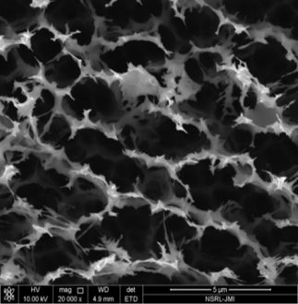

Fig1: SEM image of PS
Cyclic voltammetry measures the resulting current in an electrochemical cell by cycling the potential of the working electrode. As we can see in the fig1, 2, 3; (step a) well defined cathodic and anodic peaks (E_{pc} & E_{pa}) was obtained because activated electrode surface contains –OH groups. After silanization i.e. treating the electrode with GPMS (in step b), we found that there was significant decrease in current level indicating the SAM formation on the electrode surface rendering it insulating property.
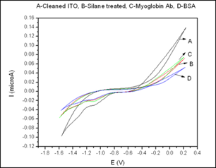
Fig2: CV spectra of Cleaned ITO (a), GPMS treated (b), monoclonal anti-myoglobin human antibody (c), BSA treated (d).
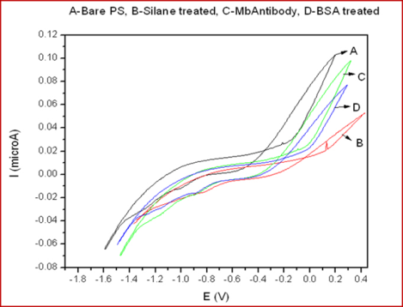
Fig3: CV spectra of bare PS (a), GPMS treated (b), monoclonal anti-myoglobin human antibody (c), BSA treated (d).
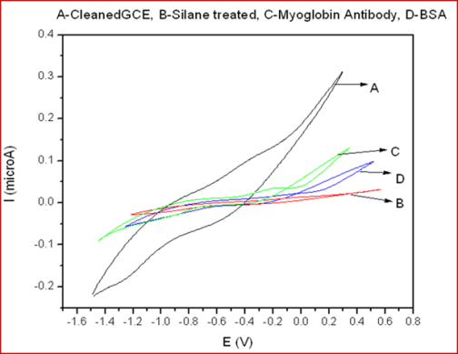
Fig4: CV spectra of cleaned GC (a), GPMS treated (b), monoclonal anti-myoglobin human antibody (c), BSA treated (d).
Further (in step c) immobilization of monoclonal anti-myoglobin human antibody whose amine groups were linked to the epoxy groups of GPMS; there was very slight increase in cathodic and anodic peak current (i_{pc} & i_{pa}) due to presence of non-binding sites present on the electrode surface which allows electron to flow through the surface. Eventually, when non-binding sites present on the electrode surface was blocked by treating electrode with BSA solution (in step d), it was found that there was significant decrease in the cathodic current (i_{pc}) and peak–to-peak separation was increased. This shows that remnant surface of electrode for electron transfer was occupied by the protein i.e., BSA.

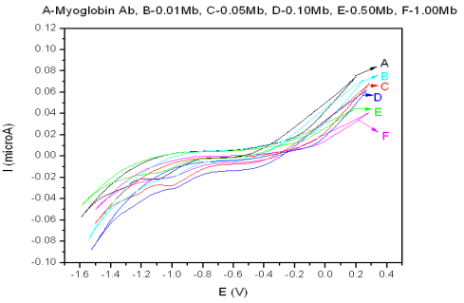
Fig5: ITO electrode-based CV spectra of different myoglobin concentration with myoglobin antibody: monoclonal anti-myoglobin human antibody (a), 0.01 µg/ml (b), 0.05 µg/ml (c), 0.10 µg/ml (d), 0.50 µg/ml (e), 1.00 µg/ml (f).

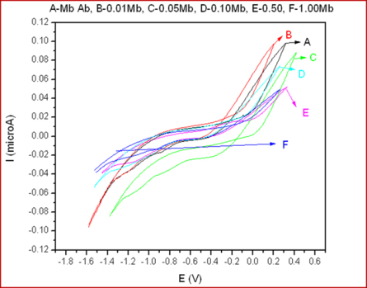
Fig6: PS electrode-based CV spectra of different myoglobin concentration with myoglobin antibody: monoclonal anti-myoglobin human antibody (a), 0.01 µg/ml (b), 0.05 µg/ml (c), 0.10 µg/ml (d), 0.50 µg/ml (e), 1.00 µg/ml (f).

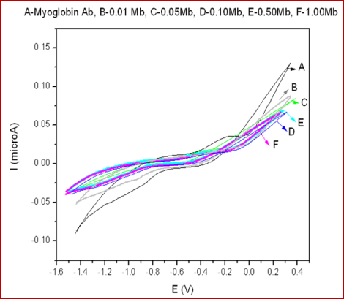
Fig7: GC electrode-based CV spectra of different myoglobin concentration with myoglobin antibody: monoclonal anti-myoglobin human antibody (a), 0.01 µg/ml (b), 0.05 µg/ml (c), 0.10 µg/ml (d), 0.50 µg/ml (e), 1.00 µg/ml (f).

It is observed from C-V studies that same pattern of result was observed on all substrates while studying different antigen (Myoglobin) concentration anodic peak current was different of every electrode with respect to different concentration. A comparison plot of efficiencies among all the three electrodes is made to determine the most sensitive material where sensitivity is calculated from the slope of the figs.
It is also observed that as the concentration of antigen increases the current level decreases because of the immune-complex formation between antigen-antibody. This spectrum indicates as the concentration of antigen goes up, electron transfer is blocked on the surface.

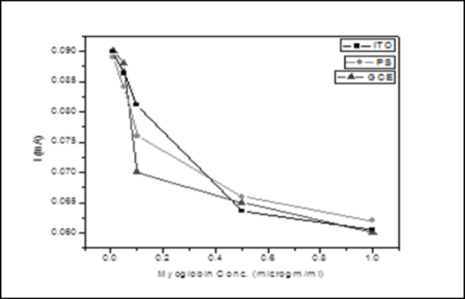
Fig8: Current v/s Myoglobin Conc. plot achieved from cyclic voltammetry studies

A fig.8 shows that GCE is highly sensitive in comparison to those materials as it is a stable, unreactive material and forms strong covalent binding upon functionalization. Being a carbon form, it is highly conductive to electrons and has great electrochemical conductivity exhibiting good repeatability, reproducibility and fast electron transfer kinetics. The reason for PS being not as sensitive as GC is due to surface instability because of the presence of highly reactive Silicon Hydride species that are very reactive both in air and water. Thus, PS substrate must be made stabilize by certain modification to use for bio sensing purpose. Similarly, ITO glass being not as sensitive as GC because of the inhomogeneous deposition of In & Sn on the glass surface resulting in surface instability.

CONCLUSION
All the bio-electrodes developed are sensitive for the lowest antigen detection limit upto 10ng/ml. But glassy carbon electrode surface is highly sensitive in comparison to other two materials as it showed large change in current response with respect to small change in the myoglobin concentration. The fabricated immunosensor is found to be efficient for detection of CVD, similar to reported sensors [7-10]. The advantage of these immunosensor is that they are very cheap and highly sensitive for abnormal myoglobin level detection in patient’s serum with cardiac problems. Another advantage is that an untrained person can also use it.

References
- Barry McDonnell, Stephen Hearty, Paul Leonard, Richard O'Kennedy Clinical Biochemistry 42 (2009) 549–561.
- Anjum Qureshi, Yasar Gurbuz, Javed H. Niazi Sensors and Actuators B 171– 172 (2012) 62– 76.
- DorotheeGrieshaber, Robert MacKenzie, Janos Voros and Erik Reimhult Sensors 2008, 8, 1400-1458.
- Mamas I. Prodromidis Electrochimica Acta xxx (2009) xxx–xxx.
- Werner Kern J. Electrochem. Soc., Vol. 137, No. 6, June 1990.
- Kumari, Vinita; Gulati, Payal; Mishra, Prabhash; Islam, S.S. Advanced Science Letters, Volume 20, Numbers 7-9, pp.1574-1577(4).
[7] Thupakula, S., Nimmala, S.S.R., Ravula, H., Chekuri, S. and Padiya, R., 2022. Emerging biomarkers for the detection of cardiovascular diseases. The Egyptian Heart Journal, 74(1), p.77.
[8] Wang, J., Tan, G.J., Han, L.N., Bai, Y.Y., He, M. and Liu, H.B., 2017. Novel biomarkers for cardiovascular risk prediction. Journal of geriatric cardiology: JGC, 14(2), p.135.
[9] Mani, V., Durmus, C., Khushaim, W., Ferreira, D.C., Timur, S., Arduini, F. and Salama, K.N., 2022. Multiplexed sensing techniques for cardiovascular disease biomarkers-A review. Biosensors and Bioelectronics, p.114680.
[10] Omran, F., Kyrou, I., Osman, F., Lim, V.G., Randeva, H.S. and Chatha, K., 2022. Cardiovascular biomarkers: lessons of the past and prospects for the future. International Journal of Molecular Sciences, 23(10), p.5680.

