**Bioenergy and Biofuels**

**Hena Hayat**

Centre for Sustainable Technologies,

Indian Institute of Science, Bengaluru-12, India

Email : henahayat@gmail.com

**Abstract**

Rising global energy demand and carbon dioxide emissions as a result of the use of fossil fuels have created a severe crisis in modern times. Demand for alternate fuel sources has increased due to the depletion of gasoline made from petroleum. The growing use of renewable energy is entering a new age. Currently, bioenergy accounts for 55% of all renewable energy supply, making it the greatest source of energy worldwide. The two key characteristics, sustainability and renewability, are what drive today's global biofuel research. The objective of the chapter is to review the numerous biofuel sources and production techniques, as well as their benefits and sustainability. Biomass from food crops makes up the first generation, followed by lignocellulosic biomass in the second generation and algal biomass in the third, which represents a potential source of renewable energy. Hydrogen, a recognized efficient energy carrier, can be produced by renewable and non-renewable resources. The chapter provides an overview of biomass (biological and thermochemical) and water splitting (electrolysis, thermolysis, and photolysis) techniques used to produce hydrogen from renewable source. Modern biofuel synthesis methods can be replaced by more environmentally friendly and secure new technologies as biochemical, bio-catalyzed electrolysis. Unprecedented attention has been paid to renewable hydrogen because of its potential to lower carbon footprints. In the move to clean energy, biohydrogen is crucial. Its uses go far beyond hydrogen fuel for transportation and are heavily utilized in chemical industries like steel and fertilizer. The microbial fuel cell has been considered as a possible alternative to traditional energy sources. Waste management, energy production, and biomass valorization are just a few of the possible future applications for MFCs. Clean fuels are suitable replacements for traditional fossil fuels as alternative energy sources, including biofuels and fuel cells.

**Key words: Bioernrgy, Biofuel, GHG, Biohydrogen, MFC**

1. **Introduction**
2. **Climate Crisis and global action**

Climate change is one of the key challenges ever to take on humanity. The impacts of climate change are already showing and will escalate over time if left uncurbed. The efforts to reduce greenhouse gases remains inadequate. Even if each current commitments and plans to limit emissions were delivered completely without any delay, global emissions would still keep thriving in the next decade, under the present disposition. More rigorous actions to reduce greenhouse gas emissions, cannot be deferred much longer.

The most recent commitment to climate goals was made in light of the climate crisis at the 26th Conference of the Parties (COP26), which took place in Glasgow in November 2021 [1]. The Glasgow Climate Pact, which intends to make the 2020s a decade of climate action and support, was adopted as a result of COP 26. A work program on climate change adaptation has been created since it is now thought that preparing for the effects of climate change is just as important as reducing emissions.

**B. Greenhouse gas (GHG) emissions and global warming**

Greenhouse gases (GHGs) act as an insulator for the earth by absorbing energy and slowing the rate at which it escapes into space. This causes the earth to warm. The warming of the Earth can be affected differently by various GHGs.(Figure- 1). Thedifferences in absorbing capacity and the time duration of their stay in the atmosphere vary with the gases.The Global Warming Potential (GWP) gives comparisons of the global warming effects of different gases in the atmosphere. Table -1. depicts the GWP of key gases according to IPCC Fifth Assessment Report, 2014 [2].

* **GWP** :It is a measurement of the amount of energy that 1 ton of gas will absorb over a certain amount of time in comparison to 1 ton of carbon dioxide (CO2) emissions.

Carbon dioxide, methane, nitrous oxide, sulphur hexafluoride, and chloroflourocarbon are the main greenhouse gases produced on a worldwide scale. Carbon dioxide, methae, nitrous oxide, F gases sulphur hexafluoride, and chloroflourocarbon (F gases) are the main greenhouse gases produced on a worldwide scale.

**Fig. -1. Global warming impact of GHGs**

*Regardless of time period , used as a reference point.

The main contributor to CO2 is the use of fossil fuels. The reference is the GWP of CO2, which is taken to be 1 regardless of time. For a very long time, CO2 is still present in the climate system. CO2 emissions increase atmospheric CO2 concentrations, which will persist for millions of years. Some solid particles or aerosols like black carbon alsocontributeto the warming of the atmosphere.

1. **Bioenergy and Biofuels**

A new era is dawning when it comes to renewable energy growth**.**At present bioenergy contributes 55% of total renewable energy supply , a largest source of global energy supply globally. The global energy consumption statisticsare charted in Fig.-2 [3].

|  |  |  |  |
| --- | --- | --- | --- |
| **Table-1 Global warming potential greenhouse gasses (GHGs)** | | | |
| **Greenhouse gases** | **GWP over 100 years time horizon** | **Remains in the atmosphere** | **Sources** |
| Carbon dioxide (CO2) | 1* | 1000s of years | Cumbustion of fossil fuel, cooking |
| Methane (CH4) | 28 | A decade on average | Agriculture activities,fossil fuel burning |
| Nitrous Oxide (N2O) . | 265 | More than 100 years | Fertilizer use, combustion of fossil fuels |
| Sulfur hexafluoride (SF6) | 23,500 | - | manufacturing of electronics and semiconductors, magnesium production, and electrical transmission and distribution equipment |
| Chloroflourocarbon (CFC) | 15000 | - | Refrigators, air conditioners, sprays, paints,fire extinguishers |

A renewable energy that is produced from biomass is referred to as bioenergy. The broad category of biomass includes organic things such as plants, trees, and waste products. Due to the recent increase in fuel prices, the quick depletion of fossil fuels, and the ecological damage caused by fossil fuels, which has altered the global climate, there has been a significant interest in bioenergy. **Bioenergy and biofuel** are the two of the most important terms considered in the reduction of GHG emissions. The word biofuel frequently used interchangeably with bio-energy, which is energy derived from biomass (Biogenic feedstock from renewable sources) such as organic waste like dung, grasses, forest wood etc.

**Fig.-2. Statistical review of world energy: 2023** (Sourced from[3])

* **Biofuel :**The word refers to power obtained from biomass that is utilized as a liquid or gaseous fuel in automobiles. Biofuels like biodiesel, bioethanol, biomethanol, and biohydrogen are examples.

**A. Classification of Biofuels**

The following categories are created based on the feedstocks. :

**A.1. First-generation biofuel**

**A.2. Second-generation biofuel**

**A.3. Third-generation biofuels**

**A.4. Fourth-generation biofuels**

Biofuels across generations are summarised in Table- 2.

**A.1 First-generation biofuels**  :

The 1st generation fuel is sourced mainly from food crops or other food products. The remaining portion of biomass can be used for other reasons, although the production method largely concentrates on producing fuel.

**A.2. Second-generation biofuels**

Second-generation biofuels are made from non-food crop feedstocks, agricultural and forestry wastes, lignocellulosic biomass, and industrial wastes. They are mostly made via methods that use technologies that use physical, biochemical, and thermochemical processes.

**A.3. Third-generation biofuels**

These fuels are sourced from microalgae. Biofuel generated from the algal oil through transesterification or hydrotreatment process. These biofuel yield can be efficiently increased using these methods. The biofuels made from conventional crops.

The 2nd and 3rd generation biofuels are put together in **advanced biofuels** categories as they are still in developing phase. They are derived from resources that are readily available and, most importantly, they are adaptable to environmental constraints and have little impact on the food chain. Microalgae and oils from animals, seafood, and leftover cooking are the main sources. [4].

**A.4. Fourth-generation biofuels**

Genetically modified (GM) organisms, such as algae, photo-biological solar fuels, and electro-fuels, are used in 4th generation biofuels.. The Genetic engineering can be helpful in improving traits like biofuel yield, photosynthetic efficiency, increasing algal biomass, product secretary systems which ultimately leads to increase in biofuel yield. Genome editing tools such as CRISPR (clustered regularly interspaced palindromic sequences), ZFN (zinc-finger nuclease) and TALEN (transcription-like effector nucleases) are widely used bioinformatics tools. The raw materials for 4th generation solar panels are widely accessible, more affordable, and never-ending.[5].

|  |  |  |  |  |
| --- | --- | --- | --- | --- |
| **Table -2. Generations of biofuel on the basis of feed-stock used** | | | | |
| **Generations** | **Sources** | **Examples** | **Benefits** | **Challenges** |
| **First**  **generation** | Edible- Food sources | -Ethanol or butanol by fermentation of starches (corn, wheat, potato) or sugars (sugar beets, sugar cane)  -Biodiesel by transesterification of plant oils, also called fatty acid methyl esters (FAMEs) and fatty acid ethyl esters. Palmoil, soyabean oil, coconut oil | -Simple, cost-effective, well established  -No intensive pre-treatment | -Food Vs Fuel conflict  -High land use , high freshwater use |
| **Second**  **generation** | Non-food agri-sources and agro-industry wastes | Seed oil : *Jatropha*, *Miscanthu*s, Switch grass etc.  Waste proucts: Agri -resdiues, forest residues, organic waste include food waste | -Valorization of waste  -Bypasses food Vs Fuel conflict | -Constricted supply of biomass  -Extensive pretreatment required for feed-stocks |
| **Third**  **generation** | Photoosynthetic living organism | Microalgae, Animal fats, Waste cooking oil | -Direct capture of Co2,  -No land use |  |
| **Fourth**  **generation** | Diverse, genome edited organism  Photobiological originated | Biofuel from genetic modified organisms,  Photobiologial solar source, Electro-biofuels | -Higher yields, improved efficiency due to genetic improvements  -Often included direct use of CO2, Syngas | -Higher regulations due to safety concerns |

**B. Other categories of biofuel**

Based on physical state, fuels can becategorised into three categories, Solid biofuel, liquid and gaseous biofuel [6]. The three types are summarised in Table-3.

**a). Solid biofuels:** Solid organic, non-fossil biomass of biological origin makes up the solid biofuels. Sources of these biofuel include, residues of agriculture and wood, wood pellets, charcoa,l other renewable organic waste. Biochar is an important example. The application of biomass lies in generation of heat, energy and thus electricity.

**b). Liquid biofuels** includes all liquid fuels that can be either triglycerides or lignocellulosic based . origin and are produced by thermal combustion of biomass, vegetable oil or algae-derived fatty acid esters, anaerobic digestion of biodegradable fraction of biomass or biowaste, Liquid biofuel are suitable to be blended with or replace liquid fuels of fossil origin , safer and easier to transport than its gaseous counterpart. Significant examples are biogasoline, biodiesels, bio jet kerosene and other liquid biofuels like bio-oil, BTL diesel.

|  |  |  |  |
| --- | --- | --- | --- |
| **Table 3 : Types of biofuel based on their physical states** | | | |
| **Biofuel type** | **Solid biofuel** | **Liquid biofuel** | **Gaseous biofuel** |
| Phase under ambient conditions | Solid form , releases heat and energy upon burning | Liquid form biofuel, can release energy to perform work , very suitable for blending. | Gas form, readily transforms energy, has a low density. |
| Shape | Defined shape | No clear shape of it own | No clear shape, spread through space |
| Ease of transportation | Easy | Easier than gas form | Difficult owing to the large volume it occupies |
| Examples | Agri-residues, wood pellets, wood residue, charcoal animal waste, biochar | Biogasoline, biojet kerosene, Biodiesel (Biomethanol  Bioethanol), BTL diesel , Bio-oil | Biogas ,Biohydrogen, biosyngas |

**c). Gaseous biofuels :**Biofuel that exist in gaseous form under ambient conditions and have low density. They can be produced by the process of thermal combustion of biomass (Pyrolysis or gasification)or anaerobic digestion of biomass. These biofuels can readily transmit heat and energy and can be transported through pipes. Significant examples are gaseous hydrocarbons (Biogas), Biohydrogen.

1. **Technologies for Biomass to energy conversion**

The fundamental advantages of using biomass is its renewable nature , less damaging to the environment due to low emissions of GHG gasses and economically more viable as compared to fossil fuels. The conversion methods for biomass depends on the nature of the feedstocks. The methods of production of biofuels varies and relies on factors like energy density, moisture content, size, and their supply [7]

Two main mechanisms allow for the conversion of biomass into energy:

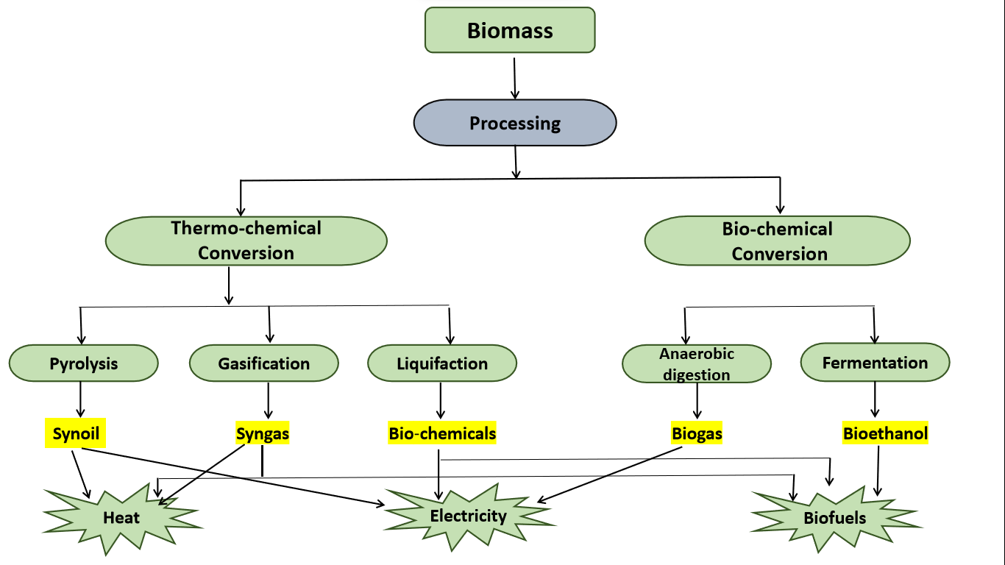

**Fig.-3. Various processes depicting biomass conversion**

1. **Thermo-chemical conversion**Through these conversion processes, the biomass is typically transformed into three types of products: biofuels, heat, and power.[Figure 3]

* **Thermo-chemical processes**

The biomass plays a significant role in the fuel industries as alternative sources of fuels and chemicals, primarily bio-oils derived following thermo-chemical conversion.

**a). Pyrolysis :**  Pyrolysis involves heating the substance without the presence of oxygen in order to convert the long-chain molecules in an organic material into their corresponding short-chain molecules [7]. One of the most important methods for converting biomass into fuel is pyrolysis. Fast pyrolysis has produced remarkable results for the recovery of biofuels with medium-low calorific value as well as for the production of concentrated fuel. Syngas and liquid fuels are often produced using main feedstock under a variety of process conditions, such as biomass or organic materials. Methane, charcoal, biodiesel,hydrogen, and bio-oil are fuels produced by the pyrolysis of biomass.

**b).**[**Gasification**](https://www.energy.gov/eere/fuelcells/hydrogen-production-biomass-gasification) : Gasification is heating organic materials at a high temperature (between 800°C and 900°C) while supplying the reactor with controlled amounts of free oxygen and steam to create syngas, a mixture of gases that is high in hydrogen and carbon monoxide contents. Gas turbines can run on the fuel syngas to produce power., for diesel engines, and for heating purposes. Syngas is prepared to produce liquid fuels via [Fischer–Tropsch process](https://www.netl.doe.gov/research/coal/energy-systems/gasification/gasifipedia/ftsynthesis). Hydrogen can be produced from syngas by separating it the from other components in syngas which can be further used a fuel [8].

**c). Liquefaction :**The process entails biomass conversion into stable liquid hydrocarbons under high hydrogen pressure and low temperature conditions [9]. Bio-oils that constitute a complex mixture organic compounds produced from dry biomass such as alcohols volatile organic acids, aldehydes, ketones, furans, phenols, ethers, esters, hydrocarbons under the high-pressure liquefaction. Catalytic liquefaction is a successful technology for creating materials with higher energy density in the liquid phase. A catalyst or a high hydrogen partial pressure are both used to facilitate catalytic conversion. However, this application creates a number of technological problems and has limited the process's use.

* **Trans-esterification** A chemical conversion process where vegetable oils, animal fats are got converted into fatty acid methyl esters (FAMEs) to produce [biodiesel](https://www.eia.gov/energyexplained/biofuels/biodiesel-rd-other-basics.php).

1. **Biological conversion :** Biological conversion of biomass utilizes processes like fermentation and anaerobic digestion for the synthesis of [ethanol](https://www.eia.gov/energyexplained/biofuels/ethanol.php) and to produce [biogas](https://www.eia.gov/energyexplained/biomass/landfill-gas-and-biogas.php) respectively.These renewable fuels are utilized as a substitute for fossil fuels.. Table- 4. lists some of the key organisms responsible for biological conversion.

|  |  |  |
| --- | --- | --- |
| **Table-4. Biological conversion : Process and Organisms** | | |
| **Process** | **Microranism** | **Final products** |
| Hydrolysis | Sacchromyces Sp,  Clostridium Sp | Simple sugar, Amino acids, Fatty acid, glycerol |
| Acidogensesis | PsuedomonasSp, Stapylococcus Sp | Acid, Alcohol, Gasses |
| Acetogenesis | Propionobacterium Sp. , Actinomyces Sp. | Acetic acid and Gasses |
| Methanogenesis | Methanobacterium Sp.Methanococcus Sp. | Gaseous fuels |

1. **Anaerobic digestion:**

Anaerobic digestion entails utilizing microbes in conditions devoid of oxygen to break down organic material. and releases methane (a carbon-rich biogas), hydrogen sulphide and heat.It’s a multistage process that involves hydrolysis to break down complex organic matter into simpler ones (sugar , amino acids) using certain kinds of bacteria followed by the conversion to Carbon dioxide, hydrogen, ammonia and organic acids by another set of bacteria under certain temperature conditions (0° C and up to 60° C). The process takes several days and involves use of feed stock from crop residues, food waste and manure. The method is regarded as the most environmentally benign and energy-efficient for producing biogas. [10]. Anaerobic digestion is frequently used to remediate wastewater and reduce landfill emissions.

**b)Fermentation**

It is an anaerobic process that is used in industry to create ethanol (bioethanol) from sources of carbohydrates like sugarcane, wheat, and sugar beet..

Saccharides are broken down in the process, and then yeast and enzymes are used to convert them to ethanol and finally, product gets purified via distillation. The solid residues remains can be utilized as animal feed, fuel run boilers ( e.g. sugarcane product), and or gasification purpose. Sugarcane is preferred as feedstock for its high energy potential of residues and high productivity [7]. Longer-chain polysaccharides are present present lignocellulosic biomass like grasses and wood, have a more complex structure. Thus, it needs to go under acid or enzymatic hydrolysis before being fermented to produce ethanol.However, ethanol sourced from lignocellulosic materials is less economical than turning starch and sugar crops into ethanol.

**III. Breakthrough development in bio-energy at a glance**

1. **Biohydrogen (H2)**

Green hydrogen is receiving increasing policy attention. Hydrogen has been pegged as the “fuel of the future” . It has a high energy density(**120-142.9 MJ/kg**), low heating value and, more importantly, it doesn't release greenhouse gases upon burning. H2 is a more effective fuel than hydrocarbon-based fossil fuels because of these characteristics. and are being considered for transportation chemical industries.The global demand for hydrogen was reported to be 94.3 million metric tons per annum in the year 2021.The worldwide demand for hydrogen is anticipated to increase nearly twofold between 2021 and 2030.According to the International Renewable Energy Agency (IRENA), H2 is created from a variety of sources, pegged as the “fuel of the future”.Steam-methane reforming (SMR), coal gasification (CG), and oil gasification are the main sources of commercial hydrogen. However, methods relying on steam methane reforming and other fossil fuels are neither sustainable nor green. [11].Despite the fact that electrolysis seems to be a clean way to produce hydrogen, it uses a tremendous amount of energy. The process is still far from being carbon-neutral if the energy necessary to separate the water atoms into H2 and oxygen (O2) atoms is generated from fossil fuels. H2 production from renewable sources is required to be sustainable.Biohydrogen is considered as promising biofuel (energy carrier) as it provides more efficient source of clean energy.

Biohydrogen is hydrogen that has been produced through biological processes ,mostly through microbial means.

**a). Methods of production of biohydrogen**

Biohydrogen is produced from various eco-friendly processes having biological routes such as biophotolysis of water (Direct biophotolysis &Indirect biophotolysis),Fermentation (Photo fermentation&Dark fermentation) andBiocatalyzed electrolysis ( microbial electronic cells) briefed in Fig. -4. [12].

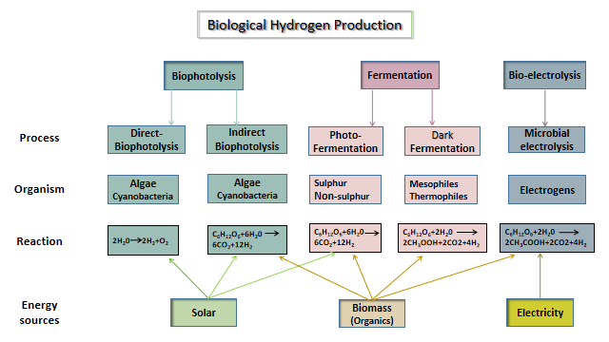

**Fig.-4. Methods for production of biological hydrogen**

Biohydrogen production requiresbiomass or biogenic materials such as agricultural and forestry residues, organicwaste and water,giving a favor over the conflict of food verses fuel, high energy input and cost. The biological pathways present a more energy-efficient and environmentally benign alternative to the traditional techniques of producing H2.

**b). Applications of Biohydrogen:**

Biohydrogen has its applications (tabulated in Fig.-5.) [13]. as fuel to reduce the carbon footprints by decarbonising the industries:

* As a fuel to decarbonise transportation system (land, Aviation and marine).
* Decarbonsing the chemical industries, specifically steel and agriculture industries , contributes to maximum GHGs emissions.
* Synthesis of green ammonia, green methanol, green methane etc.

Biohydrogen has shown potential for decarbonising the sectors primarily responsible for greenhouse gas emissions.

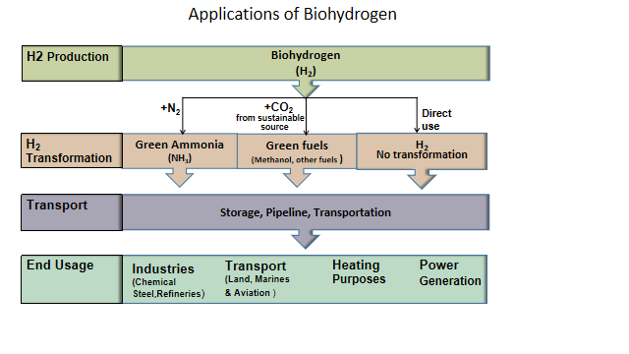

**Fig.- 5 Applications of Biohydrogen**

1. **Microbial fuel cell (MFC)**

The microbial fuel cell (MFC) technology has emerged as one of the most prominent research hotspots in the bioenergy sector in recent years. Power generation from organic substrate in batch and continuous flow microbial fuel cell operations uses an active microbe as a biocatalyst in an anaerobic anode compartment of the MFC type of fuel cell to produce bioelectricity [14].

**a). The concept of Microbial fuel cell**

The basic concept of MFC is depicted through the diagram, (Fig.-6.)adapted from [14], consists of an anode and a cathode that are divided by a proton exchange membrane (PEM). Electrons and protons are byproducts of the biocatalyst's oxidation of the carbon source. While the generated protons are transmitted to the cathode chamber via the PEM, the generated electrons are conducted through the external circuit.In the cathode chamber, the reaction between electrons andProtons takes place along with a parallel reduction of oxygen to water.

The active biocatalyst has a pivotal role in oxidizing the carbon sources to generates electrons and protons [15].

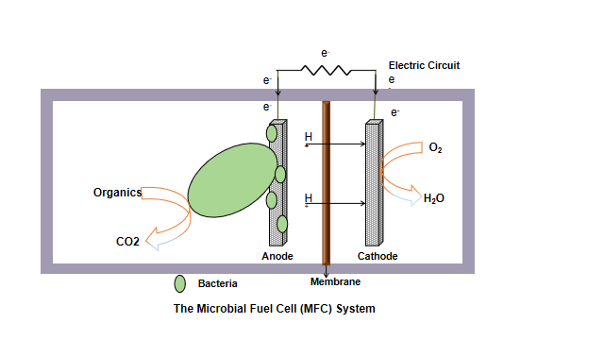

**Fig.-6. A typical microbial fuel cell system**

**b). The utilities of microbial fuel cells (MFC)**

The MFC technology has demonstrated potential uses as an integrated system for (i) recycling sustainable energy, (ii) sustainable energy recycling,(iii) Waste treatment, (iv) Biomass valorization, (v) Electricity generation, (vi) COD removal,Biosensor and (vii) Production of value-added products. Comparing MFC-based biosensors to other biosensors, they are regarded as a portable and reasonably priced detection device for bioactive toxicants.. However, few challenges in the scaling-up and commercialization of MFC systems need to be overcome. The choice of substrates must be focused on the efficiency of a particular substrate's utilization by a particular strain because the operation of MFC systems depends on the utilization of substrates by microorganisms. Technologies like mixed culture and genetic engineering are crucial for improving the substrate availability and electricity production of electrochemically active microbes [16].

For the better efficiency in operations of an MFC system, in addition to the reduction of substrate cost , wastewater and LCB (Lignocellulosic biomass ) are potentialfeedstock to achieve of MFC systems. Modifications in making material of anodesand cathodes can enhance electron transfer of electrons atextracellular level as well as assupport efficient reduction of oxygen at cathodes , resulting in improvement in the electricity output of MFC systems. Regardless of the difficulties at hand, MFCs have a tremendous role in scaling up for diverse application systems

1. **Future Prospects**

Economic expansion and the world's population's rapid growth are driving up energy demand globally.It correlates with increased energy consumption, as energy is needed in almost every aspect of our lives such as transport , in agriculture, industrial, and domestic sectors. Fossilfuels arestill a primary contributor to global energy demand , despite being a major instigator for global warming.

The improvements in end-use technologies, fuel processing technologies, and biomass energy conversion technologies all help this field move forward. Modern biomass technologies' ability to use a variety of biomass feedstocks has improved the supply potential. Additionally, the use of biomass energy has recently been modernized along three paths: (a) development of processes for upgrading raw biomass to superior fuels (like liquid fuels, gas, and briquettes), (b) penetration of biomass-based electricity generation technologies; and (c) advancement of technologies in conventional biomass applications like cooking and rural industries. New opportunities for biomass energy have emerged as a result of these advancements, allowing the world to address both the issue of energy security and environmental concerns. With the aid of contemporary technologies, along with upgrading biomass, biomass can be transformed into synthetic power and gaseous or liquid fuels such as renewable hydrogen, ethanol and methanol. The main obstacle to the adoption of modern biomass technologies has been the absence of a market for biomass energy, and as experience with these technologies grows, it becomes clear that technological push policies must be replaced or supplemented in order to effectively promote bioenergy on a broad scale.

New technologies like biochemical, bio-catalyzed electrolysis can take over present biofuel synthesis techniquesthat are more sustainable and safe. Renewable hydrogen has garnered an unprecedented amount of attention for its potential in reducing carbon footprints. Biohydrogen has an important role to play in energy transition. Its applications are not limited to hydrogen fuel as transport, but has huge utilization in chemical industries like steel and fertilizer. The microbial fuel cell has been regarded as a potential substitute for conventional energy. MFCs have promising future various domains like waste management, energy production, and biomass valorization. Clean fuels, particularly fuel cells and biofuels, are acceptable substitutes for conventional fossil fuels as new sources of energy.

**Abbreviations**

BTL- Biomass to liquid

CO2 - Carbon dioxide

COD- Chemical Oxygen demand

GHG - Green house gases

GWP- Global warming potential

LCB - Lignocellulosic biomass

MFC- Microbial fuel system

NH3 - Ammonia

PEM - [Proton exchange membrane](https://www.sciencedirect.com/topics/engineering/proton-exchange-membrane)

**References :**

1. <https://unfccc.int/conference/glasgow-climate-change-conference-october-november-2021>,
2. <https://www.ipcc.ch/assessment-report/ar5/>
3. [https://www.forbes.com/sites/rapier/2023/08/06/global-energy-trends-insights-from-the-2023-statistical-review-of-world- energy/?sh=23197c9a3502](https://www.forbes.com/sites/rapier/2023/08/06/global-energy-trends-insights-from-the-2023-statistical-review-of-world-energy/?sh=23197c9a3502)
4. H.K. Jeswani, A. Chilvers, A. Azapagic  .Environmental sustainablility of biofuels: a review . Royal Society Publishing, vol 476, pp. 2243, 2020.
5. D.Sharma D.Singh, S.L. Soni, S. Sharma, P. Kumar Sharma, A. Jhalani . A review on feedstocks, production processes, and yield for different generations of biodiesel. Fuel vol. 262, pp. 116553, Feb 2020.
6. Sangita Mahapatr , Dilip Kumar, Brajesh Singh, Pravin Kumar SachanBiofuels and their sources of production. A review on cleaner, sustainable alternatives against conventional fuel, in the framework of the food and energy nexus. Energy Nexus,Vol. 4, pp.100036, 2021.
7. R. Ruan, Y. Zhang, P. Chen, S. Liu, L. Fan, N. Zhou, K. Ding, P. Peng, M. Addy, Y. Cheng, E. Anderson, Y. Wang, Y. Liu, H. Lei, B. Li, Biofuels: alternative Feedstocks and Conversion Processes for the Production of Liquid and Gaseous Biofuels, in: Biomass, Biofuels, Biochemicals, Elsevier, pp. 3–43, 2019.
8. WorldBioenergy Association, global bioenergy statistics 2020- http://www.worldbioenergy.org/uploads/201210%20WBA%20GBS%202020.pdf
9. N.S. Hassan, A.A. Jalil, C. Hitam, D.V. Vo, W. Nabgan, Biofuels and renewable chemicals production by catalytic pyrolysis of cellulose: a review, Environ. Chem. Lett. Vol. 18,pp.1625–1648, 2020. doi:10.1007/s10311-020-01040-7.
10. P. Adams, T. Bridgwater, A. Lea-Langton, A. Ross, I. Watson, Biomass conversion technologies. In: P. Thornley, P. Adams, (eds.) *Greenhouse Gases Balances of Bioenergy Systems.*Academic Press, pp. 107–139. <https://doi.org/10.1016/B978-0-08-> 101036- 5.00008-2
11. IRENA. Hydrogen from renewable power. September. 2018.
12. Younas M,  Shafique S, Hafeez A , Javed F and Rehman F. . An Overview of Hydrogen Production: Current Status, Potential, and Challenges, Vol.15, pp.123317, 2022.
13. Li W, Cheng C, Cao G and Ren N. Enhanced biohydrogen production from sugarcane molasses by adding Ginkgo biloba leaves. Bioresour Technol vol. 298(73), pp.122523, 2022. <https://doi.org/10.1016/j.biortech.2019.122523.>
14. Kondaveeti, S.; Mohanakrishna, G.; Kumar, A.; Lai, C.; Lee, J.-K.; Kalia, V.C. Exploitation of Citrus Peel Extract as a Feedstock for Power Generation in Microbial Fuel Cell (MFC). Indian J. Microbiol*.*  Vol.59, pp.476–481, 2019.
15. Vinayak, V.; Khan, M.J.; Varjani, S.; Saratale, G.D.; Saratale, R.G.; Bhatia, S.K. Microbial fuel cells for remediation of environmental pollutants and value addition: Special focus on coupling diatom microbial fuel cells with photocatalytic and photoelectric fuel cells. J. Biotechnol.  vol. 338, pp. 5–19, 2021.
16. Jianfei Wang , Kexin Ren , Yan Zhu , Jiaqi Huang and Shijie Liu . A Review of Recent Advances in Microbial Fuel Cells: Preparation, Operation, and Application.BioTech, vol. 11, pp. 44, 2022.