Ultrasonic Device Third Eye for Blind People
¹David Solomon Raju. Y, ²B. Srinidhi, ³D. Navya

¹Associate Professor, Dept of ECE, Holy Mary Institute of Technology & Science, Hyderabad
^{2, 3} Student, Dept of ECE, Holy Mary Institute of Technology & Science, Hyderabad

¹davidsolomnraju.y@hmgi.ac.in, ²srinidhimadhu55555@gmail.com, ³navyachaitanya999@gmail.com

Abstract - People with visual disabilities are often dependent on external assistance which can be provided by humans, trained dogs, or special electronic devices as support systems for decision making. The main problem with blind people is how to navigate their way to wherever they want to go. Such people need assistance from others with good eyesight. As described by WHO, 10% of the visually impaired have no functional eyesight at all to help them move around without assistance and safely. Third eye for blinds is an innovation which helps the blinds people to navigate with speed and confidence by detecting the nearby obstacles using the help of ultrasonic waves and notify them with buzzer sound or vibration. They only need to wear this device as a band or cloth. The intensity of vibration and rate of beeping increases with decrease in distance and this is a fully automated device. An ultrasonic sensor module, HC-SR04 is used for obstacle detection in the path of the blind person and a buzzer is used to make the person alert. Arduino based third eye or extra vision for blind people have a project which include both hardware and the software work and it helps the person to recognize the object by the help of ultrasonic waves which comes from ultrasonic sensor with a vibration which is generated by the buzzer. This Project is influenced by the Stick which is used by the blind people while walking for long term carry the stick is measure issue for weak people. So, this is the wearable invention for the weak and blind people they don’t need to carrying anything in hand while walking they should only wear our invention and used to get walking easily. The Arduino is a software device which includes coding as a software function and Ultrasonic sensor, buzzer, Battery and more things as a hardware function. Ultrasonic sensor has a work to recognize the object near them and providing the signal via buzzer to the user which help the person to reach properly at their destination.
Keywords: Arduino Uno module, Vibration, Ultrasonic sense

- INTRODUCTION
Third eye for people who are blind is an innovation which helps the blind people to navigate with speed and confidence by detecting the nearby obstacles using the help of ultrasonic waves and notify them with buzzer sound or vibration. They only need to wear this device as a band or cloth. Third Eye for Blind Vibrating Ultrasonic project for blind person”. A system which is allows the visually impaired to sense the obstacles ahead. Arduino based third eye or extra vision for blind people have a project which include both hardware and the software work and it helps the person to recognize the object by the help of ultrasonic waves which comes from ultrasonic sensor with a vibration which is generated by the buzzer. This Project is influenced by the Stick which is used by the blind people while walking for long term carry the stick is measure issue for weak people. So, this is the wearable invention for the weak and blind people they don’t need to carrying anything in hand while walking they should only wear our invention and used to get walking easily. Arduino Bases third eye or extra vision for blind people has a instrument which is use to navigate the object while walking. This technology is the first hand, cap, dress wearable technology of blind people which try to solve all the problem while walking inside the house or somewhere indoor the object detection work is done by the ultrasonic sensor and the Arduino where we program for sensor and also buzzer vibration helps to walk freely without colliding. Generally, this project is wearable with the help of Gloves, rubber band etc. and PCB materials helps to build all the hardware object in it, PCB helps to build good connection between parts, and the main part of this instrument is it is very cheap in cost and easy to carry so it will drastically benefit the community. The ultrasonic sensor consists of a transmitter and a receiver. The transmitter works when you supply it with 5v DC. Then when the sound signal is reflected the receiver receives it and produces a DC voltage according to the strength of the reflected signal.

1.1 BACKGROUND OF THE STUDY
With the improvement of the living standards of the people, we have become so materialistic that we have forgotten how the physically disabled people live a tough life. They undergo rigorous, apathetic and indifferent behavior towards them for being physically disabled. They become dependent on other people in a way for their day to day routine chores. Blind and impaired persons always depend on other people for their locomotion. Eyes are prime sense of organ in perceiving the outside environment; dysfunction of such prime sense organ severely effects the knowledge perceiving capability of the outside environment. Therefore, going around to places in such environment is a very big challenge because the blind people cannot depend on their own eyes and thus face many difficulties [1].
The objective of this project The Third Eye for the Blind is to design a product which is very much useful to those people who are visually impaired and those who often have to rely on others. Third eye for Blind project is an innovation which helps the visually impaired people to move around and go from one place to another with speed and confidence by knowing the nearby obstacles using the help of the wearable band which produces the ultrasonic waves which notify them with buzz sound or vibrations. It allows the user those who are visually impaired to walk freely by detecting the obstacles. They only need to wear this device as a band or cloth on their body.
According to WHO or the World Health Organization, 39 million people are estimated as blinds worldwide. They are suffering a lot of hardship in their daily life. The physically disabled ones have been using the traditional way that is the white cane for many years which although being effective, still has a lot of disadvantages and limitations. Another way is, having a pet animal such as a dog, but it is really expensive. Thus the aim of the project Third eye for the Blind is to develop a cheap, affordable and more efficient way to help the blind people to navigate with greater comfort, speed and confidence. This is the wearable technology for the blinds which helps resolve all the problems of the existing technologies. Now a days there are so many technologies, things and smart devices for the visually impaired people for the navigation, but most of them have certain problems for the blind people and the major drawbacks are that those things need a lot of training and efforts to use. One of the main peculiarity of this innovation is, it is affordable for everyone. There are no such devices available in the market that can be worn like a cloth and having such a low cost and simplicity. With the use of this improvised device in a large scale, with improvements in the prototype, it will drastically benefit the community of the visually impaired or the blind people. The walking cane is a simple and purely mechanical device dedicated to detect the static or the constant obstacles on the ground, uneven surfaces, holes and steps via simple tactile-force feedback. This device is light, portable but limited to its size and it is not used for dynamic obstacle detection [4].
These devices operate like the radar and the system of the device uses the ultrasonic waves fascicle to identify the height, direction and the speed of the objects. The distance between the person and the obstacle is measured by the time of the wave travel. However, all the existing systems inform the blind the presence of the object at a specific distance in front of or near to him. These details helps the user or the blind people in detecting the obstacles and thus change the way and walk accordingly. Information about the objects and their place in the way of the walking like an obstacle and their characteristics can create additional knowledge to enhance the space manifestation and memory of the blind or the visually impaired people. To overcome, the abovementioned limitations this work offers a simple, efficient, configurable virtual for the blind.
1.2 AIM OF THE PROJECT
Blind people face many problems every day and not being able to see and detect obstacles in front of them is a major one. Eyes helps us to see things and fortunately, most of us are blessed with two working eyes, but not everyone is. So, as an innovator, it’s our responsibility to support and take care of those who are unable to sense things in front of them from far away as normal eyes do. In this project, we are going to make a third eye for the blind people which enables them to sense and detect walls, obstacles, or other people in front of them without the need of physical touch. This is the first wearable technology for blinds which resolves all the problems of existing technologies. Now a days there are so many instruments and smart devices for visually impaired peoples for navigation but most of them have certain problems for carrying and the major drawbacks is those need a lot of training to use. The one of the main peculiarity of this innovation is, it is affordable for everyone,
1.3 OBJECTIVE OF THE PROJECT
At the end of this project “The Third Eye for the Blind”, student involved shall be able to design a product which is very much useful to those people who are visually impaired and those who often have to rely on others. The purpose of this work is to provide an efficient way to help the blind people to navigate with greater comfort, speed and confidence. By wearing this device they can fully avoid the use of white cane and such other devices. This device will help the blind to navigate without holding a stick which is a bit annoying for them. They can simply wear it as a band or cloth and it can function very accurately and they only need a very little training to use it. This is the first wearable technology for blinds which resolves all the problems of existing technologies. Now a days there are so many instruments and smart devices for visually impaired peoples for navigation but most of them have certain problems for carrying and the major drawbacks is those need a lot of training to use. The one of the main peculiarity of this innovation is, it is affordable for everyone. There are no such devices available in the market that can be worn like a cloth and having such a low cost and simplicity. When used on a large scale, with improvements in the prototype, it will drastically benefit the community.
- LITERATURE REVIEW
The researchers wanted to create an ultrasonic distance measuring device because of the advantages it can have over the ones that are widely available today. As described by Zakari and Aliyu (2014), “The advent of EDM equipment has completely revolutionaries all surveying procedures and resulted in a change of emphasis and techniques, by reason of the fact that distance can now be measured quickly and accurately”. The researchers have examined that if a reliable ultrasonic measuring device would be introduced in the market, a lot of fields involving the importance of distance measurement would benefit from it.
2.1 Review of Existing System
Research has been conducted for new devices and technologies to design a good and reliable and efficient system for blind or visually impaired people to detect the obstacles and warn or alert them at dangerous places or obstacles. One sound for free for travel direction and the other for blocked, it was difficult for the person to differentiate the sounds. Another problem was the system would not know the user's momentary position. Time and again there have been innovations in wearable technologies for the blind. Another Visual Impairment Aid makes use of a similar concept. We have tried to build on this existing glove by making it less complex and easily constructible so as to be marketed on a large scale. The glove presented in this also happens to be much cheaper than the Visual Impairment Aid with little to no depreciation in its performance. The features of Third eye for blind people: By wearing this device they can fully avoid the use of white cane and such other devices. This devices will help the blind to navigate without holding a stick which is a bit annoying for them. They can simply wear it as a band and it can function very accurately and they only need a very little training to use it.
2.2 Overview of Proposed System
The proposed system deals with the cheaper and effective obstacle detection with a wide range of coverage. The device includes the following components: Arduino Nano, HC-SR04 Ultrasonic sensor, Pref board, Buzzer, 9V DC battery, Jumper wires
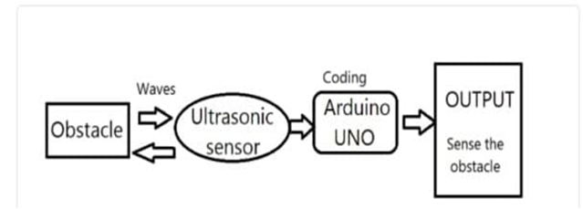
Fig. 1. Overview of Third Eye

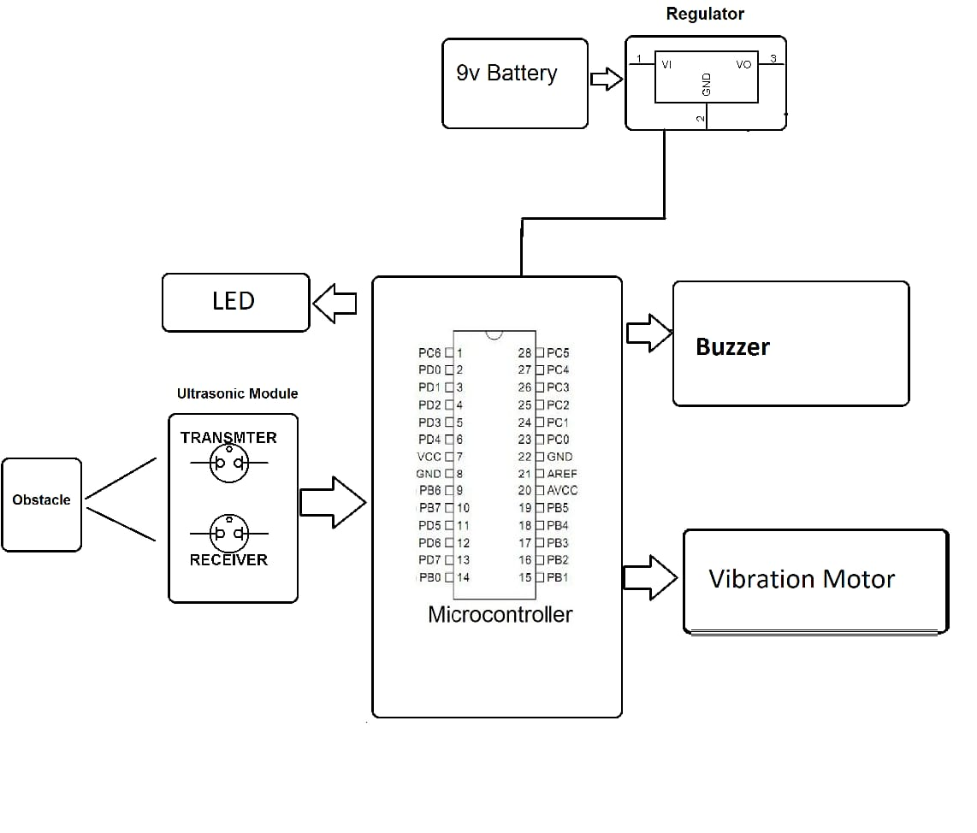Fig.2 Block Diagram of Third Eye
3. DESIGN METHODOLOGY
The aim is to provide help for the blinds with the third type of aid. The Third Eye for Blind is integrated with ultrasonic sensors. The proposed system will detect the upcoming obstacles in the path of blind person using ultrasonic waves. The system will also include buzzer sound module which will help the user with buzz alerts of the presence and direction of the obstacles. Our purpose to use this ultrasonic sensors, Arduino, voice module, and buzzer is because they are light in weight, user-friendly behaviour, easy to use and understand, flexible and cost reductive.
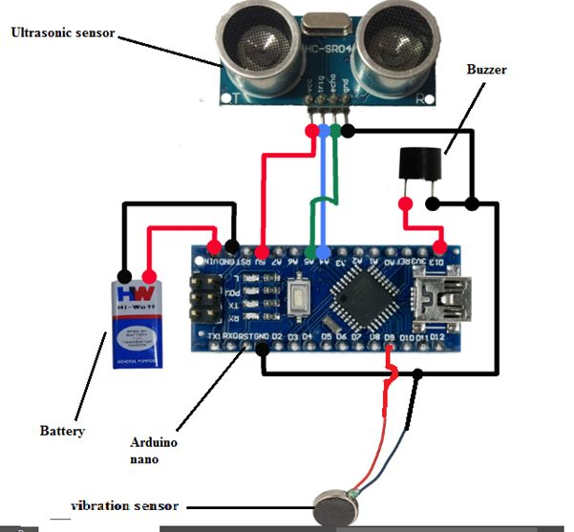
Fig 3 Circuit Diagram
This proposed system consists the equipment like Arduino UNO, ultrasonic sensor, bread board, buzzers for detecting the obstacles and letting the user know about the obstacle, Red LEDs, Switches, Jumper cable, power bank, Male and female header pins, some elastic and stickers to make the device wearable as a band for wearing for the users. The wiring of the device is done in a following manner. The Ground of LED, buzzer is connected to GND of the Arduino. The positive of the LED and the middle leg of switch is connected to the Arduino pin 5. The positive of the Buzzer is wired to the first leg of the switch. The Ultrasonic sensor is wired accordingly. The Ultrasonic sensor pin VCC is connected to the Arduino pin VCC, Ultrasonic sensor pin GND is connected to the Arduino pin GND, Ultrasonic sensor pin Trig is attached to the Arduino pin 7, Ultrasonic sensor pin Echo is connected to the Arduino PIN 6. The switch used here is for selecting the mode. (Buzzer should need or not). At the end, after all the connections are done to the Arduino board upload the code to Arduino board and power the other modules using a power bank or the power supply. The Ultrasonic sensor here used as a transceiver The ultrasonic waves are emitted by the transmitter when the objects are detected. Both the transmitter and receiver re resent inside the ultrasonic sensor. We calculate the time interval between the transmitted and received signal. The distance between the object and sensor is calculated using this. When we increase the distance between the object and the sensor the coverage angle will decrease. Sensor has coverage of 60 degree. Thus, the objective is to cover a wide angle to detect the obstacles with the help of the ultrasonic sensors to help the blind and make it easy for them to move around easily without any hassle. Hence, the distance calculation is calculated and the sensor detects and the further procedure of the buzzing sound to the user is carried out. Thus, this way Third Eye for Blind will be designed for the visually impaired people and will make it very easy and convenient as it will be a wearable device and thus will help the user in travelling and detecting the obstacles while walking very easy.
In this project the HC-SR04 Ultrasonic sensor. It works by sending sound waves from the transmitter, which then bounce off of an object and then return to the receiver. You can determine how far away something is by the time it takes for the sound waves to get back to the sensor. Using the ultrasonic sensors, blind people can detect the objects in a dimensional view around them and can easily travel anywhere. When the ultrasonic sensor detects obstacle the device will notify the user through vibrations and sound beeps. The intensity of vibration and rate of beeping increases with decrease in distance and this is a fully automated device.
MAKING THE MODULE:
First cut the pref board in 5 X 3 cm dimension and solder the female headers for the Arduino to the board.
- Then solder the buzzer.
- Then connect the vibrating motor using the glue gun and solder wires to it.
- Then connect the LED.
- Then connect the switch.
- Then connect header pins for ultrasonic sensors and for battery input.
- Then solder everything as shown in the circuit diagram.
- Now connect the Arduino and ultrasonic sensor to the board
- Connect the ultrasonic sensor to the board by using 4 jumper cables.
- Then connect a 3.7 volt mobile battery to this module.
- Then connect the elastic band as shown in the figure.
- At last upload the code to each Arduino board and power the 4 other modules using a power bank.
At last upload the code to each Arduino board and power the 4 other modules using a power bank.
FLOW CHART:
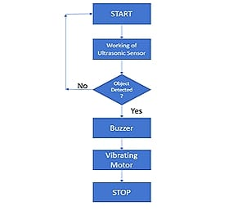
Fig 4 flow chart
PROGRAM CODE
1. Connect the Arduino nano to PC or laptop with the given USB cable.
2. Open Arduino IDE.
3. Go to tools > board: > Arduino AVR Boards and select “Arduino Nano”.
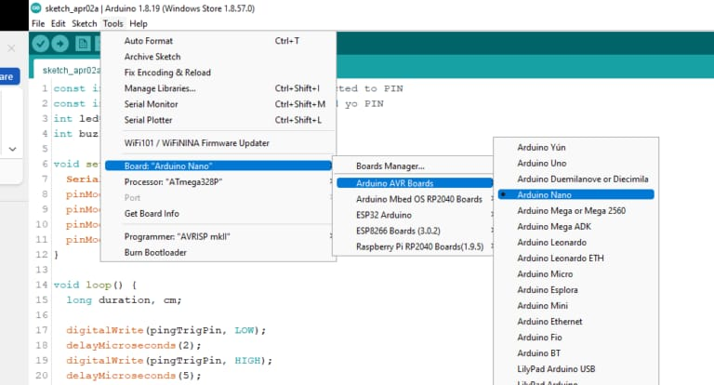
4. Select the COM Port
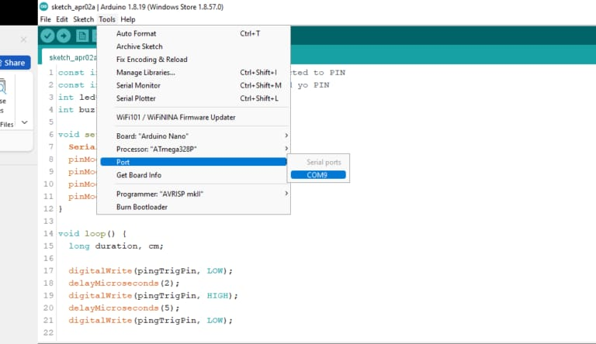
CODE:
const int pingTrigPin = A4; //Trigger connected to PIN
const int pingEchoPin = A5; //Echo connected yo PIN
int led=13; //Buzzer to PIN 4
int buz1=9;
duration = pulseIn(pingEchoPin, HIGH);
cm = microsecondsToCentimeters(duration);
Serial.print(cm);
Serial.print("cm");
Serial.println();
delay(40);
}
long microsecondsToCentimeters(long microseconds) {
return microseconds / 29 / 2;
}
5. Type the code given above in the Arduino IDE and hit upload.
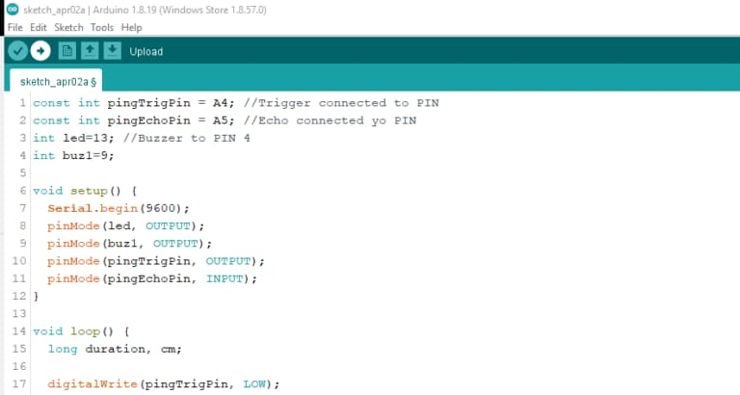
4. RESULT
With the improvement of the living standards of the people, we have become so materialistic that we have forgotten how the physically disabled people live a tough life. Eyes are responsible for observing and listen the outside environment; dysfunction of such prime sense organ severely affects the knowledge perceiving capability of the outside environment. Therefore, going around top laces in such an environment is a very big challenge because blind people cannot depend on their own eyes and thus face many difficulties. This project will help them to overcome their obstacles.
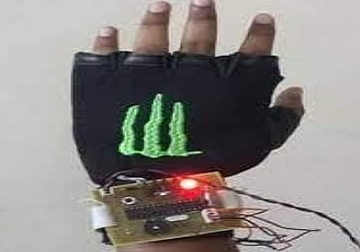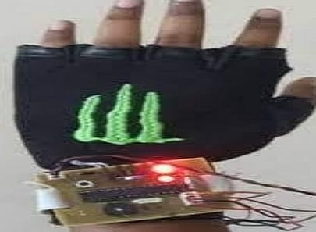
Fig5 when obstacle is not detected Fig6 when obstacle is detected
5. CONCLUSION
The objective of this project is Third Eye for the Blind is to design a product which is very much useful to those people who are visually impaired and those who often have to rely on others. The third eye for Blind project is an innovation which helps the blind person to move around and go from one place to another with speed and confidence by knowing the nearby obstacles using the help of the wearable band which produces the ultrasonic waves which notify them with buzz sound or vibrations. It allows the user those who are visually impaired to walk freely by detecting the obstacles. They only need to wear this device as a band or cloth on their body. Thus, this project Arduino based obstacle detector for blind people is a new method to resolve their problems. A less complex portable, cost efficient, easy to manage an effective system with many more amazing properties and advantages are proposed to provide
The wearable technology for blinds resolves the existing technical problems. Nowadays, there are many instruments and intelligent devices for visually impaired people for navigation. Still, most of them have specific issues with carrying, and the major drawbacks are those that need a lot of training to use. One of the main peculiarities of this innovation is that it is affordable for everyone. There are no such devices available in the market that can be worn like cloth and have such a low cost and simplicity. When used on a large scale, with improvements in the prototype, it will drastically benefit the community.
6. REFERENCES
- AA. Tahat.” A wireless ranging system for the blind long-cane utilizing a smart-phone”, in Proceedings of the 10th International Conference on Telecommunications. (ConTEL '09), IEEE, Zagreb, Croatia, June. View at Scopus. 2009, 111-117.
- D. Bolgiano, E. Meeks.” A laser cane for the blind”, IEEE Journal of Quantum Electronics. View at Google Scholar 1967
- D. Yuan R. Manduchi. “Dynamic Environment Exploration Using a Virtual White Cane”, Proceedings of the IEEE Computer Society Conference on Computer Vision and Pattern Recognition (CVPR), University of California, Santa Cruz, 2005, 1-7.
- JM. Benjamin,NA. Ali, AF. Schepis. “A laser cane for the blind”, Proceedings of San Diego Medical Symposium, 1973, 443-450.
- MA. Espinosa,S. Ungar,E. Ochaíta. “Blades comparing methods for Introducing Blind and Visually Impaired People to unfamiliar urban environments.”, Journal of Environmental psychology. 1998; 18:277- 287.
- Pooja Sharma,SL. Shimi,S. Chatterji. “A Review on Obstacle Detection and Vision”, International Journal of Science and Research Technology. 2015; 4(1):1-11.
- S. Sabarish. “Navigation Tool for Visually Challenged using Microcontroller”, International Journal of Engineering and Advanced Technology (IJEAT), 2013; 2(4):139-143.
- S. Shovel, I Ulrich, J. Borenstien. Nav Belt and the Guide Cane, IEEE “Transactions on Robotics & Automation”. 2003; 10(1):9-20

