**Application of Chromatographic Techniques in Pharmaceutical Analysis**

Juhi H. Rinke, Swapnja B. Gunjarkar, Shubham P. Bhute, Chetana M. Waghale, Ankit Kaikade and Nikhil D. Amnerkar

Adv. V. R. Manohar Institute of Diploma in Pharmacy (Govt- Aided), Wanadongri, Hingna Road, Nagpur- 441110 (M.S.)

**Abstract**

The development of pharmaceuticals brought about a revolution in human health. These medications would only serve their intended purpose if they were given in the proper dosage and were free of impurities. To ensure that medicines work as intended, numerous chemical and instrumental procedures have been developed over time and are utilized in drug assessment. Since contaminants can occur in these drugs at various points during production, transit, and storage, administration of these drugs can be harmful, they must be identified and quantitated. In this context, analytical methods and tools are vital. This study underlines the value of analytical techniques and tools in establishing the quality of the drugs. The study highlights various analytical methods that have been used in the analysis of pharmaceuticals, including Thin Layer Chromatography, High Performance Thin Layer Chromatography, High Performance Liquid Chromatography, Column Chromatography, Paper Chromatography, Gas Chromatography, and Ion-Exchange Chromatography.

**Keywords**

High Performance Thin Layer Chromatography (HPTLC)**,** chromatographic separation technique; thin layer chromatography, High performance liquid chromatography,Paper chromatography, Column chromatography, Gas chromatography, Ion-exchange chromatography.

**Introduction**

Chromatography, which is also known as colour writing, is a physical separation procedure that makes it possible to separate and purify a mixture of substances into distinct molecules that differ in their rates of distribution based on a number of factors, including:

1. Solubility

2. Affinity (whether between polar or nonpolar molecules)

3. The components in the mixture are spread between two phases, the stationary phase and the mobile phase, that move at different rates in a predetermined direction. We will define the stationary phase later **(A. Wilkinson, 1997)**.

It is known that Russian botanist Michael Tswett noticed in 1901 that chlorophyll pigments break into various colored components when they are moved over a column of CaCO3.Thus, he is known as the inventor and father of chromatography. Archer John Porter Martin and Richard Laurence Millington received the 1952 Nobel Prize in Chemistry for their work in developing multiple-based separation methods, such as partition (liquid-liquid chromatography) **(S. S. Nielsen, 2010).**

The following three components must be present in any chromatographic separation method:

Phases:

1. Sample

2. Mobile

3. Stationary phase: This solid substance, which can only be either a solid or a liquid, is where the components of a combination will be isolated and separated. Mobile phase is a solid or liquid that transports a mixture made up of a sample that will be isolated, purified, or separated at the surface of the stationary phase **(S. Aryal, 2021).**

There are two different categories of chromatographic separation methods. The first is polar stationary phase normal phase liquid chromatography (NPLC). The second method is reversed-phase liquid chromatography (RPLC), in which the stationary phase is non-polar and the mobile phase is polar. In contrast, the mobile phase is non-polar. We must select the appropriate parameter between the stationary and mobile phases in order to carry out a successful Chromatographic methods separation. The primary goal of chromatography is to distinguish between analytical methods that detect a sample's chemical composition and concentration and primitive methods that just separate and isolate mixture samples rather than determining their concentration **(K. Hostettmann, 2011).**

**Classification**

The three methods we can categorize and summarize the chromatographic method technique are as follows:

1) Depending on how the stationary phase is shaped. For instance, column and planar chromatography.

2) Rely on the stationary phase's and the mobile phase's physical states. For instance, liquid and gas chromatography.

3. Rely on the interaction of the stationary and mobile phases. As an illustration, consider affinity, ion exchange, partition, adsorption, and size exclusion chromatography.

**THIN LAYER CHROMATOGRAPHY**

For the investigation of pharmaceutical products, thin-layer chromatography (TLC) is a simple, relatively sensitive, quick, and affordable approach. Multiple research studies have demonstrated the superior separation and qualitative and quantitative analytical capabilities of TLC for a variety of organic and metal-organic substances **(J. Sherma 2008).**

In pharmaceutical analysis, TLC is most frequently employed in its semiquantitative mode, where spots of reference test solutions are visually compared against the impurity spots in a chromatogram of the test sample. The majority of TLC techniques, however, are regarded as a dated method of testing for impurities. The dependability of quantitative planar chromatography has also increased as a result of advancements in sorbent layers and equipment, making it a competitive and complementary cost option to HPLC **(K. Ferenczi-Fodor, 2001).**

**1. HIGH PERFORMANCE THIN LAYER CHROMATOGRAPHY (HPTLC)**

**1.1 Introduction**

Thin-layer chromatography (TLC) with greater and more advanced separation efficiency and detection limits is known as high performance thin layer chromatography (HPTLC), a sophisticated and automated version of TLC. Additional names for it are Flat-bed chromatography and High-Pressure Thin Layer Chromatography/Planar Chromatography. In comparison to other separation techniques, the well-known and adaptable separation technology known as HPTLC has many benefits. The sorbents' pore and particle sizes are the only fundamental differences between traditional TLC and HPTLC. It's an effective analytical technique that works equally well for quantitative jobs. Separation may occur as a result of adsorption, partition, or both, depending on the type of adsorbents utilized on the plates and the development solvent solution. There have been reports on various aspects of HPTLC fundamentals, including principle, theory, and understanding; instrumentation, including implementation, optimization, validation, automation, and qualitative and quantitative analysis; and applications, including phytochemical analysis, biomedical analysis, herbal drug quantification, analytical analysis, finger print analysis, and the potential for hyphenation (HPTLC-MS, HPTLCFTIR, and HPTLC Scanning Diode Laser).

**1.2 Principle:**

Adsorption serves as the fundamental separation principle in HPTLC, which uses a similar technique and identical physical principles as TLC (adsorption chromatography). Capillary action causes the mobile phase solvent to pass through. The components move in accordance with their propensities to interact with the adsorbent. The part that has a stronger affinity for the immobile phase moves more slowly. The elements that are less attracted to the stationary phase move more quickly. In a chromatographic plate, the components are so separated.

**1.3 Steps Involving in HPTLC** **(Fig No. 1)**

Selection of the Stationary Phase: The type of compounds to be separated should be taken into account while choosing the stationary phase during technique development **(K. Koll, E. Reich, 2003).**

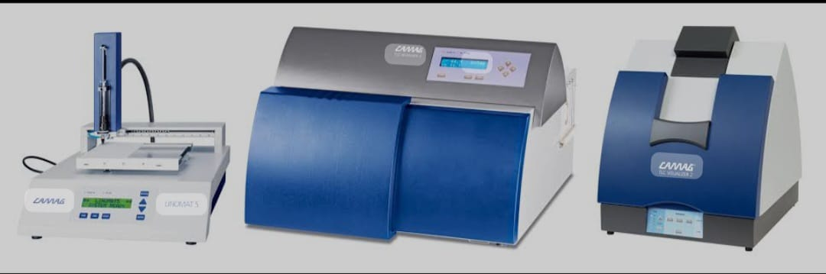

**Fig No. 1: Instrument of High Performance Thin Layer Chromatography**

Smaller (10*10 or 10*20 cm) and substantially faster (7–20 min) analysis plates are used in HPTLC. The development distance is normally 6 cm. For industrial pharmaceutical densitometric quantitative analysis, HPTLC plates are employed because they offer increased resolution, higher detection sensitivity, and superior in situ quantification. Optimizing and choosing the mobile phase. The adsorbent substance utilized as the stationary phase and the physical and chemical properties of the analyte are the main determinants in the choice of mobile phase.

**1.3.1 Sample Preparation and Application**

A good solvent system is one that alters the baseline position of every component of the combination while adding nothing to the solvent front. Between Rf 0.15 and 0.85, the peaks of interest should be resolved. Eluent strength, which is associated with the polarity of the mobile phase components, is a factor that affects the elution power of the mobile phase. More nonpolar compounds elute more quickly (or spend less time in the stationary phase), while more polar compounds elute more slowly (or spend more time in the stationary phase).

**1.3.2 Chromatogram Development (Separation)**

Even though the chromatogram development stage is the most critical one in the HTLC process, crucial parameters are frequently missed. In horizontal-development chambers, also known as twin-trough chambers, HPTLC plates are formed. Generally speaking, saturated twin-trough chambers with filter paper installed provide the best reproducibility. Preloading of solvent vapor and humidity are prevented using a twin-through chamber. Fluorescence quenching brought on by UV radiation, which is typically emitted at wavelengths between 200 and 400 nm, improves the detection of separated chemicals on the sorbent layers. Fluorescence quenching is the popular name for this phenomenon.

**1.3.3 Prewashing**

The primary goal of pre-washing is to eliminate contaminants from the atmosphere, such as water vapers and other volatile compounds, before they are exposed to the lab environment. The most popular sorbent is silica gel 60F. This sorbent's primary drawback is the presence of iron impurities. Using a 9:1 ratio of Methanol to Water, this iron is eliminated. The primary benefit of the pre-washing process is this. Several of the typical pre-washing techniques

a] Ascending method

b] Descending method

c] Continuous method

**1.3.4 Activation of plates**

HPTLC plate boxes that have just been opened don't need to be activated. Plates that are kept in the hands for a long period or exposed to excessive humidity need to be activated. Before applying the sample, plates are heated in the oven for 30 minutes at 110 to 120 °C.

**1.3.5. Pre-conditioning**

Referred to as chamber saturation. High Rf values are caused by an unsaturated chamber.

**1.3.6. Sample application**

Sample application can be done by using

1] Capillary tubes

2] Micro syringes

3] Micro bulb pipettes

4] Automatic sample applicator

**1.3.7. Post chromatographic steps**

1] Detection

2] Photo Documentation

3] Densitometry Measurements

1] Detection: The first option is non-destructive non-UV absorbing substances like ethambutol, dicyclomine, etc., followed by immersing the plates in a 0.1% iodine solution under UV light.

2] Densitometry Measurements: Measure fluorescence, UV absorption, or visibility. Create a chromatogram with peaks from the spot band.

**1.4 Applications of HPTLC**

* Pharmaceutical-industry-Quality control, identity, purity test etc.
* Food analysis – Quality control, additives, pesticides, stability testing etc.
* Clinical applications – Metabolism studies, drug screening, stability testing etc.
* Industrial applications - Process development and optimization etc.
* Forensic applications – Poisoning investigations
* Biomedical Analysis – Separation of gangliosides Cosmetics – Hydrocortisone and cinchocaine in lanolin ointment etc. Natural products, plant ingredients – Glycosides in herbal drugs, Piperine in piper longum etc.
* Finger print analysis – Finger prints for identification of liquorice, ginseng etc.
* Analysis of drug in blood. **(Parihar S 2022)**

**2. HIGH-PERFORMANCE LIQUID CHROMATOGRAPHY (HPLC):**

When performing separations using High-Performance Liquid Chromatography (HPLC), the components that need to be separated are split between two immiscible phases. **(JM. Miller, 2005).** These two phases are the stationary phase and the mobile phase, respectively **(Z. Dincer, 2003).**

Chromatographic processes can be carried out in three different ways: elution, frontal, and displacement. Elution involves injecting or placing the sample components at the start of the chromatographic system. Let's say the system is made up of a column. If so, the distribution of the components between the stationary and mobile phases determines how they elute from the column **(Qi. Meiling, Peng Wang 2004).**

The concentration distribution is typically Gaussian and symmetrical. When the small sample size is employed, symmetrical peaks appear **(JL. Rafferty, 2008).**

In this situation, efficiency is at its best, hence the liquid chromatography sample size is kept as small as possible while operating at high speed.

As the separation progresses, many interactions may take place; these are known as separation modes. Following are categories for the interaction mechanisms:

• Adsorption

• Partition

• Bonded phase

• Ion exchange

• Size exclusion

• Affinity

**2.1 Principle of HPLC**

HPLC is a separation technique that includes: Injecting a small volume of liquid sample into a tube packed with tiny particles (3 to 5 micron (m) in diameter called the stationary phase) where individual components of the sample are moved down the packed tube (column) with a liquid (mobile phase) forced through the column by high pressure provided by a pump. The column packing that separates these components from one another requires numerous chemicals and/or physical interactions between the constituent molecules and the packing particles. An amount-measuring flow-through device (detector) that detects these separated components is placed at the tube's (column's) exit. An "HPLC" is the output of this detector. While LC and HPLC function similarly in theory, HPLC has far better speed, efficiency, sensitivity, and ease of use **(JJ. Bergh, 1987).**

**2.2. Types of HPLC**

Types of HPLC generally depend on phase system used in the process.

Following types of HPLC are used in analysis:

**2.2.1. Normal phase chromatography**

This technique, also known as Normal phase HPLC (NP-HPLC), divides analytes according to polarity. Polar stationary phase and non-polar mobile phase are both used in NP-HPLC. The polar stationary phase reacted with the polar analyte and held it. Increased analyte polarity results in stronger adsorption forces, and the interaction of the polar analyte with the polar stationary phase lengthens the elution time.

**2.2.2. Reversed phase chromatography**

Reversed phase RP-HPLC (or RPC) uses an aqueous, moderately polar mobile phase and a non-polar stationary phase. The basis for RPC is the idea of hydrophobic interactions, which are brought about by repulsive forces between a polar eluent, the comparatively non-polar analyte, and the non-polar stationary phase. The contact surface area around the non-polar part of the analyte molecule, which is formed upon interaction with the ligand in the aqueous eluent, determines the analyte's affinity for the stationary phase.

**2.2.3. Size exclusion chromatography**

SEC, also known as gel permeation chromatography or gel filtration chromatography, is a type of chromatography that primarily uses size to separate particles. Additionally, it is helpful for figuring out the quaternary and tertiary structures of proteins and amino acids. The molecular weight of polysaccharides can be determined using this technique **(S.L. Abidi, 1991).**

**2.2.4 Ion exchange chromatography**

The attraction between solute ions and charged sites bound to the stationary phase generates retention in ion exchange chromatography. Same-charge ions are not included. This type of chromatography is frequently employed in the ion-exchange chromatography of proteins, the ligand exchange chromatography, the high-pH anion-exchange chromatography of carbohydrates and oligosaccharides, and other processes for the purification of water **(Hearn M.1980).**

**2.2.5. Bio-affinity chromatography**

Separation based on a particular, reversible interaction between ligands and proteins. A bio-affinity matrix has ligands covalently bonded to a solid support that holds onto proteins that interact with the ligands connected to the column.

**2.3. Instrumentation:**

• Pump

• Injector

• Column

• Detector

• Recorder or data system **(Fig No. 2)**

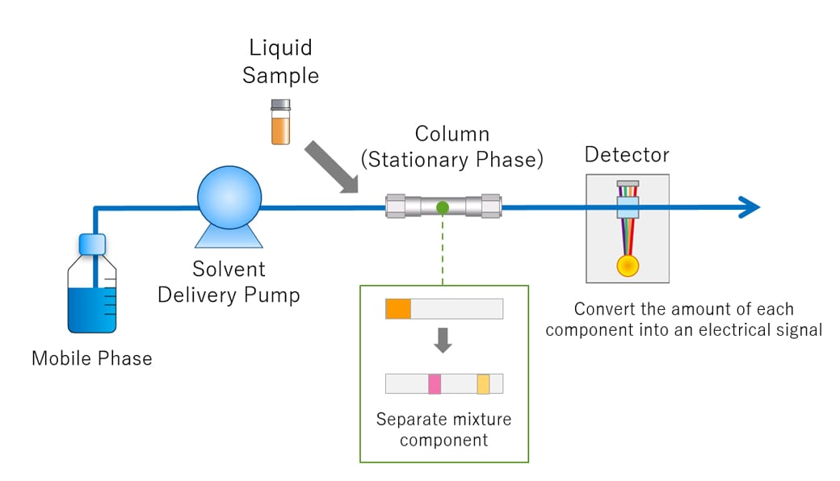

**Fig No. 2: Instrumentation of High Performance Liquid Chromatography**

**2.3.1 Pump:**

In comparison to gravity-flow columns, a pump accelerates the movement of the mobile phase through the column. Even when the make-up of the mobile phase changes, the pump is made to have a steady flow rate and prevent pulsations **(MR. Euerby, 2003).**

**2.3.2. Injectors:**

The injector is generally utilized to inject liquid samples. There are two different types of injectors: automated and manual.

**2.3.3. Columns:**

It is necessary to explain the column's significance because it is an essential part of HPLC. The most widely used and prevalent system is an HPLC column, which is a silica-based packing **(A. Tyagi, 2015).**

**2.3.4. Detector:**

In order to provide an electronic signal proportional to each separated component's concentration as it exits the column, the HPLC detector continuously scans the eluent **(M. Dare, 2015).**

The most widely used detectors:

• Refractive Index Detector

• Fluorescence Detector

• Evaporative Light Scattering Detector

• Conductivity Detector

**2.3.5. Data Recording:**

The detected signal is transformed to an electrical signal when detection is complete, which is then amplified by an amplifier and recorded as a chromatogram in data points. Then utilize the software as the display format in accordance with the manual or automated conversion criteria **(N. Erk, 2003), (J. Lindholm, 2004).**

The development of the HPLC method mainly deals with two key stages:

• Mobile phase

• Stationary phase

**2.4. Applications**

• Analysing complex mixtures, Purifying chemical compounds.

• To survey food and drug products.

• To identify confiscated narcotics

• To determine the number of chemical compounds found in new drugs in Pharmaceutics.

• Pharmaceutical applications

• Environmental applications

• Forensics

• Clinical

• Food and flavour Chromatography involves separations due to differences in the equilibrium distribution of sample components between two immiscible phases. One of these phases is moving are the mobile phase, and the other is a stationary phase **(L. Wang, 2007).**

**3. COLUMN CHROMATOGRAPHY**

**3.1 Introduction:**

The easiest and most widely used method of separation and purification is column chromatography. Column chromatography can be used to separate and purify both solid and liquid materials. In column chromatography, a stationary solid phase works with a liquid mobile phase to adsorb and separate the substances moving through it. Compounds are adsorbed according to their chemical makeup, and elution is based on the differential adsorption of a substance by the adsorbent. In column chromatography, different stationary phases, including silica, alumina, calcium phosphate, calcium carbonate, starch, and magnesia, as well as various solvent compositions, are utilized depending on the types of compounds that need to be separated and isolated. The separation of several categories of chemicals in extracts requires careful method optimization. In column chromatography, slurry (adsorbent) and a suitable solvent are poured into a cylindrical glass tube that is closed at the bottom by a piece of glass wool or porous disc. The silica-mixed samples that need to be separated are added to the column top and allowed to move with the solvent. Compounds are adsorbed at various areas due to polarity variations and desorbed with the appropriate solvent polarity. The compound with the most ability to adsorb will be at the top, while the one with the least ability will be at the bottom. Elution is the process by which compounds are desorbed and allowed to travel through the column after introducing the solvent at the top.

**3.2. Principle:**

Adsorption is the underlying principle of column chromatography. In the mobile phase, a mixture of ingredients is dissolved and added to the column; the ingredients then move in accordance with their relative accordance. When compared to a component with more adsorption and affinity with the stationary phase, the component with lower adsorption and affinity moves more quickly. The process starts with removing the parts that move quickly, and it takes longer to remove the parts that move slowly.

The classification depends on the polarity are as follows:

**1. Normal Phase Chromatography (NPLC)**

**2. Reversed-Phase Chromatography (RPLC)**

**3.3. Instrumentation:**

A typical column chromatographic system using a gas or liquid mobile phase consists of the following components: **(Fig No. 3)**

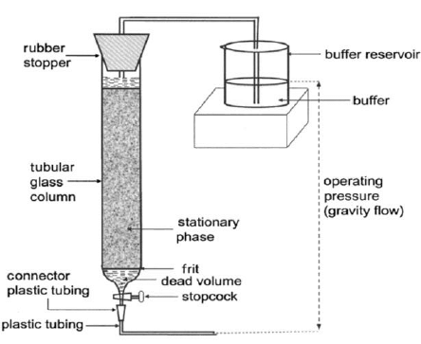

**Fig No. 3: Instrumentation of Column Chromatography**

**3.3.1. Stationary phase**: Chosen to be suitable for separating the analytes.

**3.3.2. Column**: These are typically 25 to 50 cm long, 4 mm in diameter, and made of stainless steel for liquid chromatography, whereas they are 1 to 3 meters long, 2 to 4 mm in diameter, and either made of glass or stainless steel for gas chromatography. Either the traditional type, which is filled with the stationary phase, or the microbore type, which coats the stationary phase directly on the inside wall of the column, are both acceptable.

**3.3.3. Mobile phase and delivery system:** Chosen in order to differentiate between the sample analytes and supply a steady rate of flow into the column as a complement to the stationary phase.

**3.3.4. An injector system:**

To deliver test samples to the top of the column in a reproducible manner.

**3.3.5. Detector and chart recorder**:

In order to provide a continuous record of the analytes' presence in the eluate as it leaves the column.

A physical property, like visible or ultraviolet absorption or fluorescence, is typically measured as the basis for detection.

For every distinct analyte, a peak appears on the chart recorder.

**3.3.6. Fraction collector:**

For collecting the separated analytes for further biochemical studies **(K. Wilson, 2018).**

**3.4. Application**

1. Analytical Uses: For analytical applications, capillaries constructed of glass or copper with internal diameters of 0.05–2 mm and lengths of 1–20 m are utilized. The narrow tubing's inside surface acts as a support or adsorbent for the liquid phase. Butanone/Pyridine/dilute acetic acid (5:5:1) or butanone/acetic acid/water (3:1:6) can be used to separate amino acids in glass capillaries whose internal surfaces have been treated with strong ammonia at 300°C. Seven urine steroids were isolated by scientists Vestergaard and Sayegh in 5 hours as opposed to 36 hours on a typical column. They have employed slender Teflon tubes filled with silica gel or aluminium oxide. An optical detector utilized for the gradient elution-based analysis of steroids in chloroform and acetone.

2. Separation of Diastereomers: Separation of diastereomeric 7-chloro-azibicyclo (4:1:0) - heptane is done on silica gel using pentane/ diethyl ether as solvent.

3. Separation of Tautomeric Mixtures: Separation of tautomeric mixture is possible at High temperature gas chromatography cannot be employed. However, column chromatography could be used to separate these. P-hydroxy-phenyl pyruvic acid, indolyl pyruvic acid, and their keto and enol derivatives may be isolated in a liquid phase. Weakly acidic medium is used for the separation. Before the keto form, the enols form can be seen in the elute.

4. Separation of Geometrical Isomers: Based on the steric component, Cis and Trans isomers are separated. Stronger adsorptive forces are produced by isomers whose functional group can more readily approach the adsorbent's surface. Scientist Winterstein reported the first chromatographic separation of the Cis and Trans isomers of bixin and crocetin dimethyl ether. Later, Zechmeister used calcium carbonate, aluminum oxide, and other adsorbents to separate the Cis and Trans isomers of carotenoids. Carboxylic acids Cis and Trans isomers have been distinguished on charcoal and silica gel.

5. Separation of Racemates: The first successful separations of racemates using organic solvents were achieved on lactose.

**4. PAPER CHROMATOGRAPHY**

**4.1. Introduction:**

In 1943, Synge and Martin made the original discovery of paper chromatography. Paper chromatography is a particular type of technology that uses a certain type of paper. It is a form of planar chromatography in which the stationary phase is cellulose-based filter paper used to separate the components. The technique, which is relatively inexpensive, aids in separating dissolved chemical substances based on their varied rates of migration across paper sheets. For analysis, the technique only needs a tiny amount of sample (N. W. Eigsti, 1967).

**4.2. Principle:**

The basic concept behind paper chromatography is partition, where different components are spread or divided into liquid phases. It uses an aqueous solvent that is held in the pores of filter paper and functions as the stationary phase while the mobile phase moves across the paper **(O. Coskun, 2016).** The compounds in the mixture are separated through capillary action of the paper's pores because of variations in their affinity toward water (in stationary phase solvents) and mobile phase solvents. The components can also be separated using the principle of adsorption between solid and liquid phases, where the stationary phase is a liquid solvent and the mobile phase is the solid surface of the paper. Although partitioning is the primary method of paper chromatography, it is used in other pharmaceutical applications.

**4.3. Procedure:**

The basic procedure for performing paper chromatography is explained below: **(Fig No. 4)**

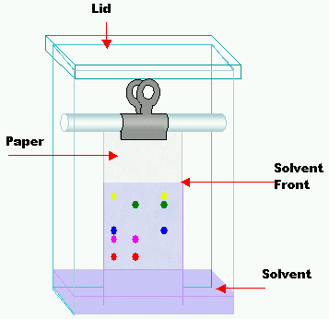

**Fig No. 4: Instrumentation of Paper Chromatography**

**4.3.1. Selecting a suitable type of development:**

Based on factors such the complexity of the solvent, the type of paper being used, the nature of the sample, etc., the type of development is chosen. Radial chromatography is frequently chosen because of its simplicity of use and high resolution. Additionally, it takes less time to complete and produces repeatable outcomes.

**4.3.2. Selecting a suitable filter paper:**

It is possible to choose the right kind of filter paper to use by looking at sample quality and pore size. Whatman No. 1 filter paper is often used as a thin layer.

**4.3.3. Prepare the sample:**

The sample is prepared by dissolving it in an appropriate solvent. It should be inert with the material being analysed, and mobile phase is typically employed for this.

**4.3.4. Spot the sample on the paper:**

The sample should be placed correctly on the paper in the middle, using a capillary tube, and in the proper place.

**4.3.5. Chromatogram development:**

The mobile phase is used to generate the chromatogram on paper. When the mobile phase is attracted to the filter paper by capillary action, the components of the samples begin to move in accordance with their affinity for the mobile phase.

**4.3.6. Paper drying and compound detection:**

The paper is dried at room temperature before being dried with an air drier once the chromatogram has developed. With the use of detecting agents, the components are recognized as being specific to certain chemical substances **(S. K. Pramod, 2017).**

**4.4. Applications**

1. Paper chromatography is a useful method to identify number of constituents present in a sample, with a correctly chosen mobile phase.

2. This method requires small scale setup, involves very minute quantity of sample and is also cost effective **(V. Jirgl, 1957).**

3. Paper chromatography is an effective tool for separation of free amino acids present in human serum **(J. Awapara, 1949).**

4. It also offers a rapid method of separating and estimating sugars quantitatively; however, the identification depends upon determination of their physical constants and formation of characteristic derivatives **(L. Hough, 1950).**

5. Paper chromatographic technique is also used for carrying out assay of pharmaceutical compounds such as mixture of phenylephrine hydrochloride, chlorpheniramine hydrochloride and dextromethorphan hydrochloride **(H. Schriftman, 1961).**

6. The technique is also useful in isolation of pair of components having sample RF values using two-dimensional paper chromatography.

7. Paper chromatography also involves inorganic applications such as separation of cations like cadmium, zinc, mercury, beryllium and calcium **(D. Clegg, 1950).**

8. Its technique is also helpful in identification of accelerator and anti-oxidant in rubber and is useful for determining its quality **(J. Zijp, 1956).**

9. Paper chromatography is widely used in detection of various plant constituents such as opium, quinine alkaloids **(M. Rasul, 2011).**

10. Paper chromatography is also used to determine rate of ongoing reaction. Therefore, it is a valuable tool in synthetic chemistry **(D. Peterson, 1950).**

**5. GAS CHROMATOGRAPHY**

**5.1. Introduction:**

A popular analytical method for separating and analyzing gaseous and volatile substances is gas chromatography. James & Martin created Modern Gas Chromatography in 1952. Since the early 1950s, this method has been used to separate amino acids. Today, however, there are many more uses for GC due to its speed and sensitivity. GC can be used for both qualitative and quantitative analysis. Through GC, very tiny quantities of sample can be analyzed. To separate the analytes in gas chromatography, the sample is dissolved in a solvent and vaporized. A stationary phase and a mobile phase divide the sample into two parts. A chemically inert gas, such helium, nitrogen, or another, makes up the mobile phase. One of the special types of chromatography is gas chromatography, which doesn't require the mobile phase to interact with the analyte. In gas-solid chromatography (GSC), the stationary phase is a solid adsorbent, while in gas-liquid chromatography (GLC), the stationary phase is a liquid on an inert support. Volatility and thermostability are the parameters for choosing which chemicals to test in GC.

**5.2. Principle:**

In gas-solid chromatography, a stationary phase made of solid adsorbent is used, and separation is accomplished through the adsorption process, whereas in gas-liquid chromatography, a thin layer of non-volatile liquid is bound to a solid support, and separation is accomplished through the partitioning process. The most often utilized technology is gas-liquid chromatography. The intended separation sample is first turned into vapours and then combined with the gaseous mobile phase. A sample's more soluble components move more slowly through stationary phase, while its less soluble components move more quickly. As a result, the components are divided based on their partition co-efficient.

**5.3. Instrumentation**:

Generally, all the chromatographs (GSC or GLC) consist of six basic components: **(Fig No. 5)**

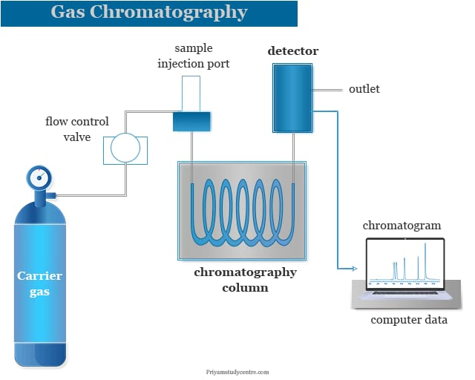

**Fig No. 5: Instrumentation of Gas Chromatography**

**5.3.1. Sample injection system**:

For inserting the sample at the top of the column, a sample port is required. A volume of the sample is injected via a rubber septum and into the vaporization chamber using a calibrated micro syringe. A sample splitter is used to send extra sample to garbage because the majority of separations only need a tiny portion of the initial sample volume. In commercial gas chromatographs, packed columns and capillary columns are alternated with split and split less injections. In order to move the sample into the column, the vaporization chamber is normally heated to a temperature that is 50 °C higher than the sample's lowest boiling point.

**5.3.2. Carrier Gas**:

A carrier gas is essential to GC. It should be dry, inert, and oxygen-free. Depending on the detector being utilized and the necessary performance, helium, nitrogen, argon, and hydrogen gases are employed as carrier gases. Carrier gas is provided under high pressure and is delivered quickly and consistently to the instrument.

**5.3.3. Separation column**: In GC, open tubular, capillary, and packed columns are employed. A wall-coated open tubular (WCOT) column and a support-coated open tubular (SCOT) column are the two different types of capillary columns. A thin layer of the stationary phase is coated along the column walls of WCOT columns. In SCOT columns, a thin layer of an adsorbent solid, such as diatomaceous earth, which is made up of the single-celled shells of sea plants, is initially applied to the column walls. The liquid stationary phase is then used to treat the adsorbent solid. Because of their larger sample capacity, SCOT columns can contain more stationary phase than WCOT columns, yet WCOT columns still perform better overall. The coated Fused Silica open tubular column is one of the most widely used varieties of capillary columns.

**5.3.4. Column Oven or Thermostat chambers:** The thermostat oven's purpose is to regulate the column's temperature so that precise work can be done. There are two ways to control the oven: isothermal programming and temperature programming. The column's temperature is maintained constant throughout the separation in isothermal programming. The column temperature is raised either continuously or incrementally as the separation advances in the temperature programming method.

**5.3.5. Detectors:** Mass spectrometers, Flame ionization detectors (FID), Electron capture detectors (ECD), Thermal conductivity detectors (TCD), Atomic emission detectors (AED), Photoionization detectors (PID), and Chemiluminescence detectors are the most prevalent detector types used in GC. The mixture's components are measured quantitatively by a detector at the bottom of the column as they elute and combine with the carrier gas.

**5.3.6. Amplification & Recorder system:** These are the last and most important GC instrumentation parts. These are designed to capture the signals sent by the detector. These analyze & amplify the signals using specialized electronic circuitry to display several peaks of the sample's elements in a comprehensible graphical representation.

To deliver the carrier gas with uniform pressure & flow rate, the GC additionally has flow regulators & flow meters.

**5.4. Applications**

• Identification of hazardous compounds in waste damps.

• Quantification of drugs & their metabolites in blood & urine for both pharmacological & forensic applications.

• Identification of reaction products.

• Quantification of pollutants in drinking & waste water.

• Analysis of industrial products for quality control.

• Skin sample analysis.

• RNA isolation.

• Astro chemistry & geochemical search **(AG. Linde, 2012).**

**6. ION EXCHANGE CHROMATOGRAPHY**

**6.1. Introduction**

Any type of charged molecule, such as a protein, an amino acid, or a tiny nucleotide, can be separated using the ion exchange chromatography technique, which allows for this. The solution that will be injected is known as the sample, and the separated components are known as the analytes. This method is employed in the purification, analysis, and quality control of water. Due to the extensive usage of mobile and stationary phase combinations, it offers a higher level of selectivity. The stationary phase components are known as ion exchangers, and they have the ability to reversibly remove ions from a solution while simultaneously replacing them with ions of an equivalent charge. Ion exchange chromatography is the most adaptable of all the techniques and a useful tool for separating ions with comparable characteristics but challenging analytical problems. It is helpful for separating organic acids, amino acids, peptides, and nucleotides as well as for figuring out complex mixtures of qualities that are extremely closely related **(M. Singh, 2003).**

**6.2. Principle Ion exchange chromatography:**

It is based on the attraction between particles with opposing charges. As an illustration, consider proteins and amino acids, which can have net positive or negative charge and are utilized to separate mixtures of these substances. The Henderson Hesselbalch equation states that the net charge displayed by these compounds depends on the pKa and pH of the solution **(GR. Chatwal, 2007).**

Analyte retention on the column in ion exchange chromatography is based on ionic contact. Ionic functional group R-X, which interacts with analyte ions of the opposite charge, is visible in the stationary phase.

Ion exchange chromatography is separated into two categories as a result of this.

(a) Cationic Ion exchange chromatography.

(b) Anionic Ion exchange chromatography.

Anionic species B-and cationic species M+ make up ionic compounds, which can be kept on stationary phase.

Because the stationary phase shows a functional group with a negative charge, cationic ion exchange chromatography retains positive charged cations.

R-X- C+ + M+B- → R-X- M+ + C++ B-

Utilizing positively charged functional groups, anionic ion exchange chromatography maintains anion.

R-X+ A-+ M+B- → R-X+ B-+ M+ + A

**6.3. Instrumentation:** **(Fig No. 6)**

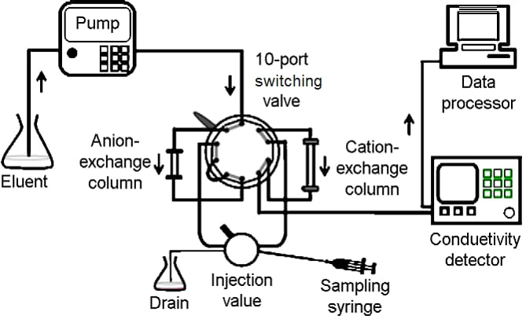

**Fig No. 6: Instrumentation of Ion- exchange Chromatography**

* A high-pressure pump with pressure and flow indicator, to deliver the eluent.

* An injector for introducing the sample into the eluent stream and onto the column

* A column, to separate the sample mixture into the individual components

* An oven, optional

* A detector, to measure the analyte peaks as eluent from the column

* A data system for collecting and organizing the chromatograms and data

**6.3.1. Columns:**

While industrial columns are often composed of either high-quality stainless steel or polymer, which are both resistant to strong acids and alkalis, laboratory columns are made of glass.

The separation factor has no bearing on the column's shape. The separation is made better by lengthening the column, but it cannot be lengthened over a critical length. If a column is too wide or too narrow in size, liquid flow may be uneven. For greater efficiency, a column with a dimension of 20:1 to 100:1 can be employed.

**6.3.2. Packing of the Column:** The column is packed using a moist approach in this instance. The mobile phases are combined with the resins before being uniformly put into the column. The sample that needs to be separated is dissolved in the mobile phases and placed into the column all at once.

**6.3.3. Application of the sample:**

The solution to be examined is put to the top of the column after it has been packed, and it is then allowed to pass through the ion exchanger bed. Syringes or pipettes are used for this purpose.

**6.3.4. Mobile phase:**

Since organic solvents are no longer used, they are less useful. As an eluting solvent, only various strengths of acids, alkalis, and buffer are utilized.

**6.3.5. Developments of the chromatogram and elution:**

Following sample introduction, the chromatogram is developed using several mobile phases. A consistent ionic strength is achieved in the aqueous salt solution. The resin's selectivity for the solute ions determines which mobile phase to use.

There are two different elution procedures:

a. Isocratic elution

b. Gradient elution

**6.3.6. Regeneration of ion exchange resin:**

After separation, the ion exchange resin could not be beneficial for the following separation since the exchange functional groups are removed. However, ion exchange resins cannot be thrown away due to their high cost. Reactivation and regeneration of the resins are therefore crucial. The efficiency of used ion exchange resins can be equalled to that of new resins through regeneration.

The term "regeneration" describes the replacement of the resin's exchangeable cations or anions. So, to regenerate the cation exchange resin, the column is charged with strong acid, such as hydrochloric acid. To regenerate the anion exchange resin, strong alkali, such as sodium hydroxide or potassium hydroxide, are also utilized.

**6.4. Application**

1. Removing monovalent and divalent ions from the water, such as sodium, potassium, calcium, and magnesium.
2. Demineralized water is obtained by removing various ions, also known as deionization. Removal of ionic contaminants from a solution through purification.
3. Separation of cation and anion inorganic ions.
4. Organic separations: The majority of pharmaceutical compounds have an acidic or basic character, either strongly or weakly. As a result, a mixture of that compound can be separated using ion exchange resin. Classes of compounds that can be separated include amino acid proteins, antibiotics, vitamins, fatty acids, and others **(J. Mendham, 2017).**

**BIBLIOGRAPHY:**

1. A. Jeanes, C. Wise, and R.-J. Dimler, “Improved techniques in paper chromatography of carbohydrates,” Analytical Chemistry, vol. 23, no. 3, pp. 415-420. 1951.
2. Abidi,S.L. High-performance liquid chromatography of phosphatidic acids and related polar lipids. J. Chromatogr. 1991; 587: 193-203.
3. Anees A. Siddiqui; Pharmaceutical Analysis; volume-I;page. No: 216 – 236.
4. Aryal, S., HARINKHEDE, P., ƧӇƛШ, Ɲ. Δ. Ƭ. Σ., PM, I. G., Singh, M., Bakhtawar., Singh, D. S. (2021, July 26). Chromatography- definition, principle, types, applications. Retrieved October 23, 2021, from <https://microbenotes.com/chromatography-principle-types-and-applications>.
5. Bergh JJ, Breytenbach JC. Stability-indicating high-performance liquid chromatographic analysis of trimethoprim in pharmaceuticals. J Chromatogr. 1987 Jan 30; 387:528-31. doi: 10.1016/s0021- 9673(01)94565-0. PMID: 3558640
6. Chatwal GR, and Anand SK. Instrumental Methods of Chemical Analysis. Himalaya Publishing House Mumbai. 2007, 2.662-2.672
7. Chromatography, classification, principle of working and selected techniques. Retrieved October 23, 2021, from https://www.scribd.com/document/178065088/Chromatography-ClassificationPrinciple-of-Working-and-Selected-Techniques
8. Chromatography, K. (2018). Review Article: Chromatography Principle and Applications.
9. D. H. Peterson, and L. M. Reineke, “A paper chromatographic technique and its application to the study of new antibiotics,” Journal of the American Chemical Society, vol. 72, no. 8, pp. 3598-3603. 1950
10. D. L. Clegg, “Paper chromatography,” Analytical Chemistry, vol. 22, no. 1, pp. 48-59. 1950
11. Dare M, Jain R, Pandey A. Method validation for stability indicating method of related substance in active pharmaceutical ingredients dabigatran etexilate mesylate by reverse phase chromatography. J Chromatogr A. 2015:6(2); 263.
12. Dincer Z, Basan H, Goger NG. Quantitative determination of ambroxol in tablets by derivative UV spectrophotometric method and HPLC. J Pharm Biomed Anal. 2003; 31 (5):867-72.
13. Dr. A. V. Kasture, Dr. K. R. Mahadik, Dr. S. G. Wadodkar, Dr. H. N. More; Pharmaceutical Analysis; volume-II; page. No: 39 – 47.
14. Erk N. Rapid and sensitive HPLC method for the simultaneous determination of dorzolamide hydrochloride and timolol maleate in eye drops with diode-array and UV detection. Pharmazie. 2003 Jul; 58(7):491-493.
15. Euerby MR, Petersson P. Chromatographic classification and comparison of commercially available reversed-phase liquid chromatographic columns using principal component analysis. J Chromatogr. 2003; 994(1-2):13-36.
16. F. Kurzer, “An early application of paper chromatography,” Journal of Chemical Education, vol. 55, no. 5, pp. 321, 1978/05/01. 1978.
17. G. Devala Rao; A Text Book of Pharmaceutical Analysis; volume-II; page. No: 54 – 57.
18. G. Zweig, and J. Sherma, “Paper Chromatography—Past, Present and Future,” Journal of Chromatographic Science, vol. 11, no. 6, pp. 279-283. 1973.
19. Gurdeep R. Chatwal, Sham K. Anand; Instrumental Methods of Chemical Analysis; page. No: 2.662-2.672.
20. H. G. Cassidy, “Investigation of paper chromatography,” Analytical Chemistry, vol. 24, no. 9, pp. 1415-1421.
21. H. Schriftman, and R. C. Shultz, “Application of paper chromatography and electrophoresis to the assay of pharmaceutical products,” Journal of pharmaceutical sciences, vol. 50, no. 4, pp. 332-336. 1961.
22. Hearn M.T.W. Ion-pair chromatography on normal and reversed-phase systems. Adv. Chromatography. 1980; 18: 59–100.
23. Hostettmann, K., Marston, A., & Hostettmann, M. (2011). Preparative Chromatography Techniques: Applications in natural product isolation. Berlin: Springer.
24. https://chem.libretexts.org/Textbook_Maps/Analytical_Chemistry/Supplemental_Modules(Analytical_Chemistry)/Instrumental_Analysis/Chromatography/Gas_Chromatograph.
25. https://www.omicsonline.org/development-and-validation-of-a-gas-chromatographymass-spectrometry-method-for-the-determination-of-pcbs-in-transformer-oil-samplesapplication-on-real-samples-from-botswana-2157-7064.1000116.php?aid=3620
26. [https://www.omicsonline.org/method-validation-for-the-trace-analysis-of-geosmin- and-](https://www.omicsonline.org/method-validation-for-the-trace-analysis-of-geosmin-%20%20%20%20%20%20and-)2-methylisoborneol%20in-water-by-salt-free-purge-and-trap-sampling-gc-ms-using-theeclipse-4660-sample-concentrator-2157-7587.1000134.php?aid=749
27. [https://www.sigmaaldrich.com/life science/ascentis](https://www.bing.com/aclk?ld=e8gQFoX0qmGiIVBWvQT9HJoDVUCUzOVZprNHrLDodSwmhLe1MJvfr7QosIsxNHNMMp0VWz4Hy8-q1uUbfBIafnpTbOBEhVo-Gd5LcWBJTI_Og5cs0SRLIUmpkrAZYBbvsd1H7sy5r7ZouJCBjA2RO7DgaGVSYHsnWdKZKv7G0jVZ8Q3ZAq2GCKguoFHvd73_EKESgaUQ&u=&rlid=4e932e00cb061dc0c2c74ae8a68c5fe2&ntb=1&ntb=1)
28. https://www.slideshare.net/shaisejacob/column-chromato
29. J. Awapara, “Application of paper chromatography to the estimation of some free amino acids in tissues of the rat,” Journal of Biological Chemistry, vol. 178, pp. 113-116. 1949.
30. J. Mendham, R.C Denney, J.D Barnes, M. Thomas, B. Siva Sankar; Text Book of Quantitative Chemical Analysis, 6th edition; page. No: 213-222.
31. J. Sherma, Modern thin-layer chromatography, Journal of AOAC International, Vol.91, No.5, 2008, pp. 1142-1144.
32. J. Zijp, “Application of paper chromatography to the identification of accelerators and antioxidants: IV. Detection of antioxidants,” Recueil des Travaux Chimiques des Pays‐Bas, vol. 75, no. 10, pp. 1129-1136. 1956
33. K. Ferenczi-Fodor, Z. Végh, A. Nagy-Turák, B. Renger, and M. Zeller, Validation and quality assurance of planar chromatographic procedures in pharmaceutical analysis, Journal of AOAC International, Vol.84, No.4, 2001, pp. 1265-1276.
34. Koll K., Reich E., Blatter A., Veit M. Validation of standardized high-performance thin-layer chromatographic methods for quality control and stability testing of herbals. J. AOAC Int. 2003; 86: 909-915.
35. L. Hough, “Application of paper partition chromatography to the separation of the polyhydric alcohols,” Nature, vol. 165, no. 4193, pp. 400-400. 1950.
36. Linde AG. Gas Chromatography. Archived from the original on 3 March 2012. Retrieved 11 March 2012.
37. Lindholm J. Development and Validation of HPLC Method for Analytical and Preparati ve Purpose, Acta Universities Upsaliensis Uppsala 2004; 13-14.
38. Luxminarayan L, Sharma N, Viswas A, Khinchi MP. A review on chromatography techniques. Asian Journal of Pharmaceutical Research and Development. 2017 Mar 1:1-08.
39. M. G. Rasul, “Extraction, Isolation and Characterization of Natural Products from Medicinal Plants,” International Journal of Basic Sciences and Applied Computing, vol. 2, no. 6, pp. 1-6. 2011
40. McMurry, J. (2015). Organic Chemistry with biological applications. Stamford, CT: Gengage Learning.
41. McNaught, A. D., & Wilkinson, A. (1997). Compendium of chemical terminology. Blackwell Scientific.
42. Meiling Qi, Peng Wang, Ruihua Cong, Jianjun Yang. Simultaneous determination of roxithromycin and ambroxol hydrochloride in a new tablet formulation by liquid chromatography. J Pharm Biomed Anal. 2004; 35(5):1287-91.
43. Miller JM. Chromatography concepts and contrasts. 2nd Ed. New Jersey. 2005:35-182
44. Nielsen, S. S. (2010). Food analysis. New York: Springer.
45. O. Coskun, “Separation techniques: chromatography,” Northern clinics of Istanbul, vol. 3, no. 2, pp. 156. 2016
46. P. A. Little, and J. A. Schleimer, "Application of Paper Chromatography to Oil Field Problems."
47. P. Parimoo; Pharmaceutical Analysis; page. No: 284 - 286.
48. Parihar S, Hooda S, Kakkar S, Bhan M. A Review on High Performance Thin Layer Chromatography Methods and Validation Parameters for Quantification of Andrographolide from Andrographis Paniculata and Its Marketed Formulations. Sch Acad J Pharm. 2022 Jan; 1:27-36.
49. R. A. Day, A. L. Underwood; Quantitative Analysis; 6th edition; page. No: 535-543.
50. Rafferty JL, Siepmann JI Schure MR. Molecular-level comparison of alkylsilane and polar-embedded reversed-phase liquid chromatography systems. Anal Chem. 2008; 80(16):6214-221.
51. S. K. Pramod, and K. A. Navnath, “A BRIEF REVIEW ON ULTRA PERFORMANCE LIQUID CHROMATOGRAPHY.” 2017.
52. Singh M, Analytical Chemistry Instrumental Technique. Dominent Publisher and Distributer Delhi. 2003, 40- 51.
53. The Nobel Prize in chemistry 1952. Retrieved October 23, 2021, from <https://www.nobelprize.org/prizes/chemistry/1952/summary/>
54. Turker AR. Separation, Preconcentration and speciation of metal ions using solid phase extraction. Sep Purification Rev. 2012:41(3);169-206
55. Tyagi A, Nitin Sharma, Mittal K, Mashru R, Bhardwaj T, Malik J. HPTLC-densitometric and RP-HPLC method development and validation for determination of salbutamol sulphate, bromhexine hydrochloride and etofylline in tablet dosage forms. Pharmaceutica Analytica Acta. 2015; 6(3):350.
56. V. Jirgl, “Paper chromatography of free amino acids in blood serum,” Clinical chemistry, vol. 3, pp. 154-155. 1957.
57. W. Eigsti, “Paper Chromatography for Student Research,” The American Biology Teacher, pp. 123-134. 1967.
58. Wang L, Jiang G, Cai Y, He B, Wang Y, Shen D. Cloud point extraction coupled with HPLC-UV for the determination of phthalate esters in environmental water samples. J Environ Sci. 2007:19(7); 874-78.
59. Wang LL, Wang JQ, Zheng ZX, Xiao P. Cloud point extraction combined with high-performance liquid chromatography for speciation of chromium (III) and chromium (VI) in environmental sediment samples. J Hazard Mater. 2010:177(1-3); 114-18.
60. Wang P, Zhao G, Tian J, Su X. High-performance liquid chromatography inductively coupled plasma mass spectrometry-based method for the determination of organic arsenic feed additives and speciation of anionic arsenics in animal feed. J Agric Food Chem. 2010:58(9);5263-5270
61. Wilson, K., Walker, J. (2018). Principles and Techniques of Biochemistry and Molecular Biology (8 Eds.). Cambridge University Press: New York.
62. Yasser M. Moustafa and Rania E. Morsi; Ion Exchange Chromatography - An Overview.