Interconnected Threads: Exploring the Ad Hoc Network Paradigm

Arnab Das

Department. of BCA

Institute of Hotel and Restaurant Management

Sonarpur, India

arnab4u.india@gmail.com

Pradyut Sarkar

Department of Computer Science,

MAKAUT

Nadia, India-741249

**ABSTRACT**

Ad hoc networking is a dynamic and decentralized approach to wireless communication, allowing devices to form temporary networks without relying on any existing infrastructure. This type of network is characterized by self-configuring nodes, wireless links, and routing protocols that enable communication in the absence of a centralized control authority. Ad hoc networks find applications in a wide range of scenarios, including disaster recovery, military operations, sensor networks, and peer-to-peer communication.This abstract provides an overview of ad hoc networking, highlighting its key components, advantages, and challenges. Ad hoc networks offer flexibility, resilience, and scalability, making them suitable for dynamic environments. However, they also face limitations such as limited resources, dynamic topology, and security vulnerabilities.Understanding the different types of ad hoc networks, including Mobile Ad hoc Networks (MANETs)[1], Vehicular Ad hoc Networks (VANETs), Wireless Sensor Networks (WSNs), and Hybrid Ad hoc Networks, is essential for designing and managing these networks effectively.This abstract serves as a foundation for further exploration of ad hoc networking. Subsequent chapters will delve into specific aspects of ad hoc networks, including routing protocols, security mechanisms, and practical applications. By gaining a comprehensive understanding of ad hoc networking, researchers and practitioners can harness its potential for creating robust and efficient wireless communication systems.

**KEYWORDS -** Adhoc networks ,Routing, Throughput.

**1. INTRODUCTION**

**1.1 UNDERSTANDING ADHOC NETWORKS**

Definition: An ad hoc network is a decentralized type of network where devices can communicate with each other without relying on any established infrastructure or centralized control.

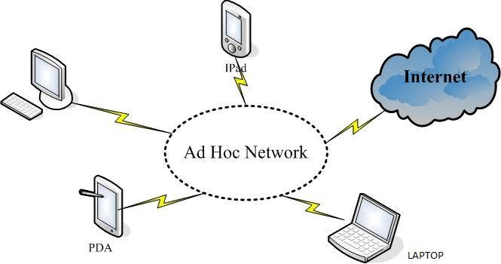

Figure 1 (AdHoc Network)

Characteristics: Ad hoc networks are self-configuring, dynamic, and temporary networks formed by wireless devices.

Applications: Ad hoc networks are widely used in various scenarios, including disaster recovery, military operations, sensor networks, and peer-to-peer communication.

**1. KEY COMPONENTS OF ADHOC NETWORKS**

Nodes: The devices participating in the ad hoc network, such as laptops, smartphones, or sensor nodes.

Wireless Links: Communication channels established between nodes without the need for wired connections.

Routing Protocols: Algorithms that determine the paths for data transmission in the network.

Network Infrastructure: The logical structure that enables node discovery, addressing, and connectivity in the absence of a centralized authority.

**1.3 ADVANTAGES AND CHALLENGES OF ADHOC NETWORK**

**ADVANTAGES:**

Flexibility: Ad hoc networks can be quickly deployed and reconfigured, making them suitable for dynamic environments.

Resilience: They are resistant to single-point failures since they do not rely on a central infrastructure.

Scalability: Ad hoc networks can easily accommodate a large number of devices.

**CHALLANGES:**

Limited Resources: Nodes in ad hoc networks often have limited power, memory, and processing capabilities.

Dynamic Topology: The network topology changes frequently due to node mobility, making routing and connectivity challenging.

Security: Ad hoc networks are susceptible to security threats, such as eavesdropping, data tampering, and node impersonation.

**1.4 TYPES OF ADHOC NETWORKS**

Mobile Ad hoc Networks (MANETs): Nodes move arbitrarily, resulting in changing network topologies.

Vehicular Ad hoc Networks (VANETs): Networks formed by vehicles for improved traffic safety, traffic efficiency, and infotainment services.

Wireless Sensor Networks (WSNs): Networks composed of small, power-constrained sensor nodes for monitoring physical or environmental conditions.

Hybrid Ad hoc Networks: Combinations of different types of networks, such as integrating MANETs and WSNs for specific applications.

**2. MOBILE ADHOC NETWORKS (MANETs)**

**2.1 INTRODUCTION TO MOBILE ADHOC NETWORKS**

Definition: Mobile Ad hoc Networks (MANETs)[2] are self-configuring networks of mobile devices that communicate with each other without relying on any fixed infrastructure or centralized control.

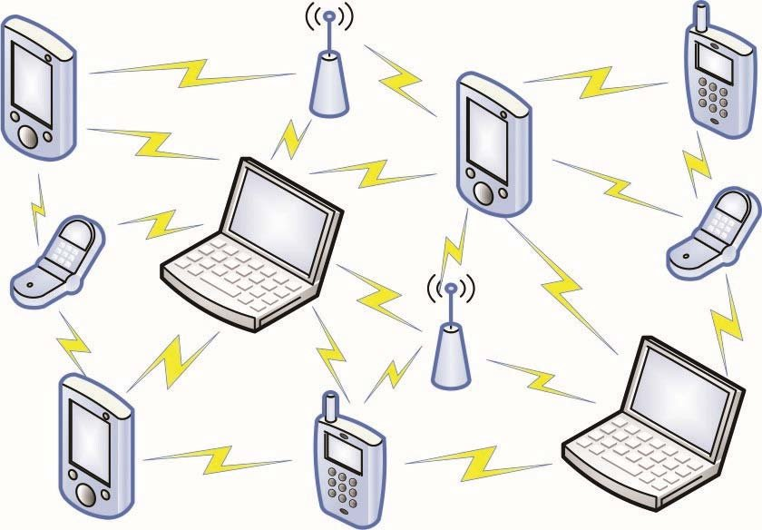

Figure 2 (Mobile Ad Hoc network)

Characteristics: MANETs are highly dynamic networks with nodes that can move freely, resulting in frequent changes in network topology.

Applications: MANETs have applications in various fields, including military operations, emergency response systems, collaborative mobile environments, and mobile sensor networks.

**2.2 ROUTING PROTOCOLS OF MANETS**

Importance of Routing: Due to the dynamic nature of MANETs, efficient and adaptive routing protocols are essential for establishing and maintaining communication paths.

Proactive Routing Protocols: Protocols like Optimized Link State Routing (OLSR) and Destination-Sequenced Distance Vector (DSDV) maintain up-to-date routing tables to enable fast route discovery and minimize latency.

Reactive Routing Protocols: Protocols like Ad hoc On-Demand Distance Vector (AODV) and Dynamic Source Routing (DSR) establish routes on-demand, reducing overhead in highly dynamic environments.

Hybrid Routing Protocols: Protocols like Zone Routing Protocol (ZRP) combine proactive and reactive approaches to achieve a balance between efficiency and adaptability.

**2.3 CHALLANGES IN MANETS**

Node Mobility: Frequent node mobility leads to rapid changes in network topology, requiring robust and efficient routing protocols to adapt to these changes.

Scalability: As the number of nodes increases, the complexity of route discovery and maintenance grows, making scalability a challenge in MANETs.

Energy Constraints: Mobile devices in MANETs often have limited battery power, necessitating energy-aware routing protocols and optimization techniques.

Security: MANETs are vulnerable to various security threats, including unauthorized access, data tampering, and node impersonation. Ensuring secure communication is crucial in MANET deployments.

**2.4 MANET ROUTING METRICS**

Metrics for Route Selection: Routing protocols in MANETs utilize metrics to evaluate and select the most suitable routes for data transmission.

Metrics Based on Distance: Euclidean distance, hop count, and geographic information are commonly used to calculate route quality.

Metrics Based on Quality of Service (QoS): Delay, throughput, packet loss, and bandwidth can be considered to prioritize routes based on specific application requirements.

**2.5 RESEARCH AND FUTURE DIRECTION**

Optimization Techniques: Ongoing research focuses on developing energy-efficient routing algorithms, load balancing mechanisms, and adaptive routing schemes to enhance MANET performance.

Security Mechanisms: Advancements in secure routing protocols, key management, and intrusion detection systems aim to address the security challenges faced by MANETs.

Internet Integration: Integration of MANETs with the Internet is a promising area, enabling seamless connectivity between MANETs and the global network.

**3. VEHICULAR ADHOC NETWORKS (VANETs)**

**3.1 INTRODUCTION TO VEHICULAR ADHOC NETWORK**

Definition: Vehicular Ad hoc Networks (VANETs)[3] are wireless networks formed by vehicles and roadside infrastructure to enable communication and exchange of information for various purposes.

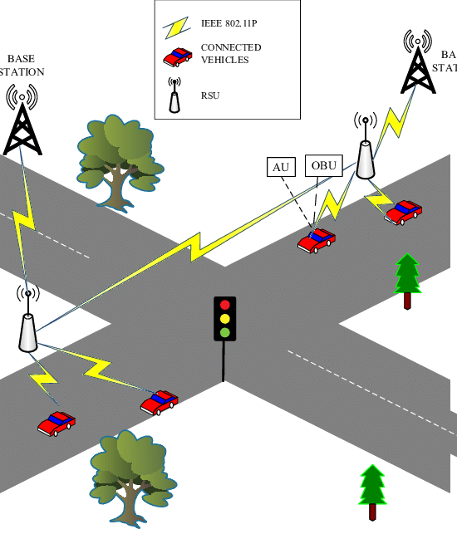

Figure 3 (Vehicular Ad hoc Networks)

Characteristics: VANETs are characterized by high node mobility, rapidly changing network topologies, and the unique challenges posed by vehicular environments.

Applications: VANETs find applications in intelligent transportation systems, traffic management, road safety, infotainment services, and cooperative driving.

**3.2 VEHICULAR COMMUNICATION TECHNOLOGIES**

Dedicated Short-Range Communications (DSRC): DSRC is a technology based on IEEE 802.11p standard, specifically designed for vehicular communication in the 5.9 GHz frequency band. It enables vehicle-to-vehicle (V2V) and vehicle-to-infrastructure (V2I) communication.

Cellular-Based Technologies: Cellular networks, such as 4G LTE and 5G, can be utilized to support VANET communication, allowing vehicles to connect to cellular networks and access a wider range of services.

**3.3 CHALLENGES IN VANETS**

High Node Mobility: Vehicles move at high speeds, resulting in frequent topology changes, requiring efficient and adaptive routing protocols to maintain communication links.

Network Scalability: VANETs involve a large number of vehicles, necessitating scalable solutions for efficient communication and resource management.

Channel Congestion and Interference: The limited available spectrum and the dense deployment of vehicles can lead to channel congestion and interference, affecting communication reliability.

Security and Privacy: VANETs face security and privacy concerns, including authentication, message integrity, privacy-preserving techniques, and protection against malicious attacks.

**3.4 VEHICULAR ROUTING PROTOCOL**

Geocast-based Routing: Geocast routing protocols use location-based addressing to forward messages to vehicles within a defined geographical area, enabling efficient dissemination of information related to road conditions or accidents.

Cluster-based Routing: Cluster-based protocols establish clusters of vehicles to reduce overhead and improve scalability. They utilize cluster heads for inter-cluster communication and efficient data dissemination.

Hybrid Routing: Hybrid routing protocols combine proactive and reactive approaches, allowing for both efficient routing maintenance and on-demand route discovery.

**3.5 SAFETY APPLICATIONS IN VANETS**

Collision Avoidance: VANETs facilitate real-time communication between vehicles, enabling collision warning systems and cooperative maneuvers for enhanced road safety.

Intersection Management: VANETs can optimize traffic flow by coordinating vehicles at intersections, reducing congestion and improving efficiency.

Emergency Services: VANETs provide a reliable communication infrastructure for emergency services, enabling quick response and efficient coordination during accidents or emergencies.

**3.6 RESEARCH AND FUTURE DIRECTIONS**

Quality of Service (QoS) Provisioning: Research focuses on QoS-aware routing and resource allocation techniques to ensure timely and reliable delivery of safety-critical and time-sensitive applications in VANETs.

Network Optimization: Ongoing efforts aim to optimize network performance by addressing challenges related to channel utilization, interference management, and efficient resource allocation.

Standardization and Integration: Standardization bodies and researchers work towards developing interoperable protocols and integrating VANETs with other emerging technologies, such as cloud computing and edge computing.

**4. WIRELESS SENSOR NETWORKS (WSNs)**

**4.1 INTRODUCTION TO WIRELESS SENSOR NETWORKS**

Definition: Wireless Sensor Networks (WSNs) are networks of small, autonomous devices called sensors that collect and transmit data from the physical environment.

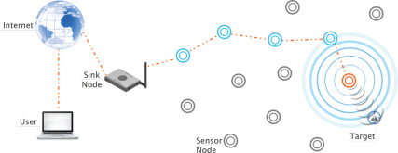

Figure 4 (Wireless Sensor Networks)

Characteristics: WSNs consist of numerous sensor nodes with limited processing, communication, and power capabilities. They operate in a distributed manner, collaboratively sensing and sharing information.

Applications: WSNs find applications in various domains, including environmental monitoring, industrial automation, healthcare, agriculture, and smart cities.

**4.2 SENSOR NODES IN WSN**

Sensor Node Components: A sensor node typically comprises a sensing unit, processing unit, wireless communication module, power source, and sometimes storage.

Sensing Technologies: Different sensors, such as temperature, humidity, light, and motion sensors, are used to capture data from the environment.

Energy Constraints: Sensor nodes are typically battery-powered, which imposes energy constraints and necessitates energy-efficient protocols and algorithms.

**4.3 COMMUNICATION IN WSN**

Data Dissemination: Sensor nodes communicate with each other and with a base station or sink node to transmit collected data.

Network Topologies: WSNs can be organized in various topologies, including star, tree, mesh, and cluster-based topologies, depending on the application requirements.

Routing Protocols: Routing protocols in WSNs determine the paths for data transmission, considering energy efficiency, data aggregation, and reliable delivery.

**4.4 CHALLENGES IN WSN**

Limited Resources: Sensor nodes have limited energy, memory, and processing capabilities, requiring energy-efficient algorithms, data compression, and aggregation techniques.

Scalability: As the number of sensor nodes increases, the network scalability becomes a challenge due to increased communication overhead and resource constraints.

Node Failure and Mobility: Sensor nodes can fail or move unpredictably, affecting network connectivity and data collection.

Data Security and Privacy: WSNs face security and privacy concerns, as the collected data may be sensitive or vulnerable to attacks.

**4.5 DATA FUSION AND PROCESSING**

Data Fusion Techniques: Data fusion combines data from multiple sensor nodes to obtain more accurate and reliable information about the environment.

Data Processing at the Edge: Edge computing techniques enable local data processing and decision-making within the WSN itself, reducing the need for data transmission and conserving energy.

**4.6 RESEARCH AND FUTURE DIRECTION**

Energy Harvesting: Research focuses on energy harvesting techniques, such as solar, thermal, and kinetic energy, to power sensor nodes and extend network lifetime.

Machine Learning and Artificial Intelligence: Integration of machine learning and AI algorithms enables intelligent data processing, anomaly detection, and predictive analytics in WSNs.

Integration with IoT and Cloud Computing: WSNs can be integrated with the Internet of Things (IoT) and cloud computing platforms, enabling seamless data sharing, analysis, and scalability.

**5. HYBRID ADHOC NETWORKS**

**5.1 INTRODUCTION TO HYBRID ADHOC NETWORKS**

Definition: Hybrid Ad hoc Networks combine different types of networks, such as Mobile Ad hoc Networks (MANETs), Vehicular Ad hoc Networks (VANETs), and Wireless Sensor Networks (WSNs), to form a hybrid architecture.

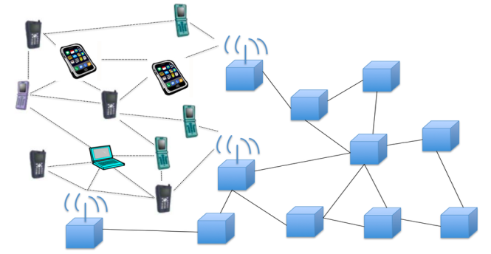

Figure 5(Hybrid Ad hoc Networks)

Characteristics: Hybrid networks leverage the strengths of each network type, allowing for enhanced communication, improved coverage, and efficient resource utilization.

Applications: Hybrid Ad hoc Networks find applications in various domains, including disaster response, surveillance systems, smart grid management, and environmental monitoring.

**5.2 TYPES OF HYBRID ADHOC NETWORKS**

MANET-WSN Integration: Integrating MANETs and WSNs enables mobile nodes to communicate with static sensor nodes, extending the coverage and functionality of WSNs.

VANET-WSN Integration: Combining VANETs and WSNs allows vehicles to gather data from roadside sensors and share real-time information with other vehicles and infrastructure.

MANET-VANET Integration: Integrating MANETs and VANETs enables communication between mobile nodes and vehicles, facilitating dynamic ad hoc networking in vehicular environments.

**5.3 HYBRID ROUTING PROTOCOLS**

Zone-based Routing: Hybrid routing protocols often utilize zone-based approaches, dividing the network into different zones and employing different routing strategies based on the location of nodes.

Cluster-Based Routing: Cluster-based techniques form clusters of nodes, where cluster heads perform inter-cluster communication, improving scalability and reducing communication overhead.

Cross-Layer Routing: Hybrid networks can benefit from cross-layer routing protocols that leverage information from multiple layers to make more informed routing decisions.

**5.4 CHALLANGES OF HYBRID NETWORK**

Heterogeneity: Hybrid networks consist of diverse network types, requiring interoperability, protocol adaptation, and efficient communication between different network components.

Mobility Management: Managing mobility in hybrid networks is crucial, considering the movement of nodes in MANETs and VANETs, while ensuring connectivity and stability.

Resource Optimization: Efficient resource allocation, power management, and load balancing are essential to optimize the performance of hybrid networks.

**5.5 SECURITY AND PRIVACY OF HYBRID NETWORKS**

Security Threats: Hybrid networks face security threats such as data confidentiality, integrity, authentication, and malicious attacks due to the diverse network components and communication links.

Privacy Preservation: Protecting the privacy of users and sensitive data in hybrid networks is crucial, considering the diverse nature of data sources and communication nodes.

**5.6 RESEARCH AND FUTURE DIRECTIONS**

Quality of Service (QoS) Provisioning: Enhancing QoS in hybrid networks through efficient resource management, traffic prioritization, and bandwidth allocation is a key research area.

Energy Efficiency: Designing energy-efficient protocols, routing algorithms, and optimization techniques is important to extend the network lifetime and reduce resource consumption.

Integration with Emerging Technologies: Integration of hybrid networks with emerging technologies such as edge computing, blockchain, and artificial intelligence can enhance network capabilities and enable innovative applications.

**6. ROUTING PROTOCOLS FOR ADHOC NETWORKS**

**6.1 INTRODUCTION**

Ad hoc networks are dynamic and self-configuring networks that lack centralized infrastructure, making routing a critical aspect of their functionality. This chapter focuses on exploring various routing protocols specifically designed for ad hoc networks. We examine their key features, mechanisms, and performance characteristics to gain insights into their suitability for different ad hoc network scenarios.

**6.2 PROACTIVE ROUTING PROTOCOLS**

Proactive routing protocols[6],[7], also known as table-driven routing protocols, are a category of routing protocols designed for dynamic networks such as ad hoc networks. The primary objective of proactive protocols is to maintain up-to-date routing information at all times, regardless of whether there are active data transmissions or route requests. This proactive nature allows for faster route establishment when the need arises.

One popular example of a proactive routing protocol is the Destination-Sequenced Distance Vector (DSDV) protocol. In DSDV, each node maintains a routing table containing information about the available routes to other nodes in the network. Nodes periodically exchange updates to ensure their routing tables stay synchronized. DSDV uses sequence numbers to differentiate between stale and fresh routing information, preventing routing loops.

Another proactive protocol is Optimized Link State Routing (OLSR), which utilizes the concept of multipoint relays (MPRs) to minimize the flooding of control messages. In OLSR, selected MPR nodes are responsible for forwarding control information to their neighbors, reducing control overhead and improving scalability.

Proactive routing protocols are known for their efficiency in networks with a high density of nodes and frequent topology changes. They are well-suited for scenarios where nodes have a consistent need for connectivity and where it is crucial to maintain up-to-date routing information continuously.

However, proactive protocols tend to consume more network resources compared to reactive (on-demand) protocols because they require periodic exchange of control messages, even when there is no active data transmission. This overhead can impact the overall network performance, especially in large-scale or highly mobile ad hoc networks.

In summary, proactive routing protocols excel in maintaining real-time routing information in dynamic networks. They offer quick route establishment and are particularly effective in networks with a stable topology or where nodes require continuous connectivity. However, the trade-off is increased control message overhead. Choosing the appropriate routing protocol depends on the specific requirements and characteristics of the ad hoc network in question.

**6.3. REACTIVE ROUTING PROTOCOLS**

Reactive routing protocols, also known as on-demand routing protocols, are a category of routing protocols designed for dynamic networks such as ad hoc networks. Unlike proactive protocols that maintain up-to-date routing information at all times, reactive protocols establish routes on-demand, i.e., when there is a specific data transmission or route request.

One prominent example of a reactive routing protocol is the Ad Hoc On-Demand Distance Vector (AODV) protocol. In AODV, when a source node wants to communicate with a destination node, it initiates a route discovery process by broadcasting a route request (RREQ) packet. The RREQ packet is flooded throughout the network, and intermediate nodes forward the packet until it reaches the destination or an intermediate node with a fresh route to the destination. Upon receiving the RREQ, a route reply (RREP) packet is generated and sent back to the source node, establishing a route.

Another reactive protocol is the Dynamic Source Routing (DSR) protocol. DSR utilizes source routing, where the entire route from source to destination is included in the packet header. When a node wants to communicate, it checks its route cache for a suitable route. If a route is not found, the node initiates a route discovery process by broadcasting a route request (RREQ) packet. Nodes along the path append their own addresses to the RREQ packet, creating a route record. The RREQ eventually reaches the destination or an intermediate node with a route to the destination, which generates a route reply (RREP) packet containing the complete route record. The RREP is sent back to the source, and subsequent data packets can be transmitted using the established route.

Reactive routing protocols offer advantages in terms of reduced control message overhead compared to proactive protocols. They are particularly suitable for networks with sporadic traffic or rapidly changing topologies. Since routes are established only when needed, reactive protocols can adapt well to dynamic ad hoc network environments.

However, reactive protocols may introduce additional latency in establishing routes, as they require the route discovery process, which involves flooding or broadcasting packets to find a suitable path. This latency can impact the overall end-to-end delay in data transmission. Additionally, reactive protocols may have higher route discovery overhead in large-scale or highly mobile networks.

In summary, reactive routing protocols excel in situations where routes are established on-demand, reducing control message overhead in the network. They are well-suited for scenarios with sporadic traffic and dynamic topologies. However, the trade-off is increased latency in route establishment. Choosing the appropriate routing protocol depends on the specific requirements and characteristics of the ad hoc network at hand.

**6.4. HYBRID ROUTING PROTOCOLS**

Hybrid routing protocols combine the characteristics of both proactive and reactive routing protocols, aiming to leverage the benefits of both approaches. They seek to strike a balance between maintaining up-to-date routing information and reducing control message overhead in dynamic networks such as ad hoc networks.

One popular example of a hybrid routing protocol is the Zone Routing Protocol (ZRP). ZRP divides the network into zones, with each node responsible for maintaining routing information within its own zone (proactive behavior) and utilizing on-demand route discovery outside the zone (reactive behavior). This hybrid approach allows for efficient routing within a local neighborhood while minimizing control message flooding throughout the entire network.

Another hybrid protocol is the Temporally Ordered Routing Algorithm (TORA). TORA uses a distributed control approach and establishes routes on-demand. However, once a route is established, it is maintained proactively until a significant topology change occurs. TORA utilizes directed acyclic graphs (DAGs) to represent the network topology, enabling efficient route updates and avoiding loops.

Hybrid routing protocols aim to overcome the limitations of purely proactive or reactive protocols. By combining proactive and reactive mechanisms, they adapt to the dynamic nature of ad hoc networks while minimizing control message overhead. These protocols often offer a good balance between route availability and control message scalability.

However, hybrid routing protocols may introduce additional complexity compared to purely proactive or reactive protocols. Designing and implementing a hybrid protocol requires careful consideration of the proactive and reactive components, as well as addressing challenges related to the zone or boundary management.

In summary, hybrid routing protocols offer a compromise between proactive and reactive approaches, taking advantage of the benefits of both. They aim to provide efficient and scalable routing in dynamic networks, such as ad hoc networks. However, their complexity and zone management considerations should be taken into account when selecting and implementing a hybrid routing protocol for a specific network scenario.

**6.5. RESEARCH TOPIC OF ROUTING PROTOCOLS[4],[5]**

|  |  |
| --- | --- |
| Research Topic | Key Focus |
| Quality of Service (QoS) Routing | Investigating routing protocols that prioritize QoS metrics |
| Energy-Efficient Routing | Analyzing routing protocols that minimize energy consumption |
| Security in Routing Protocols | Examining vulnerabilities and proposing secure routing solutions |
| Mobility-Aware Routing | Developing routing protocols that adapt to node mobility |
| Scalability in Routing | Addressing scalability challenges in large-scale networks |
| Fault-Tolerant Routing | Investigating routing protocols resilient to network failures |
| Cross-Layer Routing | Exploring routing protocols that leverage multiple network layers |
| Hybrid Routing | Evaluating the performance of hybrid routing protocols |
| Machine Learning in Routing | Applying machine learning techniques to enhance routing decisions |
| Cognitive Routing | Investigating intelligent routing protocols based on network knowledge |
| Multipath Routing[8] | Analyzing protocols that distribute traffic over multiple paths |
| Internet of Things (IoT) Routing | Examining routing protocols tailored for IoT environments |
| Software-Defined Networking (SDN) | Exploring routing protocols in SDN-based network architectures |
| Autonomous Systems Routing | Investigating routing protocols for inter-domain communication |
| Cross-Domain Routing[9],[10],[11] | Addressing routing challenges across heterogeneous networks |

Note: This is not an exhaustive list, and there are numerous other research topics related to routing protocols. The table provides a glimpse of potential areas of interest in the field of routing protocol research. Researchers may choose to delve deeper into any of these topics or explore novel aspects within the domain of routing protocols.

**1.5 CONCLUSION**

Ad hoc networks provide a flexible and decentralized approach to wireless communication.

Understanding the components, advantages, and challenges of ad hoc networks is crucial for designing and managing these networks effectively.

In the following chapters, we will delve deeper into various aspects of ad hoc networks, including routing protocols, security mechanisms, and applications, to provide a comprehensive understanding of this exciting field.

**REFERENCES**

[1]. Mohapatra, S., & Kanungo, P. Comparative performance analysis of MANET routing protocols using MATLAB simulator. In International Conference on Computational Intelligence and Information Technology (pp. 731-736). Springer, Berlin, Heidelberg.(2011, November).

[2] Rahman, M. A., Anwar, F., Naeem, J., & Abedin, M. S. M. A simulation based performance comparison of routing protocol on Mobile Ad-hoc Network (proactive, reactive and hybrid). In International Conference on Computer and Communication Engineering (ICCCE’10) (pp. 1-5). IEEE.(2010, May).

[3] Zhang and X Zhang “A binary artificial bee colony algorithm for constructing spanning trees in vehicular ad hoc networks,” Ad Hoc Networks, Volume 58, Pages 198-204, April 2017. Elsevier.

[4] S. S. Kokila1 and Dr. C. L. Brindha Devi, “Multipath Ant Colony Optimization Algorithm (MBEEACO) to Improve the Life Time of MANET”, IJFRCSCE, Vol: 3 Issue: 11, pp 338 – 344, November 2017.

[5] Kaur, M., & Gangal, A. Comparative Analysis of Various Routing Protocol in MANET. International Journal of Computer Applications, 118(8), 20766- 3207.(2015).

[6] Aggarwal, N., Chohan, T. S., Singh, K., Vohra, R., & Bahel, S. Relative Analysis of AODV & DSDV Routing Protocols for MANET based on NS2. In 2016 International Conference on Electrical, Electronics, and Optimization Techniques (ICEEOT) (pp. 3500-3503). IEEE.(2016, March).

[7] RHiteshkumar M. Nimbark, “Comparative Approach of Optimization Algorithms for High Performance Routing using Neural Network,” International Journal of Latest Trends in Engineering and Technology (IJLTET) Vol. 6 Issue 2 November 2015.

[8] Richa Kalucha and Deepak Goyal, “A Review on Artificial Bee Colony in MANET”, IJCSMC, Vol. 3, Issue. 7, pg.34 – 40, July 2014.

[9] Filomena de Santis, “An Efficient Bee-inspired Auto-configuration Algorithm for Mobile Ad Hoc Networks”, IJCA (0975 – 8887) Vol. 57, No.17, November 2012.

[10] Akhil Dubey,.Deepak Meena and Rajnesh Singh, “Artificial Bee Colony Based Energy Efficient Routing Protocols in MANET: A Survey”, IJERT Vol. 3 Issue 2, February – 2014.

[11] Kenji Leibnitz, Naoki Wakamiya and Masayuki Murata, “A Bio-Inspired Robust Routing Protocol for Mobile Ad Hoc Networks”, Invited paper at 16th International Conference on Computer Communications and Networks (ICCCN 2007), Honolulu, August 2007.