### ANTI-DIARRHEAL ACTIVITY OF WHOLE PLANT

### OF ANNONA SQUMOSA

**Dr. K. Hemamalini*, 1Dr. Sadanandam palle** A. Pavithra2, P. Pallavi2, Navadeep2, E.Harshavardan2,

**\***Professor and Principal, Department of Pharmacology, Swami Vivekananda Institute of Pharmaceutical Sciences, Vangapally (V), Yadagirigutta (M), Yadadiri-Bhongiri (D), 508286

1Professor, Chemistry department , Malla reddy Engineering college , Hyderabad 2Final year students of Department of Pharmacology, Swami Vivekananda Institute of Pharmaceutical Sciences, Vangapally.

**ABSTRACT**

The plant *Annona squamosa* belong to Annonaceae family was taken for the study. The methanolic extact of the whole plant extract was extracted and by continous hot percolation process and the Phytochemical test was evaluated and then the extract was taken for the antidiarrhoeal study with 400mg /kg as a dose after literature study and a trial for LD50 , later the Antidiarrheal activity was studied by using castor oil induced diarrhea model and compared with that of the standard loperamide with 5mg/kg body weight as dose. A significant decrease in the diarrhea was monitored and the same was compared with that of the standard drug loperamide. Finally the percentage protection was calculated and the results was found that the methanolic extract of *Annona squamosa* showed Antidiarrheal effect by reducing the stool weight.

**KEY WORDS:** *Annona squamosa*, Castor oil induced Diarrhea model, Methanolic extract.

Correspondence to: **Dr.K.Hemamalini,** Professor and Principal, Department of Pharmacology, Swami Vivekananda Institute of Pharmaceutical Sciences, Vangapally (V), Yadagirigutta (M), Yadadiri-Bhongiri (D), 508286,[rkhemamalini@gmail.com](mailto:rkhemamalini@gmail.com), 9553601248

**INTRODUCTION**

Herbal plants and its active constituents from single plant or combination of two or more plants are extracted at room temperature or by applying heat after they collected shade dried and crushed and powdered and extracted with various polarity of solvents. The final extract or the marc will contains various active compounds which may produce a synergistic or antagonistic effect for particular activity when compared to that of the standard drug or marketed drug. They may have an individual compound or a multiple compounds as an active ingredient. [1]. Nature serves different medicinal values plants which can be used to treat many diseases from ancient period. So it is very useful and very important for the communities. [2]. The modern world now follows the herbal medicine or system which helps to fight foreign invaders without side effects. [3]. WHO is documenting plants practiced by tribal from different parts of the world [4]. India is very rich in medicinal plants and have a practice of using herbal plants since ancient times. Now a days the modern isolation techniques and pharmacological testing procedure helps new plant drugs to find its own way as medicine. The plants used in the traditional system of medicine of India and China as now receiving much scientific attention [5].

**Diarrhea is rapid and frequent passage of semisolid or liquid fecal with increase in the motility of the gastrointestinal tract along with increased secretions and a decrease in the absorption of the fluid and simultaneously loss of electrolytes of** Na+ and water. Diarrhea itself is not a disease, but its an symptom of various diseases which also called loose motions. Over eating of wrong food leads to diarrhea. Sometimes putrefaction of food in the intestinal tract, fermentation, nervous irritability and use of antibiotic drugs or intake of excessive intake of laxatives. The main aim of present research work was to determine antidiarrheal activity of the methanolic extract of the whole plant of *Annona squamosa*by castor oil induced diarrhea model.

**MATERIALS AND METHODS:**

**PLANT MATERIALS**: *Annona squamosa* belongs to the family Annonaceae grows I different zones of the world. It has 44 species out of 40 are native of Americas 3 are to asia and 1 species grow in Africa. They have properties like soil binders, sand stabilizers. They exist in mannar regions for a long period.

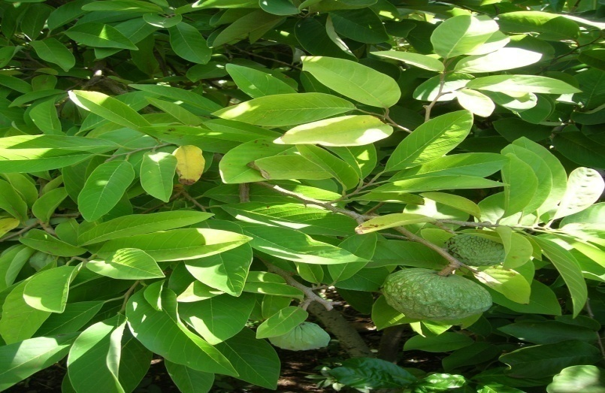

**Fig.No.1: Plant of *Annona squamosa***

The various chemical agents that are present are terpenes, alkaloids, flavonoids and phenolic compounds. Terpenes are used as insecticides and their pharmacological properties include antibacterial, antifungal, anthelmintic, antimalarial and molluscicidal [6]. Extracts of *Annona squamosa* seeds and leaves have several *in vitro* pharmacological effects such as anti-bacterial, anti-fungal and anti-inflammatory properties [7].

**Preparation of Plant Extract:** We have collected *Annona squamosa* whole plant with different parts and shade dried and coarse powdered then taken for extraction process through Soxhlet apparatus by hot continuous extraction method. The use of commercially available Soxhlet apparatus is a convenient way to prepare crude plant extract. The yield of methanolic extract was 9.52%. The extract was stored in refrigerator until further studies[8].

**Drugs:** Loperamide,castor oil, acetic acid (ASES Chemical Works, Jodhpur), and Sodium chloride (ASES Chemical Works).

**Procurement of Animals:** Male Wistar rats weighing (100–150 g) were obtained. They were housed in ventilated cages and fed with a normal pellet diet and water ad libitum[9]. All experiments was performed according to ethical guidelines in conscious animal. Research protocol was approved by the Institutional Animal Ethics Committee.

**Anti-diarrheal activity**

*In vivo* anti-diarrheal activity was evaluated by using simple Castor oil-induced diarrhea in rats model. Diarrhea was induced according to the method described by Teke et al, with some modifications [10]. Animals were fasted for 24 h prior to the experiment, but had free access to water. Rats were randomly assigned to one of the following groups (n=10): Group 1 served as control and received distilled water (10 ml/kg),   
group 2 received the reference drug, loperamide at a dose of 5.26 mg/kg, groups 3 received MEAS at the respective doses of 400 mg/kg. All drugs were administered by gavage as a single bolus. One hour after administration of the above drugs, 10 ml/kg of castor oil were orally administered to all groups. Animals were kept in separate metabolic cages with transparent plastic container beneath the cage and lined with Whatman paper to collect faces. Following castor oil administration, parameters such as latency time, frequency of defecation, total surface of impregnation and fresh total stools weight were measured for an 8 h period and compared with those of the control. Fresh stools were then dry in an oven to remove the water content.

**RESULTS AND DISCUSSION**

**Table 1: Effects of the aqueous extract of *Annona squamosa*  (MEAS) on castor oil-induced diarrhea:**

|  |  |  |  |  |  |  |
| --- | --- | --- | --- | --- | --- | --- |
| **Treatment** | **Dose  (mg/kg)** | **Latency time  (min)** | **Frequency of  defecation  (stools/8h)** | **Inhibition of  defecation  (%)** | **Total surface of  impregnation  (cm2)** | **Totalweight  expense of  deposit (g)** |
| Water | 10ml/kg | 70.62 ± 5.63 | 4.00 ± 0.50 | 0.00 | 98.11 ± 25.39 | 6.12 ± 0.68 |
| Loperamide | 5.26 | 147.62 ± 5.28 | 1.37 ± 0.46 | 65.62 | 27.85 ± 12.38 | 2.07 ± 0.49 |
| MEAS | 400 | 296.00 ± 21.50 | 1.50 ± 0.50 | 62.50 | 18.69 ± 6.89 | 2.48 ± 0.43 |

Each value represents the mean ± SEM of 10 animals; ap < 0.05, bp < 0.01,cp < 0.001, significantly different compared to negative control group (distilled water); Loperamide.

**DISCUSSION**

Castor oil has been widely used for inducing diarrhea in because it releases ricinoleic acid, a metabolite that causes diarrhea, upon metabolism in the gut. Ricinoleic acid initiates diarrhea via mechanisms such as irritation of GI mucosa, leading to the release of prostaglandin which stimulates gastrointestinal motility and electrolyte secretion, reducing electrolyte absorption from the intestine and colon; these are similar to the pathophysiologic processes resulting in diarrhea.

**CONCLUSION:** The plant extract contains pharmacologically active substances with antidiarrheal properties. This antidiarrheal activity probably results from the spasmolytic or may be due to a possible antisecretory effect of the plant extract on the intestinal smooth muscle. Plant extract can be used as an Antidiarrheal agent. The plant seems safe based on the results of acute toxicity testing.

**REFERENCES**

1. Chopra. R.N., Nayar. S.L., Chopra. I.C., “In Glossary of Indian medicinal plants”, CSIR, New Delhi, 1st ed, 1956, 197.
2. The Ayurvedic Pharmacoepiea of India, “Ministry of health and family welfare Department and Indian system of medicine and homeopathy”, New Delhi, 11, (1), 1999, 137-140.
3. Mukeshwar Pandey, Mousumi Debnath, Shobit Gupta, Surender K, Chikara, Phytomedicine: An Ancient approach turning into future potential source of therapeutics, **J, Pharmacog. Phytotherapy**, 3(3), 2011, 27-37.
4. Kaido. T.L., Veale. D.J.H., Havlik. I., and Rama. D.B.K., **J. Ethnopharm.** 55, 1997, 185-191.
5. Trease. G.E., and Evans. W.C., **Pharmacognosy**., 13th ed., 1992, 3-4.
6. J. D. Snyder and M. H. Merson, “The magnitude of the global problem of acute diarrhoeal disease: a review of active surveillance data,” *Bulletin of the World Health Organization*, vol. 60, no. 4, pp. 605–613, 1982.
7. S. Alam and S. Bhatnagar, “Current status of anti-diarrheal and anti-secretory drugs in the management of acute childhood diarrhea,” *The Indian Journal of Pediatrics*, vol. 73, no. 8, pp. 693–696, 2006.
8. D. R. Diniz-Santos, L. R. Silva, and N. Silva, “Antibiotics for the empirical treatment of acute infectious diarrhea in children,” *The Brazilian Journal of Infectious Diseases*, vol. 10, no. 3, pp. 217–227, 2006.
9. Ryu. S.D., Park. C.S., Baek. H.M., Baek. S.H., Hwang. S.Y., Chung. W.G.. “Anti diarrheal and spasmolytic activities and acute toxicity studies of Soonkijangquebo, a herbal anti diarrheal formula”, **J. Ethnopharmacol**. 91, 2004, 75-80.
10. Shiferie F, shibeshi W. In vivo Antidiarrheal and ex-vivo spasmolytic activities of the aqueous extracts of the roots of Echinops kebericho in rodents and isolated guinea pig ileum. **Int. J.Pharm. pharmacol**. 2013, 2, 110-6.