Metronidazole In-situ gel, a novel drug delivery system

Akash Mukherjee,1 Shouvik Saha2

PG institute of medical science, Chandrakona town, Paschim Medinipur

721201, West Bengal, India

**ABSTRACT**

The objective of this study was to create a novel intra-gastric floating in-situ gelling system for the controlled release of metronidazole, specifically for treating peptic ulcer disease caused by Helicobacter pylori (H. pylori). Gellan gum polymer was employed in the development of this system. In-situ gel technology is an innovative approach that facilitates the controlled and predetermined release of medication in the stomach. The metronidazole-loaded floating in-situ gelling systems were formulated using gellan gum dissolved in deionized water with the addition of sodium citrate. Varying concentrations of the drug and calcium carbonate, acting as a gas-forming agent, were also incorporated and dissolved through magnetic stirring. Our main challenge was to improve dissolution rate of metronidazole than normal metronidazole suspension. After conducting various dissolution studies we confirmed that the formulation containing 1.5% gellan gum and 1.5% calcium carbonate (formulation F5) showed longest time of release of drug (near about 7 hours) and showed best gastric residence time.

**Keywords:** In-Situ Gelling System, Metronidazole, Controlled Release , Gastric residence Time

# 1. INTRODUCTION

In situ gels are substances that are applied externally as suspensions or solutions but have the ability to transform into gels when exposed to the physiological conditions found within the human body. One or more stimuli, alone or in combination, are necessary for the sol-gel transition. The stimuli could be chemical, physiological, or physical [1].

1.1**Classification of in-situ gel** a) According to the theory of gelation, various types of gels can be categorized into the following groups based on their sensitivity:

I. pH-sensitive gels II. Thermo-sensitive gels III. Enzyme-sensitive gels IV. Ion-sensitive gels

Additionally, in-situ forming polymeric systems can be classified based on their route of administration into the following categories:

I. In-situ forming polymeric system for oral route II. In-situ forming polymeric system for ocular route III. In-situ forming polymeric system for vaginal route IV. In-situ forming polymeric system for parenteral route V. In-situ forming polymeric system for nasal route.

**1.2 Advantages of in-situ gel** - The advantages of this system include the controlled and sustained release of the drug, easy drug administration, suitability for unconscious patients, improved patient compliance and comfort, reduced dosing frequency, lower drug toxicity, and the use of natural polymers that offer biocompatibility and biodegradability. Additionally, it enhances drug bioavailability [2, 3, 4].

**1.3 Disadvantages of in-situ gel [5]** - This method demands a substantial intake of fluids. The sol form of the drug is more prone to degradation, leading to potential stability issues caused by chemical breakdown. Furthermore, after drug administration, eating and drinking may need to be restricted for several hours, making it suitable only for drugs with low dosage requirements.

1.4 **Peptic ulcer-** Peptic ulcer is a gastrointestinal condition that develops on the inner lining of the stomach and the upper part of the small intestine. It is typically caused by inflammation due to Helicobacter pylori infection and prolonged use of NSAID drugs. Helicobacter pylori is a type of bacteria that can enter your body and reside in your digestive tract. Over many years, these bacteria can lead to the formation of sores, known as ulcers, in the lining of your stomach or the upper section of your small intestine. In some cases, such an infection may even result in stomach cancer. It is widely recognized that most peptic ulcers are associated with Helicobacter pylori infection, but eliminating this bacteria is a challenging task.

However treatment of peptic ulcer is classified into four groups, that a) Single agents- tetracycline, metronidazole, clarithromycin, bismuth salt etc. b) Dual antibiotic therapy- clarithromycin plus ppi or amoxicillin plus ppi. c) Triple therapy- bismuth salts plus two antibiotics (metronidazole and amoxicillin or metronidazole and tetracycline ) d) Quadruple antibiotic therapy- bismuth based triple therapy with one proton pump inhibitor. Metronidazole is a synthetic anti protozoal and anti bacterial agent.

**2. PRE-FORMULATION STUDIES**

**FTIR studies of various ingredients (API-Metronidazole, Polymer-Gellan gum, other ingredients calcium carbonate, sodium citrate)-** FTIR analysis provides insights into the chemical reactions occurring between the Active Pharmaceutical Ingredient (API) and the excipient. Consequently, this procedure offers formulation scientists valuable information about which chemical groups should be avoided in excipients, facilitating the development of more stable blends. The compatibility of metronidazole with the gelling agent and other excipients was determined through infrared spectral analysis. IR Spectral analysis was conducted on samples comprising metronidazole, sodium citrate, gellan gum, and calcium carbonate to investigate changes in the chemical composition of the drug [21]. Fourier transform infrared (FT-IR) spectroscopy serves as a tool for characterizing the solid-state properties of pharmaceutical substances. The drug's identification was accomplished using the FT-IR spectroscopic method with an Alpha Bruker FTIR spectrophotometer. The drug was mixed with an appropriate amount of KBr and transformed into pellets using a KBr press at 20 psi for 10 minutes. The resulting disc was then placed in a sample compartment and scanned in transmission mode within the range of 4000 to 400 cm-1. The IR spectrum obtained for the drug, in conjunction with gellan gum, sodium citrate, and calcium carbonate, was compared with the standard spectra of the drug.

Top of Form

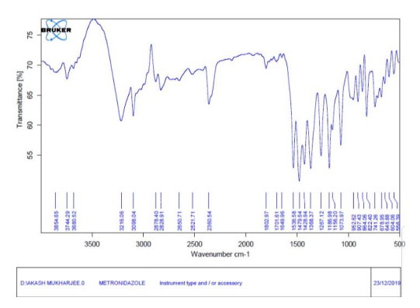

Figure 1: IR spectre of Metronidazole

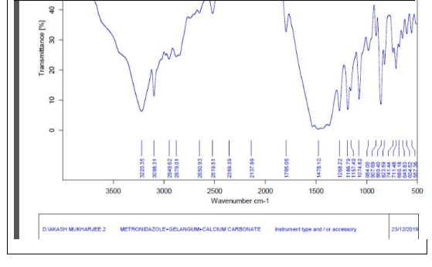

Figure 2: IR spectre of Metronidazole with Gellan gum and Calcium Carbonate

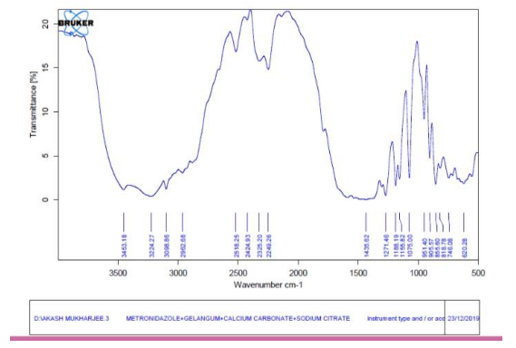

Figure 3: IR spectre of Metronidazole with Gellan gum, Calcium Carbonate and Sodium Citrate

The identification study was conducted utilizing an FTIR spectrophotometer. Various characteristic absorption peaks corresponding to metronidazole were observed at distinct wavenumbers. The peaks observed in the spectra of the pure drug align with the peaks in the official spectrum of the Indian Pharmacopeia, thereby confirming the drug's purity.

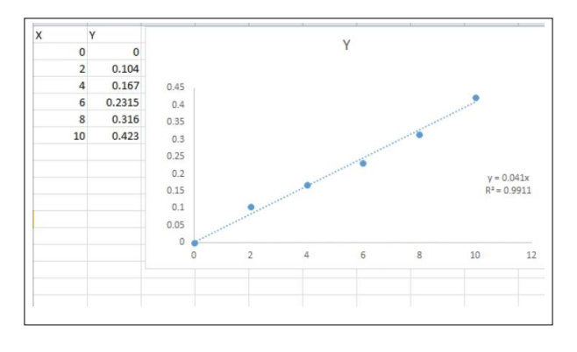**Determination of UV Absorbance Maxima of metronidazole-** The λ max of metronidazole was determined using a standard stock solution, and a blank solution of 0.1 N HCl (pH 1.2) was utilized for this analysis. The spectrum was recorded within the UV range of 200-400nm. The highest peak observed in the spectrum analysis was identified as the λ max for metronidazole, which was determined to be 274 nm.

Figure 4: standard curve of metronidazole in acidic buffer pH1.2

**3. MATERIALS**

**CHEMICALS:** Metronidazole was obtained from loba chem(Kolkata, India). Gellan gum was purchased from Balazi drugs (Kolkata, India). Other excipients (calcium carbonate and sodium citrate) were arranged from Saroda chemicals.

**APPARATUS:** Glassbeaker, glass rod, magnetic stirrer, magnetic bids, pipette, volumetric flask.

**4. METHOD**

Gellan gum solutions of different concentrations (0.5–1.5% w/v) were prepared in distilled water containing sodium citrate (1.25% w/v). Then it was heated upto 90°c to completely disperse the polymer in distilled water. Then the temperature was decreased to 40°c with constant stirring. After that various percentage (0.5-1.5 %w/v) of calcium carbonate and drug (2%) were added to it with constant stirring at constant temperature 40°c.

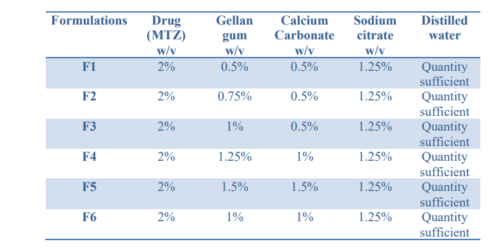

Table 1: Composition variables of metronidazole floating in situ gel formulations

**5. EVALUATION**

Prepared formulations of oral in-situ gel of metronidazole were evaluated in 4 patterns. Those are a. pH, b. floating lag time, c. floating duration, d. drug content.

**pH of prepared in-situ gels**

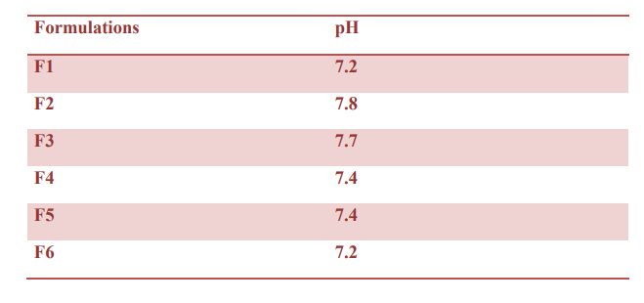

Table2: comparism study of pH between six prepared sample

**Floating lag time.** Floating lag time is defined as the time taken to float the gel over acidic medium after incorporates the in-situ suspension into acidic medium.

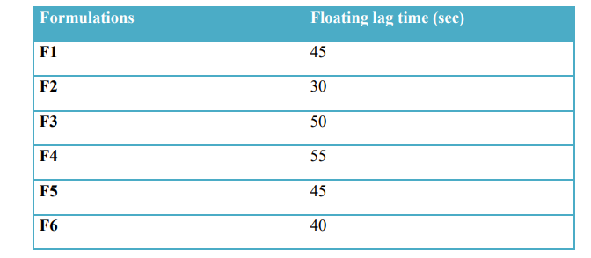

Table 3: Comparism floating lag time study between six prepared formulations

**Duration of floating**. This is the measured time that the gel how long floats on acidic medium.

**Table 4: Duration of floating of various formulations in hour**

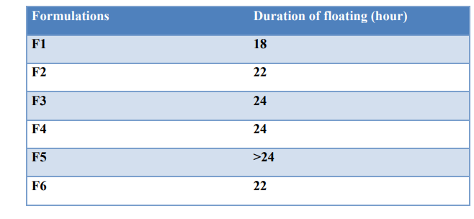

**Drug content:** This can be defined as uniformity of Content is a pharmaceutical analysis parameter for the quality control of any pharmaceutical product. 1 ml of solution was taken in 100 ml 0.1N HCl solution. Then it was heated at 35˚C and rotated at 50 rpm for 1 hour . Then it was filtered by normal filter paper. Next the filtrate was scanned against 274 nm under uv-visible spectroscopy. If the value was too high for analysis it was further diluted 100 times in 100 ml 0.1 N HCl solutions.

**Table 5:** Drug contents of various formulations

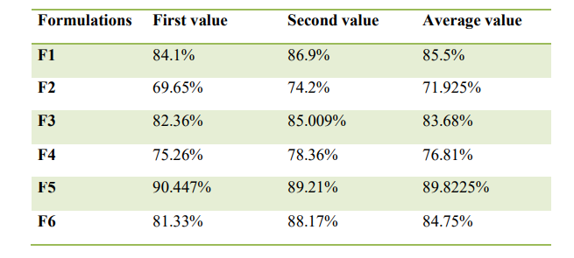

**6. RESULTS AND DISCUSSION**

The objective of the study was to prepare an oral in-situ gel of metronidazole and evaluate it in various aspects. In situ gels are systems which are applied as solutions or suspensions before entering the body, but capable to change from sol to gel forms under the physiological conditions inside our body. Peptic ulcer is a disease that generally occurs in stomach or upper intestine. Antibiotics like metronidazole, tinidazole, ornidazole used to treat peptic ulcer. But there are so many drawbacks in conventional dosage form like poor bioavailability poor transit time etc. The main Polymer gellan gum which is a anionic hetero polysaccharide. Calcium carbonate was used here as cross-linking agent. This polymer complex reacts with HCl of stomach and forms ac 3D network. Calcium carbonate reacts with acid to form CO2. Which help the 3d network to float.Total floating time was calculated for each and every formulation. In the result formulation F5 showed highest floating time which was more than 24 hours and lowest floating time showed by formulation F1 which was less than 18 hours. Similarly drug content study was performed in 0.1 N HCl solutions. Formulation F5 showed best drug content value that is 89.225 % and formulation F2 showed less drug content value that 71 %.

**7. REFERENCES**

1. Madan M., Bajaj A., Lewis S., Udupa N., Baig JA. 2009. In situ forming polymeric drug delivery systems. Indian J Pharm Sci. 71(3) pp-242–51.

2. Gurny R., Ibrahim H., Buri P. 1993. The development & use of in situ formed gel triggered by pH. In Biopharmaceutics of ocular drug delivery. ed. Edman. pp- 81-90.

3. Cohen S., Lobel E., Trevgoda A., Peled Y. 1997. A novel in situ-forming ophthalmic drug delivery system from alginates undergoing gelation in the eye. J. Control. Release. 44. pp- 201–208.

4. Srividya B., Cardoza RM., Amin PD. 2001. Sustained ophthalmic delivery of ofloxacin from a pH triggered in situ gelling system. J. Control Release.73. pp- 205–211.

5. Wen DM., Hui X., Chao W., Shu FN., Wei SP. 2008. Pluronic F127-g-poly(acrylic acid) copolymers as in situ gelling vehicle for ophthalmic drug delivery system, int. j. of pharmaceutics. 350.pp- 247-256.

6. Motto F, Gailloud P, et al. 2000. In-vitro assessment of new embolic liquids prepared from preformed polymers and water miscible solvents aneurysm treatment. Biomaterials. 21. pp- 803-811.

7. Guo JH., Skinner GW., Harcum WW., Barnum PE. 1998. Pharmaceutical applications of naturally occurring water-soluble polymers. Pharm Sci & Technol Today. 1. pp-254- 61.

8. Burkoth AK., Anseth KS. 2000. A review of photocrosslinked polyanhydrides: In situ forming degradable networks. Biomaterials. 21. pp-2395-404.

9. Grasdalen H., Smidsroed O.1987. Gelation of Gellan gum, Carbohydrate Polymers. 7. pp- 371-393.

10. Smith DA., Tipton AJ.1996. A novel parenteral delivery system. pp- 300.

11. Ito T., Yeo Y., Highley CB., Bellas E., Benitez CA., Kohane DS. 2007. The prevention of peritoneal adhesions by in situ cross-linking hydrogels of hyaluronic acid and cellulose derivatives. 28. pp- 975-983.

12. Rozier A., Mazuel C., Grove J., Plazonet B., Novel A. 1987. Ion-activated, in situ gelling polymer for ophthalmic vehicles effect on bioavailability of timolol.57. pp- 353-361.

13. Kumar MT., Bharathi D., Balasubramaniam J., Kant S., Pandit JK. 2005. pH induced in situ gelling systems of indomethacin for sustained ocular delivery. 80. pp- 09-28.

14. Hatefi A., Amsden B. 2002. Biodegradable injectable in situ forming drug delivery systems. 80. pp- 09-28.

15. Burkoth AK., Anseth KS. 2002. A review of photocrosslinked polyanhydrides: In situ forming degradable networks. 21. pp- 2395-2404.

16. Jeong B., Bae YH., Kin SW. 2000 In situ gelation of PEG-PLGA-PEG triblock copolymer aqueous solutions and degradation thereof. 50. pp- 171-177.

17. Cao S., Ren X., Zhang Q., Chen E., Xu F., Chen J., et al. 2009. In situ gel based on gellan gum as new carrier for nasal administration of mometasone furoate. 365. pp- 109-115.

18. Miyazaki S., Kawasaki N., Kudo W., Attwood D., 2001. Comparison of in situ gelling formulation for oral delivery of cimetidine. Int. J. Pharm. 220. pp- 161–168.

19. Grasdalen H., Smidsroed O. Gelation of gellan gum Carbohydrate Polymers. 1987. 7. pp- 371-93.

20. Shastri DH., Patel LD. 2010. Novel alternative to ocular drug delivery system: Hydrogel, Ind J Pharma Res. 2. pp- 01-13.