Sedimentological Characterization of Ennore Creek: Unraveling the Spatial Distribution of Calcium Carbonate, Organic Matter, and Particle Composition and their Environmental Significance.
*¹Mohamed Afzal J, ¹Sanju P, ¹Arfat Nazir ²J. Christinal, ²S. Richard Abishek.S and ²S.Muthusamy
¹Department of Geology ²PG and Research Department of Geology
University of Madras, Chennai, India V.O.Chidambaram College, Thoothukudi-628008, Tamil Nadu, India
(Affiliated to Manonmaniam Sundaranar University, Tirunelveli)

*Corresponding Author: Afzal JE-mail mohamedafzal15dec@gmail.com

ABSTRACT
Ennore Creek, located in Chennai, Tamil Nadu, is a significant coastal ecosystem affected by dynamic sedimentary processes influenced by natural and human factors. This research investigates the sedimentological characteristics of the Ennore creek, focusing on calcium carbonate (CaCO₃), organic matter, and particle composition (sand, silt, and clay percentages) from the estuary to the open ocean. The study reveals an increasing trend of calcium carbonate content from the estuary to the open ocean, indicating marine biogenic processes and environmental changes. Higher calcium carbonate abundance in the open ocean suggests increased biogenic calcification, offering insights into historical hydrological conditions and past climate changes. Organic matter content varies, higher near the estuary due to clay's presence, influencing organic matter retention. Organic matter plays a vital role in biogeochemical cycling, impacting ecological health and necessitating sustainable management. Particle composition analysis identifies diverse sedimentary environments, with higher sand content indicative of coastal erosion and sediment transport. Lower clay content suggests faster sedimentation rates or limited deposition due to creek hydrodynamics. Silt presence indicates contributions from local and upstream sources. This sedimentological study provides essential information about natural processes and human impacts in Ennore Creek, guiding conservation and sustainable practices to preserve this delicate coastal ecosystem and its biodiversity.
Keywords: Sediment Characteristics, Spatial Distribution, Ennore Creek,Environment,Chennai.

- INTRODUCTION
Ennore Creek, situated in chennai, represents a crucial coastal ecosystem, characterized by dynamic sedimentary processes influenced by various natural and anthropogenic factors. The analysis of sedimentological characteristics, encompassing the distribution of calcium carbonate (CaCO₃), organic matter, and particle composition (sand, silt, and clay percentages), is essential for unraveling the environmental history and assessing the impacts of human activities on this delicate ecosystem [1]. CaCO₃, a primary constituent of creek sediments, holds valuable information about past climatic conditions and biogenic processes in Ennore Creek [2]. The origins of CaCO₃ within sediments can be traced back to marine organisms, including shells and skeletons, as well as inorganic precipitation from carbonate-rich water sources [3]. The abundance and variations in CaCO₃ content in sediment layers offer valuable insights into historical sea level fluctuations, climatic changes, and the overall hydrological history of the region [4]. The presence of organic matter in creek sediments serves as a vital indicator of paleoenvironments and past vegetation patterns within Ennore Creek [5]. Organic matter accumulation and preservation are influenced by sedimentation rates, oxygen levels, and nutrient availability [6]. Analyzing the organic matter content allows us to understand the ecological dynamics of the creek, identify human-induced impacts, and evaluate the health of the surrounding ecosystem [7]. Particle composition, represented by sand, silt, and clay fractions, plays a fundamental role in sediment transport and deposition dynamics in Ennore Creek [8]. Factors such as water flow energy, sediment sources, and climatic conditions influence the distribution of these particles. Detailed analysis of particle size proportions provides valuable information about sedimentary processes, erosion rates, and depositional environments within the creek [9]

- STUDY AREA
The area of the research that includes the Ennore Creek is in North Chennai. A complicated brackish water system, Ennore Creek is extended in the NE-SW direction and is almost 800 metres wide. With North Latitude 13o 14' and East Longitude 80o 20' as its geographic coordinates, Ennore Creek is situated in Tamil Nadu's Thiruvallur district. Two physiographic divides that resulted from fluvial and marine processes may be found in the research region. Rivers that historically controlled the area and are currently flowing create alluvial plains in the area's western portion.The lowlands along the eastern coast, which are bordered by beach dunes, old beach ridges, mud flats, marshes, lagoons, and creeks, make up the coastal environment. The Ennore stream divides Attipattu, Pudhunagar, from the Ennore port. The study primarily concentrated on a detailed analysis of shoreline changes near the mouth area because the Ennore river mouth experiences significant changes every year.
The region has frequently seen many natural occurrences as cyclones, floods, tidal fluctuations, etc. Human habitation and the coastal ecology at the river mouth are suffering from the rapid shoreline change. Ennore Creek has a width of around 800 metres. The Kosasthalaiyar River and the Buckingham Canal feed Ennore Creek, which is intricate and rarely deeper than 5 metres outside of the monsoon season. On its northern bank, it is also connected to the Pulicat brackish water lake, which once supported a diverse range of animals and plants, including mangroves.
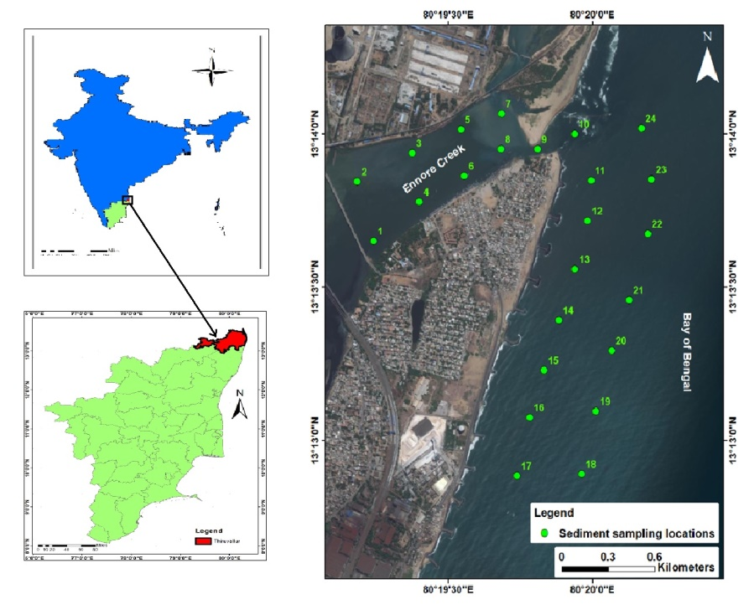
Figure 1: Study Area Map

- MATERIALS & METHODS
After a detailed review of available literature, it was resolved to collect samples from the Ennore Estuary, Ennore, Thiruvallur district, Tamil Nadu, situated near the Bay of Bengal. A total of 25 sediment samples were collected from the Ennore Creek.(Figure 1) The sampling was done on 2 October, 2021. Sampling was done with the help of a motorboat and the sampling location was noted using GPS. All the sediment samples were collected using the Van Veen Grab Sampler, which is mainly used to sample sediment in water environments. The samples were collected in newly purchased and clean Zip-lock covers and marked properly. They were dried properly for sedimentological studies.
The sun-dried surface samples underwent assays for organic matter, calcium carbonate, and sediment texture. The organic content was determined via exothermic heating and oxidation using potassium dichromate and concentrated H2SO4, followed by the titration of excess dichromate with 0.5N ferrous ammonium sulphate solutions (Gaudette et al., 1974). To determine and compute the calcium carbonate (CaCO₃) content, the method of (Piper, 1947) was employed. The distributions of sand, silt, and clay were identified for the textural analyses of the sediments (Krumbein and Pettijohn, 1938).
Determination of Sand, Silt and Clay Ratio
The sun-dried surface samples underwent assays for organic matter, calcium carbonate, sediment texture, and trace metals. The organic content was determined via exothermic heating and oxidation using potassium dichromate and concentrated H2SO4, followed by the titration of excess dichromate with 0.5N ferrous ammonium sulphate solutions (Gaudette et al., 1974). To determine and compute the calcium carbonate (CaCO₃) content, the method of (Piper, 1947) was employed. The distributions of sand, silt, and clay were identified for the textural analyses of the sediments (Krumbein and Pettijohn, 1938). The suspension that has passed through the sieve is collected in a graduated measuring cylinder that holds 1 litre. After thorough washing, if the suspension is less than 1,000 ml, the already made sodium hexametaphosphate solution is added to make it 1,000 ml. To ensure that the particles in suspension are distributed uniformly, the suspension in the measuring cylinder is vigorously stirred using a stirrer. After precisely 2 hours and 3 minutes of no stirring, a 20 ml pipette is carefully lowered into the solution to a depth of 10 cm, and the sample is removed with uniform suction to prevent any turbulence.The pipetted-out sample is transferred to a pre-weighed 50 ml beaker. In an oven, it is carefully dried without boiling or splashing. When all of the liquid and moisture content in the beaker has dried, the weight of the remaining materials is used to compute the weight of the clay particles. The weight of the silt fragments is calculated by deducting the consolidated weight of the sand and clay fragments from the measured sample weight. Individual weights of the sand, silt, and clay particles are converted to weight percentages and displayed on a trilinear diagram. The sediments in the current investigation are described using Trefethen's (1950) textural nomenclature.

Determination of Calcium Carbonate
The method outlined below was used to determine how much calcium carbonate was present in the surface sediments: It is necessary to weigh and transfer 5.0 g of the sediment into a 150 ml beaker. 100ml of 1N hydrochloric acid is measured and poured into the beaker using a pipette with an expanded jet. For one hour, the beakers are vigorously swirled repeatedly while a watch glass is placed on top of them to conceal the mouth. After the solution has settled, 20 ml of the supernatant liquid is pipetted into a tiny Erlenmeyer flask using a pipette. The pipetted liquid is mixed with 6–8 drops of bromothymol blue indicator before being titrated with sodium hydroxide solution. In some samples, the indication colour may disappear, signalling the endpoint, and blue colour is instead seen. More indicator is then added at this point, and the titration is finished. A blank titration is used to calculate the hydrochloric acid titre value. The calcium carbonate % can be calculated using the calculation below.

Calcium carbonate percentage is (blank titration times actual titration) x 5.

Determination of Readily Oxidisable Organic Matter
A 230 micron filter is used to separate the dried sediment sample. 0.5g of the separated sample is then added to a 500 ml Erlenmeyer flask. Burette is used to carefully measure out 20 ml of concentrated sulphuric acid with silver sulphate and 10 ml of 1 N potassium dichromate solution, which are poured to the flask and mixed by slowly spinning the flask for a minute. To avoid sediment building up on the sides of the flask where the reagents can't reach it, the contents and sample are thoroughly mixed. 30 minutes later, add 10 mL of 85 percent orthophosphoric acid and 0.2 g of sodium fluoride to the mixture. The diphenylamine indicator is thereafter added in 15 drops (0.5 ml) to the sample flask. A 0.5 N ferrous ammonium sulphate solution is used to titrate the final solution. The titration is carried out to a precise endpoint of one drop of vivid green. After adding around 10 ml of the ferrous solution, the mixture's colour changes from an opaque greenish-brown to green as the titration progresses. Titration causes the colour to keep fading until it reaches a bluish-black grey. Now, the hue changes to a vivid green after the addition of 10–20 drops of the ferrous solution, giving one drop ending. A standardisation blank devoid of sediment is run and recorded for every new batch of sediment samples.
% Organic Matter (readily oxidisable) = 10 (1 - T/S) x F

RESULT AND DISCUSSION
Calcium Carbonate
CaCO₃, a primary constituent of creek sediments, holds valuable information about past climatic conditions and biogenic processes in Ennore Creek. The origins of CaCO₃ within sediments can be traced back to marine organisms, including shells and skeletons, as well as inorganic precipitation from carbonate-rich water sources. The abundance and variations in CaCO₃ content in sediment layers offer valuable insights into historical sea level fluctuations, climatic changes, and the overall hydrological history of the region [4].
The increasing trend of calcium carbonate content from the Estuary to the open ocean in the Ennore Creek study area indicates significant biogenic activity and environmental changes along this gradient. In the Ennore estuary, the surface sediment samples exhibit varying calcium carbonate percentages, ranging from 1% to 25%, with an average of 13.54% (Figure 2&3).The higher calcium carbonate content in the open ocean region could be attributed to the increased input of marine organisms, such as mollusk shells and corals, which are more abundant in the open ocean environment. This suggests a higher prevalence of carbonate-producing organisms in the outer estuarine region, where the water salinity is more conducive to their growth and survival. The increasing trend of calcium carbonate content towards the open ocean suggests the gradual influence of marine processes, such as biogenic calcification and carbonate precipitation. This finding is essential for understanding the carbonate budget of the coastal ecosystem, which has implications for the overall carbon cycling and buffering capacity of the region. Moreover, the presence of calcium carbonate contributes to the sediment's buffering capability, influencing pH and alkalinity levels, which, in turn, can affect local marine biodiversity and shell-forming organisms [10]. The southern part of the sampling location, being situated near the sea shore, is more likely to be influenced by marine processes. Sea water contains dissolved calcium ions, which can combine with carbonate ions in the water to form calcium carbonate (CaCO3) through natural processes like precipitation [11]. Ennore Creek, on the other hand, may receive freshwater inflow from rivers and streams, which could be low in calcium carbonate content. Freshwater sources typically have lower concentrations of dissolved minerals, including calcium, compared to seawater [12].
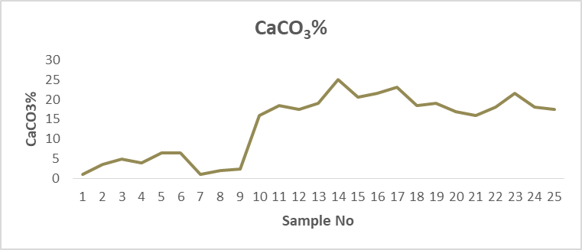
Figure2: The Graphical Representation of CaCO₃ %Ennore creek

Figure3:The Spatial Distribution of CaCo₃ %in Ennore creek
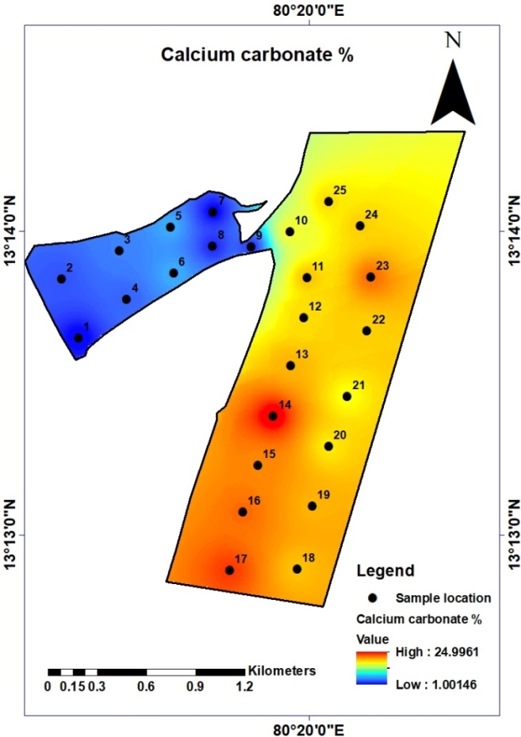
Organic Matter
The presence of organic matter in creek sediments serves as a vital indicator of paleoenvironments and past vegetation patterns within Ennore Creek. Organic matter accumulation and preservation are influenced by sedimentation rates, oxygen levels, and nutrient availability. Analyzing the organic matter content allows us to understand the ecological dynamics of the creek, identify human-induced impacts, and evaluate the health of the surrounding ecosystem [7], [13].
The organic matter content in the sediments of Ennore Creek varies from 0.8% to 4.26%, with an average of 4.310%. (Figure 4&5)The abundance of clay in the estuary could be responsible for retaining and preserving organic matter in the sediment. Organic matter is derived from various sources, including terrestrial vegetation, aquatic plants, and marine organisms [14]. Its variability is influenced by factors such as sedimentation rates, nutrient availability, and organic inputs from surrounding land areas. The presence of organic matter in sediment plays a crucial role in the biogeochemical cycling of nutrients, carbon, and other elements within the estuarine environment [15]. High organic matter content suggests enhanced nutrient recycling, which can support primary productivity and sustain a diverse ecosystem. However, excessive organic matter accumulation can lead to oxygen depletion and the formation of anoxic conditions, impacting benthic communities and potentially contributing to harmful algal blooms [16]. Ennore Creek receives freshwater inflow from rivers and streams that drain surrounding land areas. This freshwater input carries organic matter from terrestrial sources, such as decaying vegetation, soil, and other organic materials [17]. The continuous supply of organic matter from the land contributes to the higher levels observed in the creek. The sea shore is directly exposed to wave action and tidal forces, which can disperse and remove organic matter from the sediment. In contrast, Ennore Creek's relatively sheltered environment experiences lower wave energy, leading to the accumulation of organic matter in the Sediments.
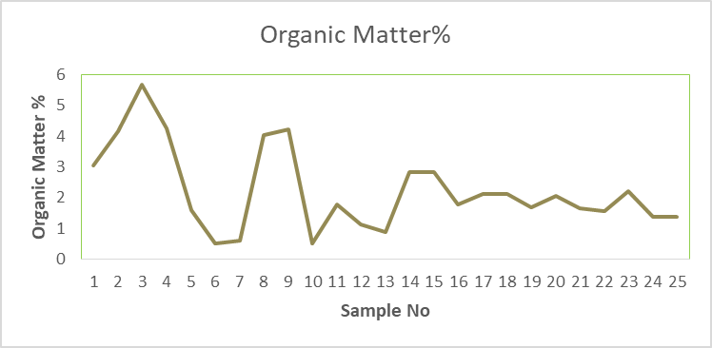
Figure 4 : TheGraphical Representation Of Organic matter% in Ennore creek
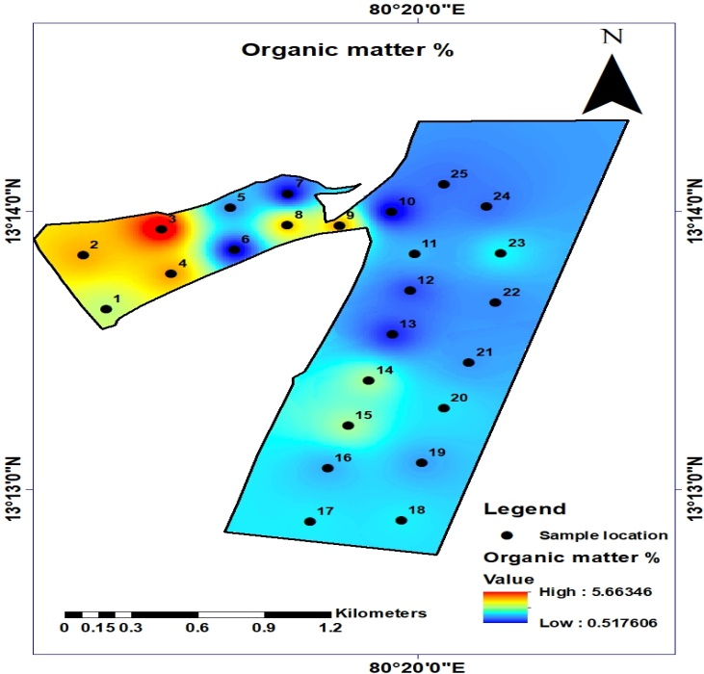
Figure 5: The Spatial Distribution of Organic Matter% in Ennore creek
Sand, Silt, Clay%
Particle composition, represented by sand, silt, and clay fractions, plays a fundamental role in sediment transport and deposition dynamics in Ennore Creek. Factors such as water flow energy, sediment sources, and climatic conditions influence the distribution of these particles. Detailed analysis of particle size proportions provides valuable information about sedimentary processes, erosion rates, and depositional environments within the creek [18].
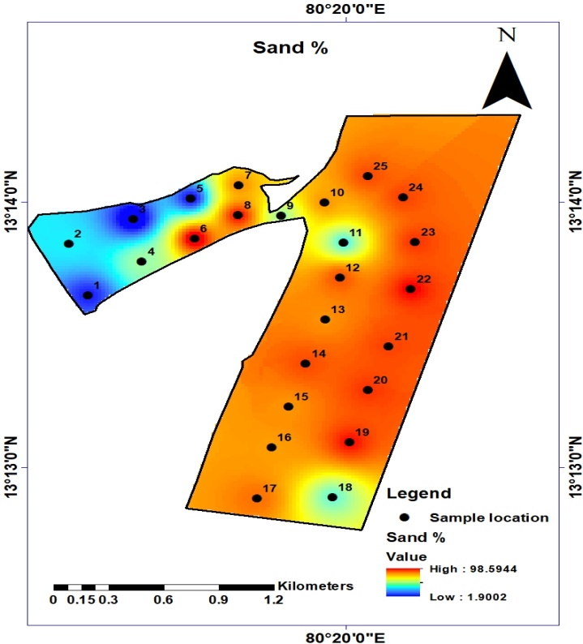
Figure 6:The Spatial Distribution of Sand% in Ennore creek
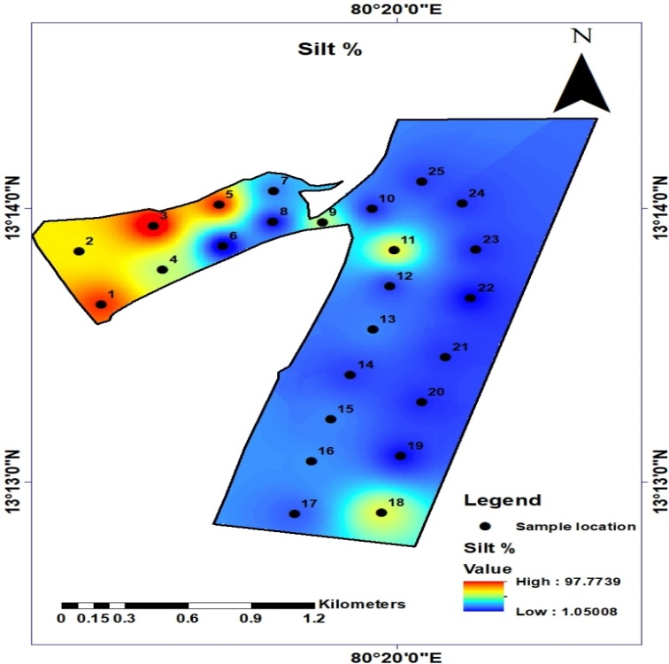
Figure 7:The Spatial Distribution of Silt % in Ennore Creek

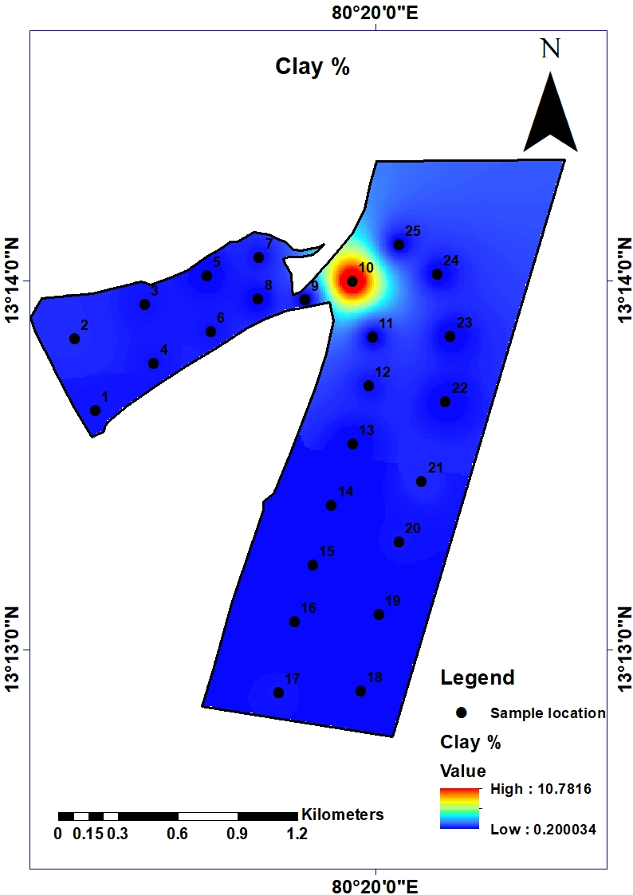
Figure 8: The Spatial Distribution of Clay% in Ennore Creek

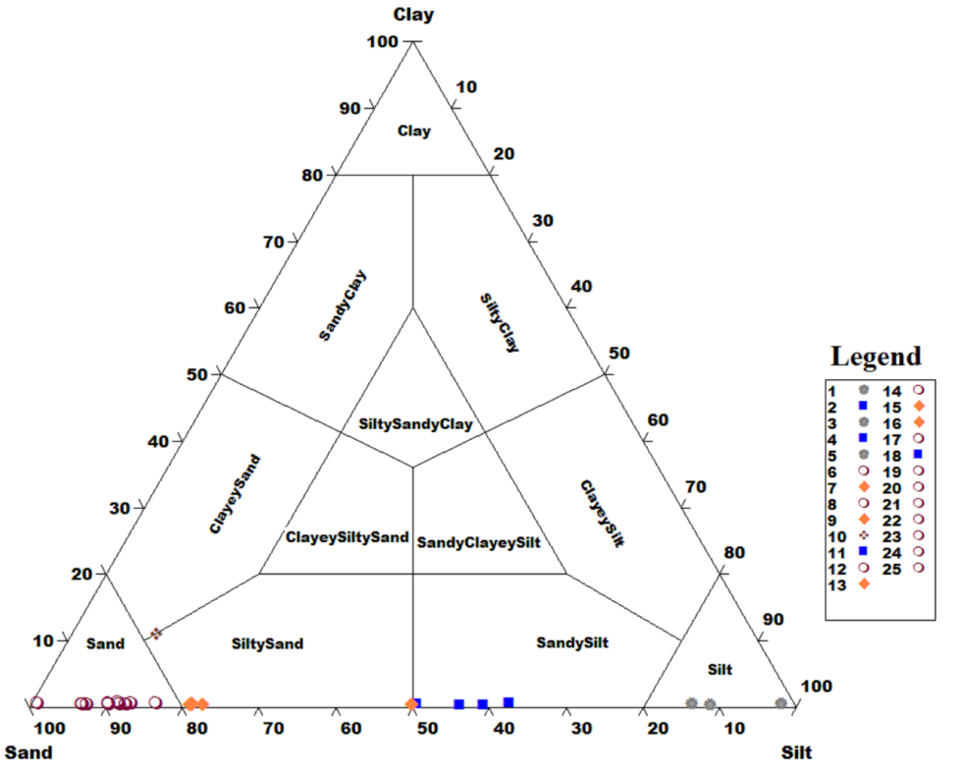
Figure 9: The Trilinear plot For Sand, Silt and Clay % in Ennore creek (Trefethen, 1950)
The sand content in the sediments ranges from 1.8% to 98.6%, with an average of 68.576%, indicating a diverse range of sand-dominated environments within the study area (Figure6&9). The higher sand content in the sediments may result from nearby coastal erosion and sediment transport, as well as contributions from riverine sources. The higher sand percentage at the sea shore compared to the river mouth and creek can be attributed to the differences in hydrodynamic processes and sediment sources in these two locations. The sources of sediment can also differ between the sea shore and the creek. The sea shore is influenced by marine processes and receives sediment inputs from various coastal areas, including nearby beaches and offshore regions, which are rich in sand.
The silt content in the sediment ranges from 1% to 97.8%, with an average of 30.704%. The relatively higher silt content suggests sediment contributions from both local and upstream sources, possibly from nearby riverine inputs or coastal erosion. The lower silt percentage at the sea shore compared to other areas, such as river mouths or creeks, can be attributed to the differences in sediment transport. Due to reduced water flow and turbulence, the seashore often represents a depositional habitat where sediments are deposited and accumulate. As a result, coarser sediments like sand tend to settle and accumulate closer to the shoreline, while finer particles like silt are transported further offshore.(Figure 7&9)
The clay content in the sediment, ranging from 0.2% to 10.8%, with an average of 0.72%, indicates limited input from fine-grained particles. The lower clay content is indicative of relatively faster sedimentation rates or limited clay deposition due to the creek's hydrodynamic energy, which might hinder the settling of fine-grained particles. The higher clay percentage in the river mouth compared to the sea and creek can be attributed to several factors related to sediment transport, hydrodynamic processes and sediment sources in these different environments. Coastal areas near river mouths can experience complex hydrodynamic processes due to the interaction of river flow and ocean tides [19]. These processes can trap and retain fine sediments like clay in the river mouth, leading to higher clay percentages.(Figure8&9)
Overall, the sedimentological characteristics of Ennore Creek provide valuable insights into the complex interactions between natural processes and human activities in this coastal ecosystem. The findings can inform conservation efforts, sustainable coastal management, and strategies to mitigate potential environmental impacts.

- CONCLUSION
In conclusion, the sedimentological analysis of Ennore Creek provides valuable insights into the complex interplay of natural processes and human activities in this critical coastal ecosystem. The increasing trend of calcium carbonate content from the estuary to the open ocean reflects the influence of marine biogenic processes and historical environmental changes. This trend enhances our understanding of past hydrological conditions and climatic fluctuations in the region. The variation in organic matter content, primarily influenced by clay presence, underscores the importance of organic matter retention and its role in biogeochemical cycling. Sustainable management of organic inputs is crucial for maintaining the ecological health of the creek. The diverse particle composition highlights distinct sedimentary environments, with implications for coastal erosion, sediment transport, and deposition dynamics. Such knowledge is vital for guiding effective coastal management strategies and conservation efforts to safeguard Ennore Creek's delicate ecosystem and its valuable biodiversity.

REFERENCE

[1] M. Ivanić et al., “Geochemistry of sedimentary organic matter and trace elements in modern lake sediments from transitional karstic land-sea environment of the Neretva River delta (Kuti Lake, Croatia),” Quaternary International, vol. 494, pp. 286–299, Nov. 2018, doi: 10.1016/j.quaint.2017.03.050.
[2] S. Kandasamy, V. Mohan, S. Srinivasalu, M. P. Jonathan, and R. Siddartha, “Distribution of nondetrital trace metals in sediment cores from Ennore Creek, Southeast Coast of India,” Journal of the Geological Society of India, vol. 62, pp. 191–204, Aug. 2003.
[3] J. W. Morse and F. T. Mackenzie, Eds., “Chapter 5 Composition and Source of Shoal-Water Carbonate Sediments,” in Developments in Sedimentology, in Geochemistry of Sedimentary Carbonates, vol. 48. Elsevier, 1990, pp. 179–239. doi: 10.1016/S0070-4571(08)70334-0.
[4] M. V. S. Guptha, P. D. Naidu, B. G. Haake, and R. Schiebel, “Carbonate and carbon fluctuations in the Eastern Arabian Sea over 140ka: Implications on productivity changes?,” Deep Sea Research Part II: Topical Studies in Oceanography, vol. 52, no. 14, pp. 1981–1993, Jul. 2005, doi: 10.1016/j.dsr2.2005.05.003.
[5] M. Jayaprakash, R. Nagarajan, P. Velmurugan, L. Giridharan, V. Neetha, and B. Urban, “Geochemical Assessment of Sediment Quality Using Multivariate Statistical Analysis of Ennore Creek, North of Chennai, SE Coast of India,” Pertanika Journal of Science and Technology, vol. 22, pp. 315–328, Dec. 2014.
[6] J. I. Hedges and R. G. Keil, “Sedimentary organic matter preservation: an assessment and speculative synthesis,” Marine Chemistry, vol. 49, no. 2, pp. 81–115, Apr. 1995, doi: 10.1016/0304-4203(95)00008-F.
[7] M. J. Hill et al., “Organic-matter decomposition in urban stream and pond habitats,” Ecological Indicators, vol. 142, p. 109232, Sep. 2022, doi: 10.1016/j.ecolind.2022.109232.
[8] P. M. Mohan, “Sediment transport mechanism in the Vellar estuary, east coast of India,” Indian Journal of Marine Sciences, vol. 29, pp. 27–31, Mar. 2000.
[9] M. Kumar, M. Dashora, R. Kumar, S. K. Dubey, P. K. Gupta, and A. Kumar, “Deciphering Depositional Environment of Playa Lakes Using Grain Size Parameters in the Arid and Semi-Arid Region of Rajasthan, India,” Agriculture, vol. 12, no. 12, p. 2043, Nov. 2022, doi: 10.3390/agriculture12122043.
[10] R. B. Wallace, H. Baumann, J. S. Grear, R. C. Aller, and C. J. Gobler, “Coastal ocean acidification: The other eutrophication problem,” Estuarine, Coastal and Shelf Science, vol. 148, pp. 1–13, Jul. 2014, doi: 10.1016/j.ecss.2014.05.027.
[11] M. M. H. Al Omari, I. S. Rashid, N. A. Qinna, A. M. Jaber, and A. A. Badwan, “Chapter Two - Calcium Carbonate,” in Profiles of Drug Substances, Excipients and Related Methodology, H. G. Brittain, Ed., Academic Press, 2016, pp. 31–132. doi: 10.1016/bs.podrm.2015.11.003.
[12] R. W. E. Yani, R. Palupi, T. Bramantoro, and D. Setijanto, “Analysis of Calcium Levels in Groundwater and Dental Caries in the Coastal Population of an Archipelago Country,” Open Access Maced J Med Sci, vol. 7, no. 1, pp. 134–138, Jan. 2019, doi: 10.3889/oamjms.2019.013.
[13] V. Ferreira, A. Elosegi, S. D. Tiegs, D. Von Schiller, and R. Young, “Organic Matter Decomposition and Ecosystem Metabolism as Tools to Assess the Functional Integrity of Streams and Rivers–A Systematic Review,” Water, vol. 12, no. 12, p. 3523, Dec. 2020, doi: 10.3390/w12123523.
[14] N. Handa, “Land sources of marine organic matter,” Marine Chemistry, vol. 5, no. 4–6, pp. 341–359, Nov. 1977, doi: 10.1016/0304-4203(77)90028-7.
[15] P. G. Falkowski, “Biogeochemical Cycles,” in Encyclopedia of Biodiversity, Elsevier, 2001, pp. 552–564. doi: 10.1016/B978-0-12-384719-5.00013-7.
[16] A. W. Griffith and C. J. Gobler, “Harmful algal blooms: A climate change co-stressor in marine and freshwater ecosystems,” Harmful Algae, vol. 91, p. 101590, Jan. 2020, doi: 10.1016/j.hal.2019.03.008.
[17] M. T. Brett et al., “How important are terrestrial organic carbon inputs for secondary production in freshwater ecosystems?,” Freshwater Biology, vol. 62, no. 5, pp. 833–853, 2017, doi: 10.1111/fwb.12909.
[18] S. Dutta, “Soil erosion, sediment yield and sedimentation of reservoir: a review,” Model. Earth Syst. Environ., vol. 2, no. 3, p. 123, Jul. 2016, doi: 10.1007/s40808-016-0182-y.
[19] F. Zhang, J. Sun, B. Lin, and G. Huang, “Seasonal hydrodynamic interactions between tidal waves and river flows in the Yangtze Estuary,” Journal of Marine Systems, vol. 186, pp. 17–28, Oct. 2018, doi: 10.1016/j.jmarsys.2018.05.005.

