SCREENING OF in vitro NITROGENASE ACTIVITY AND CELL NITROGEN CONTENT
FOR ASSESSING THE NITROGEN FIXING EFFICACY OF VARIOUS Azospirillum STRAINS ISOLATED FROM RHIZOSPHERE OF SUNFLOWER FROM DIFFERENT LOCATIONS OF TAMIL NADU

SIVASAKTHIVELAN.P¹, N.MUTHUKUMARAN², J.JAYACHITRA³, K.ARIVUKKARASU⁴ and S.GOMATHI⁵

^{1,3& 5} Department of Agricultural Microbiology, ²Department of Entomology
⁴ Department of Agronomy, Faculty of Agriculture,
Annamalai University, Annamalai Nagar – 608002, Tamil Nadu, India

*Corresponding author: plantdoctorsiva@yahoo.co.in

ABSTRACT
Sunflower (Helianthus annuus L.) a new introduction to India in seventies, popularly known as ‘Surajmukhi’ has become a familiar plant in India. It is an important oilseed crop cultivated extensively for its premier oil and manifold uses in industries and pharmaceutics. Its cultivation has gained momentum due to its special features like short duration, photo-insensitivity, drought tolerance, adaptability to wide range of soil and climatic situations, lower seed rate, round the year cultivation, an ideal catch crop, high content of quality cooking oil and high seed multiplication ratio. The in vitro nitrogenase activity and nitrogen content of Azospirillum isolates obtained from sunflower rhizosphere soil were assessed and presented here, Among the thirty isolates, SA - 17 obtained from rhizosphere soil of sunflower recorded the maximum nitrogenase activity of 496.00 n moles of C₂H₄ produced mg⁻¹ of protein h⁻¹ and cell nitrogen of 49.00 mg g⁻¹ of cell weight followed by the Reference strain Azospirillum lipoferum (MTCC - 2306) produced 492.20 n moles of C₂H₄ produced mg⁻¹ of protein h⁻¹ and cell nitrogen of 46.80 mg g⁻¹ of cell weight and SA-23 (462.30 n moles of C₂H₄ produced mg⁻¹ of protein h⁻¹ and cell nitrogen of 39.60 mg g⁻¹ of cell weight). The minimum nitrogenase activity of 160.24 n moles of C₂H₄ mg⁻¹ of protein h⁻¹ and cell nitrogen content of 15.20 mg g⁻¹was recorded in SA - 25. Based on the nitrogenase activity and nitrogen content of the isolates SA - 17 was selected as the best native strains to fix atmospheric nitrogen and it is recommended to be effectively used as Nitrogen fixing bioinoculant.
Keywords: Azospirillum, Rhizosphere, nitrogenase activity and cell nitrogen content
- INTRODUCTION
India is the fifth largest country in oilseed economy of the world next to USA, China, Brazil and Argentina besides being the world’s largest consumer of edible oils. In the agricultural economy of India, oilseeds are vital next only to food grains in terms of extent, production and value that occupy about 14 per cent gross cropped area, account for nearly 1.4 per cent gross domestic product and 8 per cent of the value of all agricultural commodities [15].
In India, 14 million farmers are engaged in production of oilseeds and another million in their processing. The oil seed crops inhabit a unique place in the national agricultural economy in providing about 13 per cent of dietary energy in addition to other nutritional requirements and raw materials for industrial uses. As per the recent estimates available, the per capita consumption of vegetable oilseeds would rise to 16.38 and 23.10 kg ha⁻¹ by 2020 and 2030, respectively from 14.57 kg ha⁻¹ in the year 2005. The projected oilseed production to encounter this mandate would be 53.40 and 81.80 million tonnes by 2020 and 2030, respectively.
Hence, there is an urgent need to increase the oilseed production on sustainable basis to meet out the needs of the expanding demand. As chances of expanding the cultivating area under oilseeds at the cost of other field crops are limited, exploring alternate, viable and economical crop management strategies to enhance the per hectare productivity of individual oilseed crops might be of suggestive and feasible approach. The exponential growth of area under cultivation of sunflower is an unparalleled example for any crop and this stands testimony for its suitability to fit to different cropping systems in the country [9].
In India, it is cultivated in 1.48 million hectare with a production of 0.85 million tonnes and with a productivity of 576 kg ha⁻¹ However, per hectare productivity of 576 kg is the lowest among the major sunflower producing nations (1632 kg ha⁻¹).
Sunflower, being an energy rich crop requires adequate supply of major nutrients. Under optimum conditions depending on the yield ability its nutrients uptake differs widely. Nutrient response studies clearly revealed the existence of linear and positive response of sunflower to increasing levels of fertilizer nutrients applications on yield. Hence, unless adequate supply of nutrients is ensured to the sunflower crop the yield may decline even on most fertile soils. However, indiscriminate prescription of inorganic fertilizers alone in long run deteriorates soil health resulting in drastic yield reduction and also spoiling the health of the soil.
Therefore, the concept of integrated approach of nutrient management is gaining momentum in view of its beneficial effect on physico-chemical soil characteristics, beneficial microbial load and sustainable crop productivity. Imbalanced soil nutrients status as a result of the continuous usage of chemical fertilizers, its escalated costs and pollution hazards to ecological situations are the other factors that weigh in favor of integrated nutrient management. Enhancements in values of growth, yield components, and yield of sunflower in the integrated application of organics with inorganic fertilizers have also been documented by several workers [10][13].
Research evidence have also shown that the use of organics like biofertilizers capable of fixing atmospheric N or convert insoluble phosphate in the soil into forms available to plants. Biofertilizers are low cost, most effective, eco-friendly and renewable sources of plant nutrients to supplement chemical fertilizers. Therefore, the seed inoculations of the biofertilizers play a vital role in maintaining long term soil fertility and sustainability. The use of biofertilizers containing different agriculturally beneficial microorganisms was known to improve plant growth promotion through the supply of plant nutrients there by releasing growth regulators and pathogen inhibitor compounds. Furthermore, it helps to sustain environmental health and soil productivity.
Agriculturally beneficial microorganisms promote growth directly, by fixation of atmospheric nitrogen, solubilization of minerals such as phosphorus, production of Siderophores [11]. Variety of microbes such as bacteria, fungi, protozoa and algae coexist in the rhizosphere. Bacteria are the most abundant among them. Plants recruit those bacteria which contribute most to their fitness by releasing certain organic compounds through their root exudates creating a very selective environment where diversity is low [6].Since, bacteria are the most numbered microorganisms in the rhizosphere soils, it is highly probable that they positively influence the plants physiology to maximum extent, especially considering their competitiveness in colonizing the root [1].
2. MATERIALS AND METHODS
2.1. Location
The in vitro experiments were conducted in the Microbiology Laboratory, Department of Agricultural Microbiology, Faculty of Agriculture, Annamalai University, Annamalai nagar, situated at 11° 24' North latitude and 79° 44' East longitude at an altitude of + 5.79 m above mean sea level.
2.2. Chemicals
The analytical reagent grade chemicals of Sigma - Aldrich, Himedia, Qualigens were used for the experiments.
2.3. Glass wares
The glass wares used for the biochemical studies were cleaned with soap solution and then treated with chromic acid solution and finally washed with water. The glass wares that cleaned were rinsed with distilled water before use. Glass wares such as Petri plates, pipettes, vials etc., were sterilized in hot air oven before use.
2.4. Reference Strain
Azospirillum lipoferum MTCC - 2306, was procured from Microbial Type Culture Collection (MTCC), Chandigarh, India and used for the present study as reference strain.
2.5. Collection of rhizosphere soil sample from sunflower fields
The well grown Sunflower plant with intact roots was uprooted from the field and excess soil was removed. The soil adhered to root surface and in between root was collected and used as rhizosphere soil. The soils apart from the plants were used as non-rhizosphere soil were stored in refrigerator at 4ºC and used for the microbiological study.
2.6. Survey for the collection of rhizosphere soil samples of Sunflower
Survey was conducted at different locations of Tamil Nadu viz., Cuddalore, Villupuram and Thiruvannamalai districts. Thirty rhizosphere soil samples ten from each district were carefully collected, transported to the laboratory and collected rhizosphere soil samples were stored in refrigerator at 4ºC for further studies.
2.7. CHARACTERIZATION OF Azospirillum
Thirty isolates of each of Azospirillum was studied and based on the result obtained; the species of each genus was ascertained. The thirty Azospirillum isolates were designated as SA - 1 to SA - 30.
2.8. Screening of Azospirillum FOR plant growth promoting TRAIT
Thirty isolates of Azospirillum was screened for their nitrogen fixing efficiency by assaying nitrogenase activity using acetylene reduction assay (ARA) method and fixed nitrogen in culture medium.
2.9. Acetylene reduction assay (ARA)
The acetylene reduction activity of the 30 rhizosphere isolates of Azospirillum was determined by following the procedure of Bergersen (1980), [2]. Semisolid nitrogen free malic acid medium was prepared and dispensed in 40 ml quantities in 130 ml glass bottles and sterilized. All the thirty Azospirillum isolates was individually inoculated to the media by adding 1ml of log phase cells and incubated at 32ºC under static condition. After four days of growth, cotton plugs were replaced with sterilized rubber stoppers. The air inside the vials was withdrawn through a gastight syringe and 1.0 ml of pure acetylene gas was injected without disturbing cultures. Control vial were also maintained.
The vials were incubated for 24 hr at room temperature. At the end of the incubation period, one ml of the gas sample was withdrawn from the vial and injected in to a gas chromatograph (Chemito 3800 model), (with FID and 80 to 100 Poropak ‘R’ column). The column temperature was maintained at 85ºC injector temperature at 100ºC and ionization temperature at 125ºC. The flow rate of carrier gas (nitrogen) was 30 ml S⁻¹. hydrogen 30 ml sec⁻¹, and oxygen 60 ml sec⁻¹. The area of the ethylene peak was recorded for each culture. The Acetylene reduction activity was calculated using the formula.

Peaklength (mm) X Attenuation X Range X 0.00446* X Volume of the gas inside the flask (ml)
Incubation Period (h) X Volume of gas sample injected into gas chromatograph (ml)

* This factor was arrived by injecting pure ethylene at different concentrations under the experimental condition.
The protein contents of the culture were estimated by following standard procedure of Bradford (1976) [4] and the ARA was expressed as n moles of C₂H₄ produced hr⁻¹ mg⁻¹ cell protein.
2.10. Estimation of fixed nitrogen from culture broth of Azospirillum isolates
The quantity of nitrogen fixed in vitro by the Azospirillum isolates was estimated by Humphries (1956) [7] method. Semisolid nitrogen free malic acid was prepared and dispensed in 100 ml quantities in 250 ml Erlenmeyer flasks. The medium was inoculated with one ml of the rhizosphere isolates and incubated at 32ºC for seven days. After seven days of incubation, the culture was mixed thoroughly with homogenizer.
Five ml of culture was withdrawn and digested with 5 ml of concentrated sulphuric acid and 5 g of digestion catalyst (K₂SO₄ and CuSO₄ in 10:1 ratio) in Tecator digestion system, until the content became colourless. After sufficient cooling, the aliquot was transferred to Microkjeldahl distillation unit. Ten ml of 40 per cent sodium hydroxide was added and steam distilled. Ammonia evolved was collected in 20 ml of two per cent boric acid containing two drops of double indicator (83.3 mg bromocresol green + 16.6 mg methyl red indicator dissolved in 10 ml of 95 per cent ethanol), back titrated against N/50 H₂SO₄. Using the titre value, the nitrogen contents was calculated and expressed in mg per 5ml of broth culture.
Total nitrogen content = Titre value x 0.00028* x 1000/1
*N/50 H₂SO₄ = 0.00028 g of N
3. EXPERIMENTAL RESULTS
The in vitro nitrogenase activity and nitrogen content of Azospirillum isolates obtained from sunflower rhizosphere soil were presented in Table – 1, Fig 1 and 2. Among the thirty isolates, SA - 17 obtained from rhizosphere soil of sunflower recorded the maximum nitrogenase activity of 496.00 n moles of C₂H₄ produced mg⁻¹ of protein h⁻¹ and cell nitrogen of 49.00 mg g⁻¹ of cell weight followed by the Reference strain Azospirillum lipoferum (MTCC - 2306) produced 492.20 n moles of C₂H₄ produced mg⁻¹ of protein h⁻¹ and cell nitrogen of 46.80 mg g⁻¹ of cell weight and SA - 23 (462.30 n moles of C₂H₄ produced mg⁻¹ of protein h⁻¹ and cell nitrogen of 39.60 mg g⁻¹ of cell weight).
The minimum nitrogenase activity of 160.24 n moles of C₂H₄ mg⁻¹ of protein h⁻¹ and cell nitrogen content of 15.20 mg g⁻¹was recorded in SA-25. Based on the nitrogenase activity and nitrogen content of the isolates SA - 17 was selected for Azospirillum Bioinoculant production.

4. DISCUSSION
The nitrogen fixing symbiotic relationship has been exploited in agriculture to enhance crop and pasture growth without the addition of nitrogen fertilizers. For this reason, the majority of research in this field and focused on herbaceous crop and forage legumes of agricultural significance. In contrast, few studies have also been made of rhizobial associations among different non-crop legumes, despite the fact that they may be ecologically important in the natural landscape [3].
In the present research, the agriculturally beneficial microbial isolate Azospirillum obtained from sunflower rhizosphere soil collected from different locations were screened for their efficiency of nitrogen fixation. The in vitro nitrogenase activity and nitrogen content of Azospirillum isolates were investigated in the present study. Among the thirty isolates, SA - 17 obtained from rhizosphere soil of sunflower recorded the maximum nitrogenase activity of 496.00 n moles of C₂H₄ produced mg⁻¹ of protein h⁻¹ and cell nitrogen of 49.00 mg g⁻¹ of cell weight followed by the Reference strain Azospirillum lipoferum (MTCC - 2306) produced 492.20 n moles of C₂H₄ produced mg⁻¹ of protein h⁻¹ and cell nitrogen of 46.80 mg g⁻¹ of cell weight. The minimum nitrogenase activity of 160.24 n moles of C₂H₄ mg⁻¹ of protein h⁻¹ and cell nitrogen content of 15.20 mg g⁻¹was recorded in SA - 25. Based on the nitrogenase activity and nitrogen content of the isolates SA - 17 was selected for further studies.
Hurek et al. (1988) [8] reported that in the rhizosphere of Kallar grass, the strains of Azospirillum lipoferum fixed more nitrogen than Azospirillum brasilense as evidenced by their nitrogenase activity. Fayez and Daw (1987) [5] observed variations in C₂H₄ reduction activities of different strains of Azospirillum brasilense isolated from cotton rhizosphere. Siripin et al. (2000) [14] screened 35 isolates of N₂-fixing bacteria to assess the production of plant growth promoting substances. Each strain has different ability to fix N₂ and has difference in physiology and morphology of the colonies and cell structure. N₂-fixing bacterial inoculation increased vetiver growth and development. Patiyuth et al. (2000) [12] revealed that the N₂-fixing bacteria (Azospirillum) produced plant growth hormone, Indole-3-acetic acid (IAA) at 30 - 40 μg/ml in the broth media there by the growth of Azospirillum was noticed inner and outer surface of the roots of vetiver.
4. SUMMARY AND CONCLUSION
The in vitro nitrogenase activity and nitrogen content was maximum in Azospirillum SA - 17 followed by the Reference strain Azospirillum lipoferum (MTCC - 2306) and SA - 23. The minimum nitrogenase activity was recorded in SA - 25.hence it is concluded that the Azospirillum strain SA - 17 is efficient and that can be suggested as a native strain which performs better in nitrogen fixation and it is recommended for the Azospirillum bioinoculant production.

Table – 1. Invitro nitrogenase activity and cell nitrogen content of Azospirillum isolates obtained from the rhizosphere of sunflower
Isolate Number | **Nitrogenase activity | ***Cell nitrogen content
SA-1 | 380.00 | 39.10
SA-2 | 346.12 | 32.00
SA-3 | 298.16 | 24.44
SA-4 | 329.00 | 31.00
SA-5 | 230.00 | 21.64
SA-6 | 293.00 | 26.76
SA-7 | 220.00 | 20.44
SA-8 | 289.00 | 24.00
SA-9 | 250.16 | 22.50
SA-10 | 190.24 | 18.23
SA-11 | 275.00 | 23.96
SA-12 | 212.00 | 21.72
SA-13 | 169.00 | 17.28
SA-14 | 349.00 | 33.26
SA-15 | 190.00 | 18.42
SA-16 | 447.00 | 43.40
SA-17 | 496.00 | 49.00
SA-18 | 394.00 | 38.49
SA-19 | 291.00 | 27.92
SA-20 | 286.00 | 27.16
SA-21 | 343.20 | 32.90
SA-22 | 373.20 | 36.19
SA-23 | 462.30 | 39.60
SA-24 | 349.20 | 32.90
SA-25 | 160.24 | 15.20
SA-26 | 260.14 | 25.14
SA-27 | 179.50 | 16.80
SA-28 | 349.14 | 32.90
SA-29 | 291.12 | 28.60
SA-30 | 386.20 | 37.17
MTCC - 2306 | 492.20 | 46.80
SEd | 1.67 | 1.62
CD(P=0.05) | 3.84 | 2.30

** n moles of C₂H₄ producing mg⁻¹ of cell protein h⁻¹

*** mg g⁻¹ cell weight

Fig – 1. Invitro nitrogenase activity of Azospirillum isolates obtained from the rhizosphere of sunflower

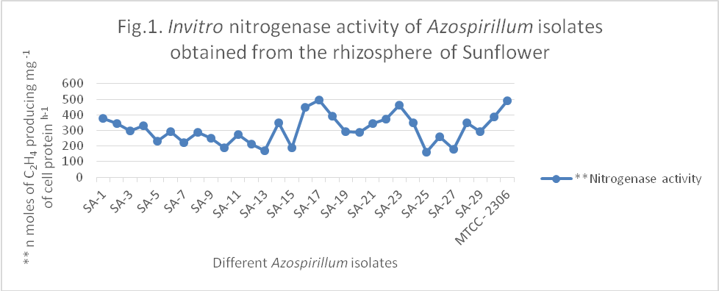

Fig – 2. Invitro cell nitrogen content of Azospirillum isolates obtained from the rhizosphere of sunflower

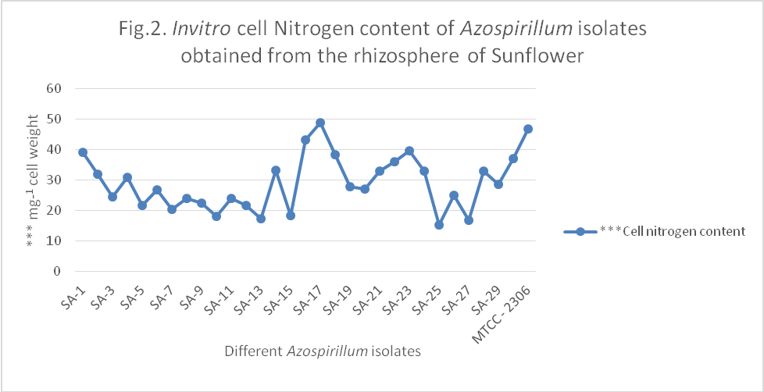
REFERENCES

- Barriuso, J., S. Ramos, B. Santamariya, C. Daza, A. Gutierrez and F.J. Manero. 2008. Effect of inoculation with putative plant growth-promoting rhizobacteria isolated from Pinus spp. on Pinus pinea growth, mycorrhization and rhizosphere microbial communities. Journal of Applied Microbiology, 105(5): 1298-1309.
- Bergersen, F.J. 1980. Methods for Evaluating Biological nitrogen fixation, John Wiley and Sons, New York, p. 702.
- Boring, L. R., W. T. Swank, J. B. Waide and G. S. Henderson. 1988. Sources, fates and impacts of nitrogen inputs to terrestrial ecosystems: Review and synthesis, Biogeochemistry, 6, 119 -159.
- Bradford, M.M. 1976. A rapid and sensitive method for the quantum for the microgram quantities of protein utilizing the principle of protein dye binding. Anals of Biochemistry, 72(1-2): 248 - 253.
- Fayez, M and Z.Y. Daw. 1987. Effect of inoculatuion with different strain of Azospirillum brasilense on cotton (Gossypium barbadense). Biological Fertillizers and Soils, 4: 91 - 95.
- Garcia, J. A. L., A. Probanza, B. Ramos, M. R. Palomino and F. J. G. Manero. 2011. Effect of inoculation of Bacillus licheniformis on tomato and pepper. Agronomie for Sustainable Development, 24 (4): 169-176.
- Humphries, E. C. 1956. Mineral components and ash analysis. Modern method of plant analysis. Springer Verlag, Berlin, 1: 468 - 502.
- Hurek, T., B. Reinhold, G. Nieman and T. Fendric. 1988. Nitrogen dependent growth of Azospirillum sp. in batch culture at low concentration of oxygen, pp. 115 - 121. In Azospirillum IV - Genetics, physiology and Ecology W.Klingmuller (Ed.) Springer-Verlag. Berlin.
- Kalloo, G. 2003. Sunflower in India. Directorate of oilseeds Research, Indian council of Agric. Res. Rajendranagar, Hyderabad, India.
- Kavitha, P and G. Swarajya Lakshmi. 2003. Effect of conjunctive use of nitrogen sources on seed yield, soil physico-chemical properties and available micronutrient status in sunflower. The Andhra Agriculture Journal, 50(1 - 2): 38 - 42.
- Kloepper, J. W. 1997. Plant growth promoting rhizobacteria (other system). In Azospirillum Plant Associations. Okon, Y. (Ed.), CRC Press, Boca Raton. pp. 137-166.
- Patiyuth, S., B. Tangcham and S. Muanjang. 2000. Studies on N₂-fixing bacteria association with Vetiver 1. Biosynthesis of plant growth hormone by Azospirillum 2 use of the gus A gene to study Azospirillum. In: Abstract on Poster Papers, ICV-2, P. 20.
- Reddy, P. V. R. M and C. K. Raja Reddy. 2001. Nutrient uptake pattern of sunflower as influence by integrated nutrient management. The Andhra Agricultural Journal, 48 (3&7): 216 - 222.
- Siripin, S., A. Thirathorn, A. Pintarake and T. Yathaputanon. 2000. Use of ¹⁵N isotope dilution method fixing bacterial inoculation on the growth of vetiver grass. In: Abstract of poster papers, ICV-2, p-30.
- Vara Prasad, B.V., A. V. Reddy and T. N. Rao. 2011. Combining ability studies for seed yield and yield contributing characters in sunflower, Helianthus annuus L. Journal of Oilseed Research, 23(1): 86 - 88.

