Metal Casting

Metal casting is indeed a fundamental manufacturing process that has been used for centuries to produce a wide range of metal parts and components. The process involves pouring molten metal into a mold with a specific shape and allowing it to cool and solidify, resulting in the formation of the desired metal object, known as the casting.

There are various methods of metal casting, each suited for different applications and requirements. Some of the common casting methods include:

1. Sand Casting: Sand casting is one of the oldest and most widely used casting methods. It involves creating a mold by compacting sand around a pattern (a replica of the desired part). Once the mold is ready, molten metal is poured into the cavity, and after solidification, the mold is broken to retrieve the casting.

2. Die Casting: Die casting is a process where molten metal is forced under high pressure into a metal mold (die) to produce intricate and detailed parts. The dies are usually made from steel and can be reused to produce many identical castings.

3. Investment Casting (Lost Wax Casting): Investment casting is a precise casting method suitable for complex shapes and high-quality finishes. A wax pattern of the part is made, and it is coated with a ceramic shell. The wax is melted out, leaving a hollow shell, and molten metal is poured into the shell. Once solidified, the ceramic shell is broken away, and the casting is retrieved.

4. Permanent Mold Casting: As mentioned in the initial statement, permanent molds made of metal can also be used for casting products. Unlike sand casting, these molds are not destroyed during the process and can be reused multiple times.

The metal casting industry is crucial for various sectors of the economy, including transportation (automobiles, aircraft, locomotives), infrastructure (office buildings, factories, schools), and homes. It allows for the production of complex and strong metal components that might be challenging or cost-prohibitive to manufacture using other methods.

Overall, metal casting remains an essential and versatile manufacturing process, continuously evolving with technological advancements to meet the growing demands of various industries.
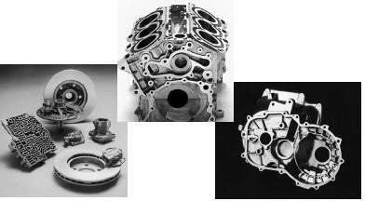

Fig. 1: Metal Cast parts

Advantages

Metal casting is a highly advantageous manufacturing process with several benefits that make it widely used across various industries:

1. Complex Shapes: The metal casting process allows molten material to flow into intricate and small sections, making it possible to create complex shapes with high precision. This reduces the need for additional operations like machining, forging, or welding, leading to cost and time savings.

2. Versatile Material Selection: Practically any ferrous or non-ferrous material can be used in metal casting, providing a wide range of options for the production of diverse components and products.

3. Weight Savings: Metal casting enables precise placement of the material, resulting in significant weight savings. By eliminating excess material and concentrating it where needed, the final product becomes lighter without compromising its structural integrity.

4. Simple and Cost-Effective Tools: The tools required for creating casting molds are relatively simple and inexpensive compared to other manufacturing processes. This aspect makes metal casting ideal for small-scale production, offering a cost-effective solution for limited production runs.

5. Unique Materials and Alloys: Some specialized parts and components can only be effectively processed through metal casting. This method accommodates the production of parts with specific material properties that are difficult to achieve using alternative techniques.

6. No Size or Weight Limitations: Unlike certain manufacturing processes, metal casting does not impose restrictions on the size and weight of the final product. This versatility allows for the production of both small and large-scale castings.

In conclusion, the metal casting process stands as a favored choice in manufacturing due to its ability to produce intricate shapes, work with a wide array of materials, achieve weight savings, cost-effectiveness for small production runs, suitability for unique alloys, and its adaptability to various product sizes and weights. These advantages have solidified metal casting's crucial role in the production of components used in numerous applications across different industries.

Limitations
1. The sand casting process has certain limitations in achieving dimensional accuracy and surface finish for castings. To address these drawbacks, several advanced casting techniques have been developed, including the die casting process, investment casting process, vacuum-sealed molding process, and shell molding process. These methods offer improved precision and surface quality compared to traditional sand casting.

2. The metal casting process is known for being labor-intensive.

Components Used for making a Mould Cavity

In the metal casting process, the following steps are involved in creating a mold using a two-piece pattern and flask:

1. Flask: A frame made of metal or wood without a fixed top or bottom, used to form the mold. It can be referred to as the drag (lower molding flask), cope (upper molding flask), or cheek (intermediate molding flask in three-piece molding).

2. Pattern: A replica of the final object to be cast, used to create the mold cavity.

3. Parting Line: The dividing line between the two molding flasks that makes up the mold.

4. Molding Sand: A mixture of silica sand, clay, and moisture that binds strongly without losing permeability to air or gases.

5. Facing Sand: A small amount of carbonaceous material sprinkled on the inner surface of the mold cavity to improve the surface finish of the castings.

6. Core: A separate part of the mold made of sand, used to create openings and various shaped cavities in the castings.

7. Pouring Basin: A funnel-shaped cavity at the top of the mold where the molten metal is poured.

8. Sprue: The passage through which molten metal flows from the pouring basin to the mold cavity, often controlling the metal flow.

9. Runner: The channel through which molten metal is carried from the sprue to the gate.

10. Gate: A channel through which molten metal enters the mold cavity.

11. Chaplets: Supports used to hold cores inside the mold cavity to overcome their own weight and the metallostatic force.

12. Riser: A column of molten metal placed in the mold to feed the castings as they shrink and solidify, also known as "feed head."

13. Vent: Small openings in the mold to allow air and gases to escape during pouring and solidification.

The process involves the following steps:
- Selecting a suitable molding box for the desired wall thickness of the casting and ensuring it accommodates the mold cavity, riser, and gating system.
- Placing the drag portion of the pattern on the bottom board and sprinkling facing sand to prevent the pattern from sticking to the molding sand.
- Filling the drag with prepared molding sand and uniformly ramming it around the pattern. Repeat the process several times.
- Removing excess sand with a strike-off bar to level the molding sand with the flask height, completing the drag.
- Sprinkling parting sand over the drag's top surface before placing the cope pattern on top and aligning it with dowel pins.
- Placing the cope (flask) over the rammed drag and sprinkling parting sand around the cope pattern.
- Positioning sprue and riser pins vertically to create suitable-sized cavities for pouring molten metal.
- Setting gaggers at appropriate locations in the cope, ensuring they do not chill the casting or fill the cope with sand during ramming.
- Striking off excess sand from the cope's top surface and creating vent holes to allow gases to escape during pouring and solidification.
- Sprinkling parting sand over the cope's surface, rolling over the cope on the bottom board, and removing both the cope and drag patterns.
- Repairing the mold if needed and applying mold coating if it's a dry sand mold.
- Inserting cores into the mold if required and closing the mold by inverting the cope over the drag.
- Clamping the cope with the drag to complete the mold, ready for pouring.
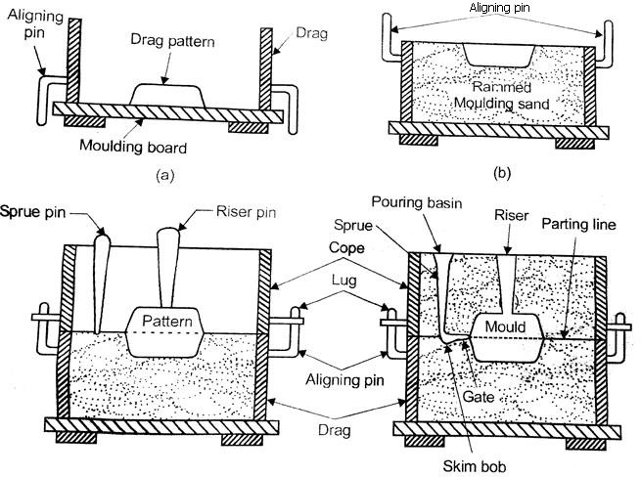

Fig. 2: Steps for making a mould cavity
PATTERN
A pattern in the metal casting process serves as a model or replica of the object to be cast. It is embedded in molding sand, and suitable ramming of molding sand is done around the pattern. When the pattern is withdrawn, it leaves a cavity known as the mold in the molding sand. The pattern is a crucial tool for forming the mold.

Objectives of a Pattern:

1. Preparation of Mold Cavity: The primary purpose of a pattern is to create a mold cavity where molten metal will be poured to form the casting.

2. Core Prints: Patterns include core prints, which form recesses to accommodate cores in the mold.

3. Parting Line and Surfaces: The pattern establishes the parting line and parting surfaces in the mold, which determine how the mold will be split for removing the pattern.

4. Inclusion of Runner, Gates, and Risers: Some patterns may include runners, gates, and risers, essential components for controlling the flow of molten metal during the casting process.

5. Cost Minimization: Properly designed patterns help reduce the overall cost of the casting process.

6. Location Indicators: Patterns may have locating pins to ensure accurate dimensions in the castings.

7. Reducing Casting Defects: Patterns with finished and smooth surfaces can minimize casting defects.

Common Pattern Materials:

1. Wood: Wood is a widely used material for pattern making due to its low cost and ease of fabrication. However, it is susceptible to moisture, warping, and wear from sand abrasion, limiting its lifespan.

2. Metal: Metallic patterns, made from materials like cast iron, brass, bronze, and aluminum alloys, are suitable for large production quantities due to their durability and resistance to moisture and wear.

3. Plastic: Patterns made from thermosetting resins are gaining popularity due to their lightness, strength, moisture resistance, and ability to produce smooth surface finishes.

4. Plaster: Gypsum-based plaster is preferred for producing intricate castings due to its high compressive strength and expansion setting properties.

5. Wax: Wax patterns are excellent for investment casting, providing high surface finish and dimensional accuracy.

Each pattern material has its advantages and limitations, and the choice of material depends on factors like production quantity, intricacy of the casting, and the required surface finish. Properly constructed patterns contribute to the success of the metal casting process and help in achieving accurate and high-quality castings.

TYPES OF PATTERN
The types of the pattern and the description of each are given as under.
- One piece or solid pattern
- Two piece or split pattern
- Cope and drag pattern
- Three-piece or multi- piece pattern
- Loose piece pattern
- Match plate pattern
- Follow board pattern
- Gated pattern
- Sweep pattern
- Skeleton pattern
- Segmental or part pattern

Single-piece or solid pattern
Solid pattern is made of single piece without joints, partings lines or loose pieces. It is the simplest form of the pattern. Typical single piece pattern is shown in Fig. 3.
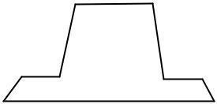

Fig. 3: Single piece pattern
Two-piece or split pattern
When solid pattern is difficult forwithdrawal from the mold cavity, then solid pattern is splited in two parts. Split pattern is made in two pieces which are joined at the parting line by means of dowel pins. The splitting at the parting line is done to facilitate the withdrawal of the pattern. A typical example is shown in Fig. 4.
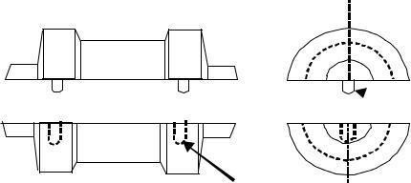

Fig. 4: Two-piece or split pattern
Cope and drag pattern
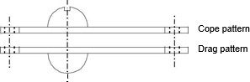
In this case, cope and drag part of the mould are prepared separately. This is done when the completemould is too heavy to be handled by one operator. The pattern is made up of two halves, which are mounted on different plates. A typical example of match plate pattern is shown in Fig. 5.

Fig. 5: Cope and drag pattern Three-piece or multi-piece pattern
Some patterns are of complicated kind in shape and hence cannot be made in one or two pieces
because of difficulty in withdrawing the pattern. Therefore these patterns are made in either three pieces or in multi- pieces. Multi molding flasks are needed to make mold from these patterns. The pattern can also be seen from the Fig. 6.
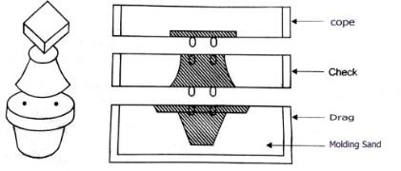

Loose-piece pattern
Fig. 6: Three-piece or multi-piece pattern

A single piece are made to have loose piece in easy to allow withdrawal from the mold the molding process are completed, after the main pattern is withdrawn leaving from that piece in the sand. After the withdrawal of piece from mold, it cavity separately formed by the pattern. It loose piece pattern is highly skilled job and expensive. The pattern can also be seen from the Fig. 7.
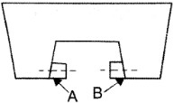

Match plate pattern
Fig. 7: Loose-piece pattern

The match plate pattern types is having two parts, one for one side and another one for another side of pattern. It is called match plate pattern. The sand casting pattern making in two pieces. It also having gates and runner attached with pattern. The molding process completed after that match plate

removed together, the gating is obtained for joining the cope and drag. It pattern is mainly used for casting of metal, usually aluminum are machined in this method with light weight and machinability. It should be possible for mass production of small casting with high dimensional accuracy. They are also used for machine molding. The cost will be high of molding but it is easily compensated by high rate of production and more accuracy. The pattern can also be seen from the Fig. 8.
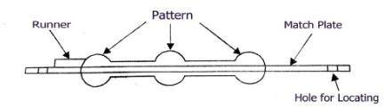

Fig. 8: Match plate pattern
Follow board type pattern
In casting process some portions are structurally weak. It is not supported properly and may be break under the force of ramming. In this stage the special pattern to allow the mold may be such as wooden material. The pattern can also be seen from the Fig. 9.
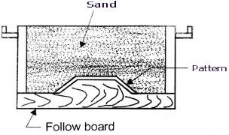

Fig. 9: Follow board type pattern
Gated Pattern
In the mass production of casings, multi cavity moulds are used. Such moulds are formed by joining a number of patterns and gates and providing a common runner for the molten metal, as shown in Fig.
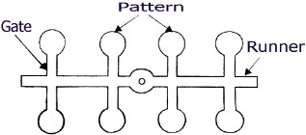
10. These patterns are made of metals, and metallic pieces to form gates and runners are attached to the pattern.

Fig. 10: Gated Pattern
Sweep Pattern
Sweep patterns are used for forming large circular moulds of symmetric kind by revolving a sweep attached to a spindle as shown in Fig. 11. Actually a sweep is a template of wood or metal and is attached to the spindle at one edge and the other edge has a contour depending upon the desired shape of the mould. The pivot end is attached to a stake of metal in the center of the mould.
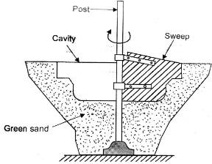

Fig. 11: Sweep Pattern

Skeleton Pattern

When only a small number of large and heavy castings are to be made, it is not economical to make a solid pattern. In such cases, however, a skeleton pattern may be used. This is a ribbed construction of wood which forms an outline of the pattern to be made. This frame work is filled with loam sand and rammed. The surplus sand is removed by strickle board. For round shapes, the pattern is made in two halves which are joined with glue or by means of screws etc. A typical skeleton pattern is shown in Fig. 12.
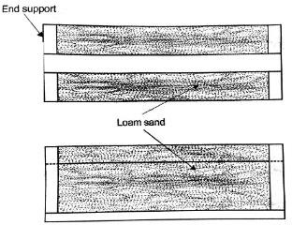

Fig. 12: Skeleton Pattern

Segmental pattern
The segmental pattern is used to prepare the mold of larger circular casting to avoid the use of solid pattern of exact size. It is similar to sweep pattern, but the difference from Sweep pattern, the sweep pattern is give a continuous revolve motion to generate the part, the segmental pattern itself and mold is prepared. In this segmental pattern construction should be save the material for pattern make and easy carried. The segmental pattern is mounted on the central pivot and mold in one position for after prepare of mold the segment is moved for next position. That is repeat together the complete mold is done. A typical segmental pattern is shown in Fig. 13.
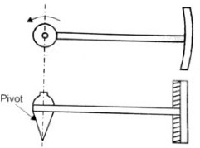

Fig. 13: Segmental pattern
Pattern Allowances
Pattern may be made from wood or metal and its color may not be same as that of the casting. The material of the pattern is not necessarily same as that of the casting. Pattern carries an additional allowance to compensate for metal shrinkage. It carries additional allowance for machining. It carries the necessary draft to enable its easy removal from the sand mass. It carries distortions allowance also. Due to distortion allowance, the shape of casting is opposite to pattern. Pattern may carry additional projections, called core prints to produce seats or extra recess in mold for setting or adjustment or location for cores in mold cavity. It may be in pieces (more than one piece) whereas casting is in one piece. Sharp changes are not provided on the patterns. These are provided on the casting with the help of machining. Surface finish may not be same as that of casting.

The size of a pattern is never kept the same as that of the desired casting because of the fact that during cooling the casting is subjected to various effects and hence to compensate for these effects, corresponding allowances are given in the pattern. These various allowances given to pattern can be enumerated as, allowance for shrinkage, allowance for machining, allowance for draft, allowance for rapping or shake, allowance for distortion and allowance for mould wall movement. These allowances are discussed asunder.

Shrinkage Allowance
In practice it is found that all common cast metals shrink a significant amount when they are cooled from the molten state. The total contraction in volume is divided into the following parts:
- Liquid contraction, i.e. the contraction during the period in which the temperature of the liquid metal or alloy falls from the pouring temperature to the liquidus temperature.
- Contraction on cooling from the liquidus to the solidus temperature, i.e. solidifying contraction.
- Contraction that results there after until the temperature reaches the room temperature. Thisis known as solid contraction.
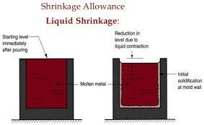
The first two of the above are taken care of by proper gating and risering. Only the last one, i.e. the solid contraction is taken care by the pattern makers by giving a positive shrinkage allowance. This contraction allowance is different for different metals. The contraction allowances for different metals and alloys such as Cast Iron 10 mm/mt.. Brass 16 mm/mt., Aluminium Alloys. 15 mm/mt., Steel 21 mm/mt., Lead 24 mm/mt. In fact, there is a special rule known as the pattern marks contraction rule in which the shrinkage of the casting metals is added. It is similar in shape as that of a common rule but is slightly bigger than the latter depending upon the metal for which it is intended. A typical shrinkage allowance can be shown in the Fig. 14.

Fig. 14: Shrinkage Allowance
Machining Allowance
It is a positive allowance given to compensate for the amount of material that is lost in machining or finishing the casting. If this allowance is not given, the casting will become undersize after machining.
The amount of this allowance depends on the size of casting, methods of machining and the degree of finish. In general, however, the value varies from 3 mm. to 18 mm. A typical machining allowance can be shown in the Fig. 15.
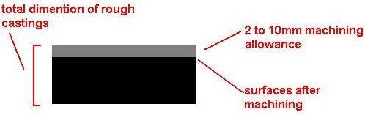

Fig. 15: Machining Allowance
Draft or Taper Allowance
Taper allowance (Fig. 1.1.11) is also a positive allowance and is given on all the vertical surfaces of pattern so that its withdrawal becomes easier. The normal amount of taper on the external surfaces varies from 10 mm to 20 mm/mt. On interior holes and recesses which are smaller in size, the taper should be around 60 mm/mt. These values are greatly affected by the size of the pattern and the molding method. In machine molding its, value varies from 10 mm to 50 mm/mt. A typical taper allowance can be shown in the Fig. 16.

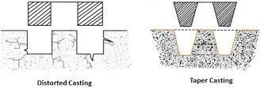

Fig. 16: Machining Allowance

Rapping or Shake Allowance
Before withdrawing the pattern it is rapped and thereby the size of the mould cavity increases. Actually by rapping, the external sections move outwards increasing the size and internal sections move inwards decreasing the size. This movement may be insignificant in the case of small and medium size castings, but it is significant in the case of large castings. This allowance is kept negative and hence the pattern is made slightly smaller in dimensions 0.5-1.0 mm.

Distortion Allowance
This allowance is applied to the castings which have the tendency to distort during cooling due to thermal stresses developed. For example a casting in the form of U shape will contract at the closed end on cooling, while the open end will remain fixed in position. Therefore, to avoid the distortion, the legs of U pattern must converge slightly so that the sides will remain parallel after cooling.

Mold wall Movement Allowance
Mold wall movement in sand moulds occurs as a result of heat and static pressure on the surface layer of sand at the mold metal interface. In ferrous castings, it is also due to expansion due to graphitisation. This enlargement in the mold cavity depends upon the mold density and mould composition. This effect becomes more pronounced with increase in moisture content and temperature.

Gating System
Gating system refers to all those elements which are connected with the flow of molten metal from the ladle to the mould cavity. The various elements that are connected with the gating system are: Pouring Basin

Sprue
- Sprue- base

Well Runner
- Runner

Extension In-gate
- Riser
Pouring Basin: In order to avoid mould erosion, molten metal is poured into a pouring basin, which acts as a reservoir from which it moves smoothly into the sprue. The pouring basin is also able to stop the slag from entering the mould cavity by means of a skimmer or skim core.

Sprue: It is the channel through which the molten metal is brought into the parting plane, where it enters the runners and gates to ultimately reach the mould cavity. If the sprue were to be straight- cylindrical then the meatl flow would not be full at the bottom to avoid this problem the sprue is designed tapper.

Sprue Base Well: This is a reservoir for metal at the bottom of the sprue, to reduce the momentum of the molten metal.

Runner: The runner takes the molten metal from sprue to the casting. Ingate: This is the final stage where the molten metal moves from the runner to the mold cavity.

Riser: Riser is a source of extra metal which flows from riser to mold cavity to compensate for shrinkage which takes place in the casting when it starts solidifying. Without a riser heavier parts of the casting will have shrinkage defects, either on the surface or internally.

Types of Gating Systems:

The gating system also depends on the direction of the parting plane, which contains the sprue, runner and the ingate. They are as follows:
Horizontal Gating System : This is used most widely. This type is normally applied in ferrous metal's sand casting and gravity die-casting of non-ferrous metals. They are used for flat casting, which are filled under gravity.
Vertical Gating System : This is applied in tall castings were high-pressure sand mold, shell mold and die-casting processes are done. Top Gating System : this is applied in places where the hot metal is poured form the top of the casting. It helps directional solidification of the casting from top to bottom. It suits only flat castings to limit the damage of the metal during the initial filling.
Bottom Gating System : it is used in tall castings where the molten metal enters the casting through the bottom.
Middle Gating System : It has the characteristics of both the top and bottom.
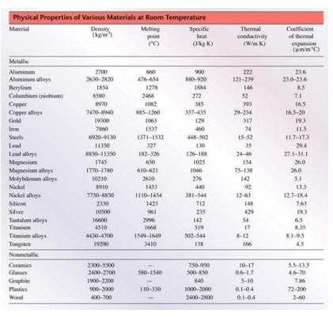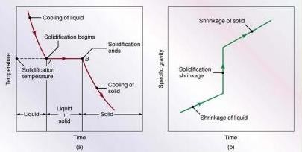

Fig. 17: Temperature as a function of time for the solidification of pure metals. Note that the
freezing takes place at a constant temperature. (b) Density as a function of time.

In order to provide defect-free casting the gating system should make certain provisions while designing the gating system.
- The mould should be completely filled in the smallest time possible without having to raise the metal temperature or use high metal heads.
- The metal should flow smoothly into the mould without any turbulence. A turbulence metal flow tends to form dross in the mould.
- Unwanted material such as slag, dross and other mould material should not be allowed to enter the mould cavity
- The metal entry into the mould cavity should be properly controlled in such a way that aspiration of the atmospheric air is prevented.
- A proper thermal gradient be maintained so that the casting is cooled without any shrinkage cavities or distortions.
- Metal flow should be maintained in such a way that no gating or mould erosion takes place.
- The gating system should ensure that enough molten metal reaches the mould cavity
- The gating system design should be economical and easy to implement and remove after casting solidification.
- Ultimately, the casting yield should be maximized.

Solidification of Metals
After pouring molten metal into a mold, a series of events takes place during the solidification of the metal and cooling to room temperature. These events greatly influence the size, shape uniformity, and chemical composition of the grains formed throughout the casting, which in turn influence its over all properties.

Solidification of Pure Metals: A pure metal solidifies at a constant temperature. It has a clearly defined melting (or freezing) point (see table above and Fig. 17). After the temperature of the molten metal drops to its freezing point, its temperature remains constant while the latent heat of fusion is given off. The solidification front (solid-liquid interface) moves through the molten metal, solidifying from the mold walls in toward the center.

The grain structure of a pure metal cast in a square mold is shown in Fig. 17 a: 9At the mold walls (usually at room temp), the metal cools rapidly and produces a solidified skin (or shell) of fine
equiaxed grains (approx. equal dims. in all dirs.) 9The grains grow in a direction opposite to that of the heat transfer out through the mold. Those grains that have favorable orientations grow preferentially away from the surface of the mold producing columnar grains (Fig. 10.3). 9As the driving force of the heat transfer is reduced away from the mold walls, the grains become equiaxed and coarse. Those grains that have substantially different orientations are blocked from further growth. Such grains development is known as homogeneous nucleation, meaning that the grains grow upon themselves, starting at the mold wall.
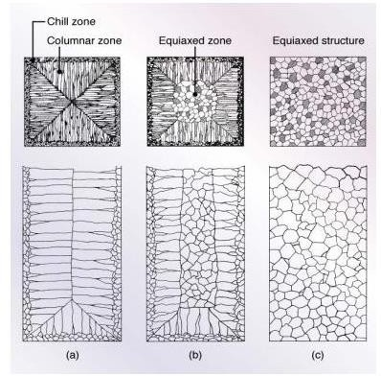
When the heat is abstracted rapidly, however, solidification it leads to fine structures due to a decrease in diffusion rates.

Fig. 18: Schematic illustration of three cast structures of metals solidified in a square mold: (a) Pure metals (b) Solid-solutions alloys and (C) Structure obtained by using nucleating agents.

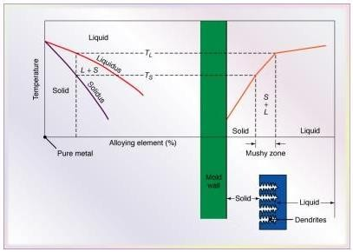
Solidification of Alloys

Fig. 19: Schematic illustration of alloy solidification and temperature distribution in the solidifying metal. Note the formation of dendrites in the mushy zone.
Solidification begins when the temperature drops below the liquidus, TL, and is complete when it reaches the solidus, TS (Fig.19). Within this temperature range, the alloy is in a mushy or pasty state with columnar dendrites (close to tree). Note the liquid metal present between the dendrite arms.

Dendrites have 3-D arms and branches (secondary arms) which eventually interlock, as can be seen in Fig.20.
(L & S) is an important factor during solidification. It is described by the freezing range as: 5 Freezing range = TL - TS (Fig. 17) .

It can be seen in Figure 10.1 that pure metals have no freezing range, and that the solidification front moves as a plane front without forming a mushy zone. In alloys with a nearly symmetrical phase diagram, the structure is generally lamellar, with two or more solid phases present, depending on the alloy system. When the volume fraction of the minor phase of the alloy is less than about 25%, the structure generally becomes fibrous. These conditions are particularly important for cast irons. For alloys, a short freezing range generally involves a temperature difference < 50o C, and a long freezing range > 110o C.

Ferrous castings generally have narrow mushy zones, whereas aluminum and magnesium alloys have wide mushy zones.
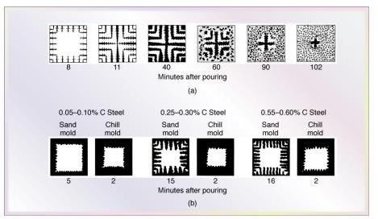

Fig. 20: (a) Solidification patterns for grey cast iron in a 180mm square casting. Note that after 11 minutes of cooling, dendrites reach each other, but the casting is still mushy throughout. It takes about two hours for this casting to solidify completely. (b)Solidification of carbon steels in sand and chill (metal) molds. Note the difference in solidification patterns as the carbon content increases.

Riser
Riser is a source of extra metal which flows from riser to mold cavity to compensate for shrinkage which takes place in the casting when it starts solidifying. Without a riser heavier parts of the casting will have shrinkage defects, either on the surface or internally.
Risers are known by different names as metal reservoir, feeders, or headers. Shrinkage in a mold, from the time of pouring to final casting, occurs in three stages.
  - during the liquid state
  - during the transformation from liquid to solid
  - during the solid state
First type of shrinkage is being compensated by the feeders or the gating system. For the second type of shrinkage risers are required. Risers are normally placed at that portion of the casting which
is last to freeze. A riser must stay in liquid state at least as long as the casting and must be able to feed the casting during this time.

Functions of Risers
- Provide extra metal to compensate for the volumetric shrinkage
- Allow mold gases to escape
- Provide extra metal pressure on the solidifying mold to reproduce mold details more exact

Design Requirements of Risers
- Riser size: For a sound casting riser must be last to freeze. The ratio of (volume / surface area)2 of the riser must be greater than that of the casting. However, when this condition does not meet the metal in the riser can be kept in liquid state by heating it externally or using exothermic materials in the risers.
- Riser placement: the spacing of risers in the casting must be considered by effectively calculating the feeding distance of the risers.
- Riser shape: cylindrical risers are recommended for most of the castings as spherical risers, although considers as best, are difficult to cast. To increase volume/surface area ratio the bottom of the riser can be shaped as hemisphere.

Riser Design
The riser is a reservoir in the mold that serves as a source of liquid metal for the casting to compensate for shrinkage during solidification. The riser must be designed to freeze after the main casting in order to satisfy its function Riser Function As described earlier, a riser is used in a sand- casting mold to feed liquid metal to the casting during freezing in order to compensate for solidification shrinkage. To function, the riser must remain molten until after the casting solidifies. Chvorinov’s rule can be used to compute the size of a riser that will satisfy this requirement. The following example illustrates the calculation. The riser represents waste metal that will be separated from the cast part and re-melted to make subsequent castings. It is desirable for the volume of metal in the riser to be a minimum. Since the geometry of the riser is normally selected to maximize the V/A ratio, this tends to reduce the riser volume as much as possible Risers can be designed in different forms. The design shown in Figure below is a side riser. It is attached to the side of the casting by means of a small channel. A top riser is one that is connected to the top surface of the casting. Risers can be open or blind. An open riser is exposed to the outside at the top surface of the cope. This has the disadvantage of allowing more heat to escape, promoting faster solidification. A blind riser is entirely enclosed within the mold, as in Figure below.
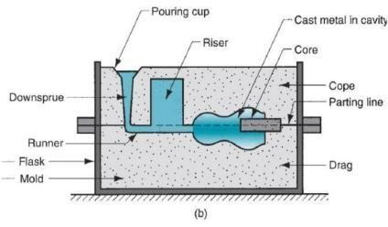

This process was patent in 20 century to make higher standards hollow castings. The first centrifugal
casting machine was invented by a British, A.G. Eckhardt in 1807. This process is widely used for casting hollow pipes, tubes and other symmetrical parts.

Core and Core Box:
Cores are compact mass of core sand that when placed in mould cavity at required location with proper alignment does not allow the molten metal to occupy space for solidification in that portion and hence help to produce hollowness in the casting. The environment in which the core is placed is much different from that of the mold. In fact the core (Fig. 22) has to withstand the severe action of hot metal which completely surrounds it. Cores are classified according to shape and position in the mold. There are various types of cores such as horizontal core, vertical core, balanced core, drop core and hanging core are shown in the Fig. 22 below.
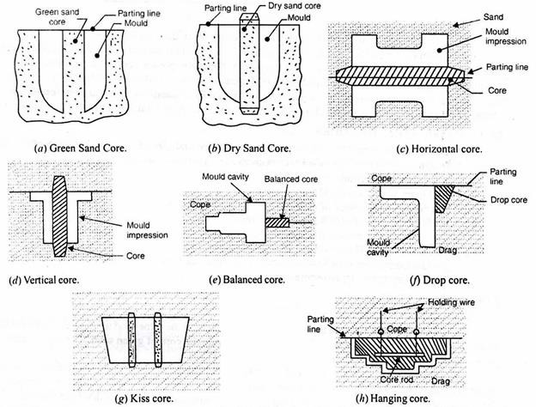

Fig. 22: Types of Core

There are various functions of cores which are given below
Core is used to produce hollowness in castings in form of internal cavities. It may form a part of green sand mold
- It may be deployed to improve mold surface.
- It may provide external undercut features in casting.
- It may be used to strengthen the mold.
- It may be used to form gating system of large size mold
- It may be inserted to achieve deep recesses in the casting

Special Casting processes:
This process was patent in 20 century to make higher standards hollow castings. The first centrifugal casting machine was invented by a British, A.G. Eckhardt in 1807. This process is widely used for casting hollow pipes, tubes and other symmetrical parts.

Centrifugal Casting:

Working Principle: It works on basic principle of centrifugal force on a rotating Component. In this process, a mould is rotated about its central axis when the molten metal is poured into it. A centrifugal force acts on molten metal due to this rotation, which forces the metal at outer wall of mould. The mould rotates until the whole casting solidifies. The slag oxide and other inclusion being lighter, gets separated from metal and segregate towards the center.

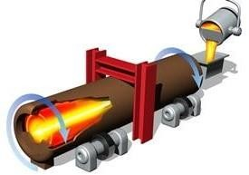

Types
True Centrifugal Casting:

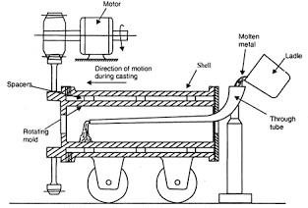
True centrifugal casting is sometime known as centrifugal casting is a process of making symmetrical round hollow sections. This process uses no cores and the symmetrical hollow section is created by pure centrifugal action. In this process, the mould rotates about horizontal or vertical axis. Mostly the mould is rotated about horizontal axis and the molten metal introduce from an external source. The centrifugal force acts on the molten metal which forces it at the outer wallof mould. The mould rotates until the whole casting solidifies. The slag particles are lighter than metal thus separated at the central part of the casting and removed by machining or other suitable process. This process
used to make hollow pipes, tubes, hollow bushes etc. which are axi symmetrical with a concentric hole.

Semi Centrifugal Casting:
This process is used to cast large size axi symmetrical object. In this process mould is placed horizontally and rotated along the vertical axis. A core is inserted at the center which is used to cast hollow section. When the mould rotates, the outer portion of the mould fill by purely centrifugal action and as the liquid metal approaches toward the center, the centrifugal component decreases
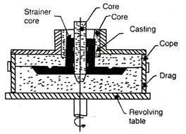
and gravity component increase. Thus a core is inserted at center to make hollow cavity at the center without centrifugal force. In this process centrifugal force is used for uniform filling of axi symmetrical parts. Gear blanks, flywheel etc. are made by this process.

Centrifuging:
In this process there are several mould cavities connected with a central sprue with radial gates. This process uses higher metal pressure during solidification. It is used to cast shapes which are not axi symmetrical. This is only suitable for small objects.
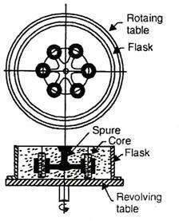
Application:

It is widely used in aircraft industries to cast rings, flanges and compressor casting. It is used for cast Steam turbine bearing shell.
Roller for steel rolling mill is another example of centrifugal casting.
It is used in automobile industries to cast gear blank, cylindrical liners, piston rings etc. It is used to cast bearings.
This process used to cast switch gear components used in electronic industries.

Advantages and Disadvantages:
It provides dense metal and high mechanical properties. Unidirectional solidification can obtain up to a certain thickness. It can use for mass production.
No cores are required for cast hollow shapes like tubes etc. Gating system and runner are totally eliminated.
All the impurity like oxide or other slag particles, segregated at center from where it can easily remove.
It required lower pouring temperature thus save energy.
Lower casting defects due to uniform solidification. Disadvantages: Limited design can be cast. It can cast only symmetrical shapes.
High equipment or setup cost.
It is not suitable for every metal. Higher maintenance required.
High skill operator required.
In this casting process, solidification time and temperature distribution is difficult to determine.

Investment Casting Process
The root of the investment casting process, the cire perdue or “lost wax” method dates back to at least the fourth millennium B.C. The artists and sculptors of ancient Egypt and Mesopotamia used the rudiments of the investment casting process to create intricately detailed jewelry, pectorals and idols. The investment casting process alos called lost wax process begins with the production of wax replicas or patterns of the desired shape of the castings. A pattern is needed for every casting to be produced. The patterns are prepared by injecting wax or polystyrene in a metal dies. A number of patterns are attached to a central wax sprue to form a assembly. The mold is prepared by surrounding the pattern with refractory slurry that can set at room temperature. The mold is then heated so that pattern melts and flows out, leaving a clean cavity behind. The mould is further hardened by heating and the molten metal is poured while it is still hot. When the casting is solidified, the mold is broken and the casting taken out.

The basic steps of the investment casting process are ( Figure 11 ) :
  - Production of heat-disposable wax, plastic, or polystyrene patterns
  - Assembly of these patterns onto a gating system
  - “Investing,” or covering the pattern assembly with refractory slurry
  - Melting the pattern assembly to remove the pattern material
  - Firing the mold to remove the last traces of the pattern material
  - Pouring
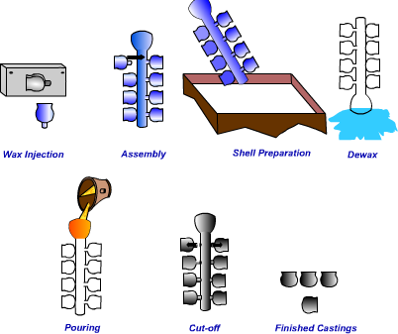
  - Knockout, cutoff and finishing.
The basic Steps of Investment Casting

Advantages
- Formation of hollow interiors in cylinders without cores
- Less material required for gate
- Fine grained structure at the outer surface of the casting free of gas and shrinkage cavities and porosity

Disadvantages
- More segregation of alloy component during pouring under the forces of rotation
- Contamination of internal surface of castings with non-metallic inclusions
- Inaccurate internal diameter

Ceramic Shell Investment Casting Process
The basic difference in investment casting is that in the investment casting the wax pattern is immersed in a refractory aggregate before dewaxing whereas, in ceramic shell investment casting a ceramic shell is built around a tree assembly by repeatedly dipping a pattern into a slurry (refractory material such as zircon with binder). After each dipping and stuccoing is completed, the assembly is allowed to thoroughly dry before the next coating is applied. Thus, a shell is built up around the assembly. The thickness of this shell is dependent on the size of the castings and temperature of the metal to be poured.

After the ceramic shell is completed, the entire assembly is placed into an autoclave or flash fire furnace at a high temperature. The shell is heated to about 982 o C to burn out any residual wax and to develop a high-temperature bond in the shell. The shell molds can then be stored for future use or molten metal can be poured into them immediately. If the shell molds are stored, they have to be preheated before molten metal is poured into them.

Advantages
- excellent surface finish
- tight dimensional tolerances
- machining can be reduced or completely eliminated

The Process
The Mold: Like in all permanent mold manufacturing processes, the first step in die casting is the production of the mold. The mold must be accurately created as two halves that can be opened and closed for removal of the metal casting, similar to the basic permanent mold casting process. The mold for die casting is commonly machined from steel and contains all the components of the gating system. Multi-cavity die are employed in manufacturing industry to produce several castings with each cycle. Unit dies which are a combination of smaller dies are also used to manufacture metal castings in industry.

In a die casting production setup, the mold, (or die), is designed so that its mass is far greater than that of the casting. Typically the mold will have 1000 times the mass of the metal casting. So a 2 pound part will require a mold weighing a ton! Due to the extreme pressures and the continuous exposure to thermal gradients from the molten metal, wearing of the die can be a problem. However in a well maintained manufacturing process, a die can last hundreds of thousands of cycles before needing to be replaced.

Die Casting Machines

In addition to the opening and closing of the mold to prepare for and remove castings, it is very important that there is enough force that can be applied to hold the two halves of the mold together during the injection of the molten metal. Flow of molten metal under such pressures will create a tremendous force acting to separate the die halves during the process. Die casting machines are large and strong, designed to hold the mold together against such forces.
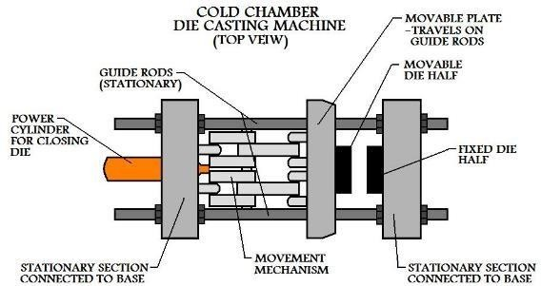
In manufacturing industry, die casting machines are rated on the force with which they can hold the mold closed. Clamping forces for these machines vary from around 25 to 3000 tons.

Melting Practices
Melting is an equally important parameter for obtaining a quality castings. A number of furnaces can be used for melting the metal, to be used, to make a metal casting. The choice of furnace depends on the type of metal to be melted. Some of the furnaces used in metal casting are as following:
- Crucible furnaces
- Cupola
- Induction furnace
- Reverberatory furnace

The crucible furnace as you see in the image below is how a crucible furnace looks. So, in this basically you have a crucible, which is normally made of clay or graphite and then this crucible will be kept and there will be heating source, and through this heating source this crucible is heated and the molten metal which is kept in the crucible normally that is melted. So, normally it is used for very you know smaller quantity of material can be normally is a held, but you can have the larger crucible, you have the crucible numbers, sometimes you have different numbers and that is basically specifies by amount of copper which can be melted into that particular number of crucible.

So, kgs of copper which can be melted like that so, if this is a large crucible certainly you need a large and that it has to be put in you will have the refractory, which is rammed from the other sides and then you will have the heat source, and then using that heat source you can heat the liquid metal which will be melted. So, as you see you will have a ladle you have the fire brick lining and then this is a chimney this is the covers, you can take the cover out and this is a air blower. So, that will be blown and then this way the heating will be done, and due to the heat the metal is melted here.

So, it is normally convenient for a smaller foundries. So, that you know for handling these smaller quantities you have to take this crucible out. So, for a smaller foundries when you have to melt in small quantities, this crucible furnace are basically important.

Now there may be basically coke fired or the oil or gas fired. So, basically when you have to use these normally for nonferrous melting, nonferrous metal these coke fired furnaces are used, and because you have the low installation cost in that low fuel cost and ease in operation. So, because of these reasons these coke fired furnaces are used for nonferrous metal. Now you have also the oil and gas
fired furnace. So, as the name indicts you have oil or gas, which are used as the heating source in such furnaces. So, basically they are cylindrical in shape and then the flame is produced by heating of this atomised fuel.

So, they will combine with air and then they will be heated, and then they will be sweeping around the crucible. So, that way it will have the enveloped in enveloped in the crucible and then uniformly heat the crucible. So, this way you have the combustion products will be coming into the contact with the charge, then they will be heating it and then they that way you can melt them by tilting you can take the you know metal out and pour it into the mould. So, you have certain advantages of this oil or gas fired furnace like you do not have any wastage of fuel. So, that is one of the. So, here if this is the oil or gas fired furnace you do not have much of the wastage of the fuel. So, you have more thermal efficiency in the case of oil or you know gas fired furnace, you have better temperature control by controlling the flow of this gases by controlling through a knob, you can have accurate control of the temperature, air contamination will be less in the case of this oil or gas fired furnaces. So, it will also save the floor space and you have also the low labour cost because here you need one person just simply to regulate these burners or so. So, this way you have these crucible furnaces and they are the different types normally you will have this used by the smaller foundries.
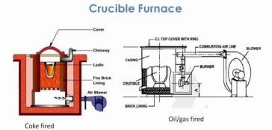

Cupola Furnace:
Cupola Furnace is a melting device used to melt cast iron, Ni-resist iron, and some bronzes and It is used in Foundries. The cupola can be made of any size and the size of the cupola is measured in diameters which range from 1.5 to 13 feet. The shape of the cupola is cylindrical and the equipment is arranged in the vertical fitted with doors which swings down and Out to drop bottom.

The top is open or fitted with a cap to escapes gases or rain entering. The cupola may be fitted with a cap to control emission of gases and to Pull the gases into the device to cool the gases and remove all the Particulate Matter.

The cupola shell is made of steel and has a refractory brick and plastic refractory Patching material lining. The clay and sand mixture is used as a bottom line and the lining is temporary. The coal can be mixed with the clay lining so when it heats up the coal decomposes and the bond becomes friable. This makes opening up of the two holes easy. The bottom of the cupola lining is compressed against the bottom doors. Cooling jackets are also fitted with some of the cupola’s to keep the sides cool and with oxygen injection to make the coke fire burn hotter.

Principal:
The cupola furnace works on a simple principal that combustion of coke generates carbon dioxide and heat and this causes the iron to melt. The iron drains downward when get melted. Afterwards, the carbon dioxide is reduced partly, reduced again by consuming energy and coke with carbon monoxide, carbon dioxide and supplied coke is present in the reaction equilibrium so it is possible to show a defined combustion ratio for the utilization of thermal energy for the coke combustion.
Finally, high concentration of carbon monoxide is present in the exhaust gas and it can be extracted from the furnace.

Construction:
Cupola furnace constructed in the form of a hollow cylindrical vertical steel shell and it is lined from inside with a refractory material. This furnace is generally supported on four cast iron lags mounted on a concrete base.

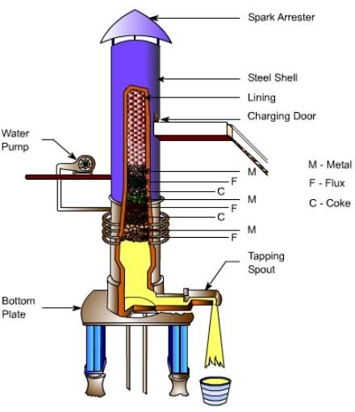

Cupola Furnace

The bottom of the furnace is closed by two cast iron doors hinged to the bed plate of the furnace. A wind box cast iron encircles to the outside of the furnace bottom. This box is connected to the furnace blower pipe known as the blast pipe. Air which supplies the oxygen necessary to burn the fuels forced through the cupola by a blower. The top of the furnace is shielded by a mesh screen and topped with a cone-shaped spark arrester, which permits the free vent of the waste gas and deflects spark and dust back into the furnace.

Working:

Basically, the operation of cupola furnace consists of following steps:

After building the cupola make sure it is dried completely before getting it to fire. Any slag around the tuyeres from previous runs needs to be cleaned properly.
Also, A broken part is repaired with the mixture of the silica sand and fire clay. Over the Brunt area, a layer of refractory material is applied To about thickness 6 inches or more is rammed on the bottom sloping toward the tap hole to ensure better flow of molten metal.
A hole opening of about 30 mm diameter and a tap hole of about 25 mm diameter is being provided there. A fire of wood is ignited. When the wood burns well coke is dumped on the bed well from the top. Make sure that the coke gets burned too. A bed of coke about 40 inches is placed next to the sand.

Firstly The air blast is turned on At a lower blowing rate than as normal for provoking the coke. A measuring rod is also used which indicates the height of the coke bed. For about 3 hours firing is done before the molten metal required.

Now the charge is fed into the cupola. Many factors like charge composition, affect the final structure of the gray cast iron obtained. It composed of 10% steel,50% grey cast iron scrap, and 3% limestone as a flux.
Alternate layers are formed by these constituents. Besides limestone, fluorspar and soda ash are also used as flux material. The main function of flux is to remove the impurities in the iron and protect the iron from oxidation.

After the fully charged furnace, it is allowed to remain as such for about 1 hour. As this process goes in charge slowly gets heated up as the air blast is kept shut this time and because of this, the iron gets soaked up.
At the end of the soaking period, the air blast is opened. The topmost opening is kept closed till the metal melts. The sufficient amount of metal is collected. The contents of the charge move downwards as the melting proceeds.

The rate of charging is equal to the rate of melting. The furnace is kept full throughout the heat. Closing feeding of charge and air blast is stopped when no more melting is required. The bottom plate swings to open when the prop is removed. The deposited slag is being removed. The cupola runs continuously and the melting period does not exceed 4 hours in most of the time. But can be operated for more than 10 hours.

Advantages:
- Low cost of construction.
- Low cost of maintenance.
- Low cost of operation.
- Very skilled operators are not required.
- Simple in construction
- Simple in operations.
- Melting composition can be controlled.
- Small floor area is required.

Disadvantages:
- With a long list of advantages, cupola furnace also comes with few of limitations or disadvantages and they are listed below:
- It is sometimes difficult to maintain the temperature in a cupola furnace.
- Metal elements are converted to their oxides which are not suitable for casting.

Application:
Cupola furnace is a used widely as a melting unit for cast iron. Some of the characteristic that makes the cupola furnace a primary method used in melting irons in the foundries. Some of them are:
- Cupola furnace is the only method which is continuous while operations.
- The melting rate of cupola furnace is high.

It is easy to operate. Operating costs in use of cupola furnace is comparability very low to other methods for this purpose.

Advanced Casting Processes:

Continuous Casting:

In this process, the molten metal is continuously supplied to the mold. The mold has an indeterminate length. When the molten metal is cast through a mold, it keeps travelling downward increasing in its length as the time passes by. The molten metal is continuously passed through the mold, at the same rate to match the solidifying casting. This results in casting of long strands of metal. The whole process of continuous casting is a precisely deliberated process that can produce astounding results.

Benefits of continuous casting
Unlike other processes of casting, the time line of steps in continuous casting is entirely different. While in other casting processes, each step of casting heating of the metal, poring of the molten liquid into casts, solidification and cast removal are a sequential process, in continuous casting all steps occur congruently and hence it saves a lot of processing time.
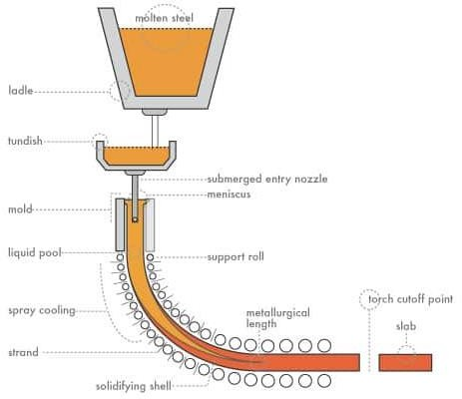

Continuous Casting of Steel

The process
Continuous casting has several advantages but it is also a process that needs distinct resources. This is the reason why this process is employed only in industries that require high yield of steel cast. The metal is first liquefied and poured into a tundish, which is a container that leads to the mold that will cast the steel. The tundish is placed about 80-90 feet above the ground level and the whole process of casting sues gravity to operate. The tundish is constantly supplied with molten steel to keep the process going. The whole process is controlled to ensure there is smooth flow of molten steel through tundish. Further, the impurities and slag are filtered in tundish before they move into the mold. The entrance of the mold is filled with inert gases to prevent reaction of molten steel with the gases in the environment like oxygen. The molten metal moves swiftly through the mold and it does not completely solidify in it.The entire mold is cooled with water that flows along the outer surface. Typically, steel casting solidifies along the walls of the casting and then gradually moves to the interior of the steel casting. The metal casting moves outside the mold with the help of different sets of rollers.
While one set of rollers bend the metal cast, another set will straighten it. This helps to change the direction of flow of the steel slab from vertical to horizontal.

Squeeze Casting
Squeeze casting is a combination of casting and forging process. The process can result in the highest mechanical properties attainable in a cast product. The development of squeeze casting process, can usher in tremendous possibility for manufacturing of components of aluminium alloys, which are not properly commercialized as yet. It can also be effective in for import substitution of critical components.

The process starts when the molten metal is poured into the bottom half of a pre-heated die. As soon as the metal starts solidifying, the upper half of the die closes and starts applying pressure during the solidification process. The extent of pressure applied is significantly less than that in forging. Parts of great detail can be produced. Coring can be used in tandem with the process to form holes and recesses. The high pressure and the close contact of molten alloy with the metal die surface results in minimum porosity and improvised mechanical properties. This process can be used for both ferrous and non-ferrous metals. This technique is very much suited for making fiber-reinforced castings from fiber cake preform.

Squeeze Casting Process (or squeeze forming) are of two types:
Direct (liquid metal forging)
This is done in equipment which closely resemble the forging process. Liquid metal is poured into lower die segment, contained in a hydraulic press. Upper die segment is closed. A very high pressure of 100 Mpa or more is applied to the whole cavity until the part gets solidified.

Indirect Squeeze Casting
This process is very much similar to die casting. It takes place in a die casting equipment. This equipment van be vertical or horizontal. The melt which is cleaned and grain -refined is poured in to the shot sleeve of a horizontal or vertical casting machine. The melt is then injected into the die through relatively large gates. This is accomplished through relatively slow velocity (less than 0.5m/sec). The melt in the die cavity is then solidified under pressures, ranging from 55MPa to 300MPa. In this process the parts displays good tensile strength.
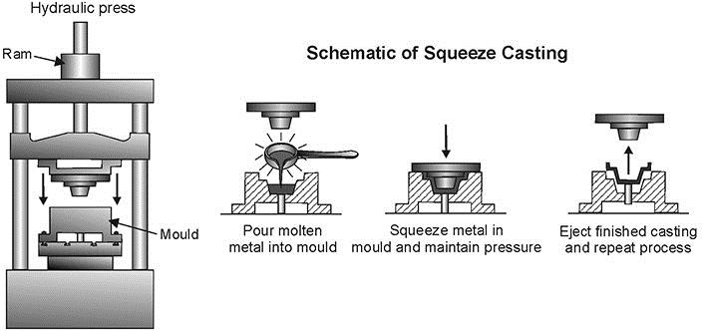

Squeeze Casting

Application of Squeeze Casting:
Squeeze casting is an economical, simple and convenient process. It has found extensive application in automotive industry in producing aluminium front steering knuckles, chassis frames, brackets or nodes. High capacity propellers for boat-engine.

Vacuum Mould Casting:
- process or vacuum molding which was developed by Japanese using unbonded sand and vacuum is a perfect substitute for permanent mold and die casting process. Now the process is employed worldwide as an effective method to cast quality products in start up and low to medium job. The most highlighted feature of vacuum molding is that the flow of molten metal can be controlled.

Process: Patterns are mounted on plates and boards, which are perforated, and each board is connected with a vacuum chamber. Unbonded sand is used for the molding purpose. Permeability is not a concern in this casting process, therefore sand of the finest structure can be used. The vented, plated pattern is coated with a layer of flexible plastic, which expand when the vacuum is applied in the mold. Enabling, the pattern to be stripped easily from the mold. Patterns should be perfectly smooth since in vacuum molding, every small intricate design gets imprinted on the cast. The pattern are not damaged during the process so they can be uses repeatedly.

In the vacuum molding process the mold are made is two parts (cope & drag) with each parts attached with its vacuum chamber. The pattern is kept and a metal or wooden flask place around it. Unbonded sand is poured over the molding box, and the tables is shaken vibrantly, by which the sand particle become tight and compact. Another layer of plastic sheet is draped over the molding box. The two halves are joined. Now the vacuum is formed through the patter. The vacuum makes the sand strong and the pattern coating expands, which makes it easy to strip the pattern from the mold.

The mold in kept in a housing and placed above a furnace of molten metal. Using sprue or gating the mold is connected inside the molten metal. When the vacuum from the mold is evacuated the molten metal gets forces into the mold, because of the difference in pressure that is created between the outer atmosphere and the mold. The plastic sheet melts and the mold is filled with the molten metal. After the metal solidifies and cools, the vacuum is released. The sand mold starts to fall apart as the solidification process completes. This sand can be cooled and reused for further casting process.

The power of vacuum: In mid 1600,Otto von Guericke a German mayor and scientist conducted the first experiment to prove the power of vacuum. He joined two large copper hemispheres and evacuated the air out of it. Now, eight horses were hooked on opposite side of the hemispheres. The horse pulled the hemisphere is two different direction, but the ball could not be torn apart. Guericke then let in air and the hemisphere came apart. In this way he proved the power and possibilities of vacuum.

Application: Vacuum molding process can be used to cast industrial components from both ferrous and non-ferrous metals.

Application:
- Casted products have high dimensional accuracy and surface finish.
- The process is economical, environment friendly and clean
- No moisture related defects for the castings
- Provides consistent thickness for wall that give the casting an aesthetic appeal
- Low cost operations.

Evaporative casting
Consumable or eva-foam casting is a sand casting process where the foam pattern evaporates into the sand mold. A process similar to investment casting, this expendable casting process is predicted to be used for 29% of aluminum and 14% of ferrous casting in 2010. There are two main evaporative casting process lost-foam casting and full moldcasting which are widely used because intricate design can be cast with relative ease and with reasonable expense. The main difference between the two is that in the lost-foam casting unbonded sand is used and in the full-mold casting green sand or bonded sand is used.

Process: In the first step of evaporative casting, a foam pattern is shaped using material like polystyrene. The pattern is attached with sprues, and gates using adhesives and brushed with refractory substances so that the molds are strong and resistant to high temperature. Refractory covered pattern assembly is then surrounded by a sand mixture to form a mold. In some instances the pattern assembly is mixed in ceramic slurry which forms a shell round the pattern when it dries.

In both cases, the mold in kept at a specific temperature to allow the metal to flow smoothly and enter into every designs and cuts made by the pattern. Molten metal is poured into the mold and the pattern-forming material disappears into the mold. The molten metal takes the shape of the mold and solidifies. When the metal solidifies it is removed from the mold to form the casting.

Unlike in the traditional sand casting method, in evaporative sand casting, the pattern does not have to be removed from the mold which reduces the need for draft provisions. Some of the parameter that are used to determine the quality of a eva-foam casting are grain fineness number, time of vibration, degree of vacuum and pouring temperature on surface roughness etc.

Applications: Evaporative castings is used for steel-casting cast iron parts like water pipe and pump parts, aluminum castings etc.

Advantages:
- High dimensional accuracy and superior casting surface smoothness
- Reduced work process unlike other casting methods
- Light weight casting are be done
- Casting have improved heat resistance and also abrasion resistance and other cast steel properties.
- Complicated shapes can be cast without using cores or drafts.

Ceramic Shell Casting:
Introduction: A process that can be fully automated, ceramic shell molding is the most rapidly used technique for mold and core making. Also known a croning process, this casting technique was invented and patented by J.Croning during World War II. Also known as the process, shell molding technique is used for making thin sections and for acquiring surface finish and dimensional accuracy.

Process: In the first stage of ceramic shell molding, a metal pattern is made which is resistant to high temperature and can withstand abrasion due to contact with sand. The sand and resin mixture for the shell mold is brought in contact with the pattern. The mold is placed in an oven where the resin is cured. This process causes the formation of a thin shell around the pattern. The thickness of the mold can be 10-20mm as compared to the heavy mold made for sand castings. When fully cured the skin is removed from the pattern, which is the shell mold.
For each ceramic shell molds there are two halves know as the cope and drag section. The two sections are joined by resin to form a complete shell mold. If an interior design is required, the cores are placed inside the mold before sealing the two parts.

For heavy castings, ceramic shell molds are held together by metals or other materials. Now, the molten metal is poured into the mold, and once it solidifies, the shell is broken to remove the casting. This process is highly useful for near net shape castings. Another advantage is that shell molding can be automated.
Automated Ceramic Shell Molding Machines and Robots: Shell molding machines like the cold shell molding machines helps in making castings with little molding material. In a cold shell molding machine the molds are made using cold binding materials. In it patterns made of wood, metal or plaster can be used. And the greatest benefit is that the mold can be kept horizontally or vertically.

Robotizing: Using robots for ceramic shell molding is a milestone for the old molding technology. Robots which are multi functional and re programmable are used in some foundries. Robots are used for a number of activities like robotic gate and sprue removal, robotic cutting of wedges for gate valves, robotic core setting, etc. The robots are reliable, consistent, more productive, provides better surface finish, and less machining etc.

Applications: A sizable amount of the casting in the steel industry are made by shell molding process, that ensures better profitability. Carbon steel, alloy steel, stainless steel, low alloys, aluminum alloys, copper, are all cast using shell molding process. Casting that require thin section and excellent dimensional accuracy are cast using this process. Body panes, truck hoods, small size boats, bath tubs, shells of drums, connecting rods, gear housings, lever arms, etc. are cast using croning process.

Advantages:
- Thin sections, complex parts and intricate designs can be cast
- Excellent surface finish and good size tolerances
- Less machining required for the castings
- Near net shape castings, almost 'as cast' quality
- Simplified process that can be handled by semi skilled operators
- Full mechanized and automated casting process
- Less foundry space required.

Casting Defects:
The following are the major defects, which are likely to occur in sand castings
  - Gas defects
  - Shrinkage cavities
  - Molding material defects
  - Pouring metal defects
  - Mold shift

Gas Defects
A condition existing in a casting caused by the trapping of gas in the molten metal or by mold gases evolved during the pouring of the casting. The defects in this category can be classified into blowholes and pinhole porosity. Blowholes are spherical or elongated cavities present in the casting on the surface or inside the casting. Pinhole porosity occurs due to the dissolution of hydrogen gas, which gets entrapped during heating of molten metal.

Causes
The lower gas-passing tendency of the mold, which may be due to lower venting, lower permeability of the mold or improper design of the casting. The lower permeability is caused by finer grain size of the sand, high percentage of clay in mold mixture, and excessive moisture present in the mold.

  - Metal contains gas
  - Mold is too hot
  - Poor mold burnout

Shrinkage Cavities
These are caused by liquid shrinkage occurring during the solidification of the casting. To compensate for this, proper feeding of liquid metal is required. For this reason risers are placed at the appropriate places in the mold. Sprues may be too thin, too long or not attached in the proper location, causing shrinkage cavities. It is recommended to use thick sprues to avoid shrinkage cavities.

Molding Material Defects
The defects in this category are cuts and washes, metal penetration, fusion, and swell.

Cut and washes
These appear as rough spots and areas of excess metal, and are caused by erosion of molding sand by the flowing metal. This is caused by the molding sand not having enough strength and the molten metal flowing at high velocity. The former can be taken care of by the proper choice of molding sand and the latter can be overcome by the proper design of the gating system.

Metal penetration
When molten metal enters into the gaps between sand grains, the result is a rough castingsurface. This occurs because the sand is coarse or no mold wash was applied on the surface of the mold. The coarser the sand grains more the metal penetration.

Fusion
This is caused by the fusion of the sand grains with the molten metal, giving a brittle, glassy appearance on the casting surface. The main reason for this is that the clay or the sand particles are of lower refractoriness or that the pouring temperature is too high.

Swell
Under the influence of metallostatic forces, the mold wall may move back causing a swell in the dimension of the casting. A proper ramming of the mold will correct this defect.

Inclusions
Particles of slag, refractory materials, sand or deoxidation products are trapped in the casting during pouring solidification. The provision of choke in the gating system and the pouring basin at the top of the mold can prevent this defect.

Pouring Metal Defects
The likely defects in this category are
  - Mis-runs and
  - Cold shuts.
A mis-run is caused when the metal is unable to fill the mold cavity completely and thus leaves unfilled cavities. A mis-run results when the metal is too cold to flow to theextremities of the mold cavity before
freezing. Long, thin sections are subject to this defect and should be avoided in casting design.

A cold shut is caused when two streams while meeting in the mold cavity, do not fuse together properly thus forming a discontinuity in the casting. When the molten metal is poured into the mold cavity through more-than-one gate, multiple liquid fronts will have to flow together and become one solid. If the flowing metal fronts are too cool, they may not flow together, but will leave a seam in the part. Such a seam is called a cold shut, and can be prevented by assuring sufficient superheat in the poured metal and thick enough walls in the casting design.

The mis-run and cold shut defects are caused either by a lower fluidity of the mold or when the section thickness of the casting is very small. Fluidity can be improved by changing the composition of the metal and by increasing the pouring temperature of the metal.

Mold Shift
The mold shift defect occurs when cope and drag or molding boxes have not been properly aligned.
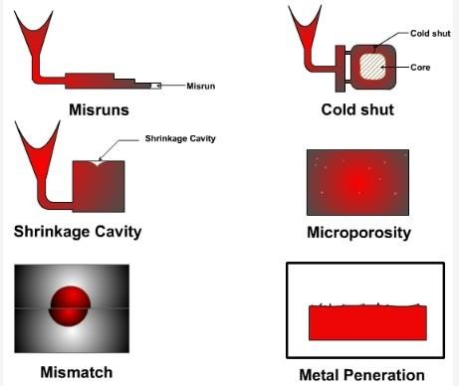
Casting Defects

