DEEP EUTECTIC SOLVENTS GLUCOSE – MALONIC ACID (DESs) AND THEIR NANO SYNTHESIS OF ZINC SULPHIDE

K.Prabhakaran¹, T. Mohana Priya², S.Sathishkumar³ and K.Gayathri⁴

^{1,3,4} Centre for research, Department of Chemistry, Kongu Engineering College (Autonomous), Perundurai, Erode-638060, Tamilnadu, India.

²Associate Professor, Department of Chemistry, Erode Arts and Science College, Erode-638009, Tamilnadu, India

Corresponding Author Details

T. Mohana Priya

Associate Professor, Department of Chemistry, Erode Arts and Science College, Erode-638009, Tamilnadu, India,

E-mail: mohanapriyachem@gmail.com, Mobile: +91 89737 77592

ABSTRACT

In this research work dealt with the synthesis of Zinc sulphide nanomaterials from a deep eutectic solvent of glucose and malonic acid by evaporation method. The GLU-MA DES was used a solvent for the preparation of ZnS nanoparticle by using NaBH4 and N₂H₄ mixture as reducing agent. The UV-Visible and FTIR spectra were recorded for these particles. From these analysis that ZnS nanoparticles were confirmed and the malonic was acted as a capping agent during the formation of nanoparticles. The field emission SEM analysis carried out to identify the morphology of ZnS nanoparticles showed that uniform sized particles are obtained in the nanoscale. In addition to that, the X-ray analysis of nanoparticles showed only manganese and oxygen elements are present in it. Therefore, Zn particles are obtained within the nanoscale in this DES of glucose and malonic acid. Further analysis of X-ray diffraction and Transmission Electron Micrograph studies are to be carried out to know the accurate particle size to the sample was prepared.

1. INTRODUCTION
During the past two decades, room temperature ionic liquids (ILs) have remarkable impact especially in the fields of catalysis, electrochemistry, material chemistry and in the pre-treatment of biomass recently.^{[1-3]} At the beginning of these research, mainly scientists focusing on the formation of ionic liquids by mixing metal salts, mostly zinc, aluminium, tin and iron chlorides, with quaternary ammonium salts. Though these salts have very high melting points, proper mixing yields the formation of a liquid phase known as eutectic mixtures are characterized by large depression of freezing point, mostly higher than 150°C. After the introduction of green chemistry in the early 1990’s, the search for metal-free ionic liquids (ILs) has become of growing interest.^{[4]}
In this context, many works were carried out for the development of ionic liquids by mixing an organic cation (usually imidazolium-based cations) with a many kind of anions, the most common ones being Cl, BF_{4,} PF₆. From that point of time, ionic liquids have emerged as new types of solvents. The probability to chemically modify the cations in combination with a large choice of anions offers chemists a wide range of ionic liquids showing severeal physical properties such as melting point, solubility, viscosity, density, conductivity, and refractivity. For example, Seddon and co-workers have reported that 1018 different ionic liquids can be theoretically produced in 2009, in that 250 ionic liquids being already commercialized ^{[5]}. Because of their low vapour pressure and high boiling point, they are recyclable and thus ionic liquids (ILs) were qualified as green solvents.
In fact, many reports notified that the hazardous toxicity and poor biodegradability of most ILs ^{[6]}. ILs with very high purity is required; even in trace amount impurities affect their physical properties. In addition, their synthesis is to be eco-friendly and it generally requires a large amount of salts and solvents in order to completely exchange the anions. Unfortunately, these disadvantages altogether with the high price of common ILs, slow down their industrial materialization. Thus, new concepts are now strongly desired in order to utilize these systems in a more rational way.
To reduce the high price and toxicity of ILs, a new generation solvent, named as Deep Eutectic Solvents (DES) ^{[7]}, has emerged at the beginning of this century. Preparation of these DESs can be done by simple mixing of two safe components (cheap, renewable and biodegradable), which are capable of forming a eutectic mixture. One of the most widespread components used for the prepartion of these DESs is choline chloride (ChCl). Choline chloride is a low cost, biodegradable and non-toxic quaternary ammonium salt which can be extracted either from biomass or synthesized readily from fossil reserves (million metric tons) through a very high atom economy process. In combination with safe hydrogen bond donors such as urea, renewable carboxylic acids (e.g. oxalic, citric, succinic or amino acids) or renewable polyols (e.g. glycerol, carbohydrates), ChCl is capable of rapidly forming a DES. Although most of DESs are prepared from ChCl as an ionic species, DESs cannot be considered as ILs due to the following two reasons. Firstly, DESs are not fully composed of ionic species and secondly, can also be prepared from non-ionic species.
As compared to the conventional ionic liquids, deep eutectic solvents obtained from ChCl draw together many advantages as listed below.
1. Low price
2. Chemical inertness with water (i.e. easy storage)
3. DESs are prepared by simply mixing two components, thus overcoming all problems
of purification and waste disposal generally encountered with ILs.
4. Mostly are biodegradable ^{[8]}, biocompatible ^{[9]} and non-toxic ^{[10]}, reinforceing
the greenness of these media ^{[11]}.
Physico-chemical properties of DESs (density, viscosity, refractive index, conductivity, surface tension, chemical inertness, etc.) are very close to the common ILs. For this reason, DESs are prepared from ChCl are called as “biocompatible” or “biorenewable” ionic liquids in a few studies. Due to their low ecological path and attractive price, DESs now become the growing interest in academic and industrial levels. The number of publications committed to the use of DESs is now promptly increasing in the current literature and further indicating the magnetism of these media.

1.1. Deep Eutectic Solvents - Definition
A Deep Eutectic Solvent is normally composed of 2 or 3 less expensive and harmless additives which are able to associating with each other, via hydrogen bond interactions, to shape a eutectic combination. The following DES is characterized with the aid of a melting point decrease than that of each character issue. Generally, DESs are characterized by a very massive melancholy of freezing factor and are liquid at temperatures decrease than 150 °C. The most of them are liquids between room temperature and 70°C. In the general public instances, a DES is acquired by using blending a quaternary ammonium salt with steel salts or a hydrogen bond donor (HBD) that has the capability to shape a complicated with the halide anion of the quaternary ammonium salt. Scheme1 summarizes the distinctive quaternary ammonium salts which might be broadly utilized in combination with various HBDs inside the formation of DESs.
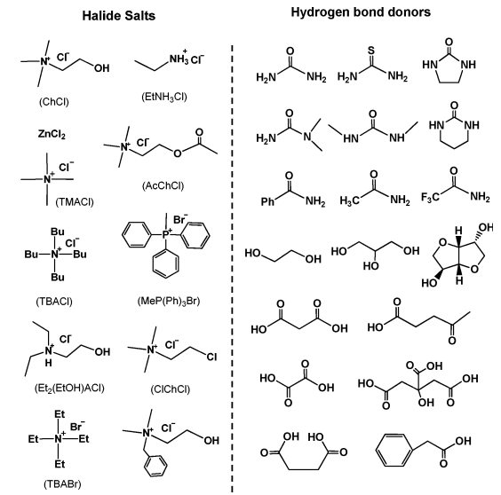
Scheme 1: Typical structures of the halide salts and hydrogen bond donors used for DES syntheses
In 2007, Abbott and co-workers defined DESs using the general formula R₁ R₂ R₃ R₄ N⁺ X – Y^{-[12]}.
Type1: DES Y=MCl_{x}, M=Zn, Sn, Fe, Al, Ga,
Type2: DES Y=MCl_{x}. _{y}H₂O, M=Cr, Co, Cu, Ni, Fe
Type3: DESY= RZwith Z=-CONH₂, -COOH, -OH

Note that the identical group additionally defined a fourth form of DES which consists of metallic chlorides (e.g, ZnCl2 combined with different HBDs together with urea, ethylene glycol, acetamide or hexanediol (kind IV DES). Because of its low value, biodegradability and occasional toxicity, ChCl was widely used as an organic salt to manufacture eutectic mixtures commonly with less expensive and innocent HBDs which includes urea, glycerol, carbohydrate-derived polyols or renewably sourced carboxylic acids. Those DESs are clever considering the fact that they showcase comparable physico-chemical houses to ordinary imidazolium based ILs and for that reason can beneficially update them in many applications.

Compared to traditional organic solvents, DESs aren't considered as risky organic solvents and now not flammable, making their storage handy. From the imaginative and prescient of green chemistry, these DESs are even greater attractive considering that a number of them had been verified to be biodegradable and well matched with enzymes similarly growing their hobby. Moreover, synthesis of DESs is 100 % atom monetary, smooth to deal with and no purification is needed, for that reason making their massive-scale use reasonable.

1.2. Properties of Deep Eutectic Solvents
DESs are chemically tailorable solvents for the reason that they can be planned by nicely combining various quaternary ammonium salts (e.g. ChCl) with different hydrogen bond donors (HBD). For this reason, assignment-particular DESs with unique physicochemical properties consisting of freezing factor, viscosity, conductivity, and pH, among others, may be prepared. Due to their promising packages, many efforts have been devoted to the physicochemical characterization of DESs.

1.2.1 Freezing point (Tf)
As we understand DESs are produced by way of blending two solids able to producing a new liquid segment through self-association thru hydrogen bonds. This new phase is typically characterized by way of a lower freezing point than that of character components. as an example, while ChCl and urea are blended together in a molar ratio 1:2, the freezing point of the eutectic is 12°C, that is considerably lower that of ChCl and urea (melting factor of ChCl and urea are 302 and 133°C, respectively). The full-size despair of the freezing factor stems from interplay among the halide anion and the hydrogen bond donor issue, right here urea. For all reported DESs, their freezing points are below 150 °C. In popular, DESs with a freezing factor decrease than 50°C are more appealing because they can be used as reasonably-priced and safe solvents in many fields.

1.2.2. Density
The density is one of the most crucial physical houses for solvents. In standard densities of DESs are measured via a specific gravity meter. Maximum of DESs show higher densities than water. For instance, kind IV ZnCl₂-HBD eutectic mixtures have densities high than 1.3 g cm⁻³. Amongst them, density of ZnCl₂-urea (1:3.5) and ZnCl₂-acetamide (1:4) had been reported as 1.63 and 1.36 g cm⁻³, respectively. This important difference of density is probably attributed to a special molecular packing of the DES. Notify that densities of the both DESs are higher than the ones of pure HBDs (acetamide: 1.16 and urea: 1.32 g cm⁻³). This phenomenon can be explained via the hollow principle. Similar to imidazolium-primarily based ILs, DESs are composed of holes or empty vacancies. Whilst ZnCl₂ changed into blended with urea as an instance, the average hollow radius become decreases, ensuing in a moderate boom of the DES density compared to that of pure urea^{[12].}

1.2.3. Viscosity
Just like most of the ILs, viscosity of DESs is a critical problem that desires to be concerned. Except for Glucose and Malonic acid eutectic mixture, maximum of the DESs show off relatively high viscosities (˃100cP) at room temperature. The high viscosity of DESs is frequently recognized to the presence of an intensive hydrogen bond community between each aspect, which ends up in a lower mobility of loose species inside the DES. The huge ion size and really small void extent of most DESs but additionally other forces inclusive of electrostatic or Vander Waals interplay may also make contributions to the high viscosity of DES. As a result of their potential applications as green media, the improvement of DESs with low viscosities is exceptionally suited. In fashionable, viscosities of eutectic combinations are especially affected by the chemical nature of the DES components (kind of the ammonium salts and HBDs, natural salt/HBD molar ratio, and so on.), the temperature, and the water content material. As mentioned above, viscosity of DES is likewise depending on the loose volume. Subsequently, the hollow principle can also be used to design DESs with low viscosities. As an example, use of small cations or fluorinated hydrogen-bond donars can cause the formation of DES with low viscosity [13].

1.2.4. Polarity
Usually, polarity of a solvent may be evaluated by its polarity scale, ET(30), that's the electronic transition power of a probe dye (e.g. Reichardt’s Dye 30, ET(30) in a solvent. By way of manner UV-Vis era and the use of Reichardt’s Dye 30, ET (30) can be calculated the usage of the following equation.
ET (30)( kcal mol-1) = hCUmaxNA= (2.8591×10-3) Umax(cm-1) = 28591/ λ max

1.2.5. Ionic conductivity
Because of their quite high viscosities, maximum of DESs show off poor ionic conductivities (< 2 mS cm⁻¹ at room temperature). Conductivities of DESs normally increase appreciably as the temperature increases because of a lower of the DES viscosity. Subsequently, Arrhenius-like equation can also be used to expect the conductivity behavior of a DES. Considering that modifications of the natural salt/HBD molar ratio considerably impact the viscosities of DES, it is clear that this parameter also dramatically affects the conductivities of DESs ^{[14]}. The conductivity of DES will increase with increasing the ChCl content material ^{[15]}. Whilst the molar fraction of ChCl is multiplied to 25 mol %, the conductivity of the ChCl-glycerol DES is 0.85 mS cm⁻¹. At better salt concentrations, these ChCl / glycerol-based DESs showcase a viscosity of (< 400 cP) and conductivity of (>1 mS cm⁻¹) corresponding to those of an IL.

1.2.6 Acidity or Alkalinity
The Hammett function has been extensively used to evaluate the acidity and basicity of non-aqueous solvents through figuring out the ionization ratio of signs in a gadget. For a basic solution, the Hammett characteristic measures the tendency of the answer to capture protons. While vulnerable acids are selected as signs, the Hammett characteristic H_ is described through the subsequent equation.
H_ = pK(HI) + log([I⁻]/[HI])
in which pK (HI) is the thermodynamic ionization steady of the indicator in water, [I⁻] and [HI] represent the molar concentrations of anionic and neutral sorts of the indicator, respectively. A medium with massive H_ cost sturdy basicity. While 4-nitrobenzylcyanide became used as indicator, the H_ value of the ChCl/urea (1:2) DES became 10.86, suggesting that this DES is weakly simple ^{[16]}. Note that after the machine contains 1-3 wt% of water, the H_ values decreases barely (from 10.77 to 10.65) due to a partial solvation of simple websites.

1.2.7 Surface tension
Upto date, research to the floor tension of DESs was very scarce. Abbott et al. stated some data about the floor anxiety of ChCl-based and ZnCl₂-based DESs. Floor tensions of ChCl/malonic acid [1:1] and ChCl/phenylacetic acid [1:2] DESs had been approximately 65 .68 and 41.86 mN m⁻¹, respectively ^{[14]}. Moreover, floor tensions of ChCl-ethylene glycol (1:3), ChCl-glycerol (1:3) and ChCl-1, 4-butanediol (1:3) eutectic combinations have been 45.40, 0.8, and 47.6 mN m⁻¹ at 20 °C respectively. Floor tension of ZnCl₂/urea (1:35) DES become 72mN m⁻¹ while the ZnCl₂/acetamide (1:4) DES has a smaller surface anxiety (53mNm-a 125°C). The ZnCl₂/ethylene glycol (1:4) and ZnCl2/1,6-hexanediol (1:3) DESs have a floor anxiety of 56.9 and 49 mN m⁻¹ at 25°C respectively. These kinds of values have been than the surface tensions of maximum of molecular solvents and a those kind of imidizolium-based totally ILs and excessive temperature molten salts, e.g. 1-butyl-3-methylimidizoliumtetrafluroborate ([BMIM] BF₄, 38.4 mN m⁻¹ at 63 °C) and KBr (77.3mNm⁻¹ at 900°C).
Floor anxiety is likewise expected to observe a comparable trend to viscosity because it strictly depends on the electricity of intermolecular interaction that governs the formations of DESs. Particularly, the floor tensions of diverse ChCl/glycerol DESs showed a linear correlation with temperature ^{[17}]. Additionally, surface anxiety of the ChCl/glycerol DES decreases as the ChCl concentration will increase; assisting that addition of ChCl to glycerol disrupts the large hydrogen bond community of glycerol.

1.3 Applications of DES
1.3.1 Hydrophilic DES and applications
Some of the underexplored fields of DES encompass biomass processing and liquid–liquid extractions or extractive distillation ^{[17a]}. NADES had been delivered whilst cell elements like fructose, glucose, citric acid, proline, and different metabolites fashioned a viscous liquid at described molar ratios ^{[17b]}. Regarded into the evolution of NADES from ionic drinks and DES and similarly elevated on the packages of NADES in prescribed drugs, cosmetics, food, and agricultural settings. NADES can be used as solubilization retailers for macromolecules and as media for enzymatic reactions ^{[17c]}. Developmental studies are presently ongoing to increase THE DES as a way to be effective for drug transport. compared to water, choline chloride-urea and choline chloride-malonic acid DES progressed their solubility with benzoic acid, danazol, griseofulvin, AMG517, and itraconazole via 5 to 22,000 folds ^{[17d]}. This amazing function of DES makes them promising for pharmaceutical applications and in drug transport. In view of this, growing HDES is eminent now not handiest for liquid–liquid extraction but also as motors for drug solubilization.

1.3.2 Challenges, possibilities, and perspectives
Regardless of the numerous blessings of HDES in extraction, a number of the exceptional obstacles of these solvents are high viscosity, cloudiness, and trouble in section separation throughout liquid–liquid extraction ^{[17e]}. Because the viscosity of DES depends on the hydrogen bond electricity of the solvent, expertise the rate switch and the molecular interplay between HBD and HBA occurring in HDES is a useful possibility for future research. A research into HDES polarity via the usage of solvatochromic molecular probes to degree hydrogen bonding acidity, hydrogen bonding basicity, and dipolarity/polarizability have to additionally be advocated to curtail phase separation problems. Because of the ever-increasing packages of HDES, in-silico fashions for predicting extraction efficiencies might be essential for future applications. Despite of the fact that HDES are considered as ‘inexperienced’ solvents, little has been finished to screen their toxicity, vapor stress, or bioavailability. Furthermore, for the reason that hydrophobicity of HDES is relative, the distinction between hydrophilic and hydrophobic DES is from time to time difficult and as a result a comprehensive guiding principle for calling DES hydrophobic need to be set up.

1.3.3. Practice of materials in DES
Traditional guidance of inorganic materials regularly takes place in water or natural solvents using in lots of cases the thermal step for crystallization and structure formation. The “solvothermal synthesis” then consists in growing single crystals from a non-aqueous solution, by using thermal remedy under strain. Currently, the ionothermal synthesis, a new artificial method related to predominantly ILs or deep eutectic solvents (DESs) as solvent, has been advanced. In these syntheses, ILs or DESs can be used as both solvent and template (additionally called shape-directing dealers). In solvothermal reactions where solvents are predominantly volatile molecules, the high temperature required for crystallization or pore shape formation needs the use of autoclaves. Contrarily, ionothermal synthesis can be with no trouble conducted in low-pressure surroundings (e.g, under ambient pressure) because of the low volatility of ILs or DESs. Using such solvents there by using reduces all security risks bobbing up from using low boiling point solvents and simplifies the syntheses manner. Extra importantly, the possibility to tune the ionic nature of DESs presents modulating reaction environments underneath which novel materials with useful structures (surface properties and porosity) may be produced.
Nowadays, the ionothermal synthesis is gaining considerable interest. On this context, a newly emerging fashion of this area is composed inside the alternative of ILs through reasonably-priced and secure DESs. As an instance, DESs based totally on ChCl/urea or ChCl/renewable carboxylic acids had been used as an alternative medium to ILs in the ionothermal strategy. As noted above, in comparison to ILs, DESs have tremendous blessings along with low toxicity, biodegradability and occasional value. Additionally, the presence of neutral components with high boiling factor including urea, carbohydrates or carboxylic acids also offer new and complementary environments to ILs which might be absolutely ionic. Further, DESs can play multiple roles at some stage in synthesis, together with the classical role of solvent, templating agent, reactant, and many others. Thanks to those houses, DESs at the moment are receiving massive attentions for the ionothermal sysnthesis of materials and the layout of novel systems. Until now several inorganic materials with favored homes and systems, which include zeolite-kind materials, steel–natural frameworks (MOFs), metal oxides, nano-substances, carbon substances, etc., were produced using the ionothermal synthesis strategy. despite the fact that some reviews converging on the instruction of inorganic substances the usage of ILs were located within the latest literature ^{[18 - 21]} a entire overview related to the use of DESs in the ionothermal synthesis of promising substances for numerous packages which includes gasoline separation, hydrogen storage, catalysis, flexible role played by using DESs throughout the material synthesis had been given by Qinghua Zhang et al.

1.3.4. Glucose primarily based DES
a novel natural deep eutectic solvent of Choline chloride with sugars together with glucose, fructose and sucrose were organized by way of younger Hae Choi et al ^{[22]}. a unique fructose-based DES of choline chloride (2-hydroxyethyl-trimethylammonium) has been synthesized at one-of-a-kind molar ratios via AdeebHayyan et al ^{[23]}. The physical homes which include density, viscosity, surface tension, refractive index and pH have been measured and analyzed as function of numerous temperatures (25–85 °C).
The evaluation of those physical residences discovered that those new DESs have the potential to be applied for viable industrial programs regarding processing and separation of meals materials. The counseled DESs have many acceptable traits, e.g. they have low vapor pressure, inflammable, biodegradable, and crafted from renewable resources. The usage of those DESs will positively affect the surroundings and make use of available renewable assets.
1.4 Decreasing agent in the training of steel / metallic Oxide /
Metal Sulphide Nano particles
Sodium borohydride is acting as a lowering agent, which is useful in organic chemistry for lowering the aldehydes and ketones to the corresponding alcohols. This compound is also used as a decreasing agent inside the instruction of metal / steel oxide /steel sulphide nano particles. Copper nano debris was prepared by chemical reduction approach the usage of NaBH₄ as lowering agent via Hina Khalid et al ^{[24]}.
Min-Joo Kim et al ^{[25]} prepared Au-Ag and Au-Cu alloy nanoparticles in CHCl₃ the use of NaBH4 because the reducing agent. Inside the coaching of iron, platinum, cadmium, palladium, silver, copper, nickel and gold nano particles in water in oil microemulsions through I. Capek ^{[26]} hydroxyl amine, hydrazine and sodium borohydride have been used as lowering agents. NaBH₄ was used as lowering agent by means of Md. Abdulla-Al-Mamun et al ^{[27]} for the synthesis of Cu nano particles in blended solvent of water and acetonitrile.

1.4.1 Z n / Zn Sulphide Nanoparticles
Metallic oxide nanoparticles have a substantially large portion in nano-technology programs, mainly in sensors. Amongst oxide styles of transition metals, manganese has many one of a kind oxide states, specifically; ZnO and ZnS. Alpha manganese sesquioxide is a cubic, and taken into consideration as the maximum popular transition metal oxide ^{[28]}. A few research pronounced that mesoporous ZnO in particular reveals higher catalytic performance and lithium storage residences as compared to the corresponding bulk ZnO due to its excessive surface region in addition to the number of energetic websites ^{[29-31]}. Moreover, non-toxic manganese oxide nanoparticles have a extensive variety of packages inclusive of an oxygen garage aspect (OSC) for a three-way catalyst systems ^{[32]}, Catalyst for eliminating carbon monoxide and nitrogen oxide from waste gases ^{[33]}, excessive density magnetic garage media ^{[34]}, molecular adsorption ^{[35]}, ion change ^{[36l]}, electrochemical supercapacitor ^{[37]}, biosensors ^{[38]} and as an adsorbent in water remedy ^{[39]}. Manganese oxide nanoparticle can be producible through thermal decomposition ^{[40,41]}, thermochemical ^{[42]}, hydrothermal ^{[43]}, arc evaporation ^{[44]} strategies.
2. AIM AND SCOPE OF THE WORK
In this research work, a deep eutectic solvent between Glucose and Malonic acid was prepared and this solvent was used for the preparation of Mn or MnO nanoparticles. Young Hae Choi et al ^{[22]} prepared the DES of ChCl with Frucupdatedse and water in the ratio of one:1:1 up-to-date as “natural deep eutectic solvents” (NADES). these NADES may also play a position in all kinds of cellular processes, explaining mechanisms and phenomena which including the biosynthesis of small molecules and macromolecules can be soluble other than water.
The physical properties of ChCl and Frucup-to-datese have been measured by using Y. Dai et al ^{[45]}. They measured the density, viscosity, decomposition temperature (T_{decomp}) and glass transition temperature (Tg) of 2:5:5 Fructose-ChCl-Water as 1.2075 g cm⁻³, 280.8 mm2 s⁻¹, 160 ºC and - 84.58 ºC respectively. Thermophysical residences and rice straw dissolution the use of DES based updated on fructose and other carbohydrates were studied with the aid of C. Florindo et al ^{[46]}. Deep eutectic solvents (DESs) have lately received a incredible hobby in numerous fields such as nanotechnology due upupdated their specific homes as new green solvents, efficient dispersants and as huge-scale media for chemical and electrochemical synthesis of advanced useful nanomaterials. DESs have also a lively position in improving the size and morphology of nanomaterials throughout synthesis degree. Furthermore, DESs constrained in nano-size pores or tubes show distinct behavior from the ones inside the same kinds but inlarger scales. Consequently, a numerous observe sprung up upupdated the importance of the synergy among DESs and nanomaterials. The primary combination of nanotechnology and ILs up-to-date posted in 2001 ^{[47]}, but, the one up-to-date DES turned inupupdated suggested as past due as 2008 introducing the use of the DES a solvent for the chemical synthesizing of gold nanoparticles. The DES of ChCl – Urea become found up to date be play a position of nanostructure sensor ^{[48]}, media for nanoparticle production ^{[49,50]}, electrolyte for nanoparticle deposition ^{[51 - 61]}, media for chemical synthesis of nanoparticles, and many others ^{[62 –75]}.

As a result, the review of research employing DESs in various nanotechnology regions discovered their particular properties of DESs offer them some benefits over the ILs. DESs were used as dispersants, exfoliating sellers and templates for nanomaterials. Their software as media up-to-date synthesize nanoparticles chemically, physically, physic-chemically or electrochemically resembles those for ILs. The positive functions of DES over ILs consisting of their clean guidance and being a great deal eco-friendlier. DESs like ILs can be acquired in nano-size with many charming functions, but those investigations are nonetheless insufficient as compared updated ILs which have terrific utilization inside the subject of nano-environment. Upto date these motives studied from the literatures we attempted up-to-date explore the application of DES in the coaching of metal / steel oxide nanoparticles. in this present take a look at we organized MnO nanoparticles using the DESs of Glucoseand Malonic acid in presence of sodium borohydride and hydrazine hydrate aggregate because the lessen.

3. EXPERIMENTAL METHODS
Materials
Commercially available reagent grade chemicals Glucose (GLU), Malonic Acid (MA), Zinc (II) Chloride Sodium borohydride and hydrazine hydratewere purchased from E.Merck and used as received without further purification for these preparations. The details of materials used in this study are given in table 1. The water used was purified through a Milliporesystem.
Components | Molecular Formula | Molar Mass g/mol | Melting  Point ºC | Structure
Glucose | C₆H₁₂O₆ | 180.156 | 146 | 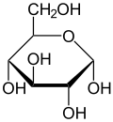
Malonic Acid | C₃H₄O₄ | 104.061 | 135 - 137 | 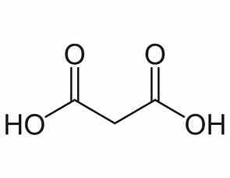
Zinc Chloride |  | 136.29 | 290 anhydrous | cl----Zn-----cl
Sodium Borohydride | NaBH₄ | 37.83 |  | 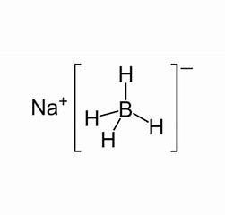
Hydrazine Hydrate | N₂H₄.H₂O | 50.061 | -52 | 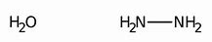

Table 1: Chemicals Used for this study

3.1. Preparation of Glucose – Malonic Acid based DES
A deep eutectic solvent using glucose and malonic acid was prepared by taking in the mole ratio of 1:1 by evaporation methods ^{[76]}. In this method 18 g of glucose and 10.4 g of malonic acid were dissolved in 20 ml of deionized water to form a clear liquid. Then excess of water was evaporated off from this homogenous liquid by gentle heating and the mixture was weighed from time to time until a constant weight was obtained. Then the clear liquid obtained was kept in a dessicator containing anhydrous CaCl₂ for 14 days. As no turbidity or precipitate was seen in the liquid, the deep eutectic solvent formed between glucose and malonic acid was tested for its pH, conductivity, density, viscosity.

3.2. Physical Characterization of DES
The conductivity of the DES was measured using Systronics Conductivity Meter 304 at room temperature. The density of the DES was measured at room temperature using a standard Pycno meter. The viscosity of the DES was measured using digital display rotational viscometer, ofLabman WENSAR make model LMDV 60 by following the standard procedure at room temperature. The pH of this ChCl-U, DES was measured using digital pH meter of ELICO make model no LI120 using the combined electrode CL-51B. These physical parameters of GLU-MA, DES were compared with the literature values.

3.3. Preparation of Zn S Nanoparticles
The Zinc Sulphide (ZnS) colloidal nanoparticles were synthesized by reduction method using NaBH₄ and N₂H₄ mixture under atmospheric conditions.The ZnS nanoparticles were synthesized using ZnCl₂, sodium borohydride and hydrazine hydrate in a molar ratio of 6:1:1 using the deep eutectic solvent obtained from glucose and malonic acid.
About 25 mg of ZnCl₂ was dissolved in 10 ml of GLU-MA, DES in a 100 ml of closed beaker. Undervigorous stirring using a magnetic stirrer with hot plate, freshly taken sodium borohydride (6.3 mg) was addedlittle by little into the reaction medium. Then the stirring was continued after the addition of hydrazine hydrate (10 mg) at the temperature of about 70 ºC until the color was changed from pink to black. After the reduction was completed, the solution wascentrifuged and the black colored particles were separated by washing withmethanol and dried in a vacuum.

3.4. Characterization of Zinc Sulphide Nanoparticles
The solubility of the dried ZnS particles were tested in various organic solvents. The UV-Visible spectrum of ZnS NPs were obtained using a double beam spectrophotometer. The FTIR spectrum of the Copper (II) Oxide nanoparticles were recorded using a Shimadzu FTIR-8900 spectrometer. The field emission scanning electron microscope image (SEM) and energy dispersive X-ray analysis (EDAX) were carried out for the ZnS NPs obtained. These data obtained in this study were compared with the data available in the literature for ZnS nanoparticles

4. RESULTS AND DISCUSSIONS

4.1. Physical Properties of Glucose – Malonic Acid DES
The deep eutectic solvent of Glucose and Malonic acid obtained by the evaporation method was examined for its physical properties such as freezing point, conductivity, density, viscosity and pH at room temperature.

4.1.1 Freezing Point
The GLU-MA DES was cooled in a freezing mixture to note its freezing point. The DES exists as a clear liquid until 10 ºC and below this temperature a turbidity was formed.

4.1.2 Conductivity
The literature survey indicates values of electrical conductivities for DES and common ionic liquids in the range of 0.1 - 14 mS cm⁻¹. The electrical conductivity of the DES of GLU- MA obtained here was found to be 0.154 mS cm⁻¹ at 25 ºC.

4.1.3 Density
Density is an important characteristic property of any liquid. Very limited information is known about the densities of ionic liquids and DES. The density of the DES of GLU-MA obtained by us was measured to be 1.1915 g cm⁻³ at 25 ºC.

4.1.4 Viscosity
The viscosity is a parameter influencing the hydrodynamic processes in all applications of ionic liquids for instance in electrolysis cells. Some aspects of transport phenomena in pure molten salts and ionic liquids are simpler than similar phenomena in aqueous solutions. Unfortunately, there are very few data on the viscosity of ionic liquids and DES. The viscosity of the DES obtained from Glucose and Malonic acid was measured to be as 5084.13 mPa. s at 25 ºC.

4.1.5 The pH
Further the pH values of GLU-MA DES obtained by us was measured to be 1.63 at 25 ºC.
The table 2 give the values of freezing point, conductivity, density, viscosity and pH values of 1:1 DES of GLU-MA prepared by us.

Table 2: Physical Parameters of GLU-MA DES

Physical Parameters | Measured Values  1:1 DES of GLU-MA
Freezing Point (oC) | ~ 10
Conductivity (mS cm-1) | 0.154
Density (g cm-3) | 1.1915
Viscosity (mPa. S) | 5084.13
pH | 1.63

  - Characterization of MnO Nanoparticles

4.2.1 The Solubility of ZnS Nanoparticles
The solubility of nanoparticles of Zinc Sulphide prepared by greener method using the deep eutectic solvent of Glucose and Malonic acid was tested in various organic solvents such as water, ethanol, chloroform and dimethyl sulfoxide. The samples are only soluble in chloroform and insoluble in the other solvents given above.

4.2.2 UV-Visible Spectrum of ZnS Nanoparticles
The UV-Visible spectrum of Zinc Sulphide nanoparticles is provided in Figure 1.
The UV–vis spectroscopy of ZnS NPs (Fig. 1) shows the absorption maximum (λmax) at 269 and 296 nm. This is due to n→π* and π→π* transitions ^{[77]}. The absorption bands seen at different places reveal that the MnO nanoparticles were formed with different morphologies with various sizes. The λmax at this wavelength indicates the formation of ZnS NPs.
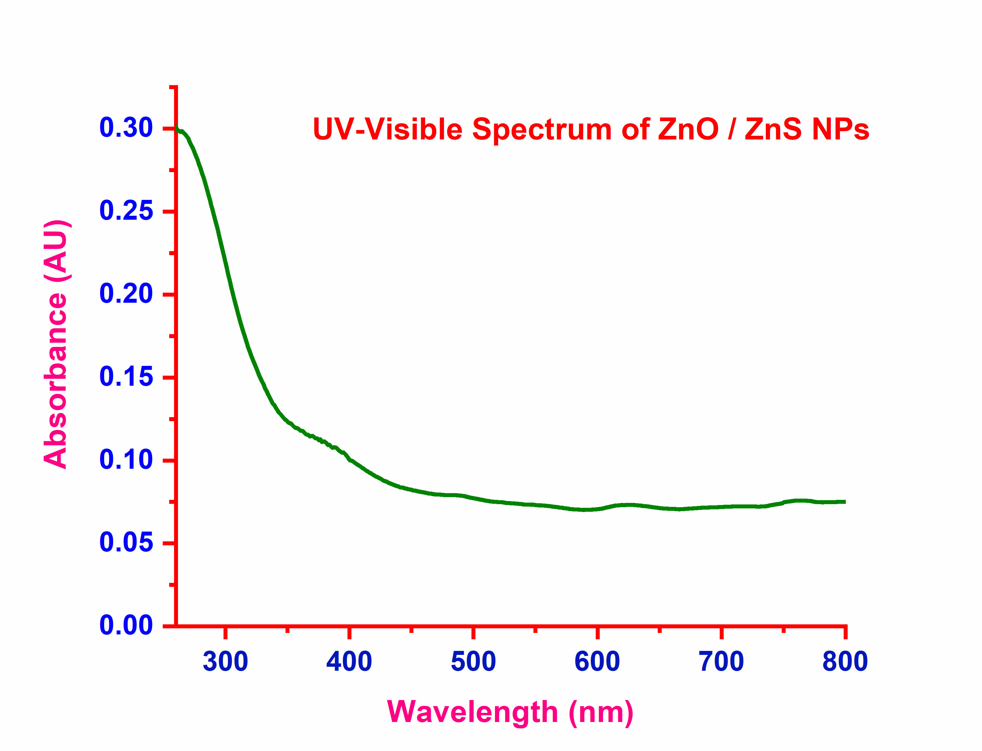
Figure 1. The UV-Visible Spectrum of MnO NPs obtained in GLU-MA DES

4.2.3 FTIR Spectrum of ZnS Nanoparticles
The FTIR spectrum obtained for ZnS nanoparticles was given in Figure 2. FTIR spectroscopy is a convenient tool to know the functionality of any organic molecule. In the present work, we used FTIR spectra to identify whether there are any peaks due to the carbonyl,hydroxyl, aliphatic CH, and CH2 groups of both glucose and malonic acid in the final nanoparticles of MnO, which would confirm the surface capping on the manganese (II) oxide nanoparticles as capping of Cu nanoparticles reported by A. B. S. Sastry et al.
drogen Energy 39 (2014) 10892–10901.
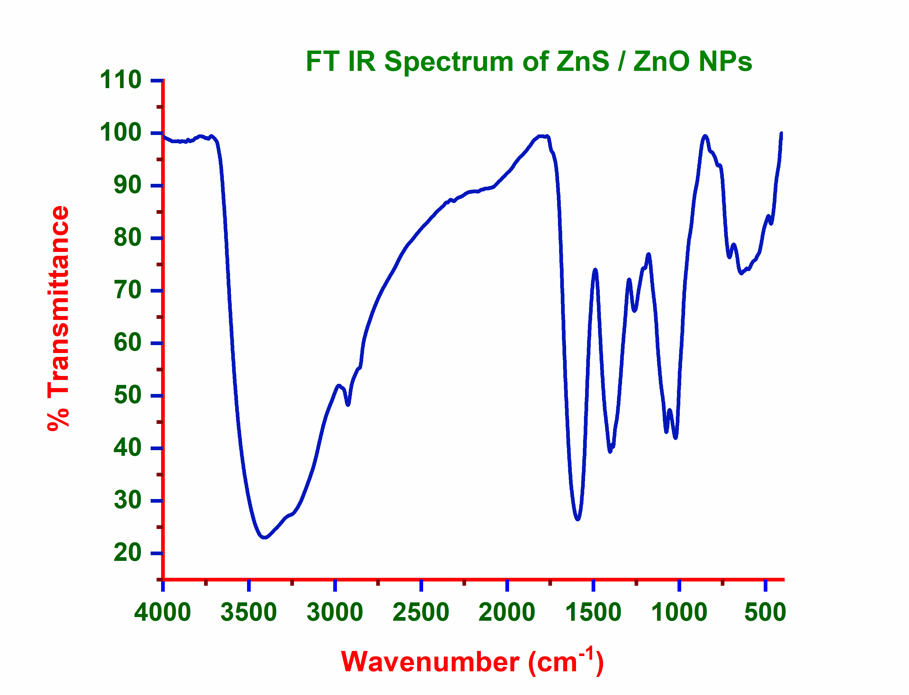
Figure 2. The FTIR Spectrum of ZnS NPs obtained in GLU-MA DES
The FTIR spectrum given in Figure 2 shows several bands between 722.41 and 539.59 cm⁻¹, which can be assigned to the vibrations of M⁺ - O bonds. The sharp peak observed at 722.41 cm⁻¹ in the spectrum MnO nanoparticles is the characteristics of Zn-S bond formation. Usually ZnS shows a strong IR band at ~ 1500 cm⁻¹ according to George Socrates. In agreement with this a strong band noticed at 922.41 cm⁻¹ of figure 2 confirmed the formation of ZnS particles during the reduction of ZnCl₂ using NaBH₄ and N₂H₄ mixture as reducing agent in the DES medium of Glucose and Malonic Acid.
For the ZnS NPs prepared using ZnCl₂ in presence of NaBH₄ and N₂H₄ as reducing agent in the DES medium of Glucose and Malonic acid, the FTIR spectrum obtained do not show any strong and sharp peak due to the C=O stretching frequency of glucose molecule. Hence it is concluded that glucose did not act as a capping agent with ZnS nanoparticles. The weak peaks noticed around 690 cm⁻¹ indicates O – H out of plane bending vibrations of malonic acid. The peak at 970.18 cm⁻¹ reveals the C – C rocking vibrations of malonic acid. The sharp peak at 1080.43 cm⁻¹ and 1177.59 can be assigned to the C – O stretching of malonic acid. Further the peaks observed at 1283.88, 1383.54 and 1446.87 cm⁻¹ indicate various C – H deformations of CH₂ group of malonic acid.
The weak bands seen at 2217.66 and 2541.62 cm⁻¹ can be assigned to O – H stretching of Carboxylic groups of malonic acid. The weak peak at 2918.94 cm⁻¹ can be assigned to the C – H stretching vibrations of aliphatic CH₂ group of malonic acid. The H bonded O – H group of malonic acid with ZnS is confirmed by the broad peak at 3506.39 cm⁻¹. These data are in good agreement with Donald L. Pavia et al ^{[80,} ^{81]}. Thus, it is evident that malonic aicd is acting as a capping agent with ZnS nanoparticles.

4.2.4 FESEM of ZnS Nanoparticles
The field emission scanning electron microscope image of ZMnS nanoparticles prepared by the chemical reduction method using NaBH₄ and N₂H₄ mixture as the reducing agent in the deep eutectic solvent of glucose and malonic acid is given in Figure 3.

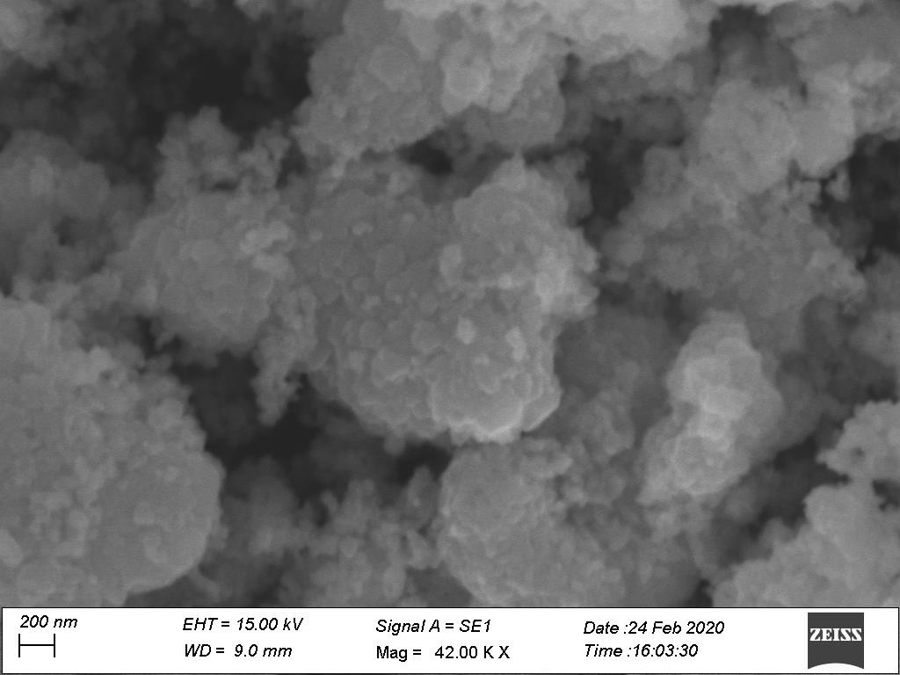

Figure 3. The FESEM of ZnS NPs obtained in GLU-MA DES
The morphological SEM examinations of synthesized ZnS powders reveal that ZnS particles generated from the GLU-MA DES were composed of a large number of uniform scales like particles. The discrete pseudo-particles are clearly visible in the nano scale level, which provides the enough evidence for the formation of ZnS nanoparticles.

4.2.5 EDAX Analysis of ZnS Nanoparticles
The presence of Mn in the prepared samples is confirmed from the selective area EDAX analysis. The weight percent and atom percent of Oxygen and Manganese are given in table 3 below. From this table it was clearly showed that only Oxygen and Manganese are present in the particles prepared from GLU-MA DES.

Table 3. The element details of EDAX analysis of ZnS Nanoparticles

Element  Line | Weight % | Weight %  Error | Atom %
S K | 60.00 | ± 2.14 | 83.74
Zn K | 40.00 | ± 2.48 | 16.26
Zn L | --- | --- | ---
Total | 100.00 |  | 100.00

SUMMARY AND CONCLUSION

A deep eutectic solvent of glucose and malonic acid was prepared by evaporation method. Its freezing point was found to be 10 ºC, which is lower than that of 146 and 135 ºC of glucose and malonic acid respectively. The liquid was clear at room temperature for more than fourteen days. The density, viscosity, conductivity and pH of the DES was measured and the values obtained are comparable with the values reported in the literature.
The GLU-MA DES was used a solvent in the preparation of ZnS nanoparticle by using NaBH4 and N2H4 mixture as reducing agent. The UV-Visible and FTIR spectra were recorded for these particles. Both the UV-Vis and IR data were compared with the various literature values. From this analysis of FTIR data, we expected that ZnS nanoparticles are formed and the malonic was acted as a capping agent during the formation of nanoparticles. The field emission SEM analysis carried out to know the morphology of ZnS nanoparticles showed that uniform sized particles are obtained in the nano scale.

In addition to this, the energy dispersive X-ray analysis of nano particles prepared showed only manganese and oxygen elements are present in it. Therefore, Zn particles are obtained within the nano scale in this DES of glucose and malonic acid. Further analysis of X-ray diffraction studies and Transmission Electron Micrograph are to be carried out to know the particle size accurately for the sample prepared.
[17e]. Van Osch, D.J.; Zubeir, L.F.; van den Bruinhorst, A.; Rocha, M.A.; Kroon, M.C. Green Chem. 2015, 17, 4518–4521.
[18]. D. Freudenmann, S. Wolf, M. Wolff and C. Feldmann, Angew. Chem., Int. Ed., 2011, 50, 11050–11060;
[19]. Z. Ma, J. Yu and S. Dai, Adv. Mater., 2010, 22, 261–285.
[20]. E. R. Parnham and R. E. Morris, Acc. Chem. Res., 2007, 40, 1005–1013
[21]. R. E. Morris, Chem. Commun., 2009, 2990–2998 A. Taubert, Acta Chim. Slov., 2005, 52, 183–186.
[22]. Young Hae Choi, Jaap van Spronsen, Yuntao Dai, Marianne Verberne, Frank Hollmann, Isabel W.C.E. Arends, Geert-Jan Witkamp, and Robert Verpoorte, Plant Physiol. Vol. 156, 2011, 1701-1705.
[23]. Adeeb Hayyan, Farouq S.Mjalli, Inas M.AlNashef, TalalAl-Wahaibi, Yahya M.Al-Wahaibi, Mohd AliHashim, Thermochimica Acta, 541, 10 August 2012, Pages 70-75.
[24]. Hina Khalid, S. Shamaila, N. Zafar, Sci.Int.(Lahore),27(4), 3085-3088, 2015.
[25]. Min-Joo Kim, Heay-Jin Na, Kyoung Chul Lee, Eun Ah Yoob and Minyung Lee, J. Mater. Chem., 2003, 13, 1789–1792.
[26]. I. Capek, Advances in Colloid and Interface Science 110 (2004) 49–74.
[27]. Md. Abdulla-Al-Mamun, Yoshihumi Kusumoto, Manickavachagam Muruganandham, Materials Letters 63 (2009) 2007–2009.
[28]. K. Byrappa T. Adschiri , 2007. Hydrothermal technology for nanotechnology Volume 53, Issue 2, June, Pages 117–166.
[29]. Y. Ren, Z. Ma, L. Qian, S. Dai, H. He, P.G. Bruce, 2009. Catalysis Letters 131 146–154.
[30]. J.N. Park, J.K. Shon, M. Jin, S.H. Hwang, G.O. Park, J.-H. Boo, T.H. Han, J.M. Kim, 2010. Chemistry Letters 39 493–495.
[31]. Hu, L. et al., 2013. Journal of Alloys and Compounds, 576, pp.86–92.
[32]. Salavati-Niasari, M., Esmaeili-Zare, M. & Gholami-Daghian, M., 2014. Advanced Powder Technology, pp.3–8.
[33]. Pugazhvadivu, K.S., Ramachandran, K. & Tamilarasan, K., 2013. Physics Procedia, 49, pp.205–216.
[34]. Han, Y.-F. et al., 2006. Catalysis Communications, 7(10), pp.739–744.
[35]. Gnanam, S. & Rajendran, V., 2013. Journal of Alloys andCompounds, 550, pp.463–470.
[36]. Liu L, Liang H, Yang H, Wei J, Yang Y., 2011. Nanotechnology. 22(1) 015603.
[37]. Zhao, D., Tan, J. S., Ji, Q. Q., Zhang, J. T., Zhao, X. S. and Guo, P. Z., 2010. Chinese Journal of Inorganic Chemistry, Vol 26 No 5
[38]. Soundappan Thiagarajan, Tsung Hsuan Tsai, Shen-Ming Chen, 2011, Int. J. Electrochem. Sci., 6 2235 – 2245.

[39]. Jie Cao QingheMaoa, Yitai Qian, 2012. Journal of Solid State Chemistry 191 10–14.
[40]. Yang, Z. et al., 2006. ChemicalPhysics Letters, 418(1-3), pp.46–49.
[41]. Tokeer A., Kandalam V. R., Samuel E. L., Ashok K. G., 2004J. Mater. Chem., ,14, 3406-341
[42]. Francis, T.M., Lichty, P.R. & Weimer, A.W., 2010. Chemical Engineering Science, 65(12), pp.3709–3717.
[43]. M. Shamshi Hassan, Touseef Amna, Dipendra Raj Pandeya, A. M. Hamza, Yang You Bing, Hyun-ChelKim, Myung-Seob Khil, 2012. Applied Microbiology and Biotechnology,Volume 95, pp 213-222
[44]. Jie Cao, QingheMao, YitaiQian, 2007. Solid State Communications 142 723–726
[45]. Yuntao Dai, Jaap van Spronsen, Geert-Jan Witkamp, Robert Verpoorte, Young Hae Choi, Analytica Chimica Acta 766 (2013) 61–68.
[46]. C. Florindo, M.M. Oliveira, L.C. Branco, I.M. Marrucho, Journal of Molecular Liquids 247, September 2017, DOI: 10.1016/j.molliq.2017.09.026
[47]. R.R. Deshmukh, R. Rajagopal, K.V. Srinivasan, Chem. Commun. (2001) 1544–1545.
[48]. Y. Zheng, L. Ye, L. Yan, Y. Gao, Int. J. Electrochem. Sci. 9 (2014)
[49]. V.S. Raghuwanshi, M. Ochmann, A. Hoell, F. Polzer, K. Rademann, Langmuir 30 (2014) 6038–6046.
[50]. V.S. Raghuwanshi, M. Ochmann, F. Polzer, A. Hoell, K. Rademann, Chem. Commun. 50 (2014) 8693–8696.
[51]. P. Martis, V.S. Dilimon, J. Delhalle, Z. Mekhalif, Electrochim. Acta 55 (2010) 5407–5410.
[52]. S. Fashu, C.D. Gu, X.L. Wang, J.P. Tu, J. Electrochem. Soc. 161 (2014) D3011–D3017.
[53]. X. Guo, S. Wang, J. Gong, J. Guo, L. Peng, W. Ding, Appl. Surf. Sci. 313 (2014) 711–719.
[54]. L. Wei, Y.-J. Fan, H.-H. Wang, N. Tian, Z.-Y. Zhou, S.-G. Sun, Electrochim. Acta 76 (2012) 468 – 474.
[55]. L. Wei, Z.-Y. Zhou, S.-P. Chen, C.-D. Xu, D. Su, M.E. Schuster, S.-G. Sun, Chem. Commun. 49 (2013) 11152–11154.
[56]. L. Wei, Y.-J. Fan, N. Tian, Z.-Y. Zhou, X.-Q. Zhao, B.-W. Mao, S.-G. Sun, J. Phys. Chem. C 116 (2011) 2040–2044.
[57]. R. Böck, G. Lanzinger, R. Freudenberger, T. Mehner, D. Nickel, I. Scharf, T.
Lampke, J. Appl. Electrochem. 43 (2013) 1207–1216.
[58]. A.P. Abbott, K. El Ttaib, G. Frisch, K.J. McKenzie, K.S. Ryder, Phys. Chem. 11 (2009) 4269–4277.
[59]. E. Gomez, E. Valles, P. Cojocaru, A. Raygani, L. Magagnin, ECS Trans.41(2012)3–9.
[60]. J.A. Hammons, T. Muselle, J. Ustarroz, M. Tzedaki, M. Raes, A. Hubin, H.
Terryn, J. Phys. Chem. C 117 (2013) 14381–14389.

[61]. A. Renjith, A. Roy, V. Lakshminarayanan, J. Colloid Interface Sci. 426 (2014)
270–279.
[62]. Y. Zhao, Y. Zhao, H. Feng, J. Shen, J. Mater. Chem. 21 (2011) 8137–8145.
[63]. X. Ge, C.D. Gu, X.L. Wang, J.P. Tu, J. Colloid Interface Sci. 438 (2015) 149–158.
[64]. X. Ge, C.D. Gu, X.L. Wang, J.P. Tu, Chem. Commun. 51 (2015) 1004–1007.
[65]. X. Ge, C.D. Gu, X.L. Wang, J.P. Tu, J. Mater. Chem. A 2 (2014) 17066–17076.
[66]. X. Ge, C.D. Gu, X.L. Wang, J.P. Tu, J. Phys. Chem. C 118 (2013) 911–923.
[67]. Q.Q. Xiong, J.P. Tu, X. Ge, X.L. Wang, C.D. Gu, J. Power Sources. 51 (2015) 1004–1007.
[68]. X.Ge, C.D. Gu, Y.Lu, X.L. Wang, J.P. Tu, J. Mater. Chem. A 1 (2013) 13454–13461.
[69]. F. Chen, S. Xie, J. Zhang, R. Liu, Mater. Lett. 112 (2013) 177–179.
[70]. Y.Huang, F.Shen, J.La, G.Luo, J.Lai, C.Liu, G.Chu, Part.Sci.Technol.31(2012)81–84.
[71]. H.-G. Liao, Y.-X. Jiang, Z.-Y. Zhou, S.-P. Chen, S.-G. Sun, Angew. Chem. Int. Ed. Engl. 47 (2008) 9100–9103.
[72]. H. Zheng, C.-D. Gu, X.-L. Wang, J.-P. Tu, J. Nanopart. Res. 16 (2014) 1–9.
[73]. A. Querejeta-Fernández, J.C. Hernández-Garrido, H. Yang, Y. Zhou, A. Varela,
M. Parras, J.J. Calvino-Gámez, J.M. González-Calbet, P.F. Green, N.A. Kotov, ACS Nano 6 (2012) 3800–3812.
[74]. Y.-H. Lu, W.-H. Lin, C.-Y. Yang, Y.-H. Chiu, Y.-C. Pu, M.-H. Lee, Y.-C. Tseng, Y.-J. Hsu, Nanoscale 6 (2014) 8796 – 8803.
[75]. C.D. Gu, M.L. Huang, X. Ge, H. Zheng, X.L. Wang, J.P. Tu, Int. J. Hydrogen Energy 39 (2014) 10892–10901.
[76]. Koon-Kwee Kow, Kamalish Shirat. Chinese Chemical Letters, 2015,26(10): 1311-1314.

