Gastro retentive drug delivery system

Yashkumar Ashok Meshram, Laximikant N. Barde, Mukesh M. Nikhade,
Shrikant V. Kamle

Jagadambha Institute of Pharmacy and Research, Kalamb, Yavatmal, M.S.

Email: - yashkumarmeshram@gmail.com, chetanbarde21@gmail.com

Abstract
In this context, various gastroretentive drug delivery systems (GRDDS) have been used to improve the therapeutic efficacy of drugs that have a narrow absorption window, are unstable at alkaline pH, are soluble in acidic conditions, and are active locally in the stomach. In this review, we discuss the physiological state of the stomach and various factors that affect GRDDS. Recently applied gastrointestinal technologies such as expandable, superporous hydrogel; bio/mucoadhesive, magnetic, ion-exchange resin; and low- and high-density-systems have also been examined along with their merits and demerits. This review provides a concise account of various attributes of recently developed approaches for GRDDS.
Key words: Gastroretentive drug delivery, Superporous hydrogel, ion-exchange resin.

INTRODUCTION
Oral route is most commonly adopted and most convenient route for drug administration. Oral route of administration has been received more attention in the pharmaceutical field because of the more flexibility in the designing of dosage form than drug delivery design for other routes.¹ This route has high patient acceptability, due to ease of administration. Over the years the oral dosage forms have become sophisticated with development of controlled release drug delivery system (CRDDS).²
Several difficulties are faced in designing controlled release systems for better absorption and enhanced bioavailability. One of such difficulties is the inability to confine the dosage form in the desired area of the gastrointestinal tract. Drug absorption from the gastrointestinal tract is a complex procedure and is subject to many variables. It is widely acknowledged that the extent of gastrointestinal tract drug absorption is related to contact time with the small intestinal mucosa³.Thus small intestinal transit time is an important parameter for drugs that are incompletely absorbed. Gastroretentive systems can remain in the gastric region for several hours and hence significantly prolong the gastric residence time of drugs. Prolonged gastric retention improves bioavailability, reduces drug waste and improves solubility for drugs that are less soluble in a high pH environment. It has applications also for local drug delivery to the stomach and proximal small intestines. Gastro retention helps to provide better availability of new products with new therapeutic possibilities and substantial benefits for patients. The controlled gastric retention of solid dosage forms may be achieved by the mechanisms of mucoadhesion, flotation, sedimentation, expansion modified shape systems or by the simultaneous administration of pharmacological agent, that delay gastric emptying.^{3,4}
The CRDDS possessing ability of being retained in the stomach are called gastro retentive drug delivery system (GRDDS) and they can help in optimizing oral controlled delivery of drugs having ‘absorption window’ by continuously releasing drug prior to absorption window, for prolonged period of time. Prolonged gastric retention improves bioavailability, reduces drug waste, and improves solubility for drugs that are less soluble in a high pH environment.¹

1.1 Gastrointestinal tract physiology
The stomach is continuous with the oesophagus at the cardiac sphincter and with the duodenum at the pyloric sphincter. It has two curvatures. The lesser curvature is short, lies on the posterior surface of the stomach and is the downwards continuation of the posterior wall of the oesophagus. Just before the pyloric sphincter it curves upwards to complete the J shape. Where the oesophagus joins the stomach the anterior region angles acutely upwards, curves downwards forming the greater curvature then slightly upwards towards the pyloric sphincter.
The stomach is divided into three regions: the fundus, the body and the antrum. At the distal end of the pyloric antrum is the pyloric sphincter, guarding the opening between the stomach and the duodenum. When the stomach is inactive the pyloric sphincter is relaxed and open and when the stomach contains food the sphincter is closed.⁵
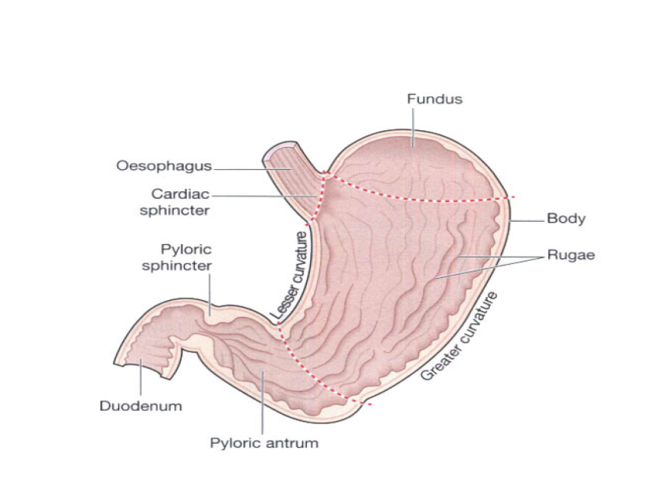
Figure 1. Physiology of stomach.⁵
  - Gastric Emptying
Gastric emptying occurs during fasting as well as fed states. The pattern of motility is however distinct in the 2 states. During the fasting state an interdigestive series of electrical events take place, which cycle both through stomach and intestine every 2 to 3 hours. This is called the interdigestive myloelectric cycle or migrating myloelectric cycle (MMC), which is further divided into following four phases.

1. Phase I (basal phase) lasts from 40 to 60 minutes with rare contractions.
2. Phase II (preburst phase) lasts for 40 to 60 minutes with intermittent action potential and contractions.As the phase progresses the intensity and frequency also increases gradually.
3. Phase III (burst phase) lasts for 4 to 6 minutes. It includes intense and regular contractions for short period. It is due to this wave that all the undigested material is swept out of the stomach down to the small
intestine. It is also known as the housekeeper wave.
4. Phase IV lasts for 0 to 5 minutes and occurs between phases III and I of 2 consecutive cycles.

After the ingestion of a mixed meal, the pattern of contractions changes from fasted to that of fed state. This is also known as digestive motility pattern and comprises continuous contractions as in phase II of fasted state. These contractions result in reducing the size of food particles (to less than 1 mm), which are propelled toward the pylorus in a suspension form. During the fed state onset of MMC is delayed resulting in slowdown of gastric emptying rate.⁴

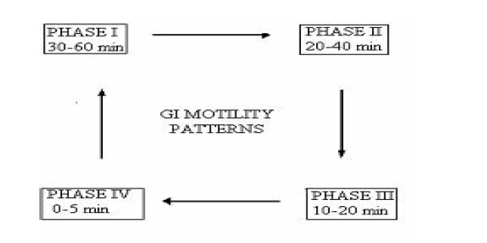
Figure 2. Patterns gastrointestinal motility.⁶

1.3. Need For Gastro retentive Drug Delivery System:
Various drugs have their greatest therapeutic effect when released in the stomach, particularly when the release is prolonged in a continuous, controlled manner. Drugs delivered in this manner have a lower level of side effects and provide their therapeutic effects without the need for repeated dosages or with a low dosage frequency. Sustained release in the stomach is also useful for therapeutic agents that the stomach does not readily absorb, since sustained release prolongs the contact time of the agent in the stomach or in the upper part of the small intestine, which is where absorption occurs and contact time is limited. Under normal or average conditions, for example, material passes through the small intestine in as little as 1-3 hours.⁷

  - Factors affecting performance of GRDDS ²

1.4.1. Formulation Factors
1.Density: FDDS are retained in the stomach by virtue of their floating tendency for which their density should be less than that of the gastric contents.
2.Shape: The effect of various geometric shapes on GRT of the dosage form has been well studied. Six shapes (ring, tetrahedron, clove leaf, string, pellet, disc) were screened in vivo for their gastric retention potential. The tetrahedron and rings exhibited nearly 100% retention at 24 hours. On the other hand, clove leaves exhibited 40-67%, discs 67% and string and pellet showed no retention at 24 hours.
3.Size: Small-sized tablets are emptied from the stomach during the digestive phase, while the larger size tablets are expelled during the housekeeping waves. Varying gastric emptying times were observed for non-disintegrating tablets of different size. Longest gastric emptying time was observed for 13 mm tablets (171±13 min) followed by 11 mm (128 ± 17min) and 7mm (116 ± 19 min) tablets.

1.4.2. Iodosyncratic Factors ²
1. Concomitant intake of food and drugs like anticholinergics, opiates and prokinetic agents.
- Biological factors like gender, age, posture, body mass index and disease state.

1.4.3. Other Factors
- Presence of food:
GRT increases in the presence of food, leading to the increase in the dissolution of the drug and a longer residence of the dosage form at the most favourable sites of absorption.
- Nature of food:
Caloric content and the frequency of intake of food affect the GRT of the dosage form. Co-administration of GIT motility decreasing drugs can increase the gastric emptying time.
- Gender factor
Women and elderly show slower gastric emptying than men. Intersubject and intersujective variations are also observed in the gastric and intestinal transit times. Subject posture also leads to variable intragastric behaviors. The upright position protects the floating form against postprandial emptying, as the floating form remains continuously above the gastric contents irrespective of their size.

CLASSIFICATION OF GASTRO RETENTIVE DRUG DELIVERY SYSTEM
A number of techniques have been used to increase the GRT of dosage forms employing a variety of concept such as floating, swelling, inflation and adhesion. These systems have been classified according to their basic principle of gastric retention as below.

GRDDS

FLOATING DRUG DELIVERY SYSTEM
EXPANDABLE SYSTEMS

BIO/MUCO ADHESIVE SYSTEM

HIGH DENSITY SYSTEM

MAGNETIC SYSTEM

EFFERVESCENT
SYSTEM

SWELLING

Figure 3. Classification of gastro retentive drug delivery system ²
NON EFFERVESCENT SYSTEM

UNFOLDING

1.5.1. Floating drug delivery system
Floating systems, first described by davis in 1968, have lower than gastric fluid, and thus remains buoyant in stomach for a prolonged period. While the system is floating on the gastric contents, the drug is released slowly at a desired rate. This result in an increase in the GRT and a better control of flocculation in the plasma drug concentrations. Floating systems can be classified into two distinctly different categories, they are ²
- Effervescent System
- Non- Effervescent System

A. Effervescent System
Effervescent systems include use of gas generating agents, carbonates (e.g. Sodium bicarbonate) and other organic acid (e.g. citric acid and tartaric acid) present in the formulation to produce carbon dioxide (CO₂) gas, thus reducing the density of the system and making it float on the gastric fluid. An alternative is the incorporation of matrix containing portion of liquid, which produce gas that evaporate at body temperature. These effervescent systems further classified into two types. ⁸
- Volatile Liquid/Vacuum Containing Systems
- Gas Generating systems

- Volatile Liquid/Vacuum Containing Systems
The GRT of a drug delivery system can be sustained by incorporating an inflatable chamber, which contains a liquid eg. ether, cyclopentane, that gasifies at body temperature to cause the inflation of the chamber in the stomach. These devices are osmotically controlled floating systems containing a hollow deformable unit that can convert from a collapsed to an expanded position, and returns to collapsed position after an extended period. The deformable system consists of two chambers separated by an impermeable, pressure-responsive, movable bladder. The first chamber contains the drug and the second chamber contains the volatile liquid. The device inflates, and the drug is continuously releases from the reservoir into the gastric fluid. ²

Figure 4. Osmotically controlled drug delivery system. ⁹

b. Gas Generating systems
These buoyant delivery system utilize effervescent reaction between carbonate/bicarbonate salts and citric/tartaric acid to liberate CO₂, which gets entrapped in the gellified hydrocolloid layer of the system, thus decreasing its specific gravity and making it float over chime.These tablets may be either single layered wherein the CO₂ generating components are intimately mixed within the tablet matrix, or they may be bilayered in which the gas generating components are compressed in one hydrocolloid containing layer, and the drug in other layer formulated for a SR effect. ²
Figure 5. Gas generating system: Schematic monolayer drug delivery system (a) Bilayer gas generating system, with (c) or without (b) semipermeable membrane.¹⁰

Raft-forming systems
Here, a gel-forming solution (e.g. sodium alginate solution containing carbonates or bicarbonates) swells and forms a viscous cohesive gel containing entrapped CO_{2,} bubbles on contact with gastric fluid. Formulations also typically contain antiacids such as aluminium hydroxide or calcium carbonate to reduce gastric acidity. Because raft-forming systems produce a layer on the top of gastric fluids, they are often used for gastroesophageal reflux treatment. ¹⁰

Figure 6. Schematic illustration of the barrier formed by a raft-forming system.¹⁰

B. Non-effervescent floating dosage form
The most commonly used excipients in noneffer- vescent FDDS are gel-forming or highly swellable cellulose type hydrocolloids, polysaccharides, and matrix forming polymers such as polycarbonate, polyacrylate, polymethacrylate and polystyrene. One of the approaches to the formulation of such floating dosage forms involves intimate mixing of drug with a gel-forming hydrocolloid, which swells in contact with gastric fluid after oral administration and maintains a relative integrity of shape and a bulk density of less than unity within the outer gelatinous barrier. The air trapped by the swollen polymer confers buoyancy to these dosage forms. In addition, the gel structure acts as a reservoir for sustained drug release since the drug is slowly released by a controlled diffusion through the gelatinous barrier.¹⁰

Hydrodynamically balanced systems:
Also known as colloidal gel barrier system. This system was first designed by Sheth & Tossounian in 1975. Such a systems containing drugs with gel-forming hydrocolloids meant to remain buoyant on the stomach contents. This prolongs GI residence time and maximizes drug reaching its absorption site absorption site in the solution from and hence is ready for absorption. These systems incorporate a high level of one or more gel- forming, highly swellable, cellulose-type hydrocolloids [e.g. hydroxyethyl cellulose (HEC), Hydroxypropyl cellulose (HPC), Hydroxypropyl methyl cellulose (HPMC), Sodium carboxymethylcellulose (NaCMC)], Polysaccharides and matrix forming polymers such as polycarbophil, polyacrylates and polystyrene, incorporated either in tablets or in capsules. On coming in contact with gastric fluid the hydrocolloid in the system hydrates and forms a colloidal gel barrier around its surface. This gel barrier controls the rate of fluid penetration into the device and consequent release of the drug. As the exterior suface of the dosage form goes into the solution, the gel layer is maintained by the adjacent hydrocolloid layer becoming hydrated. The air trapped in by swollen polymer maintains a density less than unity and confers buoyancy to these dosage forms.
The hydrodynamically balanced system must comply with three major criteria-
- It must have sufficint structure to form cohesive gel barrier
- It must maintain an overall specific density lower than that of gastric content
- It should dissolve slowly enough to serve as reservoir for the delivery system. ²
The main drawback is the passivity of the operation. It depends on the air sealed in the dry mass centre following hydration of the gelatinous surface layer and hence the characteristics and amount of polymer. Effective drug delivery depends on the balance of drug loading and the effect of polymer on its release profile. A variety of strategies has been employed to improve efficacies of the floating HBS. Some investigators developed bilayer formulations in which one layer conferred the buoyancy and the other controlled the drug release. ¹⁰

Figure 7. Hydrodynamically balanced system (HBS).¹⁰

1.5.2 Expandable System
After being swallowed, these dosage forms swell to a size that prevents their passage through the pylorus.
The expandable GRDFs are usually based on three configurations:
- A small collapsed configuration which enables sufficient oral intake
- Expanded form that is achieved in the stomach and thus prevents passage through the pyloric sphincter.
- A smaller form that is achieved in the stomach when the retention is no longer required i.e. after the GRDF has released its active ingredient, thereby enabling evacuation.
The expansion can be achieved by
- Swelling system
- Unfolding system ⁷

i) Swelling system
These are the dosage forms, which after swallowing; swell to an extent that prevents their exit from the pylorus. As a result, the dosage form is retained in the stomach for a long period of time. These systems may be named as “plug type system”, since they exhibit the tendency to remain logged at the pyloric sphincter if that exceed a diameter of approximately 12- 18 mm in their expanded state. The formulation is designed for
gastric retention and controlled delivery of the drug into the gastric cavity. Such polymeric matrices remain in the gastric cavity for several hours even in the fed state. ⁸
Figure 8. Swellable system.¹⁰
Superporous hydrogels
Although these are swellable systems, they differ sufficiently from the conventional types to warrant separate classification. With pore size ranging between 10 nm and 10 Am, absorption of water by conventional hydrogel is a very slow process and several hours may be needed to reach an equilibrium state during which premature evacuation of the dosage form may occur. Superporous hydrogels, average pore size >100 Am, swell to equilibrium size within a minute, due to rapid water uptake by capillary wetting through numerous interconnected open pores. Moreover, they swell to a large size (swelling ratio ¨100 or more) (Fig.8) and are intended to have sufficient mechanical strength to withstand pressure by gastric contraction. This is achieved by co-formulation of a hydrophilic particulate material, Ac-Di-Sol\ (croscarmellose sodium). In vivo studies with dogs showed that under fasting condition, the superporous hydrogel composite (i.e. containing Ac-Di-Sol\) remained in the stomach for 2–3 h. This time increased to >24 h after feeding, even though the fed condition was maintained only for a few hours. After several hours (¨30 h), fragmentation occurred and the composite was rapidly cleared. ¹⁰

Figure 9. Superporous hydrogels. in its dry (a) and water-swollen (b) state. On the right, schematic illustration of the transit of superporous hydrogel. These figures were originally published by Gutierrez-Rocca et al¹⁰

ii) Unfolding system
Unfoldable systems are made of biodegradable polymers. The concept is to make a carrier, such as a capsule, incorporating a compressed system which extends in the stomach. Caldwell et al. proposed different geometric forms (tetrahedron, ring or planar membrane [4-lobed, disc or 4-limbed cross form] of bioerodible polymer compressed within a capsule. ¹⁰ As shown in figure 10.
Figure 10. Different geometric shapes of unfolding systems.

1.5.3. Bio/muco adhesive systems
It is known that the surface epithelium of the stomach and intestine retains its integrity throughout the course of its lifetime, even though it is constantly exposed to a high concentration of hydrochloric acid and powerful protein splitting enzymes, like pepsin. This self – protective mechanism is due to the fact that the specialized goblet cells located in the stomach, duodenum, and transverse colon continuously secrete a large amount of mucus that remains closely applied to the surface epithelium. The mucus contains mucin, an oligosaccharide chain with terminal salicylic acid which is capable of neutralizing the hydrochloric acid and withstanding the action of pepsin and thus protects the epithelial cell membrane. A biomucoadhesive polymer is a natural or a synthetic polymer capable of producing an adhesive interaction with a biological membrane. Which is then called a bioadhesive polymer, or with the mucus lining on the GI mucosal membrane, which is thus called a mucoadhesive polymer. A biomucoadhesive polymer is known to have the following molecular characteristics:

1. It has molecular flexibility.

2. It contains hydrophilic functional groups.

3. It poses a specific molecular weight, chain length, and conformation.¹¹
The concept of using mucoadhesive polymer to extend the GI transit time is shown in figure 11.
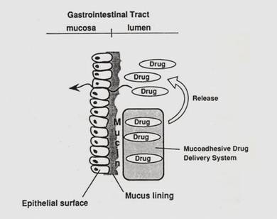
Figure 11. Interaction of a mucoadhesive drug delivery system with mucus layer on the gastrointestinal surface epithelium. ¹¹

1.5.4. High density system
High-density system is another modification of GRDDS. These systems with a density of about 3g/cm³ are reatained in the rugae of the stomach and are capable of withstanding its peristaltic movements. Systems with a threshold density of 2.6-2.8 g/cm³ can be retained in the lower part of the stomach.
The only major drawback with such system is that it is techanically difficult to manufacture such formulations with high amount of drug (>50%) and to achive a density of about 2.8. It is necessary to use diluents like barium sulphate (d=4.9), zinc oxide, titanium dioxide, iron powder, etc. to manufacture such high- density formulations.²
Figure 12. Schematic localization of an intragastric floating and high density system in the stomach.¹⁰

1.5.5. Magnetic systems
This system is based on a simple idea: the dosage form contains a small internal magnet, and a magnet placed on the abdomen over the position of the stomach. Ito et al. used this technique in rabbits with bioadhesives granules containing ultrafine ferrite (g-Fe2O3). They guided them to the oesophagus with an external magnet (¨1700 G) for the initial 2 min and almost all the granules were retained in the region after 2 h. Although these systems seem to work, the external magnet must be positioned with a degree of precision that might compromise patient compliance ¹⁰

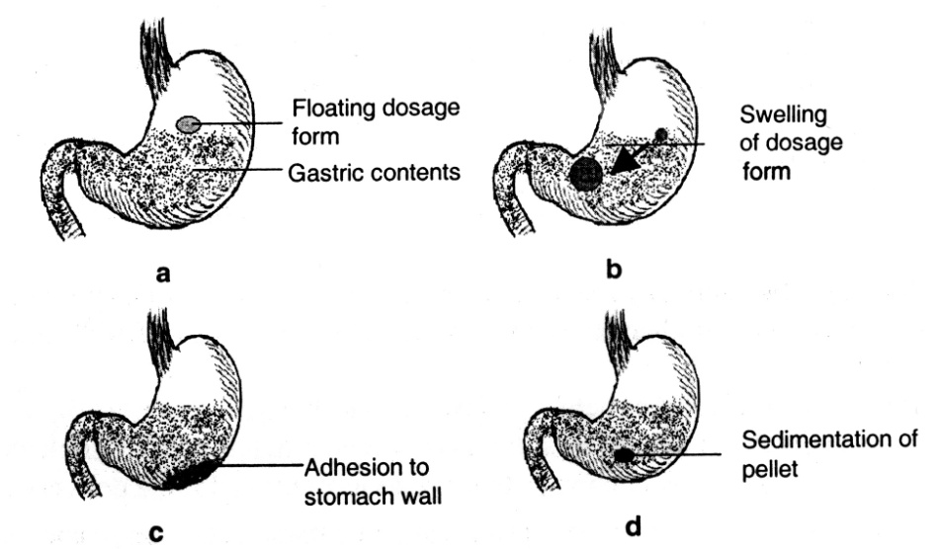
Figure 13. The various mechanisms used for development of gastroretentive drug delivery systems are shown in above Figure.²

1.6. Drug candidates criteria for formulation of floating oral sustained release systems
In general, appropriate candidates for CRGRDF are molecules that have poor colonic absorption but are characterized by better absorption properties at the upper parts of the GIT:
- Narrow absorption window in GI tract, e.g., riboflavin and levodopa
- Primarily absorbed from stomach and upper part of GItract, e.g., calcium supplements, chlordiazepoxide and cinnarazine
- Drugs that act locally in the stomach, e.g. antacids and misoprostol
- Drugs that degrade in the colon, e.g. ranitidine HCl and metronidazole
- Drugs that disturb normal colonic bacteria,e.g. amoxicillin trihydrate. ¹²

1.7. Limitations of gastroretentive drug delivery system
GRDDS have potential in improving bioavailability of drugs exhibiting ‘absorption window’, however, they have certain limitations.
- Requirement of high levels of fluids in the stomach for the delivery system to float and work efficiently.
- These systems also require the presence of food for delaying their gastric emptying.
- There are limitations to the applicability of GRDDS for drugs that have solubility or stability problems in the highly acidic gastric environment and are irritant to the gastric mucosa.
- In case of bioadhesive systems, which form electrostatic and hydrogen bonds with the mucus, the acidic environment and the thick mucus prevent the bond formation at the mucus-polymer interface. High turnover rate of the mucus may further aggravate the problem.
- For swellable systems, the maintenance of their size larger than the aperture of resting pylorus for required period of time is the major limiting factor. Above all ,any dosage form designed to stay in stomach during the fasted state should be capable of resisting the housekeeper waves of phase III contractions of migrating myoelectric cycle. ²

1.8. Drug Release Mechanism
After oral administration and exposure to aqueous medium, the polymer in hydrophilic matrix tablet quickly hydrates on the surface and forms a gel layer around the tablet. This phenomenon is also referred to glassy to rubbery state transition of polymer. The outermost layer of gelled polymer reaches a dilution point where it no longer has structural integrity and the polymer finally disentangles and leaves the surface of the matrix. This phenomenon is referred to as erosion . On a molecular level, a highly coiled long chain and branched molecule when comes in contact with water, starts uncoiling due to formation of hydrogen bond with water, Figure14. This initial hydration of the polymeric molecule is seen as a viscous gel layer formation, causing an increased in the volume of the matrix (this mechanism is referred to as swelling). As time progresses and more and more polymeric molecular chain gets uncoiled due to hydration, weaker the gel becomes on the outer region of the gel structure. Finally when the entire polymeric molecule is uncoiled, (fully hydrated, mechanism referred to as relaxation), it finally disentangles from the surface of the matrix (referred to as erosion or dissolution). Figure15. shows the overall mechanisms involved while the matrix undergoes hydration, swelling and drug release.
Figure 14: Hydrophilic polymer dissolution

Drug release from the hydrophilic matrices, takes place via:
1. Diffusion of water soluble drugs through the hydrated gel layer
2. Diffusion and erosion of insoluble drug
3. A combination of above for most drugs
As solubility of the drug reduces, the erosion mechanism becomes more prominent.
Figure 15: Schematic representation of a hydrophilic matrix undergoing hydration, swelling and dissolution.

Key attributes for a successful ER hydrophilic matrix include:
1. Fast hydration of surface polymer and gel formation (to prevent burst release of soluble to highly soluble drugs)
2. Uniform distribution of polymer in the matrix (to give consistent swelling / erosion intra and inter tablet batch)
3. Sufficient polymer concentration on the tablet surface as well as inside the tablet to prevent pre-mature tablet disintegration (extremely crucial to prevent dose-dumping)
4. Smaller particle size of polymer (in order to have uniform distribution within the tablet and also to hydrate faster due to high surface area)
5. High / sufficient gel strength of the polymer to prevent variation in drug release in fasted or fed state
6. Inert to different gastro-intestinal fluid conditions (especially pH, osmotic pressure, ionic content in fasted and fed state). ¹⁴

References
- Vyas SP, Khar RK, editors. Controlled drug delivery concept and advances First edition. New Delhi: Vallabh Prakashan; 2000. p. 156
- Chawla G, Gupta P, Bansal AK. Gastroretentive drug delivery systems. In: Jain NK, editor. Progress in controlled and novel drug delivery system. 1st ed. New Delhi (India): CBS Publishers and Distributors; 2004. p. 76-97
- AV Mayavanshi and SS Gajjar, “Floating drug delivery systems to increase gastric retention of drugs: A Review, Research J. Pharm. and Tech. 1(4): Oct.-Dec. 2008, 345-348)
- Arora S, Ali J, Ahuja A, Khar RK, Baboota S. Floating drug delivery systems: A Review. AAPS PharmSciTech 2005;6: Article 47.
- Ross and Wilson, “Anatomy and Physiology in health and illness” Ninth edition. Churchill livingstone p. 296.
- Pradeep Kare and et.al “Floating Drug Delivery Systems: An Overview”, Journal of Pharmacy Research Vol.3.Issue 6.June 2010, 1274-1279)
- Ravi p. Soni et al “Gastroretentive drug delivery systems: a Review” IJPWR Vol 2 issue 1 (Jan – Apr) – 2011: 1-24
- Shah, S. and Pandya, S.: A novel approach in gastro retentive drug delivery system: floating drug delivery system. IJPSR (2010), Vol. 1, Issue 6.p.7-18.
- Singh BN and Kim KH. Floating drug delivery systems: an approach to oral contolled drug delivery via gastric retention: Review. J Control Rel 2000;63:235-59.
- Bardonnet PL, Faivre V, Pugh WJ, Piffaretti JC, Falson F. Gastroretentive dosage forms: overview and Special case of Helicobacter pylori. J Control Rel 2006;111:1-18.
- Chain, Oral drug delivery and delivery systems, p.139
- R Garg, GD Gupta, “Progress in Controlled Gastroretentive DeliverySystems”, Tropical Journal of Pharmaceutical Research, September 2008; 7 (3): 1055-1066
- Mina Ibrahim Tadros, “Controlled-release effervescent floating matrix tablets of ciprofloxacin hydrochloride: Development, optimization and in vitro–in vivo evaluation in healthy human volunteers”, European Journal of Pharmaceutics and Biopharmaceutics 74 (2010) 332–339
- Manish Rane,et.al ,“ Hydrophilic Matrices for Oral Extended Release: Influence of Fillers on Drug Release from HPMC Matrices”, Pharma Times - Vol 42 - No. 04 - April 2010

