PROTEIN PEPTIDE CHEMISTRY AND BIOTECHNOLOGY

Abstract:
Proteins serve as the building blocks for amino acids, and structural deviations from normal can result in diseases that profoundly alter metabolic functions. Proteins are made by polymerizing amino acids with peptide bonds. The carboxyl group of one amino acid residue and the -amino group of the following form peptide bonds, which hold amino acid radicals together to form heteropolymers known as peptides. The technique of expanding a peptidic chain that is bonded to a solid lattice by incorporating amino acids in a series of stages is known as solid-phase peptide synthesis (SPPS). Steps involved in SPPS (a) Deprotection (b) coupling of following residue (c) cleavage from resin. The use of peptide and protein medications in clinical practice demonstrates that they are a logical place to start when developing new drugs. Scientists genetically altered the staphylococcus epidermis bacterium to express a protein that is frequently found in tumor cells, which decreased tumor volume and weight when the mice were treated with this bacterium. However, since this study was not conducted on humans, we must find the best bacteria to use and the best tumor antigen to use.
Keywords: heteropolymers, SPPS, Bacterium, Staphylococcus epidermis, tumor
- Introduction
The Greek word "proteins" (which means "primary") is where the term "protein" originates. Proteins are the building blocks of amino acids, and abnormalities in their structural makeup can cause molecular illnesses that significantly change metabolic processes. By polymerizing amino acids with peptide bonds, proteins are created. A dipeptide is made up of two amino acids; a tripeptide of three; a tetrapeptide of four; an oligopeptide of a few amino acids; and a polypeptide of between ten and fifty amino acids. Proteins are lengthy polypeptide chains with more than 50 amino acids, according to convention ^{[1-3]}.
Peptides are heteropolymers composed of amino acids radicals linked together by peptide bonds between carboxyl group of an amino acid residue and the α-amino group of next. Peptides are molecules that are crucial to many industries, particularly in the realms of nutrition and healthcare ^{[4]}. Recombinant DNA technology, cell-free expression systems, transgenic animals and plants, chemical synthesis, and enzyme technology using proteolytic enzymes under circumstances where the reaction's equilibrium is displaced toward the formation of peptide bonds are a few examples of these fields of application ^{[5-6]}.
Nearly 300 novel peptide-based medications are now being developed for a variety of conditions, including type II diabetes, cardiovascular disease, bone metabolism issues, and viral infections. It was a turning point for peptides as important therapies when the 36-peptide enfuvirtide, which can dock on the surface of the AIDS virus and stop the virus from human blood cells are accessed, was discovered. Viral entry inhibitors are a novel family of antiviral drugs that have drawn attention since the discovery of T20. T20 is the first peptide-based drug to be manufactured on a metric-ton scale utilizing solid-phase peptide synthesis.
- Synthesis of protein/peptide chemistry
Over the last century, organic chemistry has flourished along with the incremental advancement of peptide and protein synthesis. The first assembly of a polypeptide hormone, oxytocin, was successfully accomplished using early peptide syntheses carried out in solution. Synthetic peptides are used as antigens to stimulate the production of antibodies, enzyme substrates to determine an enzyme's active site requirements, biochemical research using enzyme inhibitors to alter signaling pathways, or medical research using enzyme inhibitors to alter pathologic processes. The creation of powerful agonists and antagonists of endogenous peptides involves the creation of bioactive peptide analogs using different linker or spacer molecules, amino acid building blocks, and altered peptide bonds.
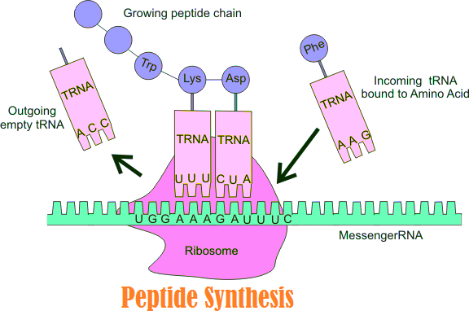
Figure1: peptide synthesis
After determining the particular amino acids of a protein needed for the biological mechanism of action, these pharmacophoric moieties may be incorporated into a short peptide. An essential goal is the creation of medications that can be taken orally. As rational drug design has considerably aided in the production of protease-resistant structural variations of endogenous peptides, it is necessary to emphasize the insertion of D-amino acids, the alteration of covalent bonds, and the construction of ring structures (cyclopeptides) ^{[8-9]}.
The following chemical techniques were used to build the chemistry: (i) choosing protective groups for amino acids and their deprotection, and (ii) forming peptide bonds. Two processes are generally used in contemporary peptide synthesis methodologies: one is based on synthesis in solution, while the other includes synthesis on a solid substrate. Racemization can take place at the activation stage, when removing protective groups from amino acids, and during other processes. The next two racemization procedures were taken into consideration:
- Direct Proton extraction
Only under extremely rare circumstances, such as the quick racemization of phenyl glycine derivatives, is this process the route. Strong bases directly extract the a-proton, which causes racemization to happen. By using appropriate reaction conditions, notably by using an additional amine, this can be avoided.
- Utilisation of oxazol-5(4H)-ones for racemization
It was suggested that the process of racemization may be explained by the creation of oxazole-5 (4H)-ones. It was demonstrated through this process that the propensity for racemization may be correlated with the characteristics of the amino-protecting molecule. Oxazole-5 (4H)-ones are easily produced when the carboxyl moiety of N-acyl amino acids (acyl14 acetyl, benzoyl, peptidyl, etc.) is activated. These oxazole-5 (4H)-ones can then be tautomerized to produce chirally volatile intermediates. It has long been believed that oxazole-5 (4H)-ones are not generated from urethane-protected amino acids, such as benzyloxycarbonyl (Z or Cbz)- or tert-butyloxycarbonyl (Boc)-amino acids, leading to an inability to resist racemization during activation and linking.
- Peptide bond
Even though it is depicted as a single bond, the peptide bond has a partial double-bond nature, which guarantees a smooth structure. Although the amide nitrogen is partially positive (+0.28) and a strong hydrogen bond donor, the carbonyl oxygen has a partial negative charge (-0.28) and is a good hydrogen bond acceptor. It suggests that the C=O and N-H peptide bonds all exist in the same plane. Spinning within the carbonyl bond is constrained (88 kJ/mol energy required to rotate) because the link connecting the carbonyl carbon and the nitrogen has a partial double-bond nature. The rotation of the peptide backbone is therefore limited to the bonds containing the carbon, making the peptide unit a flat, rigid structure: The planar peptide bond can be in either of two conformations: in the trans configuration, the C atoms are on either side of the peptide bond, while in the cis configuration, they are on the identical side.
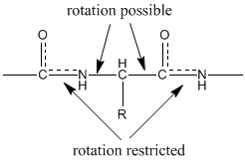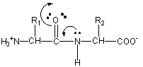
Figure 2: Peptide bond rotation Figure 3: Resonance-forms peptide bond

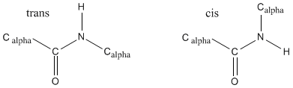
Figure 4: cis-trans peptide bond
- Solution-based peptide synthesis
Regarding the coupling chemistry and how the peptidic building blocks are combined, this method is quite adaptable. New approaches, spanning from the creation of specific groups for secondary chains to the condensation of pieces, have been developed to synthesize large molecules.
- Protecting group
A typical occurrence in reactions when none of the amino acids are shielded is the polymerization of amino acids because they are an acid with a basic group at one end and an acid group at the other. Protective groups are employed to stop this polymerization from happening. Benzyl derivatives are some of the protective groups that are utilized in solution synthesis. They may easily be removed using hydrogenolysis, which is the treatment of hydrogen gas in the presence of an appropriate catalyst.
- Z amino group
To create Z-amino acids, the Schotten-Bauman reaction is permitted to take place between benzyloxycarbonyl chloride and amino acids. At ambient temperature and atmospheric pressure, the Z group may be removed by catalytic hydrogenolysis, which doesn't damage the peptide bond or the other side-chain activities and merely produces the comparatively innocuous metabolites toluene and carbon dioxide.
- Boc group
Start-butyl chloroformate is volatile only at low temperatures, unlike benzyl chloroformate. Therefore, numerous different approaches for producing Boc-amino acids were researched. The Boc group may be eliminated by somewhat acidic environments like TFA but is resistant to catalytic hydrogenation, sodium in liquid ammonia, and alkali. Exposure with TFA at ambient temperature for 30 to 60 minutes cleaves the Boc group. Additionally, HBr cleaves it within a minute. In the synthesis of complicated peptides, orthogonal protective groups called Z and Boc groups are used. The tert-butyl (tBu) cation is produced as the result of the acidic therapies, and it loses its hydrogen to create isobutylene. Carbon dioxide and a salt of the free amino acid or peptide are the additional byproducts.
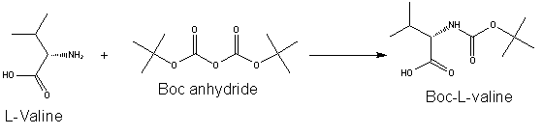
Figure 5: Creating the Boc-amino acids synthetically
- Tri group
By eliminating the Na -Z group by catalytic hydrogenolysis, the peptide chain can be extended when Lys(Boc), Glu(OtBu), and Asp(OtBu) are used. Every carboxyl group of the Tri-protected amino acid is sterically hindered, and only the N, N0 -dicyclohexylcarbodiimide (DCC) technique can generate peptide bonds with any degree of success. Catalytic hydrogenolysis, diluted acetic acid, or one equiv. of HCl can all be used to eliminate the Tri group. In the presence of the Bpoc, Boc, and tBu groups, it was removed by HCl in trifluoroethanol (pH 3.5-4.0) in a selective manner.
- Fmoc group
A tiny number of Fmoc-dipeptides are produced as a byproduct of the process used to create Fmoc-amino acids from natural amino acids and Fmoc-Cl. An option is the directly conversion of amino acids to their equivalent trimethylsilyl ester, which Fmoc-Cl may acylate without causing a side-reaction. In solution-phase synthesis, Fmoc deprotection by piperidine finally results in the development of a fulvene-piperidine adduct, which makes it challenging to remove the reaction mixture from the process. Polymer-bonded amines have been demonstrated to effectively remove the Fmoc group in solution to address this issue.
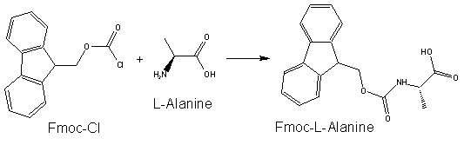
Figure 6: Fmoc reagent structure
- Peptide synthesis in solid phase
Peptide ligands attached to a solid matrix may aid in the extraction of certain molecules. Small synthesized peptides can control protein-protein interactions. The technique of expanding a peptidic chain that is bonded to a solid substrate by incorporating amino acids in a series of stages is known as solid-phase peptide synthesis (SPPS). This process is continued until the peptide with the necessary order and duration is generated ^{[10]}.
The most important factors in synthesis are the kind of solid carrier, coupling agents, and the process for cleaving the peptide from the solid matrix important factors in SPPS relate to chemical or enzymatic peptide synthesis.
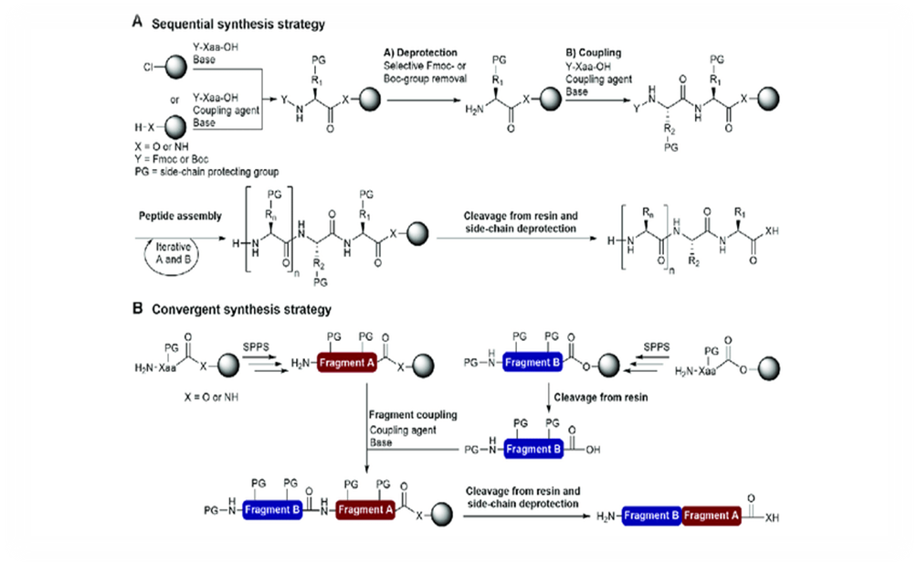
Figure7. Steps involved in SPPS (a) Deprotection (b) coupling of following residue (c) cleavage from resin.
- Deprotection
The interaction between two peptides that are one shielded at its N-terminus and the other at its C-terminus is necessary for the regulated development of a peptide bond in solution. The protected dipeptide is separated, purified, and characterized following the creation of the amide link. The resultant dipeptide amine is then connected with another amino acid covered at its Na-amino function after the Na-protecting group has been deprotected. Therefore, in order to get the required peptide, side-chain functional groups and Na-amino or carboxyl function should be covered with a suitable protective group.
The t-Boc/Bzl and Fmoc/tBu methods are the two primary protection systems that have been the subject of study and development in SPPS. The N amino group is protected by the t-Boc (tert-butoxycarbonyl) group in t-Boc/Bzl, while the lateral chains of numerous amino acids are protected by benzyl or cyclohexyl groups. The N amino group is protected by the Fmoc (9-fluorenyl methoxycarbonyl) group in Fmoc/tBu, while the lateral chains of numerous amino acids are protected by the tert-butyl group.
- Coupling of following residues
The coupling process uses several chemicals that activate the carboxyl chains of amino acids. The most widely used systems today are uronium and phosphonium sodium chloride and hydroxy benzotriazole (HOBT), which have greater accuracy, coupling yield, and responses than traditional methods like DCC/HOBT (dicyclohexyl-carbodiimide/1hydroxybenzotriazol), HOBT derivatives, and equal anhydrides. To cut down on coupling time and epimerization, many so-called in situ coupling reagents have been created. N-methylmethanaminium N-oxide hexafluorophosphate) N-[(dimethylamino)-1 H-1,2,3-triazole [4,5-b]pyridine-1-ylmethylene] or HATU is a chemical compound ^{[15-16]}.
- Cleavage, side-chain deprotection
Deprotection is performed with strong acids, which may result in undesirable lateral reactions of alkylation or acylation in some amino acids, which are encouraged by the departing protective groups. Combinations of solvents acting as nucleophiles and acids that facilitate the process of deprotection have been explored for decades to prevent such reactions. The Fmoc/tBu approach, on the other hand, allows for the use of simpler solvents such as TFA in conjunction with triisopropylsilane ^{[16]}.
- Protein modification
Numerous proteins contain elements that change their structural makeup. Any number of alterations that occur prior, during, and an amino acid is made on the ribosome may be incorporated into the protein's final structure. The easy and precise insertion of tags, labels, probes, or other functional groups into sequences that would not otherwise have them is made possible by peptide and protein engineering. To alter or replace natural residues using highly selective processes, several strategies have been developed, including genetics, chemicals, enzymatic, or chemoenzymatic reactions. Precise peptide and protein conjugates with distinctive alterations in particular locations are made using a combination of chemical and biological techniques. A growing area of science is the alteration of biological enzymes and proteins through protein engineering. The recognized processes of rational design and guided evolution, along with novel technologies, will make protein modification effective and simple. De novo engineering of enzymes, as well as new fields of protein engineering, would need the use of novel methods such as statistical design, catalytic antibodies, and mRNA display.
In order to create peptide-based, pharmacologically active molecules, various efforts have been undertaken to chemically modify peptides with better bioavailability and metabolic stability. Changes made to the lateral chains of individual amino acids are the most simple method of peptide modification. A recent and promising topic of peptide research is generation of -peptides (peptides made from artificial -amino acids). Short chains of amino acids have shown to possess intriguing biological features, such as the reduction of intestinal absorption of fat and cholesterol, and often form additional structures that are more durable than those found in environment.
It is necessary for biocatalysts to be strong enough to resist the demanding conditions of an industrial process, which often entails modifying the enzyme to create a stable biocatalyst. In terms of the link between structure and function, proteases are among the best-researched enzymes. Because they prefer amino acid residues on either side of the splitting threshold, the much of readily accessible endo and exoproteases are among the proteases used for peptide synthesis. Small peptides produced by enzymes—typically di- or tripeptides—are effectively employed in medicines, agrochemicals, human and animal nutrition, and other industries. A few relevant examples are the most well-known non-caloric sweetener, aspartame, the lysine sweet peptide, kyotorphin, angiotensin, enkephalin, and dynorphin.
- Role of Protein engineering in biotechnology
In the process of protein engineering, a protein's structure must be clarified. Not only is knowledge of a protein's structure helpful for altering the protein, but it also makes it possible to construct (small) compounds that interact with the protein, such as an deterrent or component of an enzyme. Accordingly, the protein engineering cycle is a multidisciplinary process that integrates the sciences of nature (biology, chemistry, physics, and mathematics), humanities, and computer science. In the context of biocatalyst engineering, protein engineering was described as a very promising method to increase enzyme durability and effectiveness in low-water environments ^{[17-18]}.
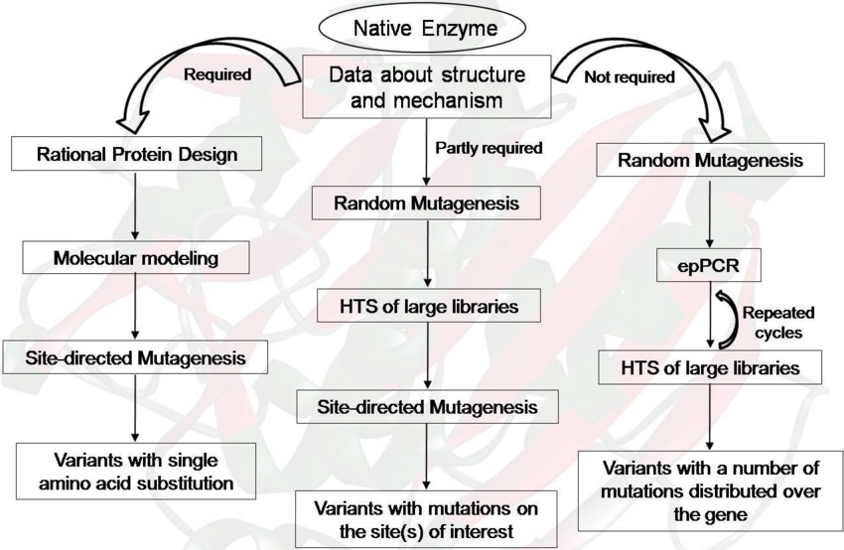
Figure 8: Representation of protein engineering strategies
Biological enzymes and proteins have been altered through protein engineering to suit the requirements of many industrial uses. This study intends to draw attention to the important contributions that protein engineering has made to synthetic biology, notably in the areas of improving enzyme performance, changing product and substrate selectivity, and changing regulatory components. Enhancing particular enzymatic functions in the production host under the necessary production circumstances is the goal of enzyme technology for enhanced activity, which aims to enhance the in vivo performance of enzymes for artificial biology. For instance, using directed evolution, the hyperthermophilic geranylgeranyl diphosphate (GGPP) synthase (GPS) from the Archaeoglobus fulgidus has been made to work at room temperature to boost the synthesis of GGPP needed to synthesize the antioxidant. Since inert insoluble heterologous aggregates of proteins may easily develop if their genes are overexpressed in numerous host systems, boosting the functional expression of enzymes can also increase their in vivo activity. Targeted evolution might be a better strategy for proteins that are poorly understood structurally or mechanistically. The size of the library and the effectiveness and efficiency of the screening procedure have a significant impact on the outcome of directed evolution.
- Methods of protein engineering
The so-called "rational design" technique, which incorporates "site-directed alteration" of proteins, is the most traditional strategy in protein engineering. The insertion of certain amino acids into a desired gene is possible thanks to site-specific mutagenesis. Site-directed mutagenesis can be done in two ways. The "overlap extension" approach is one of them. In the initial polymerase chain reaction (PCR), two PCRs take place, yielding two double-stranded DNA products. Four primers are employed in this PCR. When DNA polymerase is used for PCR, both strands of the template are reproduced without moving the primers, yielding a modified plasmid with non-overlapping splits. The mutant gene is then obtained from a circular, nicked vector by selective hydrolysis with DpnI methylase. A circular, mutant plasmid is produced once the nicked vector is transformed into competent cells, which causes the DNA break to be corrected.
However, there is little knowledge of the molecular makeup and processes of the target protein for protein engineering. As an alternative approach, "evolutionary techniques" were put out that make use of "random alteration and screening" to find the desired protein properties. Another method for protein engineering that combines logical and arbitrary methods is "localized or region-specific random alteration." To create proteins with novel specificities, it involves the simultaneous substitution of some fragments of amino acids in a particular area. Along with site-specific mutagenesis, this method also uses overlap elongation and single-round, whole-plasmid PCR alteration. As important scientific areas that bring further crucial knowledge for protein engineering studies, homology modeling of protein frameworks, NMR of massive proteins, molecular dynamics simulations of protein frameworks, and modeling of electrostatic impacts (such as pH-dependent effects) have been raised.
These techniques were divided into three categories: site-specific mutagenesis, random mutation, and "DNA shuffling" techniques used in evolutionary processes. A collection of genes with double-stranded DNA with comparable patterns are taken from diverse species or made by error-prone PCR in the DNA shuffling technique. When these genes are digested with DNaseI, tiny, arbitrarily split components are produced. These fragments are purified and put back together by PCR using a thermostable, error-prone DNA polymerase. The components serve as PCR primers on themselves, aligning and cross-priming one another. Consequently, a hybrid DNA made up of components from many parent genes is created. Applications for protein engineering are numerous and include biocatalysis in the food and manufacturing industries as well as uses in medicine, the environment, and nanobiotechnology. Enhanced protein engineering techniques will be made possible by advancements in tools for recombinant DNA technology, "omics" technologies, and high-throughput screening facilities. This will make it possible to easily modify or enhance more proteins and enzymes for further specialized uses.
- Conclusion
A potent technique for modifying the characteristics and function of peptides and proteins is site-specific modification. The development of cutting-edge therapies and diagnostics is made possible by the use of these newly synthesized peptides and proteins as materials for biochemistry studies in laboratories. The use of peptide and protein medications in clinical practice demonstrates that they are a logical place to start when developing new drugs. Innovative peptide and protein therapies that have recently been created might focus on disorders for which no approved drugs have yet been established.Through the encapsulation or modification of peptides and proteins with carrier molecules in nanoparticle form, researchers also hope to increase the availability of these substance in the central nervous system. Designing peptides for biochemical, biological, and biophysical research begins with an awareness of the potential and present restrictions in solid-phase peptide synthesis.
- Future perspective for cancer treatment using bacteria
Scientists genetically altered the staphylococcus epidermis, a common skin bacterium, to express a protein that is typically seen in tumor cells. This investigation was conducted on mice in preparation for a clinical trial in which the most effective tumor antigen and bacteria were sought after. The tumor volume and weight were decreased when the mice were treated with bacteria. This modified bacterium was applied to the mice's skin, which locally stimulated the T cells but allowed them to circulate throughout the body and finally find cancer in the lung. The main motive of the scientist is to find the best antigen and bacteria which would stop the growth of tumors in humans.
- References
- Rawat, D. S.; Ponnan, P. Editorial: Peptide Science at the Chemistry and Biology Interface. Curr. Protein Pept. Sci. 2017, 18, 884.
- M. Goodman, A. Felix, L. Moroder, C. Toniolo, Synthesis of Peptides and Peptidomimetics in Houben-Weyl-Methoden der organischen Chemie, Vol. E22, K. H. Buchel (Ed.), Thieme, Stuttgart, € 2002.
- ADAMCZAK, Marek and HARI KRISHNA, Sajja. Strategies for improving enzymes for efficient biocatalysis. Food Technology and Biotechnology, October 2004, vol. 42, no. 4, p. 251-264.
- ALBERICIO, Fernando; BURGER, Klaus; RUIZRODRIGUEZ, Javier and SPENGLER, Jan. A new strategy for solid-phase depsipeptide synthesis using recoverable building blocks. Organic Letters, February 2005, vol. 7, no. 4, p. 597-600.
- Peptides 1988, Proc. 20th Eur. Pept. Symp. (Eds.: G. Jung, E. Bayer), de Gruyter, Berlin, 1989; and references cited therein.
- Peptides 1990, Proc. 21st Eur. Pept. Symp. (Eds.: E. Giralt, D. Andreu), Escom, Leiden, 1991. [3] Peptides: Chemistry andBiology, Proc. 10th Am. Pept. Symp. (Ed.: G. R. Marshall), Escom, Leiden, 1988.
- a) Peptides, Chemistry, Structure and Biology, Proc. 11th Am. Pept. Symp. (Eds.: J. E. Rivier, G. R. Marshall), Escom, Leiden, 1990; b) Peptides, Chemistry and Biology Proc. 12th Am. Pept. Symp. (Eds.: J. A. Smith, J. E. Rivier), Escom, Leiden, 1992
- Knud J. Jensen et al. ”Solid-Phase Peptide Synthesis: An Introduction” Peptide Synthesis and Applications, Methods in Molecular Biology vol. 1047, new York 3013
Pg no. 1-21.
- Wangsa T. Ismaya, Role of protein peptide in biotechnology, Department of Biochemistry and Cell Biology, Faculty of Veterinary Medicine, Utrecht University, Yalelaan 2, 2584 CM Utrecht, The Netherlands, vol. 19 july 2011 page no. 11-18.
- Merrifield RB (1963) Solid-phase peptide synthesis. synthesis of a tetrapeptide. J Am Chem Soc 85:2149–2154.
- AMBULOS, Nicholas P.; BIBBS, Lisa; BONEWALD, Lynda F.; KATES, Steven A.; KHATRI, Ashok; MEDZIHRADSZKY, Katalin F. and WEINTRAUB, Susan T. Analysis of Synthetic Peptides. In: KATES, Steven A. and ALBERICIO, Fernando eds. Solid-Phase Synthesis: A Practical Guide. New York, Marcel Dekker Inc., 2000, p. 751-789.
- Rose K (1994) Facile synthesis of homogeneous artificial proteins. J Am Chem Soc 116:30–33.
- Bodanszky, M., Klausner, Y.S., and Ondetti, M.A. (1976) Peptide Synthesis, John Wiley & Sons, Ltd, New York, pp. 137–157.
- Goodman, M. and Levine, L. (1964) Peptide synthesis via active esters. IV. Racemization and ring-opening reactions of optically active oxazolones. Journal of the American Chemical Society, 86, 2918–2922.
- Baez-Viveros JL, Osuna J, Hernandez-Chavez G, Soberon X, Bolivar F, Gosset G. Metabolic engineering and protein directed evolution increase the yield of L-phenylalanine synthesized from glucose in Escherichia coli. Biotechnol Bioeng 2004, 87 516–24.
- Fanny Guzmán et al. “Peptide synthesis: chemical or enzymatic” Electronic Journal of Biotechnology, Vol.10 No.2, Issue of April 15, 2007 pg no. 280-314.
- Amara AA, Steinbuchel A, Rehm BH. In vivo evolution of the Aeromonas punctata polyhydroxyalkanoate (PHA) synthase: isolation and characterization of modified PHA synthases with enhanced activity. Appl Microbiol Biotechnol 2002, 59 477–82.
- ALBERICIO, Fernando. Developments in peptide and amide synthesis. Current Opinion in Chemical Biology, June 2004, vol. 8, no. 3, p. 211-221.
- ALBERICIO, Fernando. Orthogonal protecting groups for Na -amino and C-terminal carboxyl functions in solid-phase synthesis. Biopolymers - Peptide Science Section, 2000, vol. 55, no. 2, p. 123-139.
- Fanny Guzmán et al. “Peptide synthesis: chemical or enzymatic” Electronic Journal of Biotechnology, Vol.10 No.2, Issue of April 15, 2007 pg no. 280-314.

